CR#EB140166 – To add officer code field in IBAM’s One Stop Service Application (RIB) and Company Enquiry – Creation (BIB)

# Database

Update existing tables, RIB_NON_ATM_APPLICATION and BIB_COMPANY, to include 4 new fields

| **Name** | **Type** | **Required?** | **Default** | **Description** |
| --- | --- | --- | --- | --- |
| AO_Code | varchar2(16) | No | Null | Account Officer Code |
| AO_NAME | varchar2(80) | No | Null | Account Officer Name |
| RO_Code | varchar2(16) | No | Null | Refer Officer Code |
| RO_NAME | varchar2(80) | No | Null | Refer Officer Name |

# Host

1. To create new host message integration to get officer’s name for Account Officer (AO) and Refer Officer (Refer)[1]

# IBAM

## One Stop Service Application (RIB)

1. To add 2 new fields of Account Officer and Refer Officer into the One Stop Service Application screen.

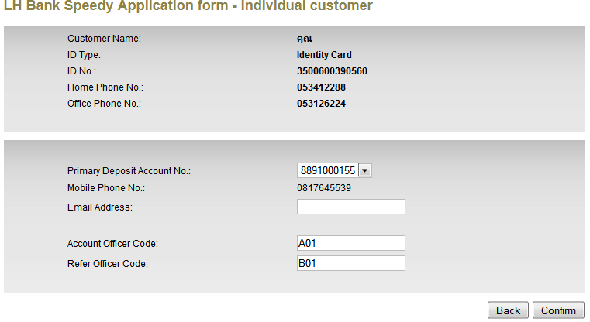

1. Upon submission, IBAM to verify officer codes with Host and retrieve the names for both Officer

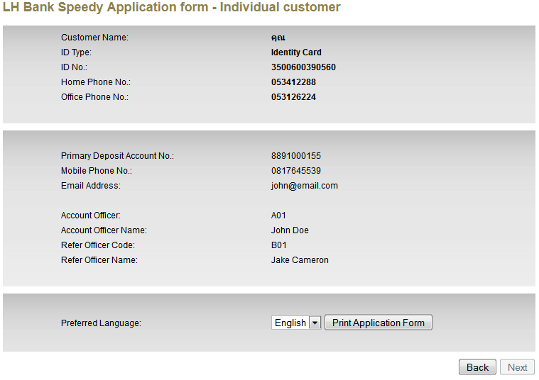

1. IBAM will save the officer codes & names into Database for recording purposes.

## RIB Application Enquiry (RIB)

At the Customer Application Details, add new fields to display.

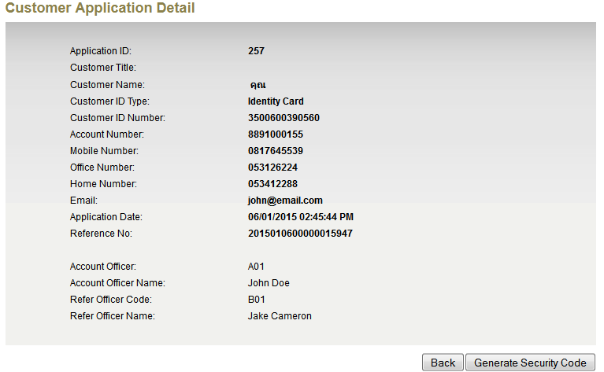

## Company Enquiry – Creation (BIB)

1. To add 2 new fields, Account Officer & Refer Officer in the Application Form

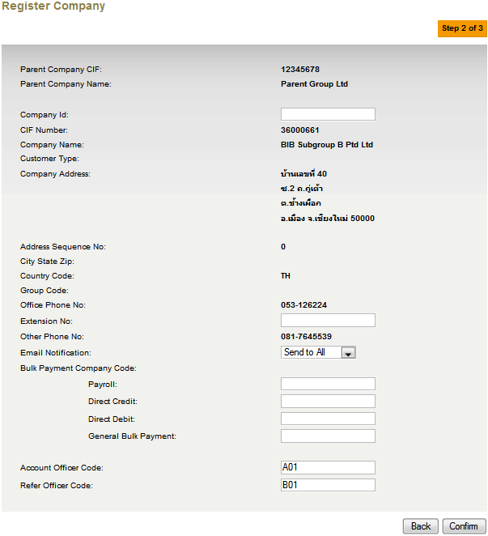

1. On submission, IBAM to verify officer codes with Host and retrieve the names for both Officers. If either one code is incorrect, IBAM will prompt error and required Admin to enter the correct officer code. If no error, IBAM to save both officer codes & names into Database to complete the company registration.

## Company Enquiry – Company Details

1. At the Company Details, add new fields to display.

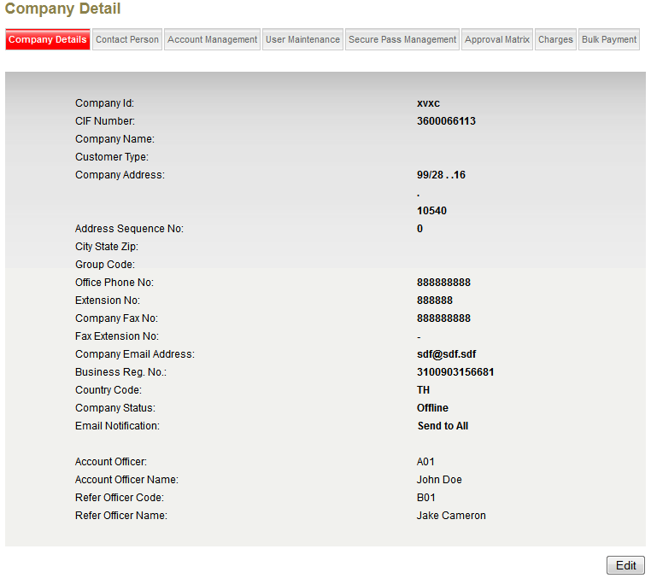

1. When edit Company Details, allow admin to update the Account Officer & Refer Officer Code.
2. On update submission, IBAM to verify officer codes with Host and retrieve the names for both Officers. If either one code is incorrect, IBAM will prompt error and required Admin to enter the correct officer code. If no error, IBAM to update both officer codes & names and other company details into Database to complete the process.

|  |  |
| --- | --- |
| Effort(man-days) | 5 |
| Affected Area | IBAM |

1. Host will return error if either one of the officer code is incorrect