Originator's Name: Chooi So Fun  Project: SMS Notification  Project Manager: Malarvily Muniandy / Christopher Gunn  Owner: PDM / RCB  Date Raised: 21.10.10  Phase/Process:  Functional Area: Consumer | Issue ID Number: UAT-SMS009  Related ID Number:  Priority: High / Medium / Low  Assigned to:  Target Resolution Date:  Actual Closed Date:
Status : Open / Investigate / Retest / Re-Open / Closed / Sign-Off (Circle one)
Category : Bugs / Set-up / Clarification / Repeated / Internal CR / CR (Circle one)
Description:
For ALL Modules:
Transaction should be unsuccessful if account is having insufficient fund to cover SMS charges, IBG/FTT/SI charges and principal amount.

(Refer to screen attached for further details).
Impact:

Investigation (Description):

Action:

Estimated Impact:

Recommendation:

Accepted (PENRIL/SA/IT):  Date: | Accepted (KFHMB):  Date:
Associated Risk Report: | Risk Report Accepted Date:
Associated Change Request Form: | Change Control Accepted on:

Open Intrabank Transfer – SMS Bene Charges is defined as 0.22.
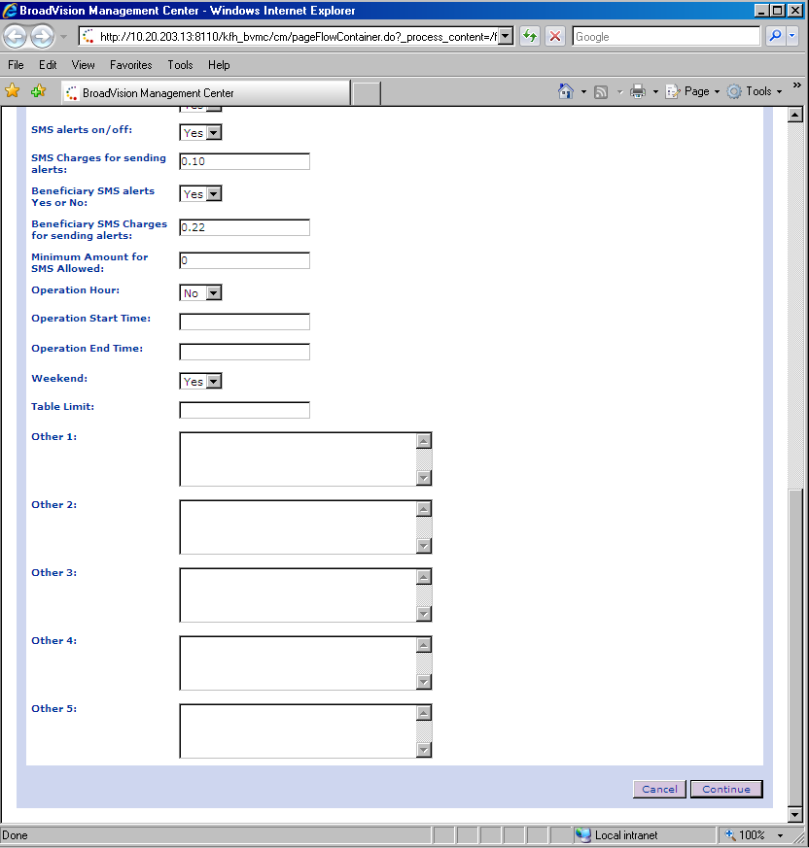
Account Balance: RM0.20 (Not sufficient to cover SMS charges to Bene)
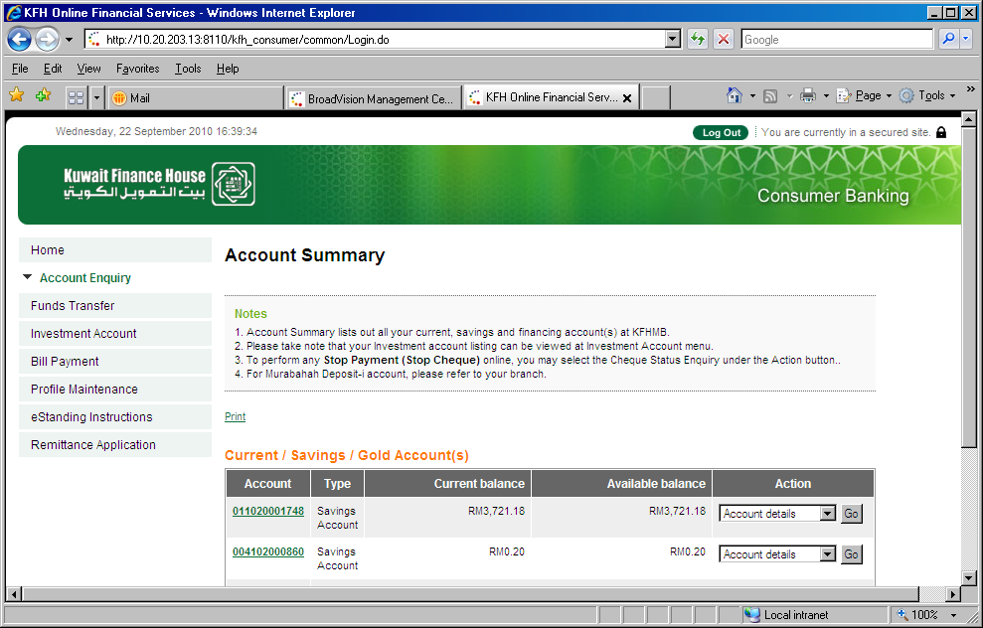

Perform Transfer – Amount 0.03 and opt for sending SMS to Bene.
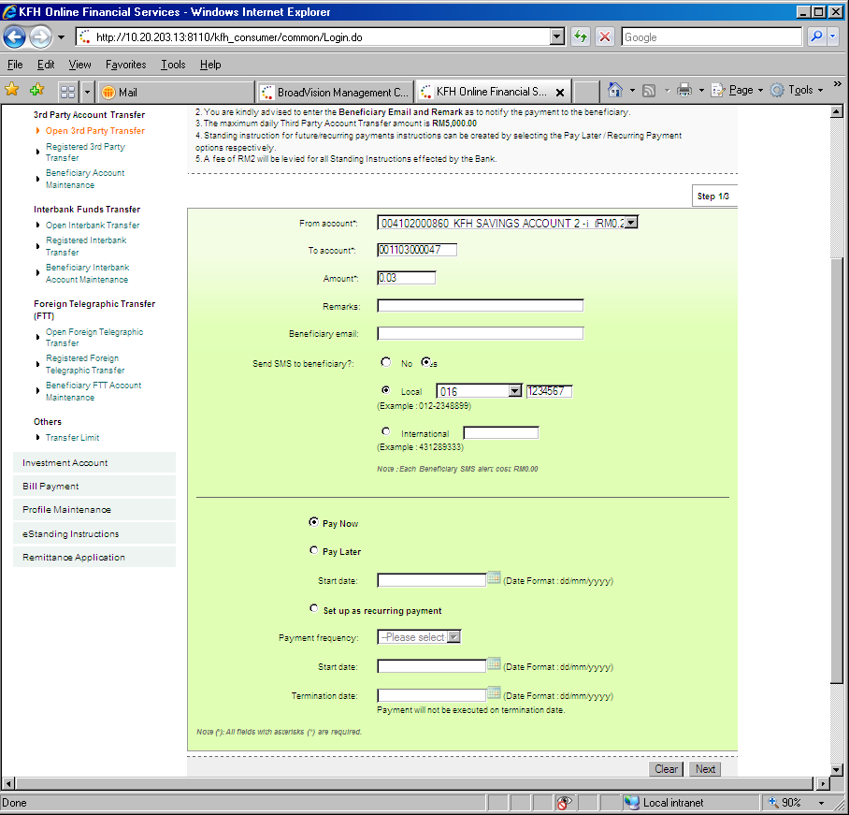
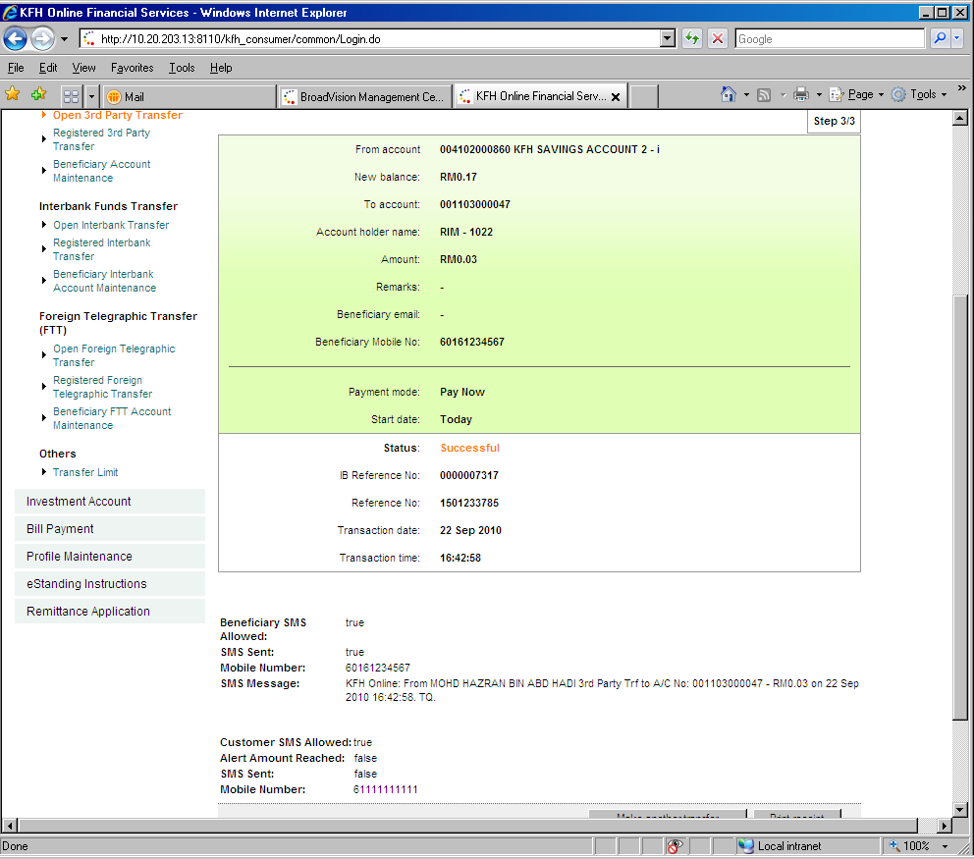
Should be Unsuccessful due to insufficient fund
SMS Sent should be having status “False” and no SMS Message to Bene.

