# Site Management – FOREX

Forex module allowing administrator to manage the forex rate

## Create Category

### Features Description

This feature allows administrator to create a new forex category

### Objectives

To categorize the currency codes for easy maintenance.

### Process Flows



Diagram 1: Create Category Process Flow

### Screen Flows

***Step 1:***

1. Admin User selects the ‘Site Management’ module, and clicks **Forex** hyperlink**.**
2. MSS shows the navigable service inside **Forex**.

*(Note that any navigable service cannot be deleted as it will make corresponding service will become unavailable at RIB.*

*Same goes creation process, be default the navigation already provided by the programmer since it stored directly to database, hence user’s creation for new navigable service would not be necessary to be included to the function.)*

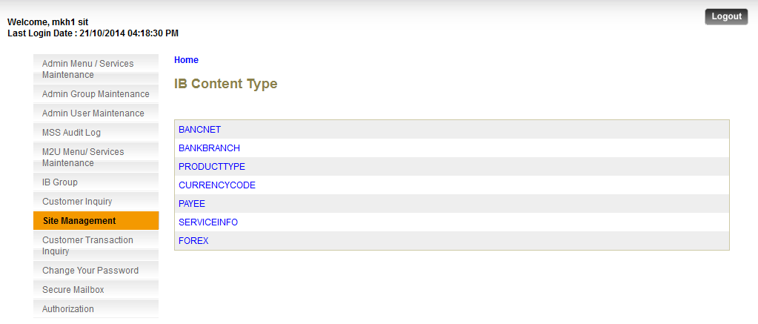

**Action:**

|  |  |  |  |
| --- | --- | --- | --- |
| No | Action | Type | Description |
|  | Forex | Hyperlink | Direct user to Forex Category List |

***Step 2:***

1. Admin User clicks on Create Category button

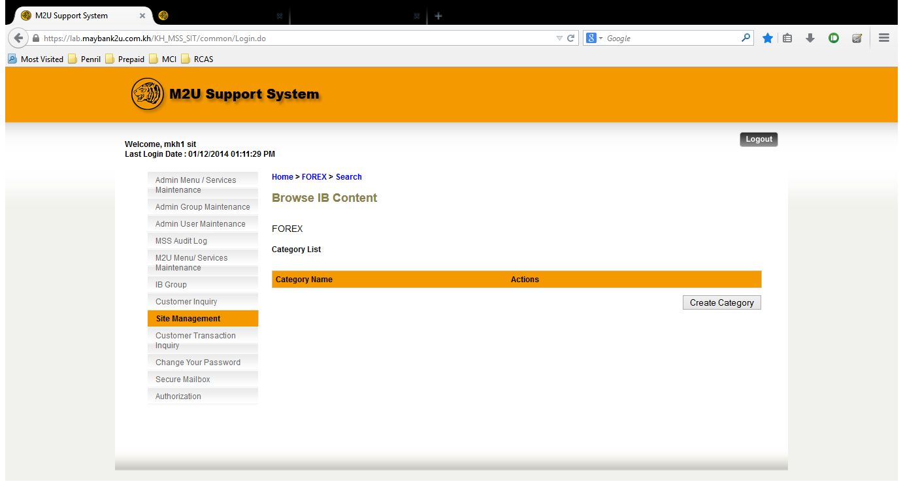

**Action:**

|  |  |  |  |
| --- | --- | --- | --- |
| No | Action | Type | Description |
|  | Create Category | Button | Forward the action to Create a Site Management Category |

***Step 3:***

1. Admin User create on Forex Parent Category
2. Clicks on Done button

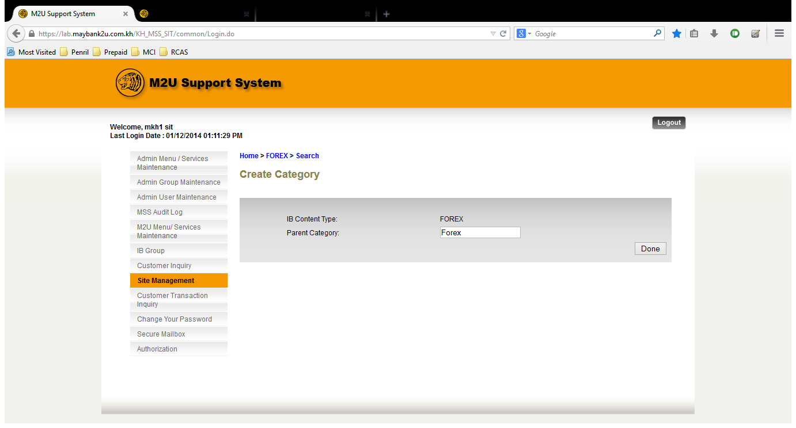

**Specification:**

|  |  |  |  |  |  |
| --- | --- | --- | --- | --- | --- |
| No | Field | Field Type | Rule | Description | Compulsory |
|  | Parent Category | Text Box | 32 digits of alphanumeric. | Describes the name of Parent Category that will be created | Yes |

**Action:**

|  |  |  |  |
| --- | --- | --- | --- |
| No | Action | Type | Description |
|  | Done | Button | Forward the action to validate the user input and create the parent category into the system and save it to the IB Database |

## Edit Category

### Features Description

This feature allows admin user to Edit Forex Category

### Process Flows



Diagram 2: Edit Category Process Flow

### Screen Flows

***Step 1:***

1. Admin User selects the ‘Site Management’ module, and clicks **Forex** hyperlink**.**
2. MSS shows the navigable service inside **Forex**.

*(Note that any navigable service cannot be deleted as it will make corresponding service will become unavailable at RIB.*

*Same goes creation process, be default the navigation already provided by the programmer since it stored directly to database, hence user’s creation for new navigable service would not be necessary to be included to the function.)*



**Action:**

|  |  |  |  |
| --- | --- | --- | --- |
| No | Action | Type | Description |
|  | Forex | Hyperlink | Direct user to Forex Category List |

***Step 2:***

1. Admin User clicks on Edit link

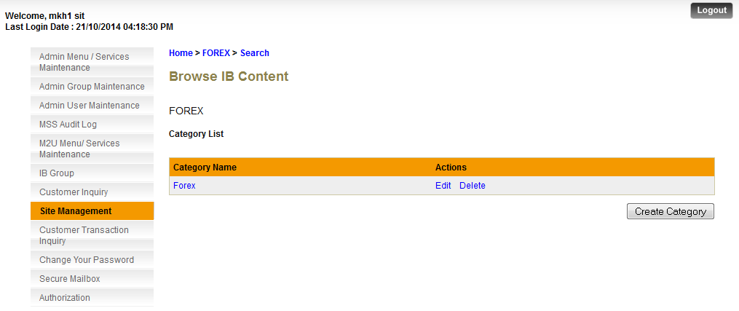

**Action:**

|  |  |  |  |
| --- | --- | --- | --- |
| No | Action | Type | Description |
|  | Edit | Hyperlink | Forwards the page to Edit page of category |

***Step 3:***

1. Admin User edit on Forex Category Name
2. Clicks on Update button after changes had been completed.
3. MSS saves the changes on the database, which result on the changes that will be occurred on the IB user system.

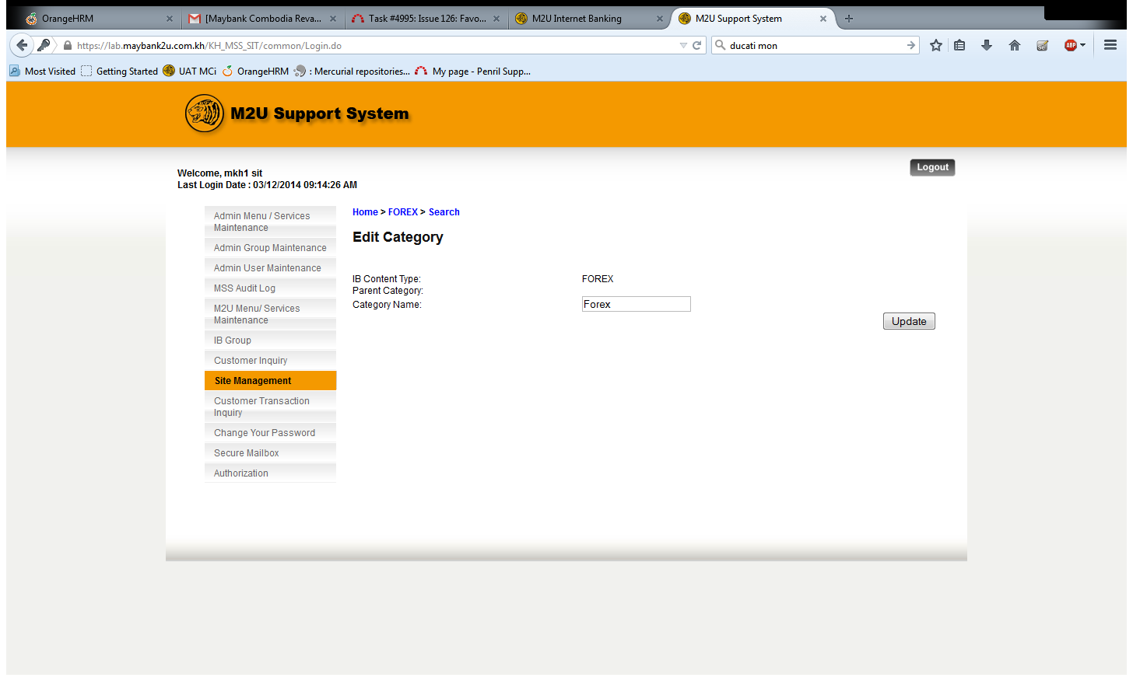

**Specification:**

|  |  |  |  |  |  |
| --- | --- | --- | --- | --- | --- |
| No | Field | Field Type | Rule | Description | Compulsory |
|  | Category Name | Text Box |  | The name of category | Yes |

**Action:**

|  |  |  |  |
| --- | --- | --- | --- |
| No | Action | Type | Description |
|  | Update | Button | Validate the user input and update the category name in database |

## Delete Category

### Features Description

This feature allows admin user to delete Forex Category

### Process Flows



Diagram 3: Delete Category Process Flow

### Screen Flows

***Step 1:***

1. Admin User selects the ‘Site Management’ module, and clicks **Forex** hyperlink**.**
2. MSS shows the navigable service inside **Forex**.

*(Note that any navigable service cannot be deleted as it will make corresponding service will become unavailable at RIB.*

*Same goes creation process, be default the navigation already provided by the programmer since it stored directly to database, hence user’s creation for new navigable service would not be necessary to be included to the function.)*



**Action:**

|  |  |  |  |
| --- | --- | --- | --- |
| No | Action | Type | Description |
|  | Forex | Hyperlink | Direct user to Forex Category List |

***Step 2:***

1. Admin User clicks on Delete link



***Step 3:***

1. Admin User Delete Category.
2. Clicks on Confirm button to delete.
3. MSS saves the changes on the database, which result on the changes that will be occurred on the IB user system.

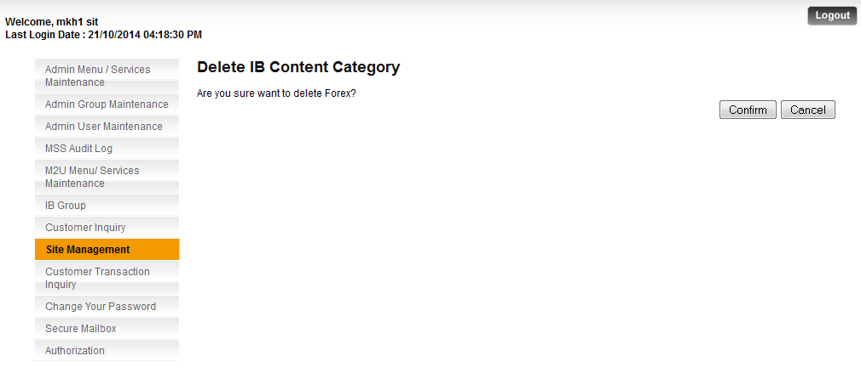

**Action:**

|  |  |  |  |
| --- | --- | --- | --- |
| No | Action | Type | Description |
|  | Confirm | Button | Confirm the delete of the category |
|  | Cancel | Button | Revert back to Category List from previous step |

## Add Content

This feature allows Admin user to view the content menu that will be displayed in Retail Internet Banking.

### Create Forex Content

#### Process Flows



#### Screen Flows

***Step 1:***

1. Admin User selects the ‘Site Management’ module, and clicks **Forex.**
2. MSS shows the navigable service inside **Forex**.

*Note that any navigable service cannot be deleted as it will make corresponding service will become unavailable at RIB.*

*Same goes creation process, be default the navigation already provided by the programmer since it stored directly to database, hence user’s creation for new navigable service would not be necessary to be included to the function*.

1. Admin user clicks on the Details link of **Forex** child node.



**Action:**

|  |  |  |  |
| --- | --- | --- | --- |
| No | Action | Type | Description |
|  | Forex | Hyperlink | Direct user to Forex Category List |

***Step 2:***

1. Admin User clicks on Create Content button

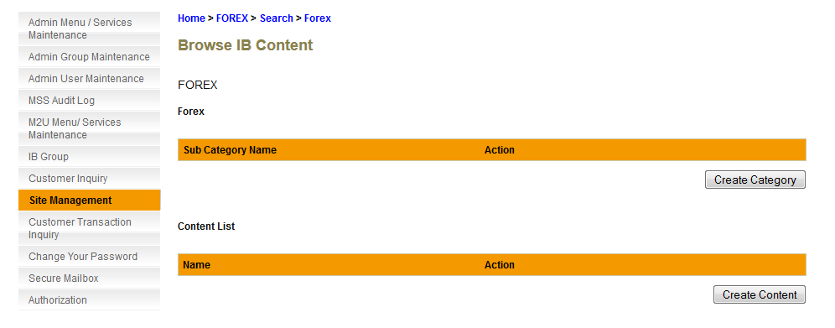

**Action:**

|  |  |  |  |
| --- | --- | --- | --- |
| No | Action | Type | Description |
|  | Create Content | Button | Forward the action to Create Forex Content |

***Step 3:***

1. Admin User create on Forex Content Category
2. Clicks on Done button
3. MSS saves the data to the database, which result on the created item will be occurred on the IB user system.

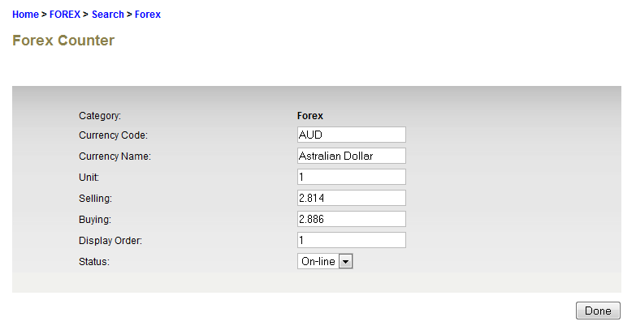

|  |  |  |  |  |  |
| --- | --- | --- | --- | --- | --- |
| No | Field | Field Type | Rule | Description | Compulsory |
|  | Currency Code | Text Box |  | The unique International Currency code representing a currency | Yes |
|  | Currency Name | Text Box |  | The currency name reflecting to the currency code | Yes |
|  | Unit | Text Box |  | The currency volume | Yes |
|  | Selling | Text Box |  | Selling Price | Yes |
|  | Buying | Text Box |  | Buying Price | Yes |
|  | Display Order | Text Box |  | Ordered by Currency Code and Currency Name. Currency Code in RIB will display based on number stated in the field. | Yes |
|  | Status | Drop down |  | Selection of “Online” and “Offline” | Yes |

**Specification:**

**Action:**

|  |  |  |  |
| --- | --- | --- | --- |
| No | Action | Type | Description |
|  | Done | Button | Forward the action to validate the user input and create the content list the system and save it to the Database |

***Step 4:***

1. Created Forex Content will be display on the list
2. Clicks on Done button

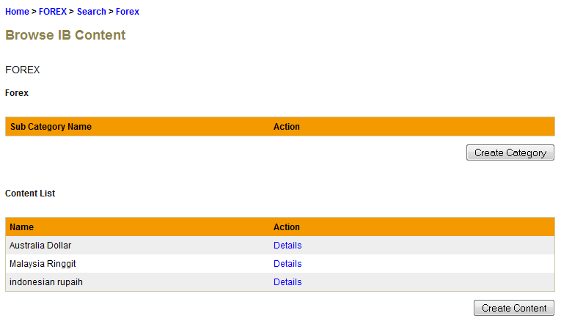

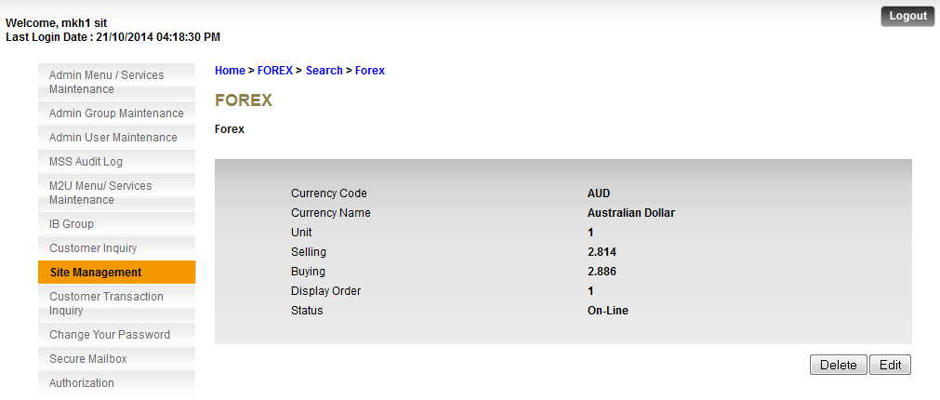

### Edit Forex Content

#### Process Flows



#### Screen Flows

***Step 1:***

1. Admin User selects the ‘Site Management’ module, and clicks **Forex.**
2. MSS shows the navigable service inside **Forex**.

***Step 2:***

1. Admin User clicks on Details link to view content details.



**Action:**

|  |  |  |  |
| --- | --- | --- | --- |
| No | Action | Type | Description |
|  | Details | Hyperlink | Direct user to Content List Details |

***Step 3:***

1. Admin User clicks on Edit button to edit the content details.



**Action:**

|  |  |  |  |
| --- | --- | --- | --- |
| No | Action | Type | Description |
|  | Edit | Hyperlink | Open Edit page of content |

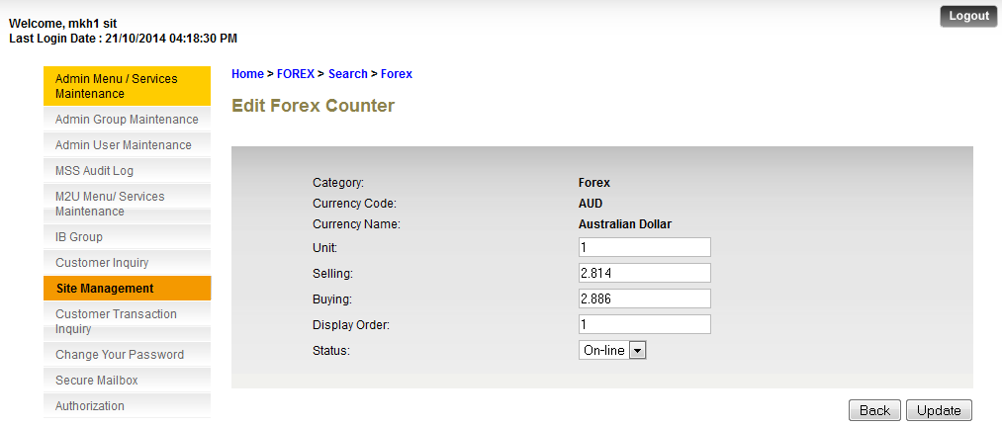

**Specification:**

|  |  |  |  |  |  |
| --- | --- | --- | --- | --- | --- |
| No | Field | Field Type | Rule | Description | Compulsory |
|  | Unit | Text Box |  | The currency volume | Yes |
|  | Selling | Text Box |  | Selling Price | Yes |
|  | Buying | Text Box |  | Buying Price | Yes |
|  | Display Order | Text Box |  | Ordered by Currency Code and Currency Name. Currency Code in RIB will display based on number stated in the field. | Yes |
|  | Status | Drop Down |  | Selection of “Online” and “Offline” | Yes |

**Specification:**

**Action:**

|  |  |  |  |
| --- | --- | --- | --- |
| No | Action | Type | Description |
|  | Update | Button | Validate the user input and update the content name in database |

### Delete Forex Content

#### Process Flows

#### Screen Flows

***Step 1:***

1. Admin User selects the ‘Site Management’ module, and clicks **Forex** hyperlink**.**
2. MSS shows the navigable service inside **Forex**.

*(Note that any navigable service cannot be deleted as it will make corresponding service will become unavailable at RIB.*

*Same goes creation process, be default the navigation already provided by the programmer since it stored directly to database, hence user’s creation for new navigable service would not be necessary to be included to the function.)*

1. Click on Category Name hyperlink.
2. MSS Display Content List
3. Click Content List Details button



**Action:**

|  |  |  |  |
| --- | --- | --- | --- |
| No | Action | Type | Description |
|  | Details | Hyperlink | Direct user to Content List Details |

***Step 2:***

1. Admin User Delete Content.
2. Clicks on Delete button to delete.
3. MSS saves the changes on the database, which result on the changes that will be occurred on the IB user system.



**Action:**

|  |  |  |  |
| --- | --- | --- | --- |
| No | Action | Type | Description |
|  | Delete | Button | Forward the action to delete Forex Content |

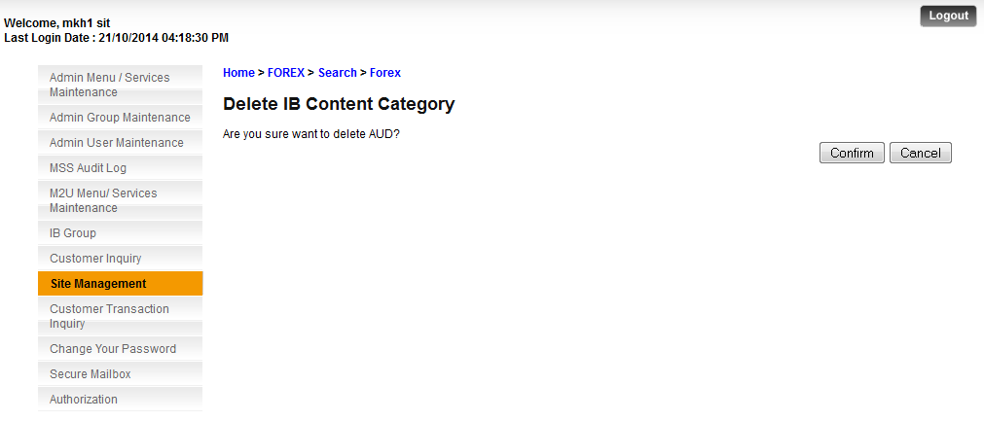

**Action:**

|  |  |  |  |
| --- | --- | --- | --- |
| No | Action | Type | Description |
|  | Confirm | Button | Confirm the delete of the content category |
|  | Cancel | Button | Revert back to Content Category List from previous step |

### Search Forex Content

#### Process Flows

#### Screen Flows

***Step 1:***

1. Admin User selects the ‘Site Management’ module, and clicks **Forex** hyperlink**.**
2. MSS shows the navigable service inside **Forex**.

*(Note that any navigable service cannot be deleted as it will make corresponding service will become unavailable at RIB.*

*Same goes creation process, be default the navigation already provided by the programmer since it stored directly to database, hence user’s creation for new navigable service would not be necessary to be included to the function.)*

1. Click on Category Name hyperlink.
2. MSS Display Content List
3. Admin User click on Search hyperlink on the top of page
4. MSS display Forex Counter Search page

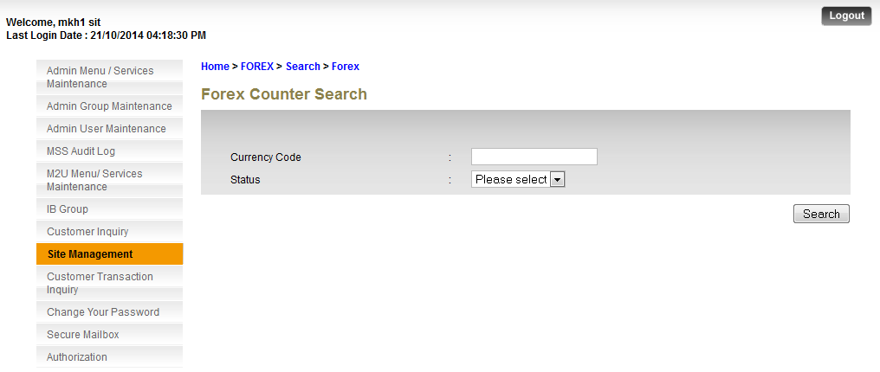

***Step 2:***

1. Admin User clicks on Search Button without inserting any field to search all.
2. MSS display All search result without any filter

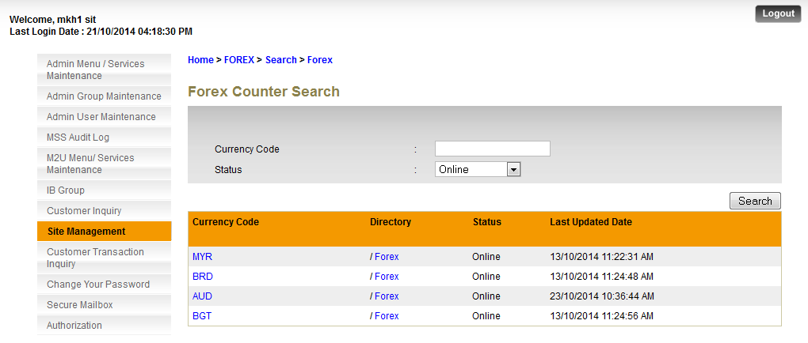

**Action:**

|  |  |  |  |
| --- | --- | --- | --- |
| No | Action | Type | Description |
|  | Search | Button | Forward the action to Search the data |