Internal testing result |  |  |  |  |  | CR-00027
Project Name: | Retail Internet Banking
Test Stage: | Unit Functionality Integration System Interface  Performance Regression Acceptance Pilot
Test Case Number: | - |  |  | Test Started Date: |  | 15/01/2015
Test Title: | RIB & BIB Demo for GST Implementation Screen
Test Description: | To ensure that RIB and BIB Demo page on GST Implementation at related module updated:-  - RIB> Bill Payment  - RIB> eIBFT  - RIB> Transaction History  - RIB> AGRONet Transaction History  - BIB> Bill Payment  - BIB> Transaction History  - BIB> AGRONetBiz Transaction History
Test Functionality: | RIB>AGRONet Demo>Bill Payment> New Bill Payment  RIB>AGRONet Demo>Bill Payment> Favourite Bill Payment  RIB>AGRONet Demo>Fund Transfer> New Instant Fund Transfer  RIB>AGRONet Demo>Fund Transfer> Favourite Instant Fund Transfer  RIB>AGRONet Demo>Account & Banking> Transaction History  RIB>AGRONet Demo>Account & Banking>AGRONet Transaction History  BIB>AGRONet Demo>Bill Payment> New Bill Payment  BIB>AGRONet Demo>Bill Payment> Favourite Bill Payment  BIB>AGRONet Demo>Account & Banking> Transaction History  BIB>AGRONet Demo>Account & Banking>AGRONet Transaction History
Test Procedure: | RIB/BIB Demo (New Bill Payment):  - Login to RIB/BIB  - Click on AGRONet Demo  - Click on Bill Payment. Click on New Bill Payment  - Select Payee Corporation Category and clicks on Next button  - Select Payee Corporation and click on Next button  - Select from account and clicks on Next button  - Clicks on Confirm button  - Clicks on Print Receipt  RIB/BIB Demo (Favourite Bill Payment):  - Login to RIB/BIB  - Click on AGRONet Demo  - Click on Bill Payment. Click on Favourite Bill Payment  - Select Payee Corporation and clicks on Next button  - Select From Account and clicks on Next button  - Clicks on Confirm button  - Clicks on Print Receipt button  RIB Demo (New Instant Interbank Transfer - eIBFT)Login to RIB/BIB  - Click on AGRONet Demo  - Click on Fund Transfer  - Click on New Fund Transfer  - Select From Account, Mode of Transfer, Beneficiary Bank and Payment Type.  - Clicks on Next button  - Clicks on Confirm button  - Clicks on Print Receipt button  RIB Demo (Favourite Instant Interbank Transfer - eIBFT)  - Login to RIB/BIB  - Click on AGRONet Demo  - Click on Fund Transfer  - Click on Favourite Fund Transfer  - Select From Account and Mode of Transfer.  - Clicks on Next button  - Clicks on Confirm button  - Clicks on Print Receipt button  RIB/BIB Demo (Transaction History)  - Login to RIB/BIB  - Clicks on AGRONet Demo  - Clicks on Account & Banking  - Clicks on Transaction History  RIB/BIB Demo (AGRONet Transaction History)  - Login to RIB/BIB  - Clicks on AGRONet Demo  - Clicks on Account & Banking  - Clicks on AGRONet Transaction History
Test Result: | Pass: Fail: | Tested by: |  |  | Nurul Akmal binti Yusof
Reason for Failure:
TEST DESCRIPTION
RIB Demo: New Bill Payment
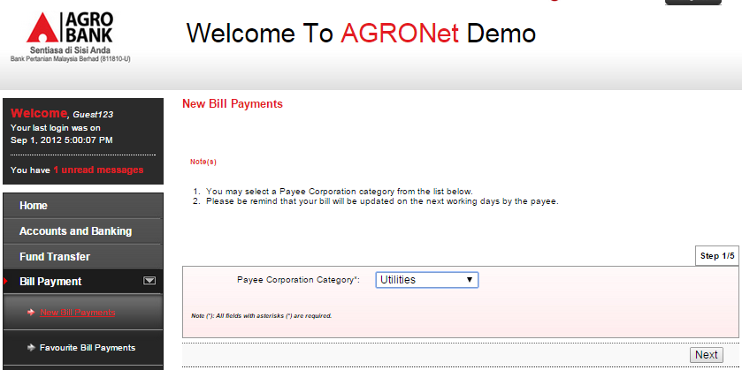
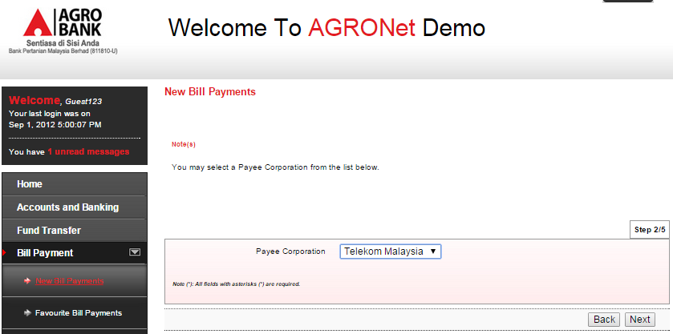

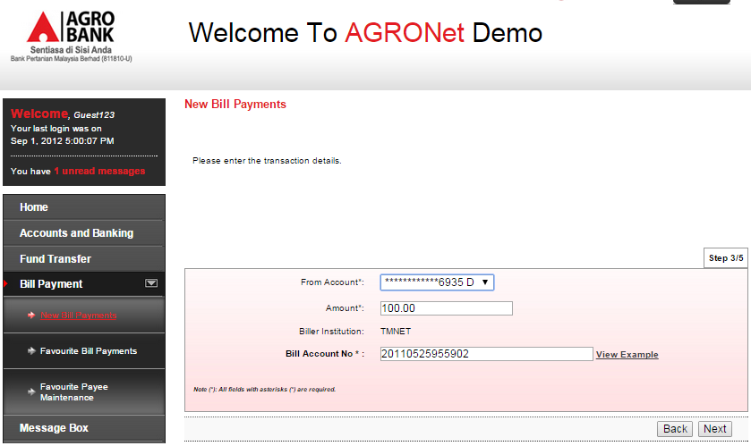
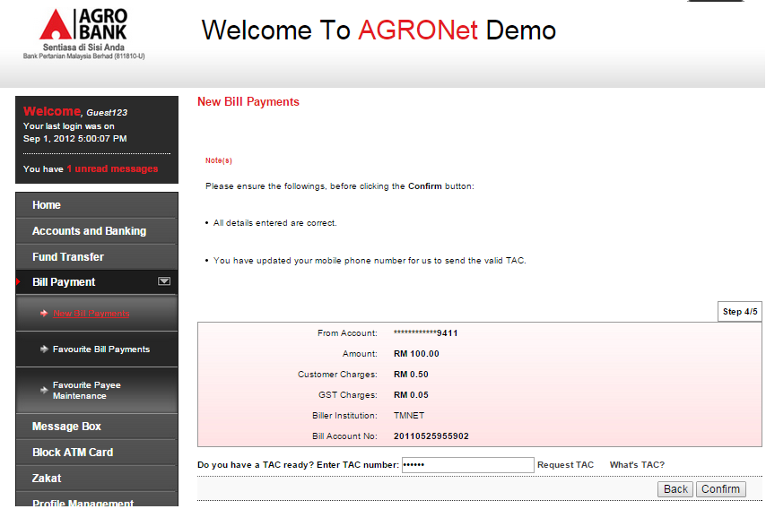

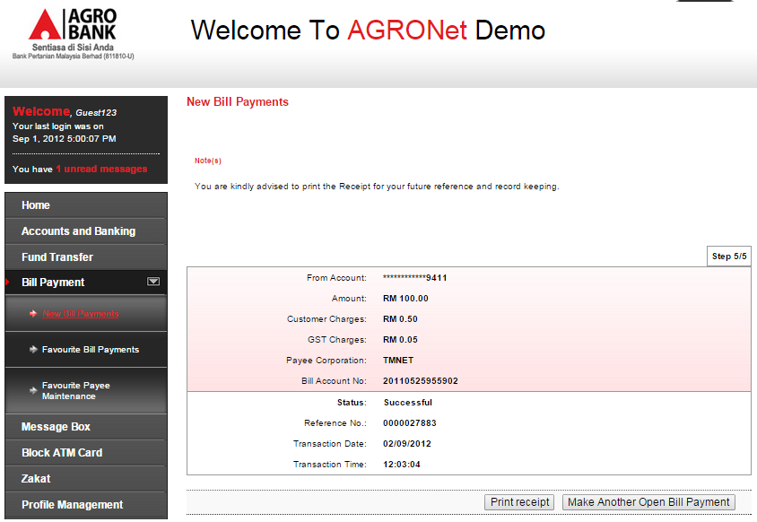
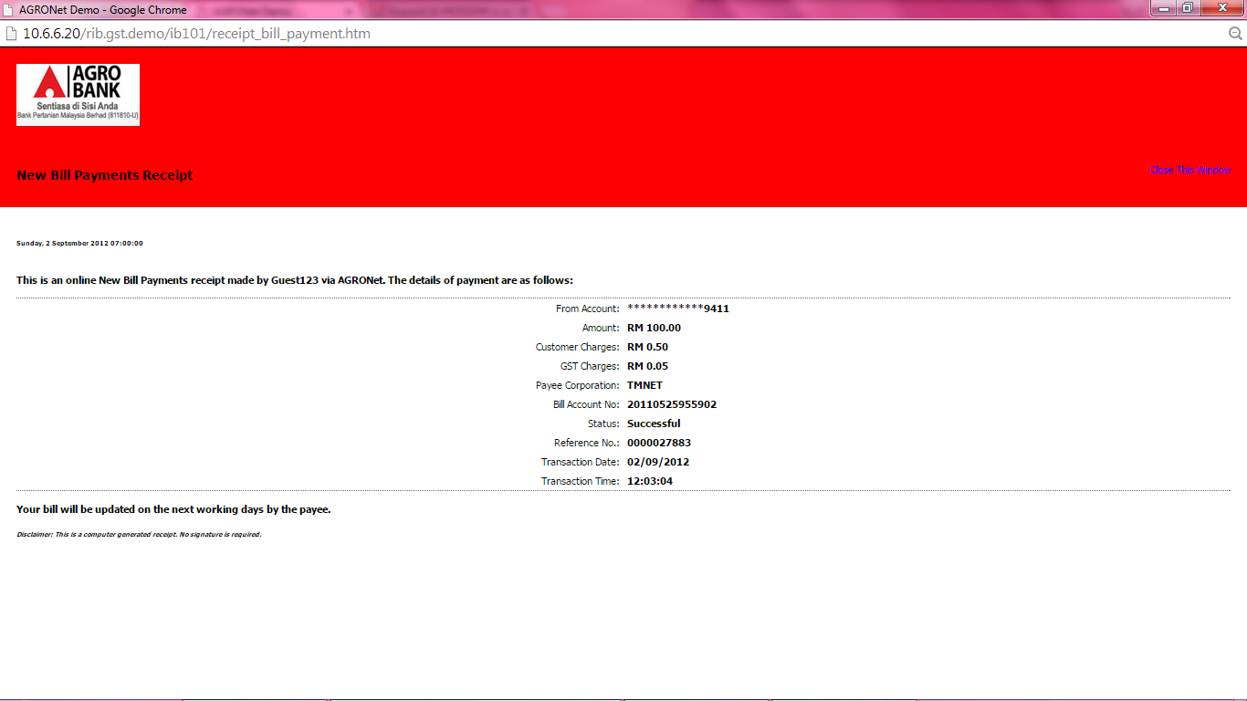

RIB Demo: Favourite Bill Payment
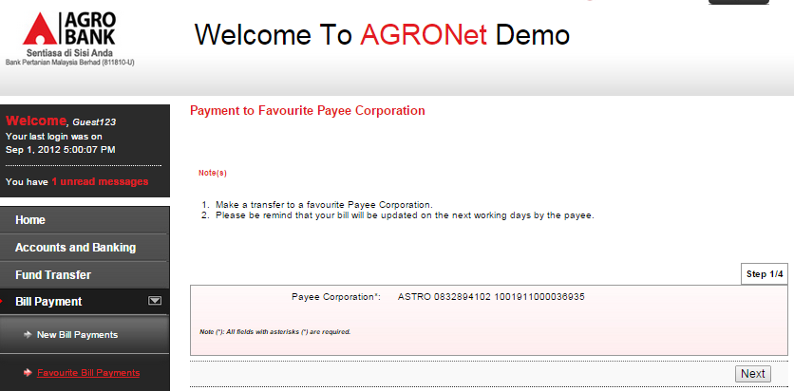
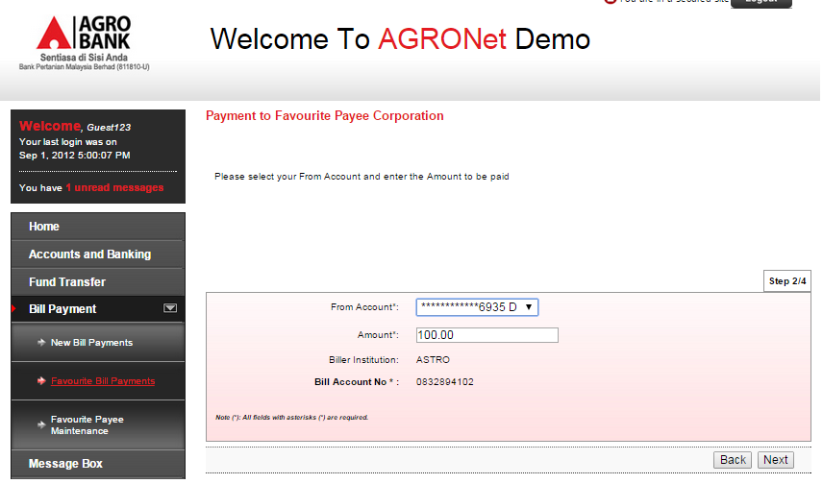
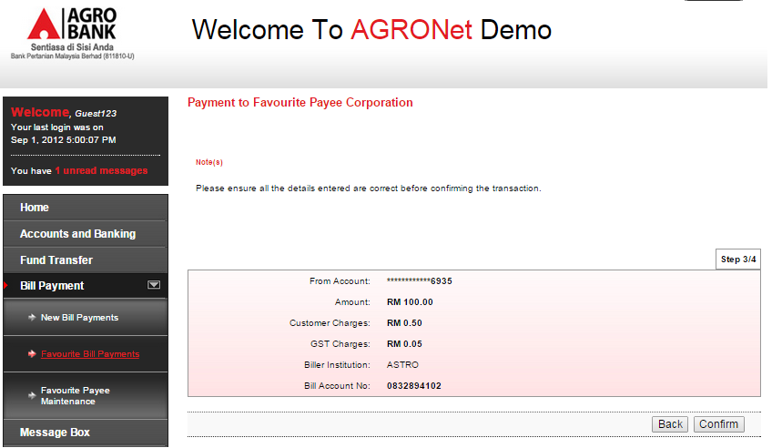
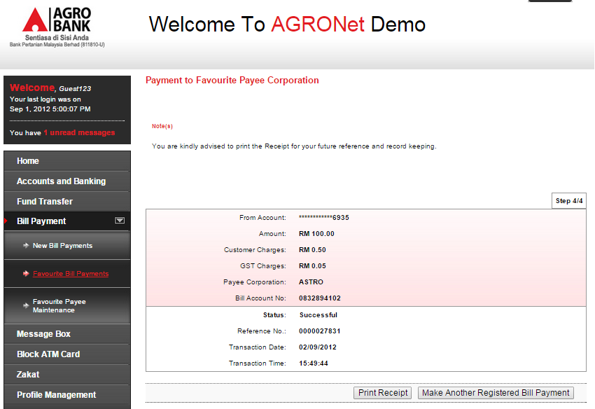
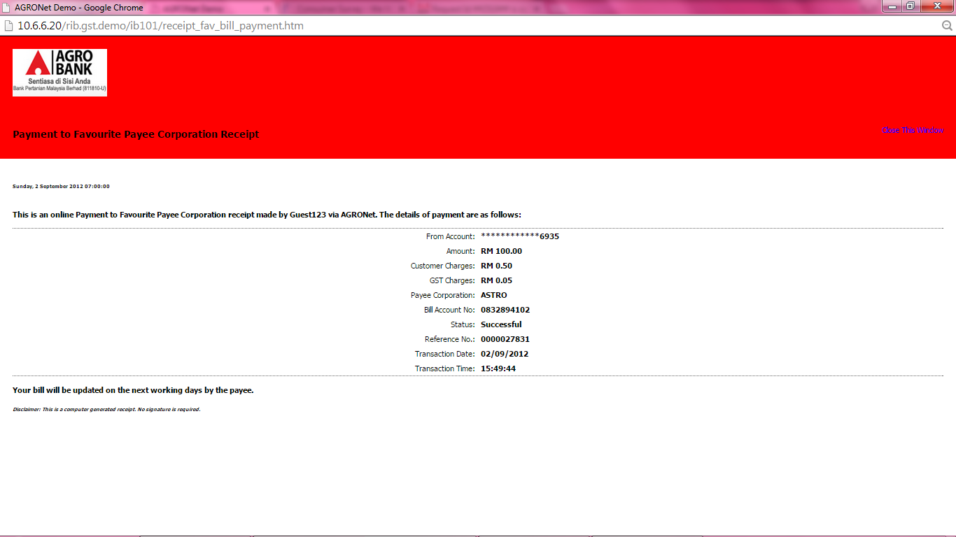

RIB Demo: New Instant Interbank Transfer (eIBFT)
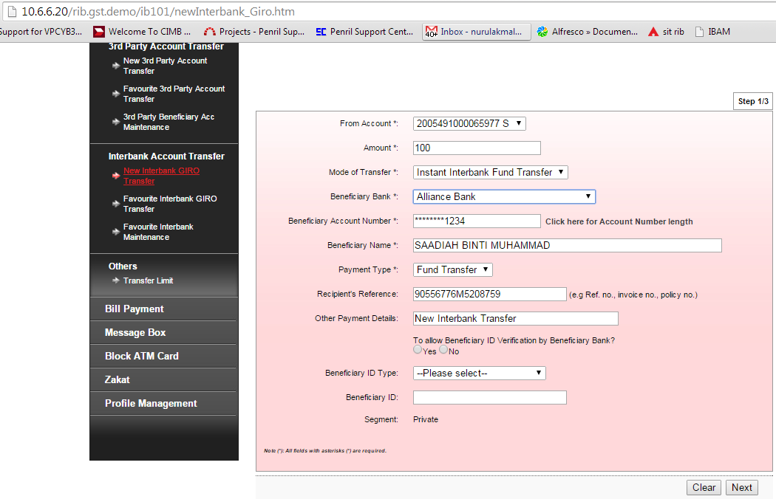

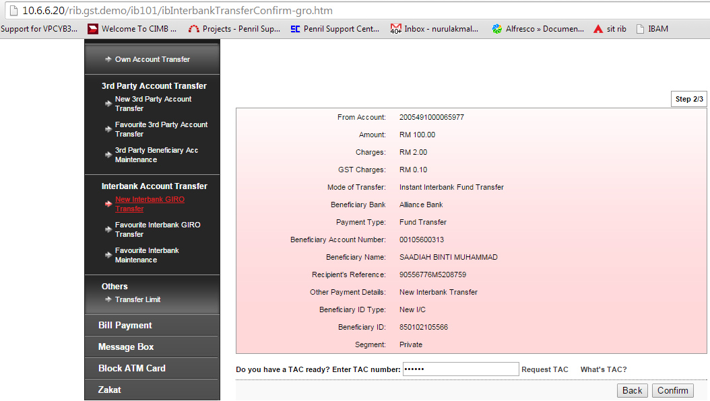
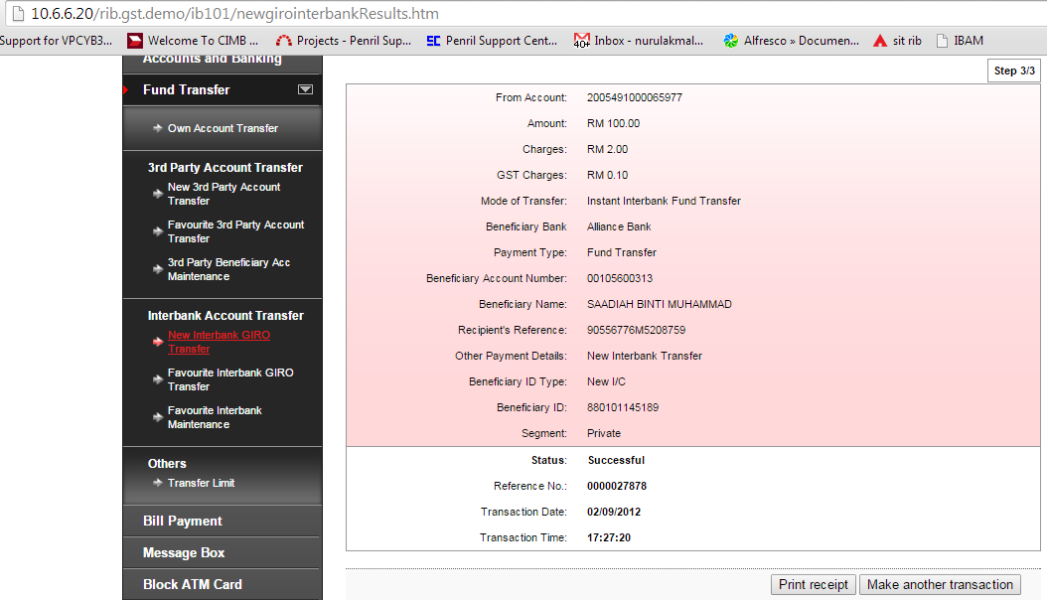
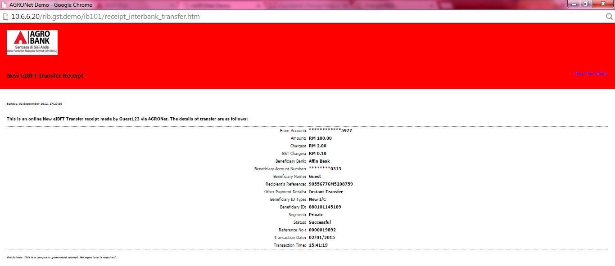
RIB Demo: Favourite Instant Interbank Transfer (eIBFT)
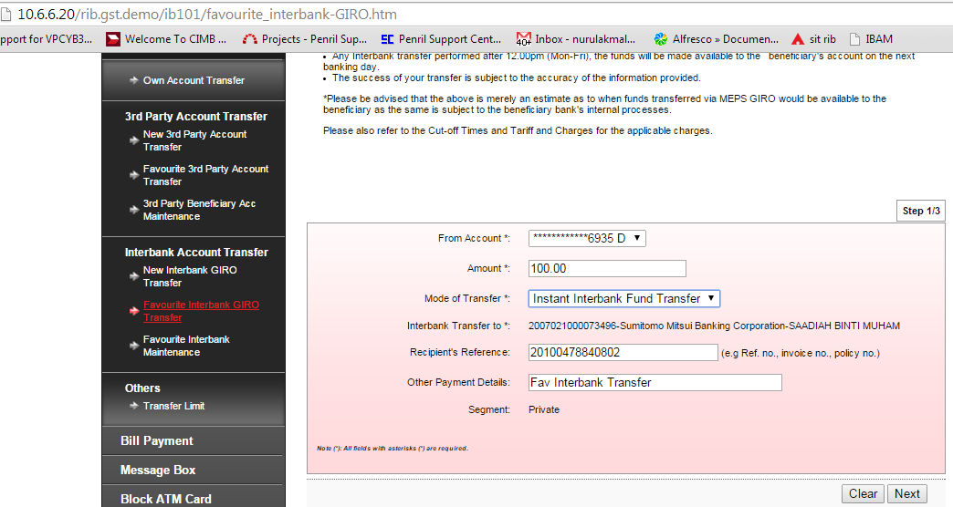
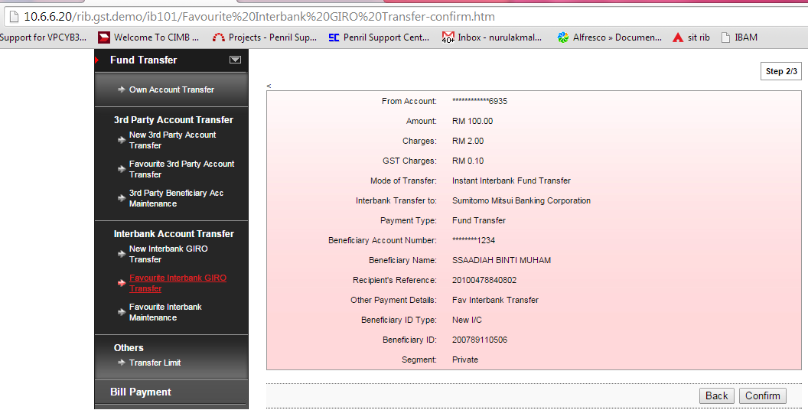
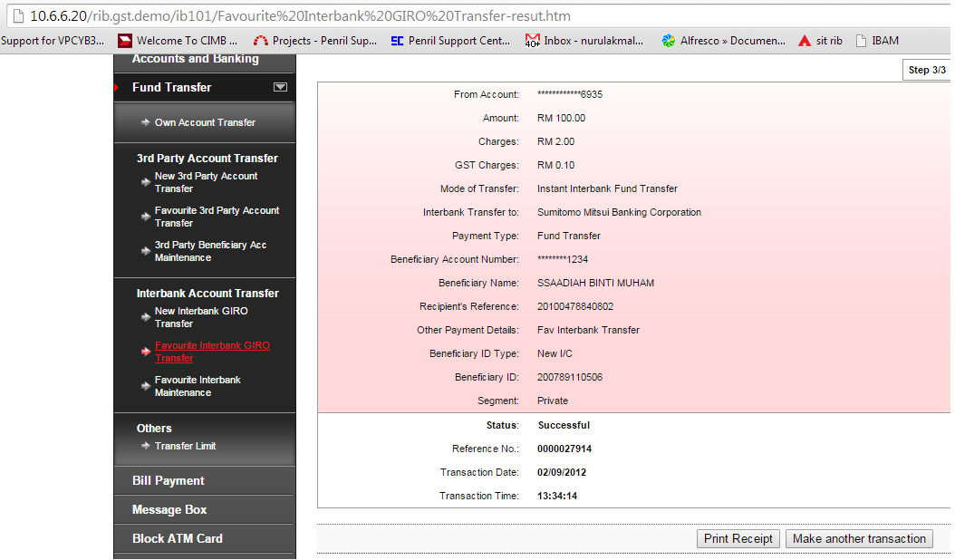
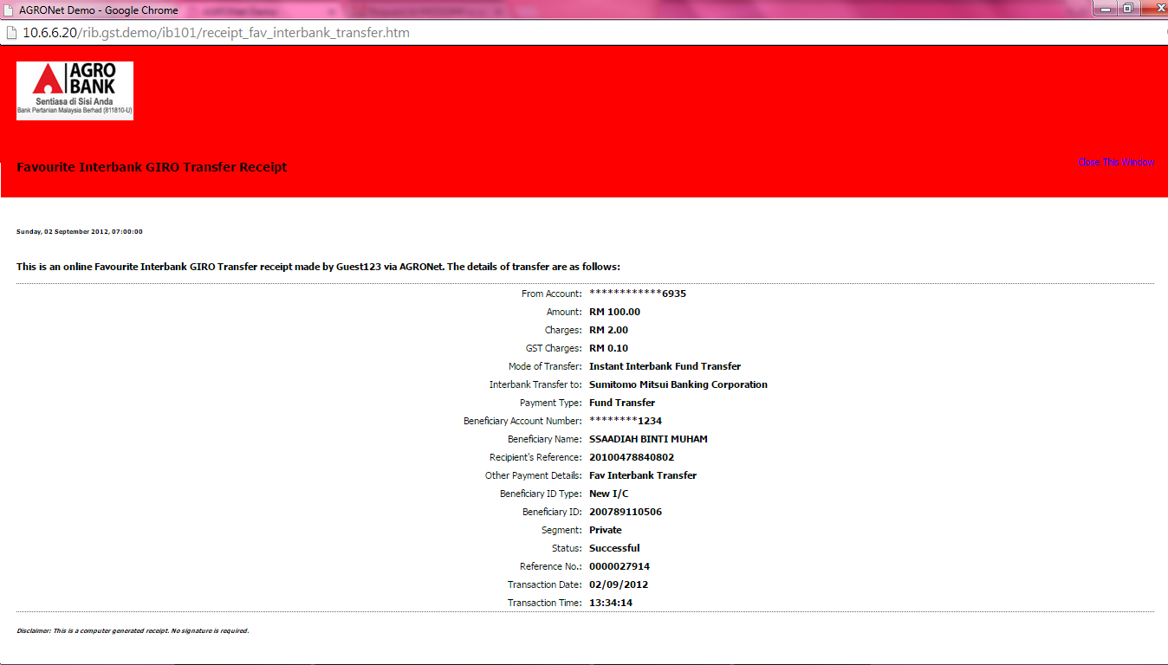
RIB Demo: Transaction History
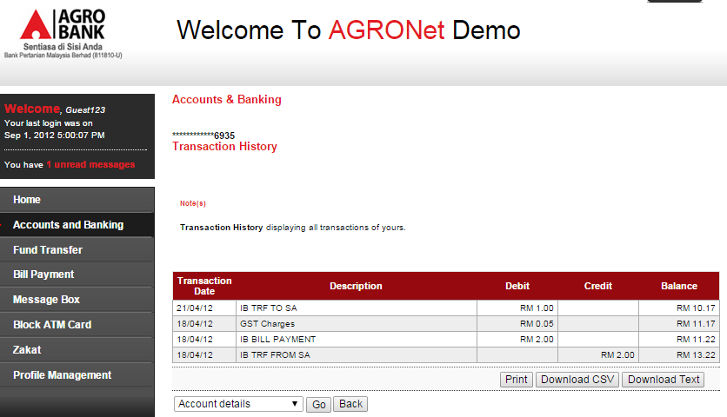

RIB Demo: AGRONet Transaction History
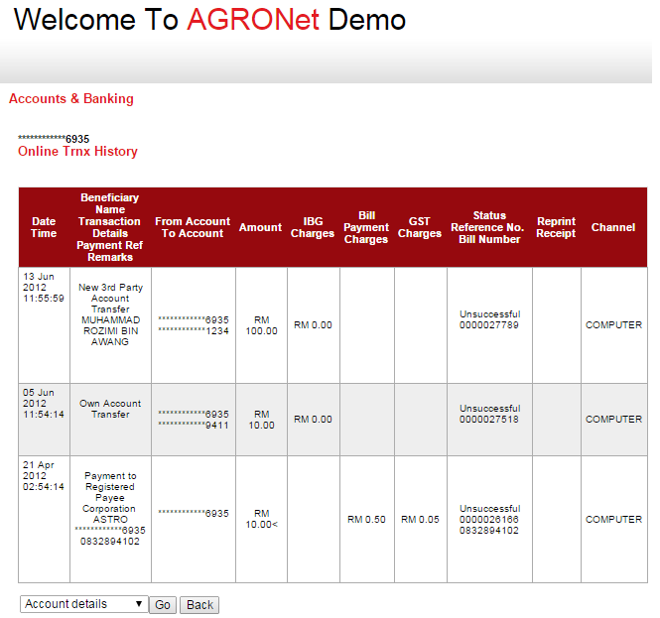
BIB Demo: New Bill Payment
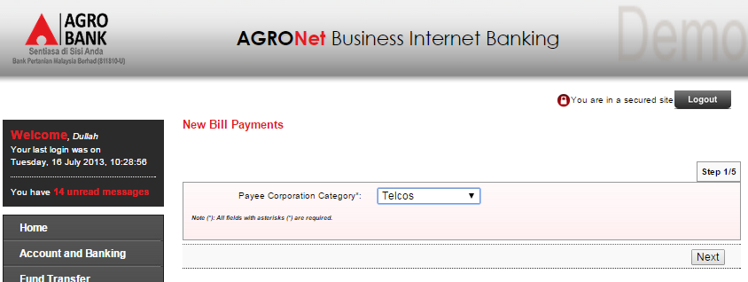
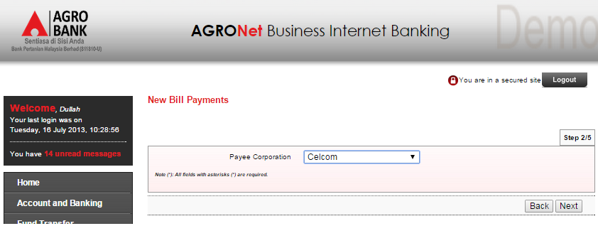
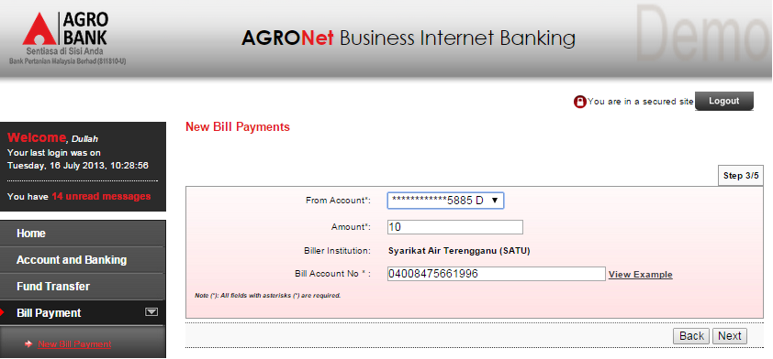
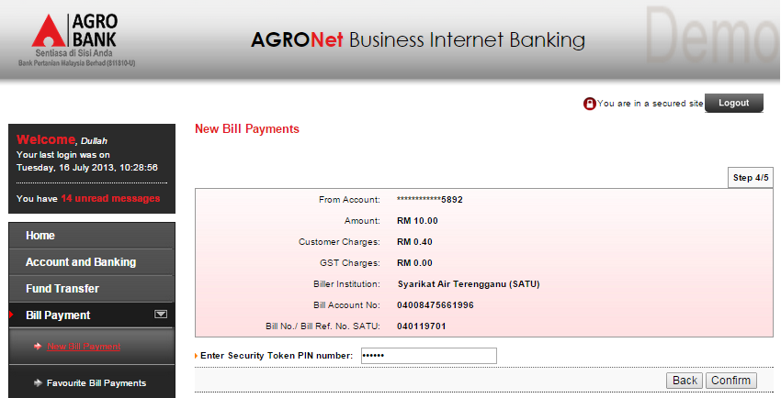
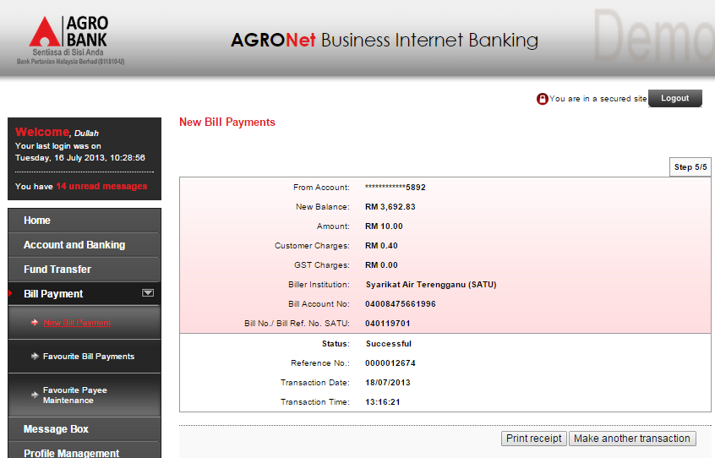
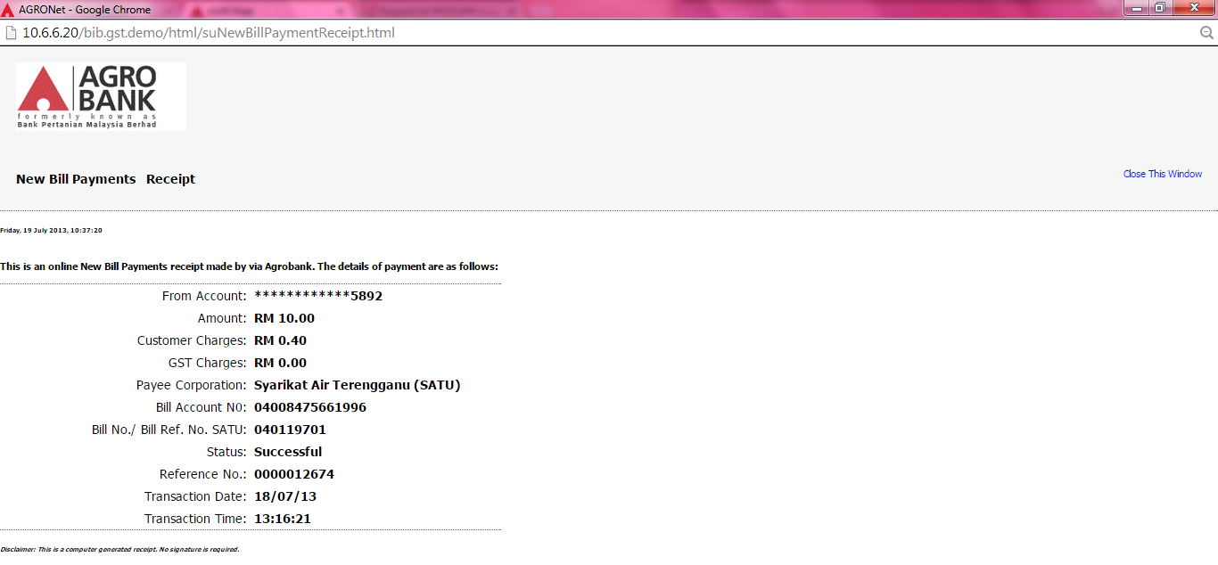
BIB Demo: Favourite Bill Payment
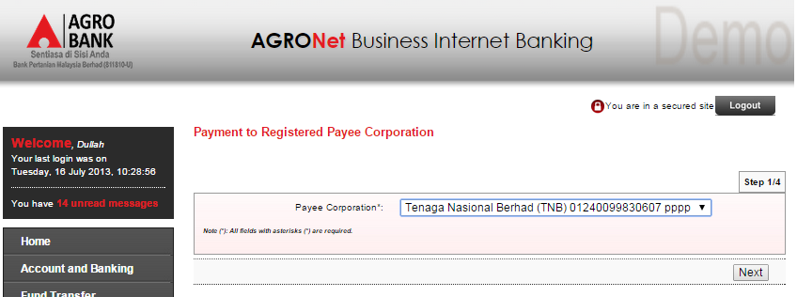
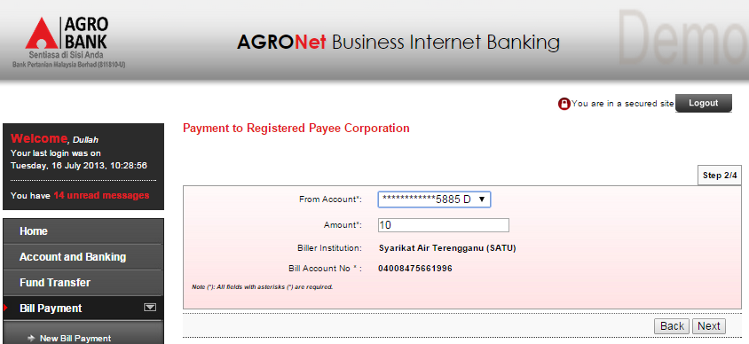
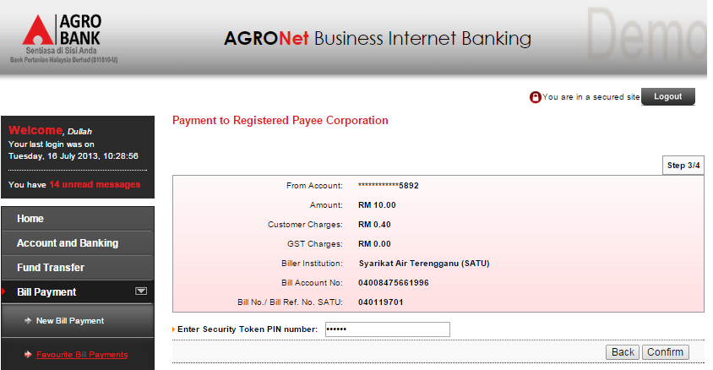
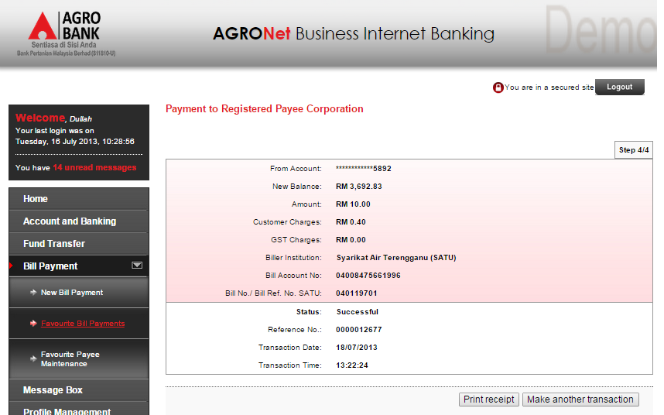
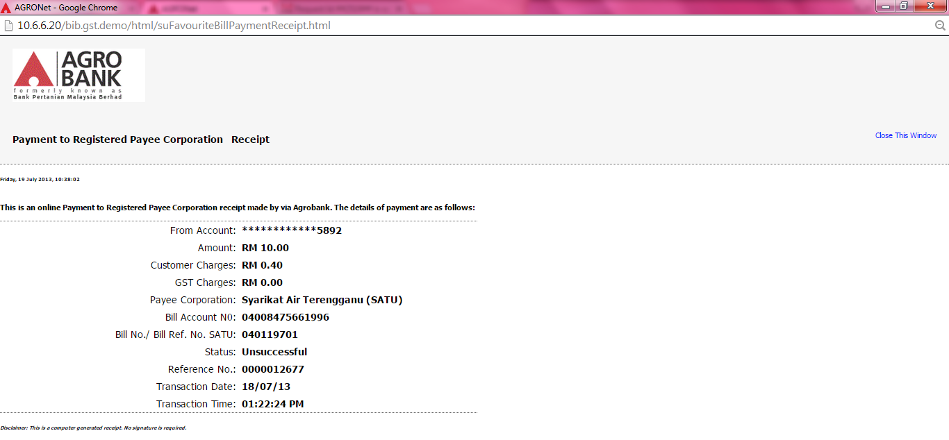

BIB Demo: Transaction History
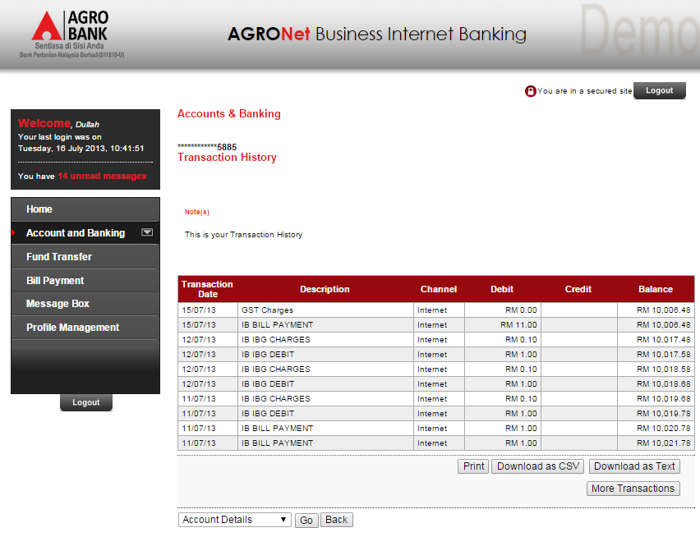

BIB Demo: AGRONet Transaction History
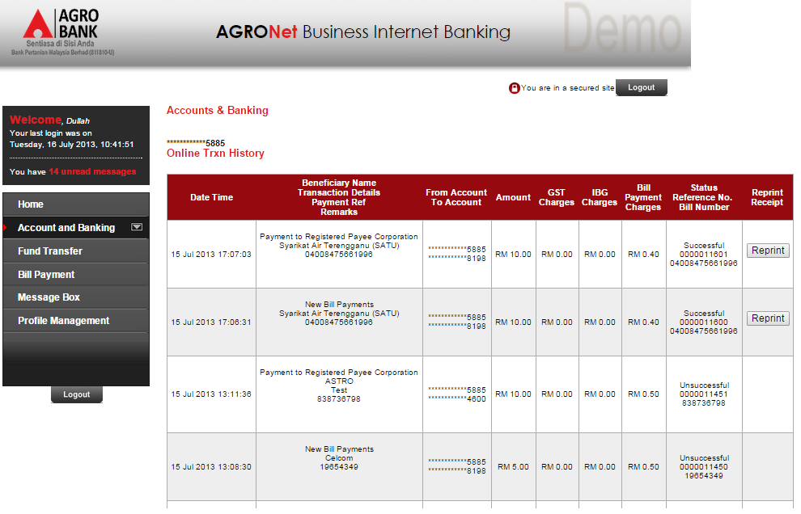

Reviewed By: (PMO
 |  |  | Name/Position : Norhaidah Binti Md Dasuki / Senior Manager, Quality Assurance and Support  Date :

