**Agrobank**

|  |
| --- |
| **Goods and Services Tax (GST)**  **(IE0000064C)** |
| Business Requirement and System Specification |

**(PENRIL/AGRO-BRS/CR/20140908/14)**

**Version 1.4**

**05 January 2015**

Prepared By:



**Penril Datability (SEA) Sdn Bhd (384556-U)**

Suite A-07-07 Plaza Mon’t Kiara

No. 2, Jalan Kiara, Mon’t Kiara

50480 Kuala Lumpur, Malaysia

Tel: (603) 6201 2622Fax: (603) 6201 7622

**Document Amendment Log**

| **Rev. No** | **Date Update** | **Description of Change** | **Update By**  **<Name, Dept>** | **Review By**  **<Name, dept>** | **Approved By**  **<Name, Dept>** |
| --- | --- | --- | --- | --- | --- |
| 1.0 | 08/12/2014 | Initial Release | Nurul Akmal binti Yusof | Norhaidah Dasuki  QA & Support | Tan Lee Yong  Professional Service |
| 1.1 | 17/12/2014 | Updated flow for IBAM Charges & Limit | Lizahwati Basirun | Norhaidah Dasuki  QA & Support | Tan Lee Yong  Professional Service |
| 1.2 | 05/01/2015 | Update New Requirement as below:-   1. eIBFT - GST & Charges calculate at HOST, front end will display the GST Charges at step 3/3 and receipt. 2. To add Fixed GST ID NUMBER [Bank Registration No] – 00548294656 at customer receipt (Bill Payment, Zakat Payment & eIBFT). | Lizahwati Basirun | Norhaidah Dasuki  QA & Support | Tan Lee Yong  Professional Service |
| 1.3 | 9/2/2015 | Updated GST charges calculation for Internet Banking and remove not related formula. | Kartono Wijaya | Tan Lee Lee  Professional Service | Tan Lee Yong  Professional Service |
| 1.4 | 12/2/2015 | Updated eIBF by   1. add * after the amount of charges of the result page 2. add * GST @ 6% included in charges on the bottom of the result page 3. maintainable in IBAM for this sentence of the percentage:  * GST @ 6% included in charges 4. Receipt to have this sentence * GST @ 6% included in charges at the bottom. | Kartono Wijaya | Tan Lee Lee  Professional Service | Tan Lee Yong  Professional Service |

**Table of Contents**

**Document Amendment Log** 2

**Table of Contents** 4

**Business Requirement Acceptance** 6

**Section A: Introduction** 7

1.1 Objective 8

1.2 Scope of Delivery 8

1.3 Development Checklist 9

**Section B: Internet Banking** 11

2 Enhancement at Retail Internet Banking (AGRONet) 11

2.1 New Bill Payment 11

2.1.1 Process Flow 11

2.1.2 Screen Flow 12

2.2 Favorite Bill Payment 18

2.2.1 Process Flow 18

2.2.2 Screen Flow 19

2.3 New eIBFT 23

2.3.1 Process Flow 23

2.3.2 Screen Flow 24

2.4 Favorite eIBFT 27

2.4.1 Process Flow 27

2.4.2 Screen Flow 28

2.5 AGRONet Transaction History 32

2.6 Transaction History (HOST) 34

3 Enhancement at Business Internet Banking (AGRONetBiz) 35

3.1 New Bill Payment 35

3.1.1 Process Flow 35

3.1.2 Screen Flow 36

3.2 Favourite Bill Payment 44

3.2.1 Process Flow 44

3.2.2 Screen Flow 45

3.3 AGRONetBiz Transaction History 53

3.4 Transaction History (HOST) 55

4 Enhancement at IBAM 56

4.1 Charges & Limit 56

4.1.1 Process Flow 56

4.1.2 Screen Flow 57

4.2 Content – Payee 61

4.2.1 Process Flow 61

4.2.2 Screen Flow 62

4.3 Report 66

**Section C: Change Impact Analysis** 69

**Appendix** 71

D1: Test Conditions on selection of Application System required 71

D2: GST Calculator Formula 72

D3: Agro Bank - Host Teller - Mapping Technical Specification 72

D4: Agro Bank – Sample Receipt 73

D5: New and Favorite eIBFT changes 73

**Business Requirement Acceptance**

I/We hereby verify that this Business Requirement consist of all the requirements requested by AGROBANK. The implemented system will fulfill ONLY this requirement.

I/We also hereby AGREE that this satisfies our entire requirement for **[CR00027 - GST]**

Any future changes to this agreed scope will be treated as an enhancement to the system. Any future changes to the project timeline will be subjected to the final approval of the project steering committee.

**AGROBANK:**

|  |  |  |  |
| --- | --- | --- | --- |
| **Approved by** | **Role** | **Signature** | **Date** |
|  |  |  |  |
|  |  |  |  |
|  |  |  |  |
|  |  |  |  |
|  |  |  |  |
|  |  |  |  |
|  |  |  |  |

**Penril Datability (SEA) Sdn. Bhd.:**

|  |  |  |  |
| --- | --- | --- | --- |
| **Approved by** | **Role** | **Signature** | **Date** |
| Norhaidah Bt Md Dasuki | Project Manager |  |  |
| Lizahwati Bt Basirun | Team Lead |  |  |
| Ngoh Chee Ping | Senior Software Engineer |  |  |

**Section A: Introduction**

This document served as the business requirement and system specification of implementing Goods and Service Tax (GST) in Agrobank Interbank Banking system for module which have charges to customer as below:

*1) Internet Banking Application Manager (IBAM)*

*a) Content - Payee*

*b) Charges & Limit*

*c) RIB/BIB Transaction Enquiry*

*d) RIB/BIB Report*

*2) Retail Internet Banking (RIB)*

*a) Bill Payment (Open & Favorite) Confirmation, Result & Receipt*

*b) eIBFT (Open & Favorite) Confirmation, Result & Receipt*

*c) AGRONet Transaction History*

*d) Transaction History (Host)*

*3) Business Internet Banking (BIB)*

*a) Bill Payment Confirmation, Result and Receipt*

*b) AGRONetBiz Transaction History*

*c) Transaction History (Host)*

This document shall explain all the features and functionalities, which is elaborating with screen captures, process flow, descriptions, input fields specifications and error messages. All screen designs provided in this document are samples and only illustration purpose for easy understanding. The screen designs are not final.

## Objective

The objective of this document is to capture user requirements of transactional and administration modules of implementing Goods and Service Tax (GST). This document will facilitate development and implementation of the mentioned modules of Internet Banking System for Agrobank.

The base line features description and screen designs will become a reference blueprint for the development team to develop the transactional and administration module. Hence, it is crucial that all stakeholders need to ensure the correctness and adequacy of the requirements captured in this document.

All stakeholders involved are expected to review and sign off this document before the development start. By signing off the document, the stakeholder has endorsed the correctness and accuracy and adequacy of the requirements documented in this document.

## Scope of Delivery

* 1. Internet Banking to update the GST amount and send to host for module that have charges to customer.
  2. Add new charges for Goods and Services Tax [GST] in all modules related under Retail Internet Banking and Business Internet Banking.
  3. A charge imposed is 6% against fee charges to customer. Calculated GST at front-end. (for eIBFT - Calculation for Customer Charges & GST will be done at Host side. )
  4. Changes will be done at the Internet Banking Application Manager [IBAM], Retail Internet Banking [RIB] and Business Internet Banking [BIB].

## Development Checklist

| System | Modules | Features | Description |
| --- | --- | --- | --- |
| IBAM | Content>Payee | Dropdown | * To add Dropdown for Indicator whether required GST payment for the payee. * (Option: No, RIB, BIB, RIB&BIB) |
| Content>Charges/Limit | New Module | * To add GST Percentage |
| RIB/BIB Report | Column | * Add column in existing report to show GST value. * Additional report on GST |
| RIB & BIB Transaction Enquiry | Field | * Add information on GST Charges to the transaction details |
| Database | Table | * GST Value |
| RIB | Bill Payment   * Open * Favourite | Field in Confirmation, Result and Receipt Screen | * IB calculates the GST value based on the formula in Appendix D2 * IB display transaction details with GST value. * Re-mapping and to send value on GST to Host * To add backend engine to calculate the GST value based on the percentage input and Charges amount. |
| eIBFT   * Open * Favourite | Field in Confirmation, Result and Receipt Screen | * Re-mapping and to get the GST value from Host * IB display transaction details with GST value. |
| AGRONet Transaction History | Field | * To add 2 column to display   + GST Charges   + Customer Charges |
| Transaction History (Host) | Field | * To display 2 lines in Transaction History Screen.   + Transaction amount + Customer charges   + GST value |
| Demo Page | HTML | * To update the Demo page on related changes |
| BIB | Bill Payment   * Open * Favourite | Field in Confirmation, Result and Receipt Screen | * IB calculates the GST value based on the formula in Appendix D2 * IB display transaction details with GST value. * Re-mapping and to send value on GST to Host * To add backend engine to calculate the GST value based on the percentage input and Charges amount. |
| AGRONet Transaction History | Field | * To add 2 column to display   + GST Charges   + Customer Charges |
| Transaction History (Host) | Field | * To display 2 lines in Transaction History Screen.   + Transaction amount + Customer charges   + GST value |
| Demo Page | HTML | * To update the Demo page on related changes |



**Section B: Internet Banking**

# Enhancement at Retail Internet Banking (AGRONet)

## New Bill Payment

Implementing new charges for Goods and Services Tax [GST] which applicable to all payee corporations that have fees charge to customer.



### Process Flow



Diagram 1: New Bill Payment Flow Diagram



There are 3 participants involved in this process which is IB User, RIB and Host. The following are the steps to perform Open Bill Payment at RIB:

### Screen Flow

***Step 4:***

* Backend engine to calculate the GST value based on the percentage and customer Charges amount set in IBAM [Refer Appendix 6 for calculator formula].

1. IBS displays New Bill Payment confirmation screen with GST value[1]*.
2. User enters the TAC number.
3. User confirms the Bill Payment by clicking on the “Confirm” button or clicks on the “Back” button to go back to the previous page.

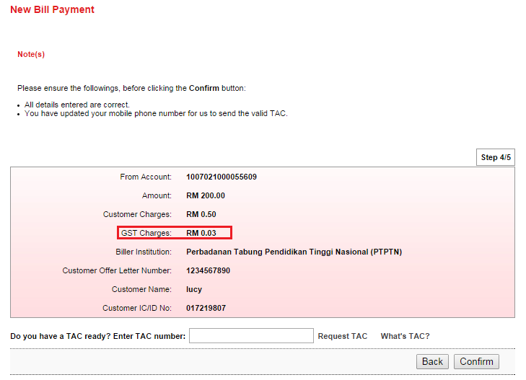

Figure 1: New Bill Payment Confirmation Screen (Step 4/5)

Display Specification:

| **No** | **Field** | **Format** | **Description** |
| --- | --- | --- | --- |
|  | From Account | Text | Shows the account number |
|  | Amount | Text | Shows the amount of bill payment |
|  | Customer Charges | Text | Shows the charges of payment |
|  | ***GST Charges*** | ***Text*** | ***Shows GST charges of payment*** |
|  | Biller Institution | Text | Shows the selected payee corporation |
|  | Others[2](Bill Reference details) | Text | Shows others payee corporation required details |

Table 1: New Bill Payment Confirmation Screen Display Field

**Input Specification:**

| **No** | **Field** | **Field Type** | **Validation Rule** | **Description** | **M/O** |
| --- | --- | --- | --- | --- | --- |
|  | TAC Number | Textbox | * Match length : 6 * Numeric | A random, temporary generated number sent to mobile phone for transaction verification | M |

Table 2: TAC Request Input Specification

**Action:**

|  |  |  |  |
| --- | --- | --- | --- |
| **No** | **Action** | **Type** | **Description** |
|  | Back | Button | Contains an action to go back to previous page |
|  | Confirm | Button | Contains an action to continue to next page |
|  | Request TAC | Button | Contains an action to generate TAC Number and shows the TAC’s Pop-up window. |
|  | What’s TAC | Hyperlink | Contains an action to shows the What’s TAC Pop-up window. |

Table 3: TAC Request List Action

List of available messages for the screen:

|  |  |  |
| --- | --- | --- |
| **No.** | **Event** | **Error Description in English** |
|  | Did not fill in TAC field. | TAC is required. |
|  | Fill in TAC with other than numeric. | TAC must be numeric. |
|  | Fill in TAC less than 6 digits. | TAC must consist of 6 digits. |
|  | Fill in invalid TAC | Invalid TAC. |
|  | Reach maximum length of attempt. | Your Account has been locked. Please call Agrobank Contact Center at 1 300 88 2476. |
|  | Fill in an expired / no longer valid TAC. | Request TAC is required. |

Table 4: TAC Request Error message list

***Step 5:***

1. IBS send Bill payment details and value on GST to the Host System which processes the Bill payment and return result.
2. IBS display New Bill payment Result screen. And User is able to make another transaction by clicking on the “Make another Open Bill Payment” button.

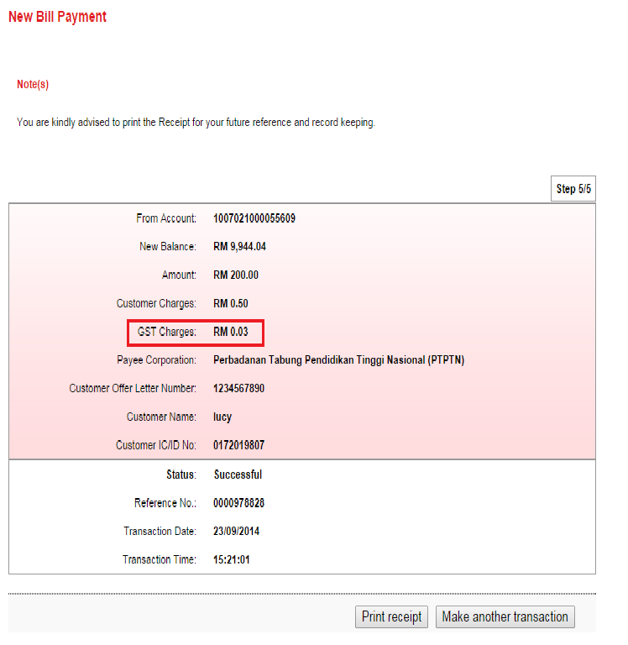

**Figure 2: New Bill Payment Result screen (Step 5/5)**

Display Fields:

| **No** | **Field** | **Format** | **Description** |
| --- | --- | --- | --- |
|  | From Account | Text | Shows the name of payee corporation |
|  | New Balance | Numeric | Shows the new balance of the account |
|  | Amount | Text | Shows the amount of the bill payment |
|  | Customer Charges | Text | Shows the charges of the payment |
|  | ***GST Charges*** | ***Text*** | ***Shows the GST charges of the payment*** |
|  | Payee Corporation | Text | Shows the selected payee corporation |
|  | Others[3](Bill Reference details) | Text | Shows others payee corporation required details |
|  | Status | Text | Shows the status of the transaction |
|  | Reference No | Numeric | Shows the reference number of particular transaction |
|  | Transaction Date | DD/MM/YYYY | Shows the date of transaction |
|  | Transaction Time | HH:MM:SS | Shows the time of transaction |

**Table 5: New Bill Payment Result Display Fields**

**Action:**

| **No** | **Action** | **Type** | **Description** |
| --- | --- | --- | --- |
|  | Print Receipt | Button | Contains an action to generate receipt’s pop-up display |
|  | Make another transaction | Button | Contains an action to go back to New Bill Payment page |

**Table 6: New Bill Payment result List Action**

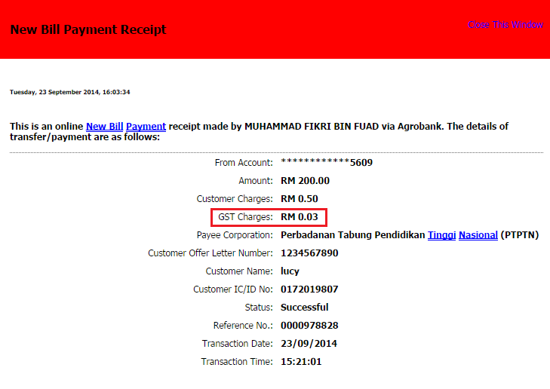

**Figure 3: New Bill Payment Receipt**

**Display Fields:**

| **No** | **Field** | **Format** | **Description** |
| --- | --- | --- | --- |
|  | From Account | Numeric | Shows the account number to debit the payment |
|  | Amount | Text | Shows the amount of the bill payment |
|  | Charges | Text | Shows the charges of the payment |
|  | ***GST Charges*** | ***Text*** | ***Shows the GST charges of the payment*** |
|  | Payee Corporation | Text | Shows name of payee corporation |
|  | Others[4](Bill Reference details) | Text | Shows others payee corporation required details |
|  | Status | Text | Shows the status of the transaction |
|  | Reference No | Numeric | Shows the reference number of particular transaction |
|  | Transaction Date | DD/MM/YYYY | Shows the date of transaction |
|  | Transaction Time | HH:MM:SS | Shows the time of transaction |

**Table 7: New Bill Payment Receipt Display Fields**

Action:

| **No** | **Action** | **Type** | **Description** |
| --- | --- | --- | --- |
|  | Close This Window | Hyperlink | Contains an action to close the print receipt window. |

**Table 8: New Bill Payment Receipt Action**

## Favorite Bill Payment

Implementing new charges for Goods and Services Tax [GST] which applicable to all payee corporations that have fees charge to customer.

### Process Flow



Diagram 2: Favorite Bill Payment Flow Diagram

There are 3 participants involved in this process which is IB User, RIB and Host. The following are the steps to perform Favorite Bill Payment:

### Screen Flow

***Step 3:***

Backend engine to calculate the GST value based on the percentage and customer Charges amount set in IBAM [Refer Appendix 6 for calculator formula].

1. IBS displays Favourite Bill Payment confirmation screen.
2. Single User confirms the Favourite Bill Payment by clicking on the “Confirm” button or clicks on the “Back” button to go back to the previous page.

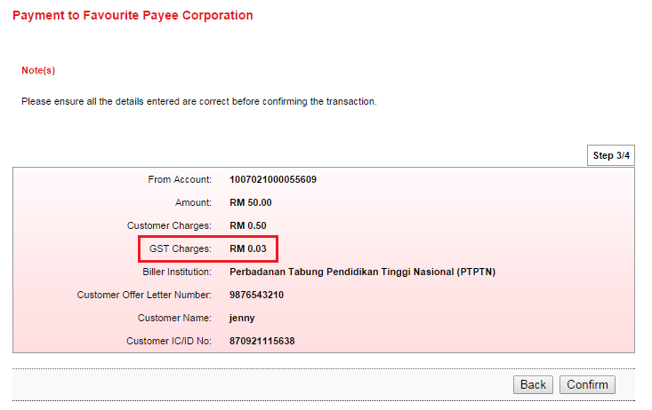

Figure 4: Favourite Bill Payment Step 3/4

**Display Specification:**

| **No** | **Field** | **Format** | **Description** |
| --- | --- | --- | --- |
| 1. | From Account | Text | Shows the account number |
| 2. | Amount | Text | Shows the amount of bill payment |
| 3. | Customer Charges | Text | Shows the charges of payment |
| 4. | ***GST Charges*** | ***Text*** | ***Shows GST charges of payment*** |
| 5. | Biller Institution | Text | Shows the selected payee corporation |
| 6. | Others[5](Bill Reference details) | Text | Shows others payee corporation required details |

Table 9: Create Content Details Display Field

**Action:**

|  |  |  |  |
| --- | --- | --- | --- |
| **No** | **Action** | **Type** | **Description** |
| 1. | Back | Button | Contains an action to go back to previous page |
| 2. | Confirm | Button | Contains an action to continue to next page |

Table 10: Favorite Bill Payment List Action

***Step 4:***

1. IBS send Bill payment details and value on GST to the Host System which processes the Bill payment and return result.
2. IBS display Bill payment Result screen. And user has the choice to make another transaction by clicking on the “Make another Registered Bill Payment” button or user can click “Print Receipt” button to generate a receipt of Favourite Bill Payment.

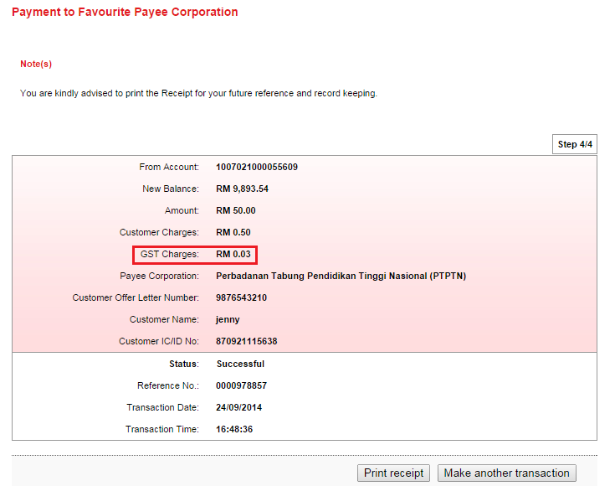

**Figure 5: Favourite Bill Payment Step 4/4**

Display Fields:

| **No** | **Field** | **Format** | **Description** |
| --- | --- | --- | --- |
| 1. | From Account | Text | Shows the name of payee corporation |
| 2. | New Balance | Numeric | Shows the new balance of the account |
| 3. | Amount | Text | Shows the amount of the bill payment |
| 4. | Customer Charges | Text | Shows the charges of the payment |
| ***5.*** | ***GST Charges*** | ***Text*** | ***Shows the GST charges of the payment*** |
| 6. | Payee Corporation | Text | Shows the selected payee corporation |
| 7. | Others[6](Bill Reference details) | Text | Shows others payee corporation required details |
| 8. | Status | Text | Shows the status of the transaction |
| 9. | Reference No | Numeric | Shows the reference number of particular transaction |
| 10. | Transaction Date | DD/MM/YYYY | Shows the date of transaction |
| 11. | Transaction Time | HH:MM:SS | Shows the time of transaction |

**Table 11: Favorite Bill Payment Result Display Fields**

**Action:**

| **No** | **Action** | **Type** | **Description** |
| --- | --- | --- | --- |
| 1. | Print Receipt | Button | Contains an action to generate receipt’s pop-up display |
| 2. | Make another transaction | Button | Contains an action to go back to New Bill Payment page |

**Table 12: Favorite Bill Payment Result List Action**

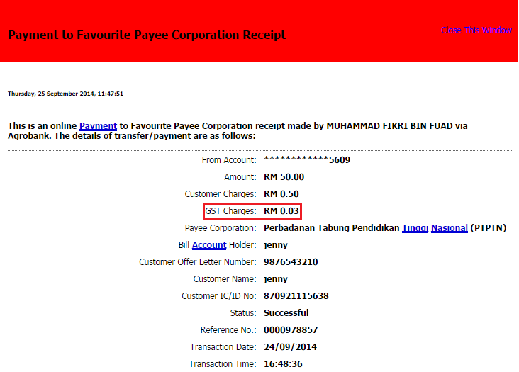

Figure 6: Favourite Bill Payment Receipt

**Display Fields:**

| **No** | **Field** | **Format** | **Description** |
| --- | --- | --- | --- |
| 1. | From Account | Numeric | Shows the account number to debit the payment |
| 2. | Amount | Text | Shows the amount of the bill payment |
| 3. | Charges | Text | Shows the charges of the payment |
| ***4.*** | ***GST Charges*** | ***Text*** | ***Shows the GST charges of the payment*** |
| 5. | Payee Corporation | Text | Shows name of payee corporation |
| 6. | Others[7](Bill Reference details) | Text | Shows others payee corporation required details |
| 7. | Status | Text | Shows the status of the transaction |
| 8. | Reference No | Numeric | Shows the reference number of particular transaction |
| 9. | Transaction Date | DD/MM/YYYY | Shows the date of transaction |
| 10. | Transaction Time | HH:MM:SS | Shows the time of transaction |

Table 13: New Bill Payment Receipt Display Fields

**Action:**

| **No** | **Action** | **Type** | **Description** |
| --- | --- | --- | --- |
| 1. | Close this Window | Hyperlink | Contains an action to close the print receipt window. |

Table 14: New Bill Payment Receipt Action

## 

## New eIBFT

Implementing new charges for Goods and Services Tax [GST] which applicable to eIBFT Transaction.



### Process Flow



Diagram 3: New eIBFT Flow Diagram



There are 4 participants involved in this process which is IB User, RIB, Middleware and Host. The following are the steps to perform Open eIBFT at RIB:

### Screen Flow

***Step 3:***

* Re-mapping and to get the GST value from Host

1. IBS send eIBFT transaction details to the Host System which processes the eIBFT and return result with the charges and GST value[8]*.
2. IBS send eIBFT transaction details to the Host System which processes the eIBFT and return result.
3. IBS display New eIBFT Result screen. And User is able to make another transaction by clicking on the “Make another Transaction” button.

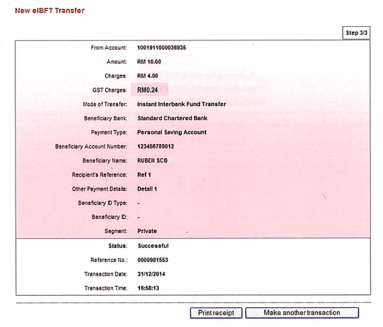

Figure 7: New Bill Payment Result screen (Step 3/3)

**Display Fields:**

| **No** | **Field** | **Format** | **Description** |
| --- | --- | --- | --- |
|  | From Account | Numeric | Shows the account number of sender |
|  | Amount | Text | Shows the inserted amount of transaction |
|  | Charges | Text | Shows the inserted charges of transaction |
|  | ***GST Charges*** | ***Text*** | ***Shows the GST charges of the payment*** |
|  | Mode of Transfer | Text | Shows the chosen mode of transfer for the transaction |
|  | Beneficiary Bank | Text | Shows the beneficiary bank of the Interbank Beneficiary |
|  | Payment Type | Text | Shows the payment type of transaction |
|  | Beneficiary Account Number | Numeric | Shows the account number of Interbank Beneficiary |
|  | Beneficiary Name | Text | Shows the beneficiary name |
|  | Recipient’s Reference | Text | Shows the reference of the payment |
|  | Other Payment Details | Text | Shows the remarks of user |
|  | Beneficiary ID Type | Text | Show the Beneficiary ID Type |
|  | Beneficiary ID | Text | Show the Beneficiary ID |
|  | Segment | Text | Shows segment for Interbank transfer |
|  | Status | Text | Shows the status of transaction |
|  | References No | Numeric | Shows the references number of particular transaction |
|  | Transaction Date | DD/MM/YYYY | Shows the date of transaction |
|  | Transaction Time | HH:MM:SS | Show the time of transaction |

Table 15: New Interbank Transfer via EIBFT Result Display Fields

**Action:**

| **No** | **Action** | **Type** | **Description** |
| --- | --- | --- | --- |
|  | Print Receipt | Button | Contains an action to generate receipt’s pop-up display |
|  | Make another transaction | Button | Contains an action to go back to New Interbank Transfer page |

Table 16: New eEIBFT result List Action

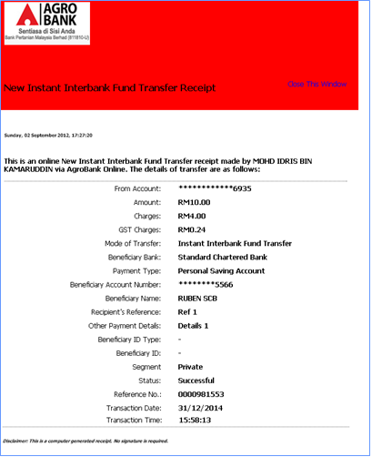

Figure 8: New eIBFT Receipt

**Display Fields:**

| **No** | **Field** | **Format** | **Description** |
| --- | --- | --- | --- |
|  | From Account | Numeric | Shows the account number to debit the payment |
|  | Amount | Text | Shows the amount of the bill payment |
|  | Charges | Text | Shows the charges of the payment |
|  | ***GST Charges*** | ***Text*** | ***Shows the GST charges of the payment*** |
|  | Mode of Transfer | Text | Shows the chosen mode of transfer for the transaction |
|  | Beneficiary Bank | Text | Shows the Beneficiary Bank |
|  | Payment Type | Text | Shows the payment type of transaction |
|  | Beneficiary Account Number | Numeric | Shows the account number of Interbank Beneficiary |
|  | Beneficiary Name | Text | Shows the name of beneficiary |
|  | Recipient’s Reference | Text | Shows the reference of the payment |
|  | Status | Text | Shows the status of transaction |
|  | References No | Numeric | Shows the references number of particular transaction |
|  | Transaction Date | DD/MM/YYYY | Shows the date of transaction |
|  | Transaction Time | HH:MM:SS | Show the time of transaction |

**Table 17: New eIBFT Receipt Display Fields**

Action:

| **No** | **Action** | **Type** | **Description** |
| --- | --- | --- | --- |
|  | Close This Window | Hyperlink | Contains an action to close the print receipt window. |

Table 18: New Bill Payment Receipt Action

## Favorite eIBFT

Implementing new charges for Goods and Services Tax [GST] which applicable to Favorite eIBFT



### Process Flow



Diagram 4: eIBFT Flow Diagram

There are 4 participants involved in this process which is IB User, RIB, Middleware and Host. The following are the steps to perform Favorite eIBFT at RIB:



### Screen Flow

***Step 3:***

* Re-mapping and to get the GST value from Host

1. IBS send eIBFT details to the Host System which processes the Bill payment and return result with Charges and GST value[9]*.
2. IBS display Favorite eIBFT Result screen. And User is able to make another transaction by clicking on the “Make another Transaction” button.

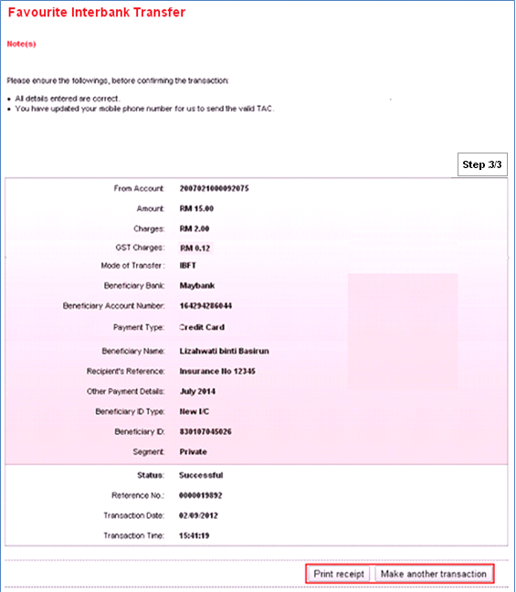

Figure 9: Favorite eIBFT result screen (Step 3/3)

**Display Fields:**

| **No** | **Field** | **Format** | **Description** |
| --- | --- | --- | --- |
|  | From Account | Numeric | Shows the account number of sender |
|  | Amount | Text | Shows the inserted amount of transaction |
|  | Charges | Text | Shows the inserted charges of transaction |
|  | ***GST Charges*** | ***Text*** | ***Shows the GST charges of the payment*** |
|  | Mode of Transfer | Text | Shows the chosen mode of transfer for the transaction |
|  | Beneficiary Bank | Text | Shows the beneficiary bank of the Interbank Beneficiary |
|  | Payment Type | Text | Shows the payment type of transaction |
|  | Beneficiary Account Number | Numeric | Shows the account number of Interbank Beneficiary |
|  | Beneficiary Name | Text | Shows the beneficiary name |
|  | Recipient’s Reference | Text | Shows the reference of the payment |
|  | Other Payment Details | Text | Shows the remarks of user |
|  | Beneficiary ID Type | Text | Show the Beneficiary ID Type |
|  | Beneficiary ID | Text | Show the Beneficiary ID |
|  | Segment | Text | Shows segment for Interbank transfer |
|  | Status | Text | Shows the status of transaction |
|  | References No | Numeric | Shows the references number of particular transaction |
|  | Transaction Date | DD/MM/YYYY | Shows the date of transaction |
|  | Transaction Time | HH:MM:SS | Show the time of transaction |

Table 19: Favorite Interbank Transfer via EIBFT Result Display Fields

**Action:**

| **No** | **Action** | **Type** | **Description** |
| --- | --- | --- | --- |
|  | Print Receipt | Button | Contains an action to generate receipt’s pop-up display |
|  | Make another transaction | Button | Contains an action to go back to Favourite Interbank Transfer page |

Table 20: Favorite eIBFT Result List Action

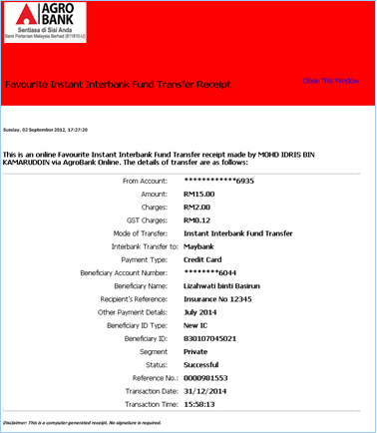

Figure 10: Favorite eIBFT Receipt

**Display Fields:**

| **No** | **Field** | **Format** | **Description** |
| --- | --- | --- | --- |
|  | From Account | Numeric | Shows the account number to debit the payment |
|  | Amount | Text | Shows the amount of the bill payment |
|  | Charges | Text | Shows the charges of the payment |
|  | ***GST Charges*** | ***Text*** | ***Shows the GST charges of the payment*** |
|  | Mode of Transfer | Text | Shows the chosen mode of transfer for the transaction |
|  | Interbank Transfer to | Text | Shows the favorite beneficiary bank |
|  | Payment Type | Text | Shows the payment type of transaction |
|  | Beneficiary Account Number | Numeric | Shows the account number of Interbank Beneficiary |
|  | Beneficiary Name | Text | Shows the name of beneficiary |
|  | Recipient’s Reference | Text | Shows the reference of the payment |
|  | Status | Text | Shows the status of transaction |
|  | References No | Numeric | Shows the references number of particular transaction |
|  | Transaction Date | DD/MM/YYYY | Shows the date of transaction |
|  | Transaction Time | HH:MM:SS | Show the time of transaction |

Table 21: Favorite eIBFT Receipt Display Fields

Action:

| **No** | **Action** | **Type** | **Description** |
| --- | --- | --- | --- |
|  | Close This Window | Hyperlink | Contains an action to close the print receipt window. |

Table 22: Favorite eIBFT Receipt Action

## AGRONet Transaction History

Online Transaction History is only applicable for monetary transactions performed in RIB. User can retrieve by select “AGRONet Transaction History” on dropdown list and clicks go to view account details page.

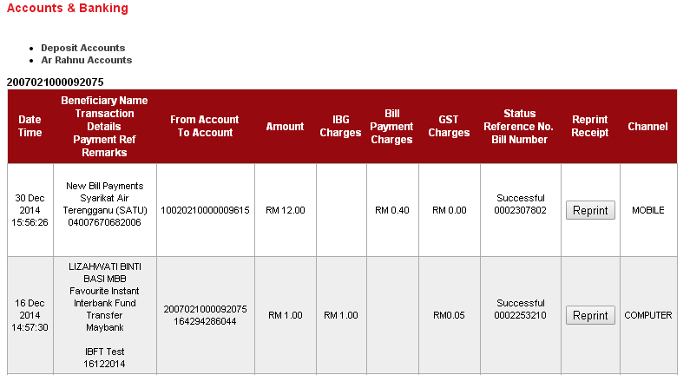

Figure 11: AGRONet Transaction History Screen

Display Fields:

| **No** | **Field** | **Format** | **Description** |
| --- | --- | --- | --- |
| 1. | Date/Time | Text | Shows date and time of transaction |
| 2.. | Beneficiary name;  Transaction Details;  Payment Ref;  Remarks; | Text | Shows beneficiary name, transaction details, Payment Reference, and Remarks |
| 3. | From account;  To account | Numeric | Shows customer account number and beneficiary account number |
| 4. | Amount | Numeric | Shows the amount of the payment |
| 5. | ***IBG Charges*** | ***Numeric*** | ***Shows the charges of the Interbank Transaction*** |
| **6.** | ***Bill Payment Charges*** | ***Numeric*** | ***Shows the charges of the payment*** |
| 7. | ***GST Charges*** | ***Numeric*** | ***Shows the GST charges*** |
| 8. | Status;  Reference No;  Bill number; | Text | Shows the reference number of bill |
| 9. | Reprint Receipt | Button | Contains an action to reprint receipt of the transaction |
| 10. | Channel | Text | Shows channel used of the payment |

Table 23: AGRONet Transaction History Display Fields

**Action:**

| **No** | **Action** | **Type** | **Description** |
| --- | --- | --- | --- |
| 1. | Reprint | Button | Contains an action to reprint receipt of the transaction |
| 2. | Go | Button | Contains an action to go to page selected from dropdown list |
| 3. | Back | Button | Contains an action to go back to previous page |
| 4. | Account Details;  AGRONet Transaction History;  Transaction History | Dropdown List | Contains an action to view account details or AGRONet Transaction History or Transaction History |

Table 24: AGRONet Transaction History List Action

## Transaction History (HOST)

This feature allows user to view or print Transaction History (from Host System). User can select “Transaction History” from the dropdown list and click “Go” button to view transaction history page.

Features: To display 2 lines in Transaction History Screen.

* Transaction amount + Customer charges
* GST value

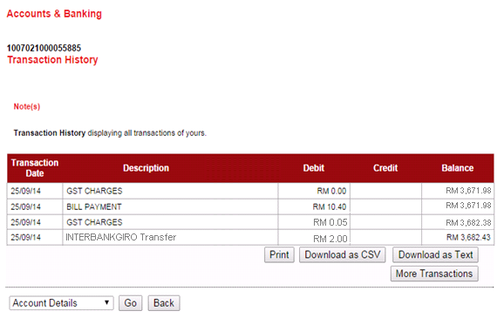

Figure 12: Transaction History Screen

**\*Current eIBFT “INTERBANK GIRO Transfer” info send by Host**

Display Fields:

| **No** | **Field** | **Format** | **Description** |
| --- | --- | --- | --- |
| 1. | Transaction Date | Text | Shows date of transaction |
| 2. | Description | Text | Shows type of transaction |
| 3. | Debit | Numeric | Shows customer account number and beneficiary account number |
| 4. | Credit | Numeric | Shows the amount of the payment |
| 5. | Balance | Numeric | Shows the GST charges of the payment |

Table 25: Transaction History Display Fields

**Action:**

| **No** | **Action** | **Type** | **Description** |
| --- | --- | --- | --- |
| 1. | Go | Button | Contains an action to go to page selected from dropdown list |
| 2. | Back | Button | Contains an action to go back to previous page |
| 3. | Account Details;  AGRONet Transaction History;  Transaction History | Dropdown List | Contains an action to view account details or AGRONet Transaction History or Transaction History |

Table 26: Transaction History List Action

# Enhancement at Business Internet Banking (AGRONetBiz)

## New Bill Payment

Implementing new charges for Goods and Services Tax [GST] which applicable to all payee corporations that have fees charge to customer.

### Process Flow



Diagram 5: New Bill Payment Flow Diagram

There are 3 participants involved in this process which is IB User, BIB and Host. The following are the steps to perform Open Bill Payment at BIB:

### Screen Flow

***Step 4:***

1. IBS displays New Bill Payment confirmation screen.
2. For “Single User”: User input Security Token Pin Number.
3. User confirms the Bill Payment by clicking on the “Confirm” button or clicks on the “Back” button to go back to the previous page

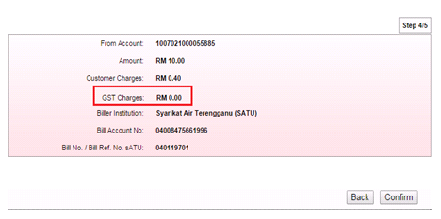

**Figure 13: BIB New Bill Payment Confirmation – Initiator (Step 4/5)**

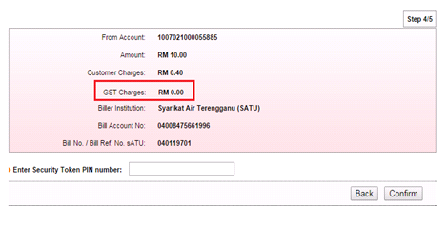

**Figure 14: BIB New Bill Payment Confirmation– Single User (Step 4/5)**

**Display Specification:**

| **No** | **Field** | **Format** | **Description** |
| --- | --- | --- | --- |
| 1. | From Account | Text | Shows the account number |
| 2. | Amount | Text | Shows the amount of bill payment |
| 3. | Customer Charges | Text | Shows the charges of payment |
| 4. | ***GST Charges*** | ***Text*** | ***Shows GST charges of payment*** |
| 5. | Biller Institution | Text | Shows the selected payee corporation |
| 6. | Others[10](Bill Reference details) | Text | Shows others payee corporation required details |

**Table 27: BIB New Bill Payment Confirmation Display Field**

**Input Specification:**

| **No** | **Field** | **Field Type** | **Validation Rule** | **Description** | **M/O** |
| --- | --- | --- | --- | --- | --- |
| 1. | Enter Security Token PIN Number | Textbox | * Match length : 6 * Numeric | A random, temporary generated number from assigned token for transaction verification | M |

**Table 28: BIB New Bill Payment Confirmation Input Specification**

**Action:**

|  |  |  |  |
| --- | --- | --- | --- |
| **No** | **Action** | **Type** | **Description** |
| 1. | Back | Button | Contains an action to go back to previous page |
| 2. | Confirm | Button | Contains an action to continue to next page |

**Table 29: BIB New Bill Payment Confirmation List Action**

**List of available messages for the screen:**

|  |  |  |
| --- | --- | --- |
| **No.** | **Event** | **Error Description in English** |
|  | Did not fill in Security Token PIN field. | Security Token PIN is required. |
|  | Fill in Security Token PIN with other than numeric. | Security Token PIN must be numeric. |
|  | Fill in Security Token PIN less than 6 digits. | Security Token PIN must consist of 6 digits. |
|  | Fill in invalid Security Token PIN | Invalid Security Token PIN. |
|  | Reach maximum length of attempt. | Your Account has been locked. Please call LH Bank’s Call Center. |
|  | Fill in an expired / no longer valid Security Token PIN. | Security Token PIN is expired. |

**Table 30: BIB New Bill Payment Confirmation Error message list**

***Step 5:***

1. IBS send Bill payment details to the Host System which processes the Bill payment and return result.
2. IBS display New Bill payment Result screen. And User is able to make another transaction by clicking on the “Make another Open Bill Payment” button.

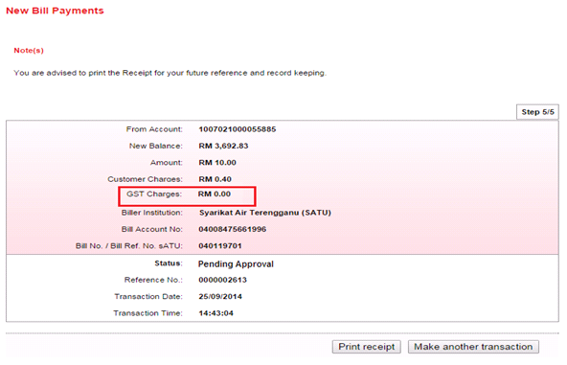

**Figure 15: BIB New Bill Payment Result – Initiator (Step 5/5)**

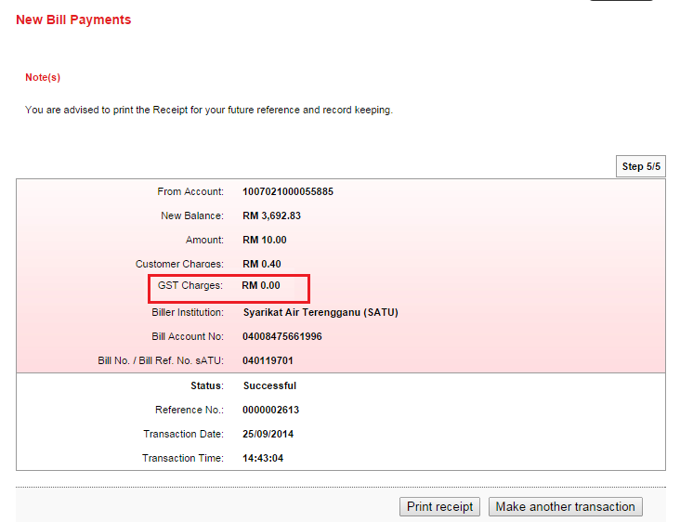

**Figure 16: BIB New Bill Payment Result – Single User (Step 5/5)**

Display Fields:

| **No** | **Field** | **Format** | **Description** |
| --- | --- | --- | --- |
| 1. | From Account | Text | Shows the name of payee corporation |
| 2. | New Balance | Numeric | Shows the new balance of the account |
| 3. | Amount | Text | Shows the amount of the bill payment |
| 4. | Customer Charges | Text | Shows the charges of the payment |
| ***5.*** | ***GST Charges*** | ***Text*** | ***Shows the GST charges of the payment*** |
| 6. | Biller Institution | Text | Shows the selected payee corporation |
| 7. | Others[11](Bill Reference details) | Text | Shows others payee corporation required details |
| 8. | Status | Text | Shows the status of the transaction |
| 9. | Reference No | Numeric | Shows the reference number of particular transaction |
| 10. | Transaction Date | DD/MM/YYYY | Shows the date of transaction |
| 11. | Transaction Time | HH:MM:SS | Shows the time of transaction |

**Table 31: BIB New Bill Payment Result Display Field**

**Action:**

| **No** | **Action** | **Type** | **Description** |
| --- | --- | --- | --- |
| 1. | Print Receipt | Button | Contains an action to generate receipt’s pop-up display |
| 2. | Make another transaction | Button | Contains an action to go back to New Bill Payment page |

**Table 32: BIB New Bill Payment Result List Action**

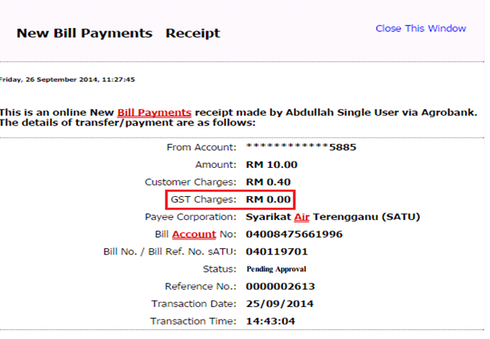

**Figure 17: BIB New Bill Payment Receipt – Initiator**

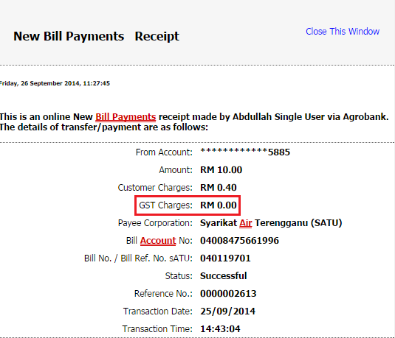

**Figure 18: BIB New Bill Payment Receipt – Single User**

**Display Fields:**

| **No** | **Field** | **Format** | **Description** |
| --- | --- | --- | --- |
| 1. | From Account | Text | Shows the name of payee corporation |
| 2. | Amount | Text | Shows the amount of the bill payment |
| 3. | Customer Charges | Text | Shows the charges of the payment |
| ***4.*** | ***GST Charges*** | ***Text*** | ***Shows the GST charges of the payment*** |
| 5. | Biller Institution | Text | Shows the selected payee corporation |
| 6. | Others[12](Bill Reference details) | Text | Shows others payee corporation required details |
| 7. | Status | Text | Shows the status of the transaction |
| 8. | Reference No | Numeric | Shows the reference number of particular transaction |
| 9. | Transaction Date | DD/MM/YYYY | Shows the date of transaction |
| 10. | Transaction Time | HH:MM:SS | Shows the time of transaction |

**Table 33: BIB New Bill Payment Receipt Display Fields**

**Action:**

| **No** | **Action** | **Type** | **Description** |
| --- | --- | --- | --- |
| 1. | Close this Window | Hyperlink | Contains an action to close the print receipt window. |

**Table 34: BIB New Bill Payment Receipt Action**

***(BIB Role: Approver)***

***Step 2:***

1. BIB System displays Pending Approval Bill Payment Screen.
2. Approver approve the Bill Payment transaction by selection Approve radio button and input Secure Pass PIN and click “Confirm” button

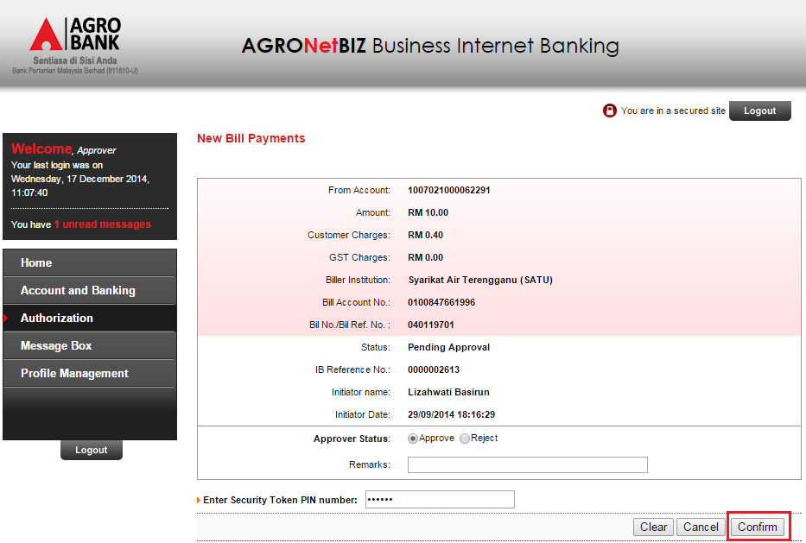

**Figure 19: BIB New Bill Payment Authorization Details Screen - Approver**

**Display Fields:**

| **No** | **Field** | **Format** | **Description** |
| --- | --- | --- | --- |
| 1. | From Account | Text | Shows the name of payee corporation |
| 2. | Amount | Text | Shows the amount of the bill payment |
| 3. | Customer Charges | Text | Shows the charges of the payment |
| ***4.*** | ***GST Charges*** | ***Text*** | ***Shows the GST charges of the payment*** |
| 5. | Biller Institution | Text | Shows the selected payee corporation |
| 6. | Others[13](Bill Reference details) | Text | Shows others payee corporation required details |
| 7. | Status | Text | Shows the status of the transaction |
| 8. | IB Reference No | Numeric | Shows the reference number of particular transaction |
| 9. | Initiator Name | Text | Displays the Initiator name |
| 10. | Initiator Date | DD/MM/YYYY HH:MM:SS | Displays the Initiator date and time |

**Table 35: BIB New Bill Payment Authorization Details Field**

**Input Specification:**

| **No** | **Field** | **Field Type** | **Validation Rule** | **Description** | **M/O** |
| --- | --- | --- | --- | --- | --- |
|  | Approver Status | Tick box | Must be selected | Status either to approve or reject | M |
|  | Remarks | Text | Numeric only | Transaction Reference | O |
|  | Enter Security Token PIN number | Text | Numeric only | Token PIN number | M |

**Table 36: BIB New Bill Payment Authorization Details Input Specification**

**Action:**

| **No** | **Action** | **Type** | **Description** |
| --- | --- | --- | --- |
|  | Clear | Button | Contains an action to clear fields that customer key in |
|  | Cancel | Button | Contains an action to cancel the process |
|  | Confirm | Button | Contains an action to confirm the status of transaction |

**Table 37: BIB New Bill Payment Authorization Details Action**

**List of available messages for the screen:**

|  |  |  |
| --- | --- | --- |
| **No.** | Event | **Error Description** |
|  | Did not fill in or select mandatory field   * Approver Status * Enter Security Token PIN Number | Approver Status is required.  Security Token PIN Number is required. |
|  | Fill in PIN Number others than numeric | Security Token PIN must be numeric. |
|  | Fill in amount less or more than 6 digits. | Security Token PIN must consist of 6 digits. |
|  | Fill in invalid PIN | Security Token PIN is invalid. |
|  | Reach maximum length of attempt. | Your Account has been locked. Please call Agrobank Contact Center at 1 300 88 2476. |
|  | Fill in an expired / no longer valid PIN. | Security Token PIN is invalid. |

**Table 38: BIB New Bill Payment Authorization Details Error Message list**

***Step 3***

1. BIB System displays New Bill Payment Approval Result Screen.
2. BIB system sends to the Host System to proceed.

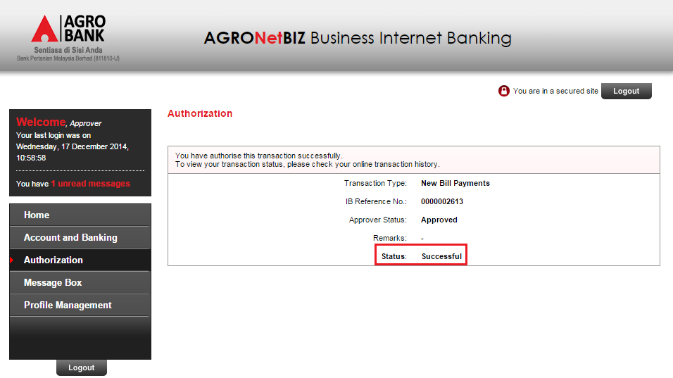

**Figure 20: BIB New Bill Payment Authorization Result Screen - Approver**

Display Fields:

| **No** | **Field** | **Format** | **Description** |
| --- | --- | --- | --- |
|  | Transaction Type | Text | Shows the customer account number |
|  | IB Reference No | Numeric | Displays the IB reference number |
|  | Approver Status | Text | Displays the approver status |
|  | Remarks | Text | Displays the Remarks (if any) |
|  | Status | Text | Displays the transaction status |

**Table 39: BIB New Bill Payment Authorization Result Display Fields**

## Favourite Bill Payment

Implementing new charges for Goods and Services Tax [GST] which applicable to all favorite payee corporations that have fees charge to customer.

### Process Flow



Diagram 6: BIB Favorite Bill Payment Flow Diagram

There are 3 participants involved in this process which is IB User, BIB and Host. The following are the steps to perform Favorite Bill Payment at BIB:

### Screen Flow

***Step 3:***

1. IBS displays Favorite Bill Payment confirmation screen.
2. For “Single User”: User enters Security Token Pin Number.
3. Single User confirms the Favourite Bill Payment by clicking on the “Confirm” button or clicks on the “Back” button to go back to the previous page.

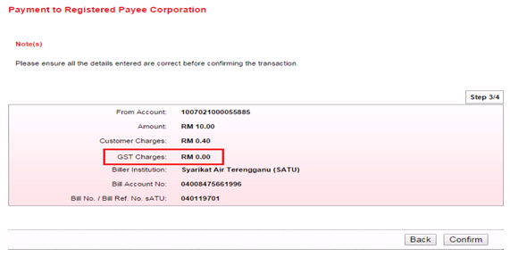

Figure 21: BIB Favorite Bill Payment Confirmation (Step 3/4)

**Display Specification:**

| **No** | **Field** | **Format** | **Description** |
| --- | --- | --- | --- |
| 1. | From Account | Text | Shows the account number |
| 2. | Amount | Text | Shows the amount of bill payment |
| 3. | Customer Charges | Text | Shows the charges of payment |
| 4. | ***GST Charges*** | ***Text*** | ***Shows GST charges of payment*** |
| 5. | Biller Institution | Text | Shows the selected payee corporation |
| 6. | Others[14](Bill Reference details) | Text | Shows others payee corporation required details |

**Table 40: BIB Favorite Bill Payment Confirmation Display Field**

**Action:**

|  |  |  |  |
| --- | --- | --- | --- |
| **No** | **Action** | **Type** | **Description** |
| 1. | Back | Button | Contains an action to go back to previous page |
| 2. | Confirm | Button | Contains an action to continue to next page |

Table 41: BIB Favorite Bill Payment Confirmation List Action

***Step 4:***

1. IBS send Bill payment details to the Host System which processes the Bill payment and return result.
2. IBS display Bill payment Result screen. And user has the choice to make another transaction by clicking on the “Make another Registered Bill Payment” button or user can click “Print Receipt” button to generate a receipt of Favourite Bill Payment.

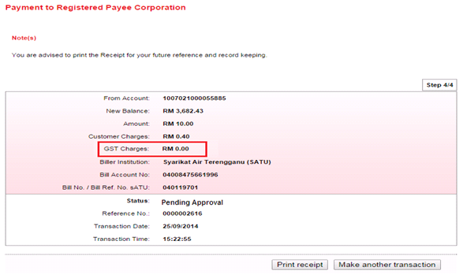

Figure 22: BIB Favorite Bill Payment Result - Initiator (Step 4/4)

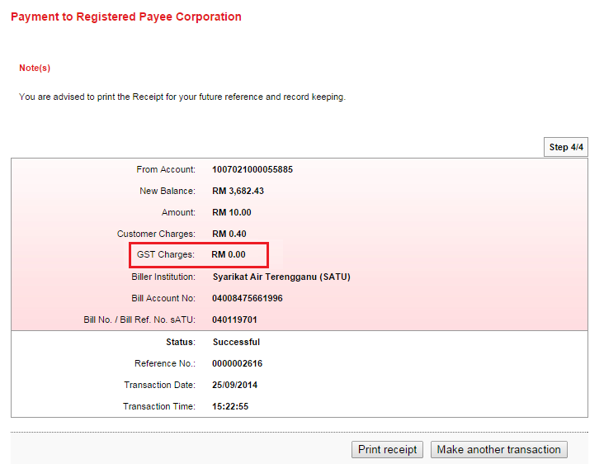

Figure 23: BIB Favorite Bill Payment Result – Single User (Step 4/4)

Display Fields:

| **No** | **Field** | **Format** | **Description** |
| --- | --- | --- | --- |
| 1. | From Account | Text | Shows the name of payee corporation |
| 2. | New Balance | Numeric | Shows the new balance of the account |
| 3. | Amount | Text | Shows the amount of the bill payment |
| 4. | Customer Charges | Text | Shows the charges of the payment |
| ***5.*** | ***GST Charges*** | ***Text*** | ***Shows the GST charges of the payment*** |
| 6. | Biller Institution | Text | Shows the selected payee corporation |
| 7. | Others[15](Bill Reference details) | Text | Shows others payee corporation required details |
| 8. | Status | Text | Shows the status of the transaction |
| 9. | Reference No | Numeric | Shows the reference number of particular transaction |
| 10. | Transaction Date | DD/MM/YYYY | Shows the date of transaction |
| 11. | Transaction Time | HH:MM:SS | Shows the time of transaction |

Table 42: BIB Favorite Bill Payment Result Display Field

Action:

| **No** | **Action** | **Type** | **Description** |
| --- | --- | --- | --- |
| 1. | Print Receipt | Button | Contains an action to generate receipt’s pop-up display |
| 2. | Make another transaction | Button | Contains an action to go back to New Bill Payment page |

Table 43: BIB Favorite Bill Payment Result List Action

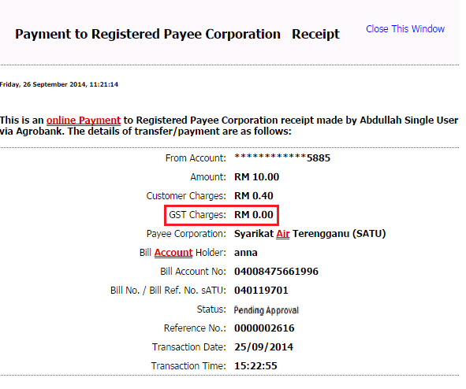

Figure 24: BIB Favorite Bill Payment Receipt

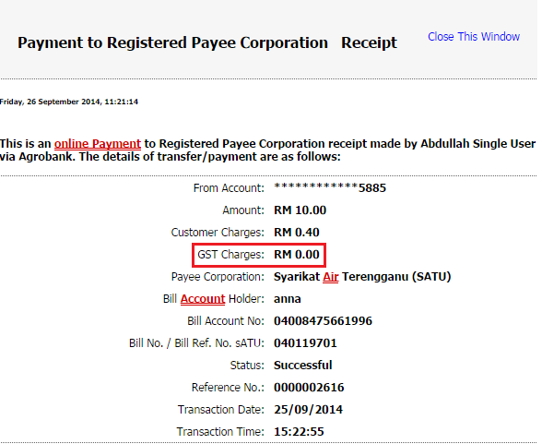

Figure 25: BIB Favorite Bill Payment Receipt

**Display Fields:**

| **No** | **Field** | **Format** | **Description** |
| --- | --- | --- | --- |
| 1. | From Account | Numeric | Shows the account number to debit the payment |
| 2. | Amount | Text | Shows the amount of the bill payment |
| 3. | Charges | Text | Shows the charges of the payment |
| ***4.*** | ***GST Charges*** | ***Text*** | ***Shows the GST charges of the payment*** |
| 5. | Payee Corporation | Text | Shows name of payee corporation |
| 6. | Others[16](Bill Reference details) | Text | Shows others payee corporation required details |
| 9. | Status | Text | Shows the status of the transaction |
| 10. | Reference No | Numeric | Shows the reference number of particular transaction |
| 11. | Transaction Date | DD/MM/YYYY | Shows the date of transaction |
| 12. | Transaction Time | HH:MM:SS | Shows the time of transaction |

Table 44: BIB Favorite Bill Payment Receipt Display Field

**Action:**

| **No** | **Action** | **Type** | **Description** |
| --- | --- | --- | --- |
| 1. | Close this Window | Hyperlink | Contains an action to close the print receipt window. |

Table 45: BIB Favorite Bill Payment Receipt Action

**(Role: Approver)**

***Step 2:***

1. BIB System displays Pending Approval Favorite Bill Payment Screen.
2. Approver approve the Favorite Bill Payment transaction by selection Approve radio button and input Secure Pass PIN and click “Confirm” button

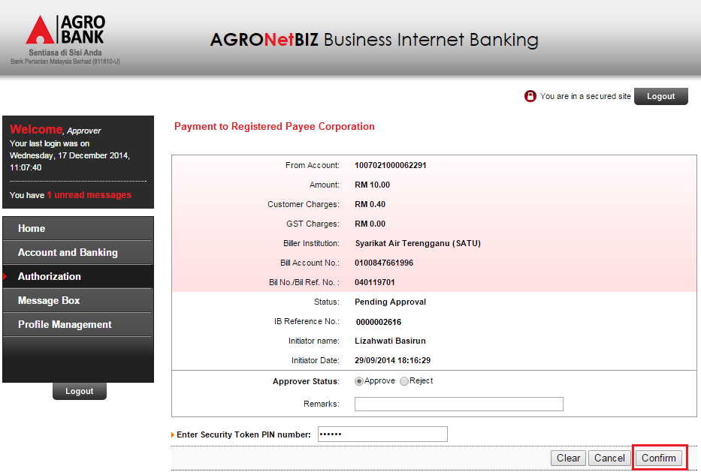

Figure 26: BIB Favorite Bill Payment Authorization Details Screen - Approver

**Display Fields:**

| **No** | **Field** | **Format** | **Description** |
| --- | --- | --- | --- |
| 1. | From Account | Text | Shows the name of payee corporation |
| 2. | Amount | Text | Shows the amount of the bill payment |
| 3. | Customer Charges | Text | Shows the charges of the payment |
| ***4.*** | ***GST Charges*** | ***Text*** | ***Shows the GST charges of the payment*** |
| 5. | Biller Institution | Text | Shows the selected payee corporation |
| 6. | Others[17](Bill Reference details) | Text | Shows others payee corporation required details |
| 7. | Status | Text | Shows the status of the transaction |
| 8. | IB Reference No | Numeric | Shows the reference number of particular transaction |
| 9. | Initiator Name | Text | Displays the Initiator name |
| 10. | Initiator Date | DD/MM/YYYY HH:MM:SS | Displays the Initiator date and time |

Table 46: BIB Favorite Bill Payment Authorization Details Field

**Input Specification:**

| **No** | **Field** | **Field Type** | **Validation Rule** | **Description** | **M/O** |
| --- | --- | --- | --- | --- | --- |
|  | Approver Status | Tick box | Must be selected | Status either to approve or reject | M |
|  | Remarks | Text | Numeric only | Transaction Reference | O |
|  | Enter Security Token PIN number | Text | Numeric only | Token PIN number | M |

Table 47: BIB Favorite Bill Payment Authorization Details Input Specification

**Action:**

| **No** | **Action** | **Type** | **Description** |
| --- | --- | --- | --- |
|  | Clear | Button | Contains an action to clear fields that customer key in |
|  | Cancel | Button | Contains an action to cancel the process |
|  | Confirm | Button | Contains an action to confirm the status of transaction |

Table 48: BIB Favorite Bill Payment Authorization Details Action

**List of available messages for the screen:**

|  |  |  |
| --- | --- | --- |
| **No.** | Event | **Error Description** |
|  | Did not fill in or select mandatory field   * Approver Status * Enter Security Token PIN Number | Approver Status is required.  Security Token PIN Number is required. |
|  | Fill in PIN Number others than numeric | Security Token PIN must be numeric. |
|  | Fill in amount less or more than 6 digits. | Security Token PIN must consist of 6 digits. |
|  | Fill in invalid PIN | Security Token PIN is invalid. |
|  | Reach maximum length of attempt. | Your Account has been locked. Please call Agrobank Contact Center at 1 300 88 2476. |
|  | Fill in an expired / no longer valid PIN. | Security Token PIN is invalid. |

Table 49: BIB New Favorite Payment Authorization Details Error Message list

***Step 3***

1. BIB System displays FavoriteBill Payment Approval Result Screen.
2. BIB system sends to the Host System to proceed.

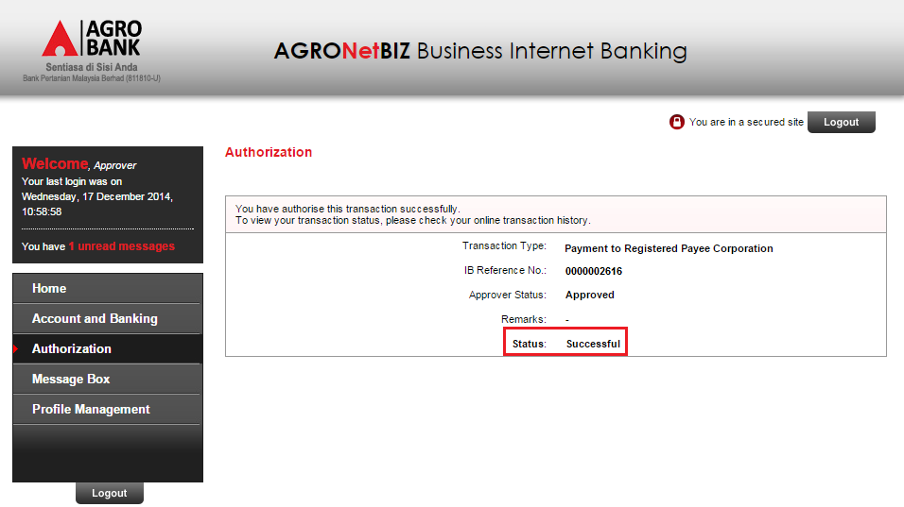

Figure 27: BIB Favorite Bill Payment Authorization Result Screen - Approver

Display Fields:

| **No** | **Field** | **Format** | **Description** |
| --- | --- | --- | --- |
|  | Transaction Type | Text | Shows the customer account number |
|  | IB Reference No | Numeric | Displays the IB reference number |
|  | Approver Status | Text | Displays the approver status |
|  | Remarks | Text | Displays the Remarks (if any) |
|  | Status | Text | Displays the transaction status |

Table 50: BIB Favorite Bill Payment Authorization Result Display Fields

## AGRONetBiz Transaction History

Online Transaction History is only applicable for monetary transactions performed in RIB. User can retrieve by select “AGRONet Transaction History” on dropdown list and clicks go to view account details page.

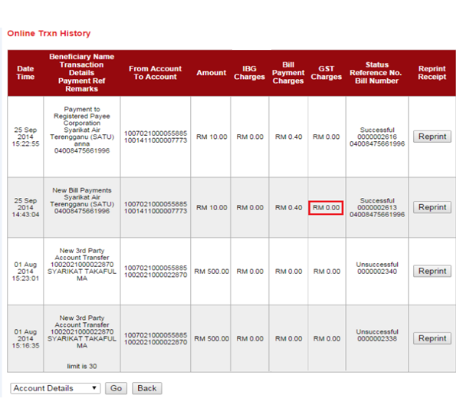

Figure 28: AGRONetBiz Transaction History

Display Fields:

| **No** | **Field** | **Format** | **Description** |
| --- | --- | --- | --- |
| 1. | Date/Time | Text | Shows date and time of transaction |
| 2.. | Beneficiary name;  Transaction Details;  Payment Ref;  Remarks | Text | Shows beneficiary name, transaction details, Payment Reference, and Remarks |
| 3. | From account to account | Numeric | Shows customer account number and beneficiary account number |
| 4. | Amount | Numeric | Shows the amount of the payment |
| ***5.*** | IBG Charges | Numeric | Shows the IBG charges of the payment |
| 6. | Bill Payment Charges | Numeric | Shows the charges of the payment |
| 7. | ***GST Charges*** | ***Numeric*** | ***Shows the GST charges of the payment*** |
| 8. | Status;  Reference No;  Bill number; | Text | Shows the reference number of bill |

Table 51: AGRONetBiz Transaction History Display Fields

**Action:**

| **No** | **Action** | **Type** | **Description** |
| --- | --- | --- | --- |
| 1. | Reprint | Button | Contains an action to reprint receipt of the transaction |
| 2. | Go | Button | Contains an action to go to page selected from dropdown list |
| 3. | Back | Button | Contains an action to go back to previous page |
| 4. | Account Details;  AGRONet Transaction History;  Transaction History | Dropdown List | Contains an action to view account details or AGRONet Transaction History or Transaction History |

Table 52: AGRONetBiz Transaction History Action

## Transaction History (HOST)

This feature allows user to view or print Transaction History (from Host System). User can select “Transaction History” from the dropdown list and click “Go” button to view transaction history page.

Features: To display 2 lines in Transaction History Screen.

* Transaction amount + Customer charges
* GST value

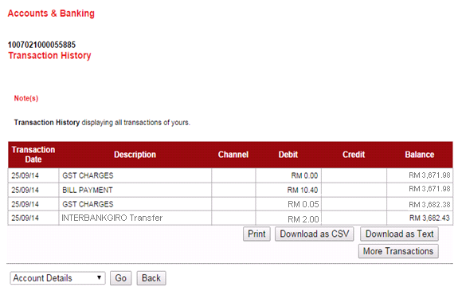

Figure 29: Transaction History (HOST)

Display Fields:

| **No** | **Field** | **Format** | **Description** |
| --- | --- | --- | --- |
| 1. | Transaction Date | Text | Shows date of transaction |
| 2.. | Description | Text | Shows type of transaction |
| 3. | Channel | Text | Shows type of channel use to the transactions |
| 4. | Debit | Numeric | Shows customer account number and beneficiary account number |
| 5. | Credit | Numeric | Shows the amount of the payment |
| 6. | Balance | Numeric | Shows the GST charges of the payment |

**Table 53: Transaction History (Host) Display Fields**

**Action:**

| **No** | **Action** | **Type** | **Description** |
| --- | --- | --- | --- |
| 1. | Go | Button | Contains an action to go to page selected from dropdown list |
| 2. | Back | Button | Contains an action to go back to previous page |
| 3. | Account Details;  AGRONet Transaction History;  Transaction History | Dropdown List | Contains an action to view account details or AGRONet Transaction History or Transaction History |

**Table 54: Transaction History (Host) Action**

# Enhancement at IBAM

## Charges & Limit

This feature allows administrator to maintain the transaction Charges and Limit for RIB and BIB.

### Process Flow



Diagram 7: Edit Charges/Limit Flow Diagram

There are 2 participants involved in this process which is IBAM Admin and IBAM System. The following are the steps to update the GST Charges percentage at IBAM:

### Screen Flow

***Step 1:***

1. Administrator can access to GST Charges Screen by clicking on the “Charges & Limit” link at the left navigation menu.
2. Admin user clicks on the ‘GST Charges’ sub-navigation.
3. IB shows GST Charges Details screen and Admin clicks on “Edit” button to update the information.

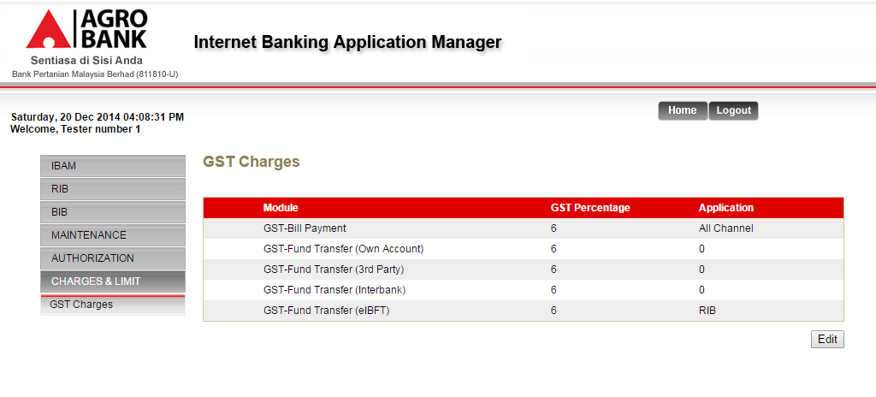

Figure 30: GST Charges Details screen

**Display Specification:**

| **No** | **Field** | **Format** | **Description** |
| --- | --- | --- | --- |
| 1. | Module | Text | Type of GST Module |
| 2. | GST Percentage | Percentage | Percentage of GST charges |
| 3. | Channel | Text | Application system required. System will read the application selection in this module as first checking. |

Table 55: GST Charges Details display field

**Action:**

|  |  |  |  |
| --- | --- | --- | --- |
| No | Action | Type | Description |
|  | Edit | Button | Contains an action to edit the GST Charges information. |

Table 56: Charges & Limit Details Screen Action

***Step 2:***

1. IBAM System shows the edit GST Charges Edit page.
2. Admin user updates the information and click on update.

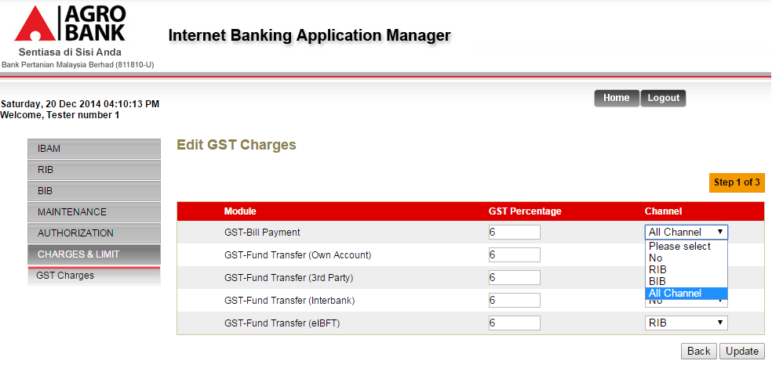

Figure 31: GST Charges Edit screen

**Display Specification:**

| **No** | **Field** | **Format** | **Description** |
| --- | --- | --- | --- |
|  | Module | Text | Type of GST Module |

Table 57: GST Charges Details Display Specification

**Input Specification:**

| **No** | **Field** | **Field Type** | **Validation Rule** | **Description** | **Compulsory** |
| --- | --- | --- | --- | --- | --- |
| 1. | GST Percentage | Text Box | Numeric  Max: 3 | Percentage of GST charges | Yes |
| 2. | Channel | Dropdown List | Optional to select the required Application | The Application system required. | Yes |

Table 58: GST Charges Details Input Specification

**Action:**

|  |  |  |  |
| --- | --- | --- | --- |
| No | Action | Type | Description |
|  | Update | Button | Forward the action to validate and update user input and save it to the D IB Database. |
|  | Back | Button | Goes back to Details page |

Table 59: GST Charges Details Screen Action

**List of available messages for the screen:**

|  |  |  |
| --- | --- | --- |
| **No.** | **Event** | **Error Description in English** |
| 1. | Did not fill in required field. | GST Percentage is required.  Application is required. |
| 2. | Fill GST Percentage with non-numeric value (exp: RM1, 1o%, 12.0%, @1 etc.) | GST Percentage is invalid. |

Table 60: GST Charges Details Input Error Message List

***Step 3:***

1. IBAM System displays the edit GST Charges Confirmation Screen.
2. User click on **Confirm** button

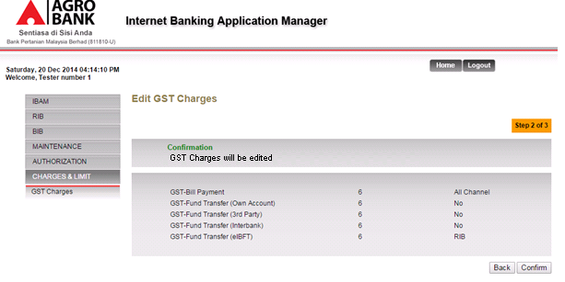

Figure 32: GST Charges Confirmation screen

**Display Specification:**

| **No** | **Field** | **Format** | **Description** |
| --- | --- | --- | --- |
|  | Module | Text | Type of GST Module |
| 2. | GST Percentage | Percentage | Percentage of GST charges |
| 3. | Channel | Text | Application system required. |

**Table 61: GST Charges Confirmation display field**

**Action:**

|  |  |  |  |
| --- | --- | --- | --- |
| No | Action | Type | Description |
|  | Confirm | Button | Contains an action to edit the GST Information. System will shows the ‘successful message’ page |
|  | Back | Button | Contains an action to let the IBAM systems go back to previous page. |

Table 62: GST Charges Confirmation Action

***Step 4:***

1. IBAM System validates save the updated data to IB Database and displays result page.
2. IBAM shows Successful message and pending for Authorization approval process.
3. Once approved IBAM will shows update information under GST Charges list

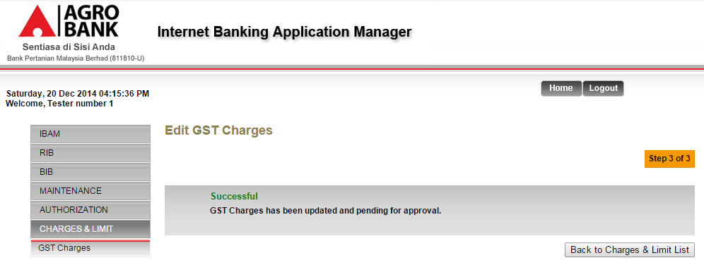

Figure 33: GST Charges Result with Authorization Process

If Charges & Limit Maker Checker Permission set as ‘Disable’

1. IBAM saves the update information and display the successful result page.
2. IBAM shows Successful message and will shows update information under User Group Maintenance list without any approval process.

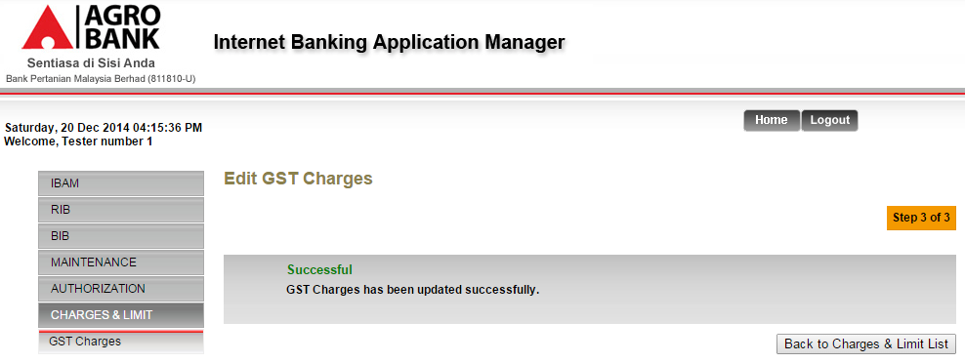

Figure 34: GST Charges Result without Authorization Process

Display Specification:

|  |  |  |  |
| --- | --- | --- | --- |
| No | Field | Format | Description |
| 1. | Result Status | Text | Edit/Delete User Group Result status |
| 2. | Result Status Notes | Text | Edit/Delete User Group Result status message |

Table 63: GST Charges Result Display Field

**Action:**

|  |  |  |  |
| --- | --- | --- | --- |
| No | Action | Type | Description |
|  | Back to Charges & Limit List | Button | Contains an action to let the IBAM system go back to Charges & Limit List page. |

Table 64: GST Charges Result Display Action

## Content – Payee

To update the GST Charges dropdown selection for individual payee at IBAM>Content>Payee.

**Purpose:**

This change will allow IB System to check whether the Payee required for GST Charges and for which Application system.

### Process Flow



Diagram 8: Edit Content Process Flow

There are 2 participants involved in this process which is User and IBAM. The following are the steps to update the GST Charges required at Payee content:

### Screen Flow

***Step 1:***

1. Admin user clicks on the ‘Parent Category Name’. IBAM System displays the ‘sub category’ list under the parent directory. For example ‘Bill Payment’.
2. Admin user clicks on the ‘Sub Category Name’. IBAM System displays the ‘Content’ list under the sub category directory. For example ‘Education Financing’ sub category under ‘Bill Payment’.
3. Admin user clicks on Content List ‘Details’ hyperlink under sub category for example ‘Perbadanan Tabung Pendidikan Tinggi Nasional (PTPTN)’.

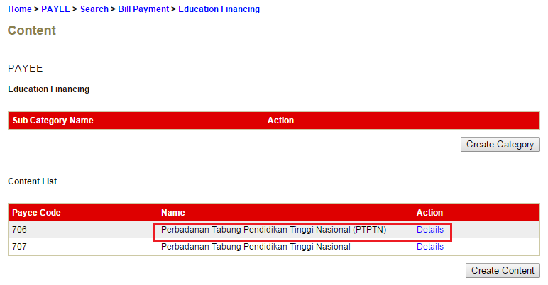

Figure 35: Content List Screen

**Action:**

| **No** | **Action** | **Type** | **Description** |
| --- | --- | --- | --- |
| 1 | Details | Hyperlink | Contains the action to show the details of specific content. |

Table 65: Content List Action

***Step 2:***

1. IBAM System shows the specific content details.
2. Admin User clicks on ‘Edit’ button.

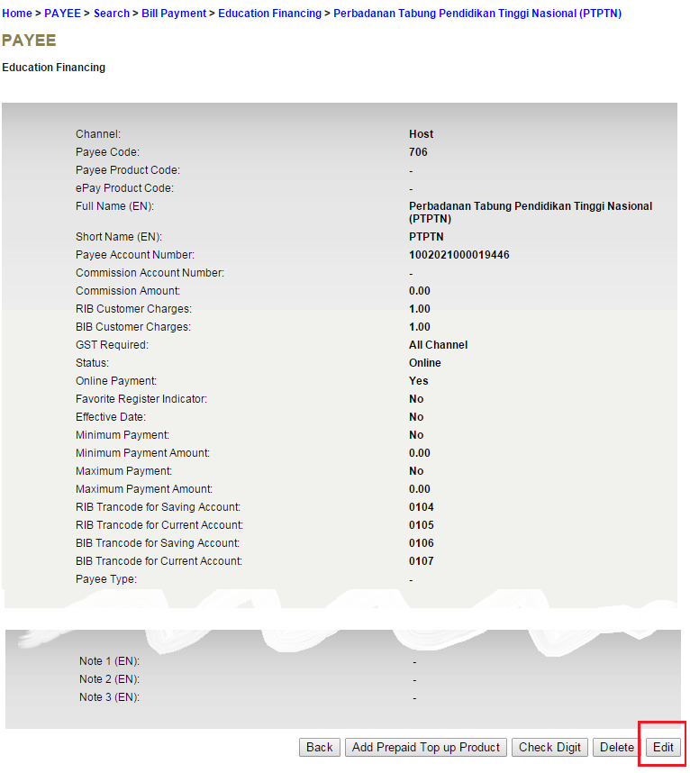

Figure 36: Content Details Screen

**Action:**

| **No** | **Action** | **Type** | **Description** |
| --- | --- | --- | --- |
| 1 | Edit | hyperlink | Contains an action to edit the content information. |
| 2 | Delete | hyperlink | Contains an action to delete the content information. |
| 3 | Back | hyperlink | Contains an action to go back to list of category or sub-category screen. |

Table 66: Content Details Action

***Step 3:***

1. IBAM System shows the edit content creation page.
2. Admin user updates the content information of **“GST Required**” and click on ‘Update’ button.

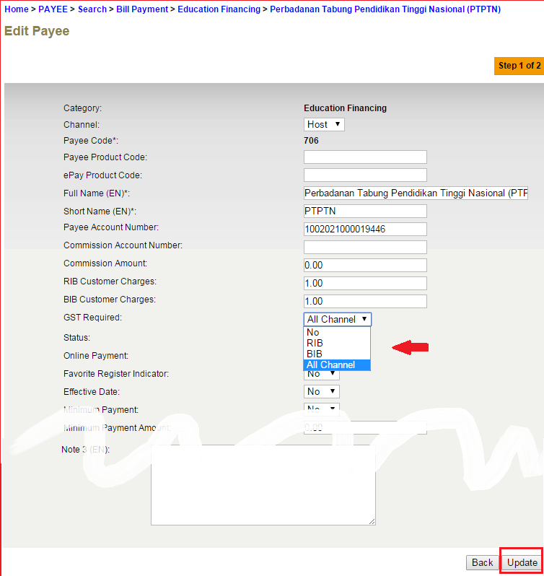

Figure 37: Edit Content Details Screen

**Input Specification (Payee - additional):**

| **No** | **Field** | **Field Type** | **Validation Rule** | **Description** | **Compulsory** |
| --- | --- | --- | --- | --- | --- |
| 1. | RIB Customer Charges | Text Box | 15,2 | Charges Amount to Customer for RIB | No |
| 2. | RIB Customer Charges | Text Box | 15,2 | Charges Amount to Customer for RIB | No |
| 3. | GST Required | Dropdown List | 1 number | Determine whether the payee is required GST Charges or not. | Yes |

Table 67: Edit Content Details additional Input Specification

**Action:**

| **No** | **Action** | **Type** | **Description** |
| --- | --- | --- | --- |
| 1 | Back | Button | Goes back to ‘content list’ page. |
| 2 | Update | Button | Forward the action to validate and update user input and save it to the D IB Database |

Table 68: Edit Content Details Action

***Step 4:***

1. IBAM validate and save inputs to IB database.
2. IBAM shows successful message and pending for Authorization approval process.
3. Once approved IBAM will shows the update details under the content type content list.

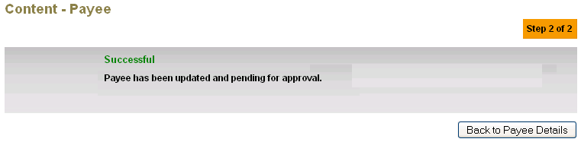

Figure 38: Edit Content Result Screen with Authorization Process

Content Maker Checker Permission set as ‘Disable’

1. IBAM updates the details to IB Database and display the result to the IBAM user
2. IBAM shows successful message and shows the updated content details under the content type without Authorization.

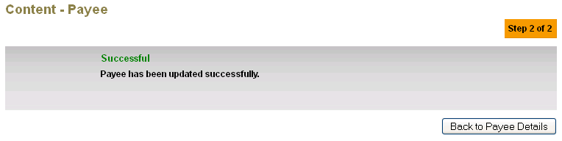

Figure 39: Edit Content Result Screen without Authorization Process

Display Specification:

| **No** | **Field** | **Format** | **Description** |
| --- | --- | --- | --- |
| 1. | Result Status | Text | Edit Content Result status |
| 2. | Result Status Notes | Text | Edit Content Result status message |

Table 69: Edit Content Result Display Fields

**Action:**

| **No** | **Action** | **Type** | **Description** |
| --- | --- | --- | --- |
| 1. | ‘Content Type’ | Button | Contains an action to go back to Content type Content List |

Table 70: Edit Content Result Action

## Report

IBAM Admin User can access to reports under IB (RIB/BIB) Report module of IBAM, the user just need to select the appropriate report type, File Type as Text (*.txt) or CSV (*.csv), Month and Year to download the report in CSV or Text format.

The following are reports related to GST

* RIB/BIB Transaction Enquiry
  + Add on GST Transaction
* Daily Consolidated Transaction Report
  + Add on GST Transaction
* Monthly Consolidated Transaction Report
  + Add on GST Transaction
* Daily Report

Below attached sample reports:

* RIB/BIB Transaction Enquiry

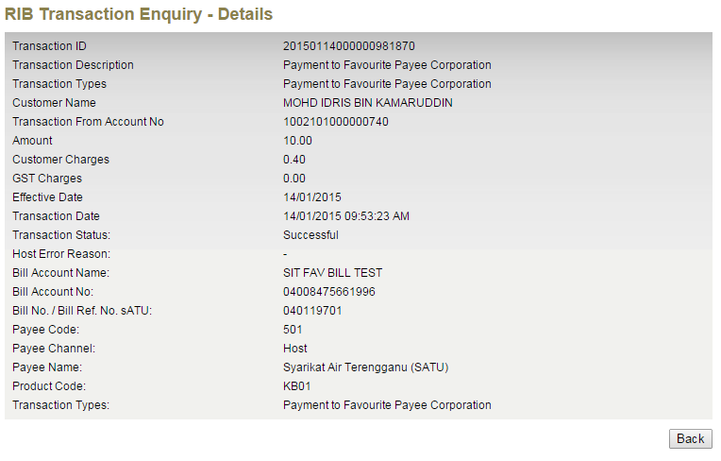

Figure 40: IBAM - RIB Transaction Enquiry

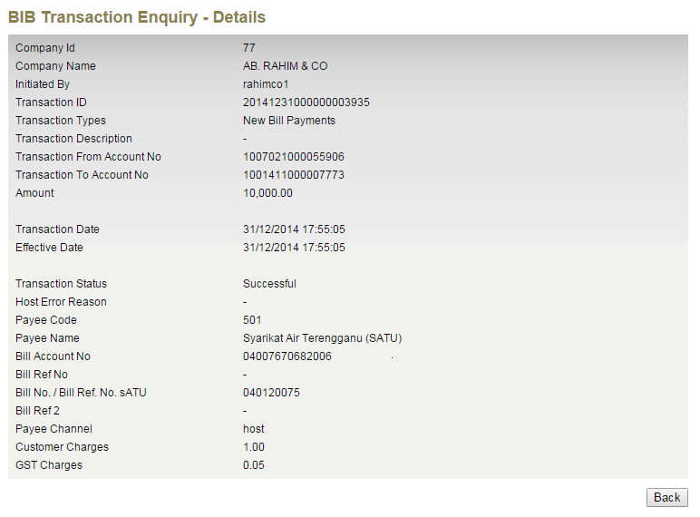

Figure 41: IBAM – BIB Transaction Enquiry

* Monthly Consolidated Transaction Report

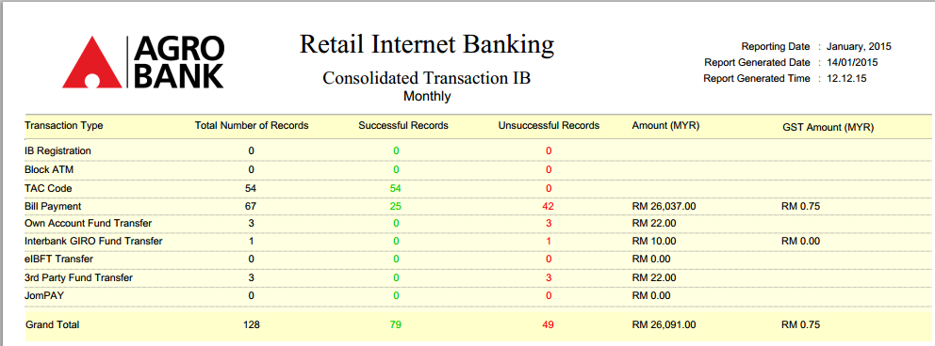

Figure 42: IBAM - RIB Monthly Consolidated Report

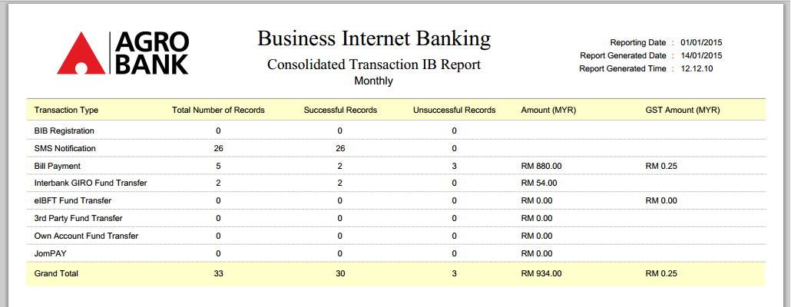

Figure 43: IBAM - BIB Monthly Consolidated Report

* Daily Report

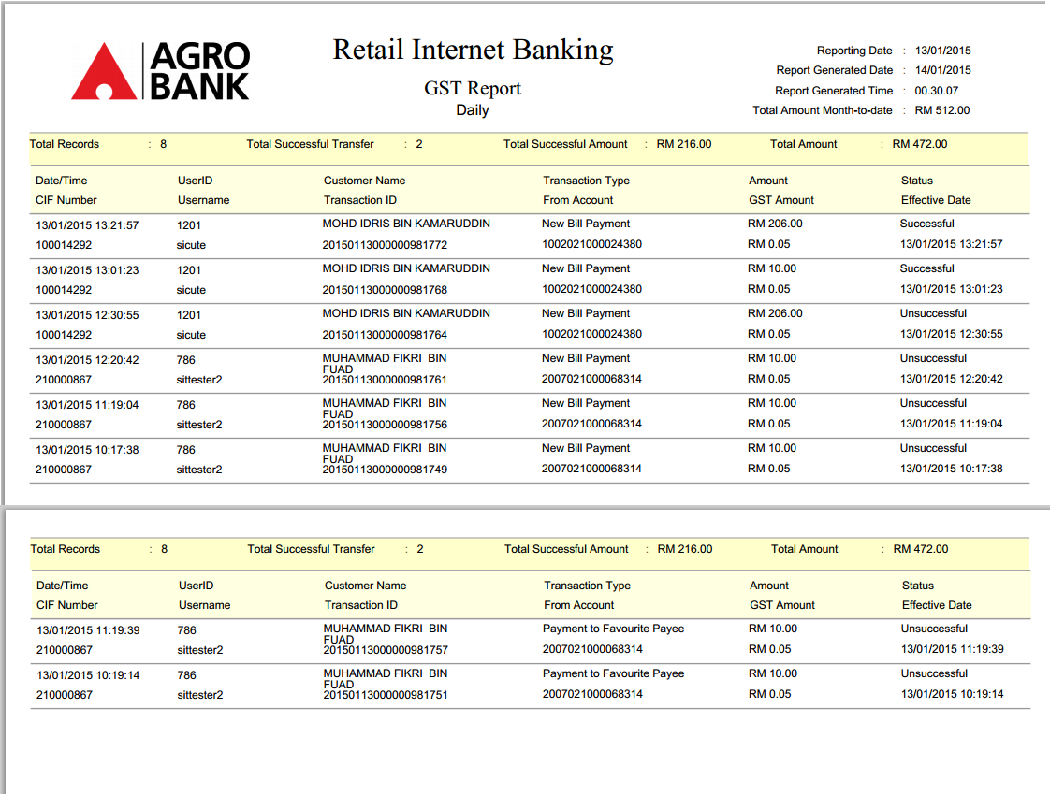

Figure 44: IBAM - RIB Daily Report

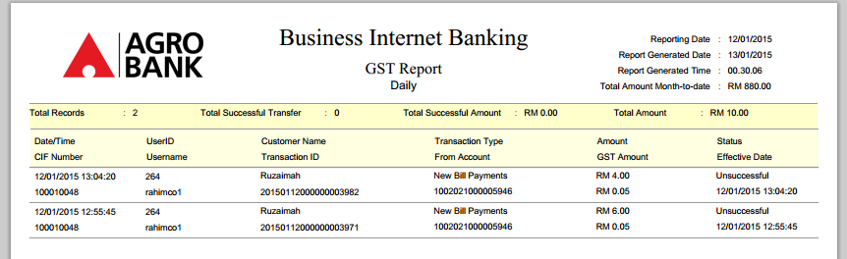

Figure 45– BIB Daily Report

**Section C: Change Impact Analysis**

Impacted Modules:-

| **No** | **System** | **Changes** |
| --- | --- | --- |
|  | IBAM>Content>Payee  IBAM>Charges & Limit>GST Charges  IBAM>User Maintenance  IBAM>IBAM Navigation  IBAM>Maker Checker Maintenance  IBAM>RIB/BIB Transaction Enquiry  IBAM>RIB Report | * To add field on GST Charges * To add new module to update the GST Charges Percentage * Add new role/permission for IBAM User to edit the “Charges & Limit” * Add new IBAM Navigation for new module “Charges & Limit” * Add Maker Checker Permission for new module “Edit - Charges & Limit” * Add information on GST Charges to the transaction details * Add/Update report for GST   1. New Daily GST report for RIB and BIB   2. Add GST Information to existing related transaction report (Bill Payment & eIBFT) |
|  | RIB>BILL Payment  RIB>Interbank>eIBFT  RIB>AGRONet Transaction History  RIB>Transaction History | * Added field to show GST value in Confirm, Result & Receipt screen * Added field to show GST value in Confirm, Result & Receipt screen * Added column to show GST value * Added field to show GST value in Description |
|  | BIB>BILL Payment  BIB>AGRONetBiz Transaction History  BIB>Transaction History | * Added field to show GST value in Confirm, Result & Receipt screen * Added column to show GST value * Added field to show GST value in Description |

 - END -

**Appendix**

## D1: Test Conditions on selection of Application System required

**Scenario 1:-**

IBAM>Charges & Limit>GST Charges

Field:-

Module: Bill Payment

Application: RIB & BIB

IBAM>Contentt>Payee> SATU

Field:-

GST Charges: RIB

***Expected Result:-***

* RIB User will be charged on GST charges of 6% when perform payment transaction for SATU
* BIB User will NOT be charged on GST charges 6% when perform payment transaction for SATU

**Scenario 2:-**

IBAM>Charges & Limit>GST Charges

Field:-

Module: Bill Payment

Application: RIB

IBAM>Contentt>Payee> SATU

Field:-

GST Charges: RIB & BIB

***Expected Result:-***

* RIB User will be charged on GST charges of 6% when perform payment transaction for SATU
* BIB User will NOT be charged on GST charges 6% when perform payment transaction for SATU

## D2: GST Calculator Formula

1. For charges / commission of RM0.40 and below, the GST portion (6%) will be borne by Agrobank due to rounding mechanism. The field / calculator for GST should be included as normal – but then when come to rounding the GST amount will become RM0.00.
2. However, for bill payment commission charge to agencies/ service provider, the GST will be calculated in total daily/ weekly/ monthly [based on arrangement/ agreement].
3. For online payments, to round up or round down to the nearest 1 sen. Example as below:

|  |  |  |  |  |
| --- | --- | --- | --- | --- |
| Product | Commission | GST charges | Amount | Result |
| PTPTN | RM0.50 | 6% | RM0.03 | RM0.03 |
| SATU | RM0.40 | 6% | RM0.024 | RM0.02 |
| eIBFT | RM0.70 | 6% | RM0.042 | RM0.04 |
| MEPS | RM0.30 | 6% | RM0.018 | RM0.02 |
| LIFB | RM3.70 | 6% | RM0.222 | RM0.22 |

## D3: Agro Bank - Host Teller - Mapping Technical Specification



## D4: Agro Bank – Sample Receipt

To add Fixed GST ID NUMBER [Bank Registration No] – 00548294656 at customer receipt (Bill Payment, Zakat Payment & eIBFT).

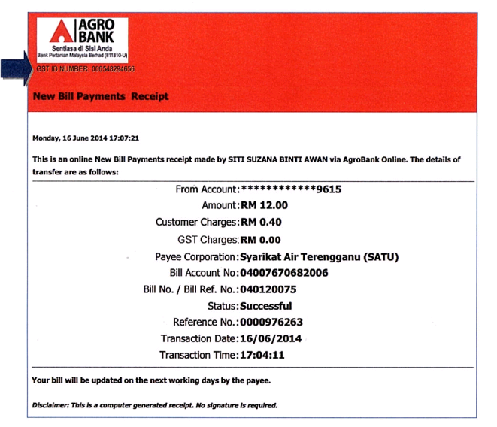

## D5: New and Favorite eIBFT changes

Based on URS version 1.4, date 29 Jan 2015 requested to amend the New and Favorite eIBFT changes as below:

1 To add * on the Charges of the result page

1. To add * GST @ 6% included in charges on bottom of the result page
2. Print receipt to display the new changes as Charges with * and the * GST @ 6% included in charges.
3. IBAM – maintainable of the percentage only for this sentence * GST @ 6% included in charges.

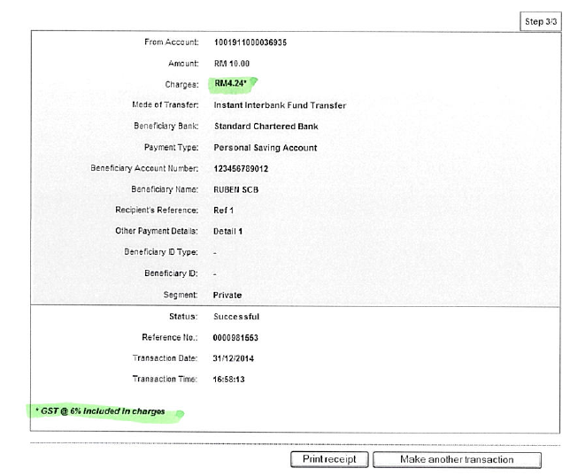

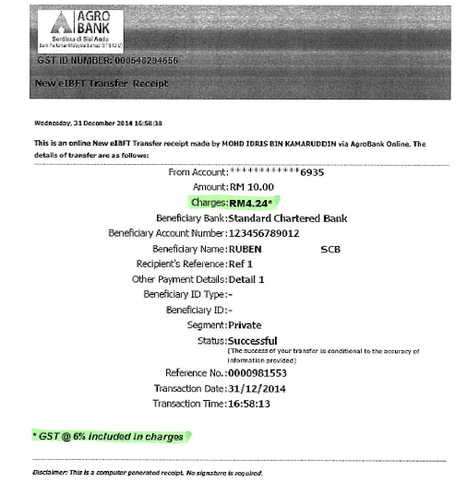

1. For GST amount of RM0.00 to RM0.02, the GST will be borne by Agrobank due to rounding mechanism.
2. Depending to Payee Corporation required details.
3. Depending to Payee Corporation required details.
4. Depending to Payee Corporation required details.
5. Depending to Payee Corporation required details.
6. Depending to Payee Corporation required details.
7. Depending to Payee Corporation required details.
8. For GST amount of RM0.00 to RM0.02, the GST will be borne by Agrobank due to rounding mechanism.
9. For GST amount of RM0.00 to RM0.02, the GST will be borne by Agrobank due to rounding mechanism.
10. Depending to Payee Corporation required details.
11. Depending to Payee Corporation required details.
12. Depending to Payee Corporation required details.
13. Depending to Payee Corporation required details.
14. Depending to Payee Corporation required details.
15. Depending to Payee Corporation required details.
16. Depending to Payee Corporation required details.
17. Depending to Payee Corporation required details.