Issue Log Form
Originator's Name: Chooi  URF ID Number: URF-14-12-163  Project: IBG Enhancement  Owner: AC  Date Raised: 13/01/2015  Module: IBG RFI  Functional Area: IBG RFI | Issue ID Number: IBG-008  Related Issue ID Number:  Severity: Critical / High / Medium / Low  Assigned to: IT  Target Resolution Date: 14/01/2015  Actual Closed Date:
Status : Open / Investigate / Retest / Re-Open / Closed / Sign-Off (Circle one)
Category : Modification / Bugs / Set-up / Clarification / Repeated / Internal CR / CR (Circle one)
Description:

RFI Crediting Process
Test Financing Account - Encountered “Credit Error” status without reject reason i/o “Successful” when retest using the same financing account no.
- 121402055718
- 001401000026
Remarks – tested on 7/1/2015 (sys date = 1/8/2014), crediting was successful

Impact:

Finding (Description):

Resolution:

Estimated Impact:

Recommendation:

Accepted ( ):  Date: | Accepted (KFHMB):  Date:
Associated Risk Report: | Risk Report Accepted Date:
Associated Change Request Form: | Change Control Accepted on:

Test on 13.1.15 – Failed with Credit Error and without reject reason
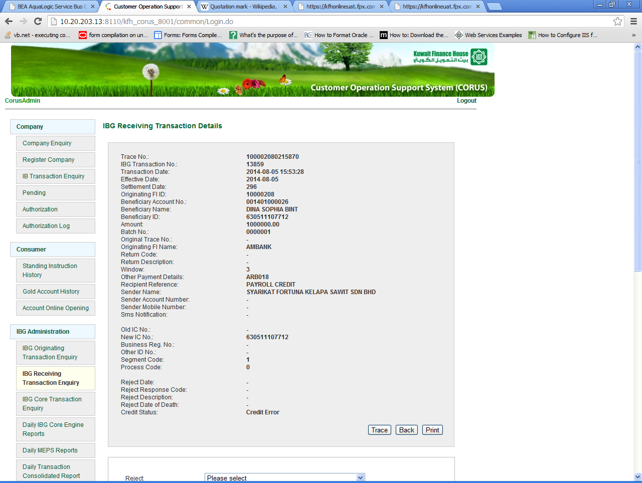
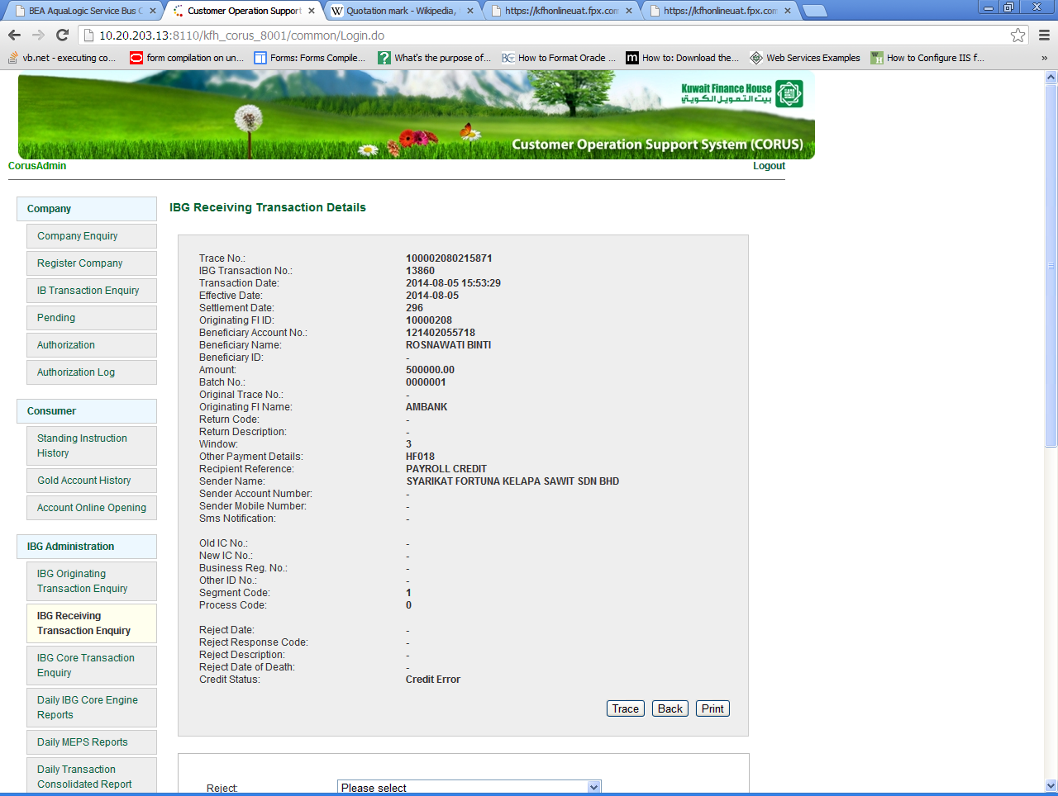

Test on 7.1.15 – Crediting Successful
