Test Issue Log |  |  |  |  | TIL No.: URF-14-12-163
Project Name: | IBSCR068 & IBSCR072 – UAT Issues
Test Stage: | Unit Functionality Integration System Interface  Performance Regression Acceptance Pilot
Test Case Number: |  |  |  | Test Started Date: |  | 10/12/2014
Test Title: | SIT Result for UAT Issue #003; #013; #023 & #024
Test Description: | #003: Transaction History - Description shall follow current BAU on the sequence and modification of service & channel ID as per User request.  #013: IBG Credit Return, to reflect below info in the description  - Recipient Reference  - Reason Message  #023: To reflect the correct description for reversal transaction. Sample test result given was based on IBG Cancellation.  #024: To reflect the info on Recipient’s Reference and Other Payment Details into the correct fields in CORUS (report, enquiry, print), Receipt, Email.
Test Functionality: | CIB/BIB  - All Transaction Module  - Transaction History  - Receipt page  - Email  CORUS  - Enquiry Page  - View Report  - Print
Test Procedure: | - Performed Transaction at all module in CIB/BIB  - Input info in Recipients Reference & Other Payment Details field  - View info on Recipients Reference & Other Payment Details in Receipt and Email  - View transaction description in Transactions History to include below info:  - Channel and Service  - Sender / Beneficiary Name  - Recipient's Reference  - Other Payment Details  - Corus – IBG Transaction  - View info on Recipients Reference & Other Payment Details in Enquiry page and Report.
Test Result: | Pass: Fail: Conditional Pass: |  | Tested by: |  | Yap Kah Yan
Reason for Failure: | CIB/BIB  Transaction History  - Description max length is 80 characters which consist below info:  - Channel and Service  - Sender & Beneficiary Name  - Recipient's Reference  - Other Payment Details  For Intra bank Transfer, system is unable to capture all info if the description (which count from first alphabet for service name) exceed 80 characters its due to no filtering for Sender and Bene Name from Host  IBG Credit Return  - Fixed issue to capture Recipient Reference in description i/o Other Payment Details  - Need IT to assist simulating the testing
TEST DESCRIPTION
1. Perform Transaction (CIB)

- Sample of Transaction Receipt page to shows CR request details as below:
  - Recipient’s Reference; Other Payment Details
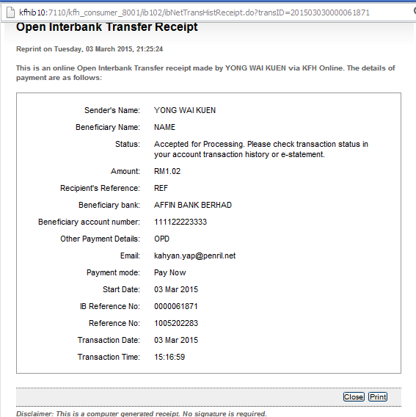

- Sample of Transaction Email page to shows CR request details as below:
  - Recipient’s Reference; Other Payment Details
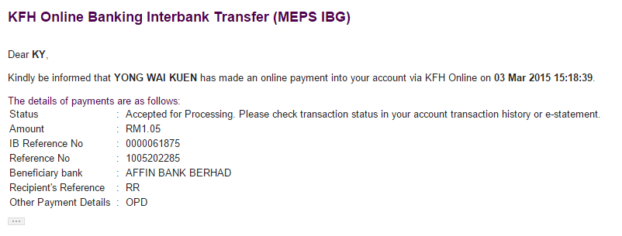

- Transaction Description to shows CR request details as below:
  - Service/Channel Name; Bene/Sender Name; Recipient’s Reference; Other Payment Details
Sample: Service/Channel;SenderName/BeneName/PrepaidType/BillerName;RecipientRef;OtherDetails
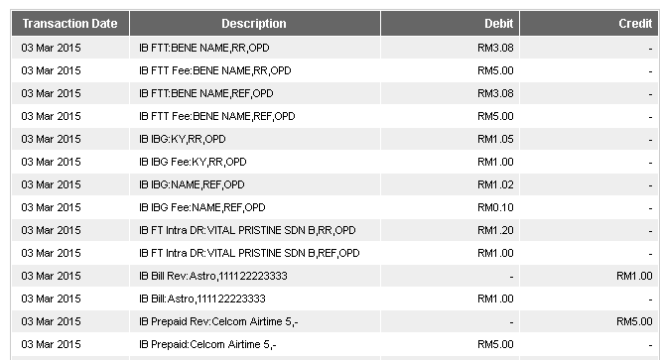

2. Perform Transaction (BIB)

- Sample of Transaction Receipt page to shows CR request details as below:
  - Recipient’s Reference; Other Payment Details
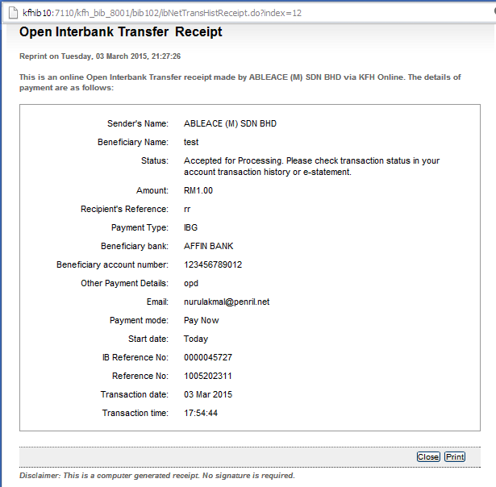

- Sample of Transaction Email page to shows CR request details as below:
  - Recipient’s Reference; Other Payment Details

- Transaction Description to shows CR request details as below:
  - Service/Channel Name; Bene/Sender Name; Recipient’s Reference; Other Payment Details
Sample: Service/Channel;SenderName/BeneName/PrepaidType/BillerName;RecipientRef;OtherDetails
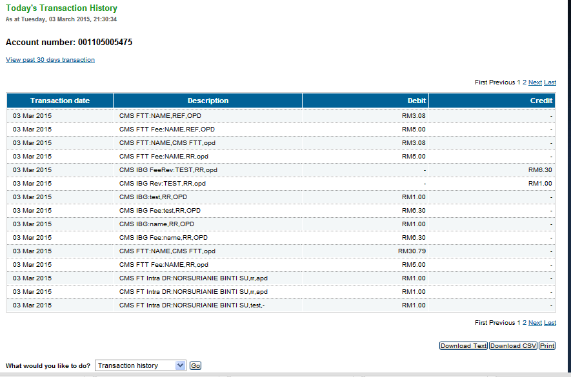

3.Negative Test: Did no enter any information in Recipients Reference field
Test Item:
- Enter Empty Value or Space To Recipients Reference
- Enter other required field.
- Click On “Next” Button

4. CORUS - Originating Transaction Enquiry (OFI)

- OFI Enquiry Page
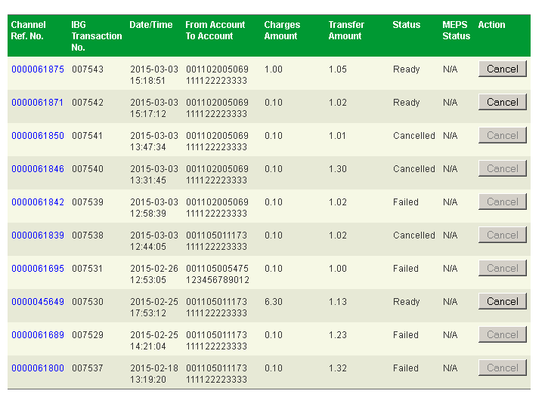

- OFI Enquiry Details Page
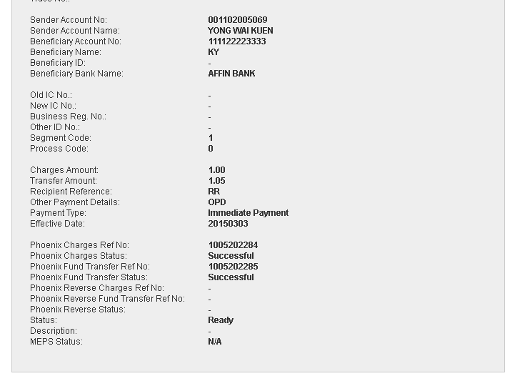

- OFI Details Print Page

- OFI View Report
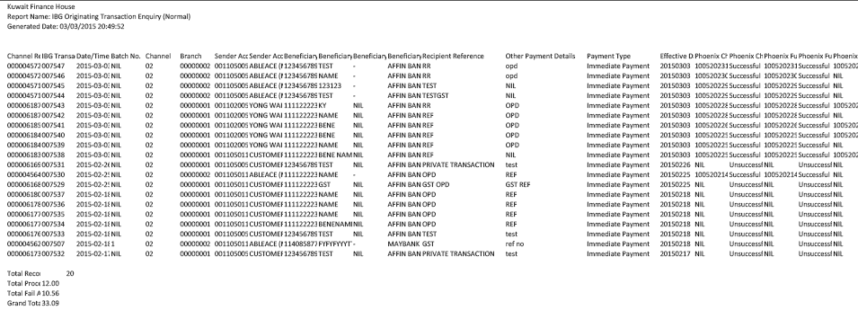

4. CORUS - Receiving Transaction Enquiry (RFI)

- RFI Enquiry Page
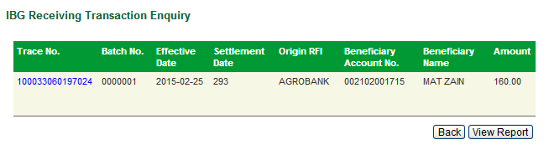
- RFI Enquiry Details Page
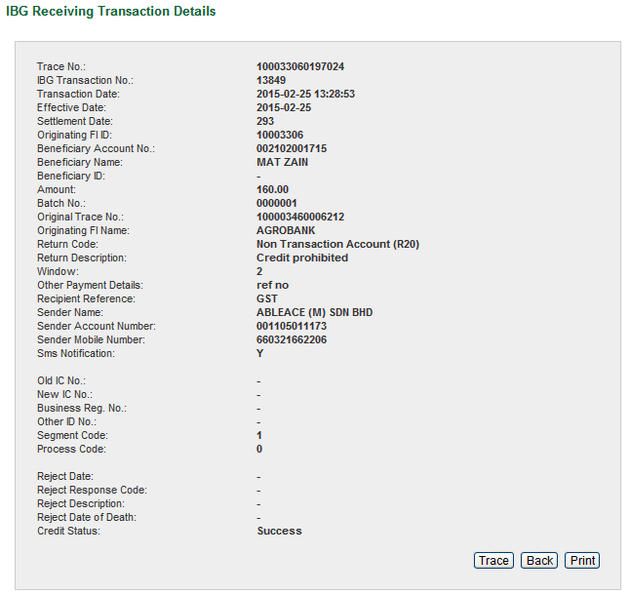

- RFI Details Print Page
- RFI View Report
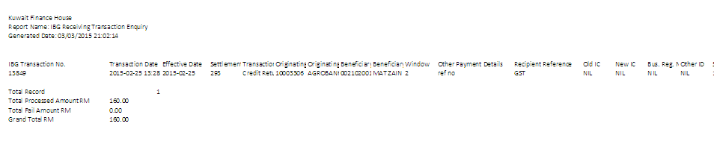

Reviewed By: (PMO)
 |  | Name/Position : Norhaidah Binti Md Dasuki / Senior Manager, Quality Assurance and Support  Date : 3/3/2015

