Issue Log Form
Originator's Name: Chooi  URF ID Number: URF-14-12-163  Project: IBG Enhancement  Owner: AC  Date Raised: 29/01/2015  Module: IBG  Functional Area: IBG | Issue ID Number: IBG-014  Related Issue ID Number:  Severity: Critical / High / Medium / Low  Assigned to: PENRIL  Target Resolution Date:  Actual Closed Date:
Status : Open / Investigate / Retest / Re-Open / Closed / Sign-Off (Circle one)
Category : Modification / Bugs / Set-up / Clarification / Repeated / Internal CR / CR (Circle one)
Description:

- Why there are 2 columns for sender names in the RFI Enquiry Report? What are the differences (Column AC & AP)?

- Why Sender Name was “NIL”, should reflect the sender name info after nacha processing

- Sender Account No. should be reflected after nacha processing i/o after crediting

Impact:

Finding (Description):

Estimated Impact:

Recommendation:

Accepted ( ):  Date: | Accepted (KFHMB):  Date:
Associated Risk Report: | Risk Report Accepted Date:
Associated Change Request Form: | Change Control Accepted on:

Why there are 2 columns for sender name?
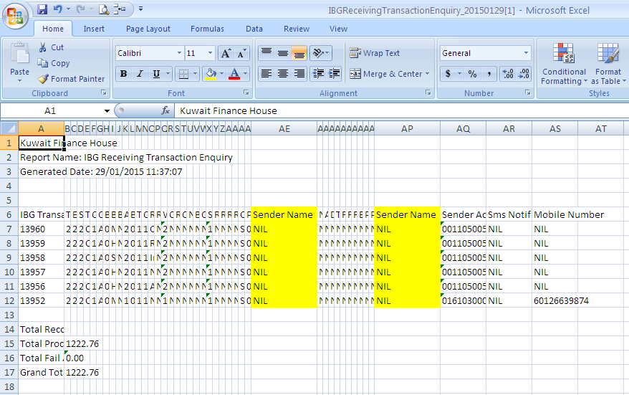

Info was not reflected for Sender Name and Sender Account Number
