Issue Log Form
Originator's Name: Chooi  URF ID Number: URF-14-12-163  Project: IBG Enhancement  Owner: AC  Date Raised: 29/01/2015  Module: IBG  Functional Area: IBG | Issue ID Number: IBG-016  Related Issue ID Number:  Severity: Critical / High / Medium / Low  Assigned to: PENRIL  Target Resolution Date:  Actual Closed Date:
Status : Open / Investigate / Retest / Re-Open / Closed / Sign-Off (Circle one)
Category : Modification / Bugs / Set-up / Clarification / Repeated / Internal CR / CR (Circle one)
Description:
Why there were double crediting entries for the 4 transactions as highlighted below?
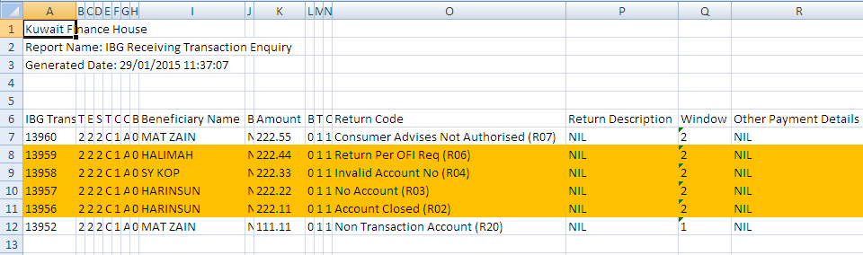

Impact:

Finding (Description):

Estimated Impact:

Recommendation:

Accepted ( ):  Date: | Accepted (KFHMB):  Date:
Associated Risk Report: | Risk Report Accepted Date:
Associated Change Request Form: | Change Control Accepted on:

