|  |  |
| --- | --- |
| **Originator's Name: Chooi So Fun**  **Project: SI**  **Project Manager:** Malarvily Muniandy / Christopher Gunn  **Owner:** PDM / RCB  **Date Raised: 24.05.2010**  **Phase/Process:**  **Functional Area: Consumer** | **Issue ID Number:** SI-UAT-0510-C028  **Related ID Number:**  **Priority:** High / Medium **/** Low  **Assigned to:**  **Target Resolution Date:**  **Actual Closed Date:** |
| **Status :** Open / Investigate / Retest / Re-Open / Closed / Sign-Off *(Circle one)*  **Category :** Bugs / Set-up / Clarification / Repeated / Internal CR / CR *(Circle one)* | |
| **Description:**  Email notification showed all SI transactions status having error. Upon checking accounts balances, transactions are successfully debited.  **Impact:** | |
| **Investigation (Description):**  **Action:**  **Estimated Impact:** | |
| **Recommendation:** | |
| **Accepted (PENRIL/SA/IT):**  **Date:** | **Accepted (KFHMB):**  **Date:** |
| **Associated Risk Report:** | **Risk Report Accepted Date:** |
| **Associated Change Request Form:** | **Change Control Accepted on:** |

**Email Notification 22.5.10:**

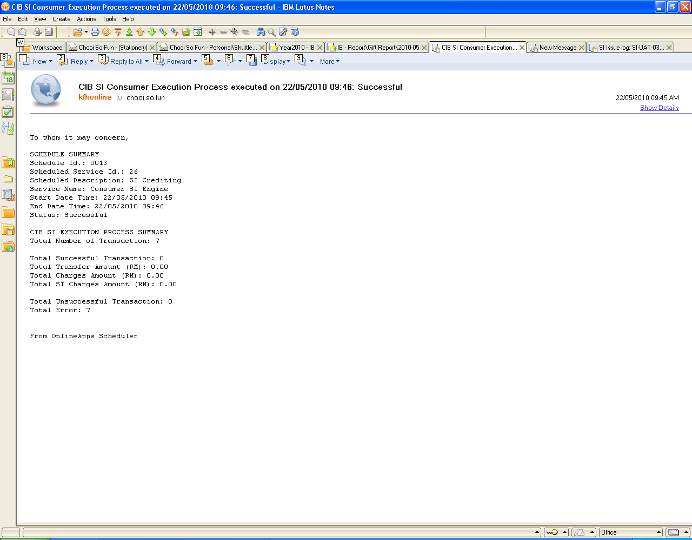

**Email Notification 23.5.10:**

**Transactions on 22.5.10:**

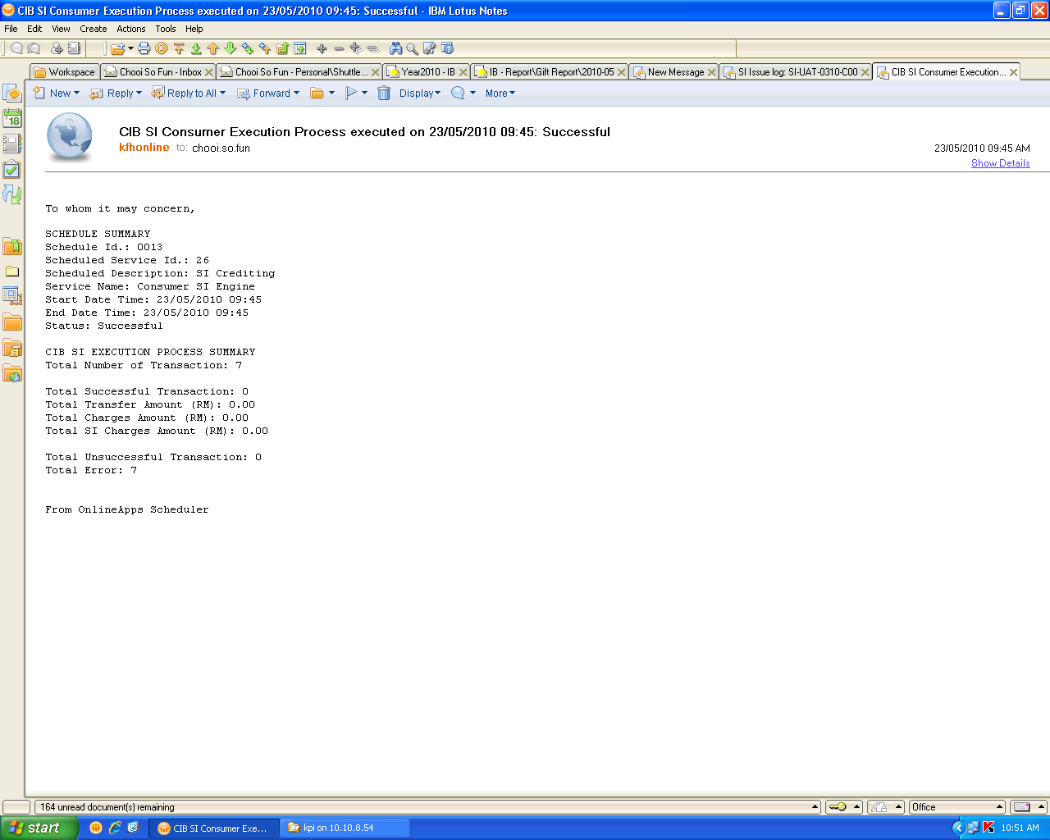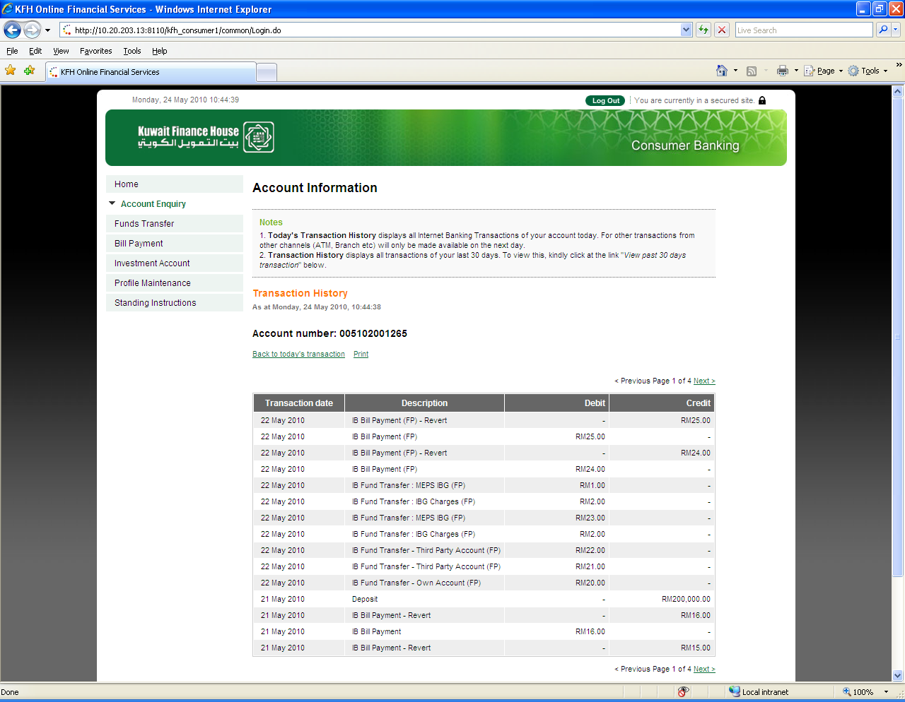

**SI History for 22.5.10:**

**Transactions on 23.5.10:**

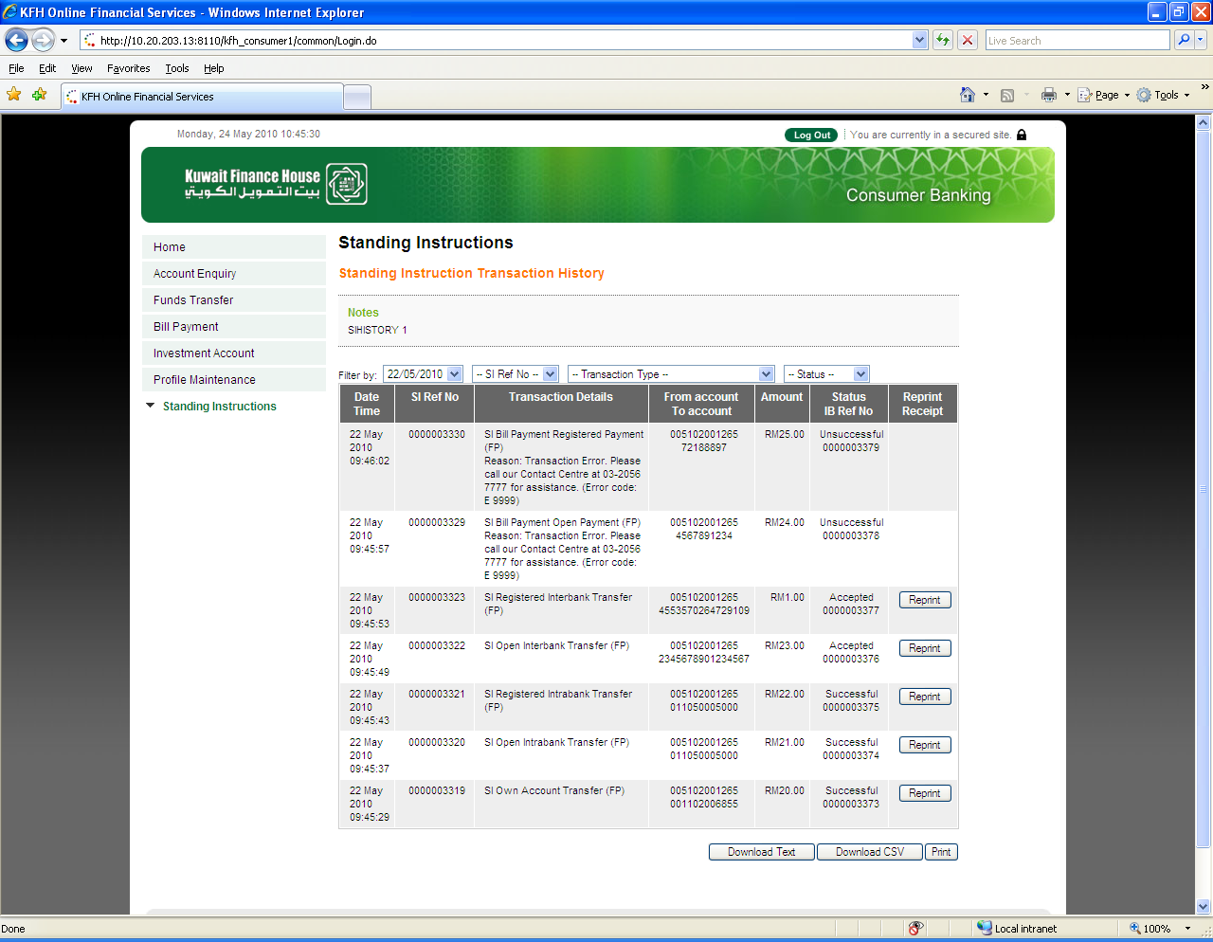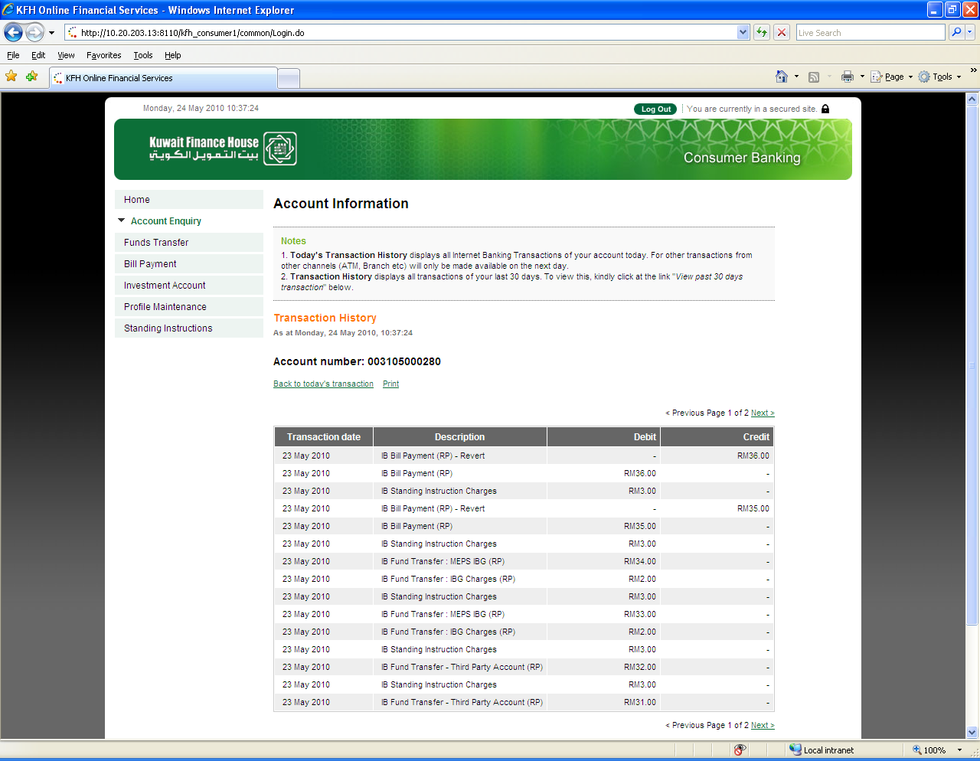

**SI History for 23.5.10:**

