Internal testing result |  |  |  |  |  | CR-00027
Project Name: | Internet Banking
Test Stage: | Unit Functionality Integration System Interface  Performance Regression Acceptance Pilot
Test Case Number: | Bug#5189 |  |  | Test Started Date: |  | 12/03/2015
Test Title: | BIB : Error while approving the Transaction
Test Description: | To ensure approver able to approve the transaction for Bill Payment module which have various amount to send
Test Functionality: | BIB>New Bill Payment  BIB>Favourite Bill Payment  BIB>Authorization
Test Procedure: | Initiator  - Login to BIB  - Click on New Bill Payment/Favourite Bill Payment  - Proceed transaction until finish  Approver  - Login to BIB  - Click on Authorization  - Click on Transaction ID  - Approved the transaction
Test Result: | Pass: Fail: | Tested by: |  |  | Lizahwati binti Basirun
Reason for Failure:
TEST DESCRIPTION
BIB – Initiator
Test Case 1: Perform New Bill payment transaction for MPK (Majlis Perbandaran Kuantan)

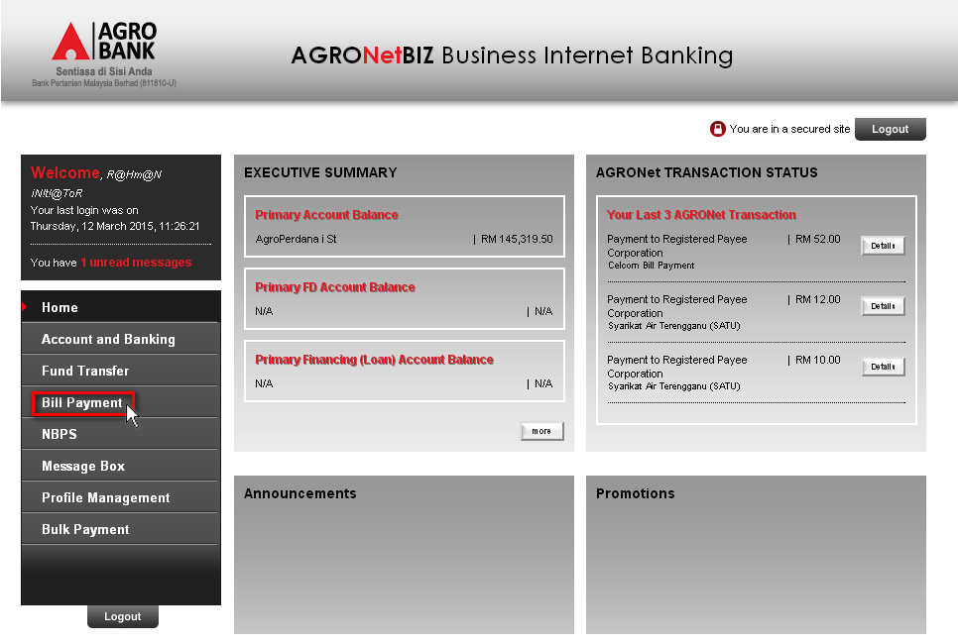
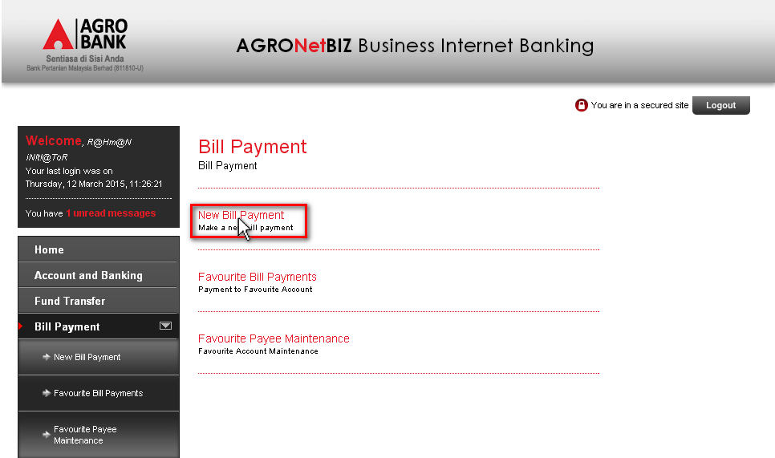
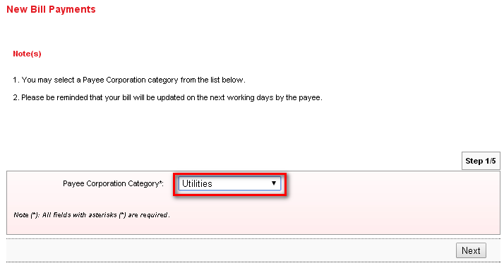
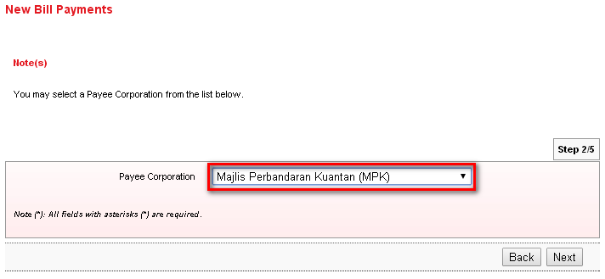
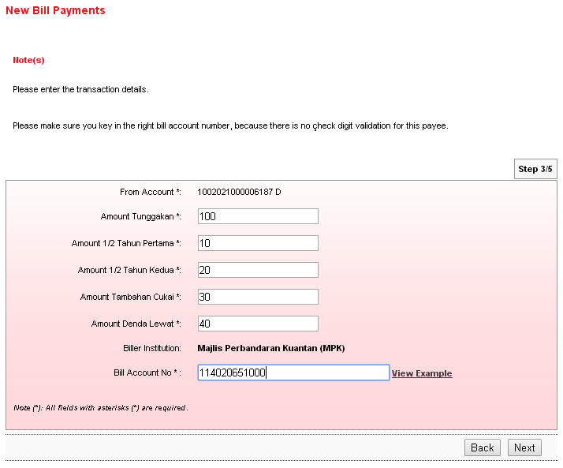
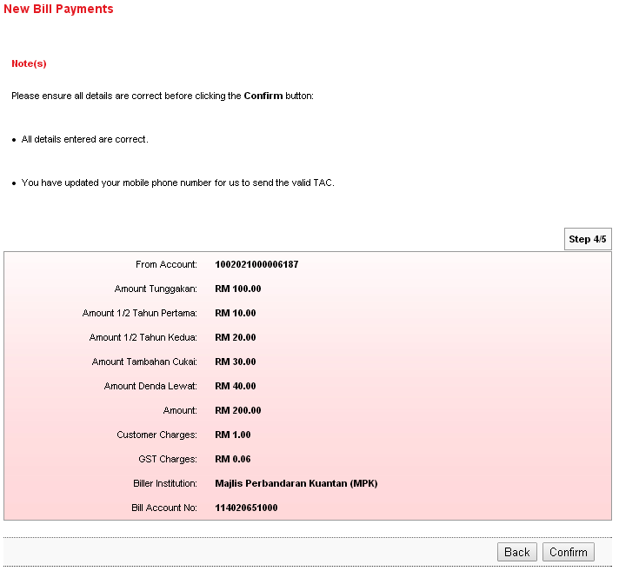
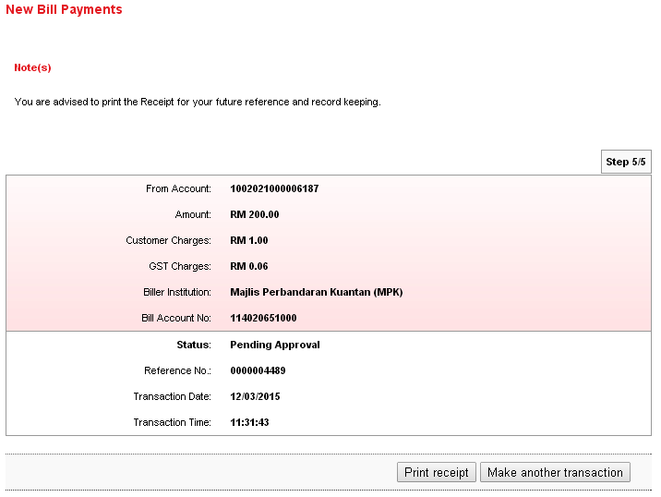
Test Case 2: Perform Favourite Bill payment transaction for MPK (Majlis Perbandaran Kuantan)
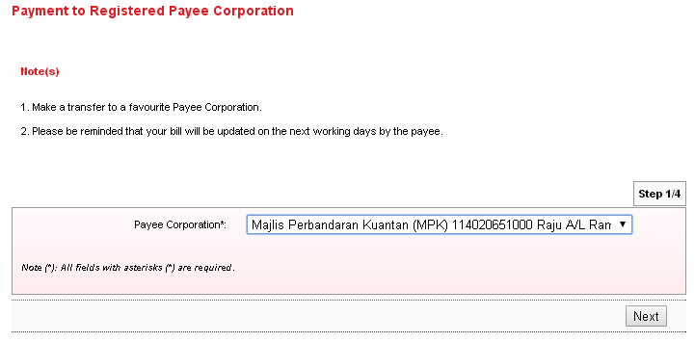
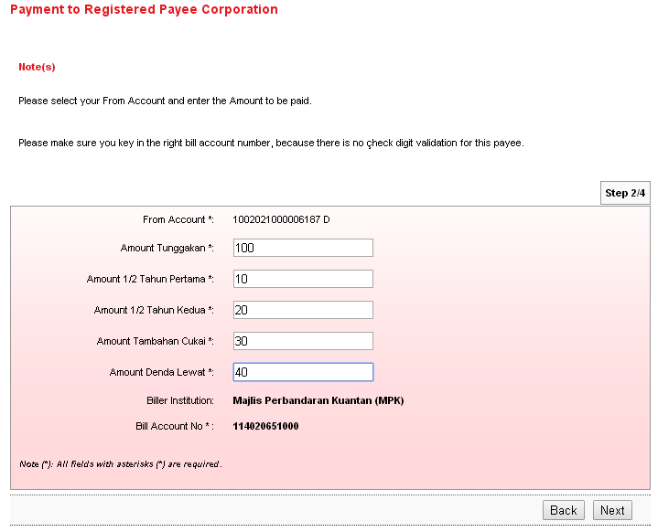
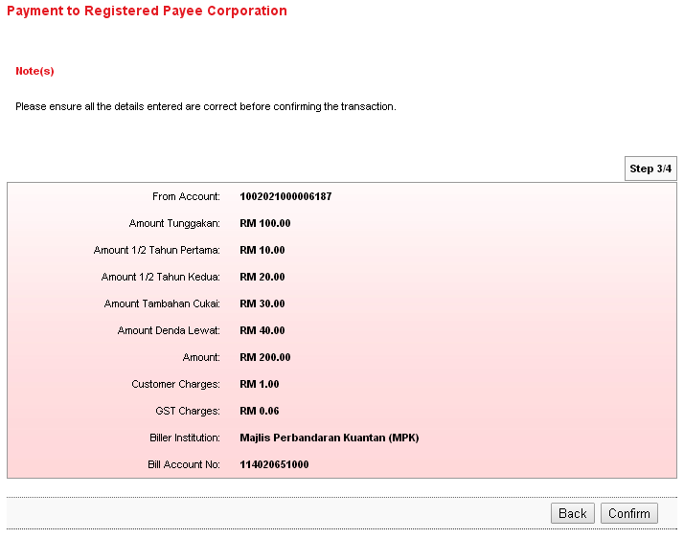
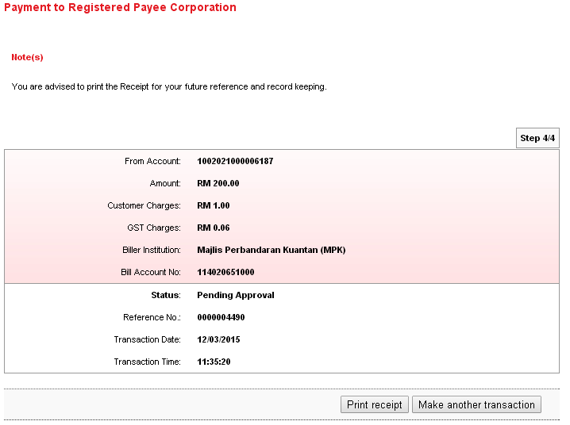
BIB – Approver
Test Case 3: Approved the transaction
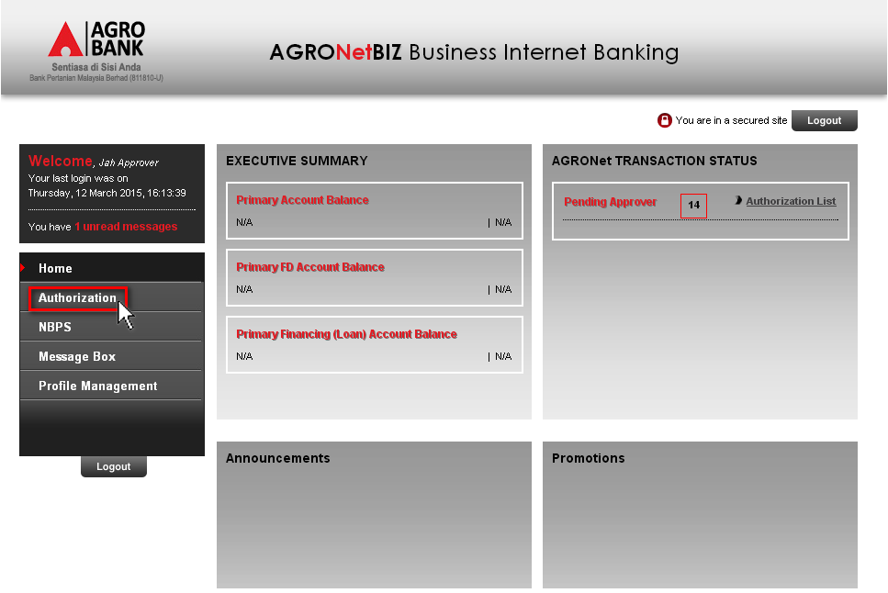
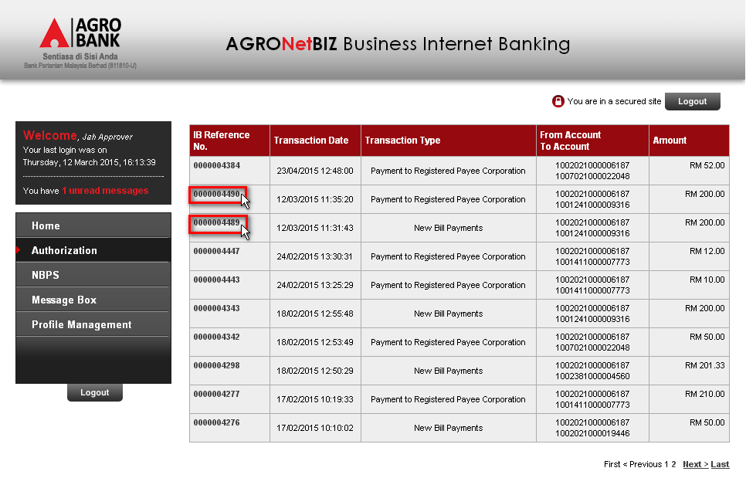
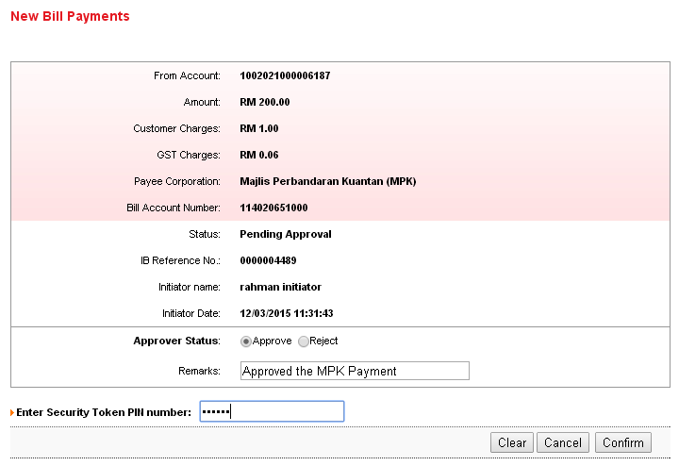
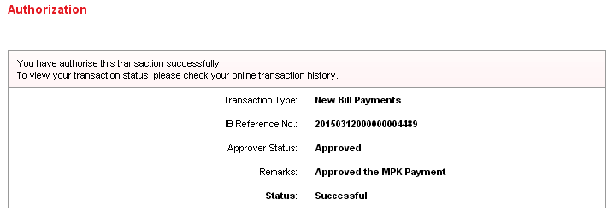

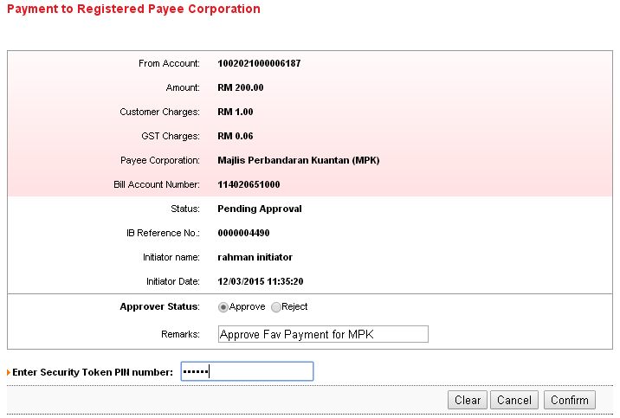
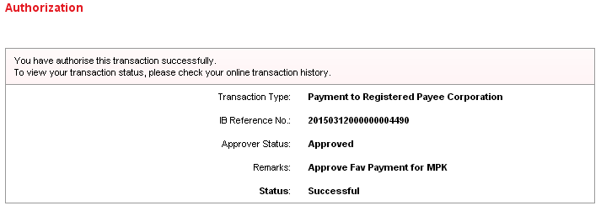

Reviewed By: (PMO
 |  |  | Name/Position : Norhaidah Binti Md Dasuki / Senior Manager, Quality Assurance and Support  Date :

