Internal testing result |  |  |  |  |  | CR-00027
Project Name: | Internet Banking
Test Stage: | Unit Functionality Integration System Interface  Performance Regression Acceptance Pilot
Test Case Number: | Bug#5237 |  |  | Test Started Date: |  | 12/03/2015
Test Title: | IBAM: RIB Transaction Enquiry Details – System displayed “Error while performing your request”
Test Description: | To ensure system able to display the transaction history details for eIBFT transaction
Test Functionality: | IBAM>RIB>RIB Transaction Enquiry
Test Procedure: | - Click on IBAM>RIB>RIB Transaction History  - Select Transaction Types as New eIBFT Transfer or Fav e-IBFT Transfer  - Click on Search button  - Click on Transaction ID
Test Result: | Pass: Fail: | Tested by: |  |  | Lizahwati binti Basirun
Reason for Failure:
TEST DESCRIPTION
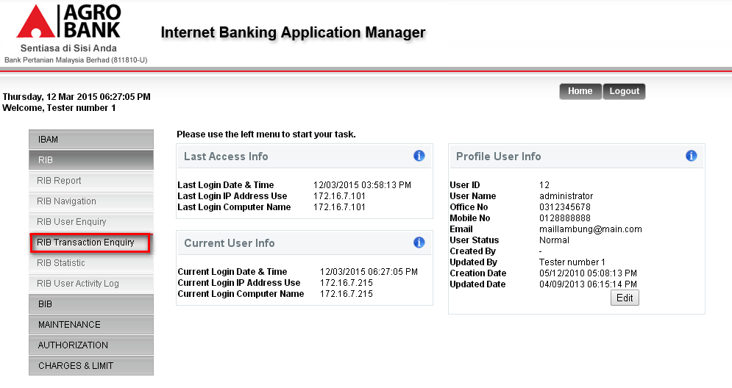
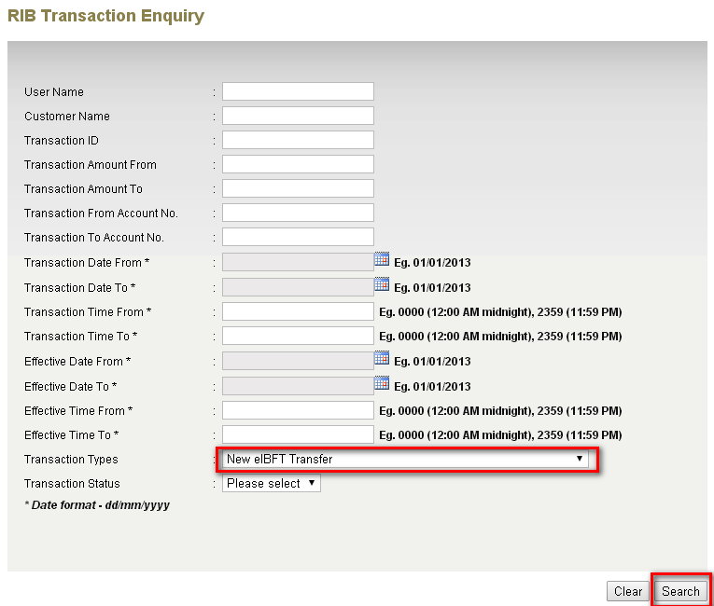
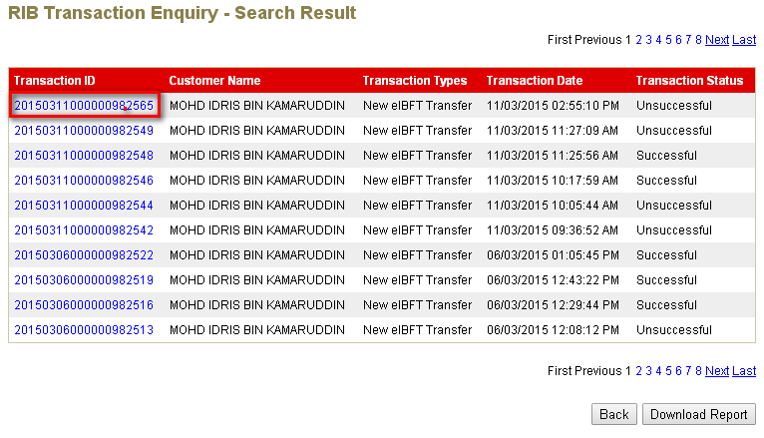
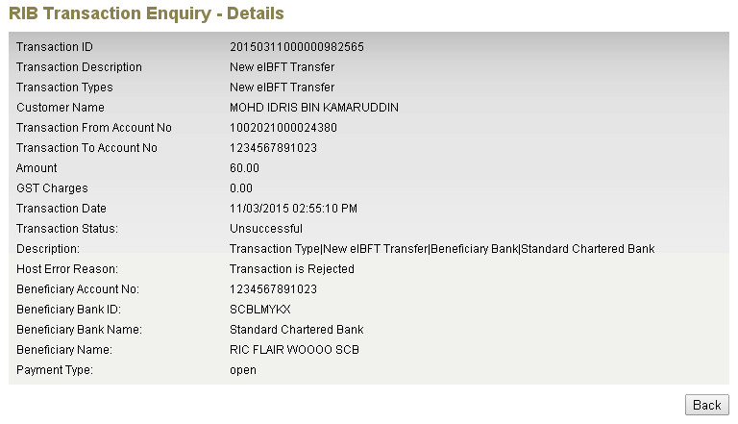
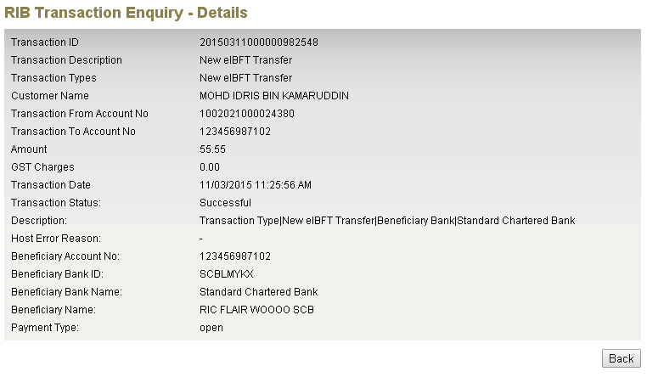
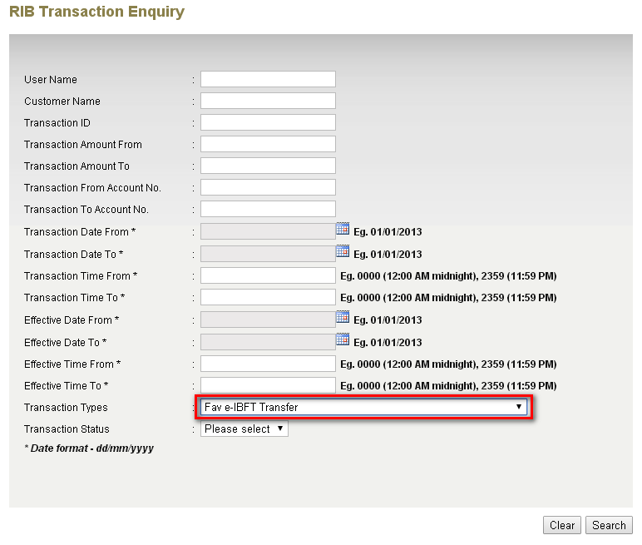
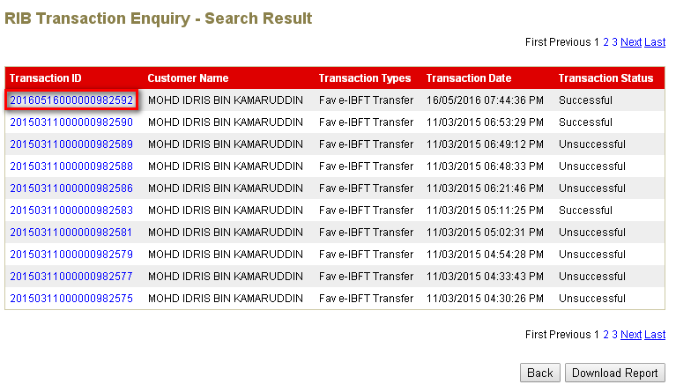
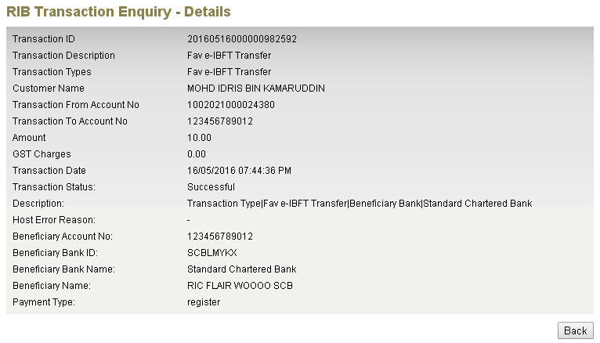
Reviewed By: (PMO
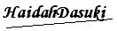 |  |  | Name/Position : Norhaidah Binti Md Dasuki / Senior Manager, Quality Assurance and Support  Date :

