Internal testing result |  |  |  |  |  | CR-00027
Project Name: | Internet Banking
Test Stage: | Unit Functionality Integration System Interface  Performance Regression Acceptance Pilot
Test Case Number: | Bug#5192 |  |  | Test Started Date: |  | 12/03/2015
Test Title: | BIB : Displaying wrong value for IBG/eIBFT Charges in AGRONet Transaction History
Test Description: | To ensure the value for IBG Charges figure displayed as RM0.00 instead empty value
Test Functionality: | BIB>Account and Banking>AGRONet Transaction History
Test Procedure: | Initiator/Single User  - Login to BIB  - Click on Account and Banking>AGRONet Transaction History
Test Result: | Pass: Fail: | Tested by: |  |  | Lizahwati binti Basirun
Reason for Failure:
TEST DESCRIPTION
Single User
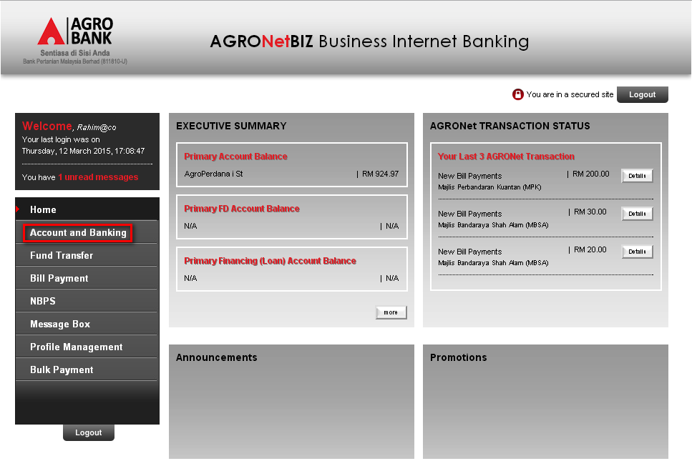
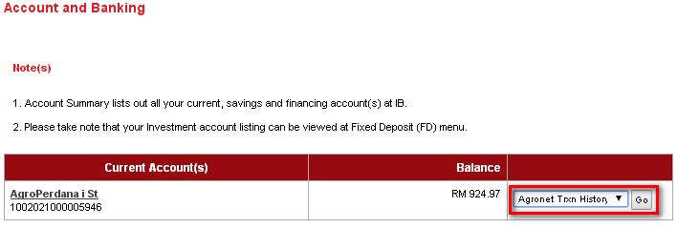

Reviewed By: (PMO
 |  |  | Name/Position : Norhaidah Binti Md Dasuki / Senior Manager, Quality Assurance and Support  Date :

