Regional Mobile Banking Platform (RMBP)

**ELECTRONIC BANKING GROUP**

|  |  |  |  |
| --- | --- | --- | --- |
| Nama Proyek | **Regional Mobile Banking Platform (RMBP)** | | |
| Nomor SR |  | | |
| **Disiapkan Oleh** | **Febhy Toomy Saputra** | Versi |  |

|  |  |  |  |  |  |  |
| --- | --- | --- | --- | --- | --- | --- |
| **Test Case No :** | | BII-RMBP-SIT / Task #5267 / ##2636## | | | | |
| **Test Objectives :** | | RMBP – M2U RMBP : Cut OFF Time for transaction SKN/RTGS & FCR | | | | |
| **Test Type :** | | Positive Test | | | | |
| **Test Tool :** | | Selenium, Mozilla Firefox, Chrome | | | | |
| **Test File Name :** | | Task #5267 / ##2636## | | | | |
| **Step No.** | **Actions** | | **Steps** | **Expected Result** | **Pass / Fail** | **Actual Result** |
| **POSITIVE TEST** | | | | | | |
|  | Show message validation Cut OFF Time for transaction SKN/RTGS & FCR. | | * Login RMBP with user: ribuser1 * Password: anything / Bii123456   **How to test :**   * See and take note what time it is now. Example now is 17:35, * Go to MSS > M2U Menu Service Maintenance > **Edit BII.FT03 for Open SKN/RTGS**, * Set end time to 17:38, * Quickly login to RIB > FT > SKN/RTGS. Choose transfer now and fill the rest of field. Remember this must be done quickly before 17:38, * It shall move to Confirmation Page without problem. In confirmation page, wait until time (17:38) has passed, don't click submit, * Key in TAC, and click submit when the time has reached more than 17:38, * It must show error: Exceed operation hour. * Repeat step 1-6 for **BII.BFT03** (Favourite SKN/RTGS), **BII.FT04** (Open FCR), **BII.BFT04** (Favourite FCR). | * Success show message validation Cut OFF Time for transaction SKN/RTGS & FCR. | Pass | * OK |
| **Remark :** | | | | | | |

**Attachment :**

**Screenshot Setting COT Admin Open SKN and Transaction COT Open SKN :**

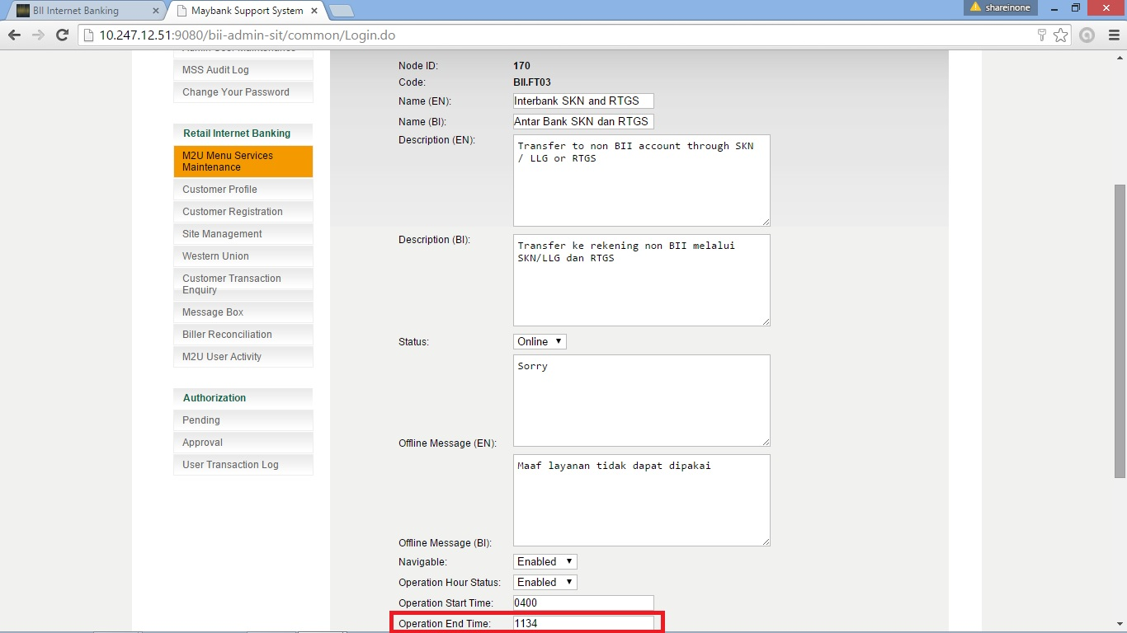

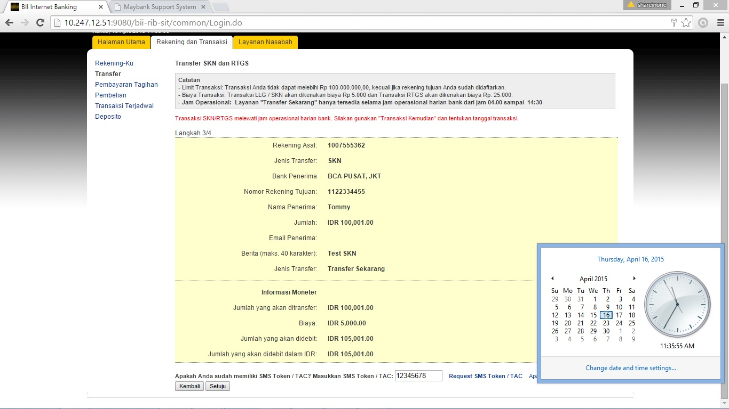

**Screenshot Setting COT Admin Fav SKN/RTGS and Transaction COT Fav SKN/RTGS :**

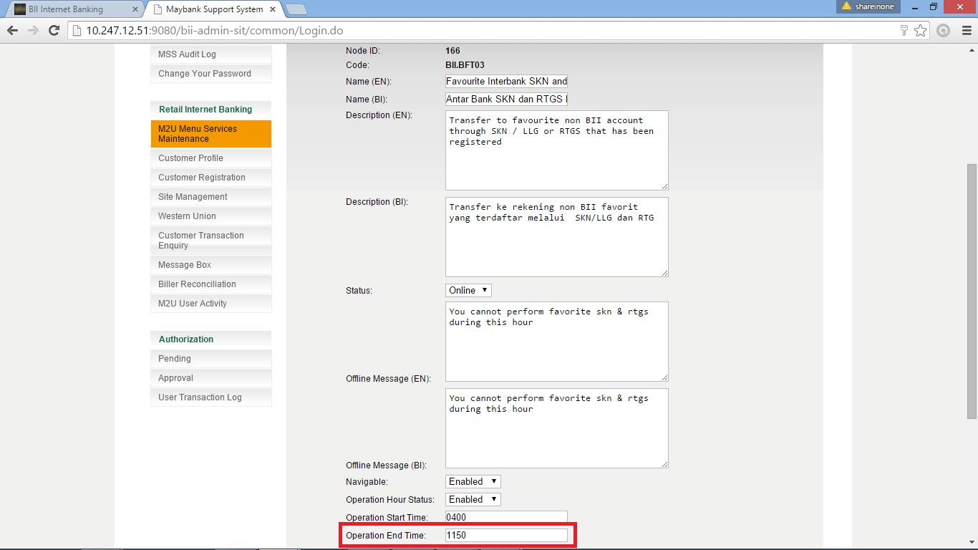

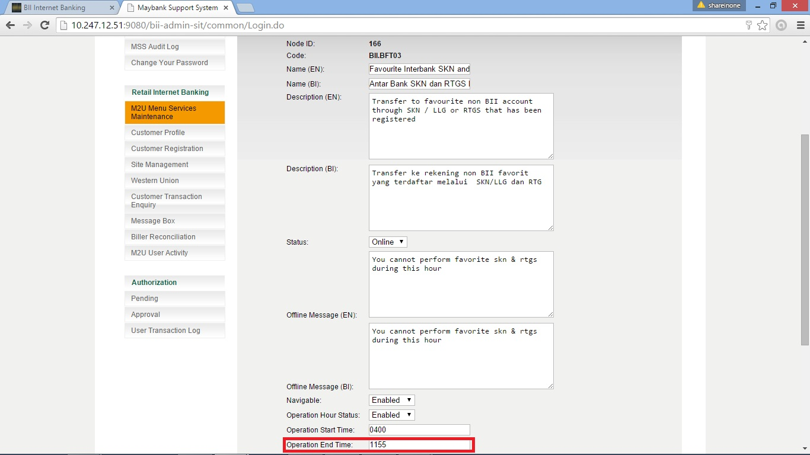

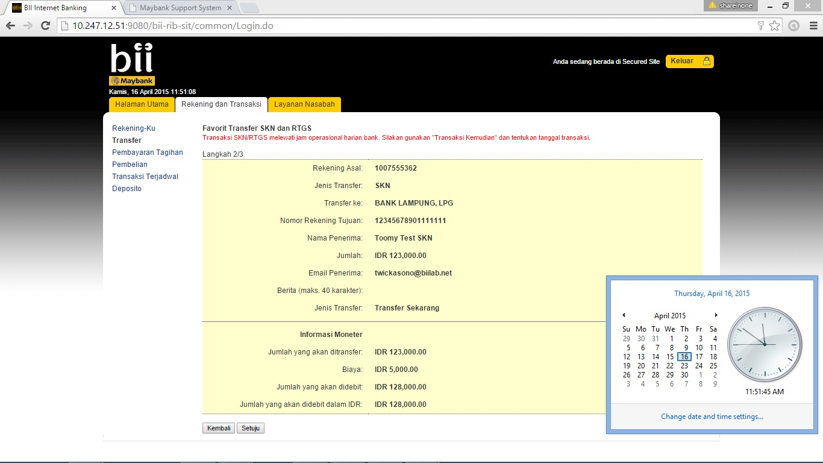

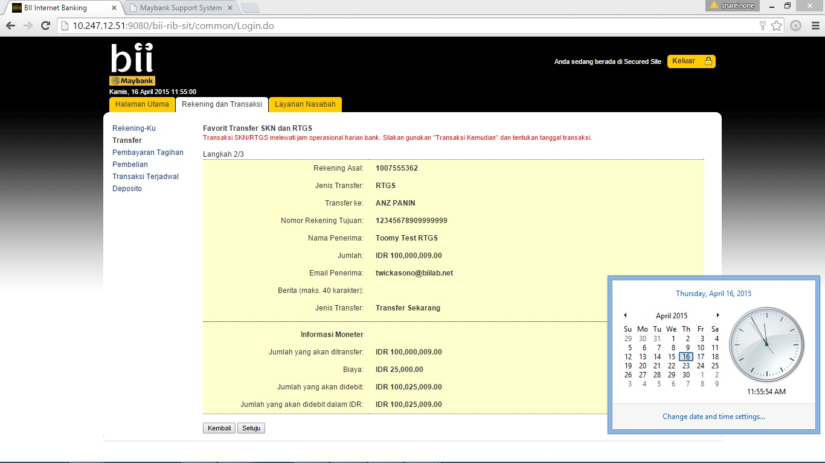

**Screenshot Setting COT Admin Open FCR and Transaction COT Open FCR :**

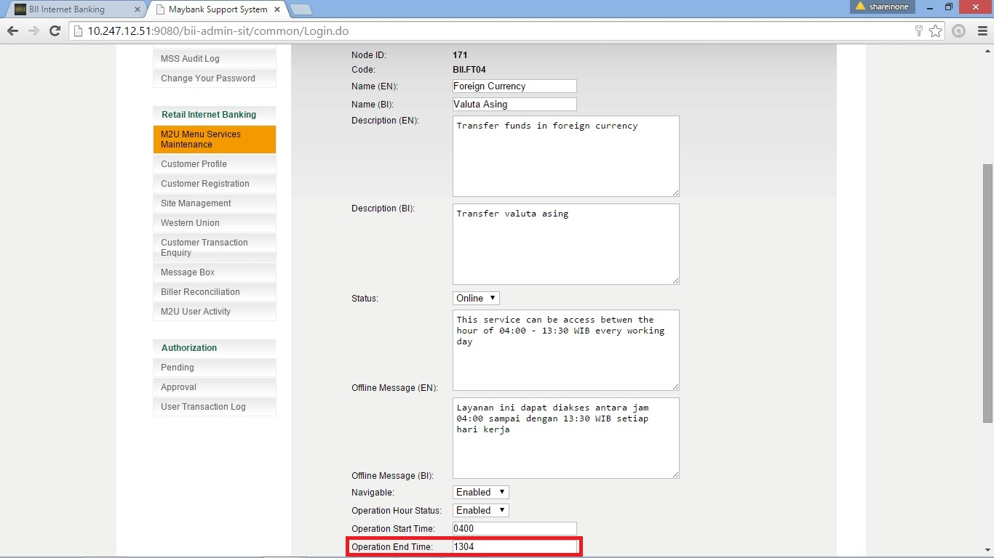

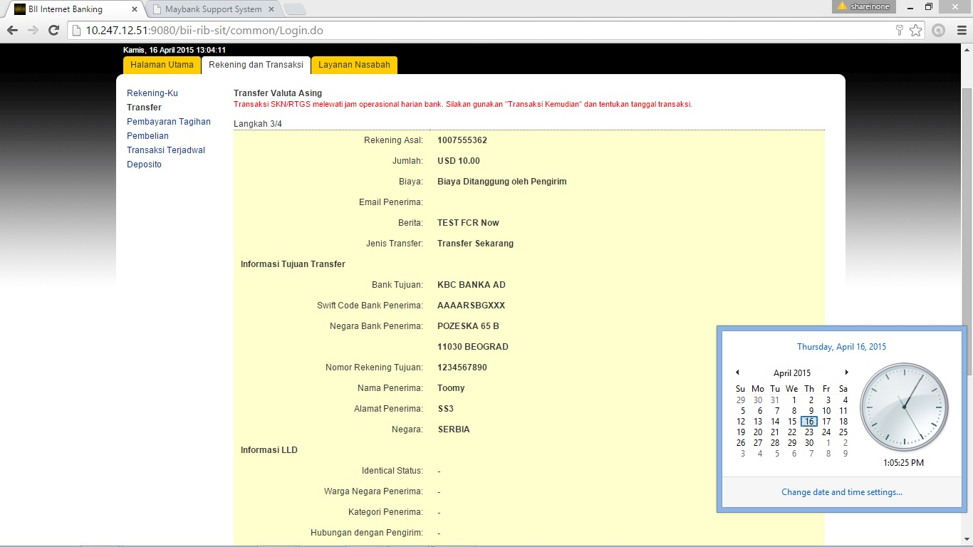

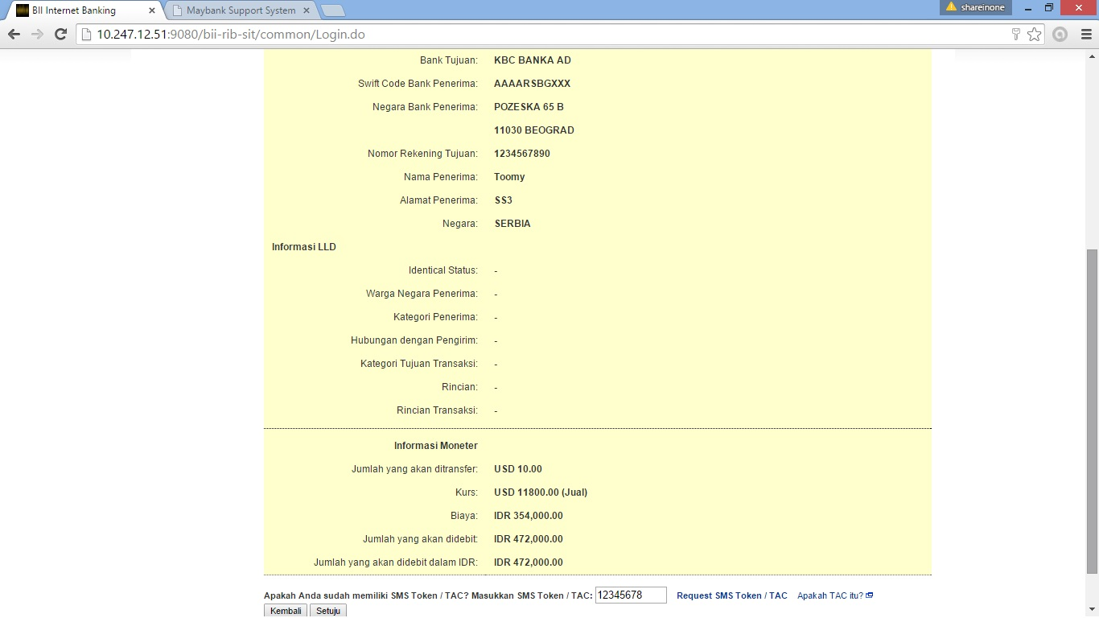

**Screenshot Setting COT Admin Fav FCR and Transaction COT Fav FCR :**

