Test Issue Log |  |  |  |  |  | SCP ID# : 2644
Project Name: | Internet Banking Application Manager
Test Stage: | Unit Functionality Integration System Interface  Performance Regression Acceptance Pilot
Test Case Number: | Support #5281 |  |  | Test Started Date: |  | 29/04/2015
Test Title: | Transaction able to exceed Global Limit
Test Description: | To ensure that Transaction Not Exceed Global Limit which is RM10000 per day.
Test Functionality: | RIB>Fund Transfer> New/Favourite 3rd Party  RIB> Fund Transfer> New/Favourite IBG Fund Transfer
Test Procedure: | 1. Set limit at RIB:-  - 3rd Party Account Transfer = RM6000  - Interbank Account Transfer = RM6000  2. Perform New 3rd Party with amount more than Transfer Limit - Unsuccessful with error Transfer Limit reached.  3. Perform Fav 3rd Party with amount more than Transfer Limit - Unsuccessful with error Transfer Limit reached.  4. Perform New IBG with amount more than Transfer Limit - Unsuccessful with error Transfer Limit reached.  5. Perform Fav IBG with amount more than Transfer Limit - Unsuccessful with error Transfer Limit reached.  6. Perform New 3rd Party with amount RM3000 - Successful  7. Perform Fav 3rd Party with amount RM3000 – Successful  8. Perform New 3rd Party with amount RM100 - Unsuccessful with error Transfer Limit reached.  9. Perform Fav 3rd Party with amount RM100 - Unsuccessful with error Transfer Limit reached.  10. Perform New IBG with amount RM3000 - Successful  11. Perform Fav IBG with amount RM3000 - Unsuccessful with error Transfer Limit reached.
Test Result: | Pass: Fail: | Tested by: |  |  | Nurul Akmal binti Yusof
Reason for Failure:
TEST DESCRIPTION
Test Item No 1:
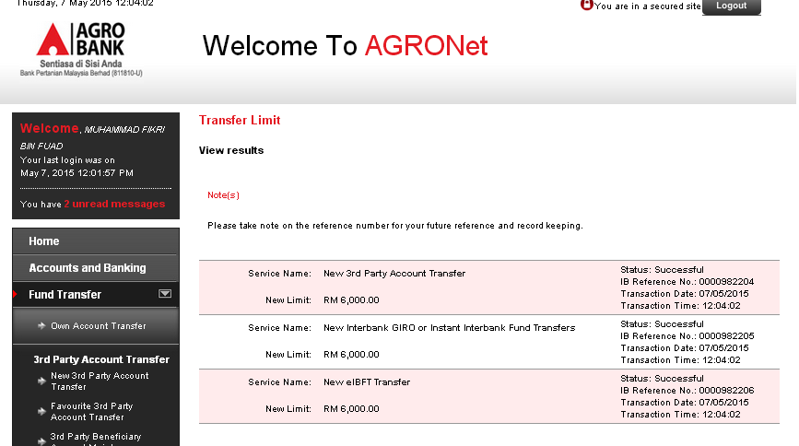

Test Item No 2:
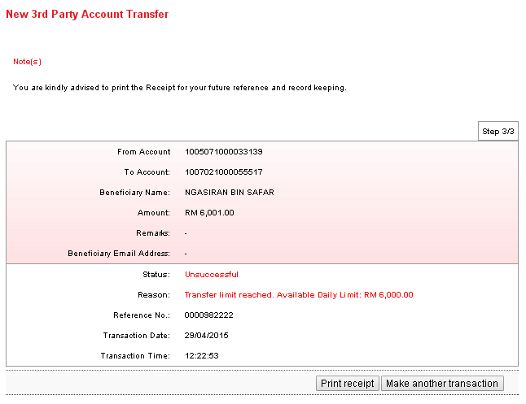
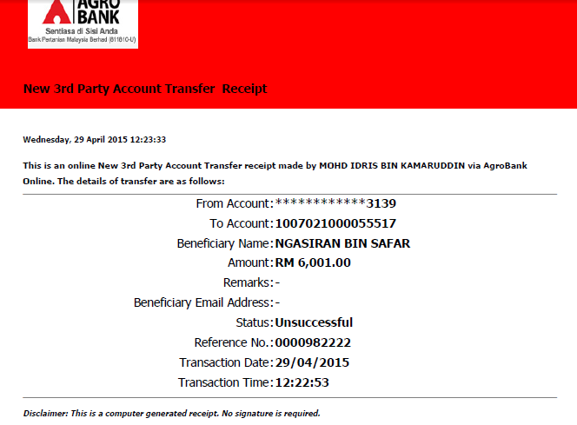

Test Item No 3:
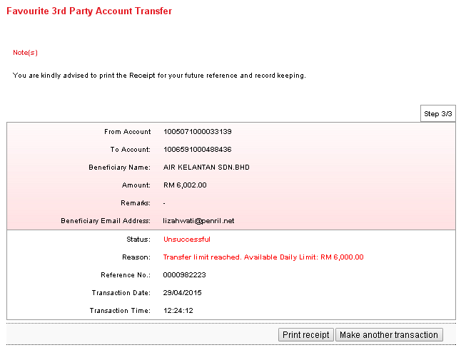
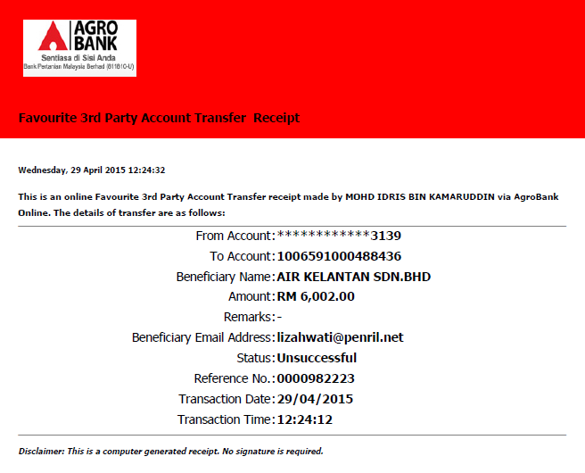

Test Item No 4:
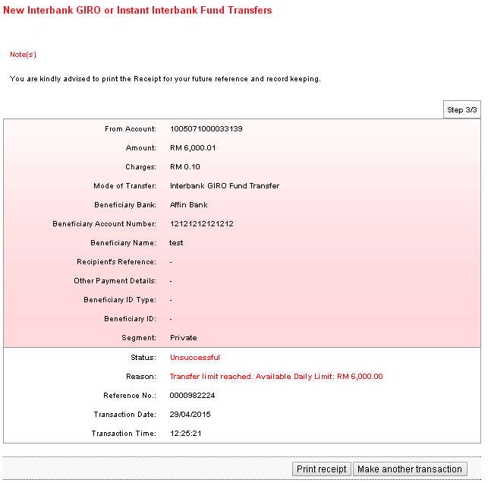
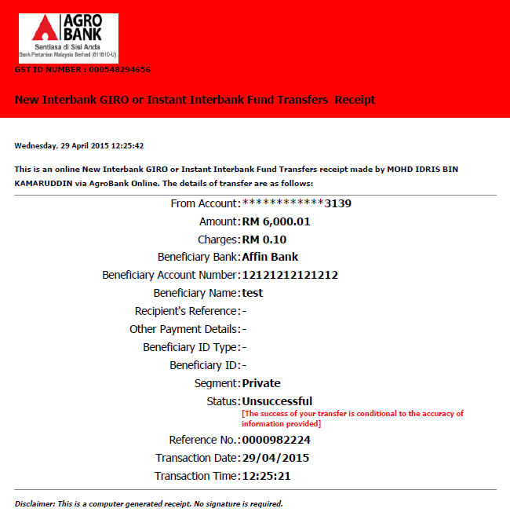

Test Item No 5:
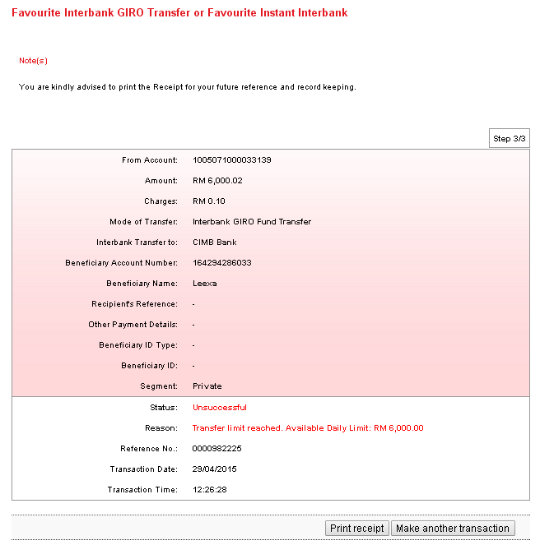
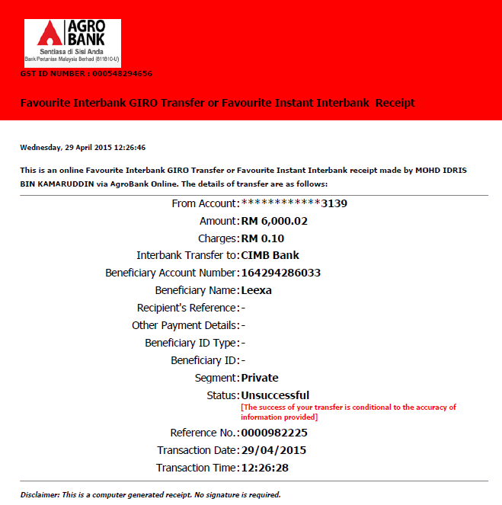

Test Item No 6:
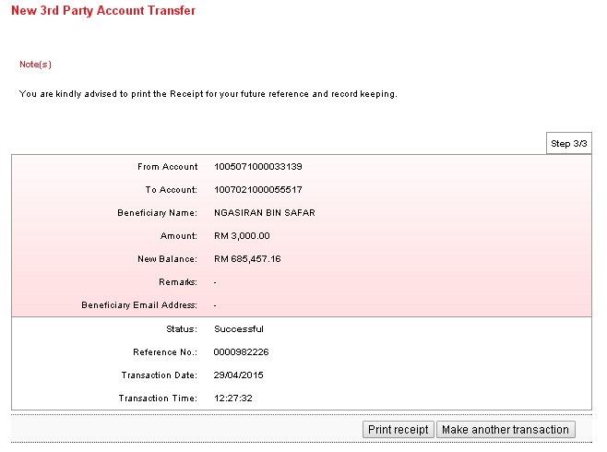
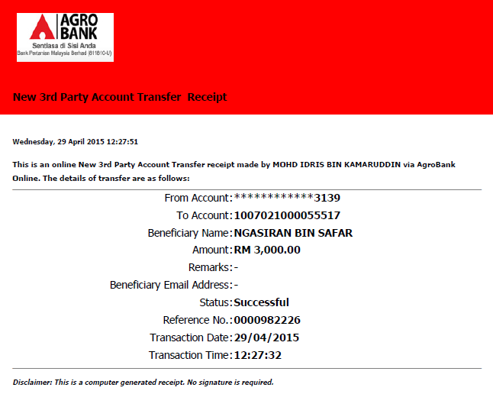

Test Item No 7:
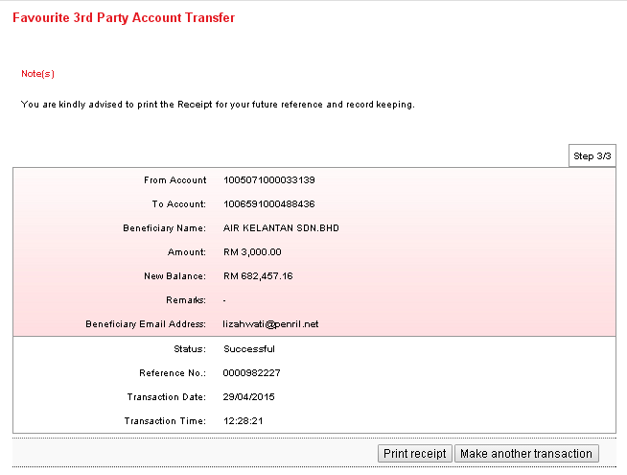
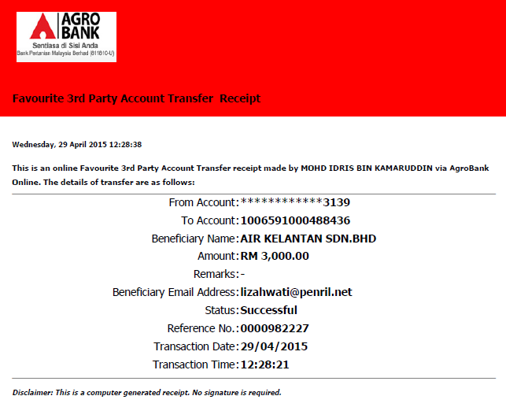
Test Item No 8:
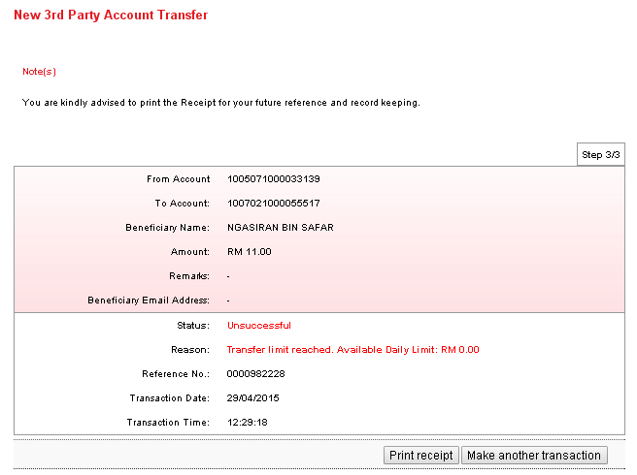
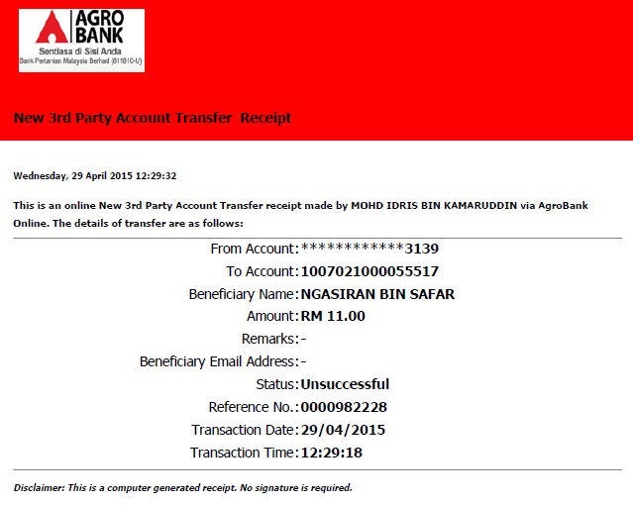
Test Item No 9:
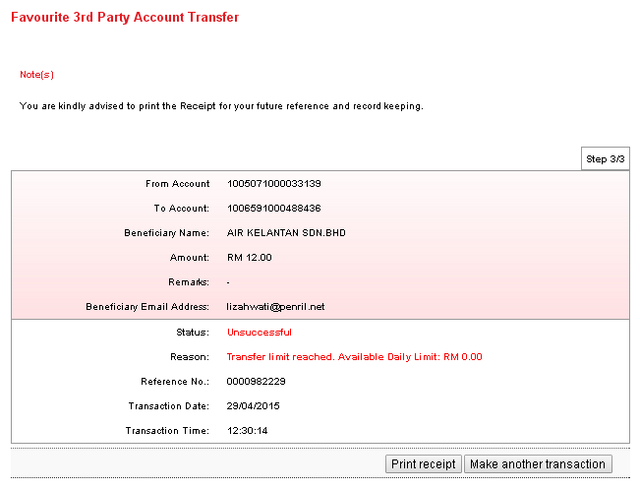
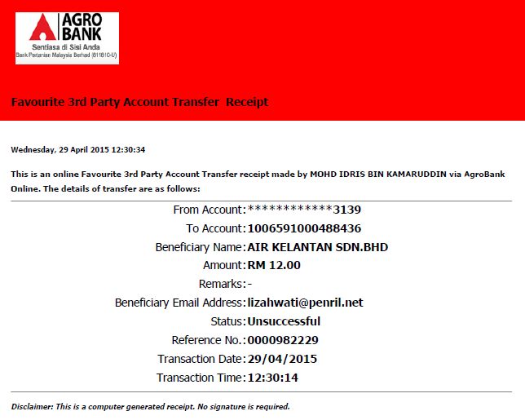

Test Item No 10:
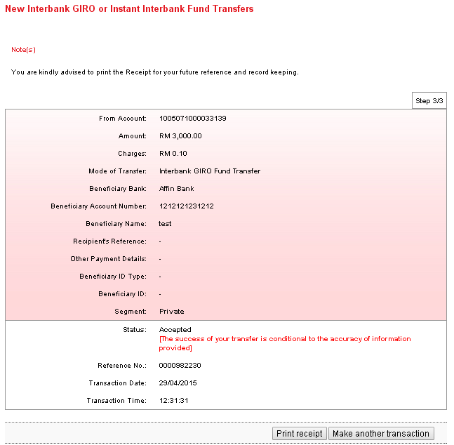
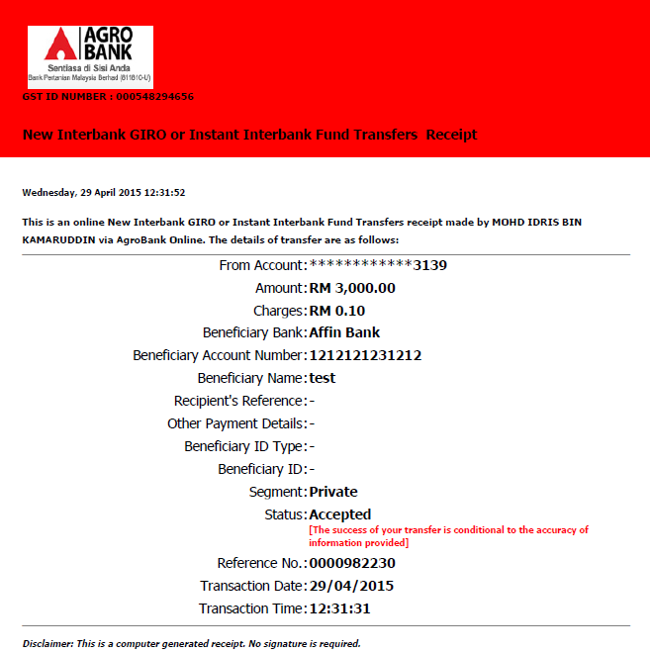

Test Item No 11:
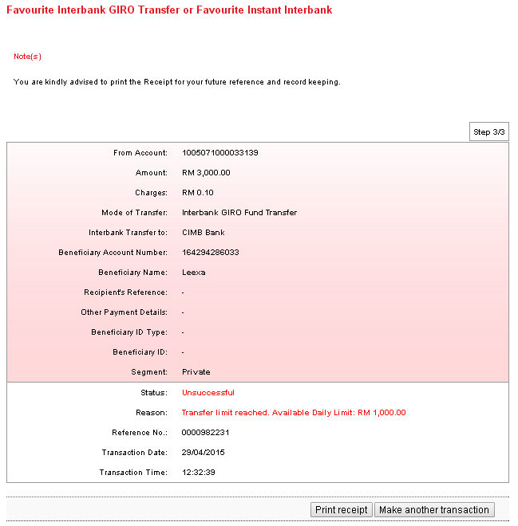
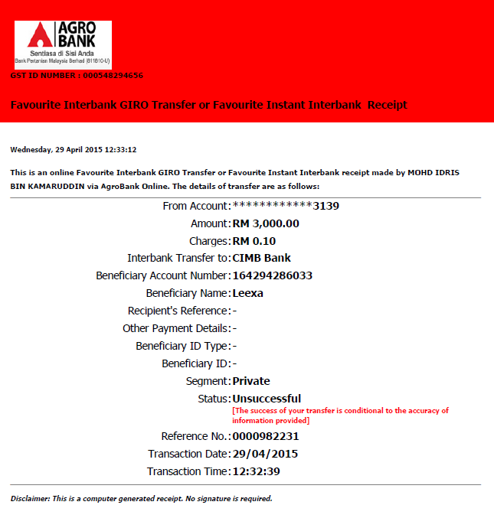

Reviewed By: (PMO)
 |  |  | Name/Position : Norhaidah Binti Md Dasuki / Senior Manager, Quality Assurance and Support  Date :

