Test Issue Log |  |  |  |  |  | SCP ID# : 2644
Project Name: | Internet Banking Application Manager
Test Stage: | Unit Functionality Integration System Interface  Performance Regression Acceptance Pilot
Test Case Number: | Support #5281 |  |  | Test Started Date: |  | 29/04/2015
Test Title: | Transaction able to exceed Global Limit. (eIBFT, 3rd Party & IBG)
Test Description: | To ensure that Transaction Not Exceed Global Limit which is RM10000 per day.
Test Functionality: | RIB>Fund Transfer> New/Favourite eIBFT  RIB>Fund Transfer> New/Favourite 3rd Party  RIB> Fund Transfer> New/Favourite IBG Fund Transfer
Test Procedure: | - Set limit at RIB:-  - eIBFT Account Transfer = RM6000  - 3rd Party Account Transfer = RM6000  - Interbank Account Transfer = RM6000  - Perform Transaction as below condition:-  Scenario Expected Results  Perform New eIBFT with amount more than Transfer Limit - Unsuccessful with error Transfer Limit reached.  Perform Fav eIBFT with amount more than Transfer Limit - Unsuccessful with error Transfer Limit reached.  Perform New 3rd Party with amount more than Transfer Limit - Unsuccessful with error Transfer Limit reached.  Perform Fav 3rd Party with amount more than Transfer Limit - Unsuccessful with error Transfer Limit reached.  Perform New IBG with amount more than Transfer Limit - Unsuccessful with error Transfer Limit reached.  Perform Fav IBG with amount more than Transfer Limit - Unsuccessful with error Transfer Limit reached.  Perform New 3rd Party with amount RM3000 – Successful  Perform Fav 3rd Party with amount RM3000 – Successful  Perform New 3rd Party with amount RM11.00 - Unsuccessful with error Transfer Limit reached.  Perform Fav 3rd Party with amount RM12.00 - Unsuccessful with error Transfer Limit reached.  Perform New IBG with amount RM3000 – Successful  Perform Fav IBG with amount RM3000 - Unsuccessful with error Transfer Limit reached.  Perform New eIBFT with amount RM1000 – Successful  Perform Fav IBG with amount RM3000 - Unsuccessful with error Transfer Limit reached.
Test Result: | Pass:  Fail:  Pass with Conditional: |  | Tested by: |  | Nurul Akmal binti Yusof  Lizahwati Basirun
Reason for Failure/Conditional: | Unable to test due development limitation which is needed to have a Sign-Off from MEPS for testing the eIBFT module.
TEST DESCRIPTION
Test Item No. 1:
- Set Transfer Limit in RIB
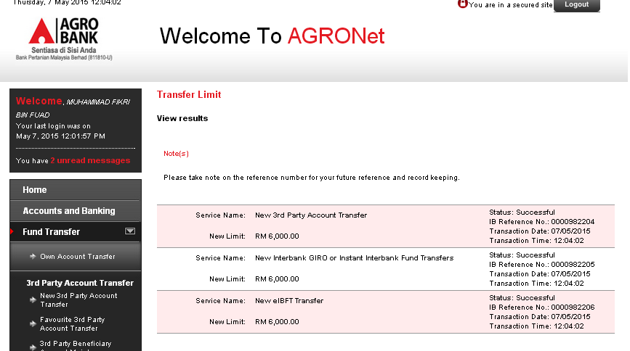
Notes*: Please take note the limit setup is for both Open and Favorite account transfer.

Test Item No. 2a:
- Perform New eIBFT with amount more than Transfer Limit
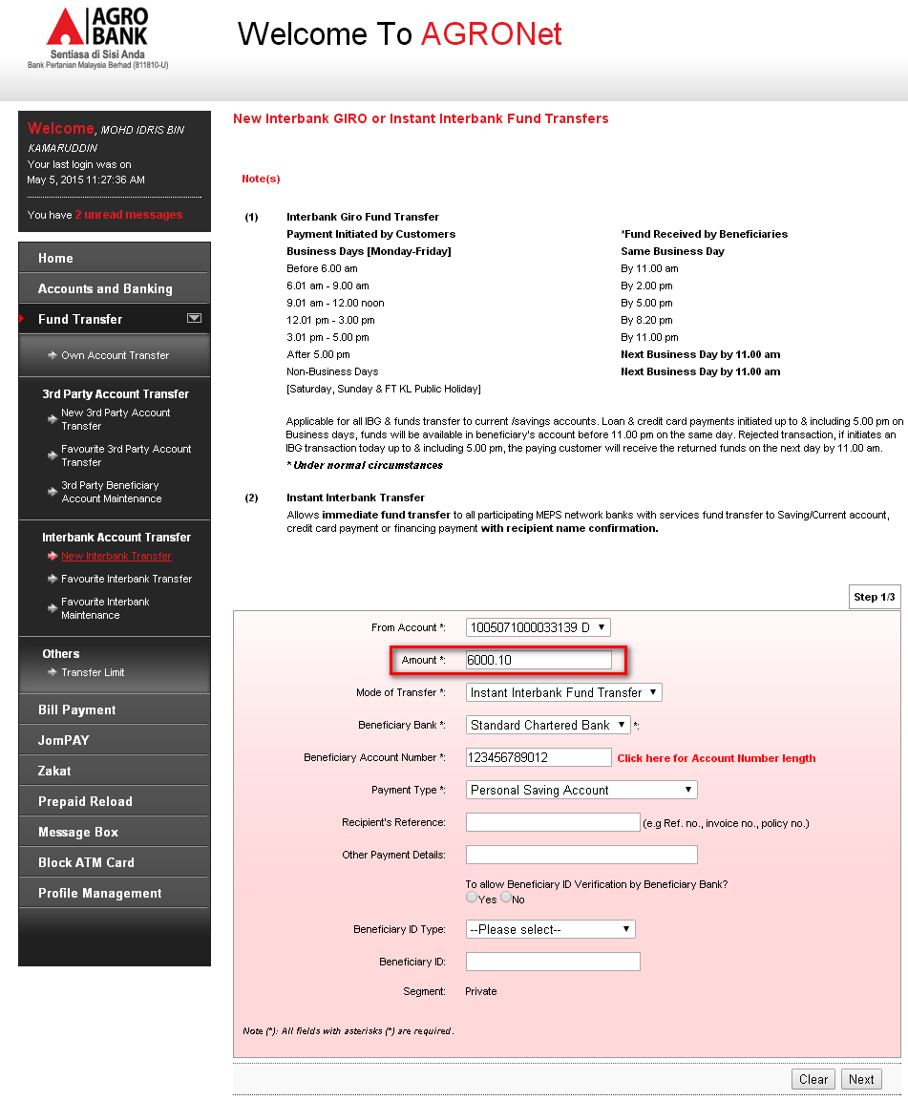
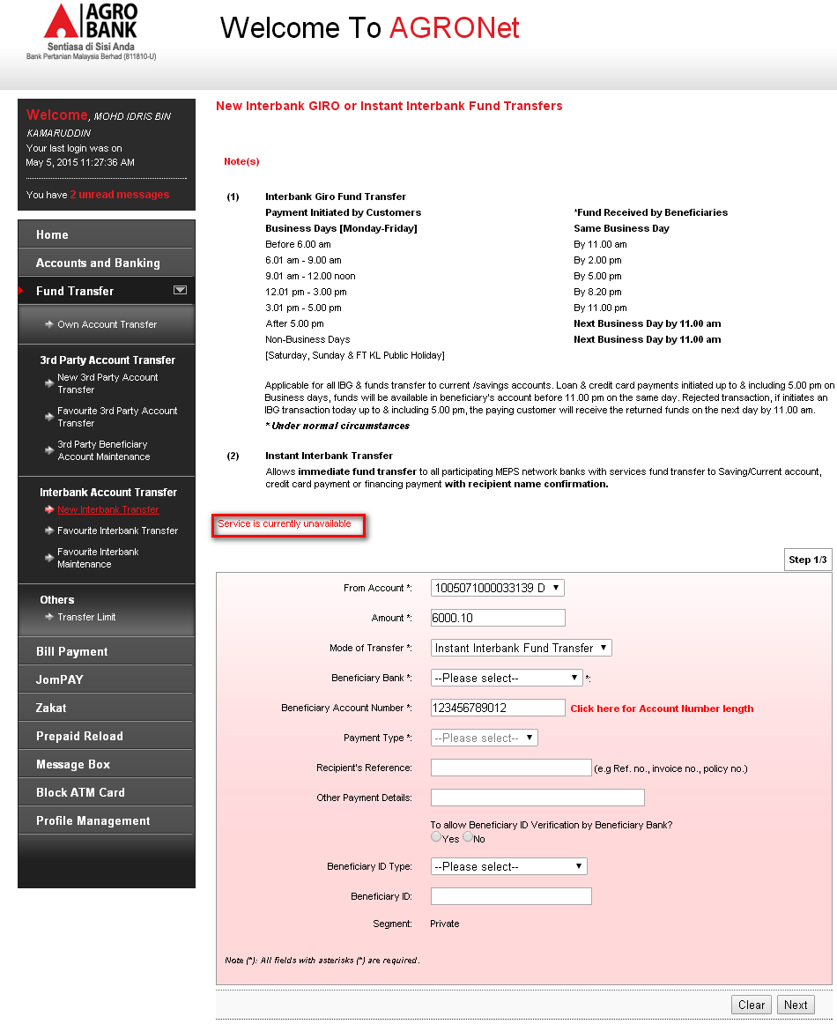
Notes: Unable to proceed testing due to development limitation

Test Item No. 2b:
- Perform New eIBFT with amount more than Transfer Limit
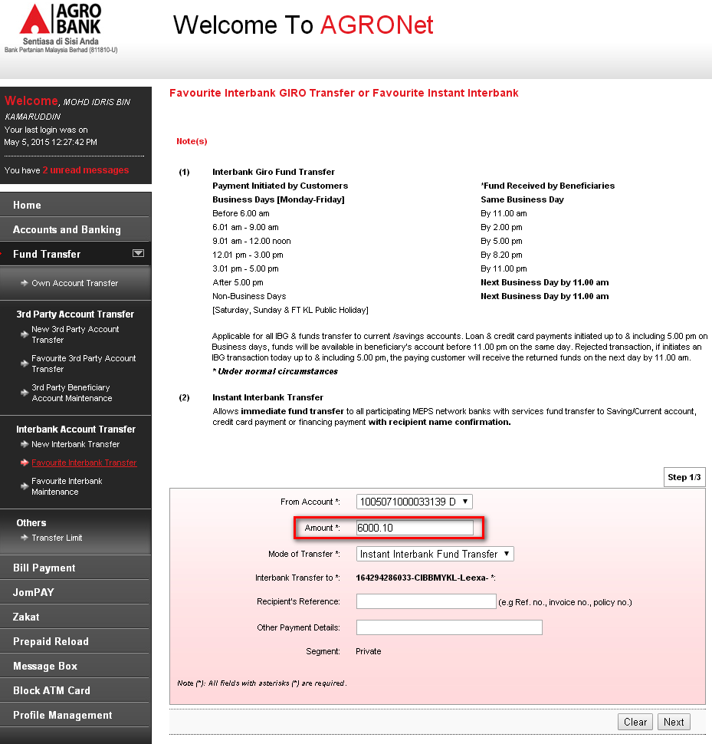
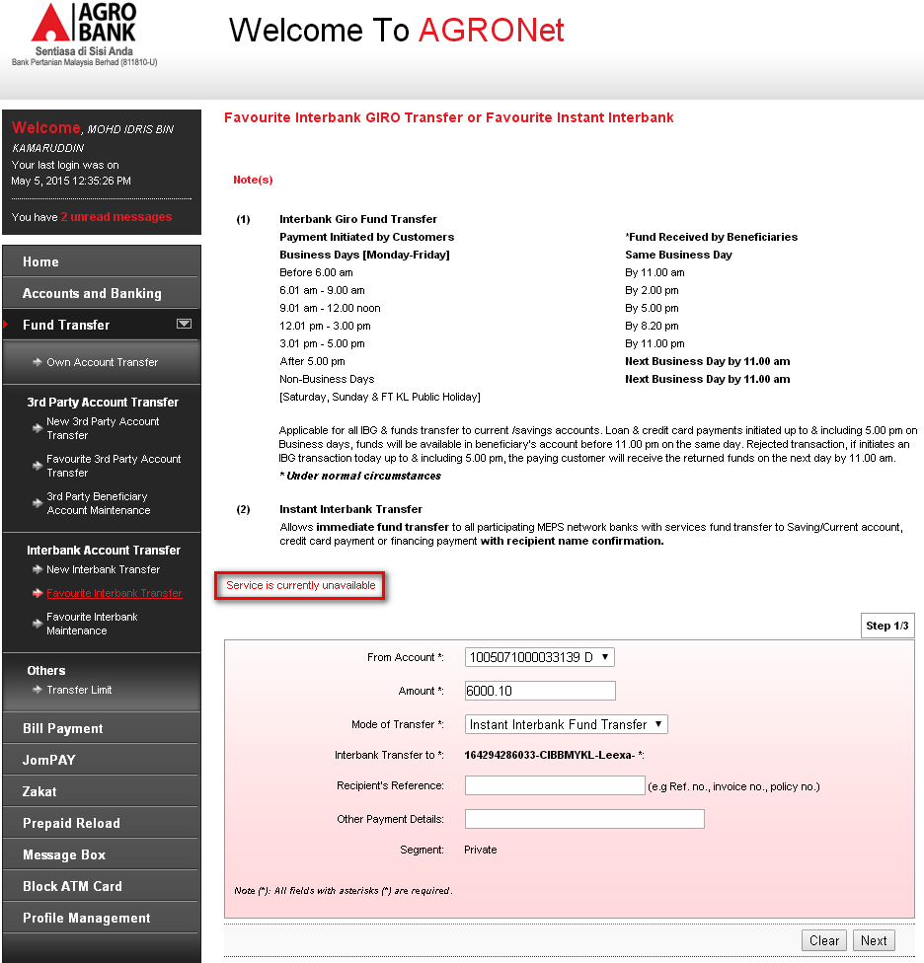

Notes: Unable to proceed testing due to development limitation

Test Item No. 2c:
- Perform New 3rd Party with amount more than Transfer Limit
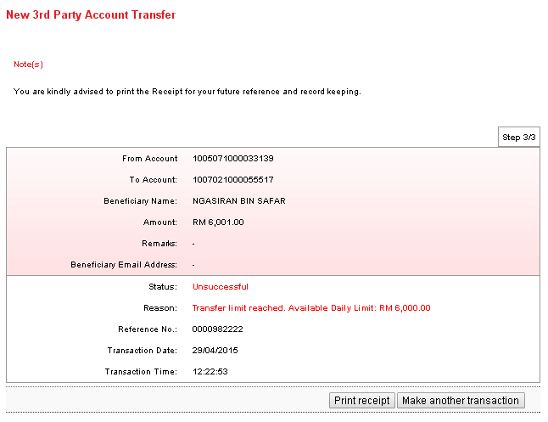
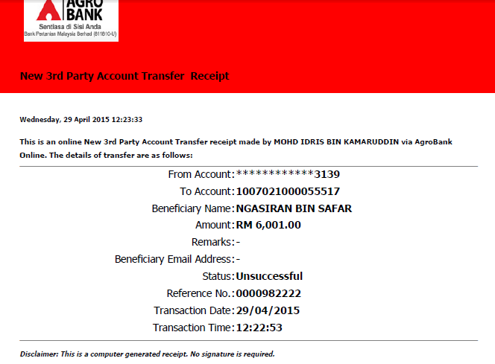

Test Item No. 2d:
- Perform Fav 3rd Party with amount more than Transfer Limit
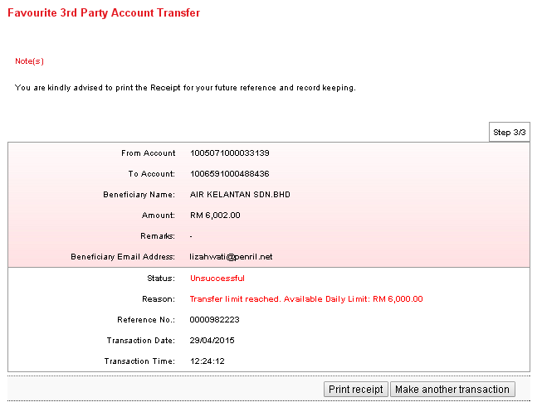
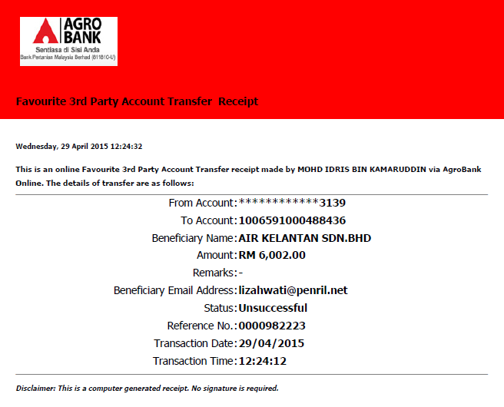

Test Item No. 2e:
- Perform New IBG with amount more than Transfer Limit
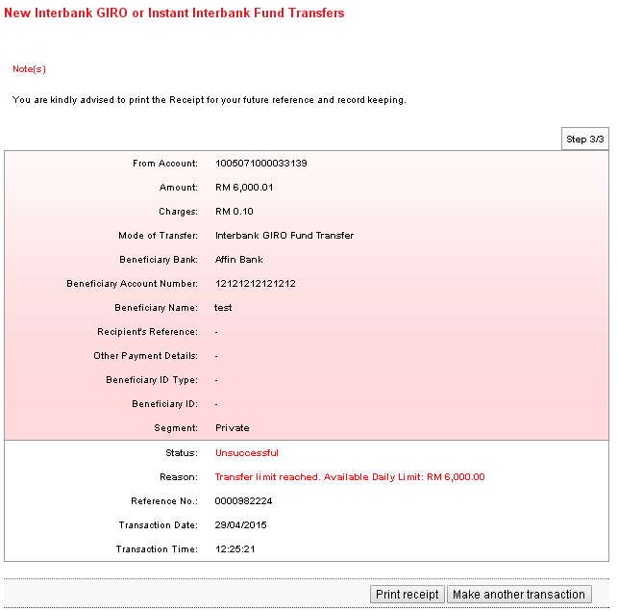
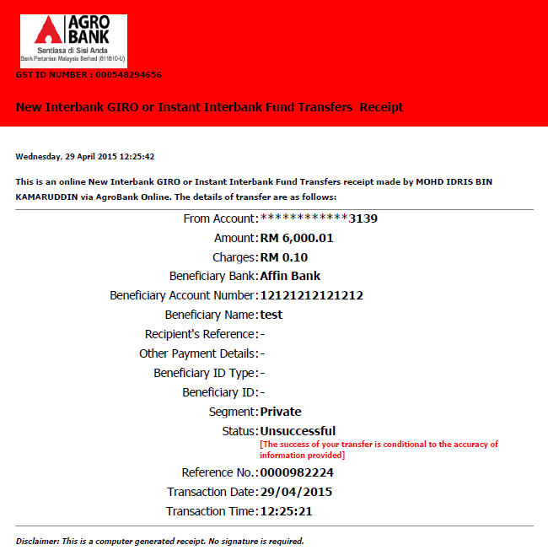

Test Item No. 2f:
- Perform New IBG with amount more than Transfer Limit
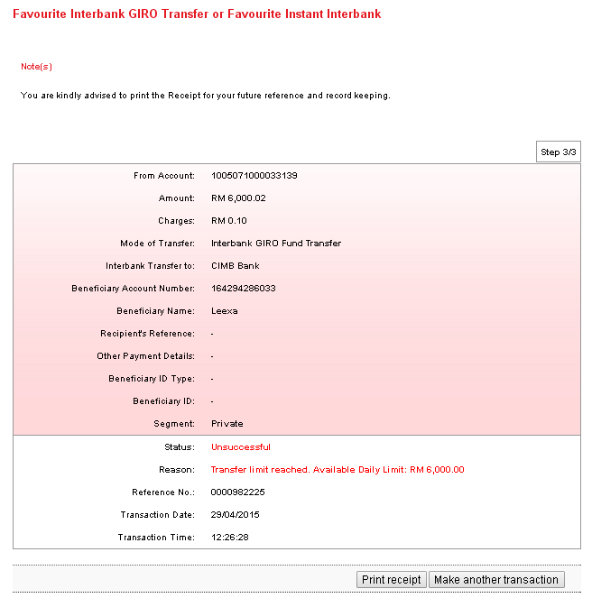
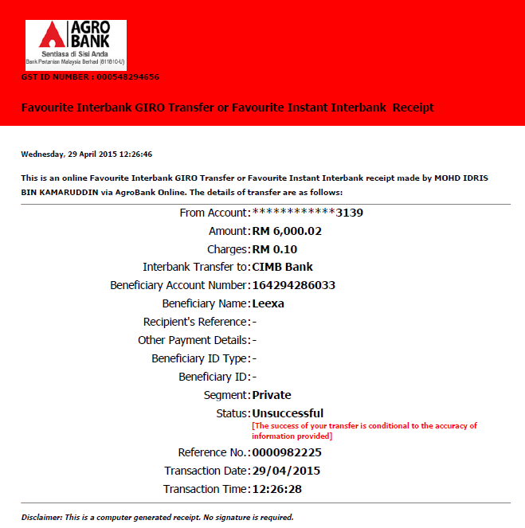

Test Item No. 2g:
- Perform New 3rd Party with amount RM3000
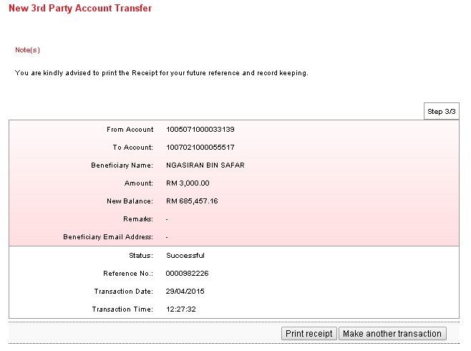
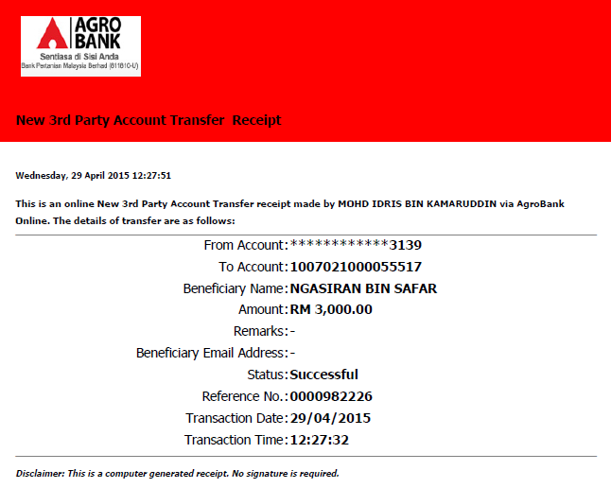

Test Item No. 2h:
- Related to transaction 2g
- Perform Fav 3rd Party with amount RM3000
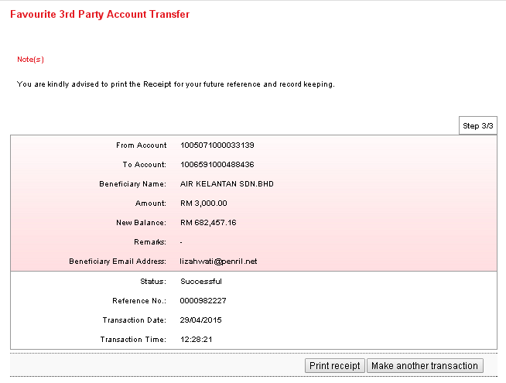
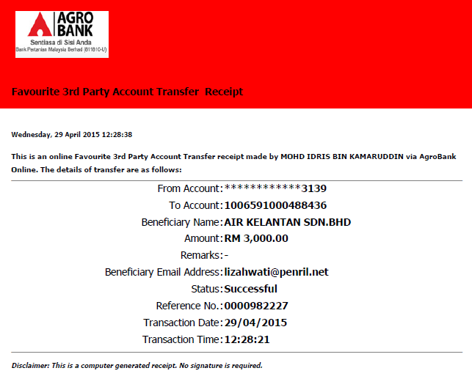

Test Item No. 2i:
- Test consists of Transfer Daily Limit for 3rd Party and Global Limit. Related to transaction 2g & 2h
- Perform New 3rd Party with amount RM11
Global Limit = 10,000
Daily Limit = 6,000
Successful Transaction = 6,000 (New & Fav 3rd Party)
Available Global Balance = 4,000
Available Daily Balance = 0.00 (3rd party)
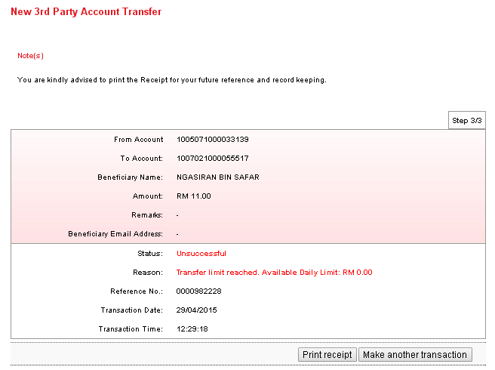
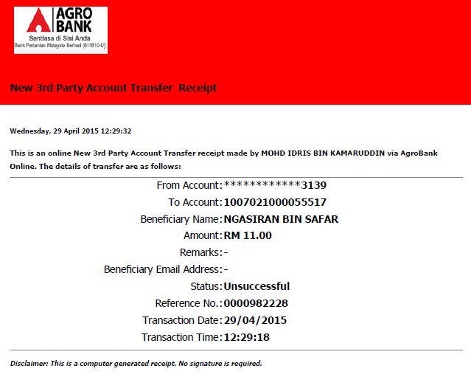

Test Item No. 2j:
- Test consists of Transfer Daily Limit for 3rd Party and Global Limit. Related to transaction 2g & 2h
- Perform New 3rd Party with amount RM12
Global Limit = 10,000
Daily Limit = 6,000
Successful Transaction = 6,000 (New & Fav 3rd Party)
Available Global Balance = 4,000
Available Daily Balance = 0.00 (3rd party)
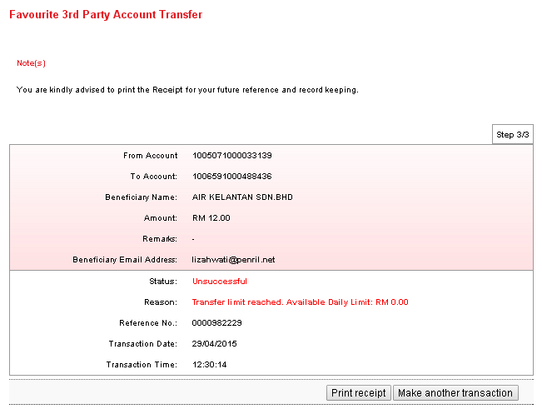
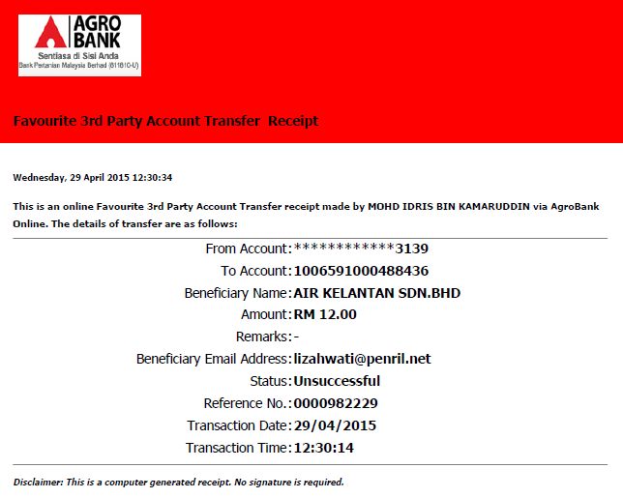

Test Item No. 2k:
- Test consists of Transfer Limit for IBG and Global Limit functionality. Related to transaction 2g & 2h
- Perform New IBG with amount RM3000
Global Limit = 10,000
Daily Limit = 6,000
Available Global Balance = 4,000
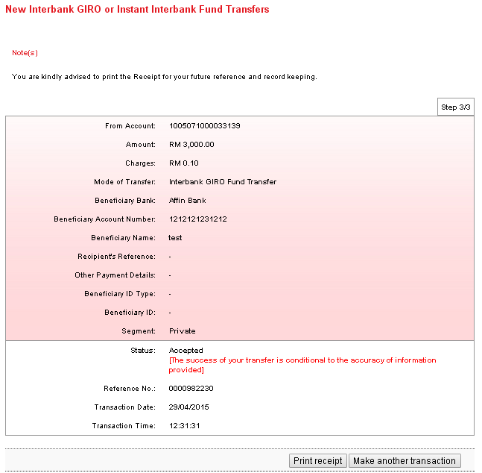
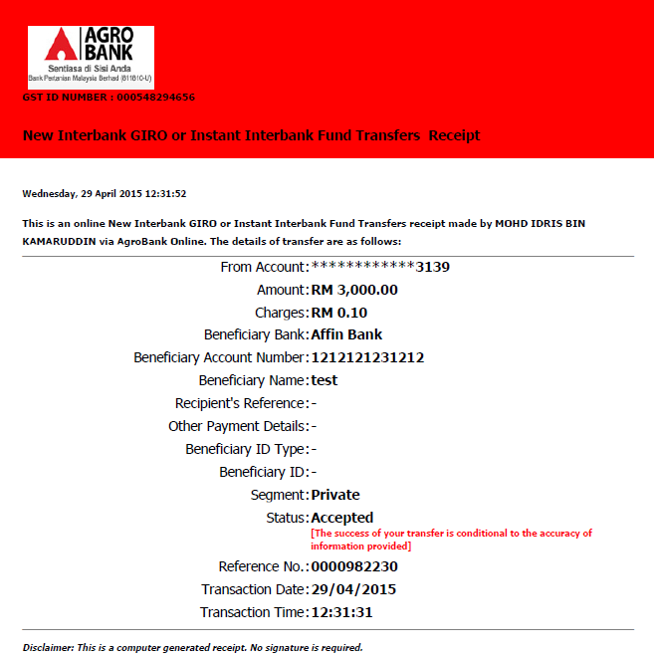

Test Item No. 2l:
- Test consists of Transfer Limit for IBG and RIB Global Limit functionality. Related to transaction 2g, 2h & 2k
- Perform New IBG with amount RM3000
Global Limit = 10,000
Daily Limit = 6,000
Successful Transaction = 9,000 (IBG & 3rd Party)
Available Global Balance = 1,000
Available Daily Balance = 3,000 (IBG)
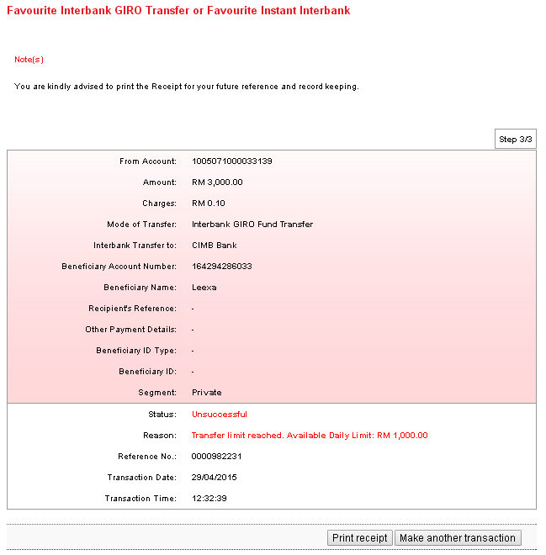
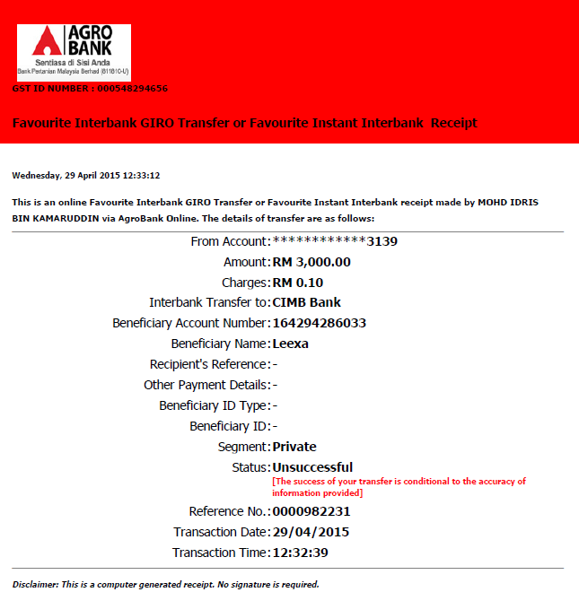

Test Item No. 2m:
- Test consists of Transfer Limit for eIBFT and RIB Global Limit functionality. Related to transaction 2g, 2h & 2k
- Perform New eIBFT with amount RM1000
Global Limit = 10,000
Daily Limit = 6,000
Available Global Balance = 1,000

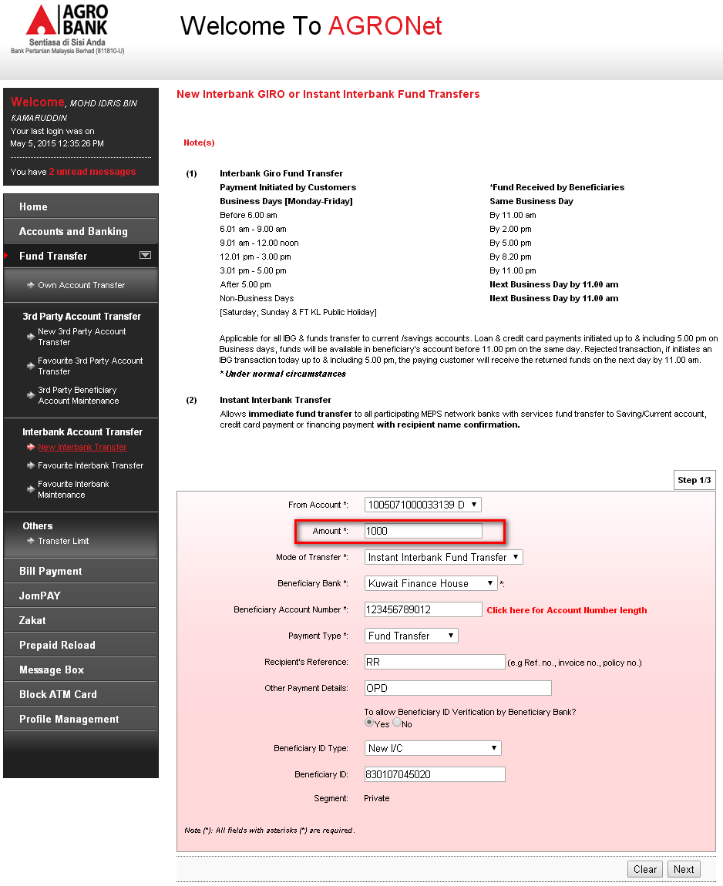
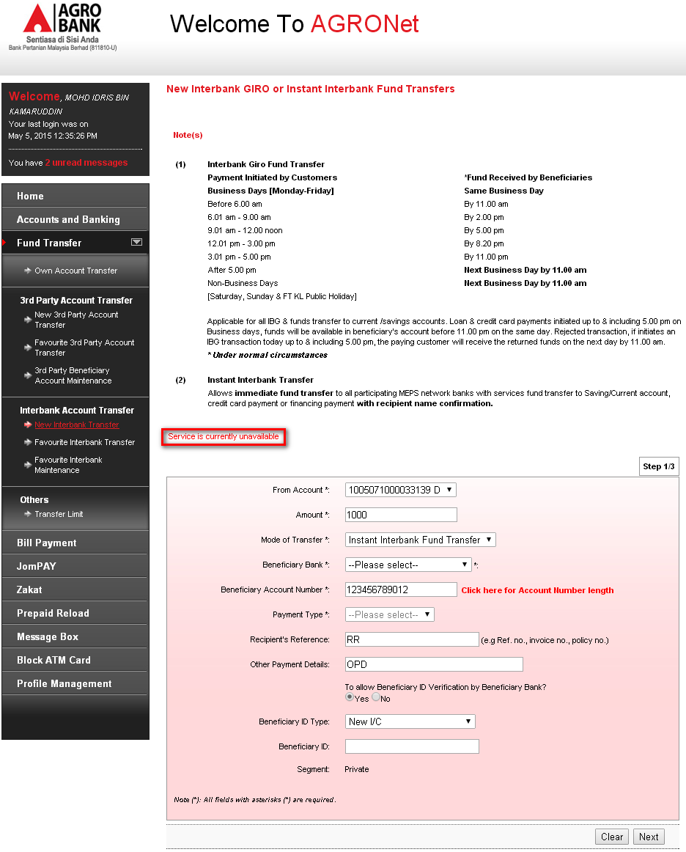

Notes: Unable to proceed testing due to development limitation

Test Item No. 2n:
- Test consists of Transfer Limit for eIBFT and RIB Global Limit functionality. Related to transaction 2g, 2h, 2k & 2m
- Perform Favourite eIBFT with amount RM1000
Global Limit = 10,000
Daily Limit = 6,000
Successful Transaction = 1,000 (New eIBFT)
Available Global Balance = 0.00
Available Daily Balance = 5,000
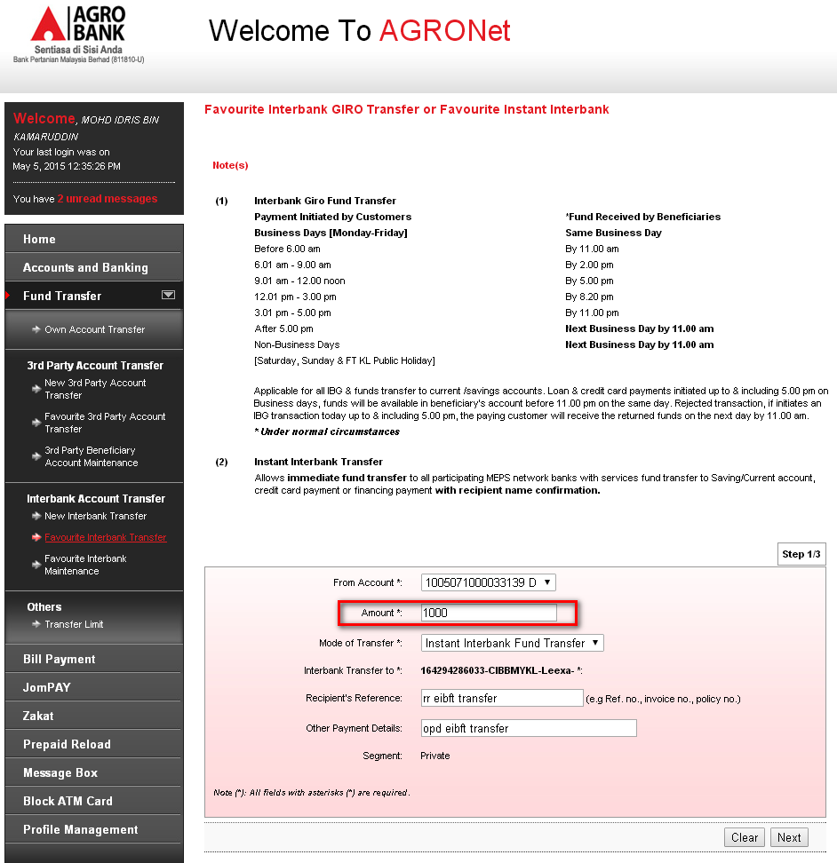
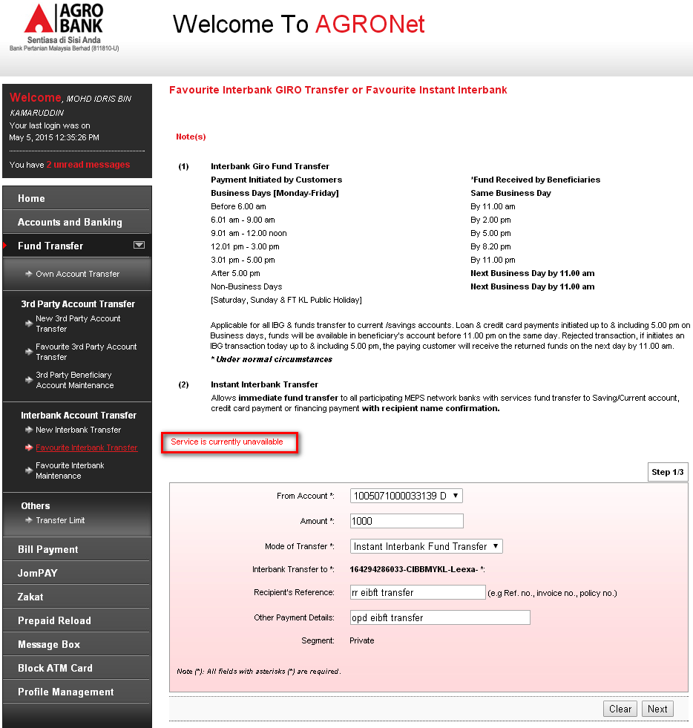
Notes: Unable to proceed testing due to development limitation

Reviewed By: (PMO)
 |  | Name/Position : Norhaidah Binti Md Dasuki / Senior Manager, Quality Assurance and Support  Date :

