CR Resolution

**EB150031 - To allow cheque number 8 digits in RIB , BIB**

**RIB & BIB**

To allow up to 8 digits cheque number in stop cheque module.

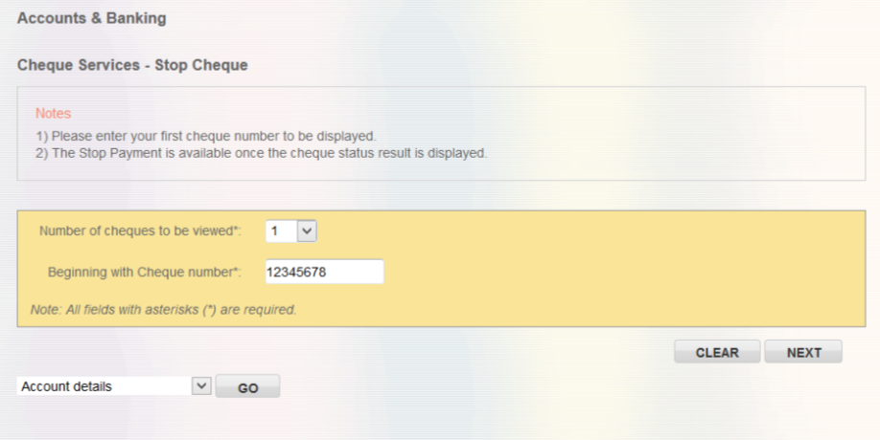

IB need to append “0” in front cheque number for display in inquiry screen, because host response only provide 7 digits for cheque number.

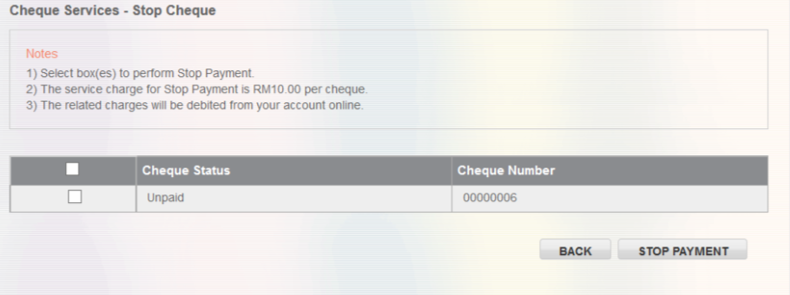

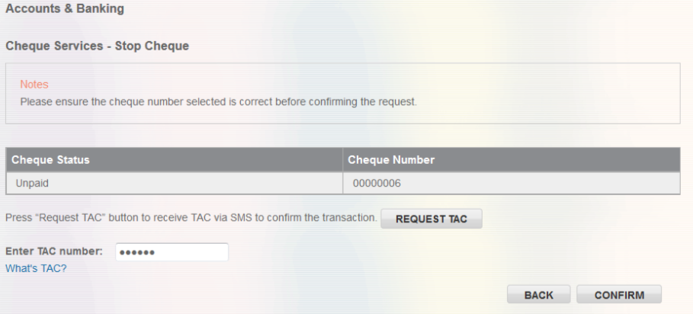

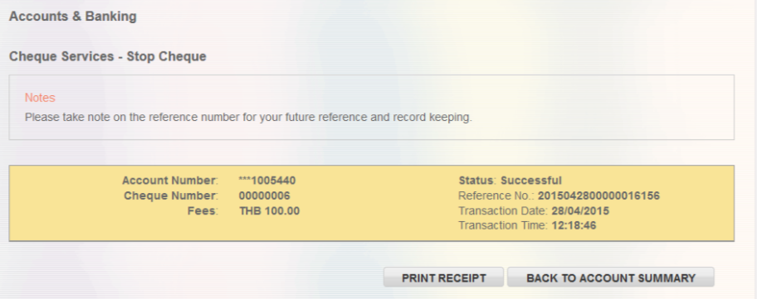

Print receipt also display as 8 digits cheque number.

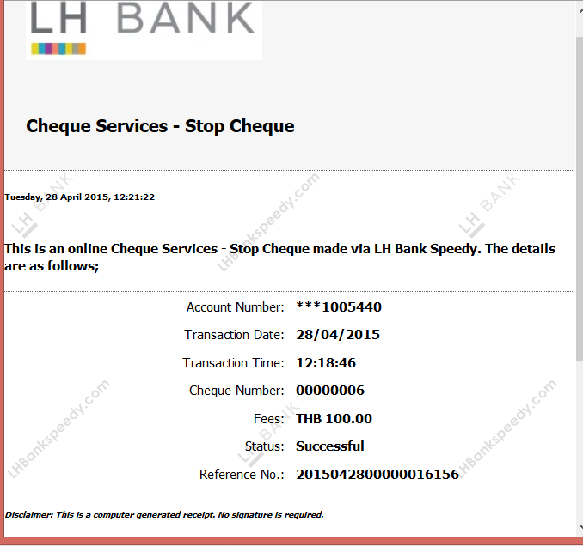

## Host

There are no changes on Host side. But IB needs to send last 7 digits to host side, because the request field only can accept up to 7 digits.

|  |  |
| --- | --- |
| Effort(man-days) | 1 |
|  | RIB  BIB  User Manual –RIB  User Manual –BIB |