|  |
| --- |
| **Kuwait Finance House (M) Berhad**  **KFH Online Banking**  **(Payment Reference)** |
| Business Requirement Specification |

29th Sept 2014

Reference: KFH/IBSCR072BRS/Payment Reference

**Prepared By:**



Penril Datability (M) Sdn Bhd (816792-X)

Suite A-07-07 Plaza Mon’t Kiara

No. 2, Jalan Kiara, Mon’t Kiara

50480 Kuala Lumpur, Malaysia

Tel: (603) 6201 2622 Fax: (603) 6201 7622

**Document Amendment Log**

|  |  |  |  |  |  |
| --- | --- | --- | --- | --- | --- |
| **Version No** | **Date Updated** | **Description of Change** | **Updated By**  **<Name, Dept>** | **Reviewed By**  **<Name, Dept>** | **Approved By <Name, Dept>** |
| 1.0 | 16/05/2014 | Initial Release | Shuhaida Subri Penril Datability | Norhaidah Dasuki  Penril Datability |  |

**Table of Contents**

Business Requirement Acceptance 4

1 Introduction 5

1.1 Objective 5

1.3 Scope of Delivery 6

SECTION A: Online Banking 9

2 Consumer (CIB) and Business (BIB) Banking 9

2.1 Process Flow 9

2.2 Screen Flow 9

2.2.1 Reload & Bill Payment 10

2.2.2 Own Account Transfer 13

2.2.3 Interbank Transfer (IBG) 13

2.2.4 Intrabank Transfer 13

Figure 28: Sample Channel & Services – Bulk Payment 14

2.2.5 Bulk Payment 14

2.2.6 Rentas 14

2.2.7 Foreign Telegraphic Transfer (FTT) 14

Business Requirement Acceptance

I/We hereby verify that this Business Requirement consist of all the requirements requested by Kuwait Finance House (M) Berhad. The implemented system will fulfill ONLY this requirement.

I/We also hereby AGREE that this satisfies our entire requirement for IBSCR072 – Payment Reference

Any future changes to this agreed scope will be treated as an enhancement to the system. Any future changes to the project timeline will be subjected to the final approval of the project steering committee.

**Kuwait Finance House (M) Berhad:**

|  |  |  |  |
| --- | --- | --- | --- |
| **Approved by** | **Role** | **Signature** | **Date** |
|  |  |  |  |
|  |  |  |  |
|  |  |  |  |
|  |  |  |  |
|  |  |  |  |
|  |  |  |  |
|  |  |  |  |

**Penril Datability (SEA) Sdn. Bhd.:**

|  |  |  |  |
| --- | --- | --- | --- |
| **Approved by** | **Role** | **Signature** | **Date** |
| Norhaidah Bt Md Dasuki | Project Manager |  |  |
| Tan Lee Yong |  |  |  |

# Introduction

This document describes the features, process flow and screen design of Payment Reference. Implementation of payment reference standard will allows both payers (senders) and payee (recipients) to identify the source and purpose of the payments.

## Objective

The objective of this document is to capture user requirements of transactional and administration modules of Payment Reference. This document will facilitate development and implementation of the mentioned modules of Internet Banking System for Kuwait Finance House Malaysia Berhad (“KFHMB”).

The base line features description and screen designs will become a reference blueprint for the development team to develop the transactional and administration module. Hence, it is crucial that all stakeholders need to ensure the correctness and adequacy of the requirements captured in this document.

All stakeholders involved are expected to review and sign off this document before the development start. By signing off the document, the stakeholder has endorsed the correctness and accuracy and adequacy of the requirements documented in this document.

## 

## Scope of Delivery

| **Application** | **Module** | **Description** | **Effort** |
| --- | --- | --- | --- |
| **Consumer Internet Banking (CIB)** | **IBG (Interbank Transfer)** | 1. To pass Beneficiary Name, Recipient’s Reference & Other Payment Details into Transaction Description that need to send to IBG WebService | In the quotation |
| **Intrabank (3rd Party Transfer)** | 1. Change Remarks to Recipient’s Reference 2. Add new field Other Payment Details 3. Reflect Recipient’s Reference & Other Payment Details(Optional) into receipt & transaction history 4. To pass Beneficiary Name, Recipient’s Reference & Other Payment Details(Optional) into Transaction Description that need to send to esb | In the quotation |
| **IBFT (IPay)** | 1. Change Remarks to Recipient’s Reference 2. Change Transaction Reference number o Other Payment Details 3. Reflect Recipient’s Reference & Other Payment Details(Mandatory) into receipt & transaction history 4. To pass Beneficiary Name, Recipient’s Reference & Other Payment Details(Mandatory) into Transaction Description that need to send to MEPS | In the quotation |
| **FTT** | 1. Change Remarks to Recipient’s Reference 2. Add new field Other Payment Details 3. Reflect Recipient’s Reference & Other Payment Details(Optional) into receipt & transaction history 4. To pass Beneficiary Name, Recipient’s Reference & Other Payment Details(Optional) into Transaction Description that need to send to esb | In the quotation |
| **Reload & Bill Payment** | 1. To pass Beneficiary Name, Recipient’s Reference & Other Payment Details(Optional) into Transaction Description that need to send to esb | In the quotation |
| **Transaction History** | 1. Provide and reflect the Sender Name, Recipient Reference and Other Payment Reference on the screen | In the quotation |
| **Business Internet Banking (BIB)** | **IBG (Interbank Transfer)** | 1. To pass Beneficiary Name, Recipient’s Reference & Other Payment Details into Transaction Description that need to send to IBG WebService | In the quotation |
| **Intrabank (3rd Party Transfer)** | 1. Change Remarks to Recipient’s Reference 2. Add new field Other Payment Details 3. Reflect Recipient’s Reference & Other Payment Details(Optional) into receipt & transaction history 4. To pass Beneficiary Name, Recipient’s Reference & Other Payment Details(Optional) into Transaction Description that need to send to esb | In the quotation |
| **Bulkpayment** | 1. Apply same format and validation check for Recipient’s Reference & Other Payment Details according to IBG transaction. | In the quotation |
| **Rentas** | 1. Apply same format and validation check for Recipient’s Reference & Other Payment Details according to IBG transaction. | In the quotation |
| **FTT** | 1. Change Remarks to Recipient’s Reference 2. Add new field Other Payment Details 3. Reflect Recipient’s Reference & Other Payment Details(Optional) into receipt & transaction history 4. To pass Beneficiary Name, Recipient’s Reference & Other Payment Details(Optional) into Transaction Description that need to send to esb | In the quotation |
| **Reload & Bill Payment** | 1. To pass Beneficiary Name, Recipient’s Reference & Other Payment Details(Optional) into Transaction Description that need to send to esb | In the quotation |
| **Transaction History** | 1. Provide and reflect the Sender Name, Recipient Reference and Other Payment Reference on the screen | In the quotation |
| **IBG Core** | **IBG Process** | 1. Related to change request stated in IBSCR068 | N/A |
| **CORUS** | **Transaction Inquiry/Report** | 1. To reflect all payment reference information namely to the Transaction Inquiry result and details screen 2. To change the label/report header accordingly. | In the quotation |
| **IBG OFI/RFI** | 1. Related to change request stated in IBSCR068 | N/A |
| **BVMC** | **CIB Report** | 1. Add field to reflect all payment reference information namely to the Transaction Inquiry result and details screen 2. To change the label/report header accordingly. 3. *refer Appendix E | In the quotation |
|  | **BIB Report** | 1. Add field to reflect all payment reference information namely to the Transaction Inquiry result and details screen 2. To change the label/report header accordingly. 3. *refer Appendix E | In the quotation |
| **Database** | | 1. Add column to store on the Payment Reference information - Beneficiary Name, Recipient’s Reference & Other Payment | In the quotation |

Table 2: Payment Reference Scope

# SECTION A: Online Banking

# Consumer (CIB) and Business (BIB) Banking

IB will cater all the details sent by host at the Account and Banking>Transaction History – Transaction Details column.

These changes will cater for:

1. Retails Internet Banking (CIB)
2. Business Internet Banking(BIB)

**Purpose:**

This changes will allowed CIB and BIB User able to view the history details of IBG transactions in the Account and Banking summary.

## Process Flow



Figure 1: Transaction Process Flow

## Screen Flow

***Step 1:***

* User accesses the Landing page and clicks “Account Enquiry”
* User can view or print Transaction History (from Host System) by select on “Transaction History” from the drop down list and click “Go” button to view transaction history page for the selected account field.
* User views Transaction history details.

### Reload & Bill Payment

|  |  |  |  |
| --- | --- | --- | --- |
| **Transaction Type** | **Channel & Service** | **Payment Reference Standard** | **Example** |
| Prepaid - Pin Based | IB Prepaid | Prepaid Type | IB Prepaid:U Mobile RM50 |
| CMS Prepaid | Prepaid Type | CMS Prepaid:U Mobile RM50 |

**Figure 2: Sample Channel & Services – Prepaid Pin Based**

#### U Mobile

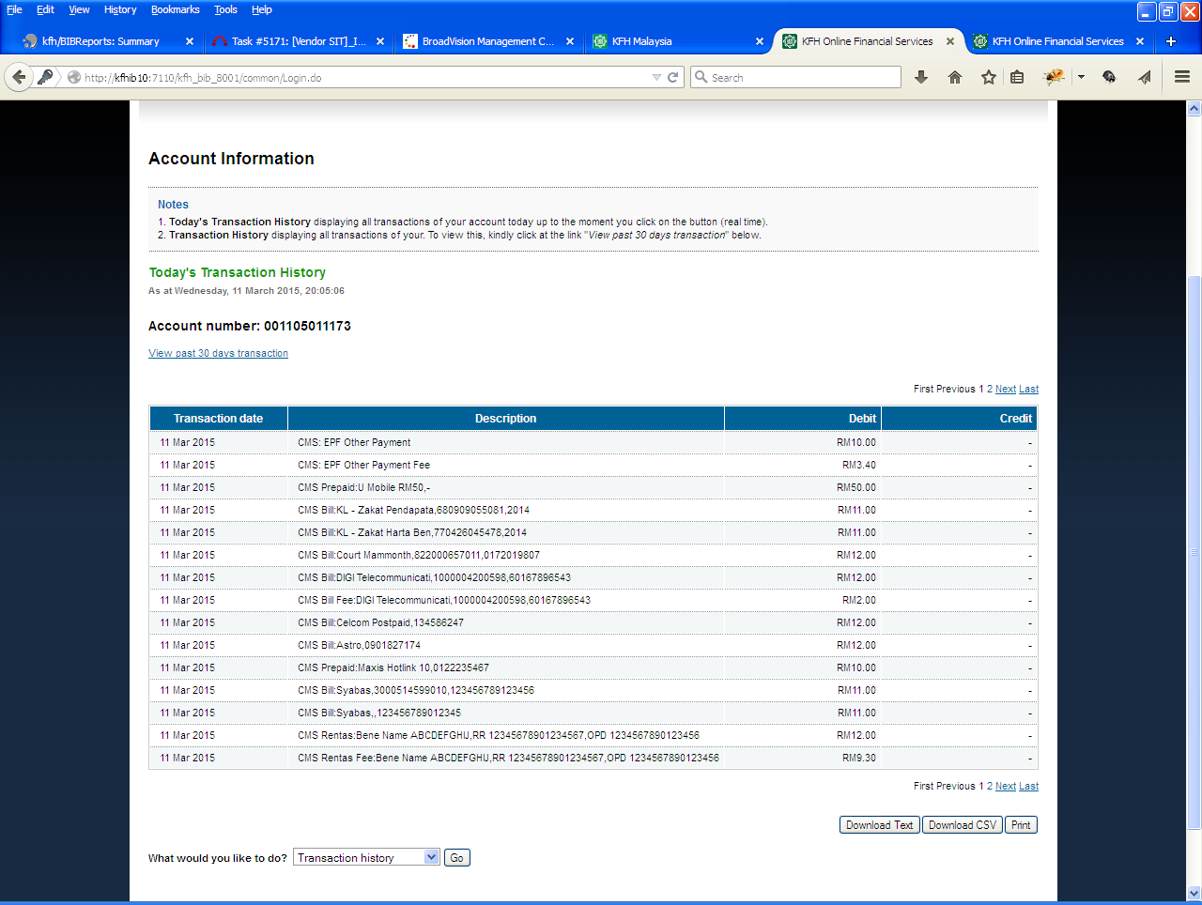

Figure 3: BIB Transaction History screen

|  |  |  |  |
| --- | --- | --- | --- |
| **Transaction Type** | **Channel & Service** | **Payment Reference Standard** | **Example** |
| Prepaid - Pinless | IB Prepaid | Prepaid Type, Mobile No. | IB Prepaid:Maxis Hotlink 10, 0122235467 |
| CMS Prepaid | Prepaid Type, Mobile No. | CMS Prepaid: Maxis Hotlink 10, 0122235467 |

**Figure 4: Sample Channel & Services – Prepaid pinless**

#### Maxis Hotlink

|  |  |  |  |
| --- | --- | --- | --- |
| **Transaction Type** | **Channel & Service** | **Payment Reference Standard** | **Example** |
| Bill - Broadcasting & Telecommunication | IB Bill  CMS Bill | Payee Corporation, Bill Account No. | IB Bill:Astro,0901827174 |
| CMS Bill:Celcom Postpaid,134586247 |
| IB Bill:Digi Postpaid,1000004200598 |
| IB Bill:U Mobile Postpaid,134365214 |

**Figure 5: Sample Channel & Services – Bill payment (Broadcasting & Telecommunication)**

#### Astro

C:\Users\User\Desktop\payment reference for brs\astro.png

Figure 6: CIB Transaction History Screen



Figure 7: BIB Transaction History screen

#### Celcom Postpaid

C:\Users\User\Desktop\payment reference for brs\celcom postpaid.png

Figure 8: CIB Transaction History Screen



Figure 9: BIB Transaction History Screen

#### Digi Postpaid

#### Umobile Postpaid

|  |  |  |  |
| --- | --- | --- | --- |
| Transaction Type | Channel & Service | Payment Reference Standard | Example |
| Bill – Government Agency | IB Bill | Payee Corporation, Bill Account No. | IB Bill:Lembaga Tabung Haji,130901000220190 |
| CMS Bill | CMS Bill:Lembaga Tabung Haji,130901000220190 |
| IB Bill Fee | IB Bill Fee:Lembaga Tabung Haji,130901000220190 |
| CMS Bill Fee | CMS Bill:Lembaga Tabung Haji,130901000220190 |

Figure : Sample Chanel & Services – Bill Payment (Charity)

#### Lembaga Tabung Haji



Figure 11: BIB Transaction History screen

|  |  |  |  |
| --- | --- | --- | --- |
| **Transaction Type** | **Channel & Service** | **Payment Reference Standard** | **Example** |
| Bill - Retail & Shopping | IB Bill | Payee Corporation, Bill Account No. | IB Bill:Courts Mammoth,822000657011 |
| CMS Bill | CMS Bill:Courts Mammoth,822000657011 |

**Figure 12: Sample Channel & Services – Bill Payment (Retail & Shopping)**

#### Courts Mammoth

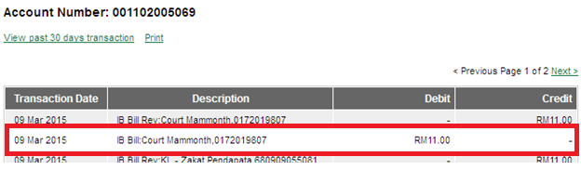

Figure 13: CIB Transaction History Screen



Figure 14: BIB Transaction History screen

|  |  |  |  |
| --- | --- | --- | --- |
| Transaction Type | Channel & Service | Payment Reference Standard | Example |
| Bill - Charity | IB Bill | Payee Corporation, Contact No. (if any) | IB Bill:Al-Madinah International Foundation,- |
| CMS Bill | CMS Bill:Al-Madinah International Foundation,0162638141 |

Figure 15: Sample Chanel & Services – Bill Payment (Charity)

#### Al Madinah International Foundation



Figure 16: CIB Transaction History screen

|  |  |  |  |
| --- | --- | --- | --- |
| **Transaction Type** | **Channel & Service** | **Payment Reference Standard** | **Example** |
| Bill - Utilities | IB Bill | Payee Corporation, Bill Account No. | IB Bill:Sabah Electricity Sdn Bhd,310508809840 |
| CMS Bill | CMS Bill:Syabas,3000514599010 |

**Figure 17: Sample Channel & Services – Bill Payment (Utilities)**

#### Sabah Electricity

#### Syabas

C:\Users\User\Desktop\payment reference for brs\Syabas.png

Figure 18: CIB Transaction History screen



Figure 19: BIB Transaction History screen

|  |  |  |  |
| --- | --- | --- | --- |
| **Transaction Type** | **Channel & Service** | **Payment Reference Standard** | **Example** |
| Bill - Zakat | IB Bill | Payee Corporation, IC or Passport No. | IB Bill:KL - Zakat Harta Benda,770426045478 |
| CMS Bill | CMS Bill:KL - Zakat Pendapatan,680909055081 |

**Figure 20: Sample Channel & Services – Bill Payment (Zakat)**

#### Zakat Pendapatan

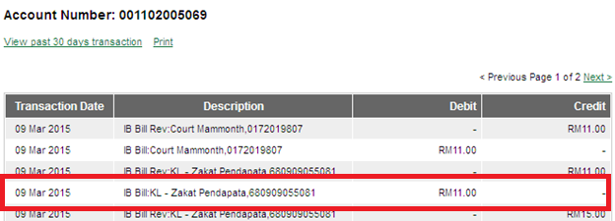

Figure 21: CIB Transaction History screen



Figure 22: BIB Transaction History screen

#### Zakat Harta Benda

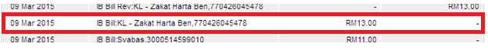

Figure 23: CIB Transaction History screen



Figure 24: CIB Transaction History screen

|  |  |  |  |
| --- | --- | --- | --- |
| **Transaction Type** | **Channel & Service** | **Payment Reference Standard** | **Example** |
| Own Account Transfer | IB | IB: Fund Transfer - Own Account | IB:Fund Transfer - Own Account |
| CMS | Fund Transfer - Own Account | CMS:Fund Transfer - Own Account |

Figure : Sample Channel & Services – Own Account Transfer

### Own Account Transfer

|  |  |  |  |
| --- | --- | --- | --- |
| **Transaction Type** | **Channel & Service** | **Payment Reference Standard** | **Example** |
| IBG Transfer | IB IBG | Bene Name, Receipient Reference, Other Payment Details | IB IBG:Bene Name ABCDEFGHIJ,RR 12345678901234567,OPD 1234567890123456 |
| CMS IBG | CMS IBG:Bene Name ABCDEFGHIJ,RR 12345678901234567,OPD 1234567890123456 |

Figure : Sample Channel & Services - IBG

### Interbank Transfer (IBG)

|  |  |  |  |
| --- | --- | --- | --- |
| **Transaction Type** | **Channel & Service** | **Payment Reference Standard** | **Example** |
| 3rd Party Account Transfer | IB FT Intra: | Bene Name, Recipient Reference, Other Payment Details | IB FT Intra:Bene Name ABCDEFGHIJ,RR 12345678901234567,OPD 1234567890123456 |
| CMS FT Intra: | Bene Name, Recipient Reference, Other Payment Details | CMS FT Intra:Bene Name ABCDEFGHIJ,RR 12345678901234567,OPD 1234567890123456 |

**Figure 27: Sample Channel & Services – 3rd Party Transfer**

### Intrabank Transfer

|  |  |  |  |
| --- | --- | --- | --- |
| **Transaction Type** | **Channel & Service** | **Payment Reference Standard** | **Example** |
| Bulk - Intra | CSM Intra(B): | Bene Name, Recipient Reference, Other Payment Details | CMS Intra(B):Bene Name ABCDEFGHIJ,RR 12345678901234567,OPD 1234567890123456 |
| Bulk - IBG | CMS IBG(B): | Bene Name, Recipient Reference, Other Payment Details | CMS IBG(B):Bene Name ABCDEFGHIJ,RR 12345678901234567,OPD 1234567890123456 |
| CMS IBG Fee(B): | CMS IBG Fee(B):Bene Name ABCDEFGHIJ,RR 12345678901234567,OPD 1234567890123456 |
| Bulk - Rentas | CMS Rentas(B): | Bene Name, Recipient Reference, Other Payment Details | CMS RTG(B):Bene Name ABCDEFGHIJ,RR 12345678901234567,OPD 1234567890123456 |
| CMS Rentas Fee(B): | CMS RTG Fee(B):Bene Name ABCDEFGHIJ,RR 12345678901234567,OPD 1234567890123456 |

### Figure 28: Sample Channel & Services – Bulk Payment

### Bulk Payment

|  |  |  |  |
| --- | --- | --- | --- |
| **Transaction Type** | **Channel & Service** | **Payment Reference Standard** | **Example** |
| RENTAS | CMS Rentas: | Bene Name, Receipient Reference, Return Reason Message | CMS Rentas:Bene Name ABCDEFGHIJ,RR 12345678901234567,OPD 1234567890123456 |
| CMS Rentas Fee: | CMS Rentas Fee:Bene Name ABCDEFGHIJ,RR 12345678901234567,OPD 1234567890123456 |

**Figure 29: Sample Channel & Services – RENTAS**

### Rentas



Figure : BIB Transaction History Screen

|  |  |  |  |
| --- | --- | --- | --- |
| **Transaction Type** | **Channel & Service** | **Payment Reference Standard** | **Example** |
| Foreign Telegraphic Transfer | IB FTT | Bene Name, Recipient Reference, Return Reason Message | IB FTT:Bene Name ABCDEFGHIJ,RR 12345678901234567,OPD 1234567890123456 |
| CMS FTT | CMS FTT:Bene Name ABCDEFGHIJ,RR 12345678901234567,OPD 1234567890123456 |
| IB FTT Fee | IB FTT Fee:Bene Name ABCDEFGHIJ,RR 12345678901234567,OPD 1234567890123456 |
| CMS FTT Fee | CMS FTT Fee:Bene Name ABCDEFGHIJ,RR 12345678901234567,OPD 1234567890123456 |

**Figure 31: Sample Channel & Services – Foreign Telegraphic Transfer**

### Foreign Telegraphic Transfer (FTT)

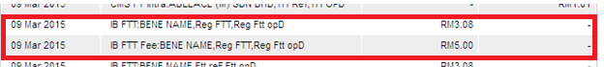

Figure : CIB Transaction History screen