**Agrobank**

|  |
| --- |
| **IBG Notes for Recipient’ Reference and Other Payment Details** |
| Business Requirement and System Specification |

**(PENRIL/AGRO-BRS/CR/20150514/16)**

**Version 1.0**

**14 May 2015**

Prepared By:



**Penril Datability (SEA) Sdn Bhd (384556-U)**

Suite A-07-07 Plaza Mon’t Kiara

No. 2, Jalan Kiara, Mon’t Kiara

50480 Kuala Lumpur, Malaysia

Tel: (603) 6201 2622Fax: (603) 6201 7622

**DOCUMENT AMENDMENT LOG**

|  |  |  |  |  |  |
| --- | --- | --- | --- | --- | --- |
| Rev. No | Date Update | Description of Change | Update By  <Name, Dept> | Review By  <Name, dept> | Approved By  <Name, Dept> |
| 1.0 | 14/05/2015 | Initial Release | Lizahwati binti Basirun  Penril Datability |  |  |
|  |  |  |  |  |  |
|  |  |  |  |  |  |
|  |  |  |  |  |  |
|  |  |  |  |  |  |

Table of Contents

Section 1: Introduction 4

Section 2: Internet Banking 5

1 Interbank Transfer 5

1.1 New Interbank GIRO Transfer or Instant Interbank Fund Transfer 5

1.1.1 Process Flows 5

1.1.2 Screen Flows 5

Section 3: Change Impact Analysis 9

Section 1: Introduction

This document served as the business requirement and system specification for the below:-

1. Retail Internet Banking (RIB)
   1. New or Favourite Interbank GIRO or Instant Interbank Fund Transfers
2. Business Internet Banking (BIB)
   1. New or Favourite Interbank GIRO

This document shall explain all the features and functionalities, which is elaborating with screen captures, process flow, descriptions, input fields specifications and error messages. All screen designs provided in this document are samples and only illustration purpose for easy understanding. The screen designs are not final.

Section 2: Internet Banking

# Interbank Transfer

The customer able to view the notes for the Recipient’s Reference and Other Payment Details in the Interbank Transfer details screen

These changes will cater for:

1. Retails Internet Banking (RIB)
2. Business Internet Banking(BIB)

## New Interbank GIRO Transfer or Instant Interbank Fund Transfer

### Process Flows



Diagram 1: Interbank Transfer details Flow Diagram

### Screen Flows

***Step 1:***

1. User can view the interbank notes enhancement at details page. User click on the Fund Transfer module then click on the Interbank Account Transfer.
2. User views the notes enhancement.

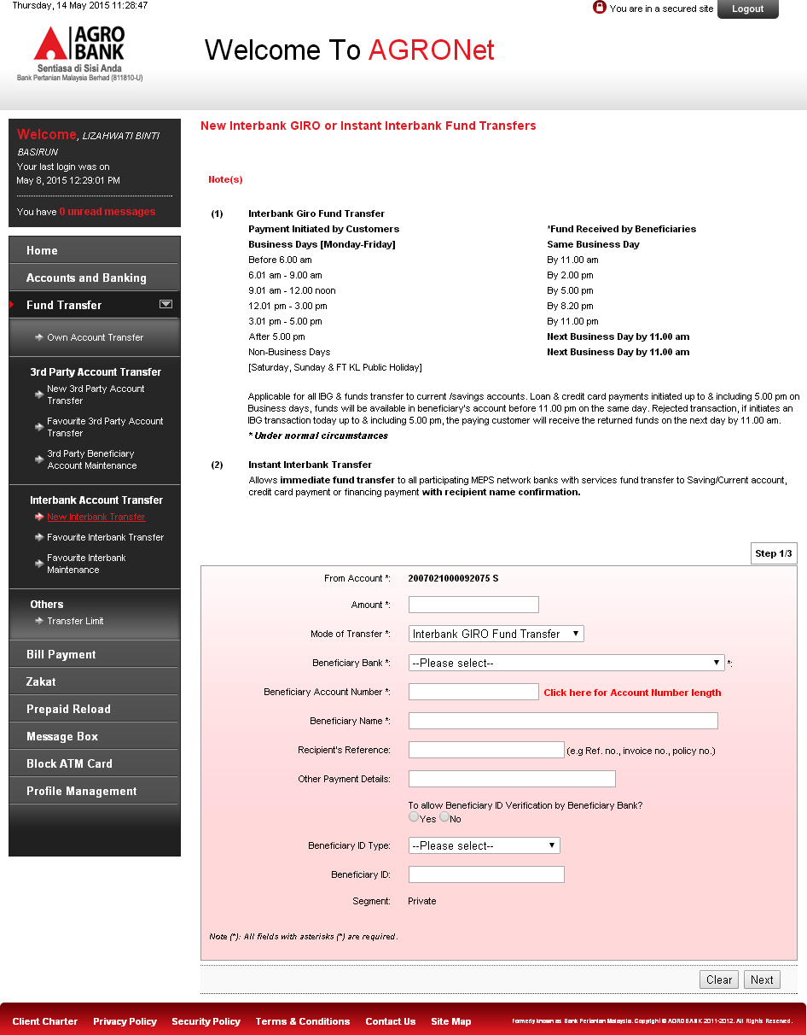

Figure 1: BEFORE Enhancement Screen for Interbank Transfer Details page

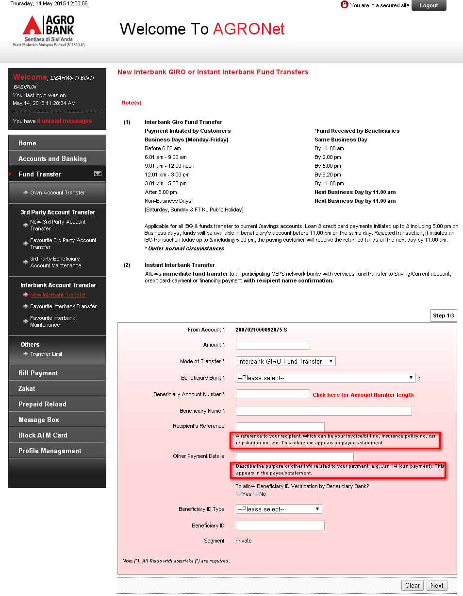

Figure 2: AFTER Enhancement Screen for Interbank Transfer Details page

**Display Fields:**

| **No** | **Field** | **Format** | **Description** |
| --- | --- | --- | --- |
|  | From Account | Dropdown list | Shows the account number of sender |
|  | Amount | Text Field | Shows the inserted amount of transaction |
|  | Mode of Transfer | Dropdown list | Shows the type of transfer |
|  | Charges | Text Field | Shows the inserted charges of transaction |
|  | Beneficiary Bank | Dropdown list | Shows the beneficiary bank of the Interbank Beneficiary |
|  | Beneficiary Account Number | Text Field | Shows the account number of Interbank Beneficiary |
|  | Beneficiary Name | Text Field | Shows the beneficiary name |
|  | ***Recipient’s Ref.*** | ***Text Field*** | ***Shows the reference of the payment*** |
|  | ***Other Payment Details*** | ***Text Field*** | ***Shows the others payment details of user*** |
|  | Beneficiary ID Type | Dropdown list | Show the Beneficiary ID Type |
|  | Beneficiary ID | Text | Show the Beneficiary ID |
|  | Segment | Text | Shows segment for Interbank transfer |

Table 1: Interbank Transfer details fields

**Notes as per requirement:**

|  |  |
| --- | --- |
| Fields | Notes to insert below the fields |
| Recipient’s Reference | A reference to your recipient, which can be your invoice/bill no, insurance policy no, car registration no, etc. This reference appears on payee's statement. |
| Other Payment Details | Describe the purpose of other info related to your payment (e.g. Jan 14 loan payment). This appears in the payee's statement. |

Section 3: Change Impact Analysis

Impacted Modules:-

|  |  |  |
| --- | --- | --- |
| No | Modules | Changes |
|  | RIB >Interbank Account Transfer   * New Interbank GIRO Transfer or Instant Interbank Fund Transfer * Favourite Interbank GIRO Transfer or Instant Interbank Fund Transfer | Added notes below the Recipient’s Reference and Other Payment Details text fields |
|  | BIB > Interbank Account Transfer   * New Interbank GIRO Transfer * Favourite Interbank GIRO Transfer | Added notes below the Recipient’s Reference and Other Payment Details text fields |