|  |
| --- |
| **Kuwait Finance House (M) Berhad**  **KFH Online Banking**  **(Payment Reference)** |
| Business Requirement Specification |

22th September 2014

Reference: KFH/IBSCR07/2BRS/PR

(Version 1.0)

**Prepared By:**



Penril Datability (M) Sdn Bhd (816792-X)

Suite A-07-07 Plaza Mon’t Kiara

No. 2, Jalan Kiara, Mon’t Kiara

50480 Kuala Lumpur, Malaysia

Tel: (603) 6201 2622 Fax: (603) 6201 7622

Document Amendment Log

|  |  |  |  |  |  |
| --- | --- | --- | --- | --- | --- |
| **Version No** | **Date Updated** | **Description of Change** | **Updated By**  **<Name, Dept>** | **Reviewed By**  **<Name, Dept>** | **Approved By <Name, Dept>** |
| 1.0 |  | Initial Release | Nurul Akmal  Penril Datability | Norhaidah Dasuki  Penril Datability |  |

Table of Contents

Document Amendment Log 2

Table of Contents 3

Business Requirement Acceptance 4

SECTION A: Introduction 5

1.1 Objective 6

1.2 Dependencies 6

1.3 Scope of Delivery 7

SECTION B: Online Banking 10

2. Consumer and Business Internet Banking 10

2.1 Transaction History 10

2.1.1 Process Flow 10

2.1.2 Screen Flow 10

2.1.3 Transaction History Description 11

2.1.3.1 Prepaid Reload 11

2.1.3.2 Bill Payment 12

2.1.3.3 Fund Transfer – Own Account Transfer 15

Business Requirement Acceptance

I/We hereby verify that this Business Requirement consist of all the requirements requested by Kuwait Finance House (M) Berhad. The implemented system will fulfill ONLY this requirement.

I/We also hereby AGREE that this satisfies our entire requirement for IBSCR072 – Payment Reference

Any future changes to this agreed scope will be treated as an enhancement to the system. Any future changes to the project timeline will be subjected to the final approval of the project steering committee.

**Kuwait Finance House (M) Berhad:**

|  |  |  |  |
| --- | --- | --- | --- |
| **Approved by** | **Role** | **Signature** | **Date** |
|  |  |  |  |
|  |  |  |  |
|  |  |  |  |
|  |  |  |  |
|  |  |  |  |
|  |  |  |  |
|  |  |  |  |

**Penril Datability (SEA) Sdn. Bhd.:**

|  |  |  |  |
| --- | --- | --- | --- |
| **Approved by** | **Role** | **Signature** | **Date** |
| Norhaidah Bt Md Dasuki | Project Manager |  |  |
| Tan Lee Yong |  |  |  |

SECTION A: Introduction

This document describes the features, process flow and screen design of payment reference standard in KFH Interbank Banking system to allows both payers (senders) and payee (recipients) to identify the source and purpose of the payments. Following transactional features will be captured in modules as below:-

The scope is inclusive all services that have Payment Reference impact for the below channels:

1. Consumer Internet Banking
2. Business Internet Banking
3. ATM (IBG Services)
4. Over the Counter (IBG Services)

The changes are to display Sender Name, Beneficiary Name, Recipient Reference and Other Payment Details on bank statements and electronic files (e.g. e-Statement, Receipt, Email Notification, Online Transaction History, reports.)

The services breakdown is as follows:

* Consumer Internet Banking (CIB)
  + Interbank Transfer (IBG, iPAY)
  + Intrabank Transfer
  + Foreign Telegraphic Transfer (FTT)
  + Bill Payment & Reload
  + Transaction History (Host)

*Standing Instruction (SI) is part of CIB component

* Business Internet Banking (BIB)
  + Interbank Transfer (IBG, Rentas)
  + Intrabank Transfer
  + Foreign Telegraphic Transfer (FTT)
  + Bill Payment & Reload
  + Bulk Payment
  + Transaction History (Host)

*Standing Instruction (SI) is part of BIB component

* IBG Transactions initiated from all channel (IB, BIB, ATM and GFS)
* CORUS
  + T

This document shall explain all the features and functionalities, which is elaborating with screen captures, process flow, descriptions, input fields specifications and error messages. All screen designs provided in this document are samples and only illustration purpose for easy understanding. The screen designs are not final.

## Objective

The objective of this document is to capture user requirements of transactional and administration modules of Payment Reference. This document will facilitate development and implementation of the mentioned modules of Internet Banking System for Kuwait Finance House Malaysia Berhad (“KFHMB”).

The base line features description and screen designs will become a reference blueprint for the development team to develop the transactional and administration module. Hence, it is crucial that all stakeholders need to ensure the correctness and adequacy of the requirements captured in this document.

All stakeholders involved are expected to review and sign off this document before the development start. By signing off the document, the stakeholder has endorsed the correctness and accuracy and adequacy of the requirements documented in this document.

## Dependencies

Implementation of this CR is having dependencies on external system, of KFH below:

KFH Host (Core Banking)

KFH ATM

KFH OTC

## 

## Scope of Delivery

| **Application** | **Module** | **Description** |
| --- | --- | --- |
| **Consumer Internet Banking (CIB)** | **Interbank Giro Transfer (IBG)** | * To pass Beneficiary Name, Recipient’s Reference & Other Payment Details into Transaction Description that need to send to IBG WebService. |
| **Intrabank Transfer (3rd Party)** | * Change Remarks to Recipient’s Reference * Add new field Other Payment Details * Beneficiary Name and Recipient Reference must be made mandatory for sender to furnish the information. * To pass Beneficiary Name, Recipient’s Reference & Other Payment Details (Optional) into Transaction Description that need to send to esb. |
| **IBFT (IPay)** | * Change Remarks to Recipient’s Reference * Change Transaction Reference number to Other Payment Details * Beneficiary Name, Recipient Reference and Other Payment Details must be made mandatory for sender to furnish the information. * To pass Beneficiary Name, Recipient’s Reference & Other Payment Details(Mandatory) into Transaction Description that need to send to MEPS |
| **FTT** | * Change Remarks to Recipient’s Reference * Add new field Other Payment Details * Beneficiary Name and Recipient Reference must be made mandatory for sender to furnish the information. * To pass Beneficiary Name, Recipient’s Reference & Other Payment Details(Optional) into Transaction Description that need to send to esb |
| **Reload & Bill Payment** | * For Bill Payment, to pass Biller Name and Biller Account No/Contact No. to Transaction Description that need to send to esb * For Reload, to pass Prepaid Type and Mobile No. (if any) to Transaction Description that need to send to esb |
| **Receipt & Email Notification** | * To reflect the source and purpose of the payments, namely Sender Name, Beneficiary Name, Recipient Reference and Other Payment Reference. |
| **Transaction History** | As Sender/Originating Bank:   * To reflect the source and purpose of the payments, namely Beneficiary Name, Recipient Reference and Other Payment Reference on the screen   Exp.:  Channel & Service: Bene’s Name, Recipient Ref, Other Payment Details  *IB Intra DR: Adam Iskandar, Rental Inv10500, Pay for July 2014*  As Beneficiary/Receiving Bank:   * To reflect the source and purpose of the payments, namely Sender Name, Recipient Reference and Other Payment Reference on the screen   Exp.:  Channel & Service: Sender’s Name, Recipient Ref, Other Payment Details  *IB Intra CR: Adam Iskandar, Rental Inv10500, Pay for July 2014*  *\**Notes: Apply the same sequence to all type of services however for Bill Payment and Reload is as below  Bill Payment:  Channel & Service: Biller Name, Biller Account No./Contact No.  *IB Bill Payment: Digi Postpaid, 1.31234556*  Reload:  Channel & Service: Prepaid Type, Mobile No. (if any)  *IB Prepaid Top Up: Maxis30, 0121234567* |
| **Business Internet Banking (BIB)** | **Interbank Giro Transfer (IBG)** | * To pass Beneficiary Name, Recipient’s Reference & Other Payment Details into Transaction Description that need to send to IBG WebService. |
| **Intrabank Transfer (3rd Party)** | * Change Remarks to Recipient’s Reference * Add new field Other Payment Details * Beneficiary Name and Recipient Reference must be made mandatory for sender to furnish the information. * To pass Beneficiary Name, Recipient’s Reference & Other Payment Details (Optional) into Transaction Description that need to send to esb. |
| **Bulkpayment** | * Apply same format and validation check for Recipient’s Reference & Other Payment Details according to IBG transaction. |
| **Rentas** | * Apply same format and validation check for Recipient’s Reference & Other Payment Details according to IBG transaction. |
| **FTT** | * Change Remarks to Recipient’s Reference * Add new field Other Payment Details * Beneficiary Name and Recipient Reference must be made mandatory for sender to furnish the information. * To pass Beneficiary Name, Recipient’s Reference & Other Payment Details(Optional) into Transaction Description that need to send to esb |
| **Reload & Bill Payment** | * For Bill Payment, to pass Biller Name and Biller Account No/Contact No. to Transaction Description that need to send to esb * For Reload, to pass Prepaid Type and Mobile No. (if any) to Transaction Description that need to send to esb |
| **Receipt & Email Notification** | * To reflect the source and purpose of the payments, namely Sender Name, Beneficiary Name, Recipient Reference and Other Payment Reference. |
| **Transaction History** | As Sender/Originating Bank:   * To reflect the source and purpose of the payments, namely Beneficiary Name, Recipient Reference and Other Payment Reference on the screen   Exp.:  Channel & Service: Bene’s Name, Recipient Ref, Other Payment Details  *CMS Intra DR: Adam Iskandar, Rental Inv10500, Pay for July 2014*  As Beneficiary/Receiving Bank:   * To reflect the source and purpose of the payments, namely Sender Name, Recipient Reference and Other Payment Reference on the screen   Exp.:  Channel & Service: Sender’s Name, Recipient Ref, Other Payment Details  *CMS Intra CR: Adam Iskandar, Rental Inv10500, Pay for July 2014*  *\**Notes: Apply the same sequence to all type of services however for Bill Payment and Reload is as below  Bill Payment:  Channel & Service: Biller Name, Biller Account No./Contact No.  *CMS Bill Payment: Digi Postpaid, 1.31234556*  Reload:  Channel & Service: Prepaid Type, Mobile No. (if any)  *CMS Prepaid Top Up: Maxis30, 0121234567* |
| **IBG Core** | **IBG Process** | * Related to change request stated in IBSCR068 |
| **CORUS** | **Transaction Inquiry/Report** | * To reflect all payment reference information namely to the Transaction Inquiry result and details screen * To change the label/report header accordingly. |
| **IBG OFI/RFI** | * Related to change request stated in IBSCR068 |
| **BVMC** | **CIB Report** | * Add field to reflect all payment reference information namely to the Transaction Inquiry result and details screen * To change the label/report header accordingly |
|  | **BIB Report** | * Add field to reflect all payment reference information namely to the Transaction Inquiry result and details screen * To change the label/report header accordingly |
| **Database** | | * Add column to store on the Payment Reference information - Beneficiary Name, Recipient’s Reference & Other Payment |

Table 1: Payment Reference Development Scope

SECTION B: Online Banking

# Consumer and Business Internet Banking

# Transaction History

IB will cater all the details sent by host at the Account and Banking>Transaction History – Transaction Details column.

**Purpose:**

This change will allowed CIB and BIB User able to to identify and to view the details of payment source and purpose in the Account and Banking transaction history details and summary.

## Process Flow



Diagram 1: Transaction History Process Flow

## Screen Flow

***Step by Step:***

1. User accesses the Landing page and clicks “Account Enquiry”
2. User can view or print Transaction History (from Host System) by select on “Transaction History” from the drop down list and click “Go” button to view transaction history page for the selected account field.
3. User views Transaction history details.

## Transaction History Description (as Sender/Originating Bank)

### Prepaid Reload

#### Pin Based

|  |  |  |  |
| --- | --- | --- | --- |
| **Transaction Type** | **Channel & Service** | **Payment Reference Standard** | **Example** |
| Prepaid - Pin Based | IB Prepaid | Prepaid Type | IB Prepaid:U Mobile RM50 |
| CMS Prepaid | Prepaid Type | CMS Prepaid:U Mobile RM50 |

Table 2: Prepaid Reload Pin Based Specification

Sample:

Figure 1: CIB Prepaid Reload Pin Based Transaction Details



Figure 2: BIB Prepaid Reload Pin Based Transaction Details

#### Pinless

|  |  |  |  |
| --- | --- | --- | --- |
| **Transaction Type** | **Channel & Service** | **Payment Reference Standard** | **Example** |
| Prepaid - Pinless | IB Prepaid | Prepaid Type, Mobile No. | IB Prepaid: Maxis Hotlink 10, 0122235467 |
| CMS Prepaid | Prepaid Type, Mobile No. | CMS Prepaid: Maxis Hotlink 10, 0122235467 |

Table 3: Prepaid Reload Pinless Specification

Sample:

Figure 3: CIB Prepaid Reload Pinless Transaction Details

Figure 4: BIB Prepaid Reload Pinless Transaction Details

### Bill Payment

#### Broadcasting & Telecommunication

|  |  |  |  |
| --- | --- | --- | --- |
| **Transaction Type** | **Channel & Service** | **Payment Reference Standard** | **Example** |
| Bill - Broadcasting & Telecommunication | IB Bill | Payee Corporation, Bill Account No. | IB Bill:Astro,0901827174 |
| CMS Bill | CMS Bill:Celcom Postpaid,134586247 |

Table 4: Bill Payment – Broadcasting & Telecommunication Specification

Sample:

C:\Users\User\Desktop\payment reference for brs\astro.png

Figure 6: CIB Bill Payment – Broadcasting & Telecommunication Transaction Details

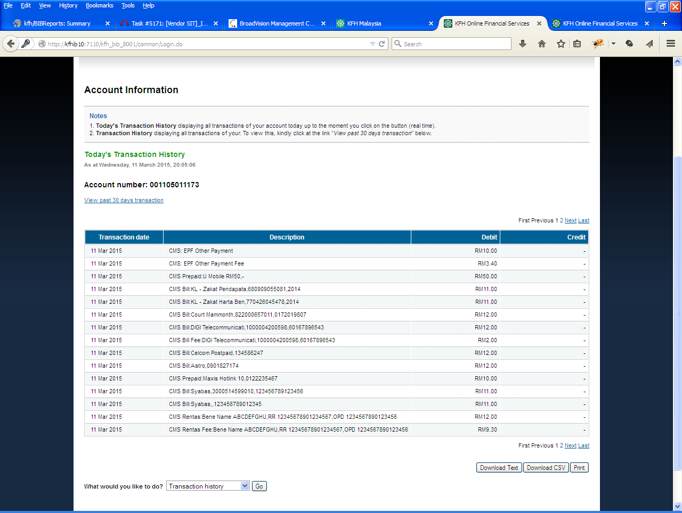

Figure 7: BIB Bill Payment – Broadcasting & Telecommunication Transaction Details

#### Government Agency

|  |  |  |  |
| --- | --- | --- | --- |
| **Transaction Type** | **Channel & Service** | **Payment Reference Standard** | **Example** |
| Bill – Government Agency | IB Bill | Payee Corporation, Bill Account No. | IB Bill: Lembaga Tabung Haji, 130901000220190 |
| CMS Bill | CMS Bill:Lembaga Tabung Haji, 130901000220190 |
| IB Bill Fee | IB Bill Fee:Lembaga Tabung Haji, 130901000220190 |
| CMS Bill Fee | CMS Bill:Lembaga Tabung Haji, 130901000220190 |

Table 4: Bill Payment – Government Agency Specification

Sample:

Figure 8: CIB Bill Payment – Government Agency Transaction Details



Figure 9: BIB Bill Payment – Government Agency Transaction Details

#### Retail & Shopping

|  |  |  |  |
| --- | --- | --- | --- |
| **Transaction Type** | **Channel & Service** | **Payment Reference Standard** | **Example** |
| Bill - Retail & Shopping | IB Bill | Payee Corporation, Bill Account No. | IB Bill:Courts Mammoth,822000657011 |
| CMS Bill | CMS Bill:Courts Mammoth,822000657011 |

Table 5: Bill Payment - Retail & Shopping Specification

Sample:

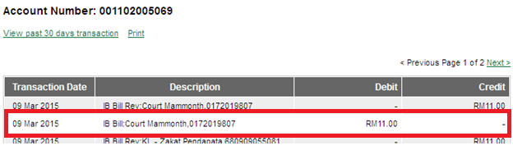

Figure 10: CIB Bill Payment – Retail & Shopping Transaction Details



Figure 11: BIB Bill Payment – Retail & Shopping Transaction Details

#### Charity

|  |  |  |  |
| --- | --- | --- | --- |
| **Transaction Type** | **Channel & Service** | **Payment Reference Standard** | **Example** |
| Bill - Charity | IB Bill | Payee Corporation, Contact No. (if any) | IB Bill:Al-Madinah International Foundation,- |
| CMS Bill | CMS Bill:Al-Madinah International Foundation, 0162638141 |

Table 6: Bill Payment - Charity Specification

Sample:



Figure 12: CIB Bill Payment – Charity Transaction Details

Figure 13: BIB Bill Payment – Charity Transaction Details

#### Utilities

|  |  |  |  |
| --- | --- | --- | --- |
| **Transaction Type** | **Channel & Service** | **Payment Reference Standard** | **Example** |
| Bill - Utilities | IB Bill | Payee Corporation, Bill Account No. | IB Bill:Sabah Electricity Sdn Bhd,310508809840 |
| CMS Bill | CMS Bill:Syabas,3000514599010 |

Table 7: Bill Payment - Utilities Specification

Sample:

C:\Users\User\Desktop\payment reference for brs\Syabas.png

Figure 14: CIB Bill Payment – Utilities Transaction Details



Figure 15: BIB Bill Payment – Utilities Transaction Details

#### Zakat

|  |  |  |  |
| --- | --- | --- | --- |
| **Transaction Type** | **Channel & Service** | **Payment Reference Standard** | **Example** |
| Bill - Zakat | IB Bill | Payee Corporation, IC or Passport No. | IB Bill:KL - Zakat Harta Benda,770426045478 |
| CMS Bill | CMS Bill:KL - Zakat Pendapatan, 680909055081 |

Table 8: Bill Payment - Zakat Specification

Sample:

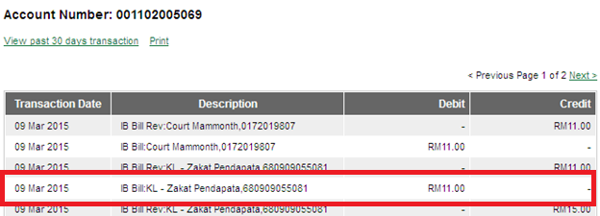

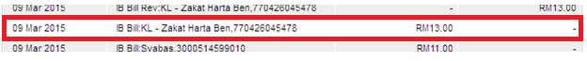

Figure 16: CIB Bill Payment – Zakat Transaction Details





Figure 17: BIB Bill Payment – Zakat Transaction Details

### Fund Transfer

#### Interbank Giro Account Transfer

|  |  |  |  |
| --- | --- | --- | --- |
| **Transaction Type** | **Channel & Service** | **Payment Reference Standard** | **Example** |
| IBG Transfer | IB IBG | Bene Name, Receipient Reference, Other Payment Details | IB IBG:Bene Name ABCDEFGHIJ,RR 12345678901234567,OPD 1234567890123456 |
| CMS IBG | CMS IBG:Bene Name ABCDEFGHIJ,RR 12345678901234567,OPD 1234567890123456 |

Table 9: Fund Transfer – IBG Transfer Specification

Sample:

Figure 18: CIB IBG Account Transfer Transaction Details

Figure 19: BIB IBG Account Transfer Transaction Details

#### Intrabank Account Transfer

|  |  |  |  |
| --- | --- | --- | --- |
| **Transaction Type** | **Channel & Service** | **Payment Reference Standard** | **Example** |
| 3rd Party Account Transfer | IB FT Intra: | Bene Name, Recipient Reference, Other Payment Details | IB FT Intra:Bene Name ABCDEFGHIJ,RR 12345678901234567,OPD 1234567890123456 |
| CMS FT Intra: | CMS FT Intra:Bene Name ABCDEFGHIJ,RR 12345678901234567,OPD 1234567890123456 |

Table 10: Fund Transfer – Intrabank Account Transfer Specification

Sample:

Figure 20: CIB IBG Account Transfer Transaction Details

**Figure 21: BIB IBG Account Transfer Transaction Details**

#### Rentas AccountTransfer

|  |  |  |  |
| --- | --- | --- | --- |
| **Transaction Type** | **Channel & Service** | **Payment Reference Standard** | **Example** |
| RENTAS | CMS Rentas: | Bene Name, Recipients Reference, Other Payment Details | CMS Rentas:Bene Name ABCDEFGHIJ,RR 12345678901234567,OPD 1234567890123456 |

Table 11: Fund Transfer – Rentas Account Transfer Specification

Sample:



Figure 22: BIB Rentas Account Transfer Transaction Details

#### Foreign Telegraphic AccountTransfer

|  |  |  |  |
| --- | --- | --- | --- |
| **Transaction Type** | **Channel & Service** | **Payment Reference Standard** | **Example** |
| Foreign Telegraphic Transfer | IB FTT | Bene Name, Recipient Reference, Other Payment Details | IB FTT:Bene Name ABCDEFGHIJ,RR 12345678901234567,OPD 1234567890123456 |
| CMS FTT | CMS FTT:Bene Name ABCDEFGHIJ,RR 12345678901234567,OPD 1234567890123456 |

Table 12: Fund Transfer – FTT Account Transfer Specification

Sample:

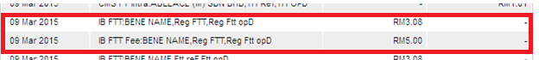

Figure 23: CIB Rentas Account Transfer Transaction Details

Figure 24: BIB Rentas Account Transfer Transaction Details

#### Bulk Payment Transfer

|  |  |  |  |
| --- | --- | --- | --- |
| **Transaction Type** | **Channel & Service** | **Payment Reference Standard** | **Example** |
| Bulk - Intra | CSM Intra(B): | Bene Name, Recipient Reference, Other Payment Details | CMS Intra(B):Bene Name ABCDEFGHIJ,RR 12345678901234567,OPD 1234567890123456 |
| Bulk - IBG | CMS IBG(B): | CMS IBG(B):Bene Name ABCDEFGHIJ,RR 12345678901234567,OPD 1234567890123456 |
| Bulk - Rentas | CMS Rentas(B): | CMS RTG(B):Bene Name ABCDEFGHIJ,RR 12345678901234567,OPD 1234567890123456 |

Table 13: Fund Transfer – FTT Account Transfer Specification

Sample:

Figure 25: BIB Bulk Payment Transaction Details

### Standing Instruction

#### Interbank Giro Account Transfer

|  |  |  |  |
| --- | --- | --- | --- |
| **Transaction Type** | **Channel & Service** | **Payment Reference Standard** | **Example** |
| Bill Payment | IB Bill | Bene Name, Receipient Reference, Other Payment Details | IB IBG:Bene Name ABCDEFGHIJ,RR 12345678901234567,OPD 1234567890123456 |
| CMS Bill | CMS IBG:Bene Name ABCDEFGHIJ,RR 12345678901234567,OPD 1234567890123456 |
| IBG | IB IBG |  |
| CMS IBG |  |
| Intrabank |  |  |
|  |  |

Table 14: Standing Instructions Specification

Sample:

### Fee/Charges

#### Transaction Fee

|  |  |  |  |
| --- | --- | --- | --- |
| **Transaction Type** | **Channel & Service** | **Payment Reference Standard** | **Example** |
| IBG | IB IBG Fee | Bene Name, Receipient Reference, Other Payment Details |  |
| CMS IBG Fee |  |
| Rentas | CMS Rentas Fee: | CMS Rentas Fee:Bene Name ABCDEFGHIJ,RR 12345678901234567,OPD 1234567890123456 |
| FTT | IB FTT Fee | IB FTT Fee:Bene Name ABCDEFGHIJ,RR 12345678901234567,OPD 1234567890123456 |
| CMS FTT Fee | CMS FTT Fee:Bene Name ABCDEFGHIJ,RR 12345678901234567,OPD 1234567890123456 |
| IBFT |  |  |  |
| Bill Payment |  |  |  |

Table 15: Transaction Fee Specification

Sample:

#### GST Fee

|  |  |  |  |
| --- | --- | --- | --- |
| **Transaction Type** | **Channel & Service** | **Payment Reference Standard** | **Example** |
| IBG | IB IBG GST Fee | Bene Name, Receipient Reference, Other Payment Details |  |
| CMS IBG GST Fee |  |
|  |  |  |  |
|  |  |  |  |
|  |  |  |  |
|  |  |  |  |

Table 16: GST Fee Specification

Sample:

#### Standing Instruction Fee

|  |  |  |  |
| --- | --- | --- | --- |
| **Transaction Type** | **Channel & Service** | **Payment Reference Standard** | **Example** |
| IBG | IB IBG SI Fee | Bene Name, Receipient Reference, Other Payment Details |  |
| CMS IBG SI Fee |  |
|  |  |  |  |
|  |  |  |  |
|  |  |  |  |

Table 17: SI Fee Specification

Sample:

#### Bulk Payment Fee

|  |  |  |  |
| --- | --- | --- | --- |
| **Transaction Type** | **Channel & Service** | **Payment Reference Standard** | **Example** |
| IBG | CMS IBG Fee(B): | Bene Name, Receipient Reference, Other Payment Details | CMS IBG Fee(B):Bene Name ABCDEFGHIJ,RR 12345678901234567,OPD 1234567890123456 |
| Rentas | CMS Rentas Fee(B): | CMS RTG Fee(B):Bene Name ABCDEFGHIJ,RR 12345678901234567,OPD 1234567890123456 |

Table 18: Fund Transfer – IBG Transfer Specification

Sample:

## Transaction History Details (as Beneficiary/Receiving Bank)

### Fund Transfer

#### Interbank Giro Account Transfer

|  |  |  |  |
| --- | --- | --- | --- |
| **Transaction Type** | **Channel & Service** | **Payment Reference Standard** | **Example** |
| IBG Transfer | IB IBG | Sender Name, Receipient Reference, Other Payment Details | IB IBG:Sender Name ABCDEFGHIJ,RR 12345678901234567,OPD 1234567890123456 |
| CMS IBG | CMS IBG:Sender Name ABCDEFGHIJ,RR 12345678901234567,OPD 1234567890123456 |

Table 19: Fund Transfer – IBG Transfer (Sender) Specification

#### Intrabank Giro Account Transfer

|  |  |  |  |
| --- | --- | --- | --- |
| **Transaction Type** | **Channel & Service** | **Payment Reference Standard** | **Example** |
| 3rd Party Account Transfer | IB FT Intra: | Sender Name, Recipient Reference, Other Payment Details | IB FT Intra:Sender Name ABCDEFGHIJ,RR 12345678901234567,OPD 1234567890123456 |
| CMS FT Intra: | CMS FT Intra:Sender Name ABCDEFGHIJ,RR 12345678901234567,OPD 1234567890123456 |

Table 20: Fund Transfer – IBG Transfer (Sender) Specification

# Enhancement of Payment/Transaction Details Screen

## Interbank Giro Account Transfer

# CORUS

# Enhancement of IB Transaction Inquiry Screen

## IB Transactions

## Bulk Payment

## SI History

# Enhancement of IBG OFI & RFI Screen

## OFI

## RFI

# BVMC

# Enhancement of IB Report

List of IB Report affected is as below: