**Agrobank**

|  |
| --- |
| **AGRONet Registration – filter by BIN No./Card Type** |
| Business Requirement and System Specification |

**(PENRIL/AGRO-BRS/CR00044/CM201400920)**

**Version 1.0**

**18 May 2015**

Prepared By:



**Penril Datability (SEA) Sdn Bhd (384556-U)**

Suite A-07-07 Plaza Mon’t Kiara

No. 2, Jalan Kiara, Mon’t Kiara

50480 Kuala Lumpur, Malaysia

Tel: (603) 6201 2622Fax: (603) 6201 7622

**DOCUMENT AMENDMENT LOG**

|  |  |  |  |  |  |
| --- | --- | --- | --- | --- | --- |
| Rev. No | Date Update | Description of Change | Update By  <Name, Dept> | Review By  <Name, dept> | Approved By  <Name, Dept> |
| 1.0 | 18/05/2015 | Initial Release | Lizahwati binti Basirun  Penril Datability |  |  |
|  |  |  |  |  |  |
|  |  |  |  |  |  |
|  |  |  |  |  |  |
|  |  |  |  |  |  |

Table of Contents

Section 1: Introduction 5

Section 2: IBAM 6

1 RIB BIN No. Maintenance 6

1.1 Add BIN No. 6

1.1.1 Process Flows 6

1.1.2 Screen Flows 6

1.2 Edit BIN No. 12

1.2.1 Process Flows 12

1.2.2 Screen Flows 12

1.3 Delete BIN No. 14

1.3.1 Process Flows 14

1.3.2 Screen Flows 14

2 IBAM Navigation 16

2.1 View Details 16

2.1.1 Process Flows 16

2.1.2 Screen Flows 16

2.2 Edit Details 19

2.2.1 Process Flows 19

2.2.2 Screen Flows 19

3 Audit Trail 20

3.1 View Details 21

3.1.1 Screen Flows 21

4 Maker Checker Maintenance 23

4.1 View Details 23

4.1.1 Screen Flows 23

5 User Group Maintenance 24

5.1.1 Screen Flows 25

6 User Profile Maintenance 27

6.1.1 Screen Flows 27

7 Authorization 29

7.1 View Details 29

7.1.1 Screen Flows 29

Section 3: Retail Internet Banking 32

8 RIB Registration 32

8.1 Registration 32

8.1.1 Process Flows 32

8.1.2 Screen Flows 32

Section 3: Change Impact Analysis 38

Section 1: Introduction

This document served as the business requirement and system specification for below:-

1. Internet Banking Application Manager (IBAM)
   1. RIB BIN No. Maintenance (New navigation module)
2. Retail Internet Banking (RIB)
   1. Registration

This document shall explain all the features and functionalities, which is elaborating with screen captures, process flow, descriptions, input fields specifications and error messages. All screen designs provided in this document are samples and only illustration purpose for easy understanding. The screen designs are not final.

Section 2: IBAM

# RIB BIN No. Maintenance

To add the new module which it can be maintainable the RIB BIN No. based on below functions:

1. Add
2. Edit
3. Delete

## Add BIN No.

### Process Flows



Diagram 1: Adding the details of BIN

### Screen Flows

***Step 1:***

1. User access to RIB BIN No. Maintenance side navigation. User can add the BIN No. by click on the Add BIN No. button.

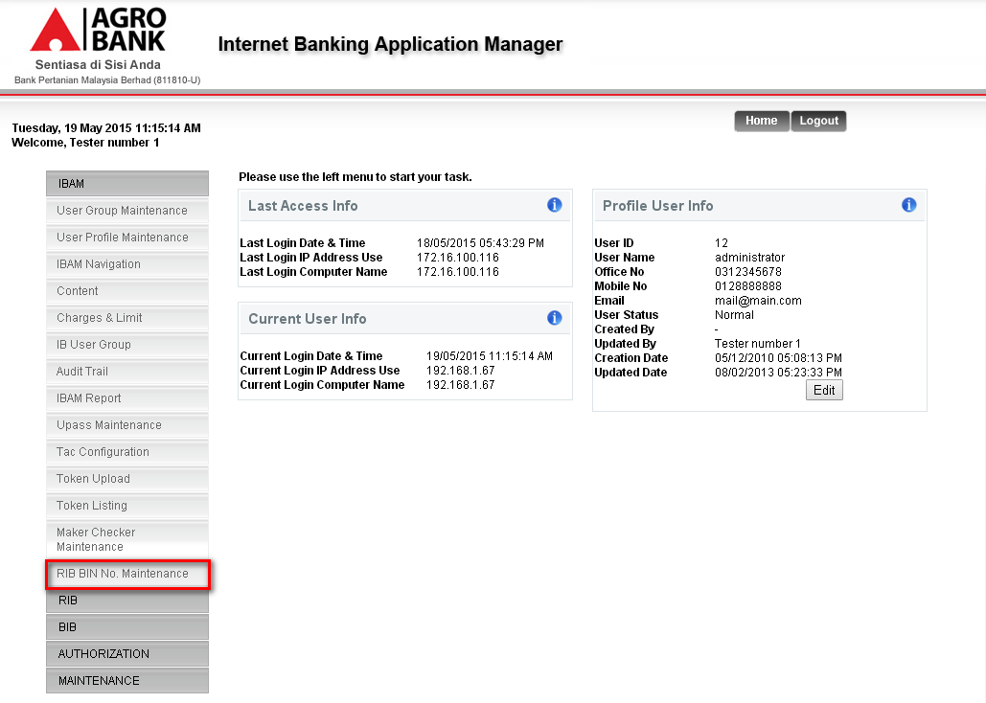

Figure 1: Home screen to navigate the RIB BIN No. Maintenance module

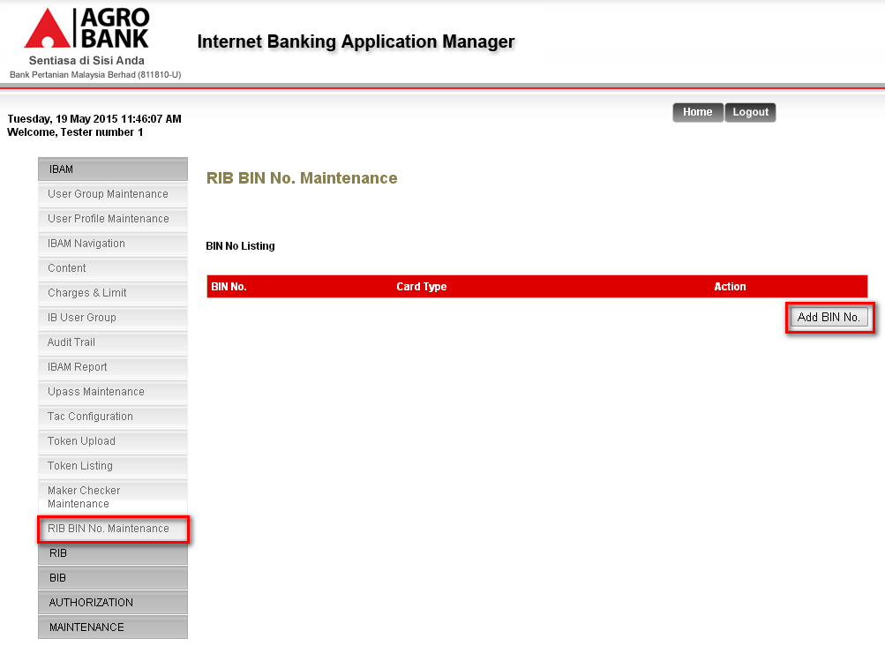

**Action:**

|  |  |  |  |
| --- | --- | --- | --- |
| No | Action | Type | Description |
|  | Details | Button | Contains an action to view the details of BIN No. |
|  | Add BIN No. | Button | Contains an action to allow user to add new BIN No. |

Table 1: RIB BIN No. Action

***Step 2:***

1. User enters the BIN No. and Card Type then click on “Done” button.

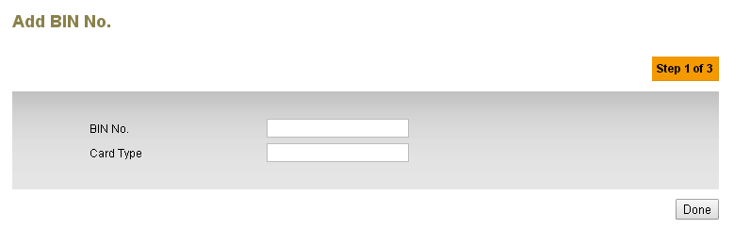

Figure 2: Add BIN No. details screen– Step 1 of 3

**Input Specification:**

| **No** | **Field** | **Field Type** | **Validation Rule** | **Description** | **M/O** |
| --- | --- | --- | --- | --- | --- |
|  | BIN No. | Text box | Numeric  Max length: 6 | RIB BIN No. | M |
|  | Card Type | Text box | Alphanumeric | Type of card | M |

**Table 2: Add BIN No. detail Input Specification**

**Action:**

| **No** | **Action** | **Type** | **Description** |
| --- | --- | --- | --- |
|  | Done | Button | Contains an action to continue to next page |

**Table 3: Add BIN No. details List Action**

**List of available messages for the screen:**

|  |  |  |
| --- | --- | --- |
| **No.** | **Event** | **Error Description in English** |
|  | Did not fill in or select mandatory field   * BIN No. * Card Type | BIN No. is required |
| Card Type is required. |
|  | Fill in fields below with other than numeric   * BIN No. | BIN No. is not numeric |
|  | Fill in fields below with other than alphanumeric.   * Card Type | Card Type is not alphanumeric |
|  |

**Table 4: Add RIB No. details Error Message List**

***Step 3:***

1. User validates the details that they have input and click on “Confirm” button.

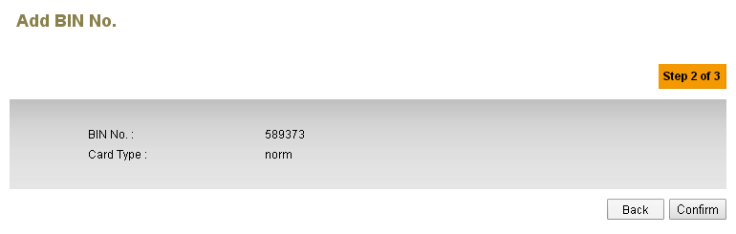

Figure 3: Add BIN No. confirm screen – Step 2 of 3

**Display Fields:**

|  |  |  |  |
| --- | --- | --- | --- |
| No | Field | Format | Description |
|  | BIN No. | Text | Shows the RIB BIN No. |
|  | Card Type | Text | Shows the type of card |

Table 5: RIB BIN No. Display Field

**Action:**

|  |  |  |  |
| --- | --- | --- | --- |
| No | Action | Type | Description |
|  | Confirm | Button | Contains an action to confirm the details of BIN No. |
|  | Back | Button | Contains an action to allow user back to previous page |

Table 6: RIB BIN No. Action

***Step 4:***

1. BIN No. has been added and pending for approval when the user login as Maker and successfully added if login as Administrator.

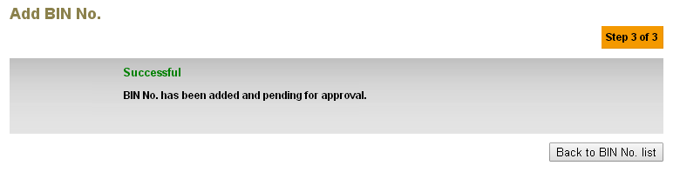

Figure 4: Add BIN No. result screen – Step 3 of 3 (Maker Checker)

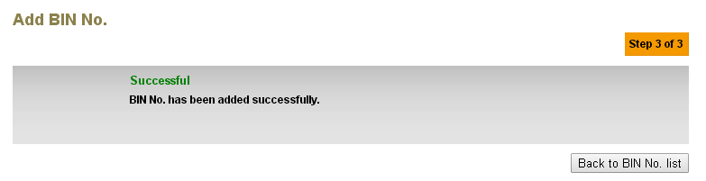

Figure 5: Add BIN No. result screen – Step 3 of 3 (Administrator)

**Action:**

|  |  |  |  |
| --- | --- | --- | --- |
| No | Action | Type | Description |
|  | Back to BIN No. list | Button | Contains an action to allow user back to BIN No listing |

Table 7: RIB BIN No. Action

***Step 5:***

1. List of BIN No. will display list of RIB BIN No. that has been created. Click on the Details to view the details of the BIN No.

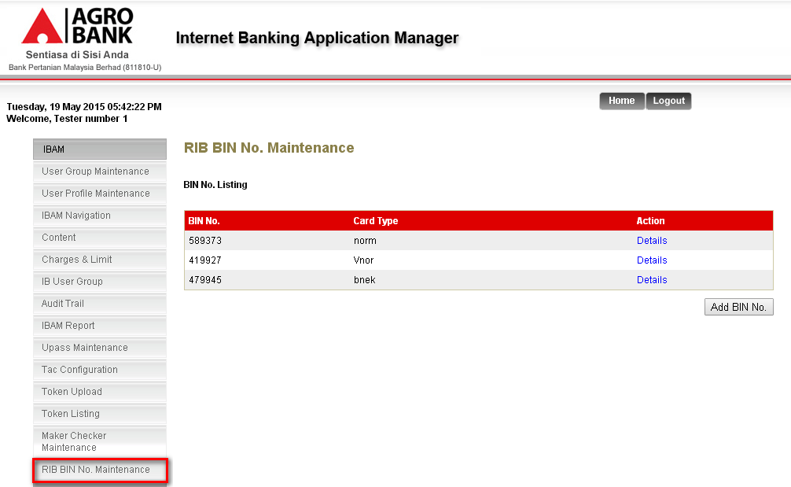

Figure 6: BIN No. listing screen

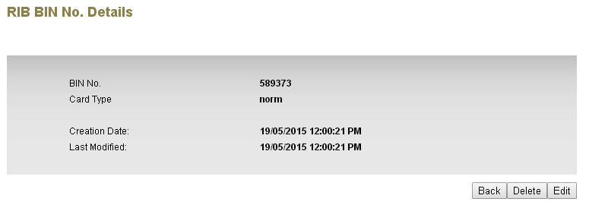

Figure 7: BIN No. details screen

**Display Fields:**

|  |  |  |  |
| --- | --- | --- | --- |
| No | Field | Format | Description |
|  | BIN No. | Text | Shows the RIB BIN No. |
|  | Card Type | Text | Shows the type of card |
|  | Creation Date | Text | Shows the date and time of creation |
|  | Last Modified | Text | Shows the date and time of last modification |

Table 8: RIB BIN No. Display Field

**Action:**

|  |  |  |  |
| --- | --- | --- | --- |
| No | Action | Type | Description |
|  | Back | Button | Contains an action to allow user go to listing page |
|  | Delete | Button | Contains an action to allow IB User to delete the BIN No. |
|  | Edit | Button | Contains an action to allow IB User to edit the BIN details |

Table 9: RIB BIN Action

## Edit BIN No.

### Process Flows



Diagram 2: Edit the details of BIN

### Screen Flows

***Step 1:***

1. User clicks on the BIN No. details navigation to view the details of the BIN No.
2. After that, click on the Edit button then edit and click on Update button

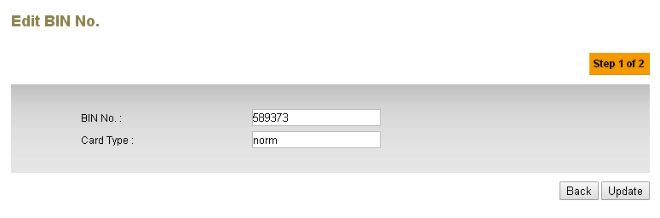

Figure 8: BIN No. edit details screen

**Input Specification:**

| **No** | **Field** | **Field Type** | **Validation Rule** | **Description** | **M/O** |
| --- | --- | --- | --- | --- | --- |
|  | BIN No. | Text box | Numeric  Max length: 6 | RIB BIN No. | M |
|  | Card Type | Text box | Alphanumeric | Type of card | M |

**Table 10: Edit BIN No. detail Input Specification**

**Action:**

| **No** | **Action** | **Type** | **Description** |
| --- | --- | --- | --- |
|  | Back | Button | Contains an action to go to previous page |
|  | Update | Button | Contains an action to go to next page |

**Table 11: Edit BIN No. details List Action**

**List of available messages for the screen:**

|  |  |  |
| --- | --- | --- |
| **No.** | **Event** | **Error Description in English** |
|  | Did not fill in or select mandatory field   * BIN No. * Card Type | BIN No. is required |
| Card Type is required. |
|  | Fill in fields below with other than numeric   * BIN No. | BIN No. is not numeric |
|  | Fill in fields below with other than alphanumeric.   * Card Type | Card Type is not alphanumeric |

**Table 12: Edit RIB No. details Error Message List**

***Step 2:***

1. BIN No. has been updated and pending for approval when the user login as Maker and successfully updated if login as Administrator.

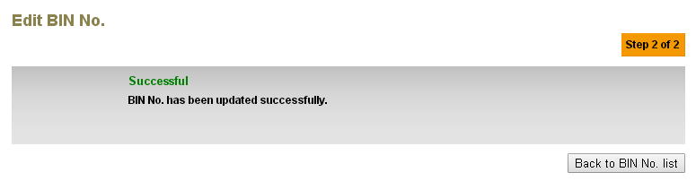

Figure 9: Edit BIN No. result screen – Step 3 of 3 (Maker Checker)

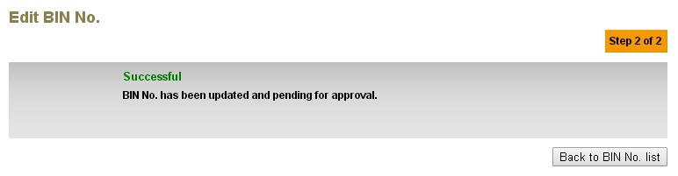

Figure 10: Edit BIN No. result screen – Step 3 of 3 (Administrator)

**Action:**

|  |  |  |  |
| --- | --- | --- | --- |
| No | Action | Type | Description |
|  | Back to BIN No. list | Button | Contains an action to allow user back to BIN No listing |

Table 13: RIB BIN No. Action

## Delete BIN No.

### Process Flows



Diagram 3: Adding the details of BIN

### Screen Flows

***Step 1:***

1. User clicks on the BIN No. details navigation to view the details of the BIN No.
2. After that, click on the Delete button which system will displayed the confirmation page

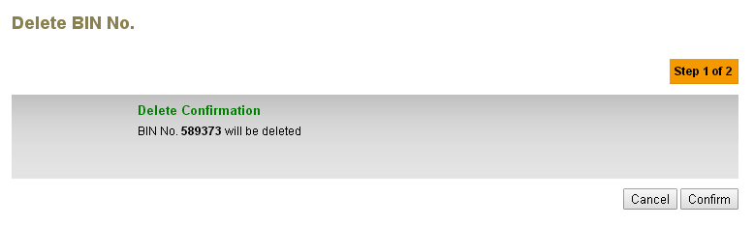

Figure 11: BIN No. delete confirmation screen

**Action:**

|  |  |  |  |
| --- | --- | --- | --- |
| No | Action | Type | Description |
|  | Cancel | Button | Contains an action to allow user to cancel the activity |
|  | Confirm | Button | Contains an action to go to next page |

Table 14: RIB BIN No. Action

***Step 2:***

1. BIN No. has been deleted and pending for approval when the user login as Maker and successfully deleted if login as Administrator.

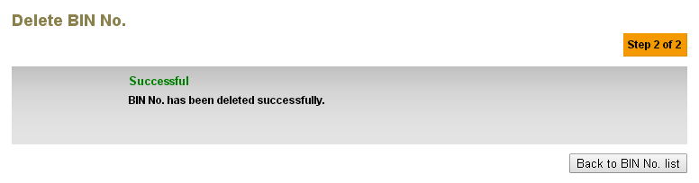

Figure 12: Delete BIN No. result screen – Step 3 of 3 (Maker Checker)

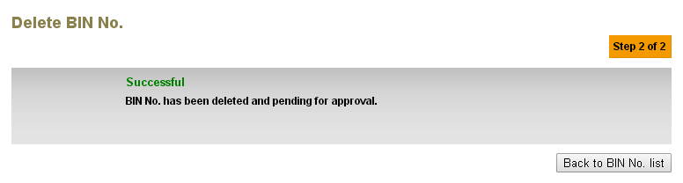

Figure 13: Delete BIN No. result screen – Step 3 of 3 (Administrator)

**Action:**

|  |  |  |  |
| --- | --- | --- | --- |
| No | Action | Type | Description |
|  | Back to BIN No. list | Button | Contains an action to allow user back to BIN No listing |

Table 15: RIB BIN No. Action

# IBAM Navigation

This feature allows IBAM user to edit the navigation menu that will be displayed in IBS

## View Details

### Process Flows



Diagram 4: View the IBAM Navigation Details

### Screen Flows

***Step 1:***

1. User access to IBAM Navigation and click on IBAM hyperlink.

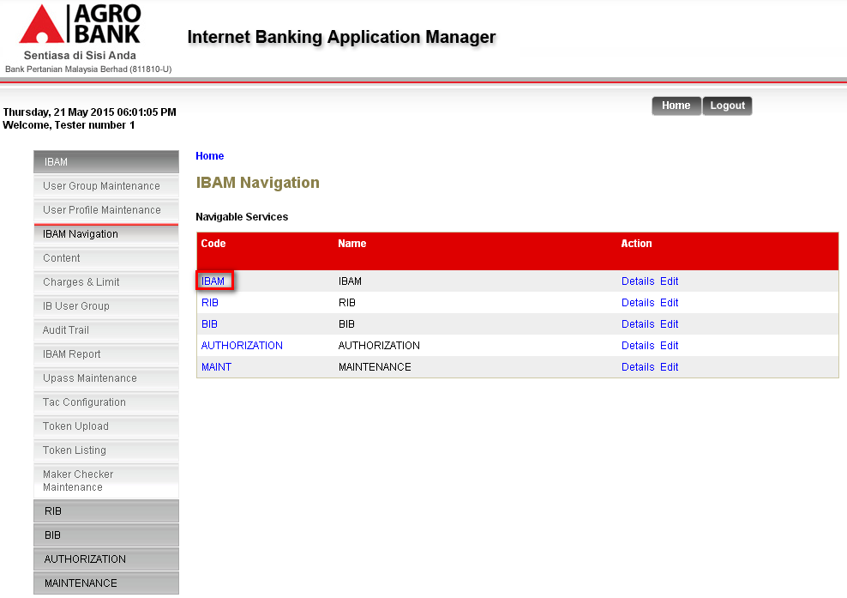

Figure 14: Home for IBAM Navigation

***Step 2:***

1. Click on Details hyperlink to view the details of RIB BIN No. Maintenance.

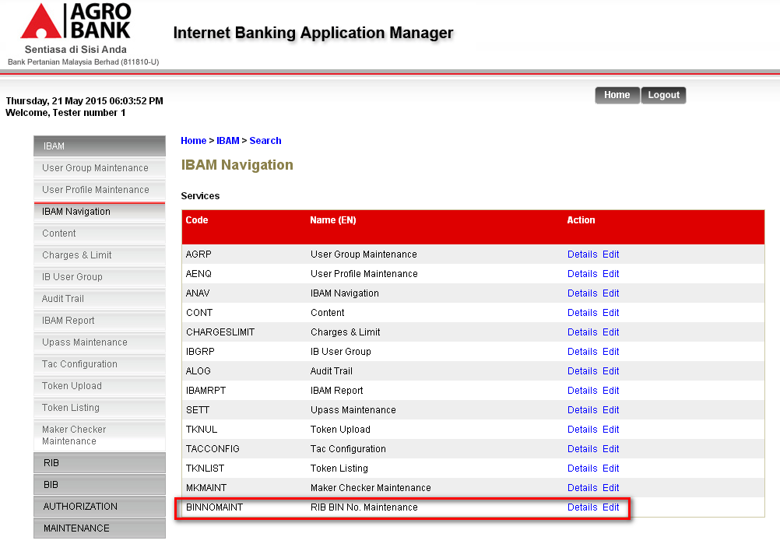

Figure 15: List of IBAM Navigation

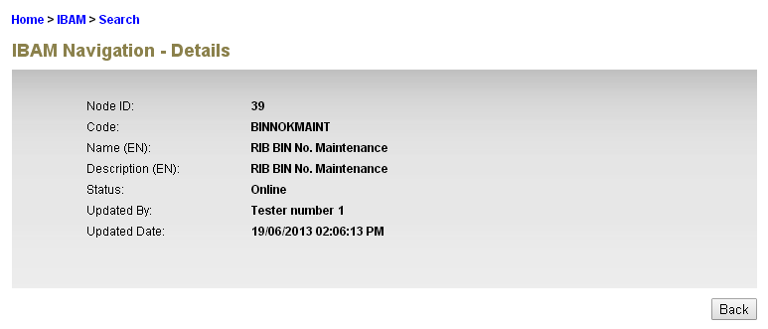

Figure 16: Details of RIB BIN No. Maintenance

## Edit Details

### Process Flows



Diagram 5: Edit the IBAM Navigation

### Screen Flows

***Step 1:***

1. User access to IBAM Navigation and click on IBAM hyperlink.
2. Click on Edit hyperlink to edit the details of RIB BIN No. Maintenance.

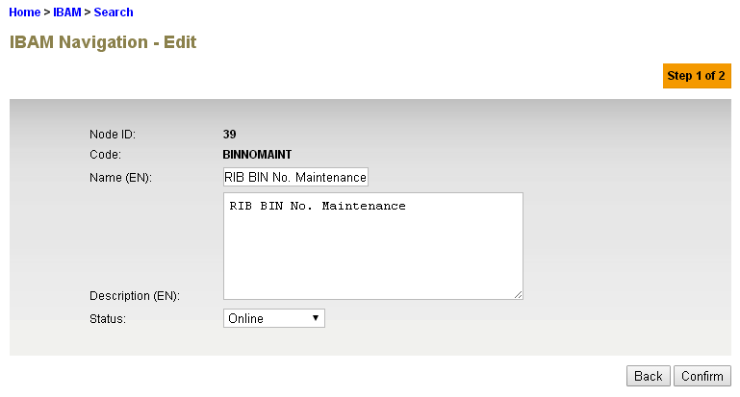

Figure 17: Edit BIN No. details page

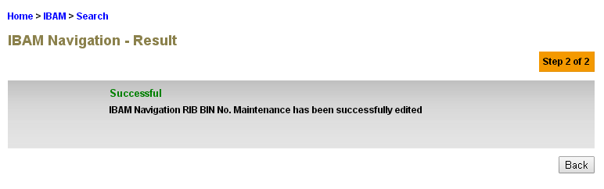

Figure 18: IBAM Navigation RIB BIN No. Maintenance result screen – Step 2 of 2 (Maker Checker)

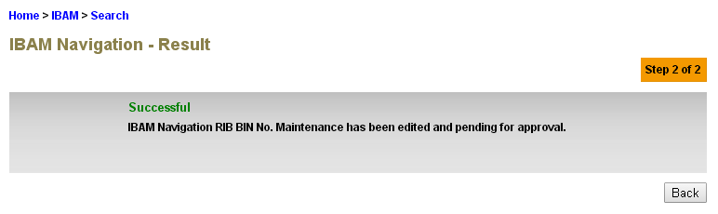

Figure 19: IBAM Navigation RIB BIN No. Maintenance result screen – Step 2 of 2 (Administrator)

# Audit Trail

To add the activity for RIB BIN No. which user able to view the activities of RIB BIN No. maintenance module

## View Details

### Screen Flows

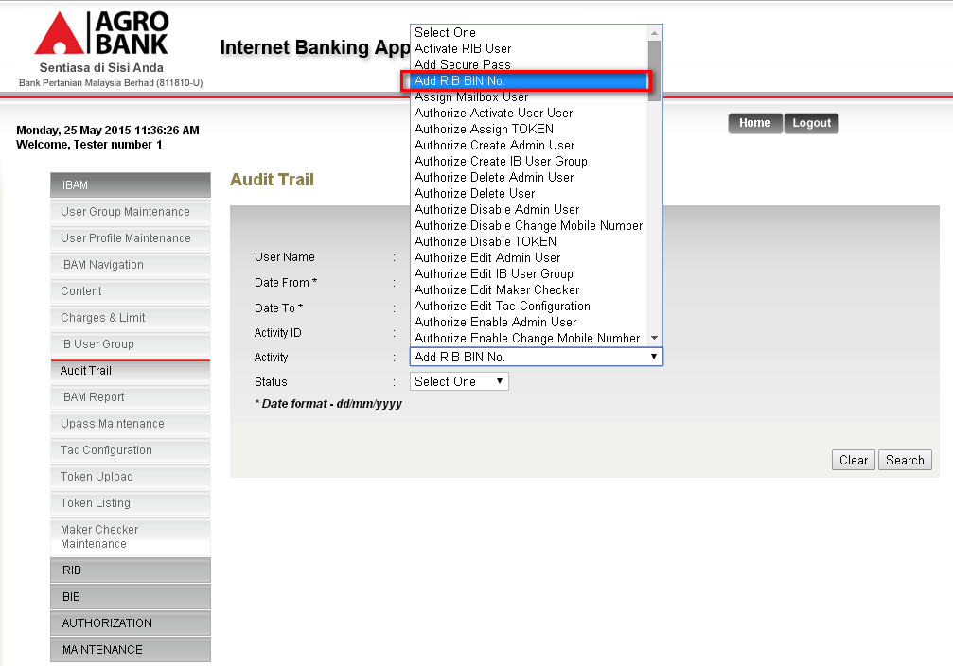

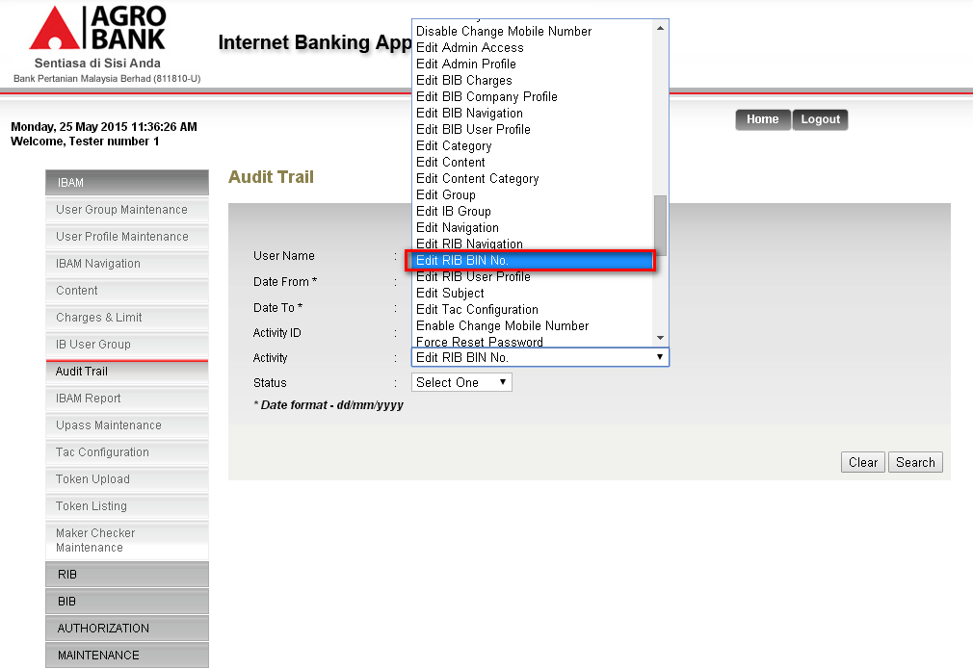

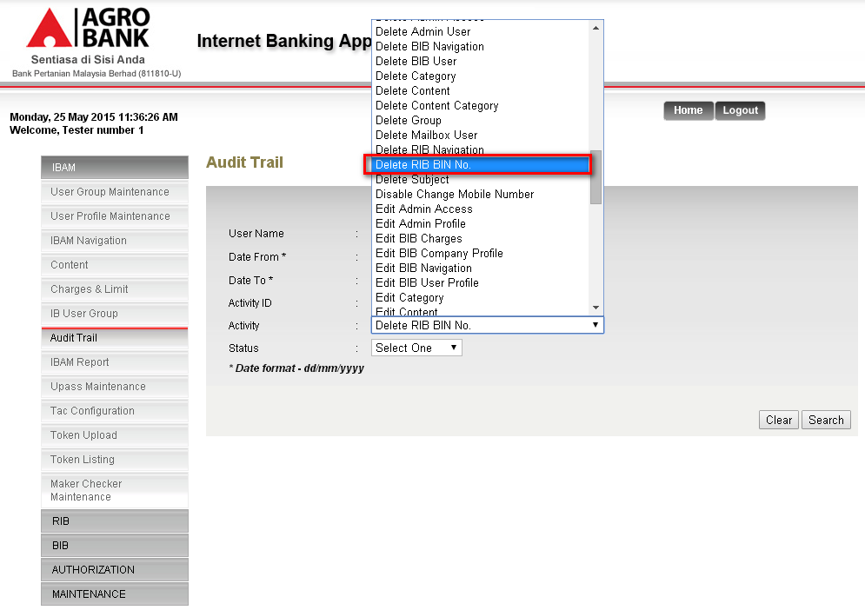

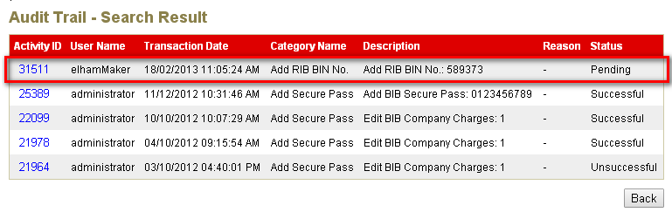

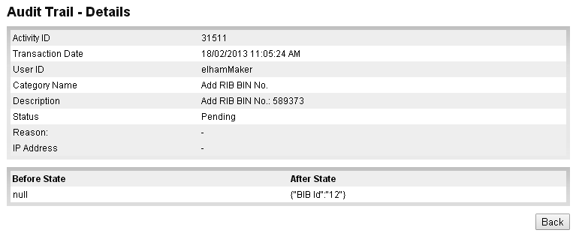

# Maker Checker Maintenance

This feature allows administrator to enable and disable the transaction authorization process for RIB BIN No. action ID.

## View Details

### Screen Flows

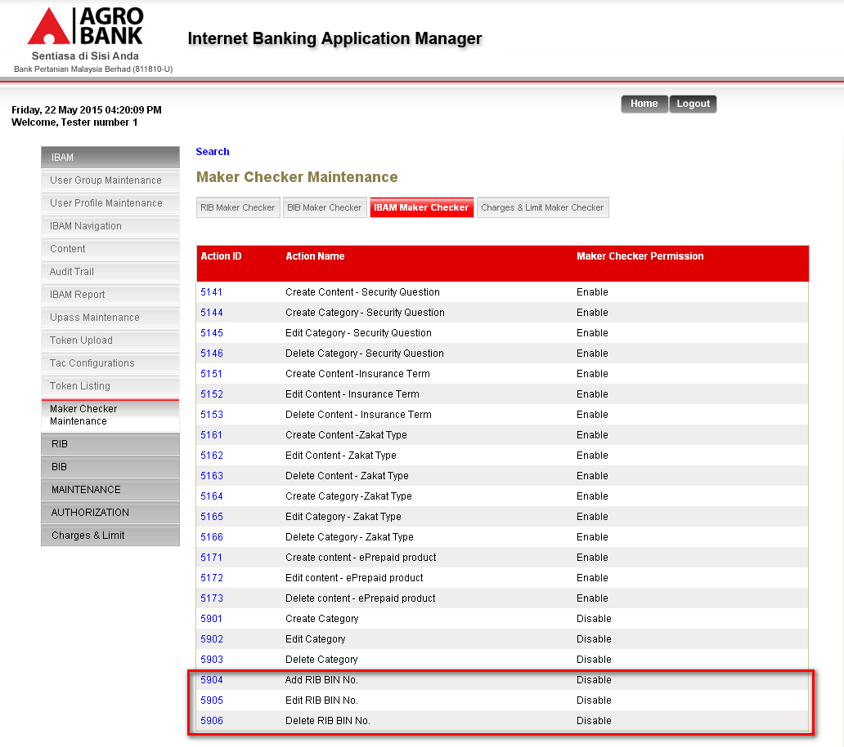

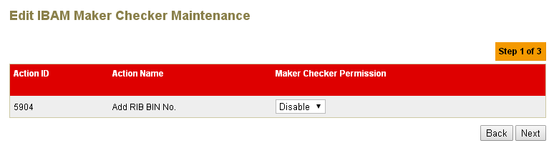

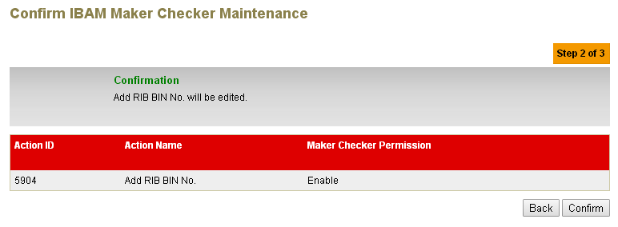

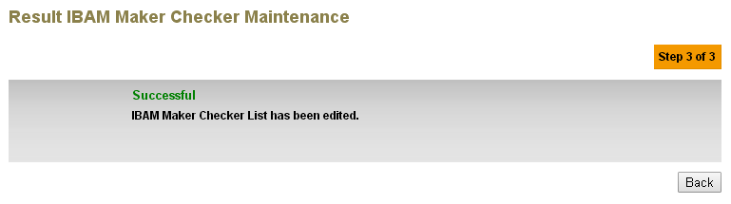

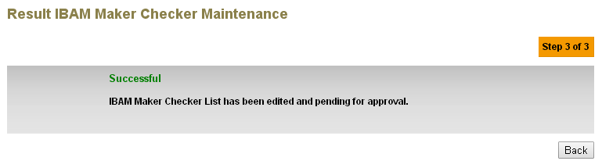

# User Group Maintenance

To view the group access for RIB BIN No. Maintenance

### Screen Flows

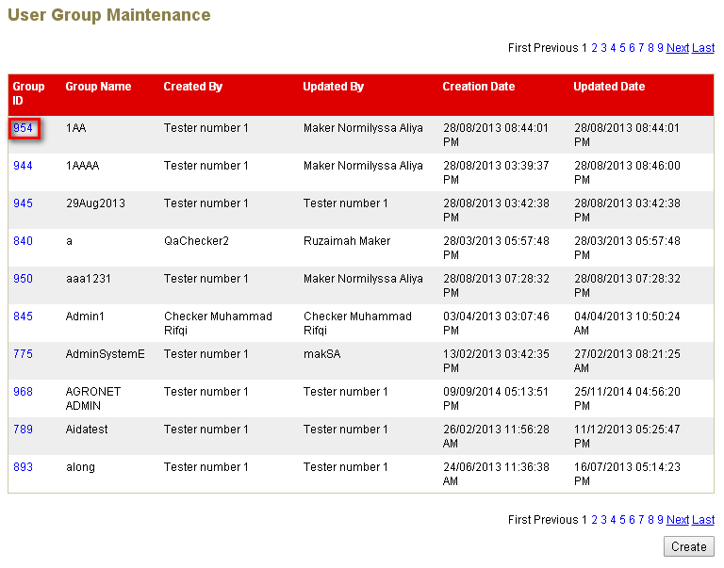

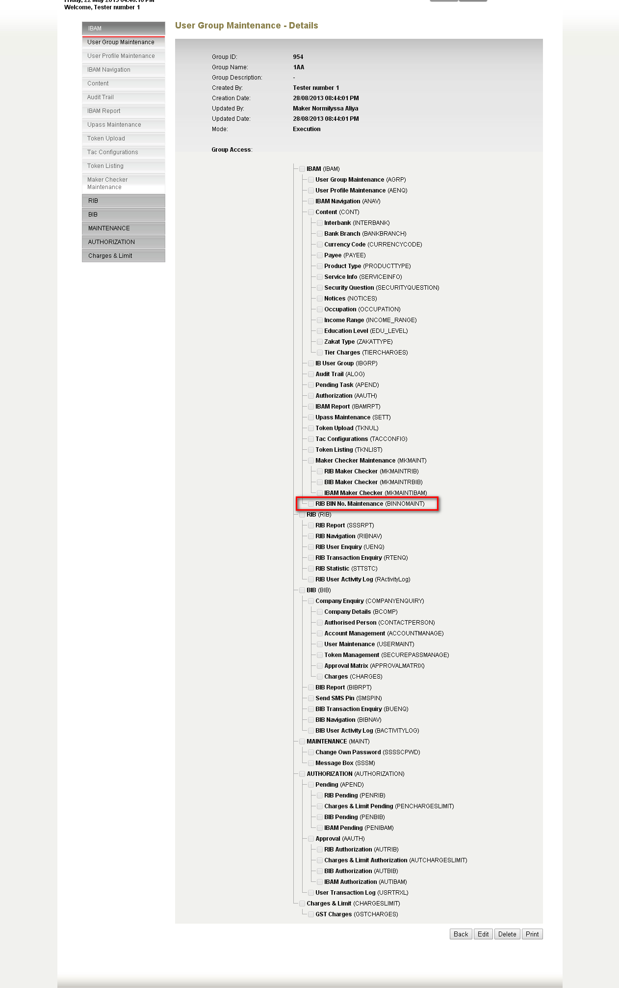

# User Profile Maintenance

To view the access for RIB BIB No. Maintenance in user profile maintenance module

### Screen Flows

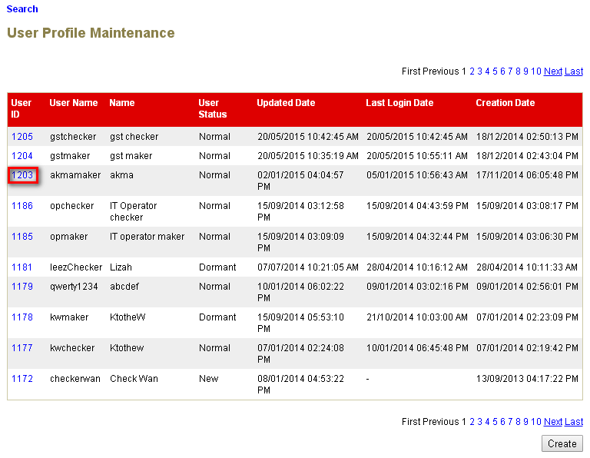

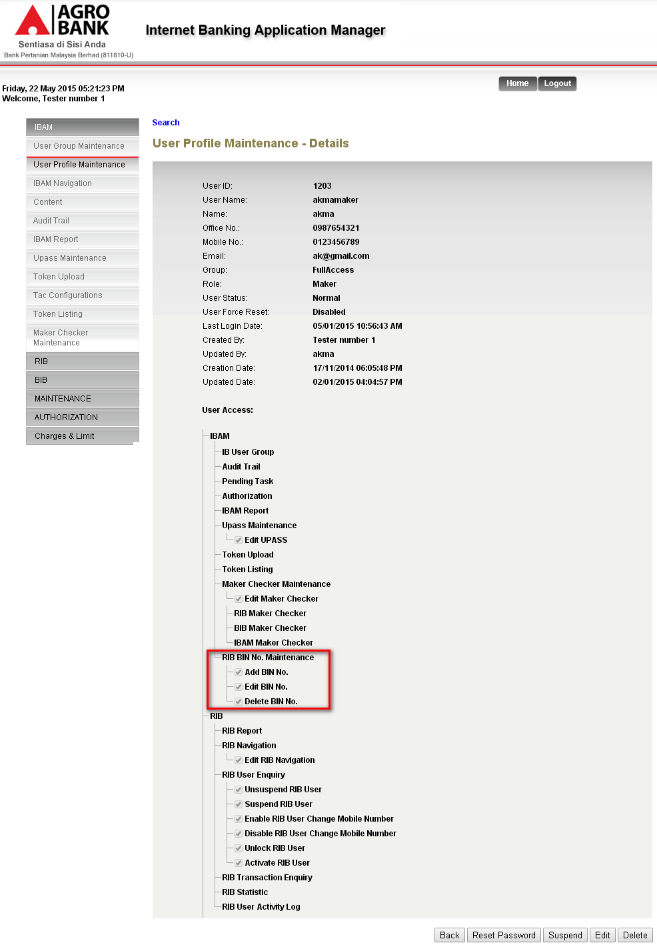

# Authorization

To view the maker checker details for each activity that has been done

## View Details

### Screen Flows

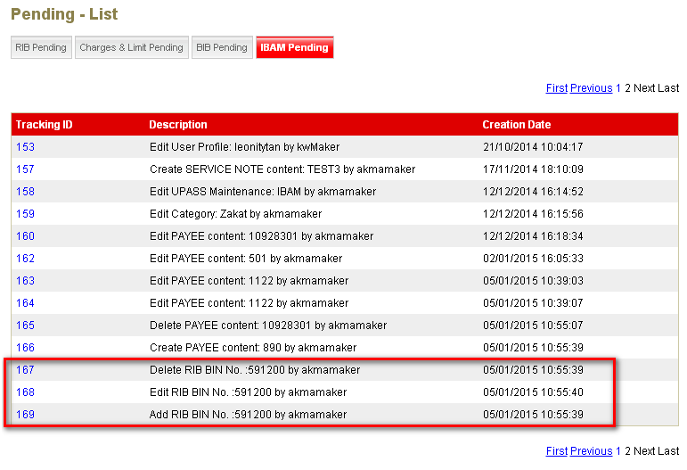

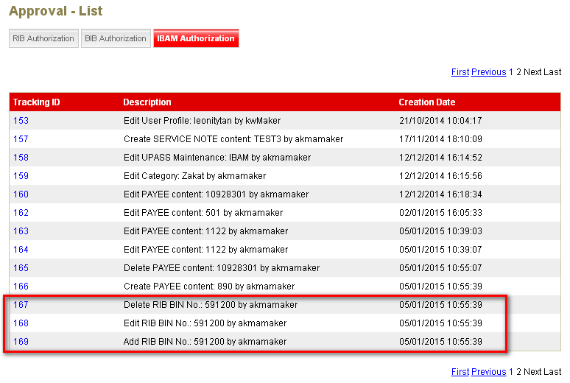

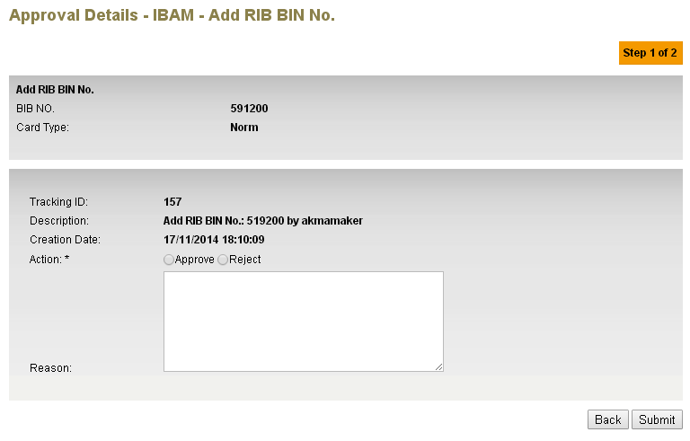

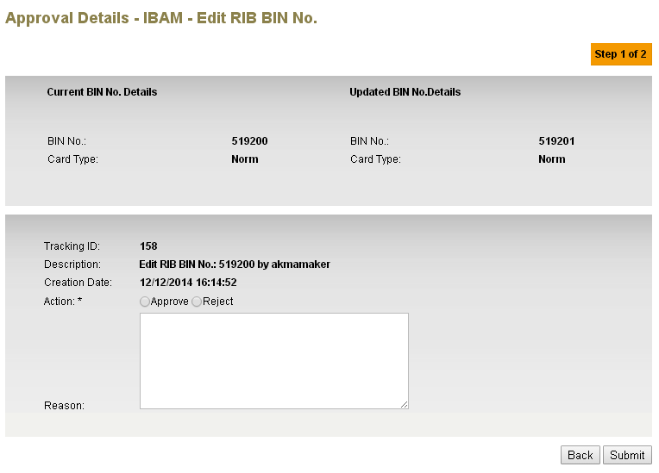

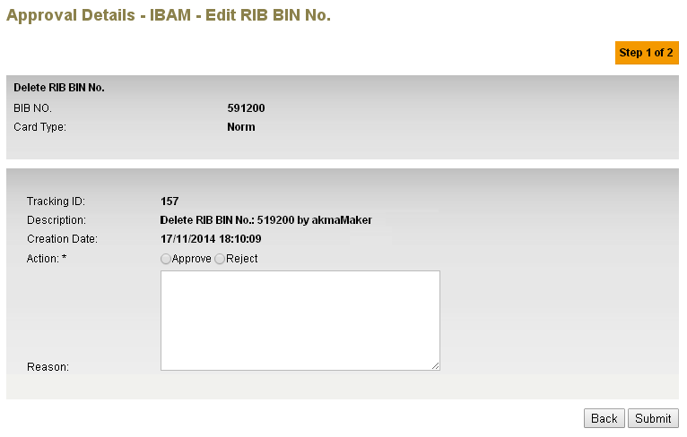

Section 3: Retail Internet Banking

# RIB Registration

To validate the card number based on bank identification number [BIN No./card type] that has been registered in IBAM.

## Registration

### Process Flows



Diagram 1: Registration flow

### Screen Flows

***Step 1:***

1. User access to RIB url. System display the Security Tips and user click on OK button to proceed to login page.

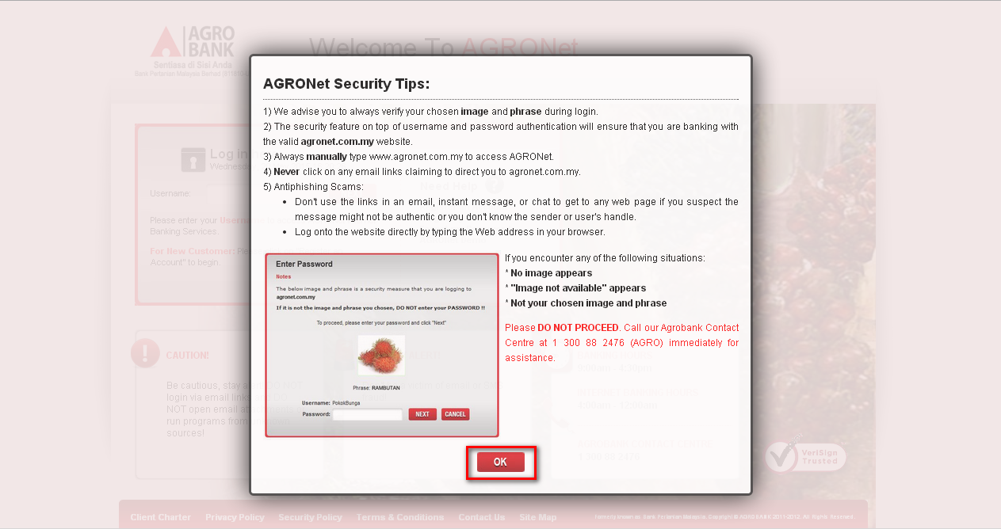

Figure 14: Security Tips page

**Action:**

|  |  |  |  |
| --- | --- | --- | --- |
| No | Action | Type | Description |
|  | OK | Button | Contains an action to go login page |

Table 16: Registraion Action

1. User click on “Registration an Account” hyperlink

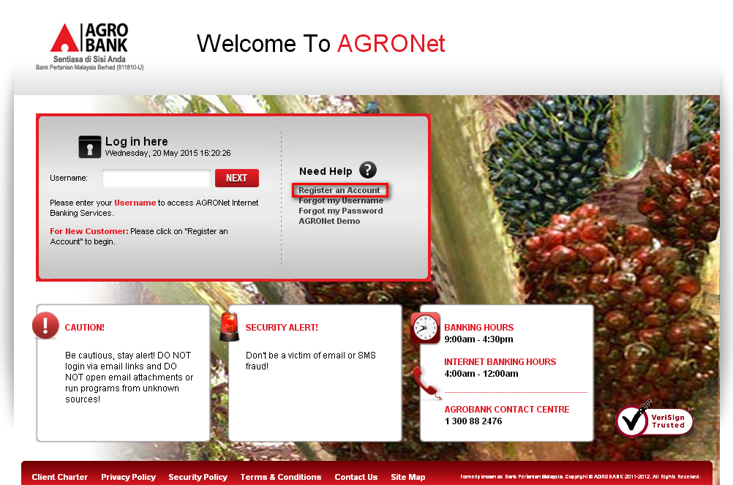

Figure 15: AGRONet Login page

**Action:**

|  |  |  |  |
| --- | --- | --- | --- |
| No | Action | Type | Description |
|  | Register an Account | Hyperlink | Contains an action to go to registration page |

Table 17: Registration Action

1. Users read on the Terms and Condition for the registration of AGRONet then click on Accept button.

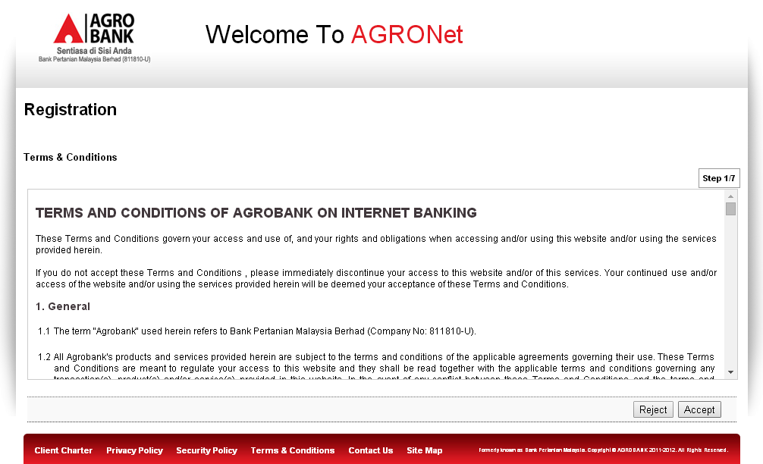

Figure 16: Terms and Condition page

**Action:**

|  |  |  |  |
| --- | --- | --- | --- |
| No | Action | Type | Description |
|  | Reject | Button | Contains an action to reject the activity |
|  | Accept | Button | Contains an action to go to Next page |

Table 18: Registration Action

1. User fills up the required details on the registration details page.

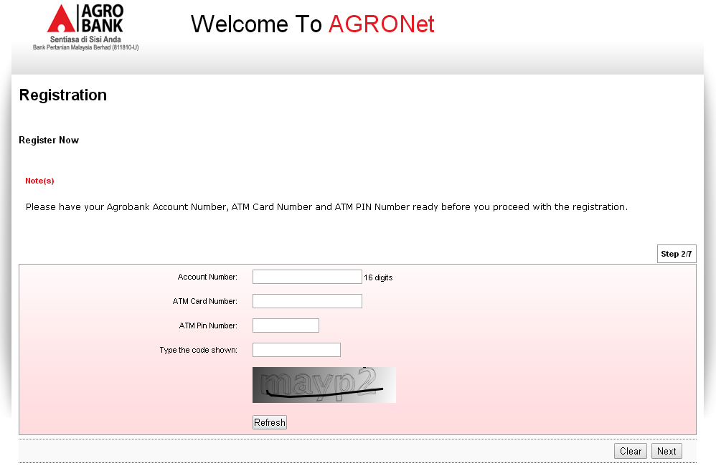

Figure 17: Registration details page

**Input Specification:**

| **No** | **Field** | **Field Type** | **Validation Rule** | **Description** | **M/O** |
| --- | --- | --- | --- | --- | --- |
|  | Account Number | Text box | Numeric  Max length: 16 | RIB Account Number | M |
|  | ATM Card Number | Text box | Numeric  Max length: 16 | RIB ATM Card Number | M |
|  | ATM PIN Number | Text box | Numeric, masked  Max length: 6 | PIN No for the ATM Card | M |
|  | Code CAPTCHA | Text box | Alphanumeric | CAPTCHA code for human verification | M |

**Table 19: Registration**

**Action:**

| **No** | **Action** | **Type** | **Description** |
| --- | --- | --- | --- |
|  | Refresh | Button | Contains an action to go to clear the security code |
|  | Clear | Button | Contains an action to go to clear the page |
|  | Next | Button | Contains an action to go to next page |

**Table 20: Edit BIN No. details List Action**

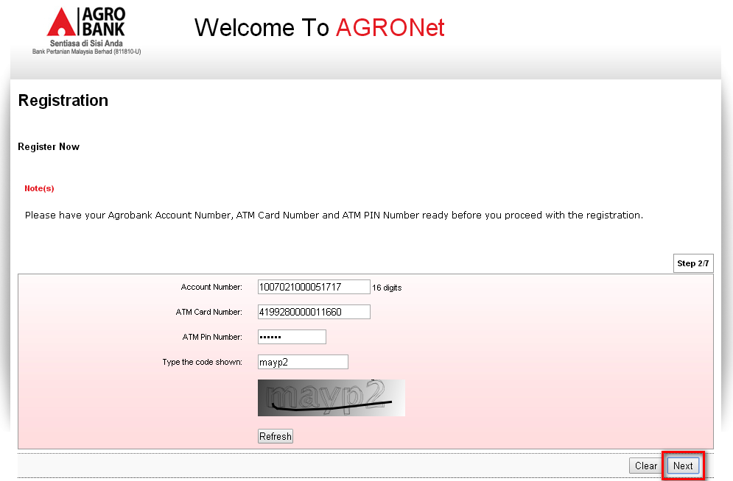

Figure 18: Registration details page

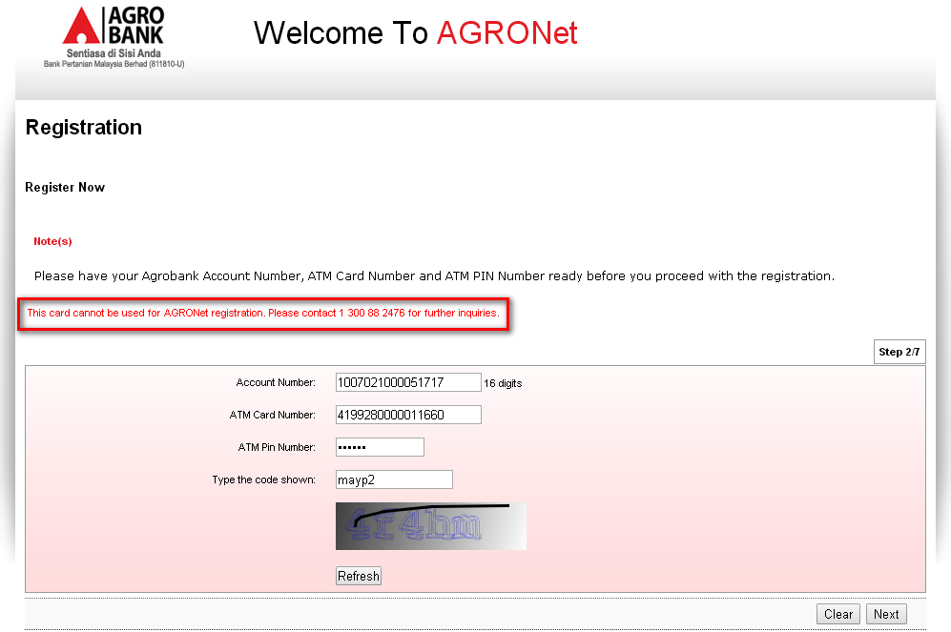

Figure 17: Registration details page with error message displayed

Section 3: Change Impact Analysis

Impacted Modules:-

|  |  |  |
| --- | --- | --- |
| No | Modules | Changes |
|  | RIB >Registration | * Display error message if user key in unauthorized card number |
|  | IBAM>RIB BIN No. Maintenance  IBAM>IBAM Navigation  IBAM>Audit Trail  IBAM>Maker Checker Maintenance  IBAM>User Group Maintenance  IBAM>User Profile Maintenance  IBAM>Authorization | * Add new navigation * Add new modules * Add activity list * Add permission * Add new module * Add new module * Add pending and approval activity |