***Issue Form (PROD)***

|  |  |
| --- | --- |
| **Originator's Name:** Chooi So Fun  **Project:** Internet Banking  **Project Manager:** Malarvili  **Module : Prepaid**  **Date Raised: 04.06.2014**  **Phase :** Internet Banking  **Functional Area : Prepaid** | **Issue ID Number:**  **Related Issue ID Number:** HD00016084  **Classification:**  **Priority:** Critical/High/Medium/Low  **Assigned to: Vendor / IT / PMO SA / UPA**  **Actual Closed Date:** |
| **Status:** Open/Assigned/Investigated/Resolved/Approved/Deferred/No Action  *(Circle one)* | |
| **Description :**  There were total extra 7 Prepaid transactions performed on 3 June 2015 were successful captured at ePay. Customers’ accounts were debited and credited to ePay’s account accordingly. However, all these 7 transactions were not reflected in all the BVMC Report.  *Please refer to file attached for further details.* | **Impact:** |
| **Findings/Root Caused (Description):** | **Resolution:** |
| **Estimated Impact :** |  |
| **Recommendation:** | |
| **Accepted :**  **(Vendor / IT / PMO SA / UPA)**  **Date:** | **Accepted (KFHMB Tester):**  **Date:** |

**The below 7 transactions performed on 3 June 2015 were successful where customers’ accounts were debited and credited to ePay’s account**

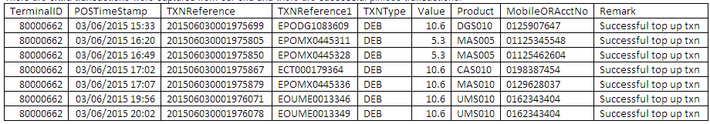

**ePay’s account - Credited**

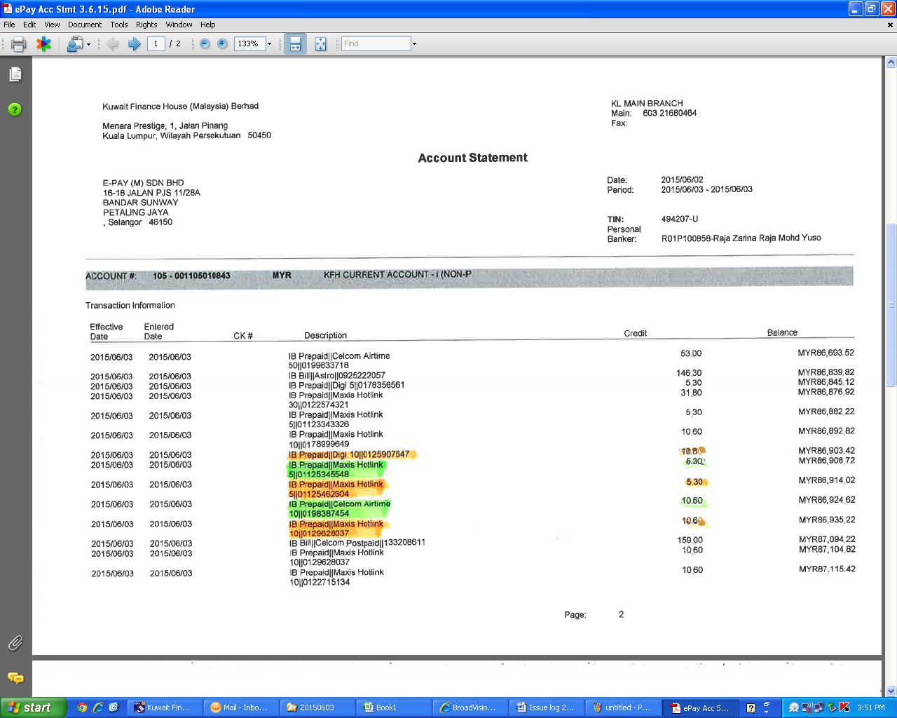

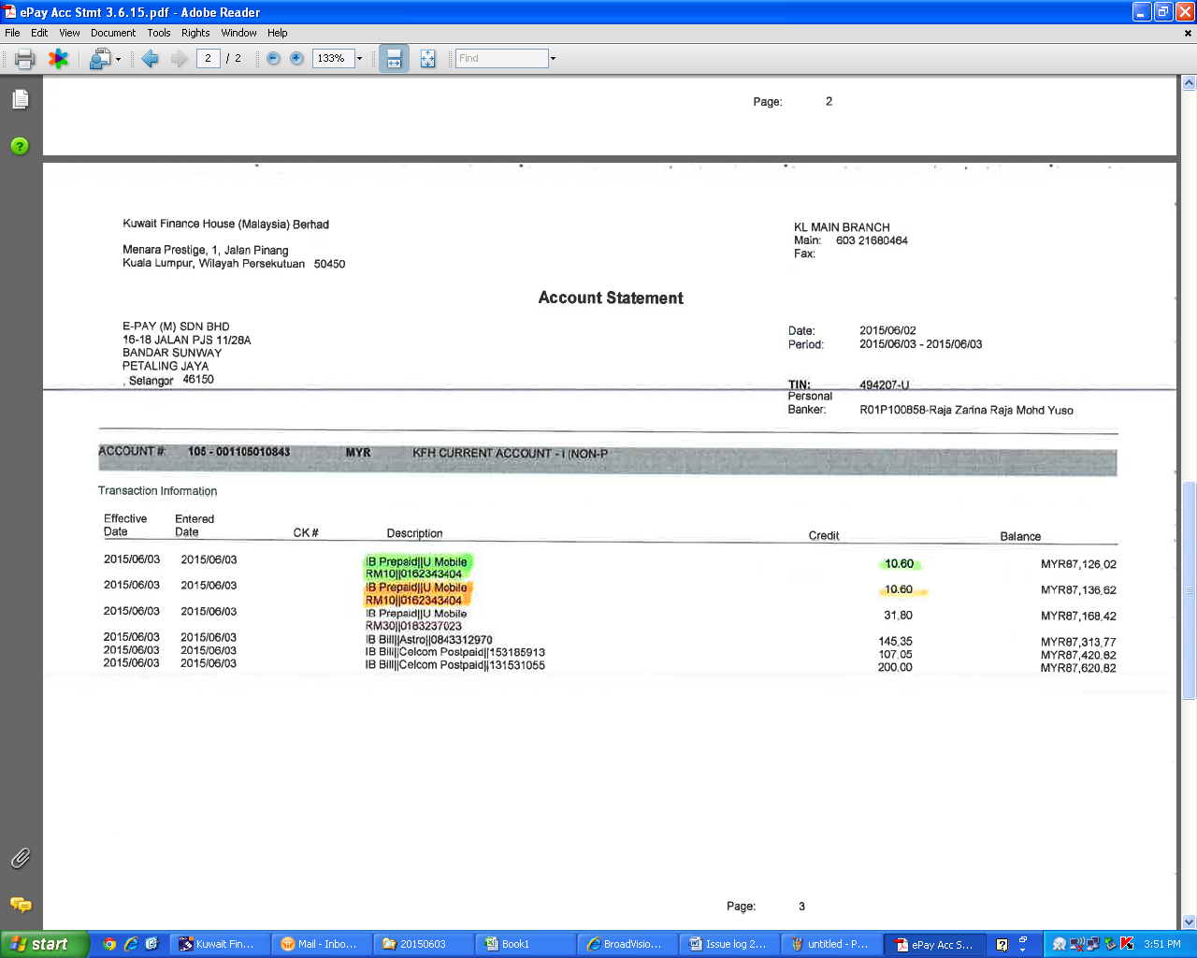

**Phoenix Report – Customers’ account Debited and Credited to ePay’s account**

