**SUSPENDED AGRONET ID WILL BE ACTIVATED ONCE DSUCCESSFUL ID FORGOT PASSWORD**

1. **SUSPENDED ID AT IBAM**

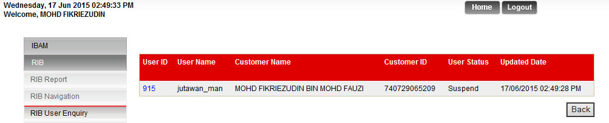

1. **TRY LOGIN AGRONET**

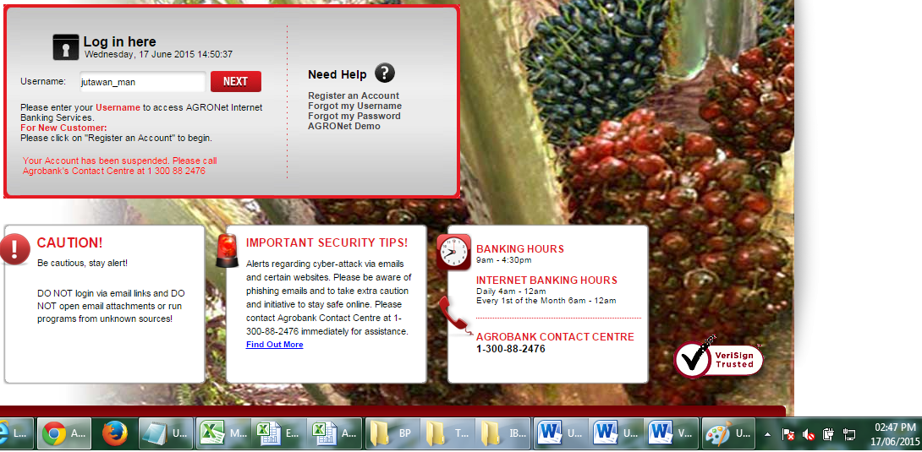

1. **TRY USE FORGOT PASSWORD**

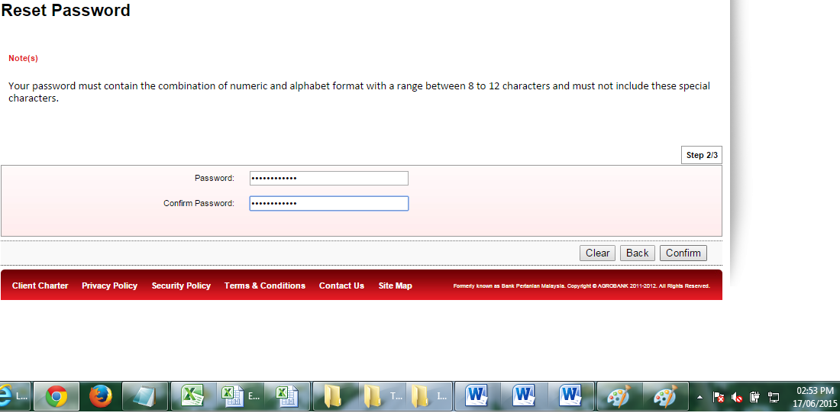

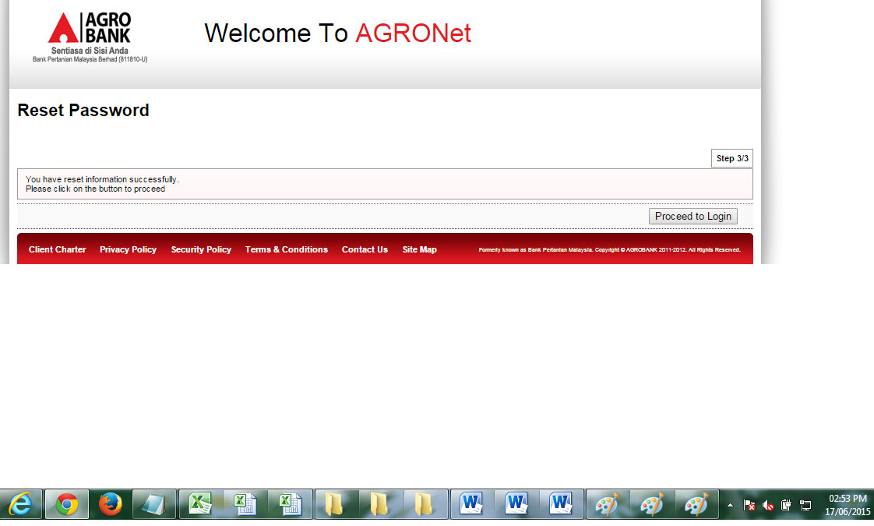

1. **TRY LOGIN AGRONET**

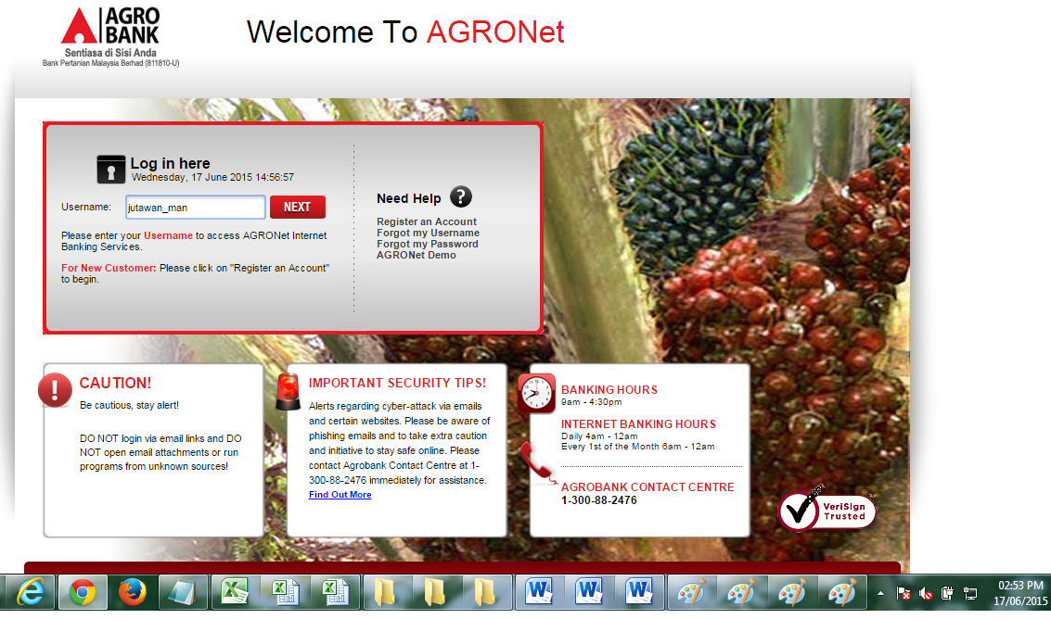

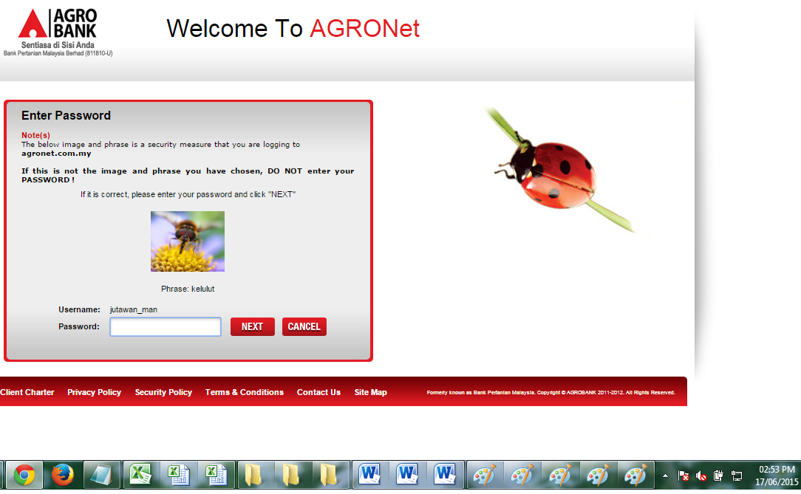

1. **CHECK STATUS ID AT IBAM ; THE AGRONET ID BECOME ACTIVATE**

