**Details of SR:**

MSS :- display FCR charges type (SHA / OUR) in cust trx enquiry

- Site Management - interbank / SKN/RTGS Enhance drop down top ten bank for value "Please Select" is not set to 0.

cause this impact to order bank list function

* in all search menu set case insensitive

**Test Script #1: N/A (CR)**

**Test Script #2: (this only found at customer transaction enquiry)**

1. go to customer transaction enquiry > search user id ‘RIBUSER1’
2. It shall be able to list down all the transaction performed by this user.

**Screen Capture:**

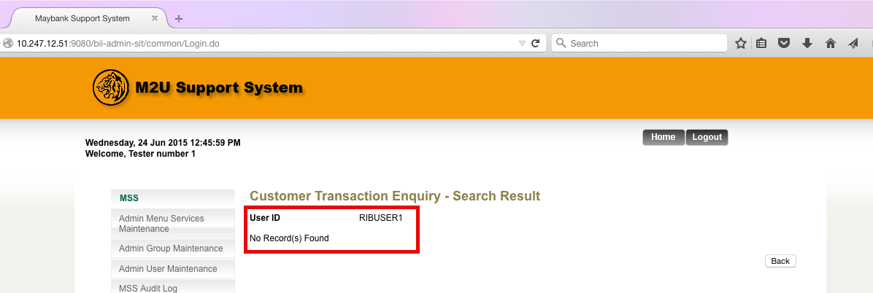

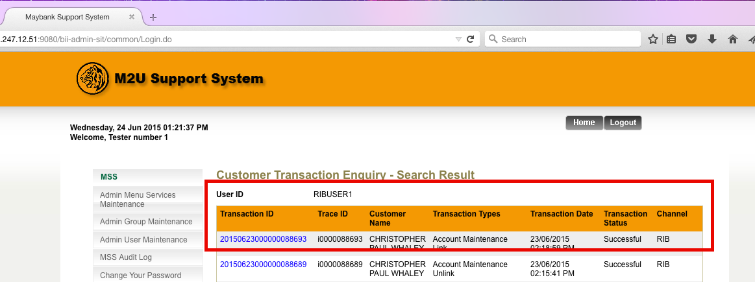

**Test Script #3**

**Check ordering if set as ‘please select’:**

1. Go to admin > site management > search > mandiri syar
2. Edit > top 10 bank
3. Set to 5
4. See the result in RIB > SKN/RTGS
5. Step 1 -2, set top 10 to ‘please select’
6. See the result in RIB > SKN/RTGS

**Check for order number duplication:**

1. Go to admin > site management > search > mandiri syar
2. Edit > top 10 bank
3. Set to 5
4. See the result in RIB > SKN/RTGS
5. Step 1 -2, top 10 order to 5 for other SKN bank
6. See the result in RIB > SKN/RTGS. Mandiri syariah will be overwritten (default using ascending order). And this new skn bank will be in 5th order

**Production Notes:**

Make sure there is no duplicated order number by executing below query:

select skn_top_ten, skn_indicator, count(*) from dbo.ib_bancnet_list group by skn_top_ten, skn_indicator having count > 1;

**Screen Capture Before:**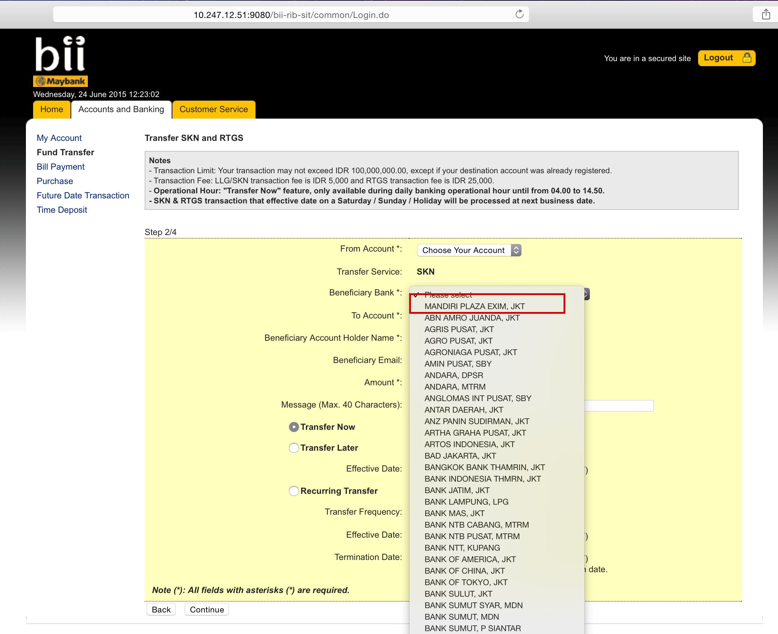

**Screen Capture After:** 