**Payment via Credit Card Summary > Details > Pay Button**

**Full Amount Test Script:**

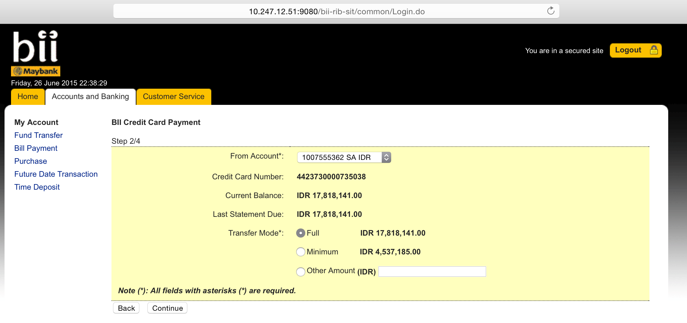

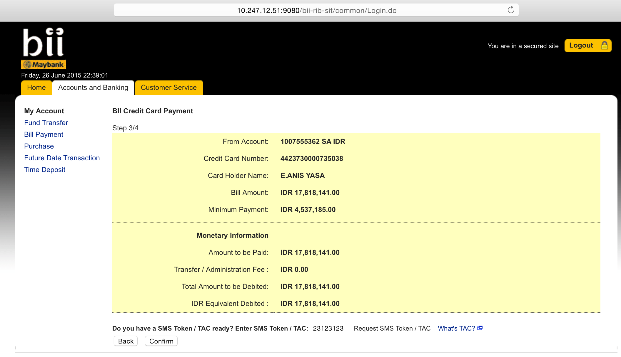

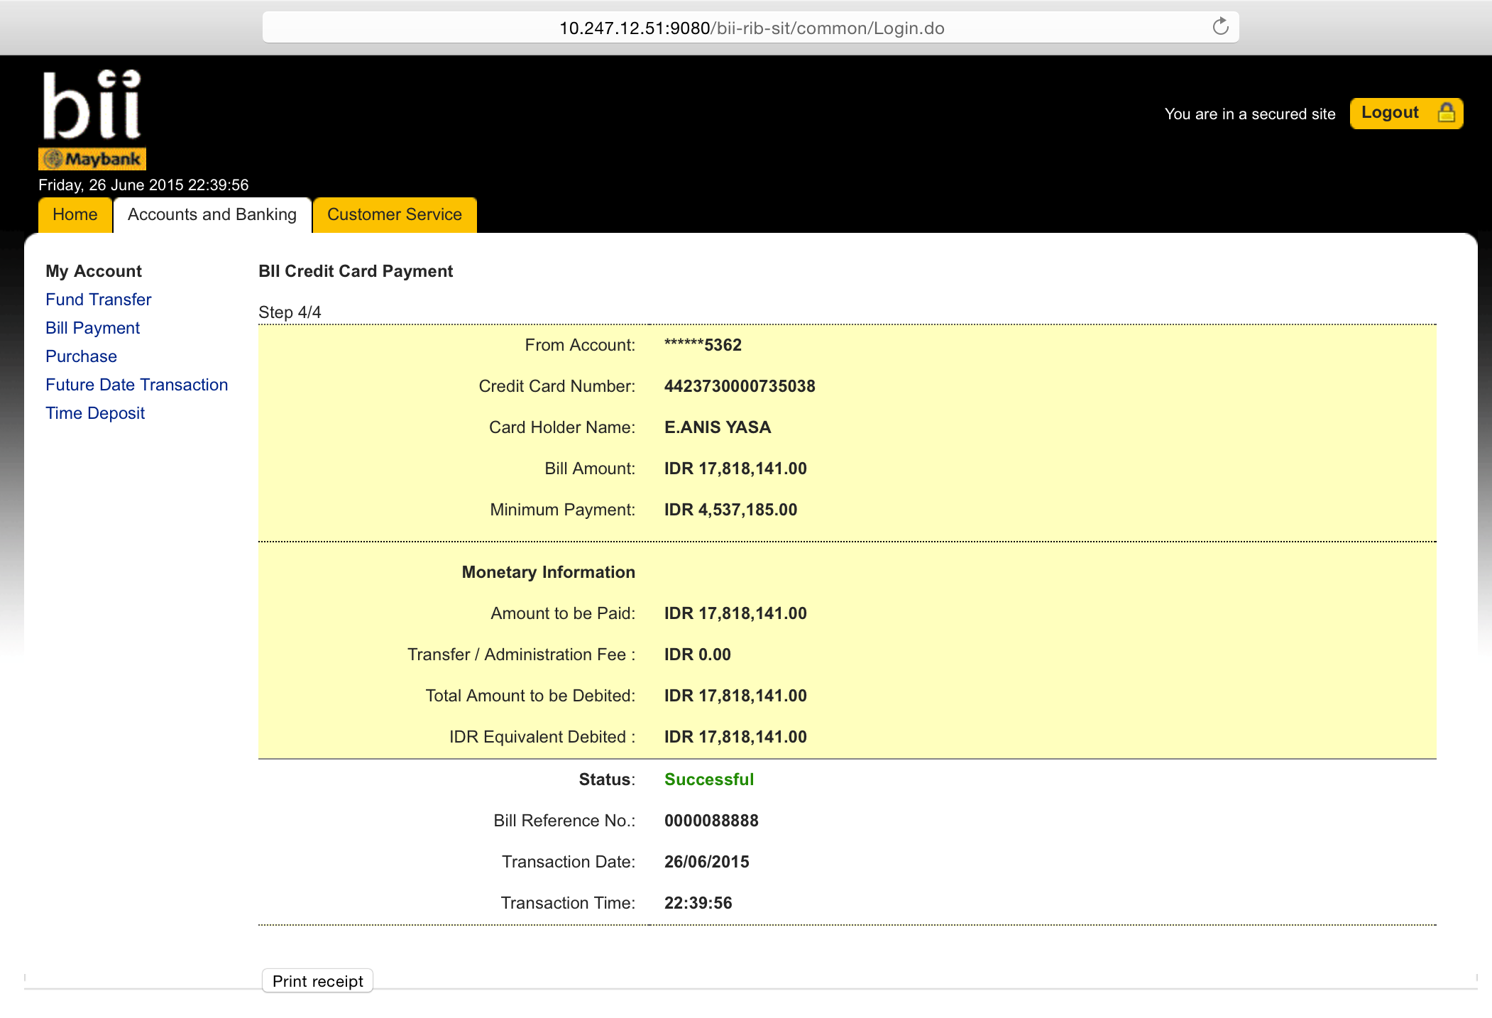

[6/26/15 22:39:56:521 WIT] 000000fa SystemOut O [26/06/2015] [22:39:56:521] [INFO] [ESBPostpaidPaymentServices]:371 - <<<<<<<<<<<<<<<<< Header >>>>>>>>>>>>>>>>>>>

[6/26/15 22:39:56:522 WIT] 000000fa SystemOut O [26/06/2015] [22:39:56:521] [INFO] [ESBPostpaidPaymentServices]:372 - Message ID: D8EB683F-A9D4-40F8-8BE1-C2067CC0B554

[6/26/15 22:39:56:522 WIT] 000000fa SystemOut O [26/06/2015] [22:39:56:522] [INFO] [ESBPostpaidPaymentServices]:373 - Branch Code: 270

[6/26/15 22:39:56:522 WIT] 000000fa SystemOut O [26/06/2015] [22:39:56:522] [INFO] [ESBPostpaidPaymentServices]:374 - Channel ID: M2U

[6/26/15 22:39:56:522 WIT] 000000fa SystemOut O [26/06/2015] [22:39:56:522] [INFO] [ESBPostpaidPaymentServices]:375 - Client Supervisor ID: 0000

[6/26/15 22:39:56:523 WIT] 000000fa SystemOut O [26/06/2015] [22:39:56:522] [INFO] [ESBPostpaidPaymentServices]:376 - Client UserID: 0000

[6/26/15 22:39:56:523 WIT] 000000fa SystemOut O [26/06/2015] [22:39:56:523] [INFO] [ESBPostpaidPaymentServices]:377 - Reference No: M2U/123/2013

[6/26/15 22:39:56:523 WIT] 000000fa SystemOut O [26/06/2015] [22:39:56:523] [INFO] [ESBPostpaidPaymentServices]:378 - Sequence No: 8495

[6/26/15 22:39:56:524 WIT] 000000fa SystemOut O [26/06/2015] [22:39:56:523] [INFO] [ESBPostpaidPaymentServices]:379 - Transaction Date: 26-06-2015

[6/26/15 22:39:56:524 WIT] 000000fa SystemOut O [26/06/2015] [22:39:56:524] [INFO] [ESBPostpaidPaymentServices]:380 - Transaction Time: 22:39:56

[6/26/15 22:39:56:524 WIT] 000000fa SystemOut O [26/06/2015] [22:39:56:524] [INFO] [ESBPostpaidPaymentServices]:111 - <<<<<<<<<<<<<<<<< Request >>>>>>>>>>>>>>>>>>>

[6/26/15 22:39:56:524 WIT] 000000fa SystemOut O [26/06/2015] [22:39:56:524] [INFO] [ESBPostpaidPaymentServices]:112 - RoutingCode:

[6/26/15 22:39:56:525 WIT] 000000fa SystemOut O [26/06/2015] [22:39:56:524] [INFO] [ESBPostpaidPaymentServices]:116 - ### ISO8583MsgType ###

[6/26/15 22:39:56:525 WIT] 000000fa SystemOut O [26/06/2015] [22:39:56:525] [INFO] [ESBPostpaidPaymentServices]:119 - Message Type Identifier: 0100

[6/26/15 22:39:56:525 WIT] 000000fa SystemOut O [26/06/2015] [22:39:56:525] [INFO] [ESBPostpaidPaymentServices]:127 - Processing Code: 191000

[6/26/15 22:39:56:526 WIT] 000000fa SystemOut O [26/06/2015] [22:39:56:525] [INFO] [ESBPostpaidPaymentServices]:131 - Transaction Amount: 1781814100

[6/26/15 22:39:56:526 WIT] 000000fa SystemOut O [26/06/2015] [22:39:56:526] [INFO] [ESBPostpaidPaymentServices]:135 - System Trace Audit Number: 088888

[6/26/15 22:39:56:526 WIT] 000000fa SystemOut O [26/06/2015] [22:39:56:526] [INFO] [ESBPostpaidPaymentServices]:139 - Local Time Transaction: 223956

[6/26/15 22:39:56:526 WIT] 000000fa SystemOut O [26/06/2015] [22:39:56:526] [INFO] [ESBPostpaidPaymentServices]:143 - Local Date Transaction: 0626

[6/26/15 22:39:56:527 WIT] 000000fa SystemOut O [26/06/2015] [22:39:56:526] [INFO] [ESBPostpaidPaymentServices]:147 - Pos Entry Mode Code: 018

[6/26/15 22:39:56:527 WIT] 000000fa SystemOut O [26/06/2015] [22:39:56:527] [INFO] [ESBPostpaidPaymentServices]:151 - Acquiring Institution ID: 001

[6/26/15 22:39:56:527 WIT] 000000fa SystemOut O [26/06/2015] [22:39:56:527] [INFO] [ESBPostpaidPaymentServices]:155 - Retrieval Reference Number: 000000088888

[6/26/15 22:39:56:527 WIT] 000000fa SystemOut O [26/06/2015] [22:39:56:527] [INFO] [ESBPostpaidPaymentServices]:163 - Card Acceptor Terminal ID: 11007

[6/26/15 22:39:56:528 WIT] 000000fa SystemOut O [26/06/2015] [22:39:56:528] [INFO] [ESBPostpaidPaymentServices]:170 - Card Acceptor Identification Code: 10.230.1.237

[6/26/15 22:39:56:528 WIT] 000000fa SystemOut O [26/06/2015] [22:39:56:528] [INFO] [ESBPostpaidPaymentServices]:174 - Card Acceptor Name Location: CHRISTOPHER PAUL WHALEY

[6/26/15 22:39:56:528 WIT] 000000fa SystemOut O [26/06/2015] [22:39:56:528] [INFO] [ESBPostpaidPaymentServices]:178 - 046 Additional Data: BII Credit Card Payment

[6/26/15 22:39:56:529 WIT] 000000fa SystemOut O [26/06/2015] [22:39:56:528] [INFO] [ESBPostpaidPaymentServices]:182 - 048 Additional Data: 4423730913

[6/26/15 22:39:56:529 WIT] 000000fa SystemOut O [26/06/2015] [22:39:56:529] [INFO] [ESBPostpaidPaymentServices]:187 - Currency Code: 360

[6/26/15 22:39:56:529 WIT] 000000fa SystemOut O [26/06/2015] [22:39:56:529] [INFO] [ESBPostpaidPaymentServices]:203 - Payee: 4423730000735038

[6/26/15 22:39:56:529 WIT] 000000fa SystemOut O [26/06/2015] [22:39:56:529] [INFO] [ESBPostpaidPaymentServices]:207 - From Account: 0161007555362

[6/26/15 22:39:56:531 WIT] 000000fa SystemOut O wsRequest.getSendMessageRequest().getISO8583Msg().getDE003ProcessingCode().substring(0, 2) =19

[6/26/15 22:39:56:531 WIT] 000000fa SystemOut O [26/06/2015] [22:39:56:531] [INFO] [ESBPostpaidPaymentServices]:225 - <<<<<<<<<<<<<<<<< Response >>>>>>>>>>>>>>>>>>>

[6/26/15 22:39:56:531 WIT] 000000fa SystemOut O [26/06/2015] [22:39:56:531] [INFO] [ESBPostpaidPaymentServices]:226 - Response Code: 00

[6/26/15 22:39:56:531 WIT] 000000fa SystemOut O responseData.getDE103ToAccount():null

[6/26/15 22:39:56:531 WIT] 000000fa SystemOut O [26/06/2015] [22:39:56:531] [INFO] [ESBPostpaidPaymentServices]:258 - Message Type Identifier: null

[6/26/15 22:39:56:532 WIT] 000000fa SystemOut O [26/06/2015] [22:39:56:532] [INFO] [ESBPostpaidPaymentServices]:259 - Primary Account Number: null

[6/26/15 22:39:56:532 WIT] 000000fa SystemOut O [26/06/2015] [22:39:56:532] [INFO] [ESBPostpaidPaymentServices]:260 - Processing Code: null

[6/26/15 22:39:56:532 WIT] 000000fa SystemOut O [26/06/2015] [22:39:56:532] [INFO] [ESBPostpaidPaymentServices]:261 - Amount Transaction: null

[6/26/15 22:39:56:533 WIT] 000000fa SystemOut O [26/06/2015] [22:39:56:532] [INFO] [ESBPostpaidPaymentServices]:262 - System Trace Audit Number: null

[6/26/15 22:39:56:533 WIT] 000000fa SystemOut O [26/06/2015] [22:39:56:533] [INFO] [ESBPostpaidPaymentServices]:263 - Local Time Transaction: null

[6/26/15 22:39:56:533 WIT] 000000fa SystemOut O [26/06/2015] [22:39:56:533] [INFO] [ESBPostpaidPaymentServices]:264 - Local Date Transaction: null

[6/26/15 22:39:56:533 WIT] 000000fa SystemOut O [26/06/2015] [22:39:56:533] [INFO] [ESBPostpaidPaymentServices]:265 - Pos Entry Mode Code: null

[6/26/15 22:39:56:534 WIT] 000000fa SystemOut O [26/06/2015] [22:39:56:533] [INFO] [ESBPostpaidPaymentServices]:266 - Acquiring Institution ID: null

[6/26/15 22:39:56:534 WIT] 000000fa SystemOut O [26/06/2015] [22:39:56:534] [INFO] [ESBPostpaidPaymentServices]:267 - Track 2 Data: null

[6/26/15 22:39:56:534 WIT] 000000fa SystemOut O [26/06/2015] [22:39:56:534] [INFO] [ESBPostpaidPaymentServices]:268 - Retrieval Reference Number: null

[6/26/15 22:39:56:535 WIT] 000000fa SystemOut O [26/06/2015] [22:39:56:534] [INFO] [ESBPostpaidPaymentServices]:269 - Auth Identification Response: null

[6/26/15 22:39:56:535 WIT] 000000fa SystemOut O [26/06/2015] [22:39:56:535] [INFO] [ESBPostpaidPaymentServices]:270 - Response Code: null

[6/26/15 22:39:56:535 WIT] 000000fa SystemOut O [26/06/2015] [22:39:56:535] [INFO] [ESBPostpaidPaymentServices]:271 - Card Acceptor Terminal ID: null

[6/26/15 22:39:56:535 WIT] 000000fa SystemOut O [26/06/2015] [22:39:56:535] [INFO] [ESBPostpaidPaymentServices]:272 - Card Acceptor Identification Code: null

[6/26/15 22:39:56:536 WIT] 000000fa SystemOut O [26/06/2015] [22:39:56:535] [INFO] [ESBPostpaidPaymentServices]:273 - Card Acceptor Name Location: null

[6/26/15 22:39:56:536 WIT] 000000fa SystemOut O [26/06/2015] [22:39:56:536] [INFO] [ESBPostpaidPaymentServices]:274 - 046 Additional Data: null

[6/26/15 22:39:56:536 WIT] 000000fa SystemOut O [26/06/2015] [22:39:56:536] [INFO] [ESBPostpaidPaymentServices]:275 - 048 Additional Data: null

[6/26/15 22:39:56:536 WIT] 000000fa SystemOut O [26/06/2015] [22:39:56:536] [INFO] [ESBPostpaidPaymentServices]:276 - Currency Code Transaction: null

[6/26/15 22:39:56:537 WIT] 000000fa SystemOut O [26/06/2015] [22:39:56:536] [INFO] [ESBPostpaidPaymentServices]:277 - End Point Switch Trace Number: null

[6/26/15 22:39:56:537 WIT] 000000fa SystemOut O [26/06/2015] [22:39:56:537] [INFO] [ESBPostpaidPaymentServices]:278 - Network Management Code: null

[6/26/15 22:39:56:537 WIT] 000000fa SystemOut O [26/06/2015] [22:39:56:537] [INFO] [ESBPostpaidPaymentServices]:279 - Original Data Elements: null

[6/26/15 22:39:56:537 WIT] 000000fa SystemOut O [26/06/2015] [22:39:56:537] [INFO] [ESBPostpaidPaymentServices]:280 - Payee: null

[6/26/15 22:39:56:538 WIT] 000000fa SystemOut O [26/06/2015] [22:39:56:537] [INFO] [ESBPostpaidPaymentServices]:281 - From Account: null

[6/26/15 22:39:56:538 WIT] 000000fa SystemOut O [26/06/2015] [22:39:56:538] [INFO] [ESBPostpaidPaymentServices]:282 - To Account: null

[6/26/15 22:39:56:538 WIT] 000000fa SystemOut O [26/06/2015] [22:39:56:538] [INFO] [WsIntegrationService]:104 -

<<<<<<<<<<<<<<<<< Performance Calculate Result >>>>>>>>>>>>>>>>>>>

**Minimum Amount Test Script:** 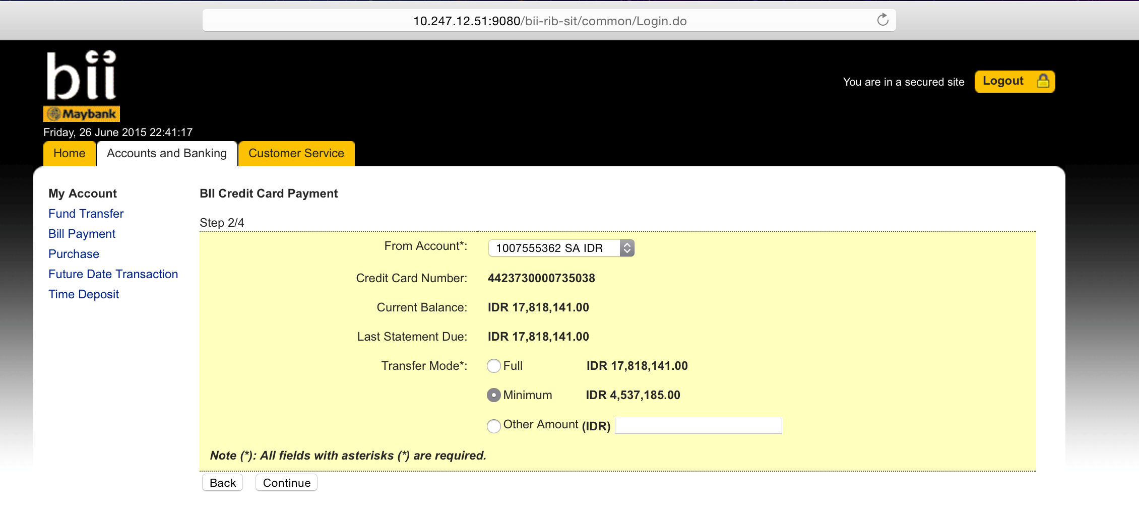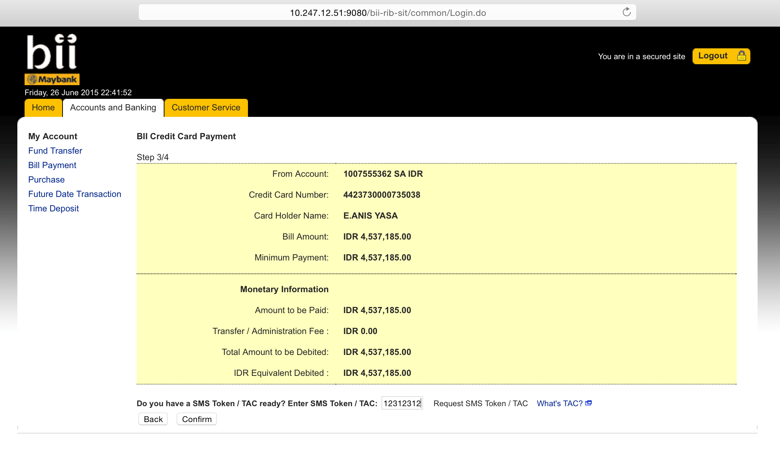

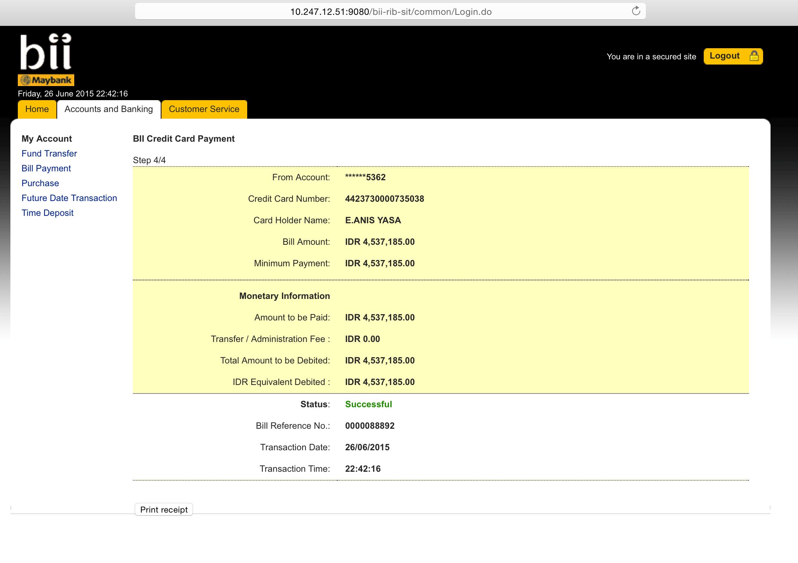

[6/26/15 22:42:16:235 WIT] 000000f8 SystemOut O [26/06/2015] [22:42:16:235] [INFO] [ESBPostpaidPaymentServices]:371 - <<<<<<<<<<<<<<<<< Header >>>>>>>>>>>>>>>>>>>

[6/26/15 22:42:16:236 WIT] 000000f8 SystemOut O [26/06/2015] [22:42:16:235] [INFO] [ESBPostpaidPaymentServices]:372 - Message ID: 1DF4FC09-84EC-4D85-81A1-8801C56679C9

[6/26/15 22:42:16:236 WIT] 000000f8 SystemOut O [26/06/2015] [22:42:16:236] [INFO] [ESBPostpaidPaymentServices]:373 - Branch Code: 270

[6/26/15 22:42:16:236 WIT] 000000f8 SystemOut O [26/06/2015] [22:42:16:236] [INFO] [ESBPostpaidPaymentServices]:374 - Channel ID: M2U

[6/26/15 22:42:16:236 WIT] 000000f8 SystemOut O [26/06/2015] [22:42:16:236] [INFO] [ESBPostpaidPaymentServices]:375 - Client Supervisor ID: 0000

[6/26/15 22:42:16:237 WIT] 000000f8 SystemOut O [26/06/2015] [22:42:16:236] [INFO] [ESBPostpaidPaymentServices]:376 - Client UserID: 0000

[6/26/15 22:42:16:237 WIT] 000000f8 SystemOut O [26/06/2015] [22:42:16:237] [INFO] [ESBPostpaidPaymentServices]:377 - Reference No: M2U/123/2013

[6/26/15 22:42:16:237 WIT] 000000f8 SystemOut O [26/06/2015] [22:42:16:237] [INFO] [ESBPostpaidPaymentServices]:378 - Sequence No: 8495

[6/26/15 22:42:16:237 WIT] 000000f8 SystemOut O [26/06/2015] [22:42:16:237] [INFO] [ESBPostpaidPaymentServices]:379 - Transaction Date: 26-06-2015

[6/26/15 22:42:16:238 WIT] 000000f8 SystemOut O [26/06/2015] [22:42:16:237] [INFO] [ESBPostpaidPaymentServices]:380 - Transaction Time: 22:42:16

[6/26/15 22:42:16:238 WIT] 000000f8 SystemOut O [26/06/2015] [22:42:16:238] [INFO] [ESBPostpaidPaymentServices]:111 - <<<<<<<<<<<<<<<<< Request >>>>>>>>>>>>>>>>>>>

[6/26/15 22:42:16:238 WIT] 000000f8 SystemOut O [26/06/2015] [22:42:16:238] [INFO] [ESBPostpaidPaymentServices]:112 - RoutingCode:

[6/26/15 22:42:16:238 WIT] 000000f8 SystemOut O [26/06/2015] [22:42:16:238] [INFO] [ESBPostpaidPaymentServices]:116 - ### ISO8583MsgType ###

[6/26/15 22:42:16:238 WIT] 000000f8 SystemOut O [26/06/2015] [22:42:16:238] [INFO] [ESBPostpaidPaymentServices]:119 - Message Type Identifier: 0100

[6/26/15 22:42:16:239 WIT] 000000f8 SystemOut O [26/06/2015] [22:42:16:238] [INFO] [ESBPostpaidPaymentServices]:127 - Processing Code: 191000

[6/26/15 22:42:16:239 WIT] 000000f8 SystemOut O [26/06/2015] [22:42:16:239] [INFO] [ESBPostpaidPaymentServices]:131 - Transaction Amount: 453718500

[6/26/15 22:42:16:239 WIT] 000000f8 SystemOut O [26/06/2015] [22:42:16:239] [INFO] [ESBPostpaidPaymentServices]:135 - System Trace Audit Number: 088892

[6/26/15 22:42:16:239 WIT] 000000f8 SystemOut O [26/06/2015] [22:42:16:239] [INFO] [ESBPostpaidPaymentServices]:139 - Local Time Transaction: 224216

[6/26/15 22:42:16:240 WIT] 000000f8 SystemOut O [26/06/2015] [22:42:16:239] [INFO] [ESBPostpaidPaymentServices]:143 - Local Date Transaction: 0626

[6/26/15 22:42:16:240 WIT] 000000f8 SystemOut O [26/06/2015] [22:42:16:240] [INFO] [ESBPostpaidPaymentServices]:147 - Pos Entry Mode Code: 018

[6/26/15 22:42:16:240 WIT] 000000f8 SystemOut O [26/06/2015] [22:42:16:240] [INFO] [ESBPostpaidPaymentServices]:151 - Acquiring Institution ID: 001

[6/26/15 22:42:16:240 WIT] 000000f8 SystemOut O [26/06/2015] [22:42:16:240] [INFO] [ESBPostpaidPaymentServices]:155 - Retrieval Reference Number: 000000088892

[6/26/15 22:42:16:241 WIT] 000000f8 SystemOut O [26/06/2015] [22:42:16:240] [INFO] [ESBPostpaidPaymentServices]:163 - Card Acceptor Terminal ID: 11007

[6/26/15 22:42:16:241 WIT] 000000f8 SystemOut O [26/06/2015] [22:42:16:241] [INFO] [ESBPostpaidPaymentServices]:170 - Card Acceptor Identification Code: 10.230.1.237

[6/26/15 22:42:16:241 WIT] 000000f8 SystemOut O [26/06/2015] [22:42:16:241] [INFO] [ESBPostpaidPaymentServices]:174 - Card Acceptor Name Location: CHRISTOPHER PAUL WHALEY

[6/26/15 22:42:16:241 WIT] 000000f8 SystemOut O [26/06/2015] [22:42:16:241] [INFO] [ESBPostpaidPaymentServices]:178 - 046 Additional Data: BII Credit Card Payment

[6/26/15 22:42:16:242 WIT] 000000f8 SystemOut O [26/06/2015] [22:42:16:241] [INFO] [ESBPostpaidPaymentServices]:182 - 048 Additional Data: 4423730913

[6/26/15 22:42:16:242 WIT] 000000f8 SystemOut O [26/06/2015] [22:42:16:242] [INFO] [ESBPostpaidPaymentServices]:187 - Currency Code: 360

[6/26/15 22:42:16:242 WIT] 000000f8 SystemOut O [26/06/2015] [22:42:16:242] [INFO] [ESBPostpaidPaymentServices]:203 - Payee: 4423730000735038

[6/26/15 22:42:16:242 WIT] 000000f8 SystemOut O [26/06/2015] [22:42:16:242] [INFO] [ESBPostpaidPaymentServices]:207 - From Account: 0161007555362

[6/26/15 22:42:16:242 WIT] 000000f8 SystemOut O wsRequest.getSendMessageRequest().getISO8583Msg().getDE003ProcessingCode().substring(0, 2) =19

[6/26/15 22:42:16:243 WIT] 000000f8 SystemOut O [26/06/2015] [22:42:16:242] [INFO] [ESBPostpaidPaymentServices]:225 - <<<<<<<<<<<<<<<<< Response >>>>>>>>>>>>>>>>>>>

[6/26/15 22:42:16:243 WIT] 000000f8 SystemOut O [26/06/2015] [22:42:16:243] [INFO] [ESBPostpaidPaymentServices]:226 - Response Code: 00

[6/26/15 22:42:16:243 WIT] 000000f8 SystemOut O responseData.getDE103ToAccount():null

[6/26/15 22:42:16:243 WIT] 000000f8 SystemOut O [26/06/2015] [22:42:16:243] [INFO] [ESBPostpaidPaymentServices]:258 - Message Type Identifier: null

[6/26/15 22:42:16:243 WIT] 000000f8 SystemOut O [26/06/2015] [22:42:16:243] [INFO] [ESBPostpaidPaymentServices]:259 - Primary Account Number: null

[6/26/15 22:42:16:244 WIT] 000000f8 SystemOut O [26/06/2015] [22:42:16:243] [INFO] [ESBPostpaidPaymentServices]:260 - Processing Code: null

[6/26/15 22:42:16:244 WIT] 000000f8 SystemOut O [26/06/2015] [22:42:16:244] [INFO] [ESBPostpaidPaymentServices]:261 - Amount Transaction: null

[6/26/15 22:42:16:244 WIT] 000000f8 SystemOut O [26/06/2015] [22:42:16:244] [INFO] [ESBPostpaidPaymentServices]:262 - System Trace Audit Number: null

[6/26/15 22:42:16:244 WIT] 000000f8 SystemOut O [26/06/2015] [22:42:16:244] [INFO] [ESBPostpaidPaymentServices]:263 - Local Time Transaction: null

[6/26/15 22:42:16:244 WIT] 000000f8 SystemOut O [26/06/2015] [22:42:16:244] [INFO] [ESBPostpaidPaymentServices]:264 - Local Date Transaction: null

[6/26/15 22:42:16:245 WIT] 000000f8 SystemOut O [26/06/2015] [22:42:16:244] [INFO] [ESBPostpaidPaymentServices]:265 - Pos Entry Mode Code: null

[6/26/15 22:42:16:245 WIT] 000000f8 SystemOut O [26/06/2015] [22:42:16:245] [INFO] [ESBPostpaidPaymentServices]:266 - Acquiring Institution ID: null

[6/26/15 22:42:16:245 WIT] 000000f8 SystemOut O [26/06/2015] [22:42:16:245] [INFO] [ESBPostpaidPaymentServices]:267 - Track 2 Data: null

[6/26/15 22:42:16:245 WIT] 000000f8 SystemOut O [26/06/2015] [22:42:16:245] [INFO] [ESBPostpaidPaymentServices]:268 - Retrieval Reference Number: null

[6/26/15 22:42:16:246 WIT] 000000f8 SystemOut O [26/06/2015] [22:42:16:245] [INFO] [ESBPostpaidPaymentServices]:269 - Auth Identification Response: null

[6/26/15 22:42:16:246 WIT] 000000f8 SystemOut O [26/06/2015] [22:42:16:246] [INFO] [ESBPostpaidPaymentServices]:270 - Response Code: null

[6/26/15 22:42:16:246 WIT] 000000f8 SystemOut O [26/06/2015] [22:42:16:246] [INFO] [ESBPostpaidPaymentServices]:271 - Card Acceptor Terminal ID: null

[6/26/15 22:42:16:246 WIT] 000000f8 SystemOut O [26/06/2015] [22:42:16:246] [INFO] [ESBPostpaidPaymentServices]:272 - Card Acceptor Identification Code: null

[6/26/15 22:42:16:247 WIT] 000000f8 SystemOut O [26/06/2015] [22:42:16:246] [INFO] [ESBPostpaidPaymentServices]:273 - Card Acceptor Name Location: null

[6/26/15 22:42:16:247 WIT] 000000f8 SystemOut O [26/06/2015] [22:42:16:247] [INFO] [ESBPostpaidPaymentServices]:274 - 046 Additional Data: null

[6/26/15 22:42:16:247 WIT] 000000f8 SystemOut O [26/06/2015] [22:42:16:247] [INFO] [ESBPostpaidPaymentServices]:275 - 048 Additional Data: null

[6/26/15 22:42:16:247 WIT] 000000f8 SystemOut O [26/06/2015] [22:42:16:247] [INFO] [ESBPostpaidPaymentServices]:276 - Currency Code Transaction: null

[6/26/15 22:42:16:247 WIT] 000000f8 SystemOut O [26/06/2015] [22:42:16:247] [INFO] [ESBPostpaidPaymentServices]:277 - End Point Switch Trace Number: null

[6/26/15 22:42:16:248 WIT] 000000f8 SystemOut O [26/06/2015] [22:42:16:247] [INFO] [ESBPostpaidPaymentServices]:278 - Network Management Code: null

[6/26/15 22:42:16:248 WIT] 000000f8 SystemOut O [26/06/2015] [22:42:16:248] [INFO] [ESBPostpaidPaymentServices]:279 - Original Data Elements: null

[6/26/15 22:42:16:248 WIT] 000000f8 SystemOut O [26/06/2015] [22:42:16:248] [INFO] [ESBPostpaidPaymentServices]:280 - Payee: null

[6/26/15 22:42:16:248 WIT] 000000f8 SystemOut O [26/06/2015] [22:42:16:248] [INFO] [ESBPostpaidPaymentServices]:281 - From Account: null

[6/26/15 22:42:16:249 WIT] 000000f8 SystemOut O [26/06/2015] [22:42:16:248] [INFO] [ESBPostpaidPaymentServices]:282 - To Account: null

**Other Amount Test Script:** 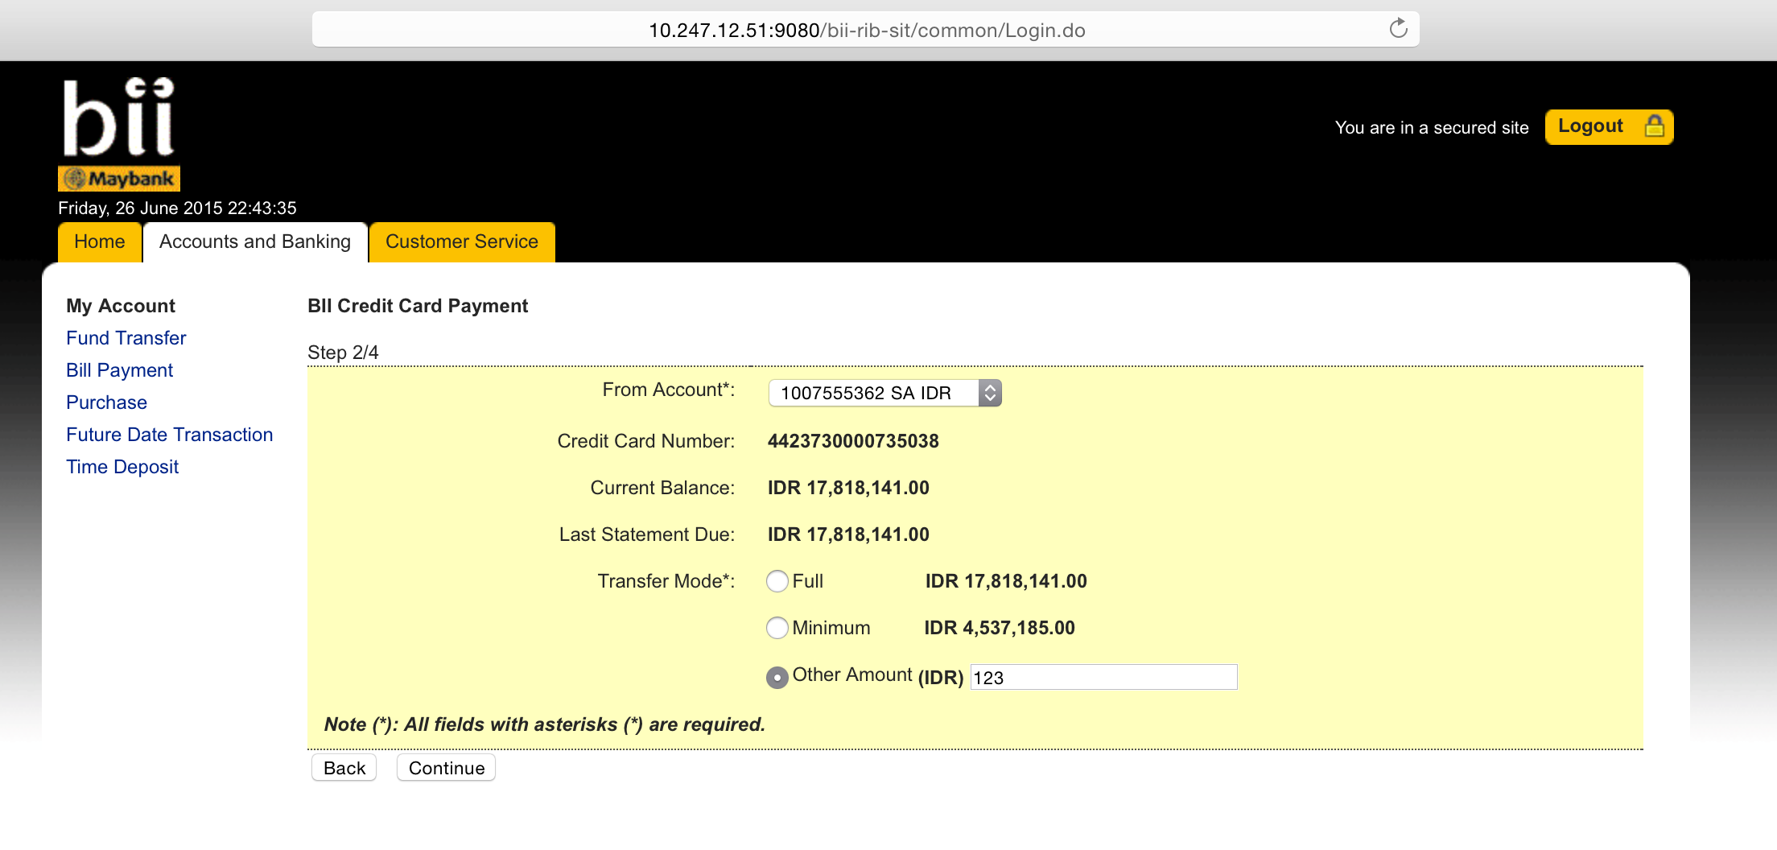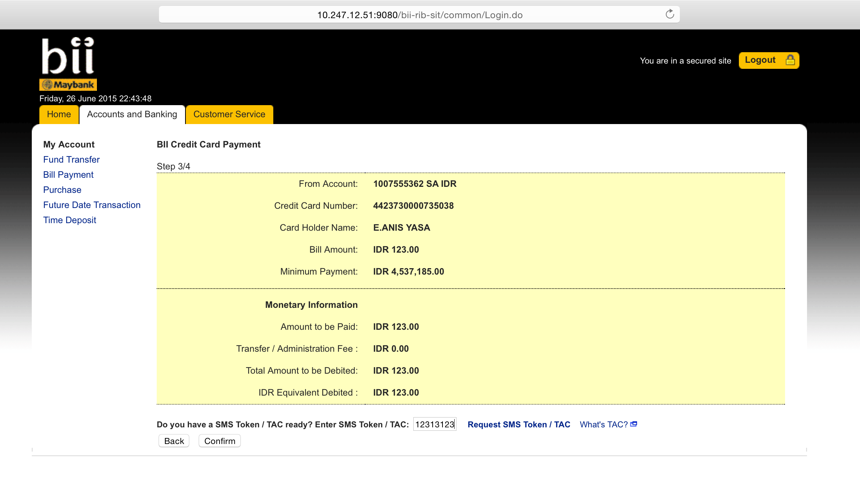

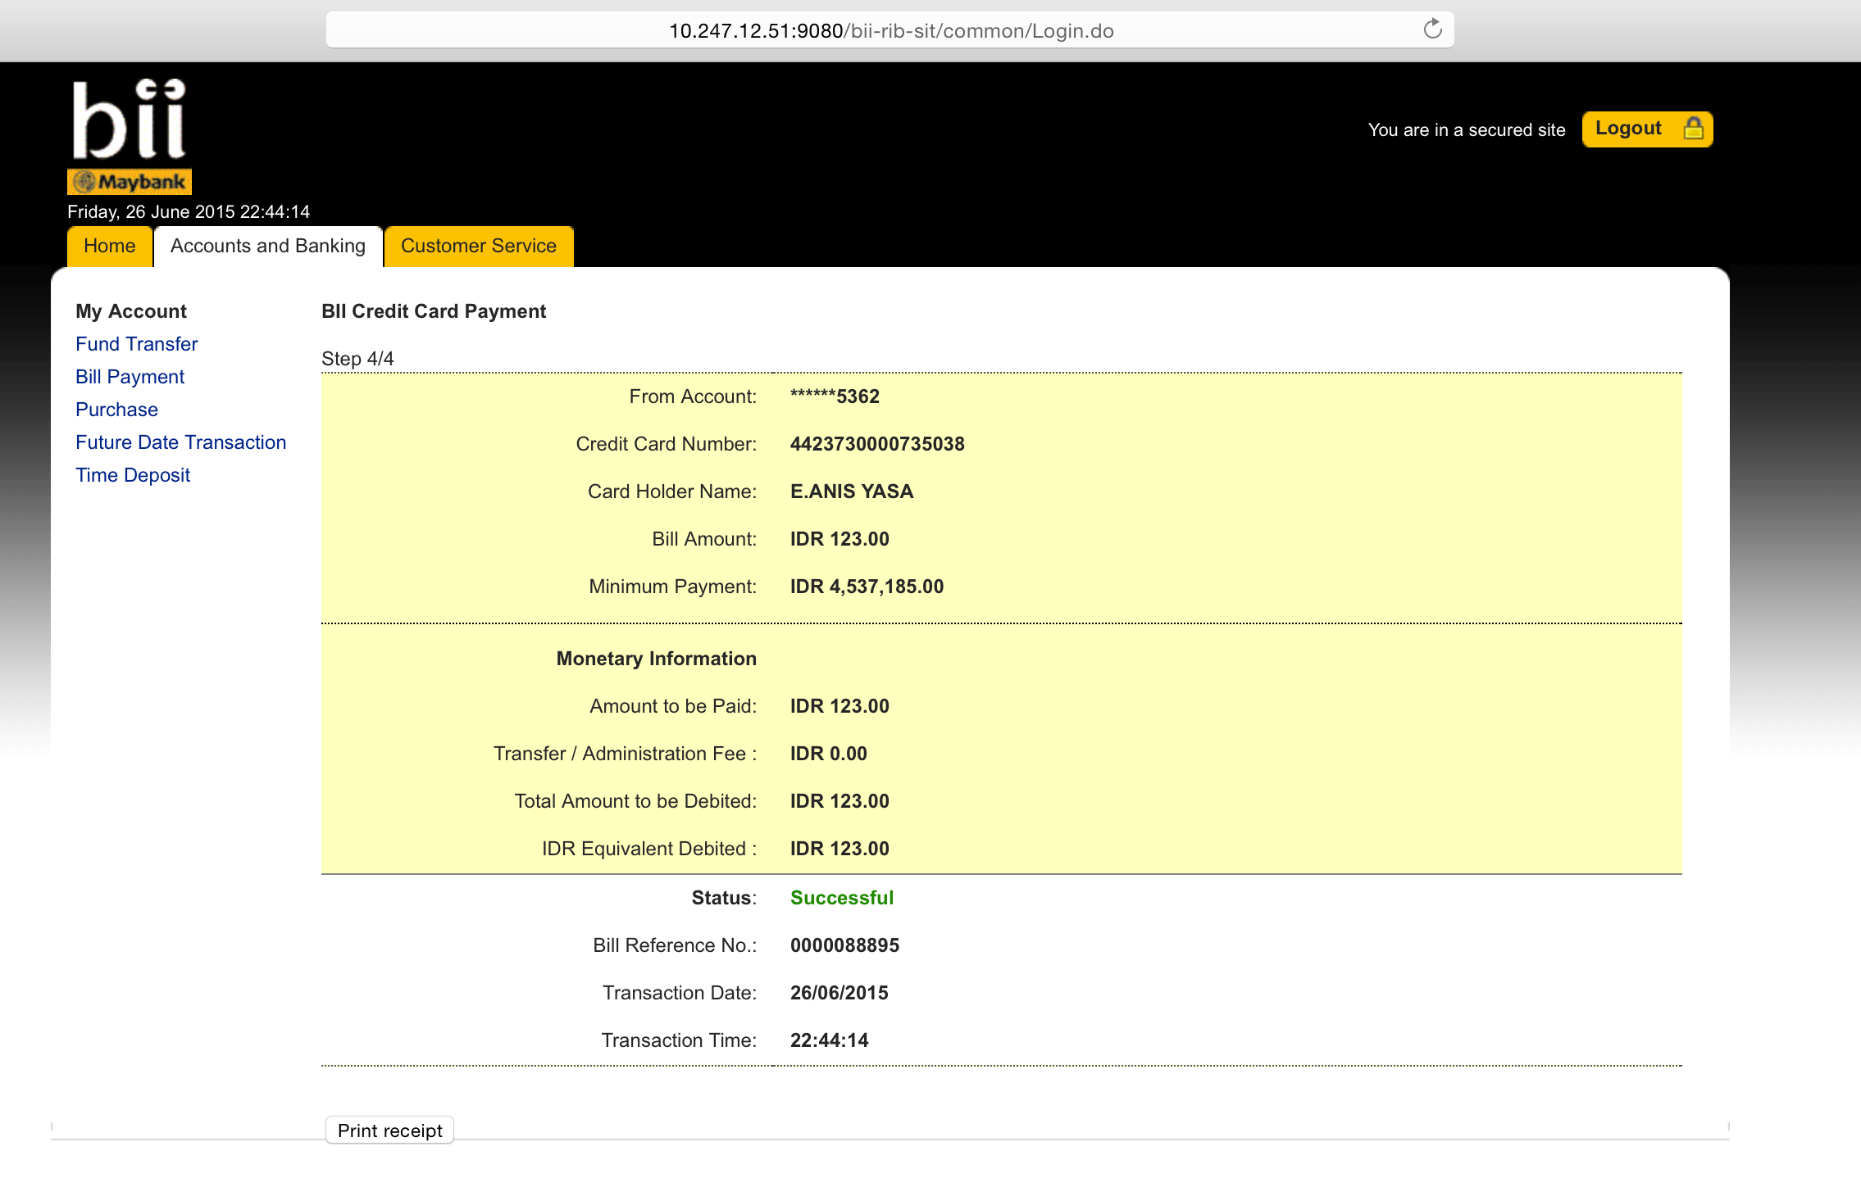

[6/26/15 22:44:14:772 WIT] 00000116 SystemOut O [26/06/2015] [22:44:14:772] [INFO] [ESBPostpaidPaymentServices]:371 - <<<<<<<<<<<<<<<<< Header >>>>>>>>>>>>>>>>>>>

[6/26/15 22:44:14:773 WIT] 00000116 SystemOut O [26/06/2015] [22:44:14:772] [INFO] [ESBPostpaidPaymentServices]:372 - Message ID: 491F0963-56A0-4F0E-8B7F-41AA14A43840

[6/26/15 22:44:14:773 WIT] 00000116 SystemOut O [26/06/2015] [22:44:14:773] [INFO] [ESBPostpaidPaymentServices]:373 - Branch Code: 270

[6/26/15 22:44:14:773 WIT] 00000116 SystemOut O [26/06/2015] [22:44:14:773] [INFO] [ESBPostpaidPaymentServices]:374 - Channel ID: M2U

[6/26/15 22:44:14:773 WIT] 00000116 SystemOut O [26/06/2015] [22:44:14:773] [INFO] [ESBPostpaidPaymentServices]:375 - Client Supervisor ID: 0000

[6/26/15 22:44:14:774 WIT] 00000116 SystemOut O [26/06/2015] [22:44:14:773] [INFO] [ESBPostpaidPaymentServices]:376 - Client UserID: 0000

[6/26/15 22:44:14:774 WIT] 00000116 SystemOut O [26/06/2015] [22:44:14:774] [INFO] [ESBPostpaidPaymentServices]:377 - Reference No: M2U/123/2013

[6/26/15 22:44:14:774 WIT] 00000116 SystemOut O [26/06/2015] [22:44:14:774] [INFO] [ESBPostpaidPaymentServices]:378 - Sequence No: 8495

[6/26/15 22:44:14:774 WIT] 00000116 SystemOut O [26/06/2015] [22:44:14:774] [INFO] [ESBPostpaidPaymentServices]:379 - Transaction Date: 26-06-2015

[6/26/15 22:44:14:775 WIT] 00000116 SystemOut O [26/06/2015] [22:44:14:774] [INFO] [ESBPostpaidPaymentServices]:380 - Transaction Time: 22:44:14

[6/26/15 22:44:14:775 WIT] 00000116 SystemOut O [26/06/2015] [22:44:14:775] [INFO] [ESBPostpaidPaymentServices]:111 - <<<<<<<<<<<<<<<<< Request >>>>>>>>>>>>>>>>>>>

[6/26/15 22:44:14:775 WIT] 00000116 SystemOut O [26/06/2015] [22:44:14:775] [INFO] [ESBPostpaidPaymentServices]:112 - RoutingCode:

[6/26/15 22:44:14:775 WIT] 00000116 SystemOut O [26/06/2015] [22:44:14:775] [INFO] [ESBPostpaidPaymentServices]:116 - ### ISO8583MsgType ###

[6/26/15 22:44:14:775 WIT] 00000116 SystemOut O [26/06/2015] [22:44:14:775] [INFO] [ESBPostpaidPaymentServices]:119 - Message Type Identifier: 0100

[6/26/15 22:44:14:776 WIT] 00000116 SystemOut O [26/06/2015] [22:44:14:775] [INFO] [ESBPostpaidPaymentServices]:127 - Processing Code: 191000

[6/26/15 22:44:14:776 WIT] 00000116 SystemOut O [26/06/2015] [22:44:14:776] [INFO] [ESBPostpaidPaymentServices]:131 - Transaction Amount: 12300

[6/26/15 22:44:14:776 WIT] 00000116 SystemOut O [26/06/2015] [22:44:14:776] [INFO] [ESBPostpaidPaymentServices]:135 - System Trace Audit Number: 088895

[6/26/15 22:44:14:776 WIT] 00000116 SystemOut O [26/06/2015] [22:44:14:776] [INFO] [ESBPostpaidPaymentServices]:139 - Local Time Transaction: 224414

[6/26/15 22:44:14:777 WIT] 00000116 SystemOut O [26/06/2015] [22:44:14:776] [INFO] [ESBPostpaidPaymentServices]:143 - Local Date Transaction: 0626

[6/26/15 22:44:14:777 WIT] 00000116 SystemOut O [26/06/2015] [22:44:14:777] [INFO] [ESBPostpaidPaymentServices]:147 - Pos Entry Mode Code: 018

[6/26/15 22:44:14:777 WIT] 00000116 SystemOut O [26/06/2015] [22:44:14:777] [INFO] [ESBPostpaidPaymentServices]:151 - Acquiring Institution ID: 001

[6/26/15 22:44:14:777 WIT] 00000116 SystemOut O [26/06/2015] [22:44:14:777] [INFO] [ESBPostpaidPaymentServices]:155 - Retrieval Reference Number: 000000088895

[6/26/15 22:44:14:778 WIT] 00000116 SystemOut O [26/06/2015] [22:44:14:777] [INFO] [ESBPostpaidPaymentServices]:163 - Card Acceptor Terminal ID: 11007

[6/26/15 22:44:14:778 WIT] 00000116 SystemOut O [26/06/2015] [22:44:14:778] [INFO] [ESBPostpaidPaymentServices]:170 - Card Acceptor Identification Code: 10.230.1.237

[6/26/15 22:44:14:778 WIT] 00000116 SystemOut O [26/06/2015] [22:44:14:778] [INFO] [ESBPostpaidPaymentServices]:174 - Card Acceptor Name Location: CHRISTOPHER PAUL WHALEY

[6/26/15 22:44:14:778 WIT] 00000116 SystemOut O [26/06/2015] [22:44:14:778] [INFO] [ESBPostpaidPaymentServices]:178 - 046 Additional Data: BII Credit Card Payment

[6/26/15 22:44:14:779 WIT] 00000116 SystemOut O [26/06/2015] [22:44:14:778] [INFO] [ESBPostpaidPaymentServices]:182 - 048 Additional Data: 4423730913

[6/26/15 22:44:14:779 WIT] 00000116 SystemOut O [26/06/2015] [22:44:14:779] [INFO] [ESBPostpaidPaymentServices]:187 - Currency Code: 360

[6/26/15 22:44:14:779 WIT] 00000116 SystemOut O [26/06/2015] [22:44:14:779] [INFO] [ESBPostpaidPaymentServices]:203 - Payee: 4423730000735038

[6/26/15 22:44:14:779 WIT] 00000116 SystemOut O [26/06/2015] [22:44:14:779] [INFO] [ESBPostpaidPaymentServices]:207 - From Account: 0161007555362

[6/26/15 22:44:14:779 WIT] 00000116 SystemOut O wsRequest.getSendMessageRequest().getISO8583Msg().getDE003ProcessingCode().substring(0, 2) =19

[6/26/15 22:44:14:780 WIT] 00000116 SystemOut O [26/06/2015] [22:44:14:779] [INFO] [ESBPostpaidPaymentServices]:225 - <<<<<<<<<<<<<<<<< Response >>>>>>>>>>>>>>>>>>>

[6/26/15 22:44:14:780 WIT] 00000116 SystemOut O [26/06/2015] [22:44:14:780] [INFO] [ESBPostpaidPaymentServices]:226 - Response Code: 00

[6/26/15 22:44:14:780 WIT] 00000116 SystemOut O responseData.getDE103ToAccount():null

[6/26/15 22:44:14:780 WIT] 00000116 SystemOut O [26/06/2015] [22:44:14:780] [INFO] [ESBPostpaidPaymentServices]:258 - Message Type Identifier: null

[6/26/15 22:44:14:780 WIT] 00000116 SystemOut O [26/06/2015] [22:44:14:780] [INFO] [ESBPostpaidPaymentServices]:259 - Primary Account Number: null

[6/26/15 22:44:14:780 WIT] 00000116 SystemOut O [26/06/2015] [22:44:14:780] [INFO] [ESBPostpaidPaymentServices]:260 - Processing Code: null

[6/26/15 22:44:14:781 WIT] 00000116 SystemOut O [26/06/2015] [22:44:14:780] [INFO] [ESBPostpaidPaymentServices]:261 - Amount Transaction: null

[6/26/15 22:44:14:781 WIT] 00000116 SystemOut O [26/06/2015] [22:44:14:781] [INFO] [ESBPostpaidPaymentServices]:262 - System Trace Audit Number: null

[6/26/15 22:44:14:781 WIT] 00000116 SystemOut O [26/06/2015] [22:44:14:781] [INFO] [ESBPostpaidPaymentServices]:263 - Local Time Transaction: null

[6/26/15 22:44:14:781 WIT] 00000116 SystemOut O [26/06/2015] [22:44:14:781] [INFO] [ESBPostpaidPaymentServices]:264 - Local Date Transaction: null

[6/26/15 22:44:14:782 WIT] 00000116 SystemOut O [26/06/2015] [22:44:14:781] [INFO] [ESBPostpaidPaymentServices]:265 - Pos Entry Mode Code: null

[6/26/15 22:44:14:782 WIT] 00000116 SystemOut O [26/06/2015] [22:44:14:782] [INFO] [ESBPostpaidPaymentServices]:266 - Acquiring Institution ID: null

[6/26/15 22:44:14:782 WIT] 00000116 SystemOut O [26/06/2015] [22:44:14:782] [INFO] [ESBPostpaidPaymentServices]:267 - Track 2 Data: null

[6/26/15 22:44:14:782 WIT] 00000116 SystemOut O [26/06/2015] [22:44:14:782] [INFO] [ESBPostpaidPaymentServices]:268 - Retrieval Reference Number: null

[6/26/15 22:44:14:783 WIT] 00000116 SystemOut O [26/06/2015] [22:44:14:782] [INFO] [ESBPostpaidPaymentServices]:269 - Auth Identification Response: null

[6/26/15 22:44:14:783 WIT] 00000116 SystemOut O [26/06/2015] [22:44:14:783] [INFO] [ESBPostpaidPaymentServices]:270 - Response Code: null

[6/26/15 22:44:14:783 WIT] 00000116 SystemOut O [26/06/2015] [22:44:14:783] [INFO] [ESBPostpaidPaymentServices]:271 - Card Acceptor Terminal ID: null

[6/26/15 22:44:14:783 WIT] 00000116 SystemOut O [26/06/2015] [22:44:14:783] [INFO] [ESBPostpaidPaymentServices]:272 - Card Acceptor Identification Code: null

[6/26/15 22:44:14:784 WIT] 00000116 SystemOut O [26/06/2015] [22:44:14:783] [INFO] [ESBPostpaidPaymentServices]:273 - Card Acceptor Name Location: null

[6/26/15 22:44:14:784 WIT] 00000116 SystemOut O [26/06/2015] [22:44:14:784] [INFO] [ESBPostpaidPaymentServices]:274 - 046 Additional Data: null

[6/26/15 22:44:14:784 WIT] 00000116 SystemOut O [26/06/2015] [22:44:14:784] [INFO] [ESBPostpaidPaymentServices]:275 - 048 Additional Data: null

[6/26/15 22:44:14:784 WIT] 00000116 SystemOut O [26/06/2015] [22:44:14:784] [INFO] [ESBPostpaidPaymentServices]:276 - Currency Code Transaction: null

[6/26/15 22:44:14:784 WIT] 00000116 SystemOut O [26/06/2015] [22:44:14:784] [INFO] [ESBPostpaidPaymentServices]:277 - End Point Switch Trace Number: null

[6/26/15 22:44:14:785 WIT] 00000116 SystemOut O [26/06/2015] [22:44:14:784] [INFO] [ESBPostpaidPaymentServices]:278 - Network Management Code: null

[6/26/15 22:44:14:785 WIT] 00000116 SystemOut O [26/06/2015] [22:44:14:785] [INFO] [ESBPostpaidPaymentServices]:279 - Original Data Elements: null

[6/26/15 22:44:14:785 WIT] 00000116 SystemOut O [26/06/2015] [22:44:14:785] [INFO] [ESBPostpaidPaymentServices]:280 - Payee: null

[6/26/15 22:44:14:785 WIT] 00000116 SystemOut O [26/06/2015] [22:44:14:785] [INFO] [ESBPostpaidPaymentServices]:281 - From Account: null

[6/26/15 22:44:14:786 WIT] 00000116 SystemOut O [26/06/2015] [22:44:14:785] [INFO] [ESBPostpaidPaymentServices]:282 - To Account: null

**Logout Summary:**

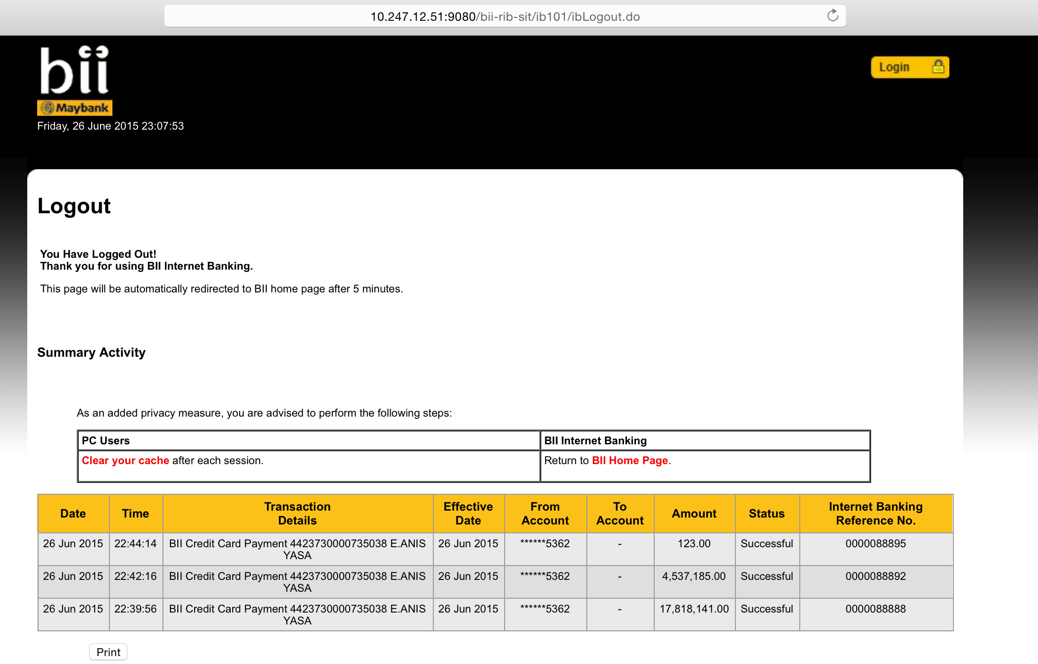

**BII CC Enhancement Test Script – Acc Summary & Details:**

1. Login using ribuser1 in SIT,
2. Go to My Accounts > Credit Card
3. Balance shall mention: ‘Last Statement Due’ / ‘Total Tagihan Terkini’
4. Go to CC details shall mention: ‘Total Tagihan Terkini & Total Pemakaian Terkini’ / ‘Current Balance & Last Statement Due’.

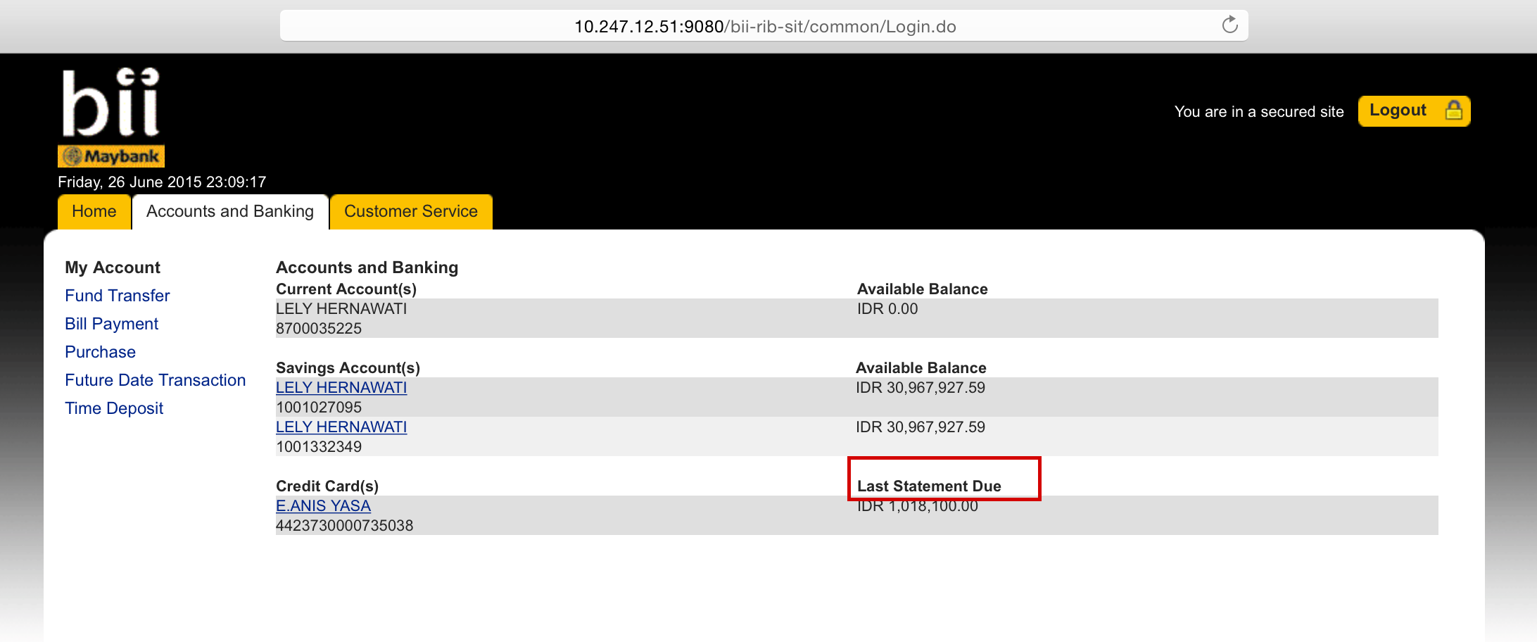

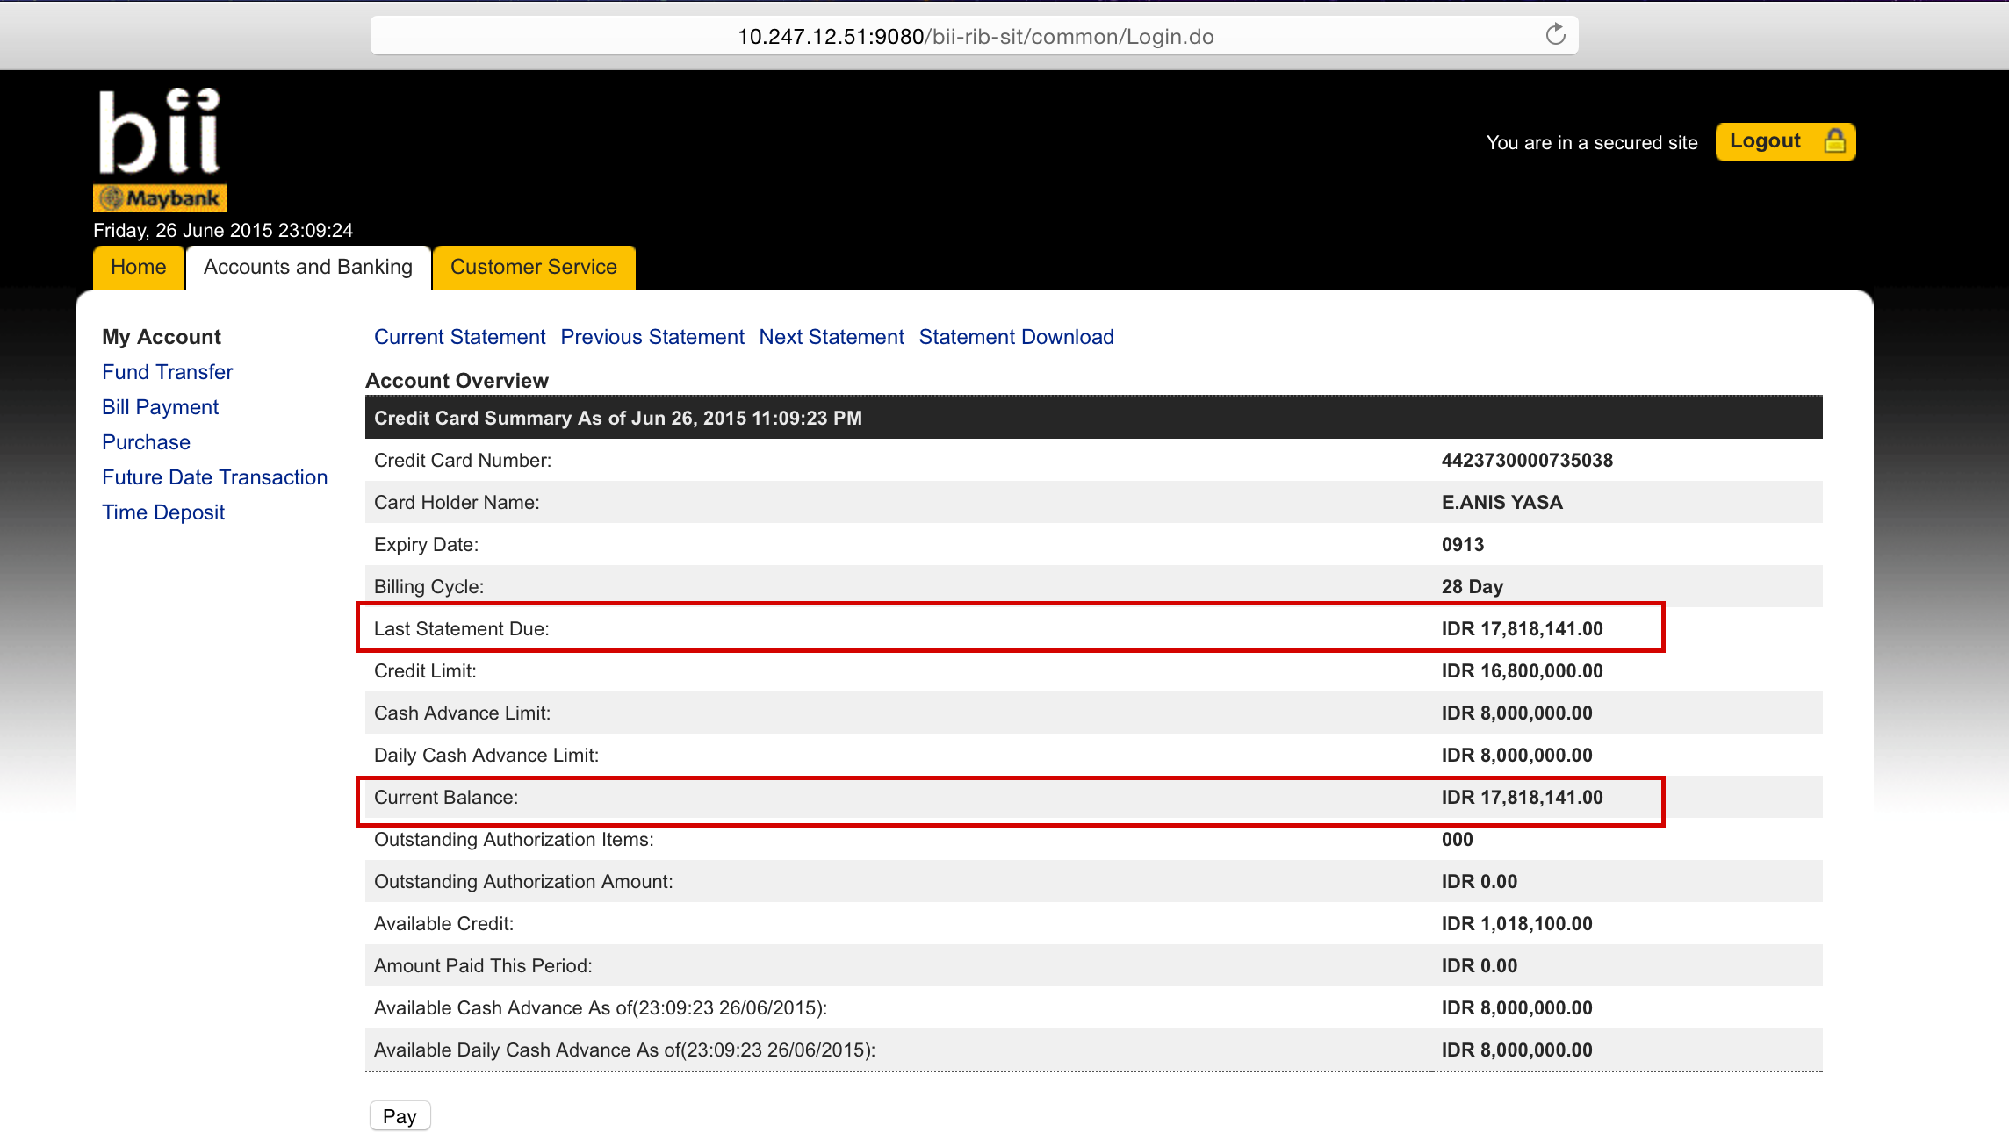

**BII CC Enhancement Test Script – BII CC Payment:**

1. Login using ribuser1 in SIT,
2. Bill Payment > BII CC Payment,
3. Screen shall show as follows:

4. Current Balance = No calculation. Negative shall show ‘CR’

5. Last Statement Due = Full Amount – Paid Amount.

6. Minimum amount = Minimum Amount – Paid Amount. Negative shall show ‘CR’ (need further confirmation).

