Test Issue Log |  |  |  |  | TIL No.: URF-14-12-163
Project Name: | Conditional Sign-Off IBSCR068 & IBSCR072
Test Stage: | Unit Functionality Integration System Interface  Performance Regression Acceptance Pilot
Test Case Number: |  |  |  | Test Started Date: |  | 25/06/2015
Test Title: | Result for Issue #023, #035, #038, #046, #049, #048, #042
Test Description: | #048- Bulk Rentas Transaction – Email Notification
Test Functionality:
Test Procedure:
Test Result: | Pass: Fail: Conditional Pass: |  | Tested by:
Reason for Failure:
TEST DESCRIPTION
IBG-048: Bulk Rentas Transaction – Email Notification

Role : Approver All
Confirm Page
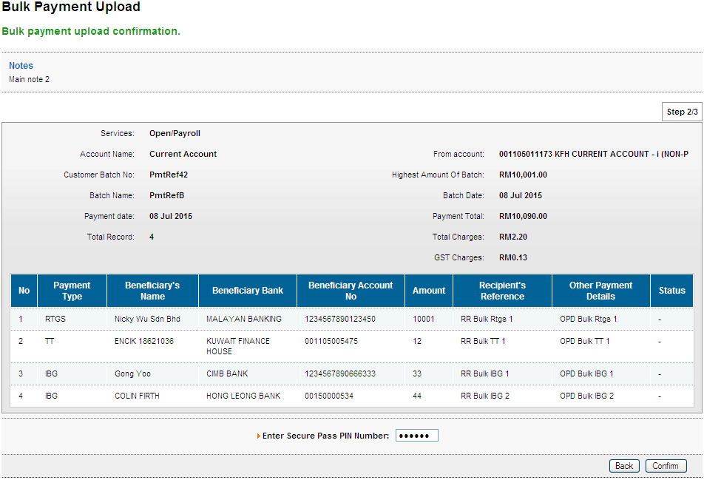
Result Page
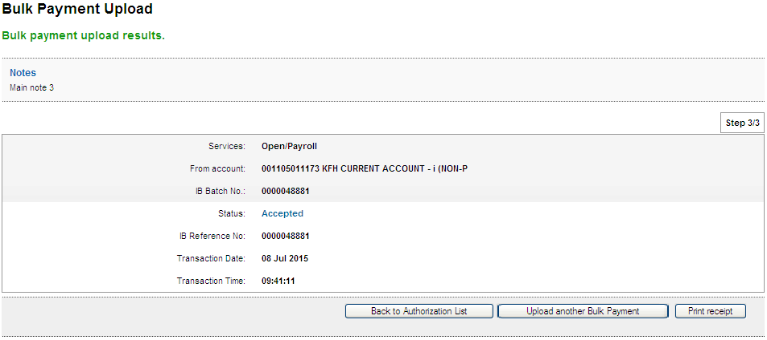
Print Receipt
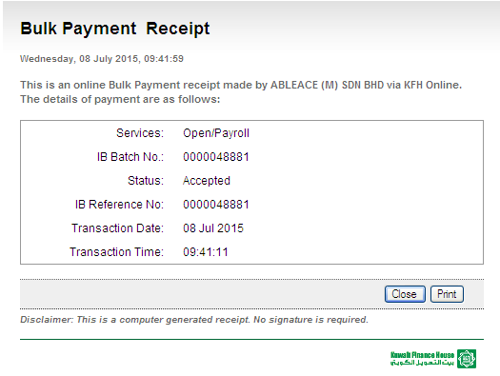
Transaction History
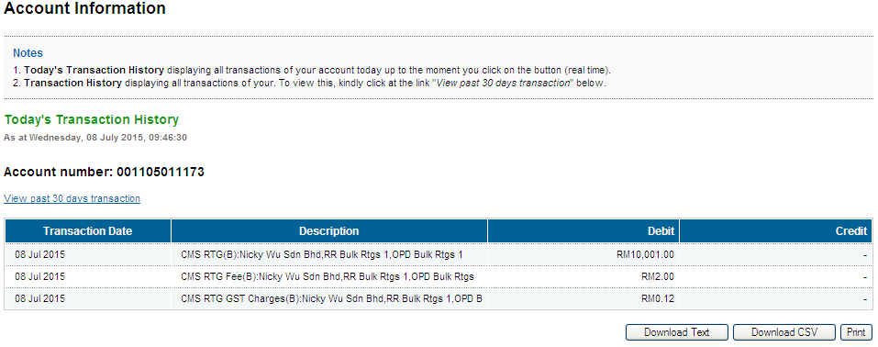
Email Notification
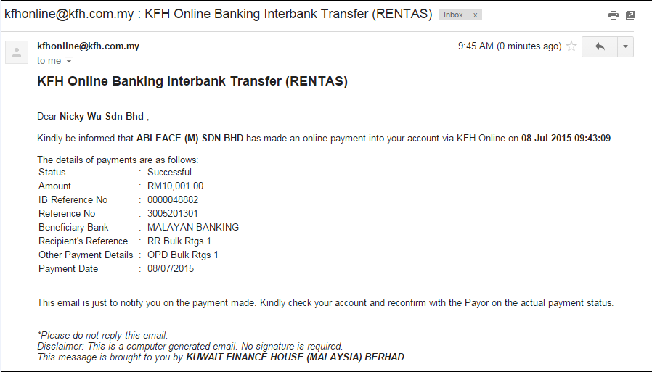

Role : Initiator
Confirm Page
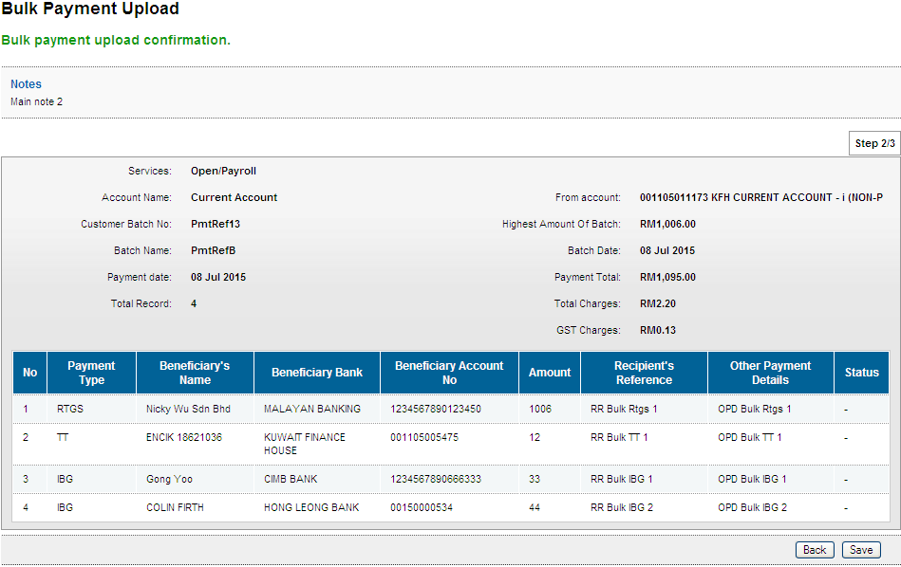
Result Page
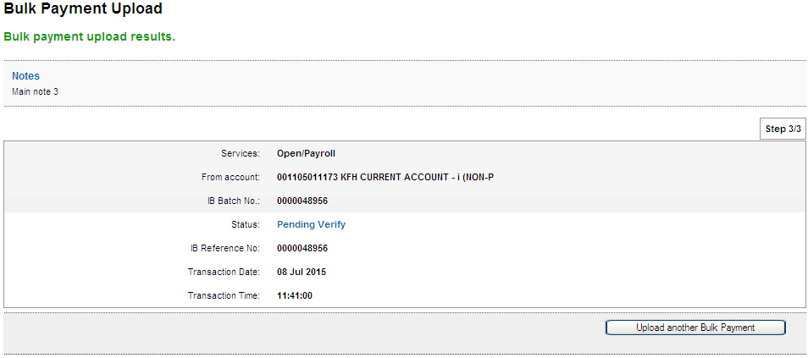

Role : Verifier
Confirm Page
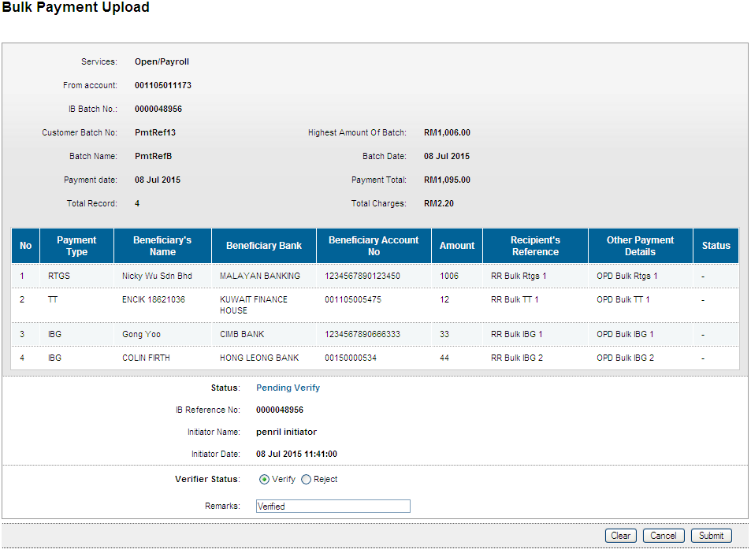
Result Page
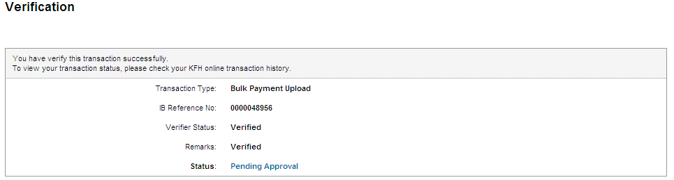

Role : Approver
Confirm Page
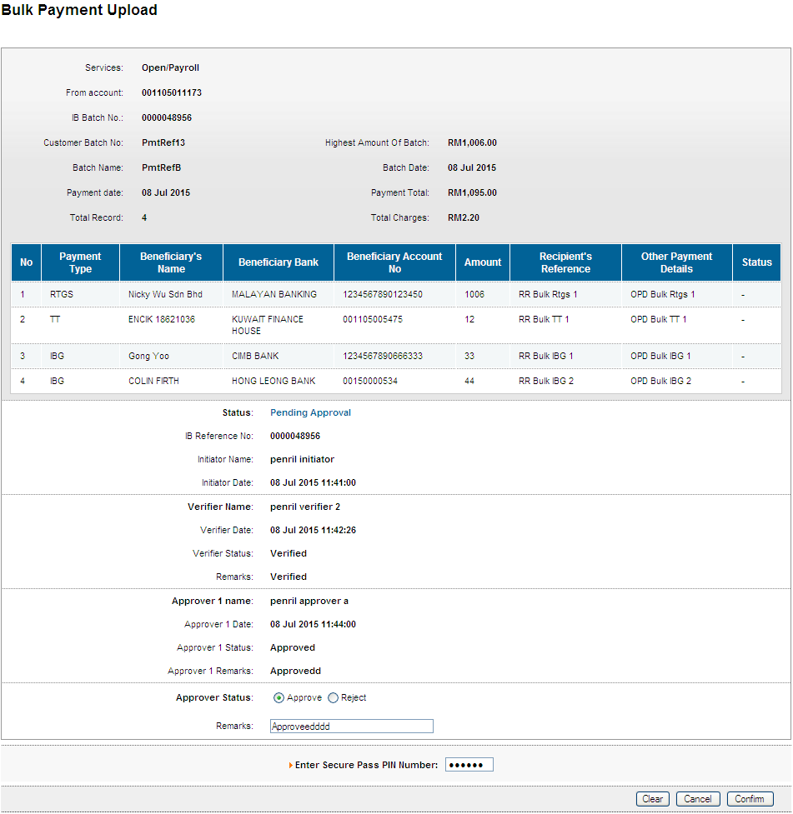
Result Page
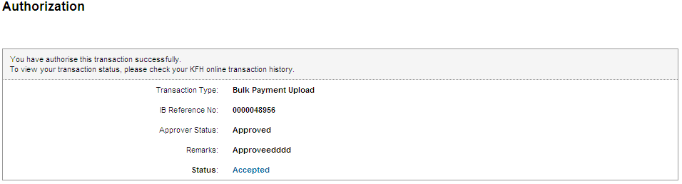
Print Receipt
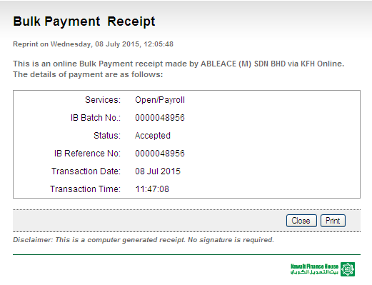
Transaction History
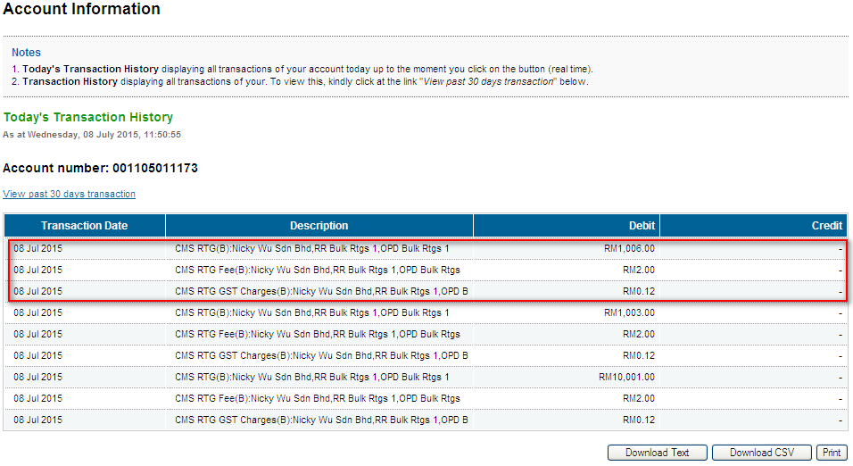
Email Notification
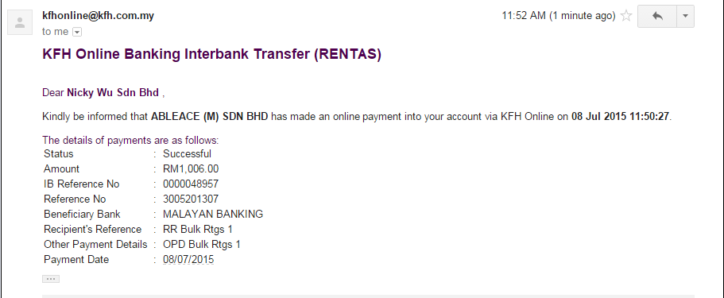

Role : Init-Veri
Confirm Page
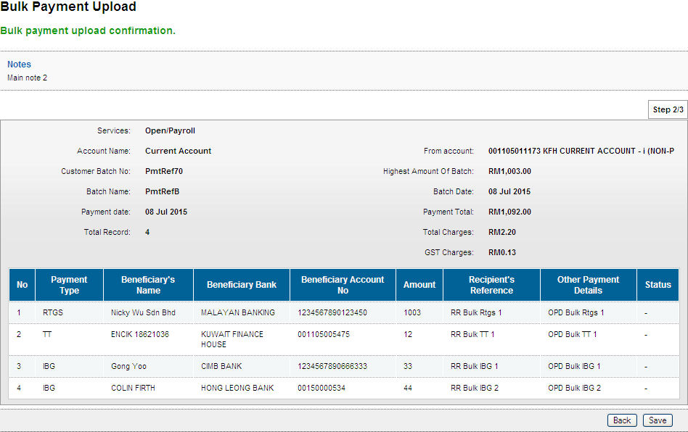
Result Page
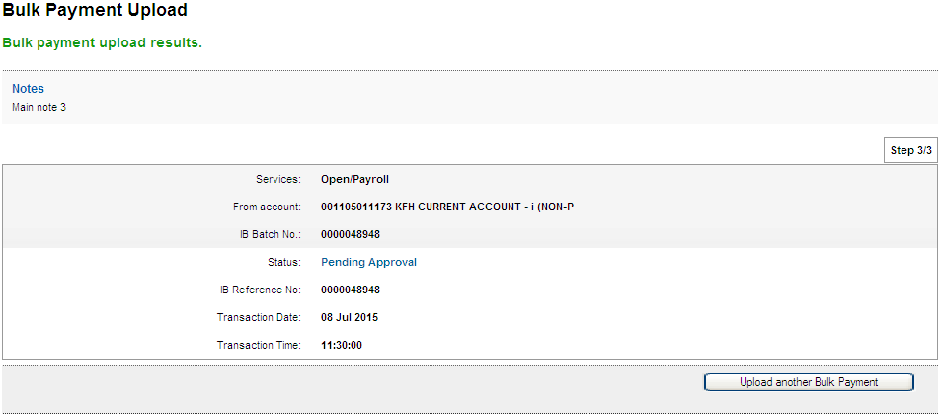

Role : Approver
Confirm Page
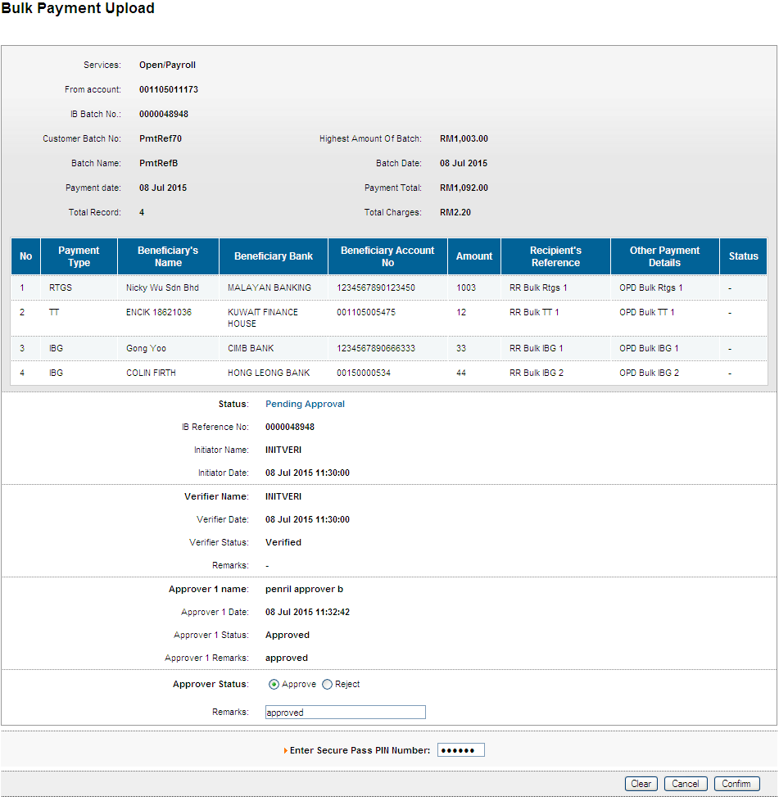
Result Page
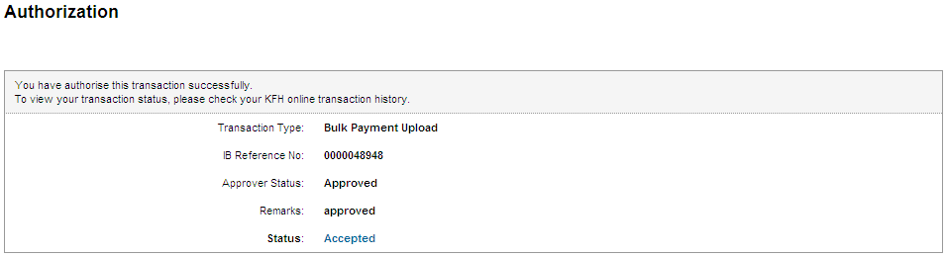
Print Receipt
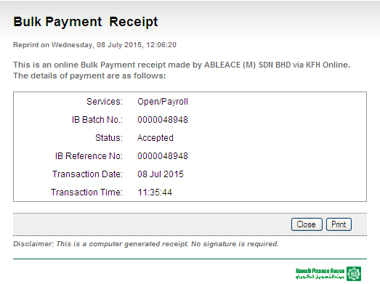
Transaction History
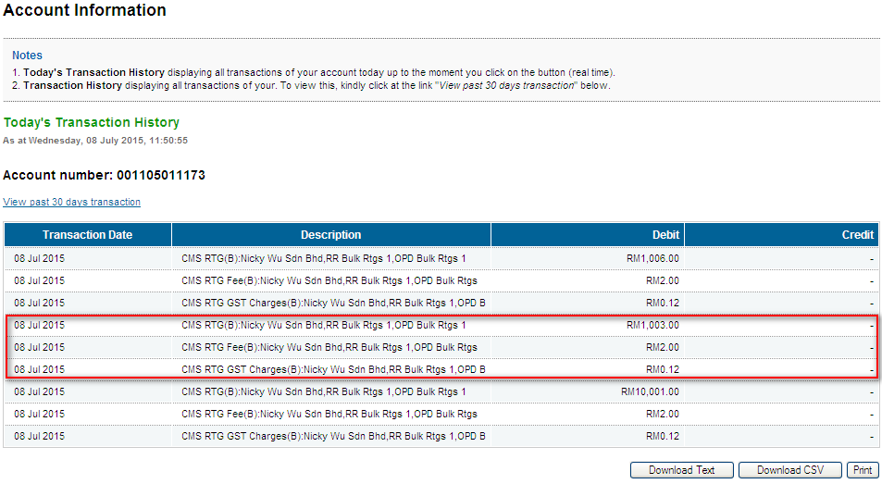
Email Notification
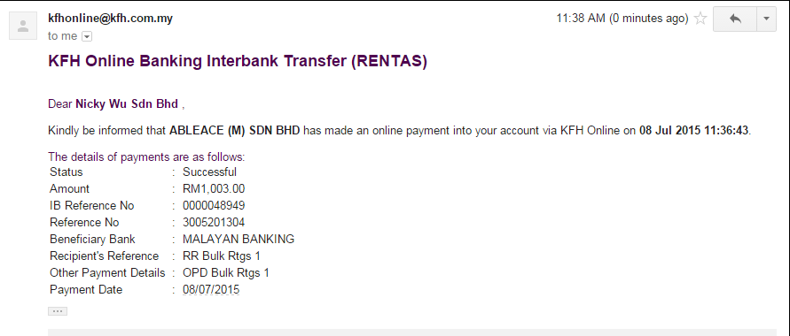

Reviewed By: (PMO)
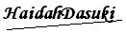 |  | Name/Position : NorhaidahBintiMdDasuki / Senior Manager, Quality Assurance and Support  Date :16/3/2015

