**[Request ID :##2742##] : Urgent : Update profile keep loading until its timeout**

1. Login using ribuser1, password: Bii123456,
2. Go to, Customer Service menu, Profile Maintenance,
3. Change display name or language or both,
4. Key in TAC and click next,

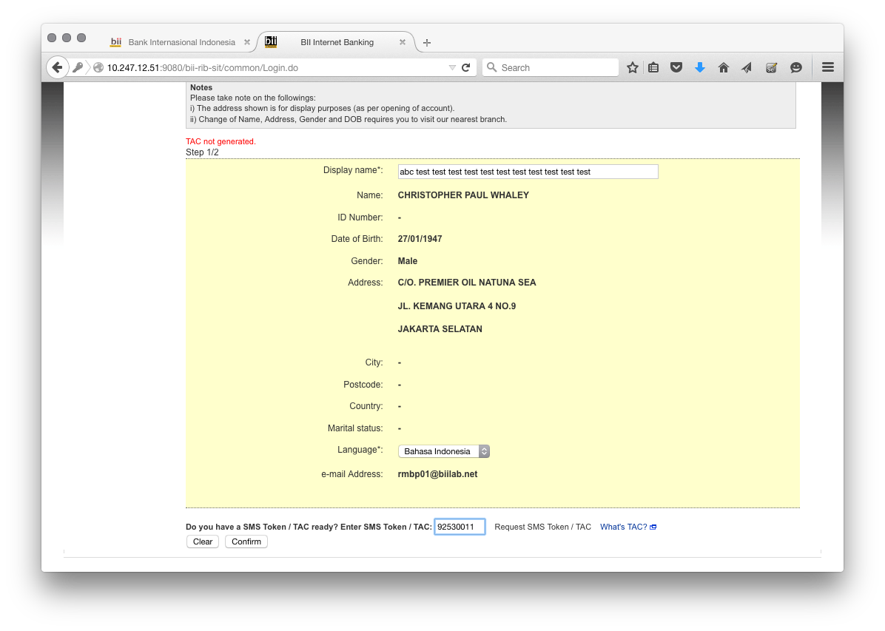

1. Change shall be done in quick manner by system (previously it shows loading icon above 5 minutes), 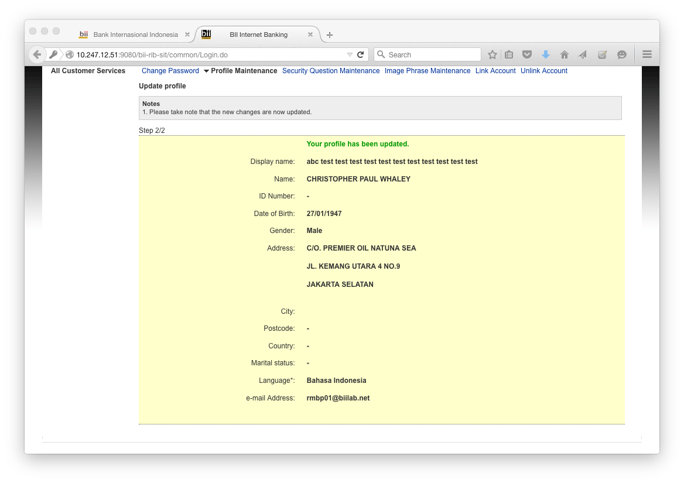
2. Check the timestamp in the log. The profile update description shall be in sequence as below written:

**[7/24/15 14:57:10:365 WIT] 000001fb SystemOut O PROFILE UPDATE : CLONING BEAN**

**[7/24/15 14:57:10:365 WIT] 000001fb SystemOut O PROFILE UPDATE : SUCCESSFUL CLONING BEAN**

**[7/24/15 14:57:10:365 WIT] 000001fb SystemOut O PROFILE UPDATE : GET BEAN DIFF**

**[7/24/15 14:57:10:380 WIT] 000001fb SystemOut O PROFILE UPDATE : SUCCESSFUL GET BEAN DIFF**

**[7/24/15 14:57:10:380 WIT] 000001fb SystemOut O PROFILE UPDATE : UPDATING IBCUSTPROFILE**

**[7/24/15 14:57:10:438 WIT] 000001fb SystemOut O PROFILE UPDATE : SUCCESSFUL UPDATE IBCUSTPROFILE**

**Additional Info:**

1. **Database shall capture the changes as well. This can be checked by performing below query:**

*select before_value, after_value from dbo.ib_cust_profile where user_id = 1391;*

