**[Request ID :##2743##] : Unable to see TD list in TD Account Menu**

1. Login using ribuser1, password: Bii123456,
2. Navigate to “Deposito” > “Rekening Deposito”,
3. Take note the list of TD account list,

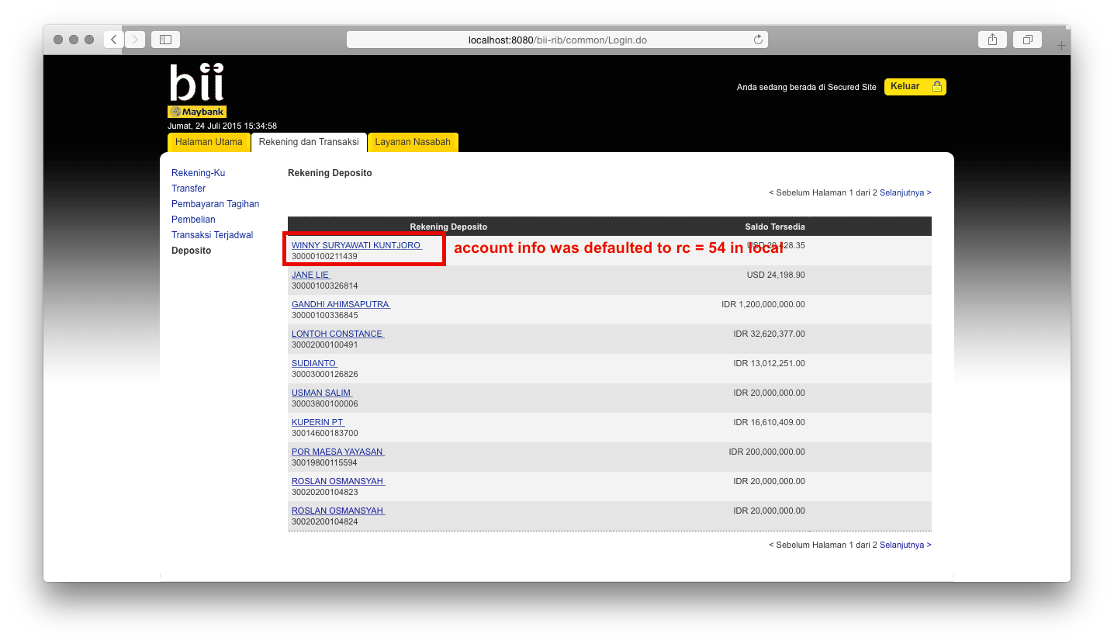

1. Simulate the TD account closing by returning Account Info response code 54 (for certain TD accounts) via host / esb / related channel,

Note: For this test script generation purpose, tester runs the application locally using IDE in debug mode, so the response code can be changed in real time to simulate this test case.

1. TD account that returns 54 will dissapear from the list and it still enables the module to show the rest of non-54 TD accounts.

