**[Request ID :##2445##] : use phone number as TAC number in FTL from jetsweb**

**Previous system:**

* Customer able to key in mobile no manually during FTL.

**Expected result on new changes:**

* Customer shall not be able to key in mobile no manually during FTL. M2U takes mobile no from database,
* This applies to registration via MSS as well.

**Impact / other area to test:**

* Registration via ATM,
* Registration via MSS,
* Migration from IBS,
* Financial / non financial mode functionality,
* User with CC only,
* User with CASA.

**Steps:**

1. Remove duplicating CIF no:

**For CC only user:**

update dbo.ib_cust_profile set cp_cust_no = '1010000000000014DEL' where cp_cust_no = '1010000000000014';

**For CASA user:**

update dbo.ib_cust_profile set cp_cust_no = ‘xxxxDEL' where cp_cust_no = 'xxxxxxx';

Replace xx with desired number.

1. Migrate with following detail from jetsweb:

Registration no: 150715888880002

Registration PIN: 973563

Take note that the mobile number is already pre-filled in via jetsweb.



1. TAC Mobile Number is pre-filled in and non editable: 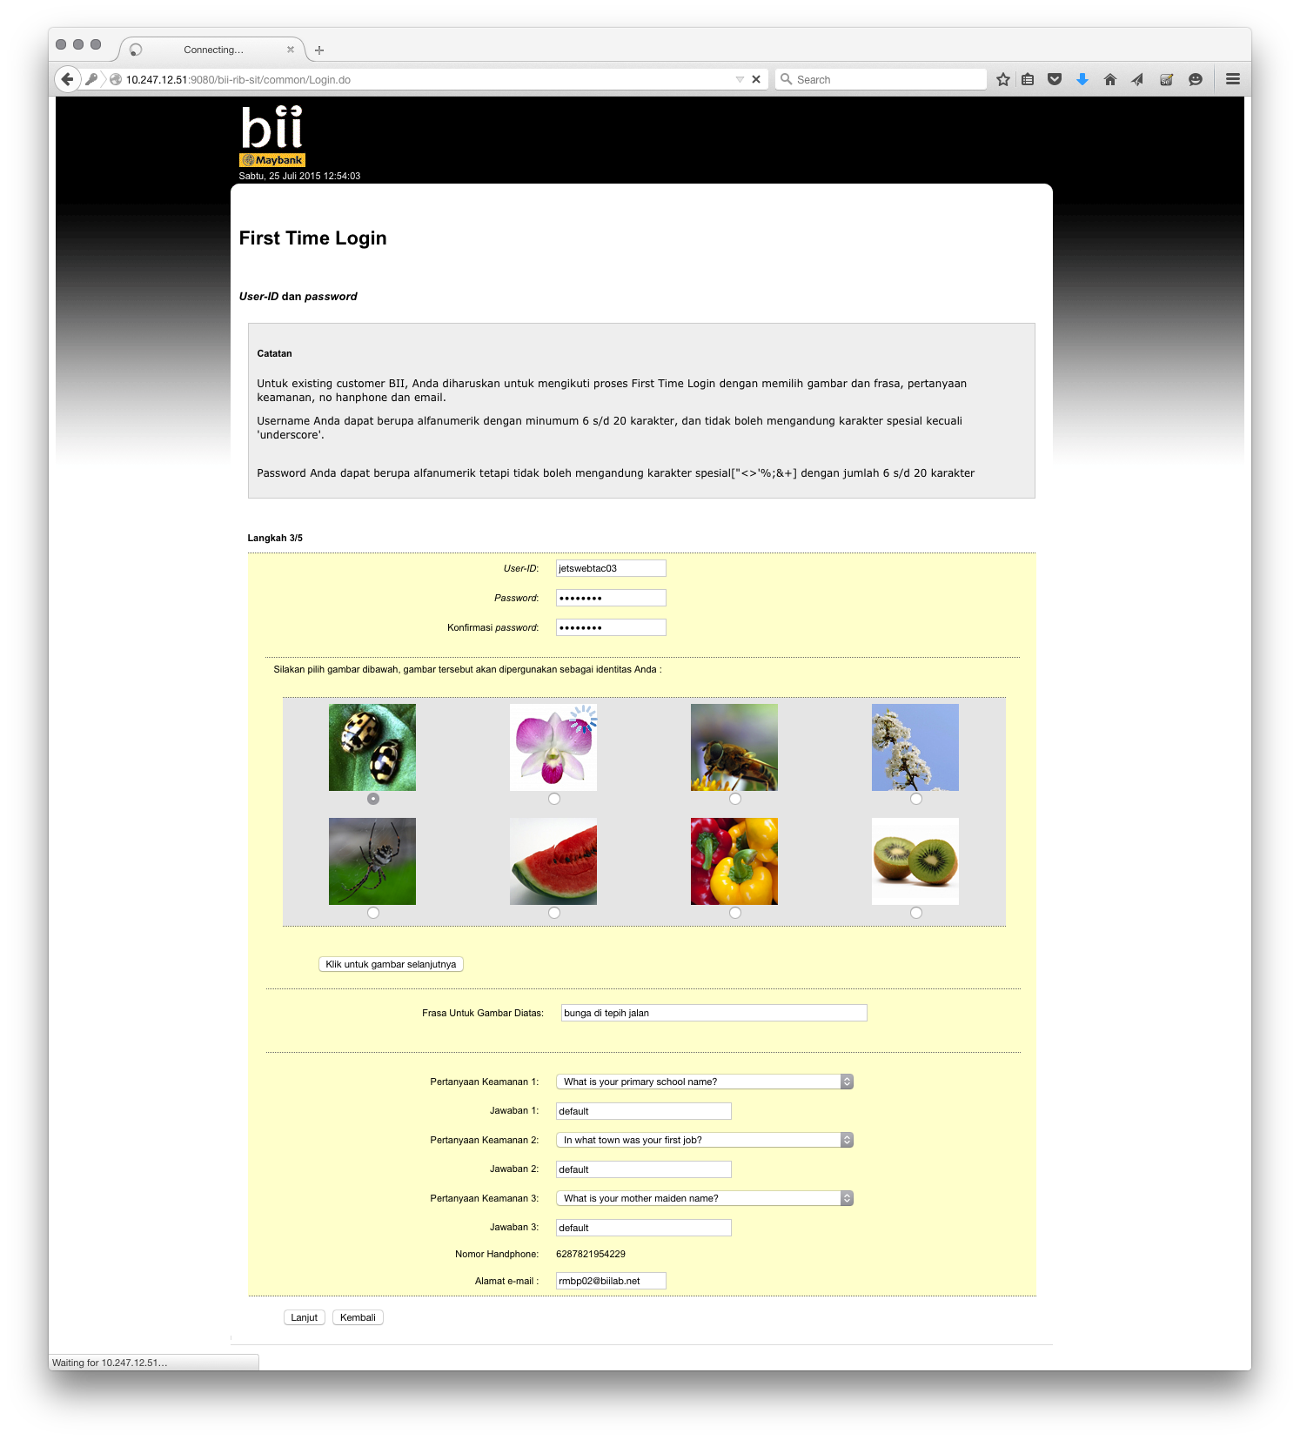

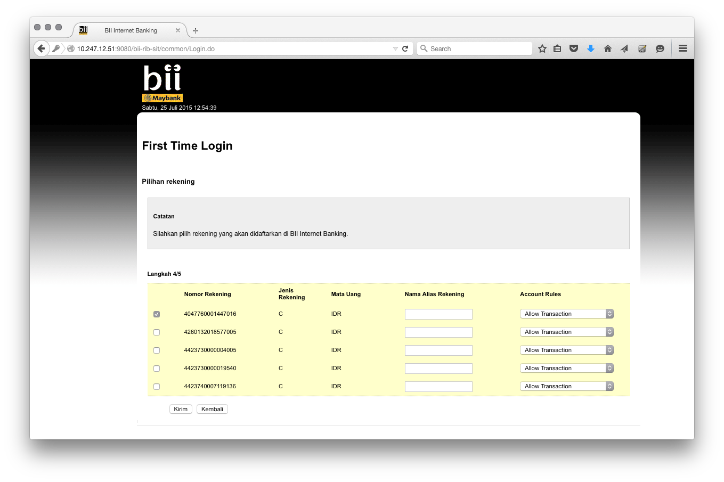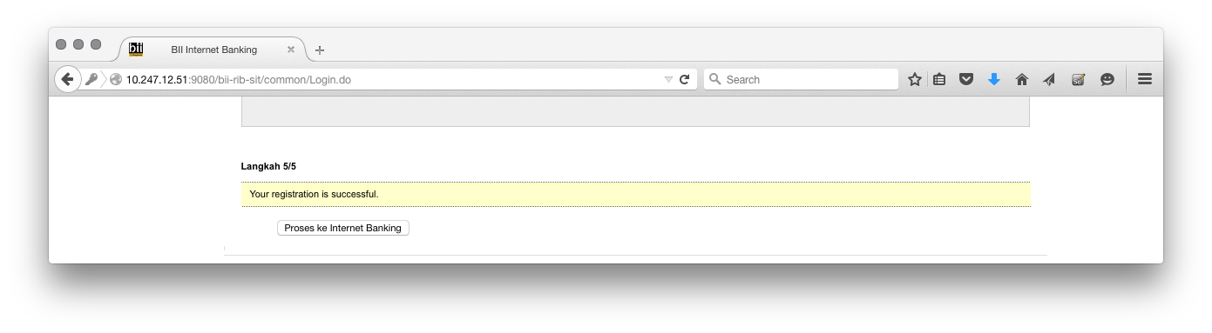

1. Log in test:

Username: jetswebtac03

Password: Aaaa1111

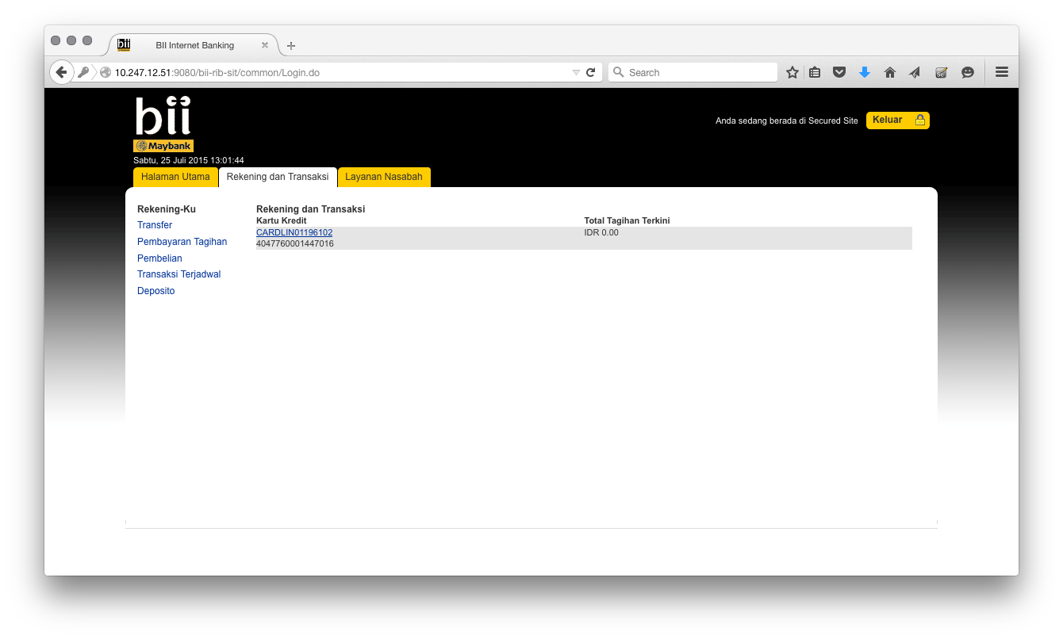

1. Registration from jetsweb is defaulted to non-transactional:

