Test Issue Log |  |  |  |  | TIL No.: URF-14-12-163
Project Name: | Conditional Sign-Off IBSCR068 & IBSCR072
Test Stage: | Unit Functionality Integration System Interface  Performance Regression Acceptance Pilot
Test Case Number: | IBG-046 |  |  | Test Started Date: |  | 25/06/2015
Test Title: | CIB EPF – Inaccurate Description
Test Description: | To ensure description for EPF transaction in CIB reflect Channels & Services and EPF number.
Test Functionality: | CIB  - Open / Registered Statutory Payment
Test Procedure: | - Perform Open / Registered Statutory Payment for CIB  - View Transaction Description in Transaction History
Test Result: | Pass: Fail: Conditional Pass: |  | Tested by: |  | Leonard Lim
Reason for Failure:
TEST DESCRIPTION
IBG-046: CIB EPF-Inaccurate Description
Open Statutory Payment - EPF
Confirm Page
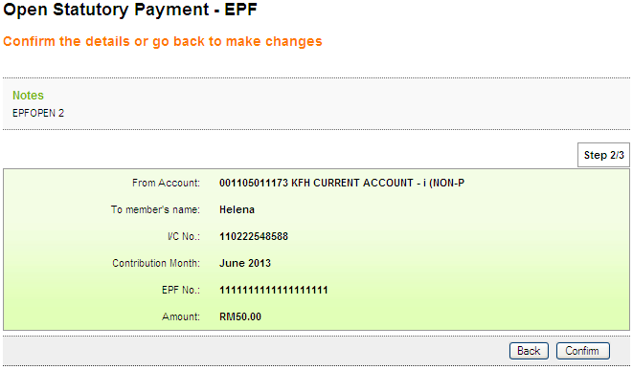
Result Page
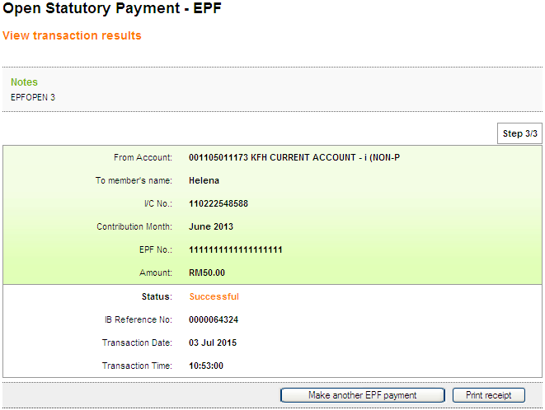

Print Receipt
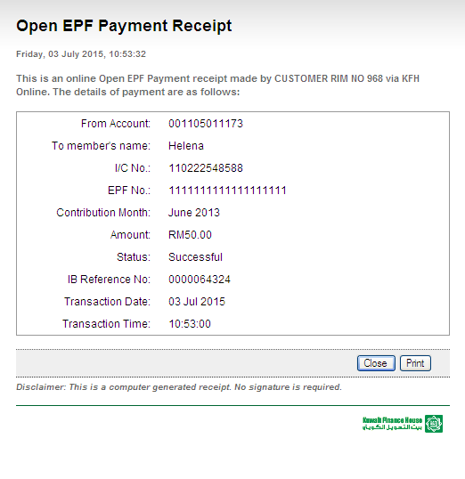

Transaction History
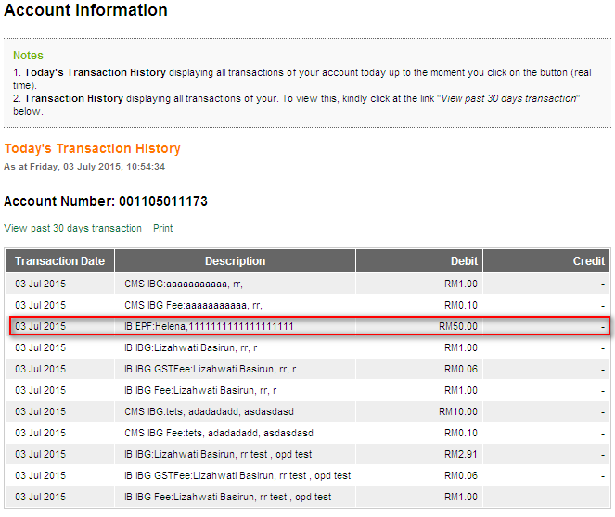

Registered Statutory Payment - EPF
Confirm Page
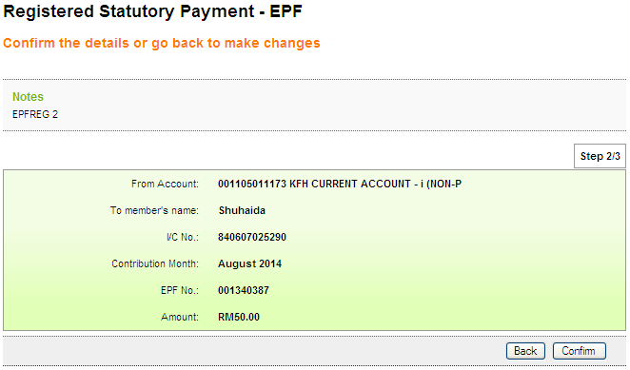
Result Page
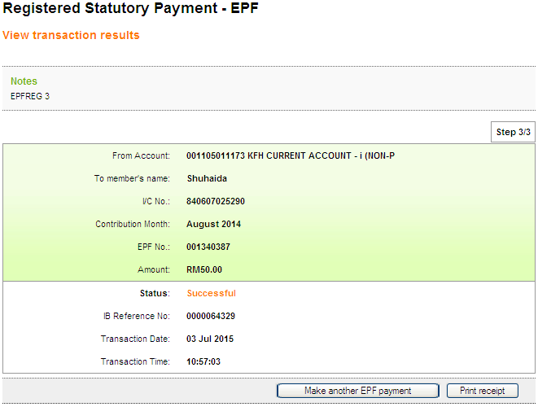
Print Receipt
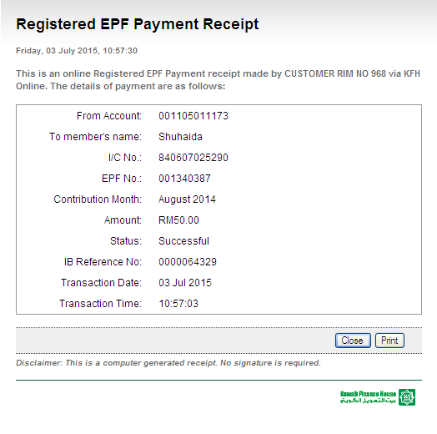

Transaction History
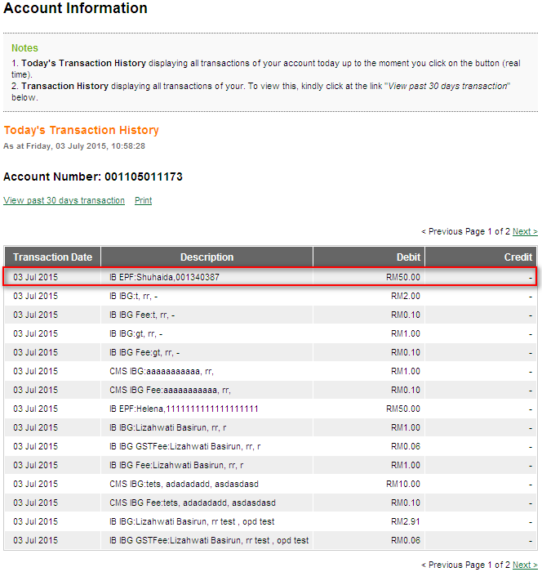

Reviewed By: (PMO)
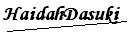 |  | Name/Position : NorhaidahBintiMdDasuki / Senior Manager, Quality Assurance and Support  Date :

