Test Issue Log |  |  |  |  | TIL No.: URF-14-12-163
Project Name: | Conditional Sign-Off IBSCR068 & IBSCR072
Test Stage: | Unit Functionality Integration System Interface  Performance Regression Acceptance Pilot
Test Case Number: | IBG-049 |  |  | Test Started Date: |  | 25/06/2015
Test Title: | BIB EPF- Inaccurate Description
Test Description: | To Ensure transaction Description for EPF Other Payment transaction in BIB
Test Functionality: | BIB  - Bulk Payment  >EPF Other Payment (Form F, Late Charges Payment, Dividend Loss Payment, Other Charges)
Test Procedure: | - Perform EPF Other Payment (Form F, Late Charges Payment, Dividend Loss Payment, Other Charges) for BIB  - View Transaction Description in Transaction History
Test Result: | Pass: Fail: Conditional Pass: |  | Tested by: |  | Leonard Lim
Reason for Failure:
TEST DESCRIPTION
IBG-049: BIB EPF-Inaccurate Description
Role : Approver All
Form F

Confirm Page
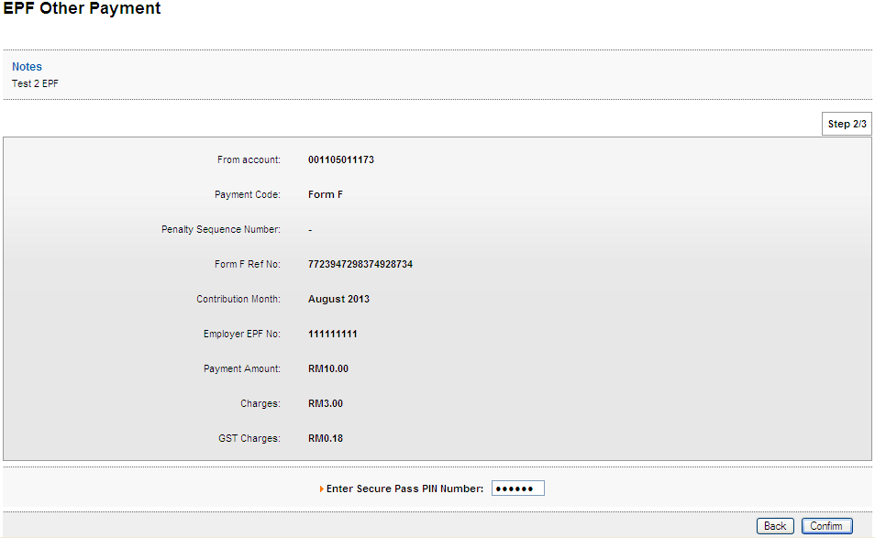
Result Page
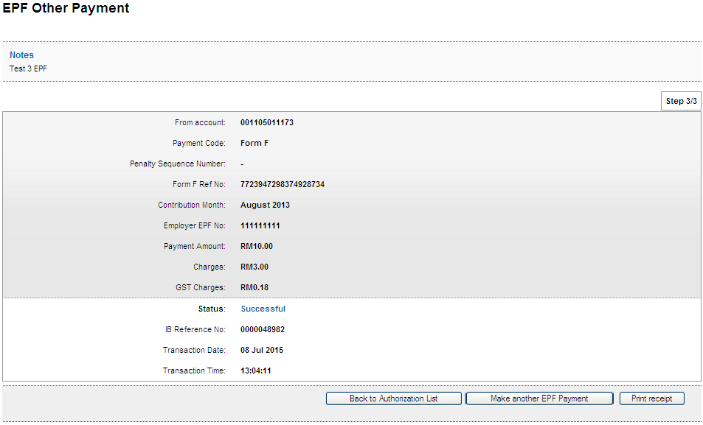
Print Receipt
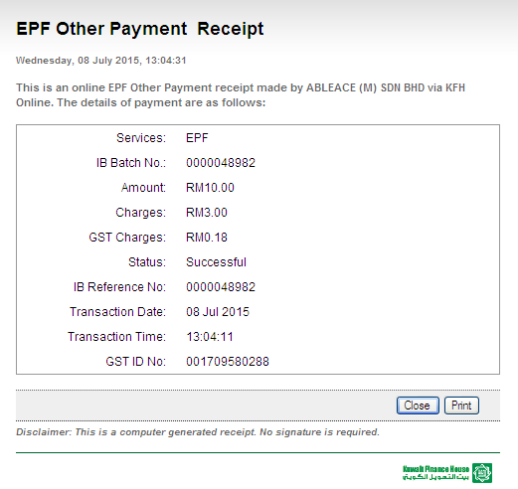
Transaction History
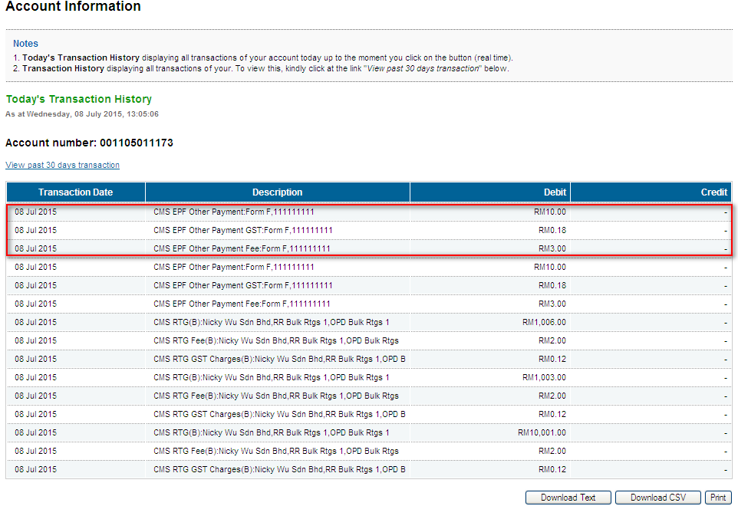
Late Charges Payment
Confirm Page
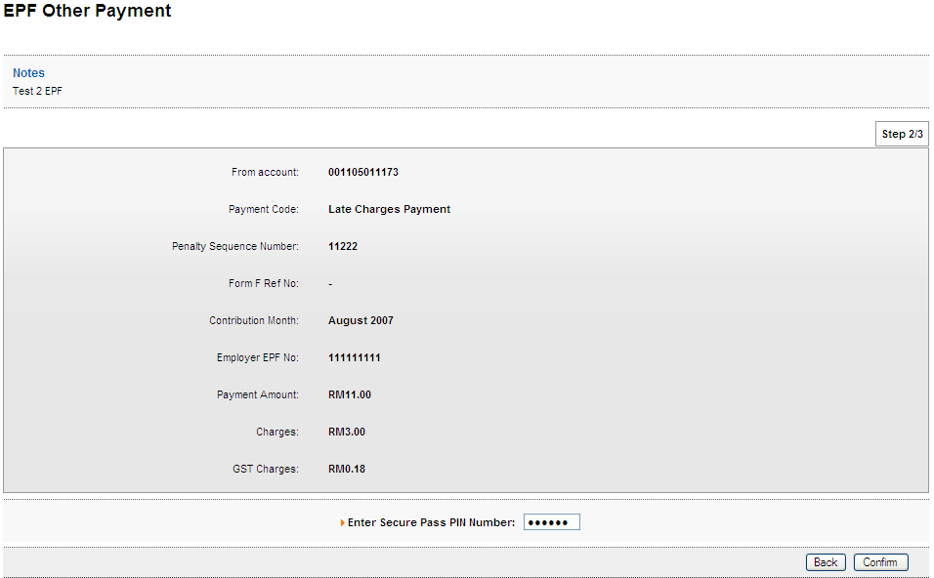
Result Page
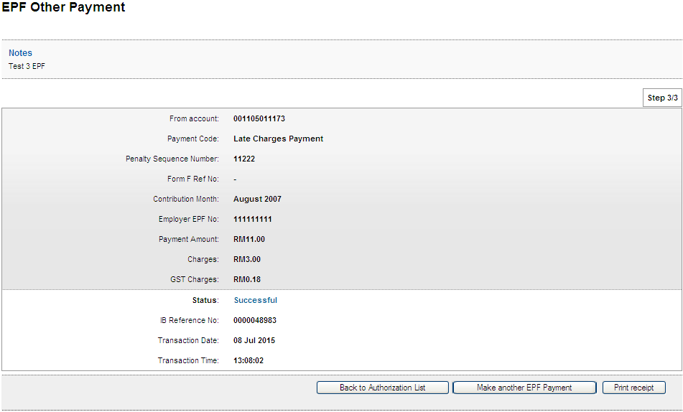
Print Receipt
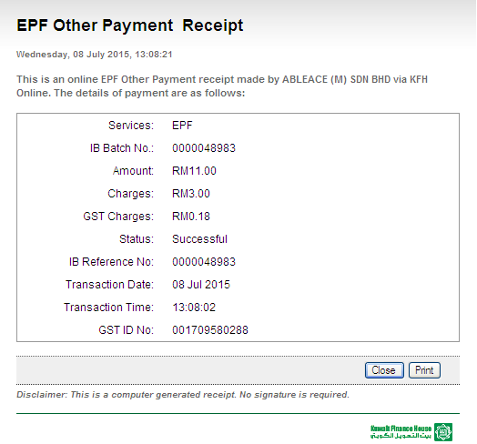
Transaction History
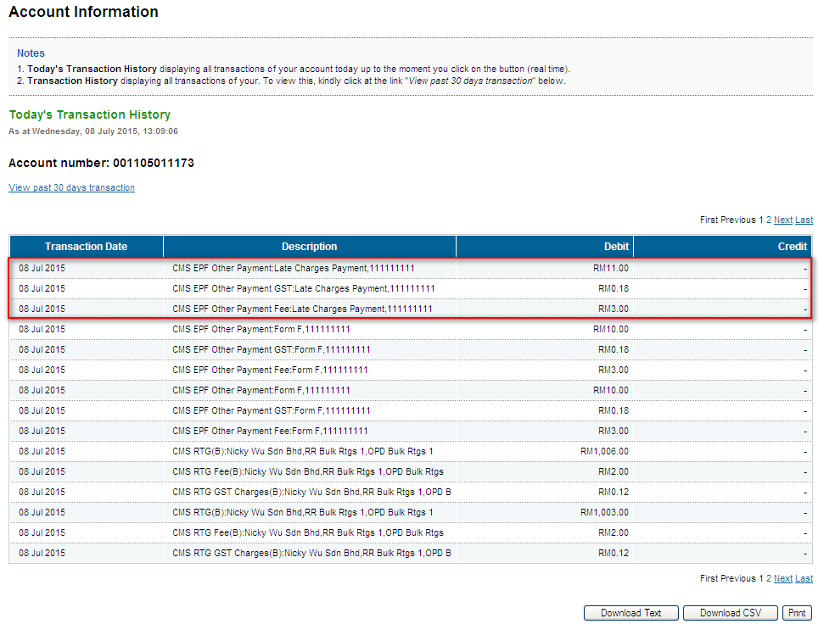
Dividend Loss Payment
Confirm Page
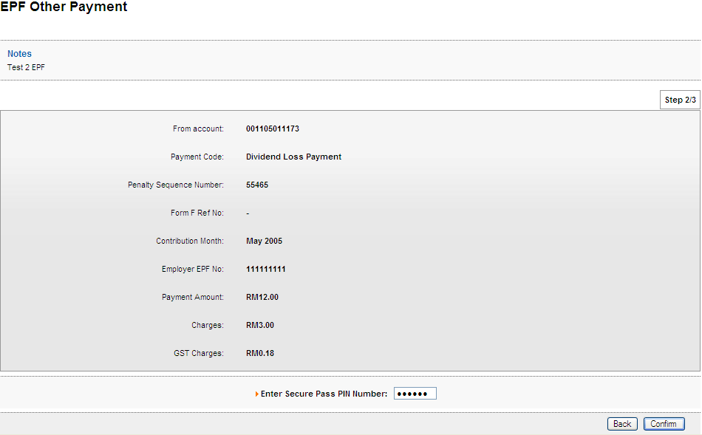
Result Page
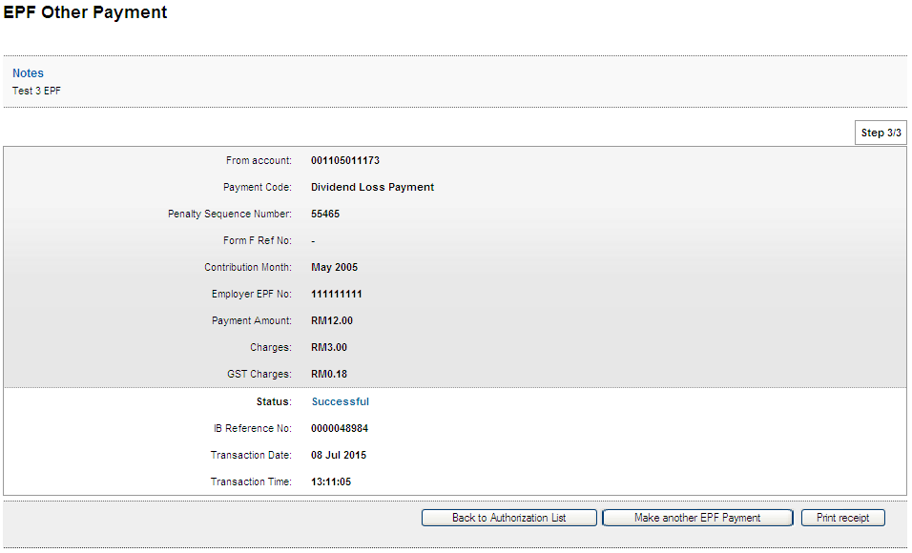
Print Receipt
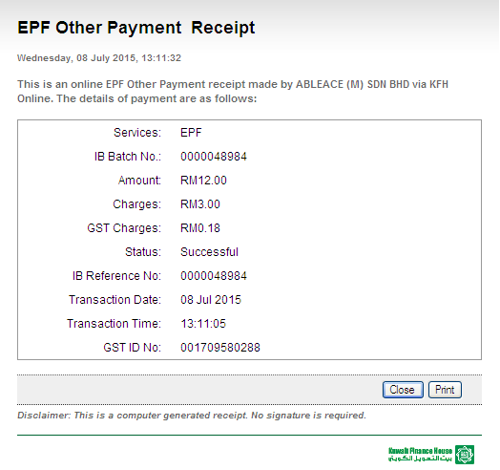
Transaction History
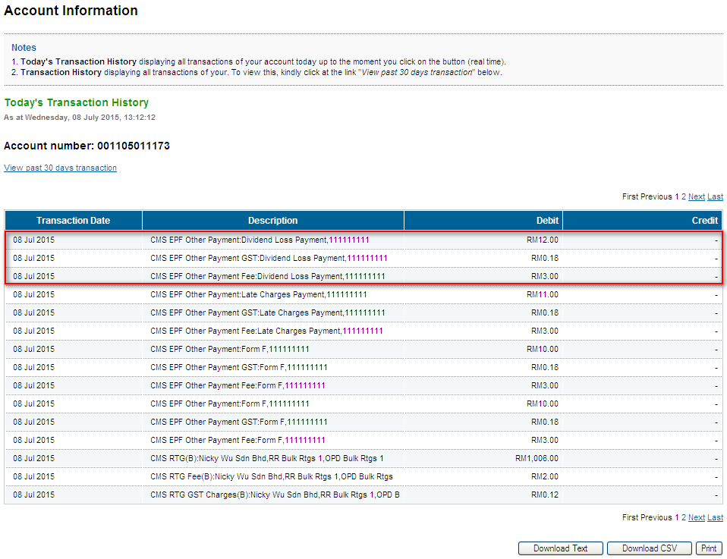
Other Charges
Confirm Page
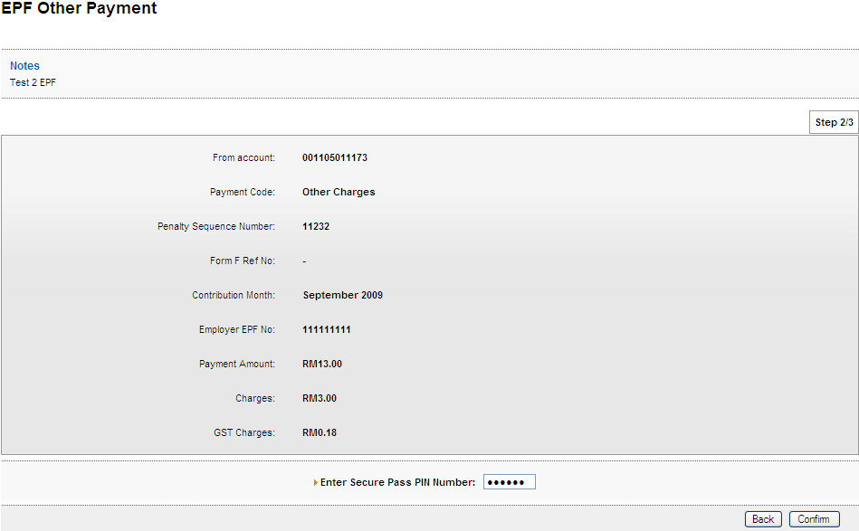
Result Page
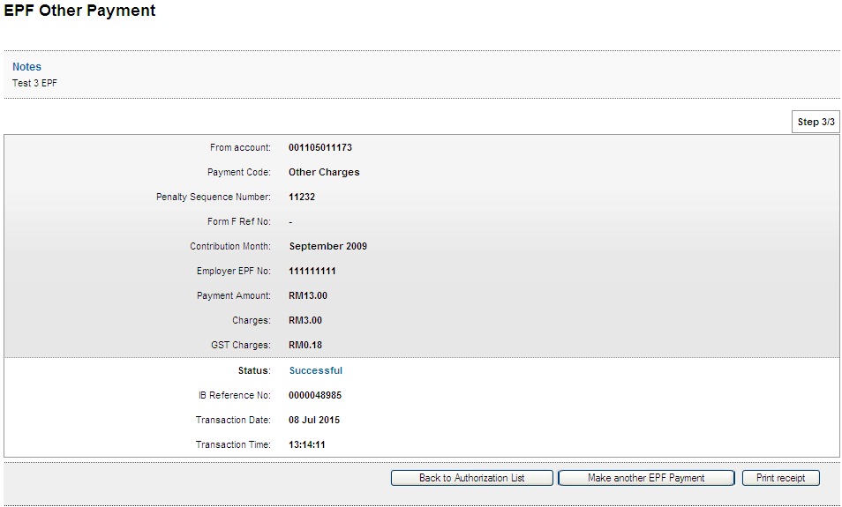
Print Receipt
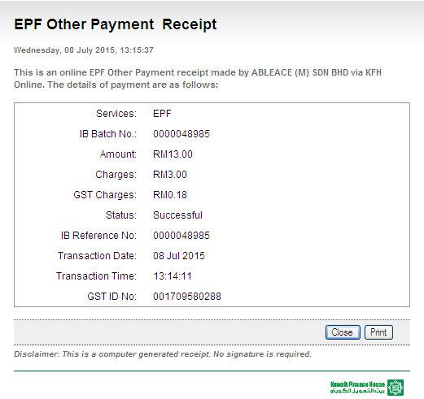
Transaction History
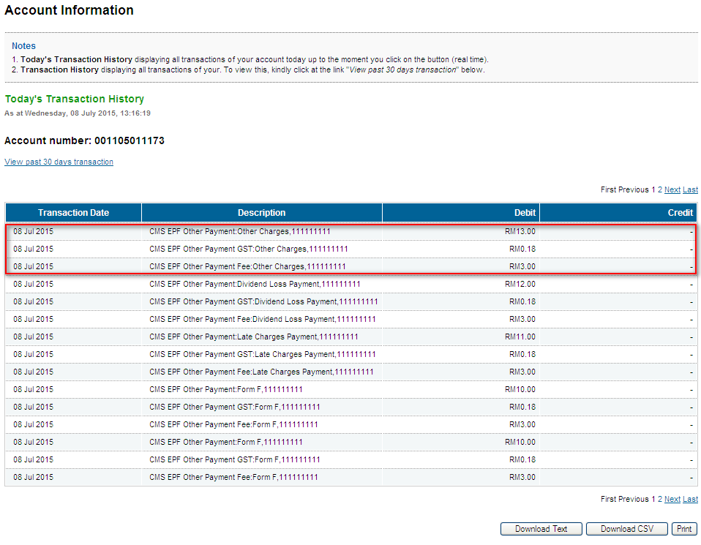

Role : Initiator
Form F
Confirm Page
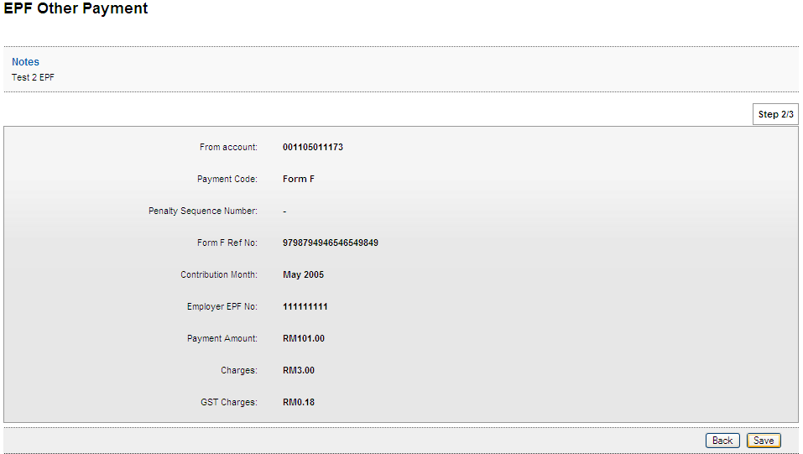
Result Page
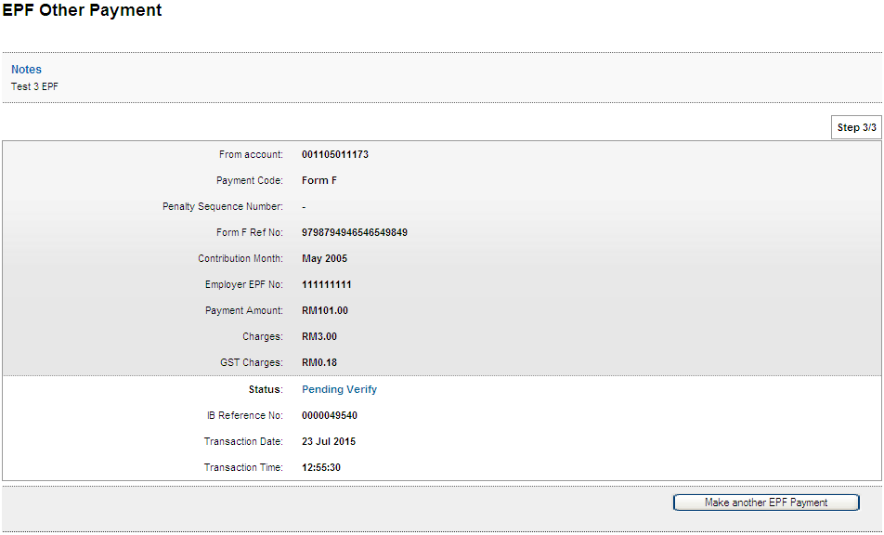
Late Charges Payment
Confirm Page
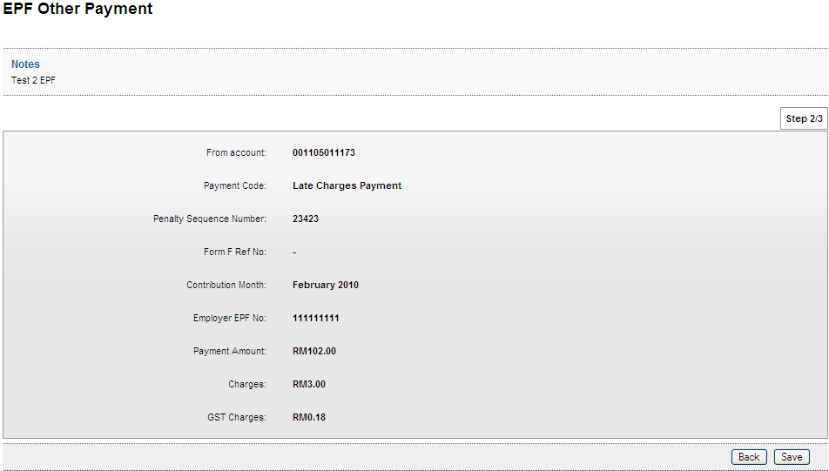
Result Page
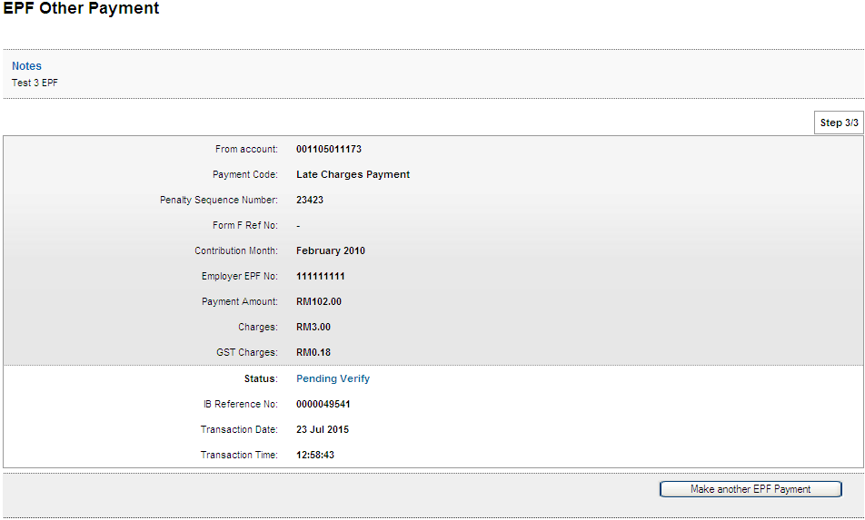

Dividend Loss Payment
Confirm Page
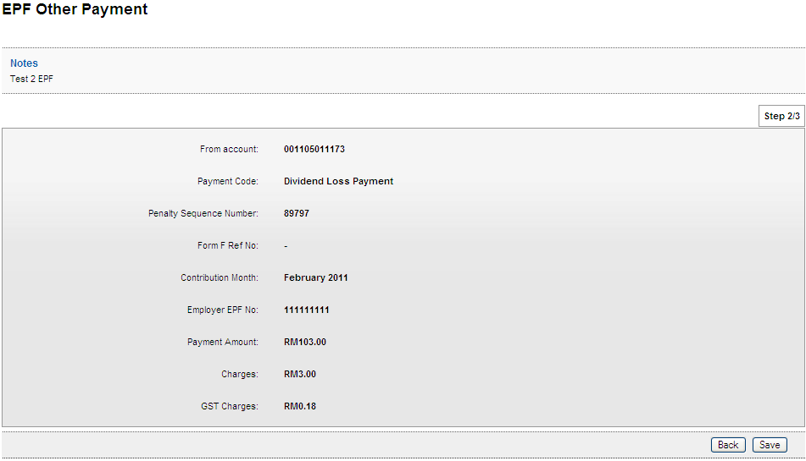
Result Page
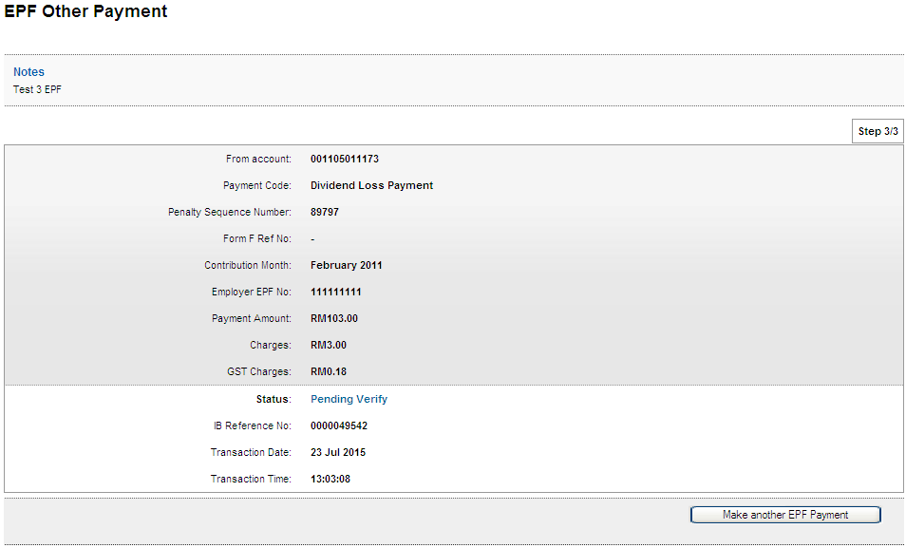
Other Charges
Confirm Page
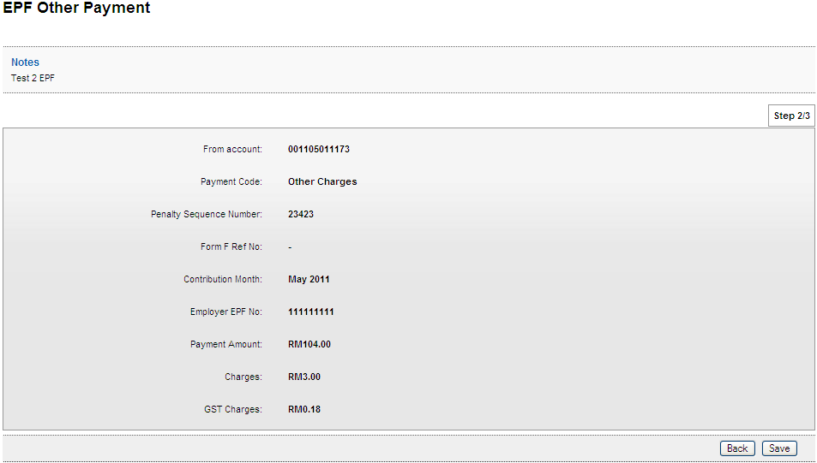
Result Page
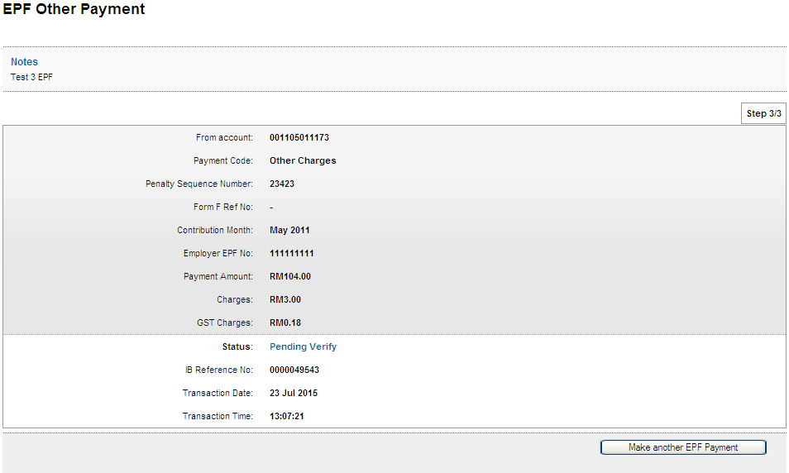

Role : Verifier
Form F
Confirm Page
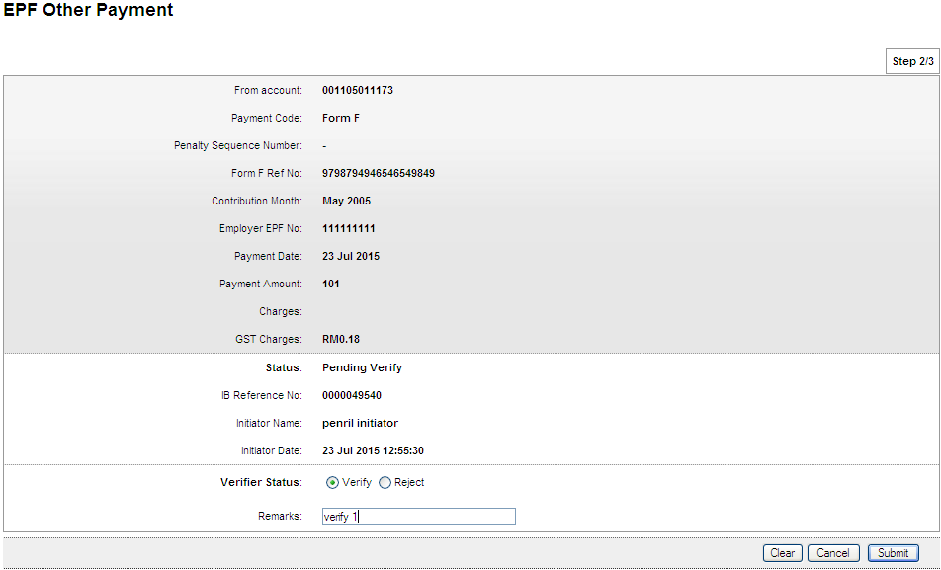
Result Page
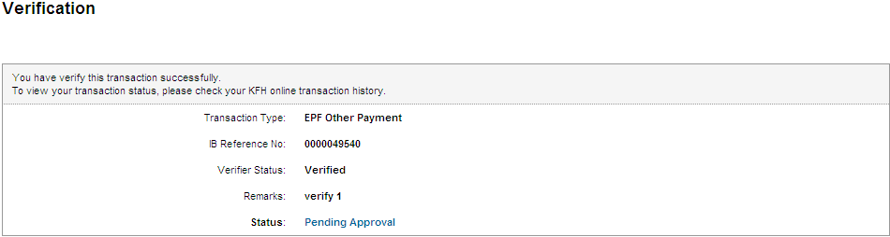

Late Charges Payment
Confirm Page
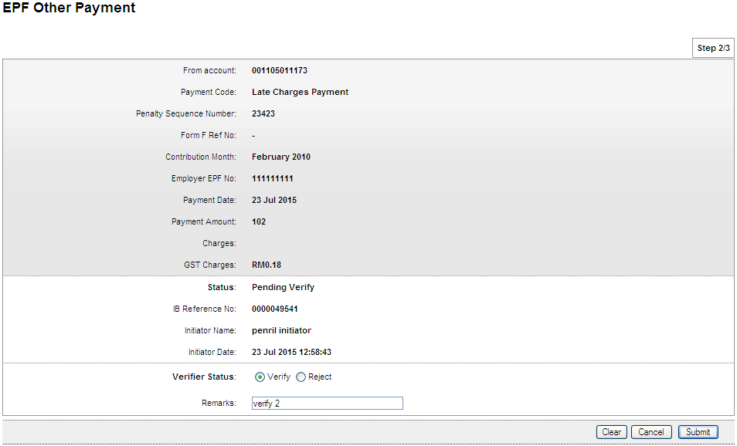
Result Page
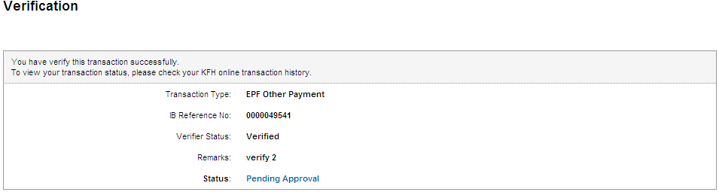

Dividend Loss Payment
Confirm Page
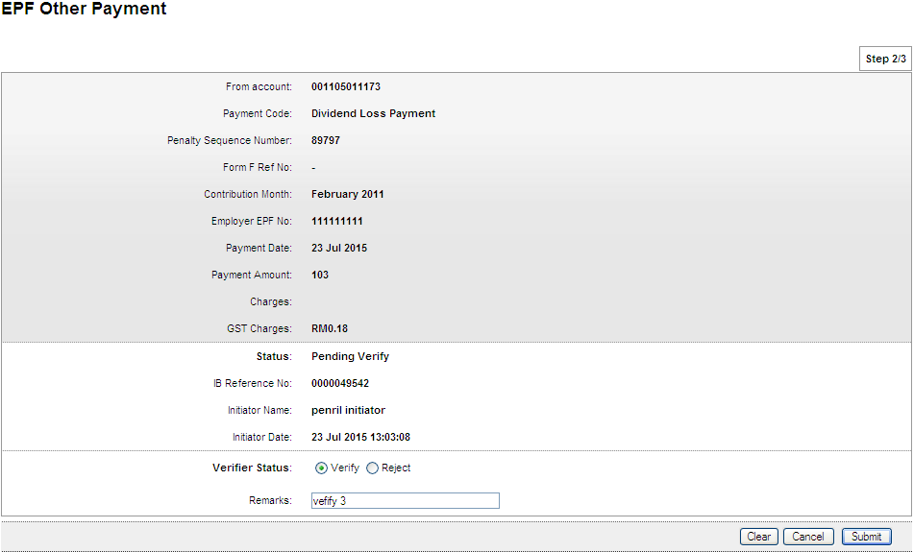
Result Page
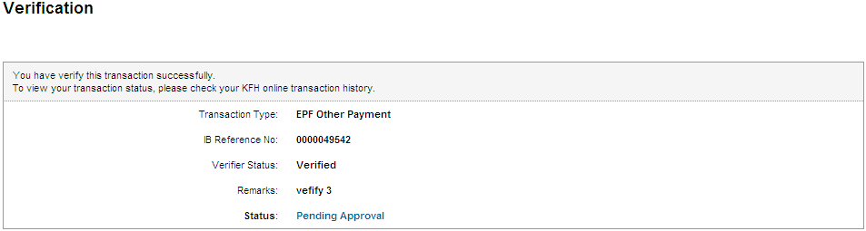

Other Charges
Confirm Page
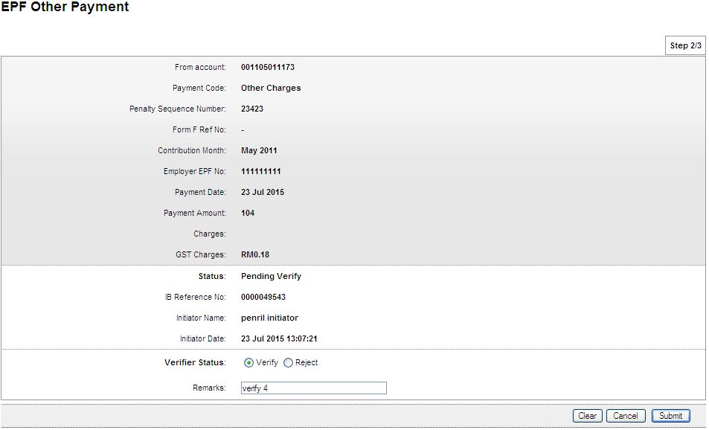
Result Page
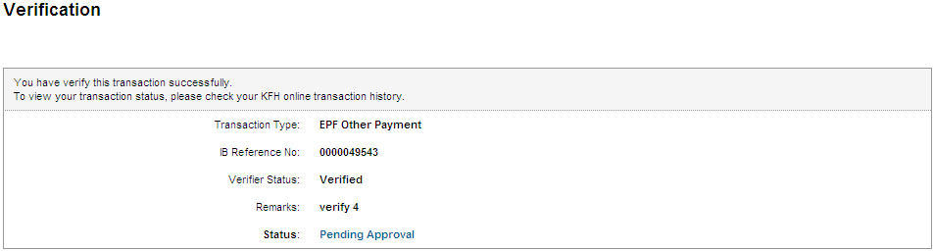

Role : Approver
Form F
Confirm Page
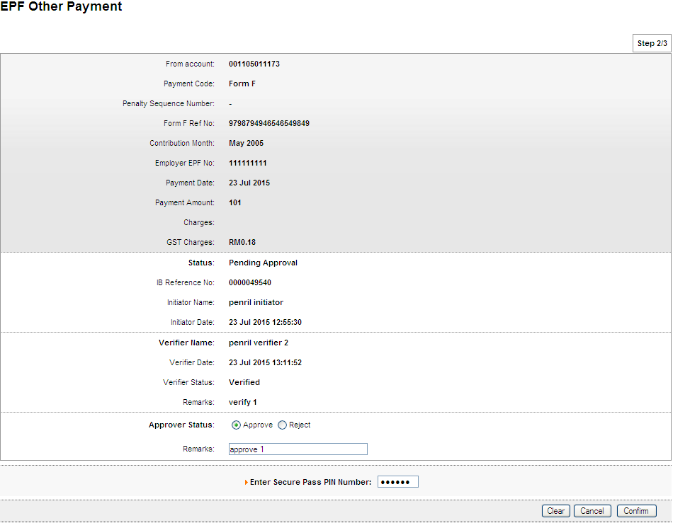
Result Page
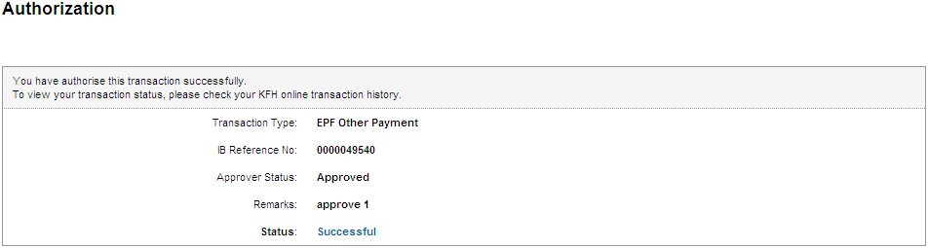
Print Receipt
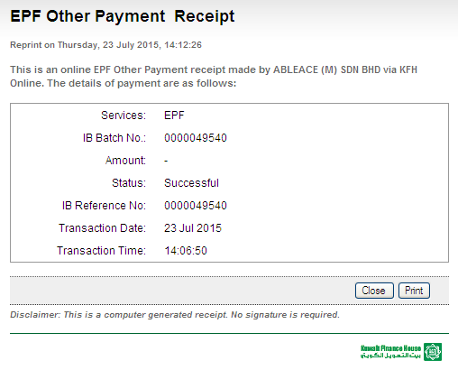
Transaction History
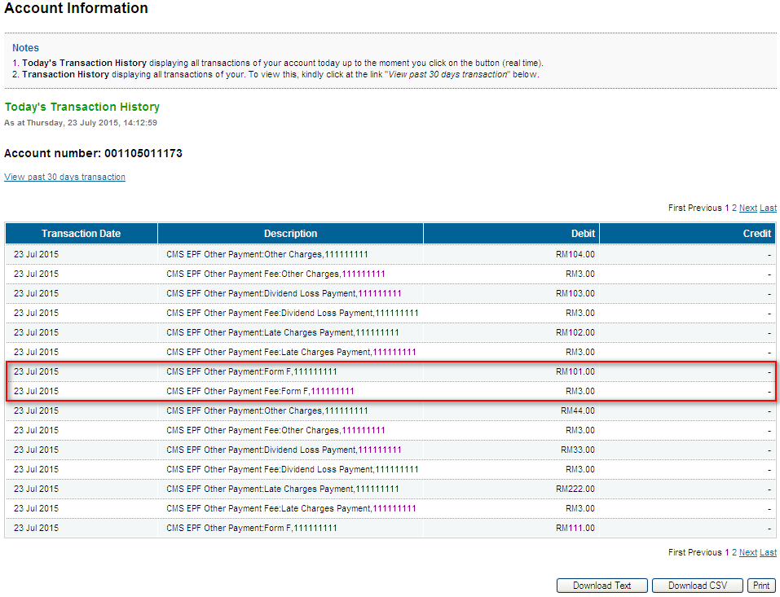
Late Charges Payment
Confirm Page
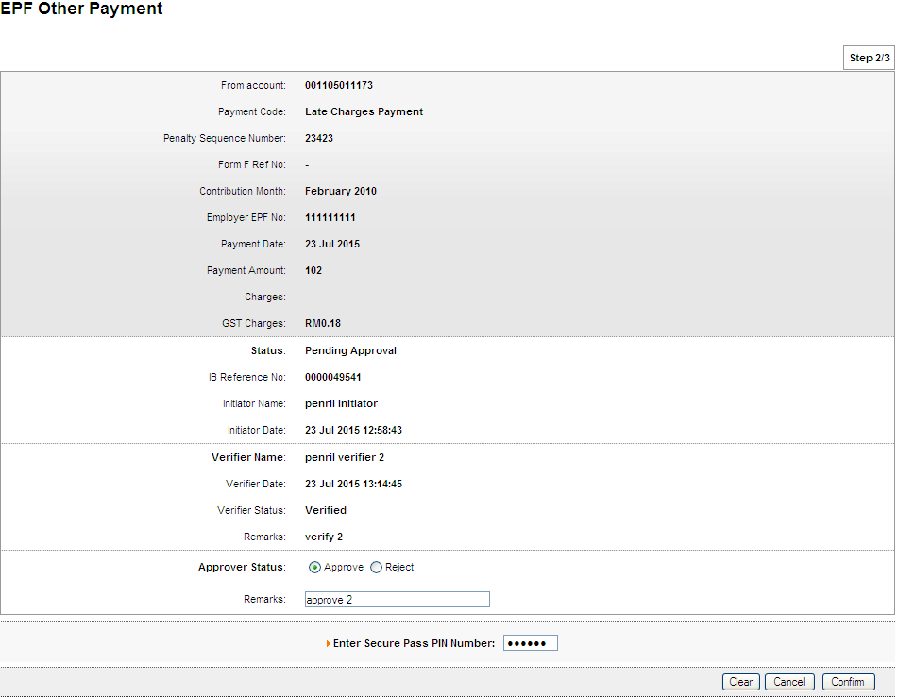
Result Page
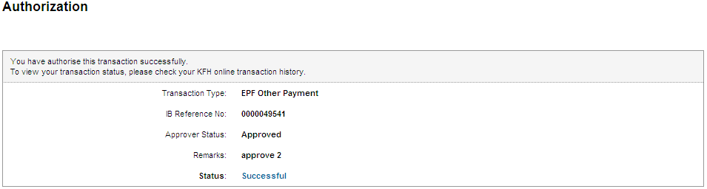
Print Receipt
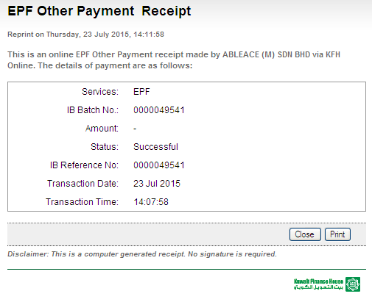
Transaction History
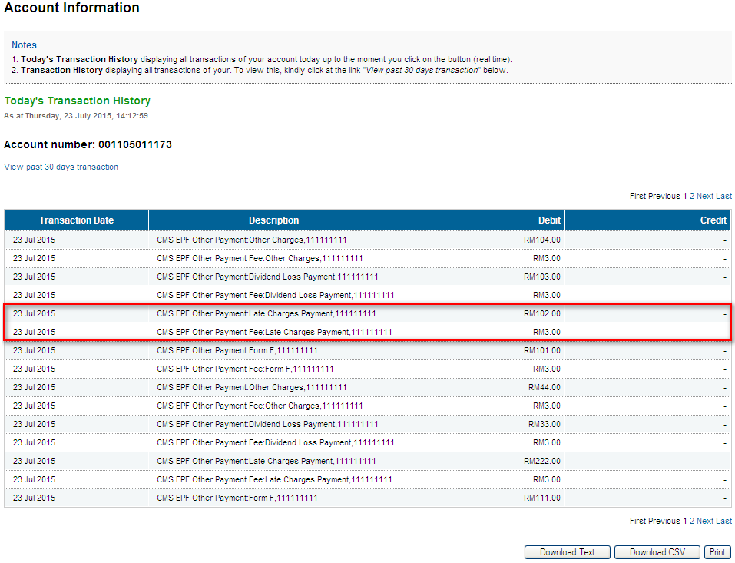
Dividend Loss Payment
Confirm Page
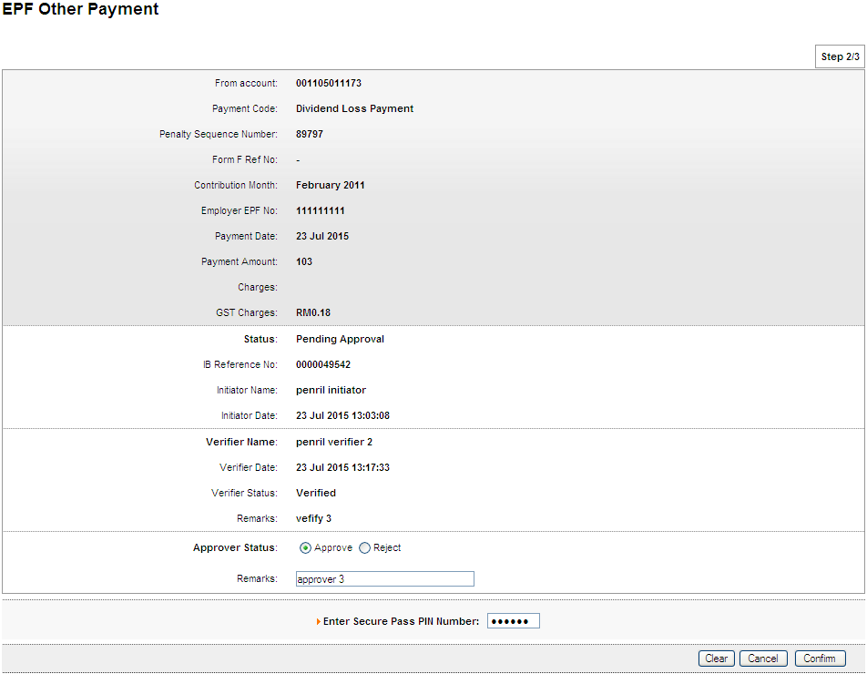
Result Page
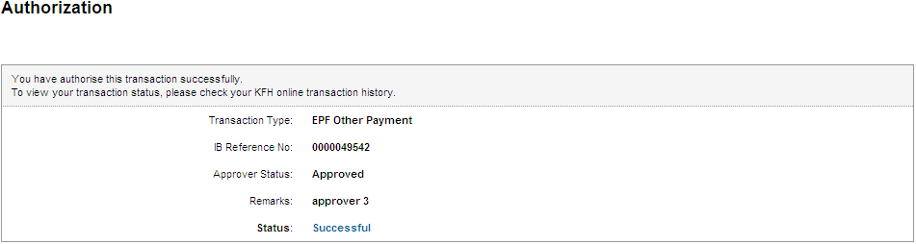
Print Receipt
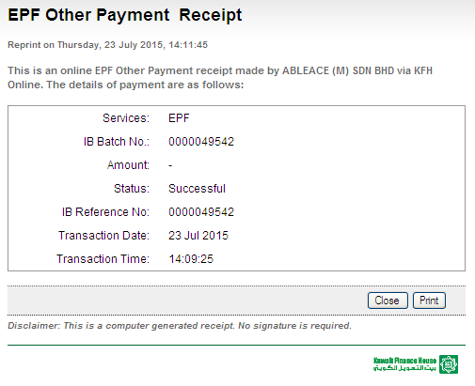
Transaction History
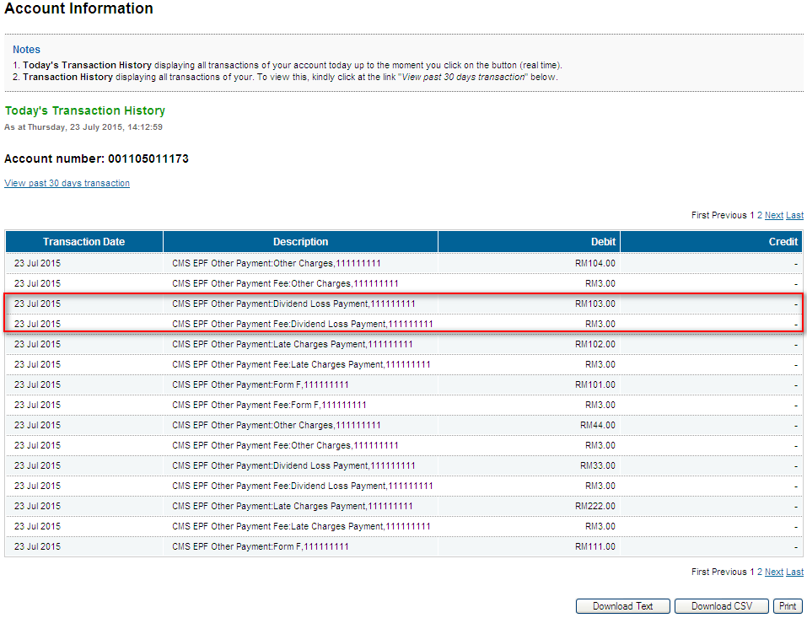
Other Charges
Confirm Page
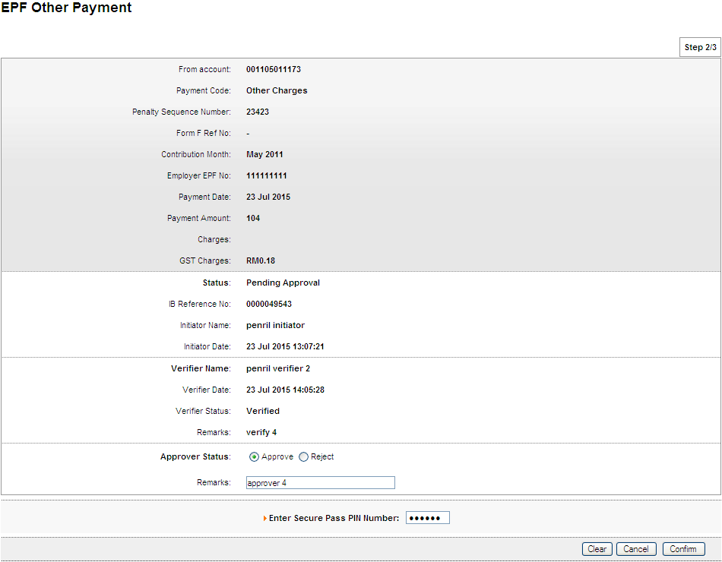
Result Page
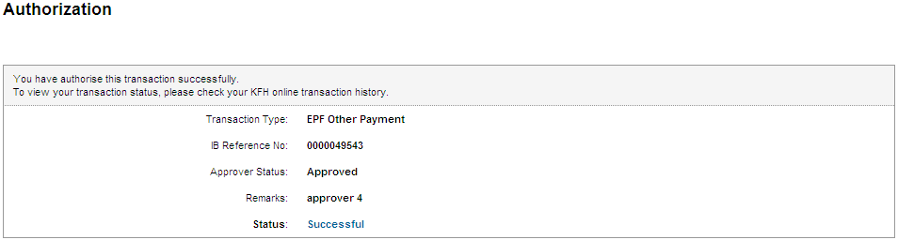
Print Receipt
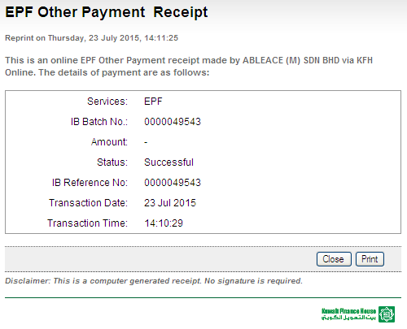
Transaction History
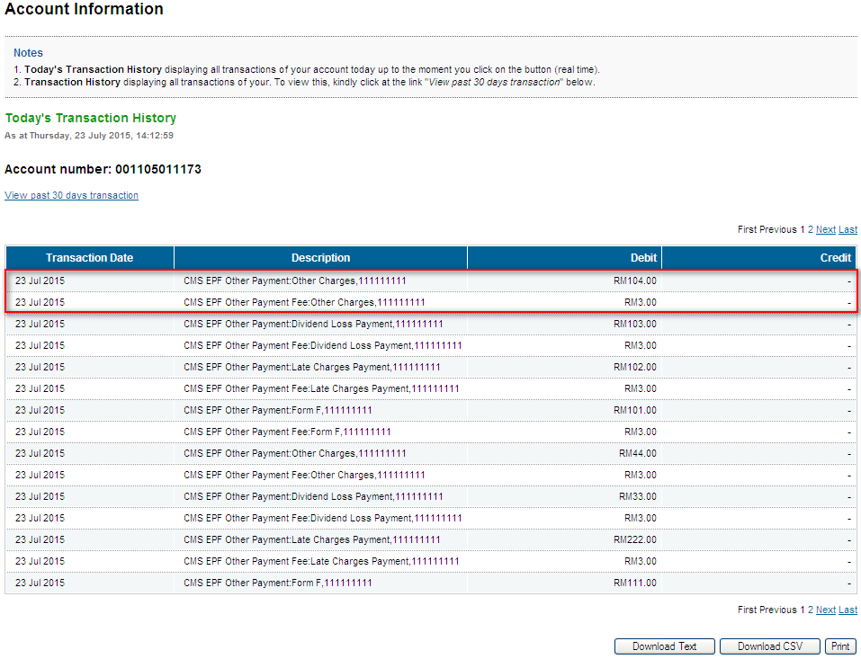

Role : Init-Veri
Form F
Confirm Page
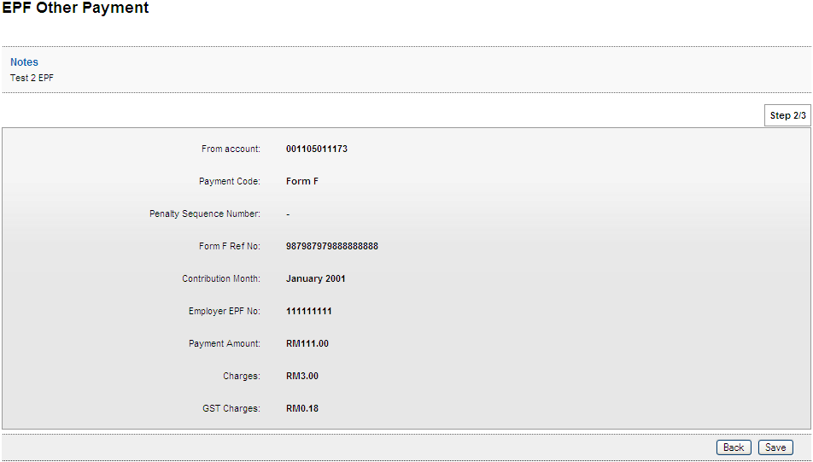
Result Page
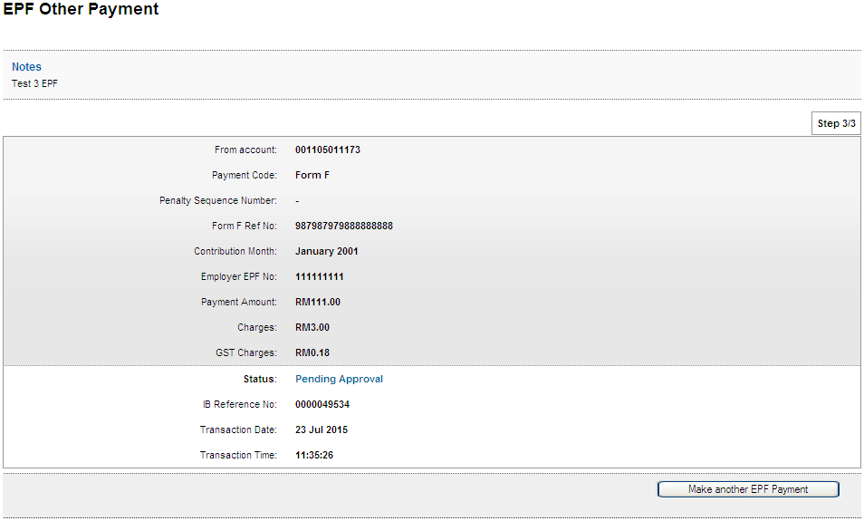

Late Charges Payment
Confirm Page
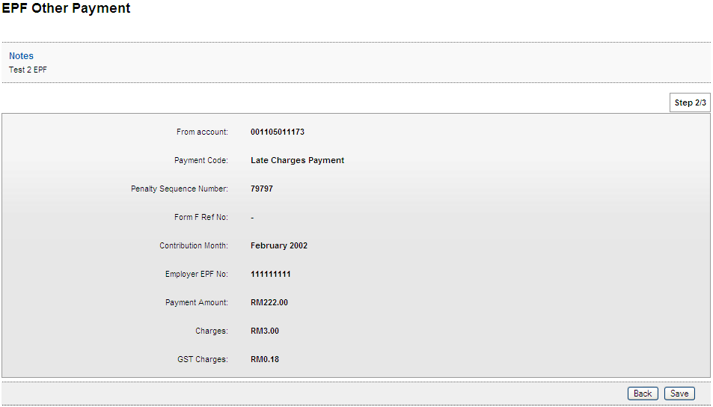
Result Page
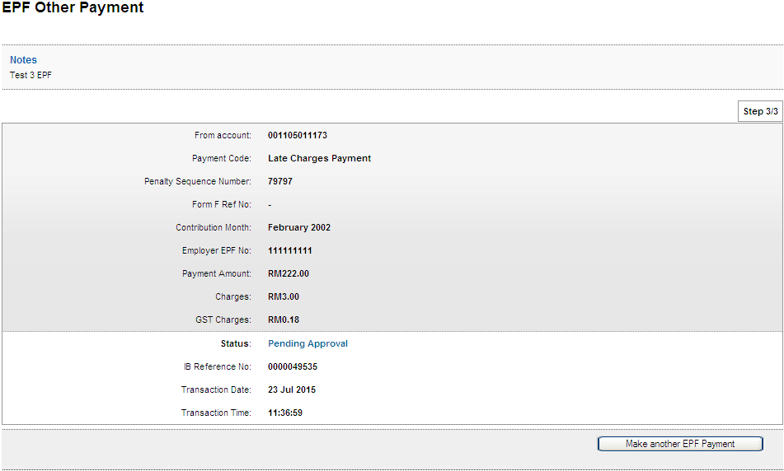

Dividend Loss Payment
Confirm Page
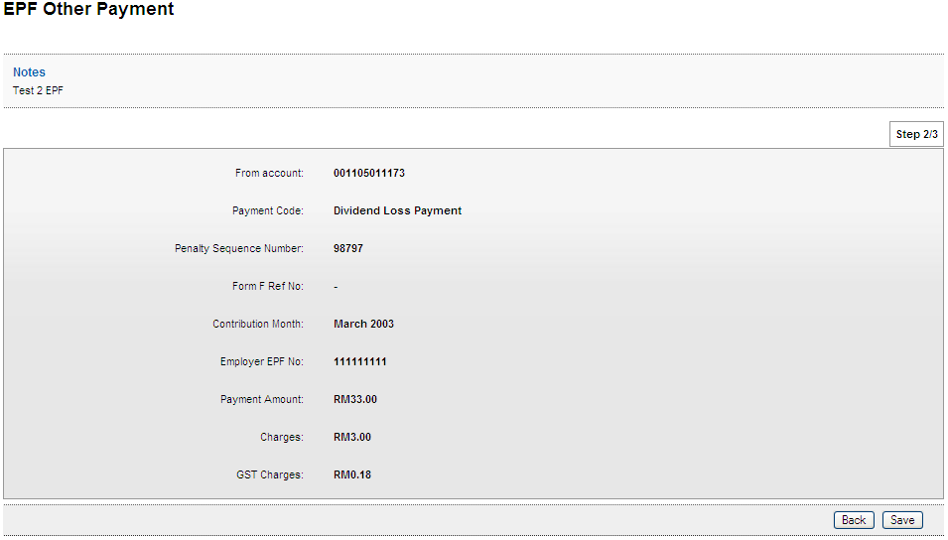
Result Page
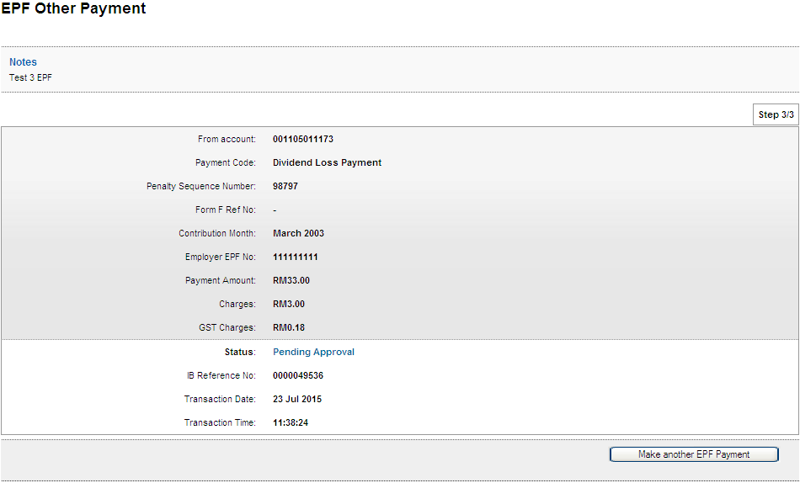

Other Charges
Confirm Page
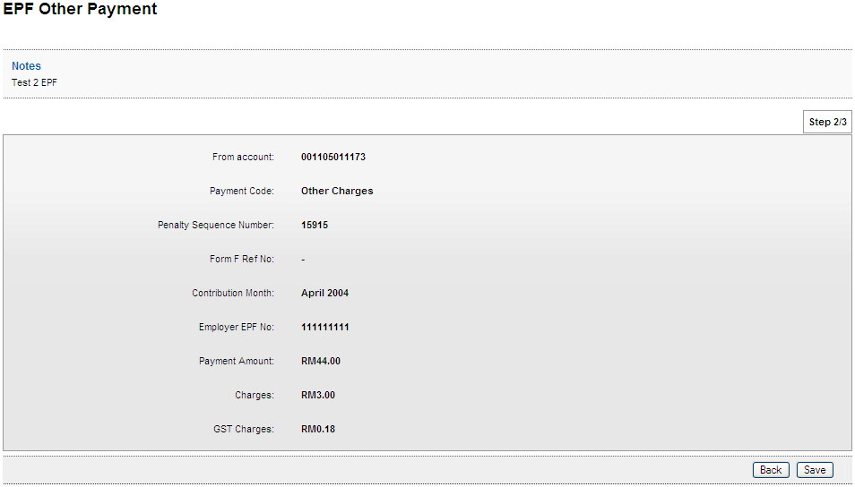
Result Page
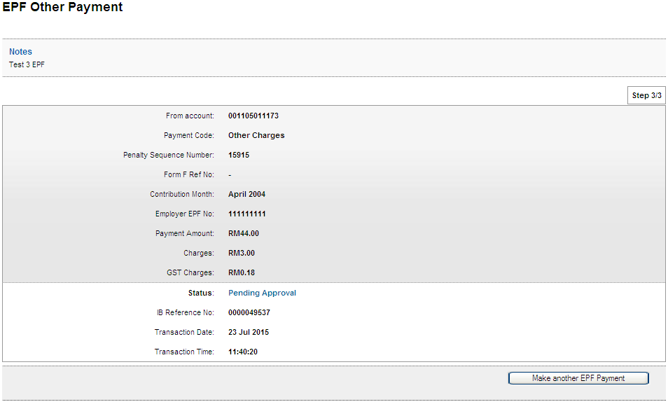

Role : Approver
Form F
Confirm Page
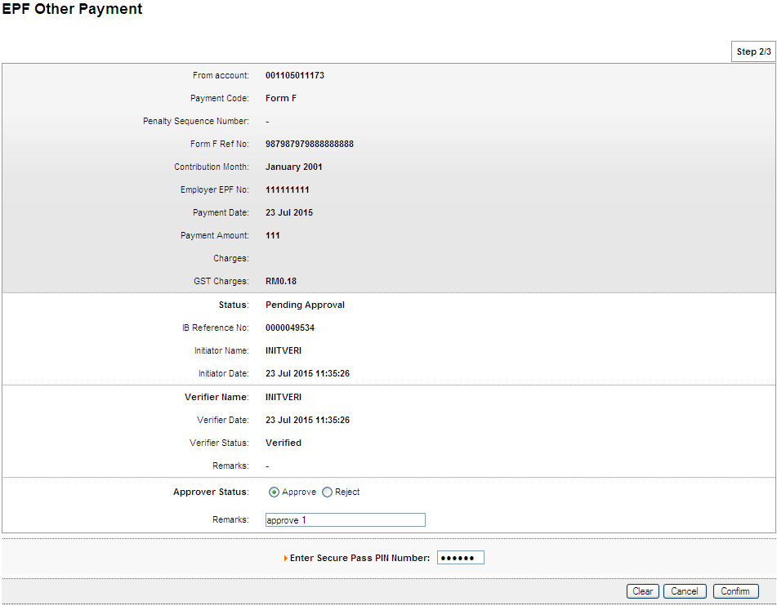
Result Page
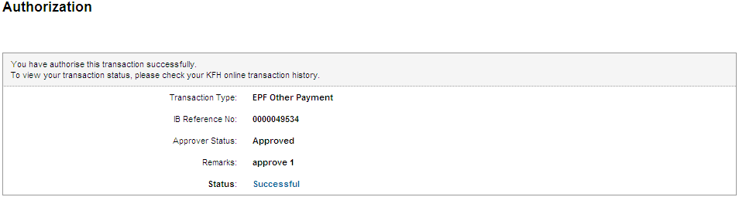
Print Receipt
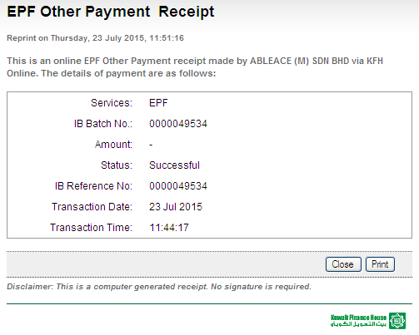
Transaction History
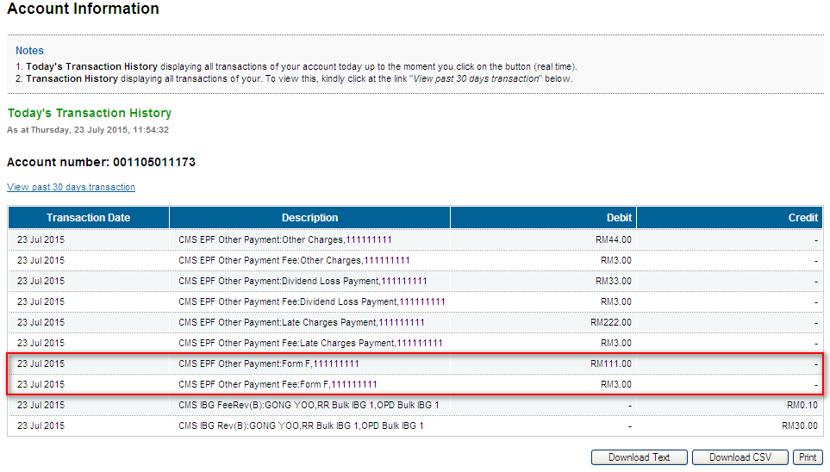
Late Charges Payment
Confirm Page
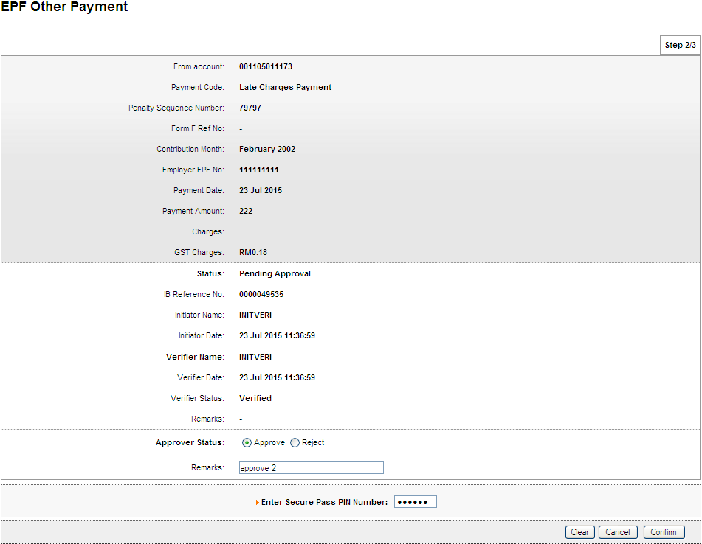
Result Page
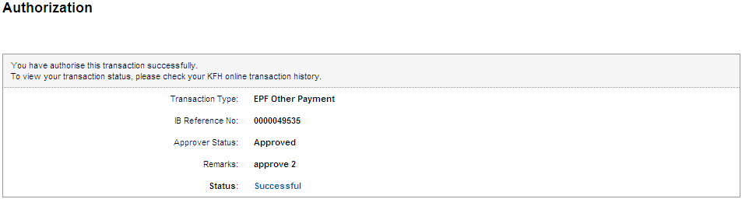
Print Receipt
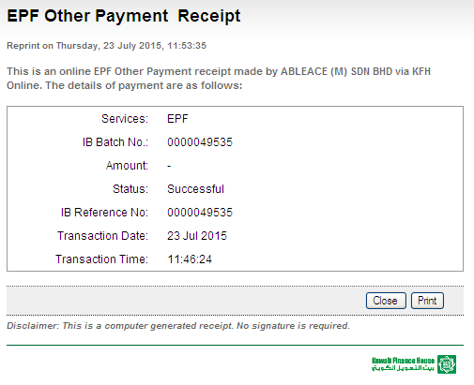
Transaction History
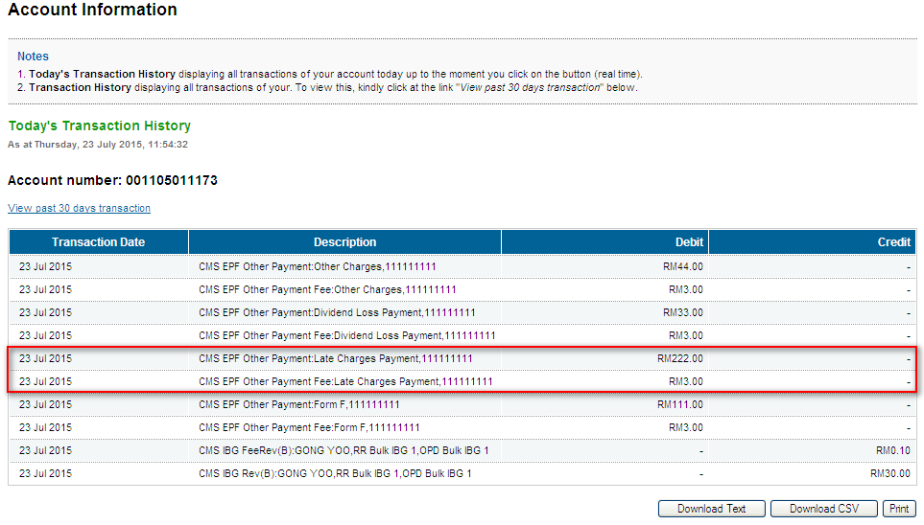
Dividend Loss Payment
Confirm Page
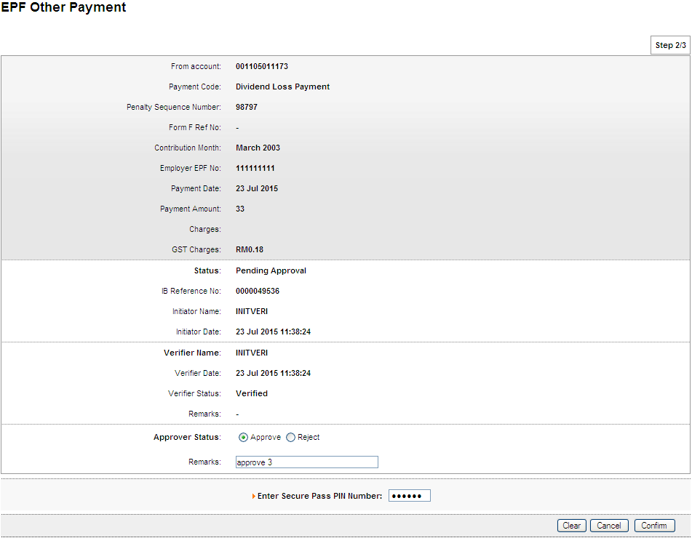
Result Page
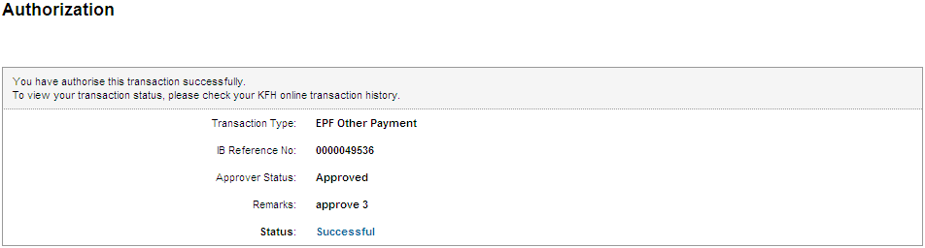
Print Receipt
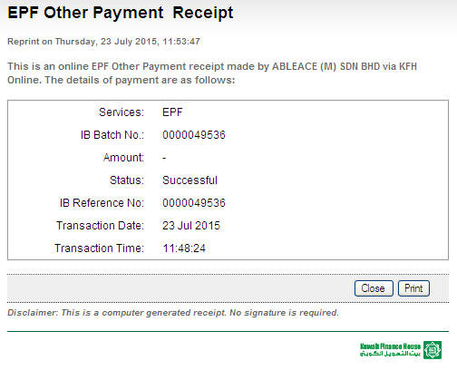
Transaction History
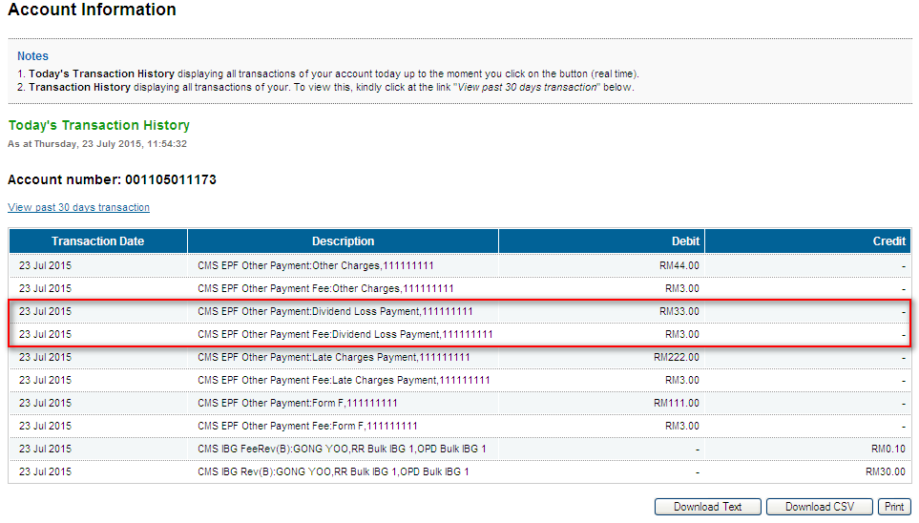
Other Charges
Confirm Page
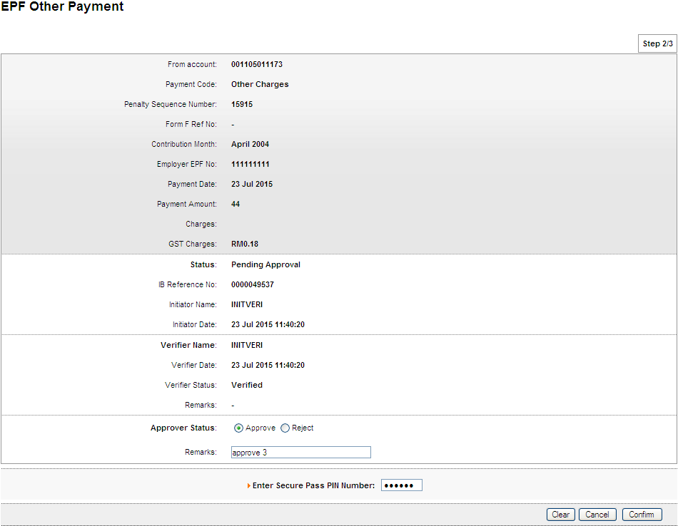
Result Page
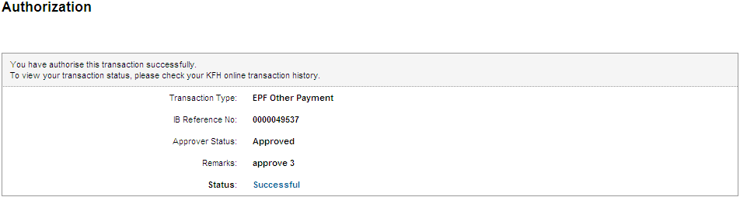
Print Receipt
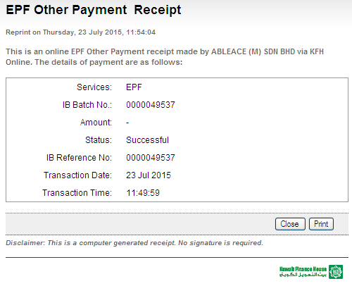
Transaction History
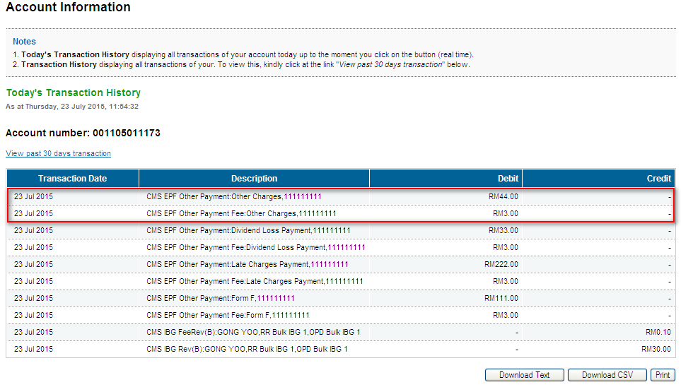

Reviewed By: (PMO)
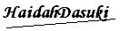 |  | Name/Position : NorhaidahBintiMdDasuki / Senior Manager, Quality Assurance and Support  Date :

