Test Issue Log |  |  |  |  | TIL No.: URF-14-12-163
Project Name: | Conditional Sign-Off IBSCR068 & IBSCR072
Test Stage: | Unit Functionality Integration System Interface  Performance Regression Acceptance Pilot
Test Case Number: | IBG-038 |  |  | Test Started Date: |  | 25/06/2015
Test Title: | To Remove Sender’s Name from Description for Sender’s Statement (FTT & Rentas)
Test Description: | To permanently discard sender’s name from description for sender’s statement (FTT & Rentas) in CIB and BIB
Test Functionality: | CIB  - Registered / Open FTT Transfer  BIB  - Open / Registered Rentas Transfer  - Open / Registered FTT Transfer
Test Procedure: | - Perform Registered / Open FTT Transfer for CIB, Perform Open /Registered Rentas Transfer and FTT Transfer for BIB  - View transaction Description in Transaction History and Log
Test Result: | Pass: Fail: Conditional Pass: |  | Tested by: |  | Leonard Lim
Reason for Failure: | Unable to Test SI, caused by unavailability for tester to access scheduler
TEST DESCRIPTION
IBG-038: To remove sender’s name from description for sender’s statement (FTT& Rentas)
CIB
Registered FTT Transfer (Pay Now)
Confirm Page
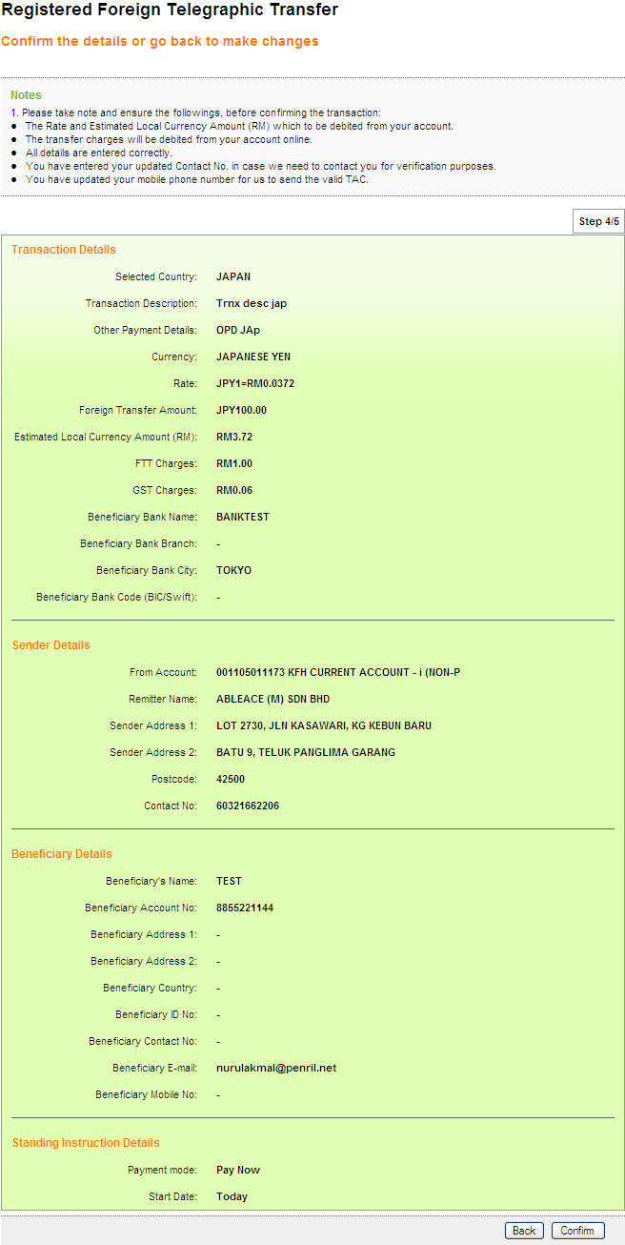
Result Page
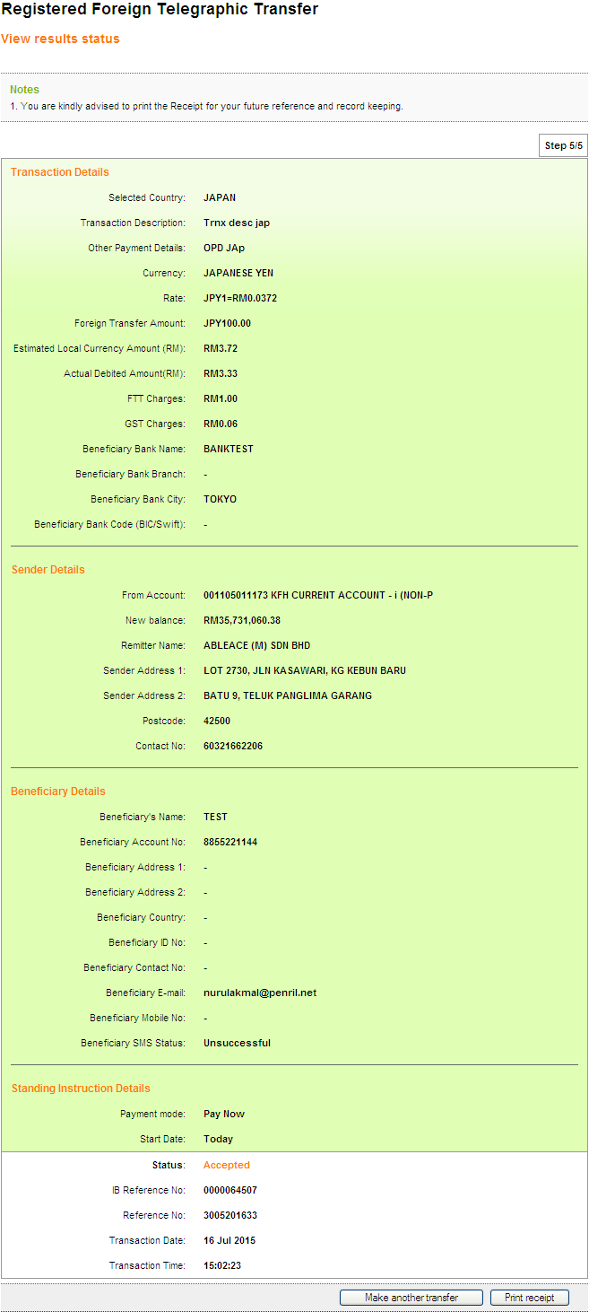
Print Receipt
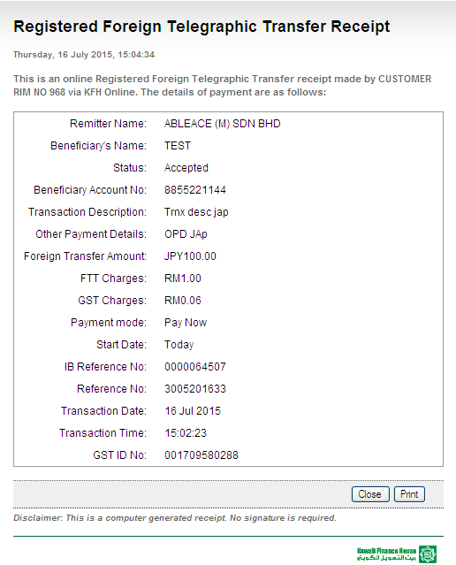
Transaction History
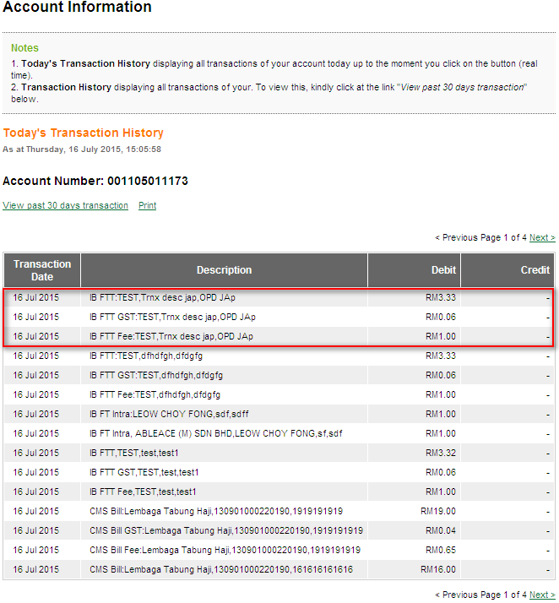
Log
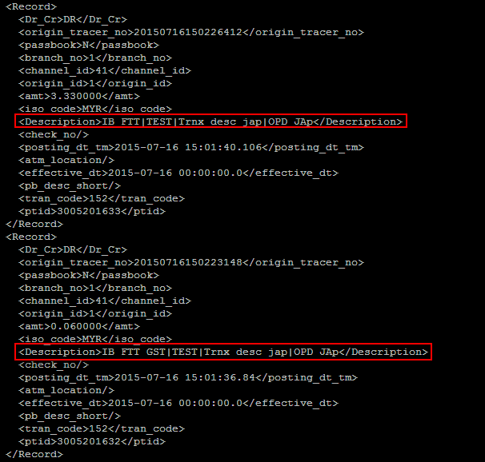
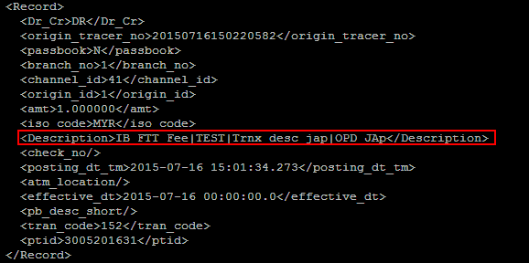
Open FTT Transfer (Pay Now)
Confirm Page
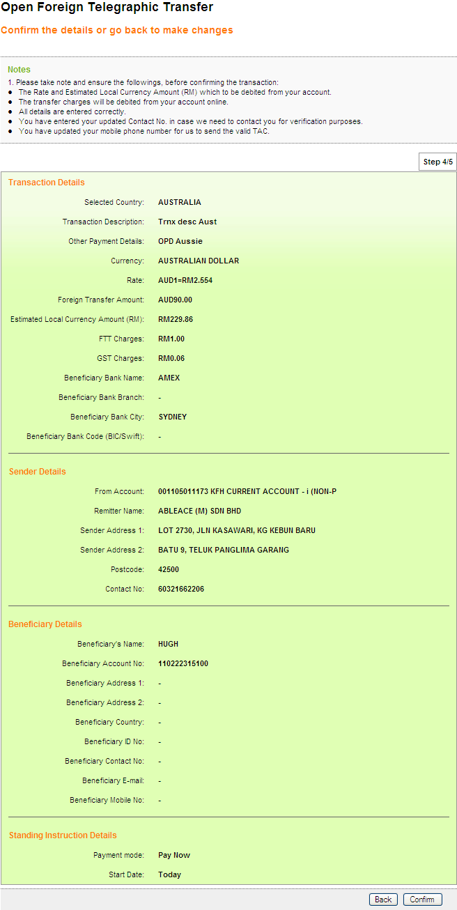
Result Page
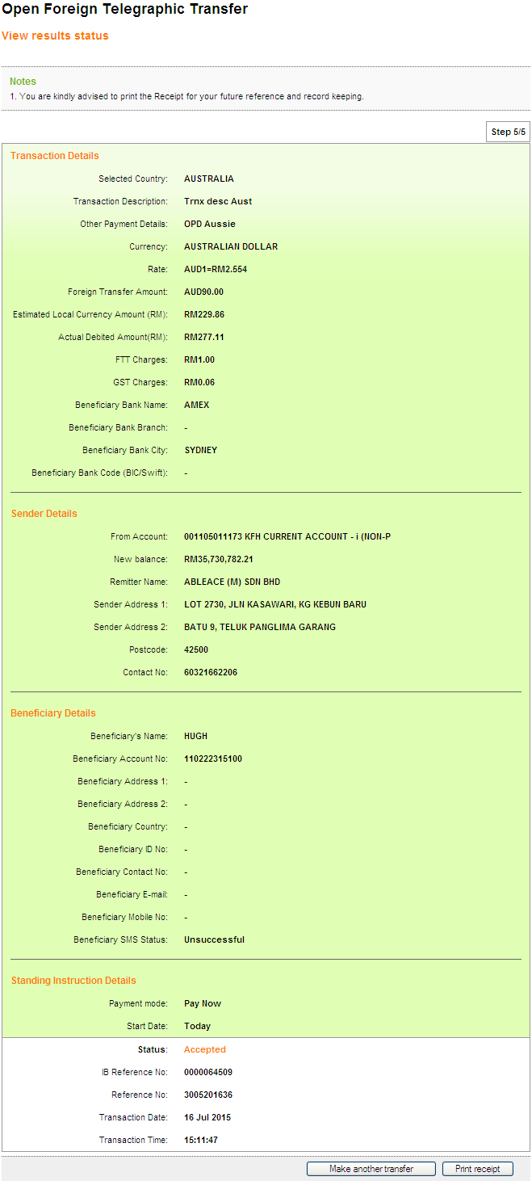
Print Receipt
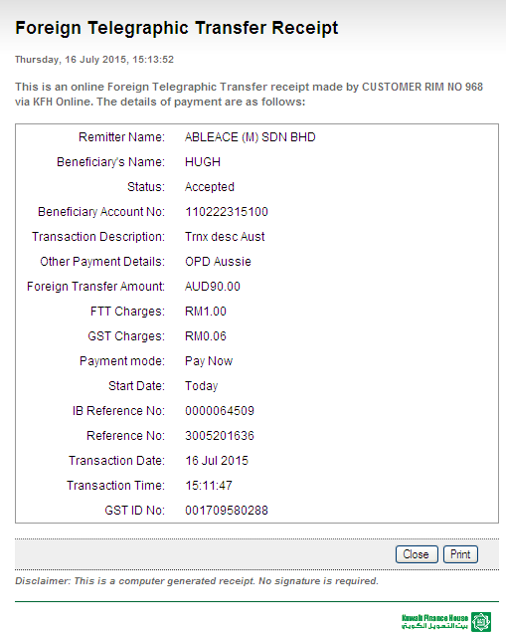
Transaction History
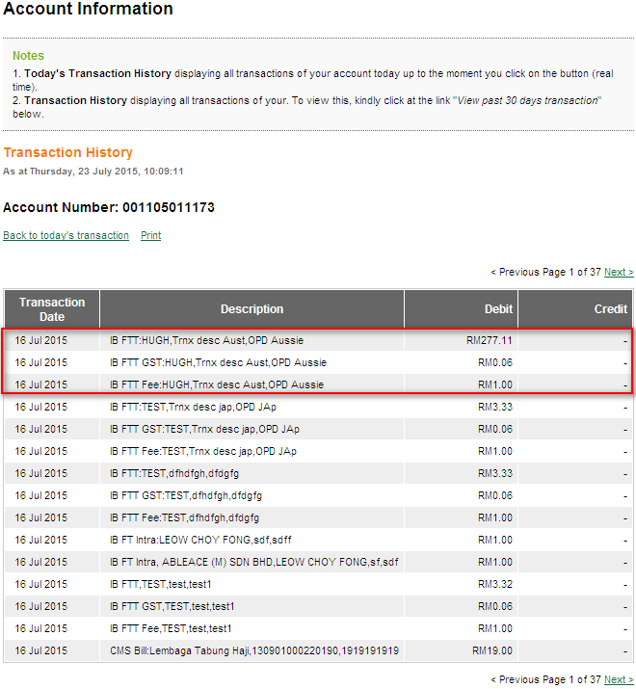
Log
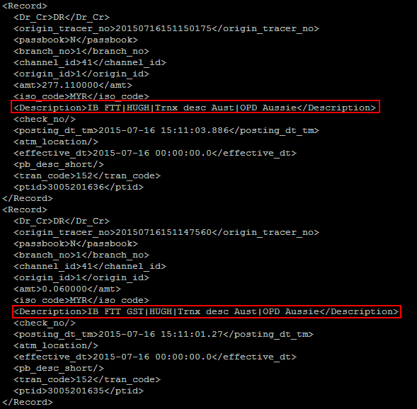

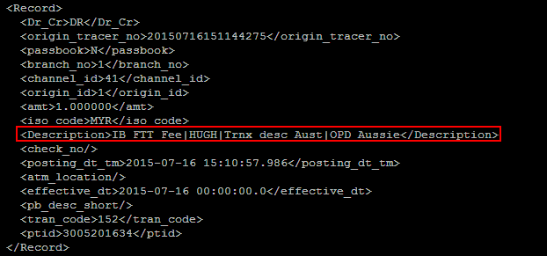
Registered FTT Transfer (Pay Later)

Open FTT Transfer (Pay Later)

Registered FTT Transfer (Reccuring)

Open FTT Transfer (Reccuring)

BIB
ROLE : Approver all
Registered Interbank Transfer (RENTAS) Pay Now
Confirm Page
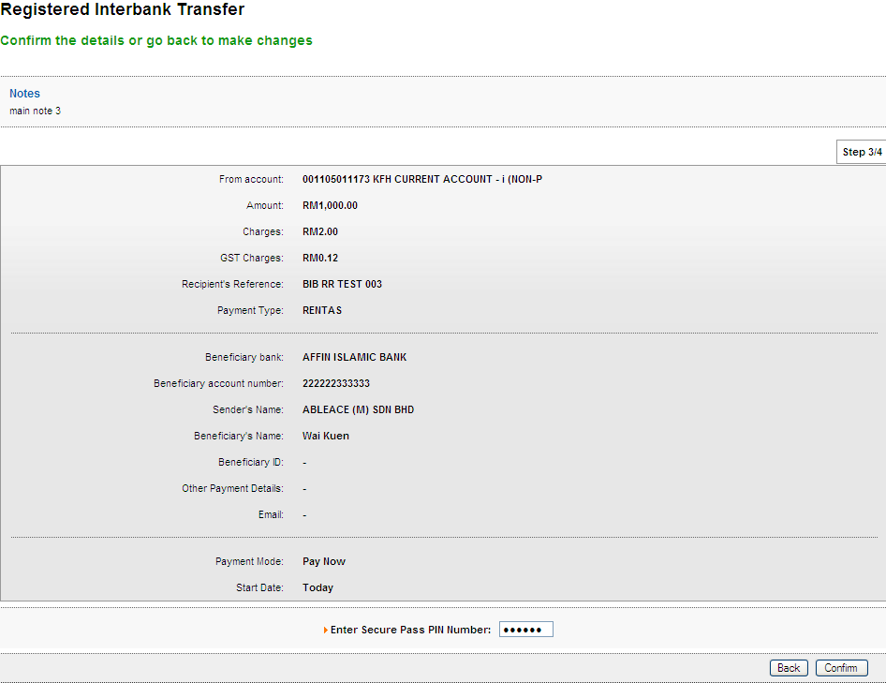
Result Page
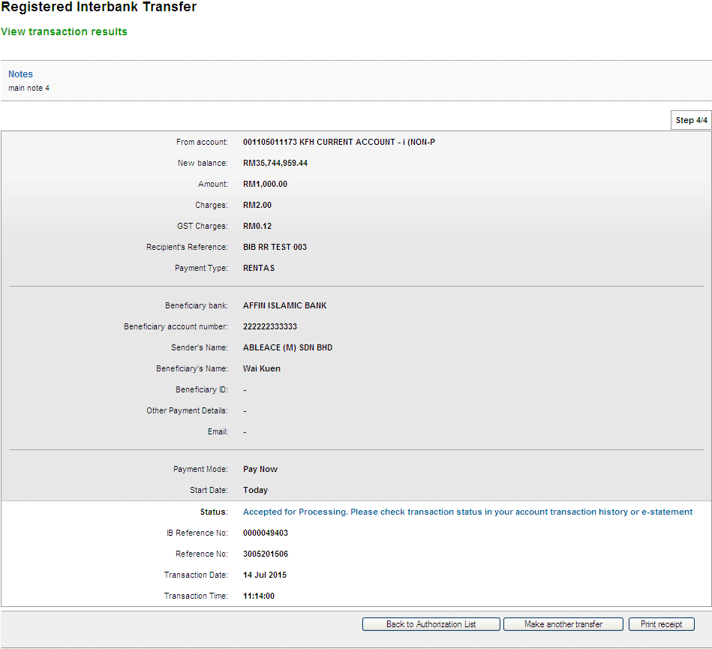
Print Receipt
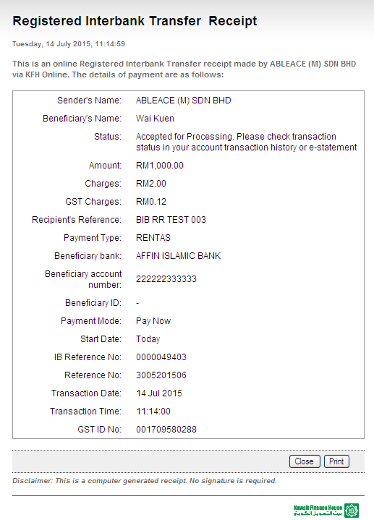
Transaction History
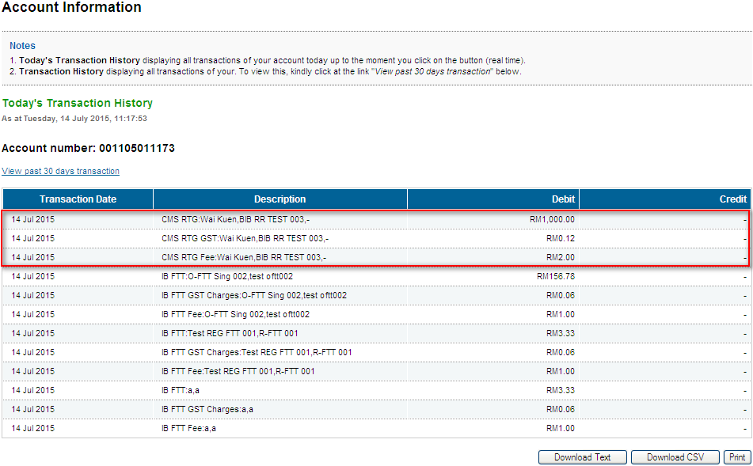
Log
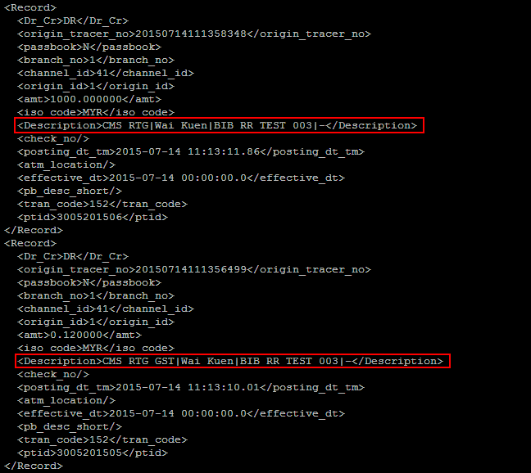
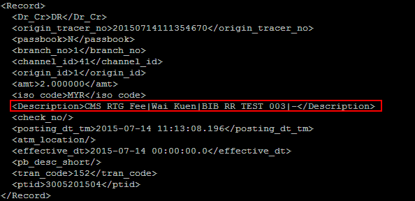
Open Interbank Transfer (RENTAS) Pay Now
Confirm Page
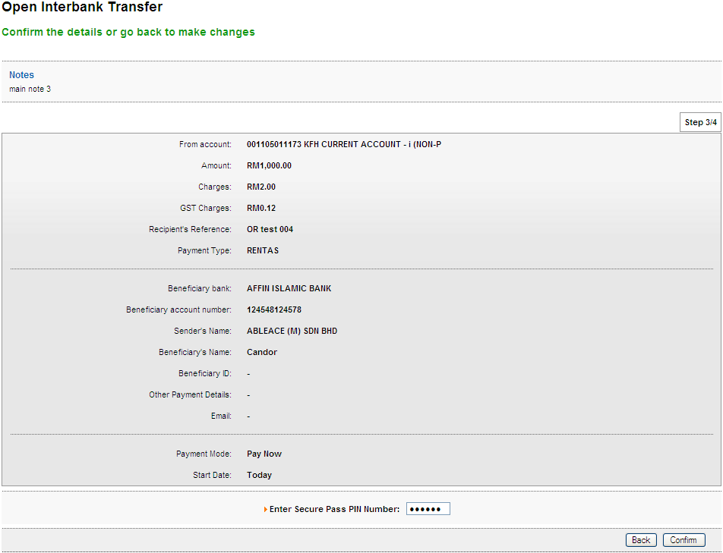
Result Page
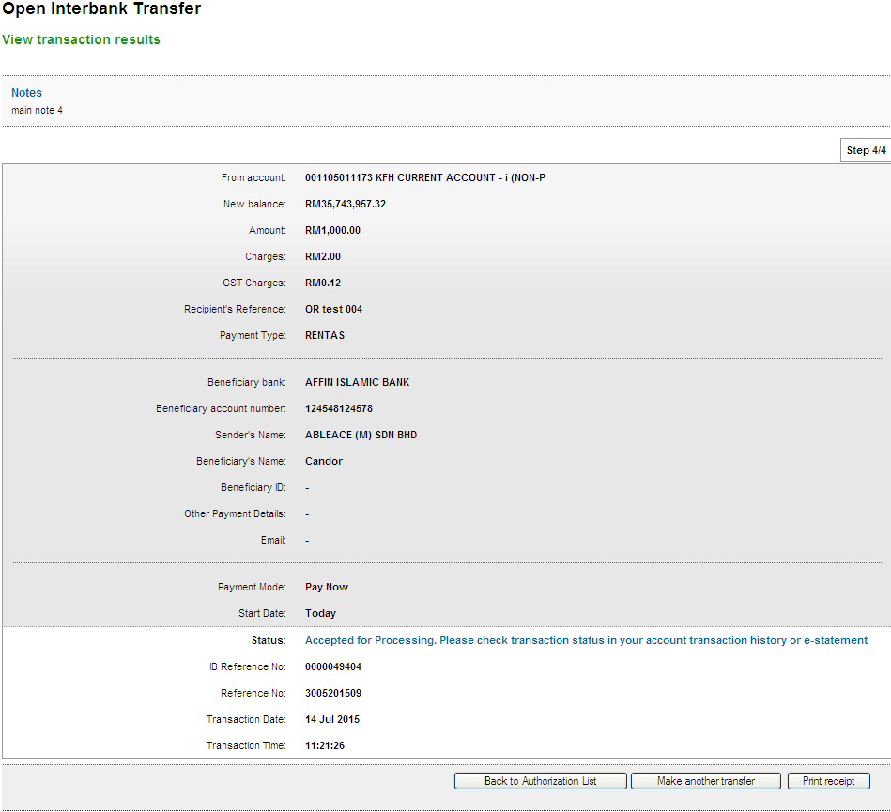
Print Receipt
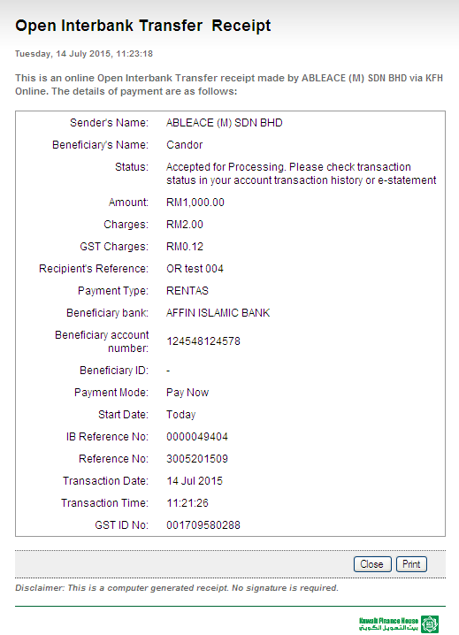
Transaction History
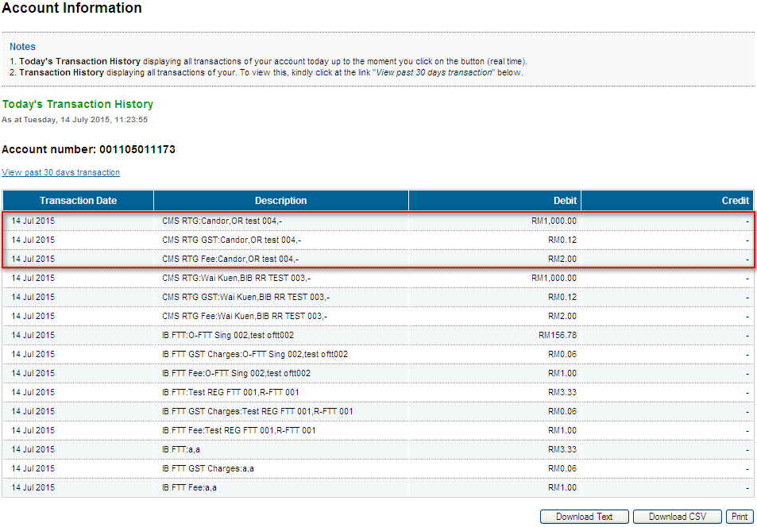
Log
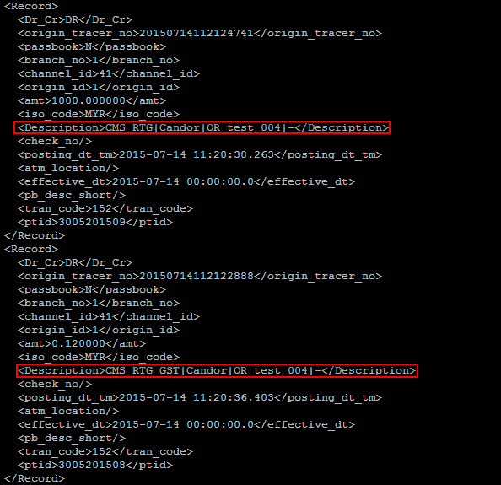
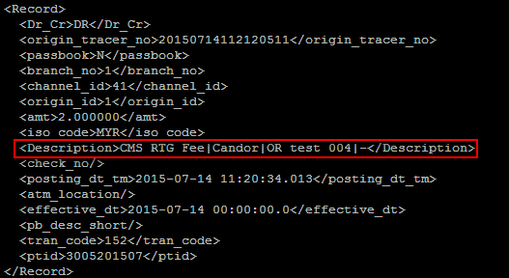
Registered FTT Transfer (Pay Now)
Confirm Page
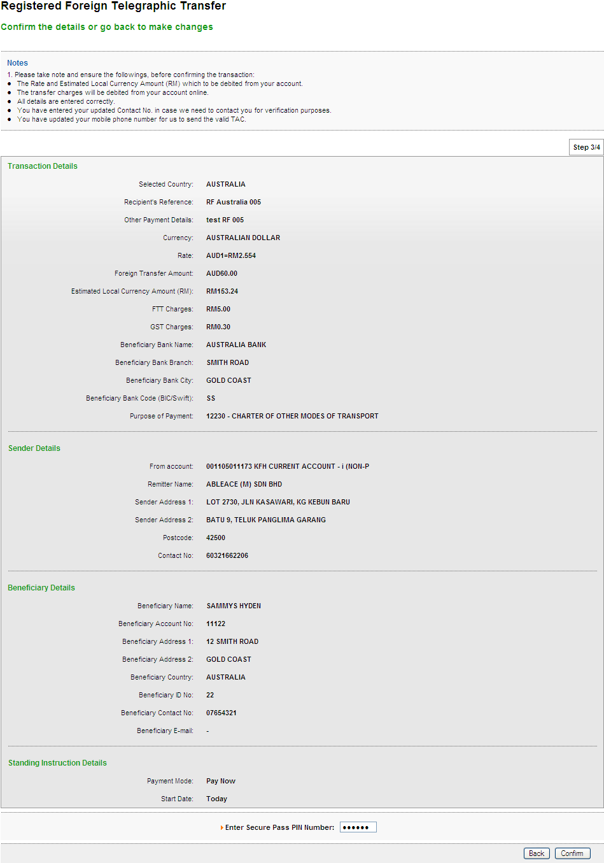
Result Page
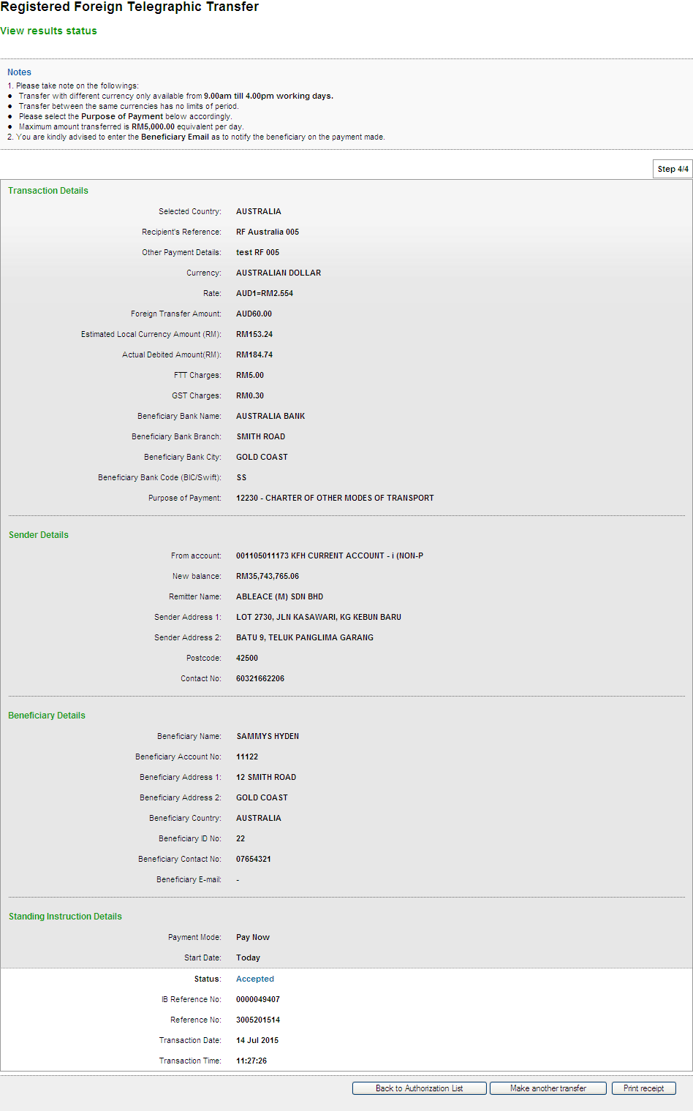
Print Receipt
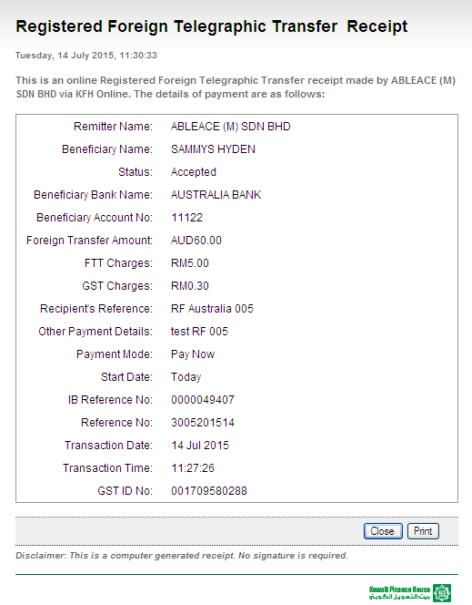
Transaction History
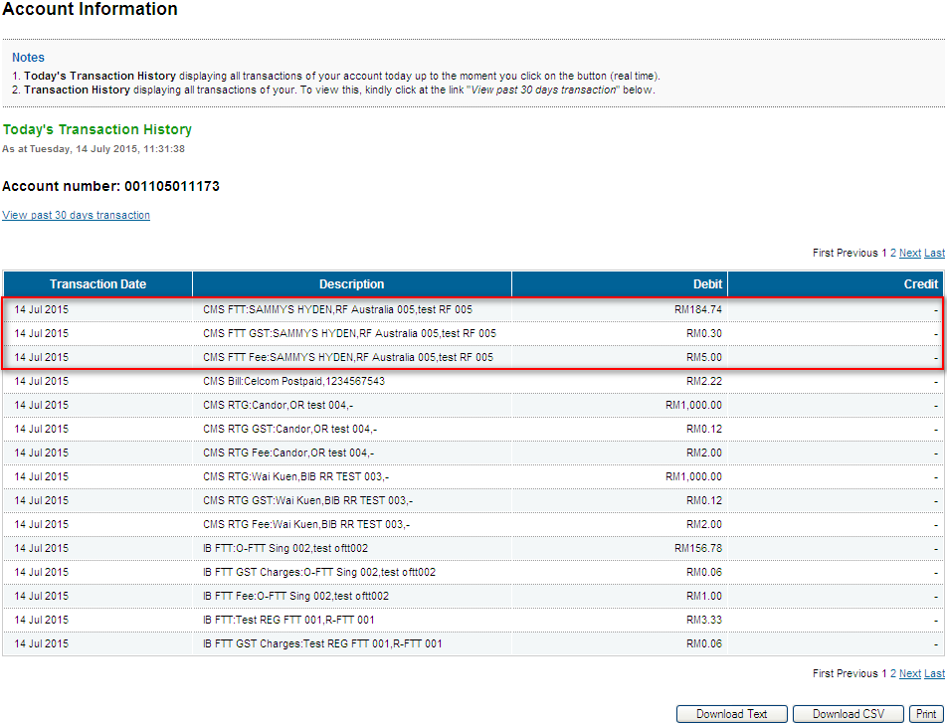
Log
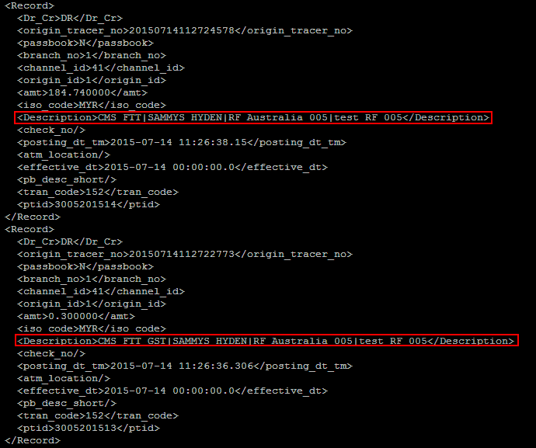
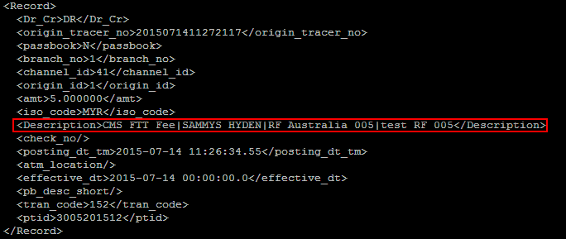
One-time FTT Transfer (Pay Now)
Confirm Page
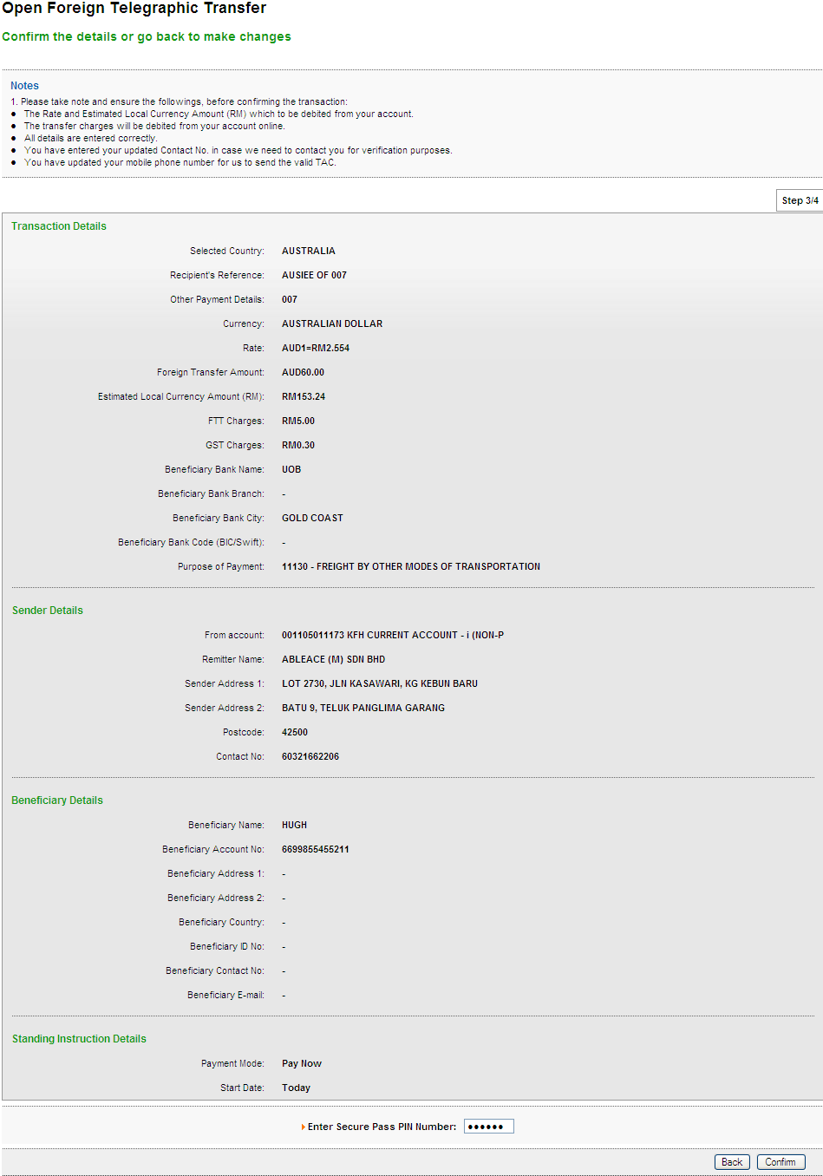
Result Page
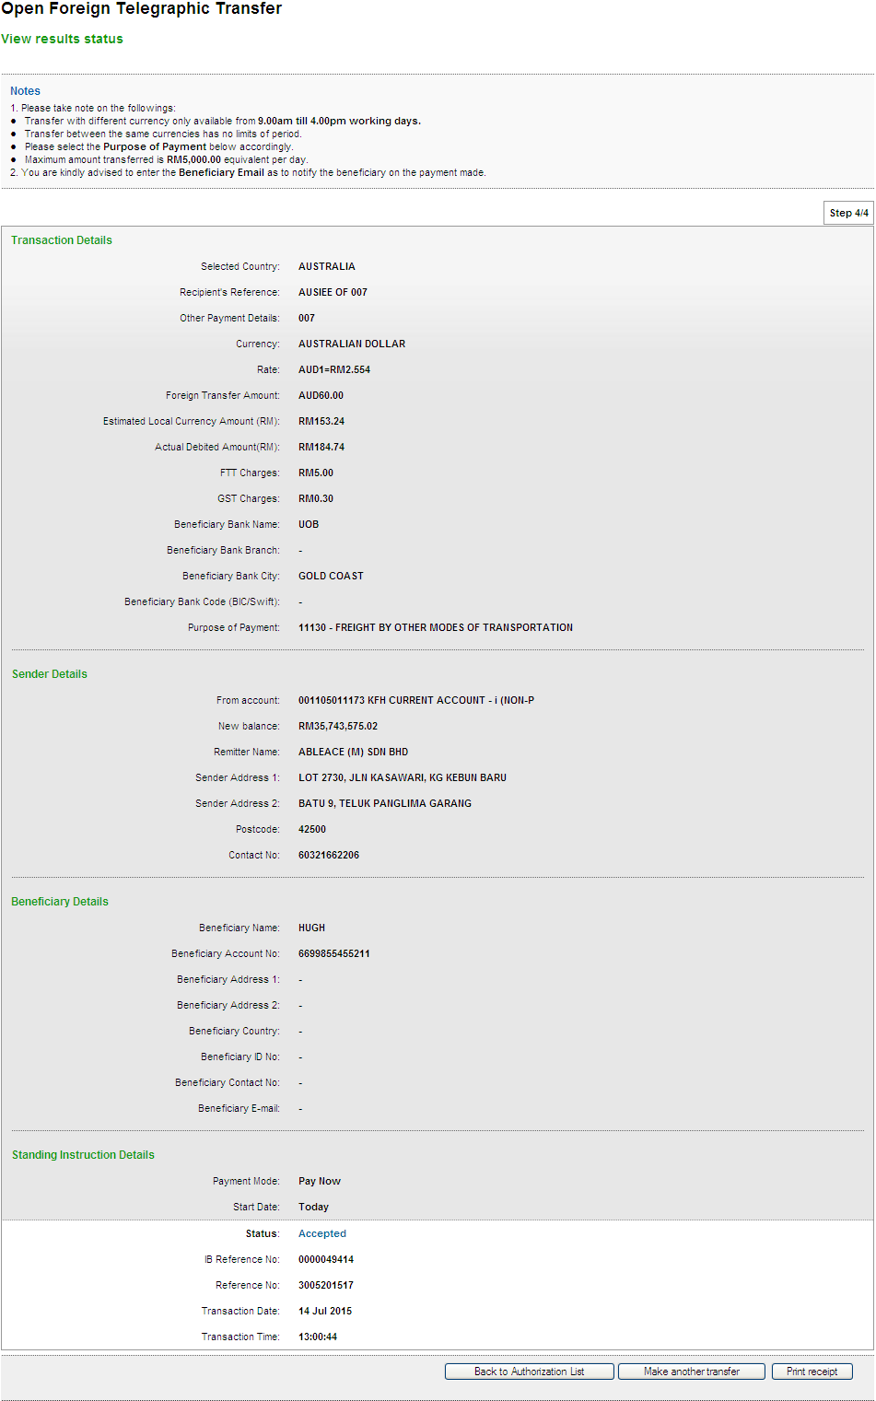
Print Receipt
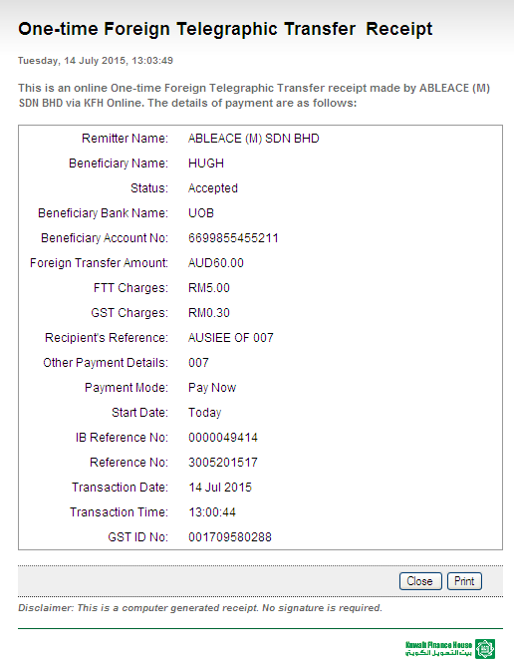
Transaction History
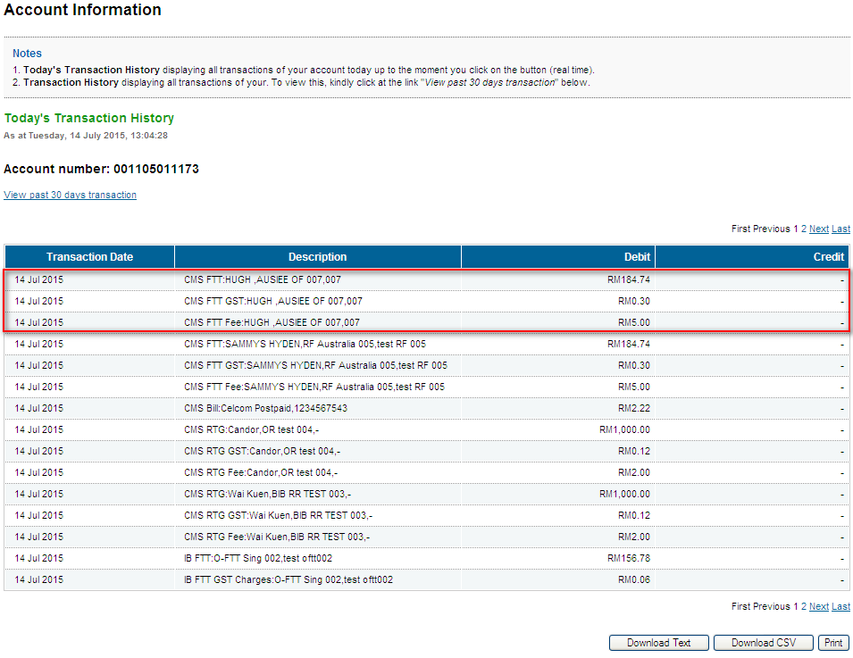
Log
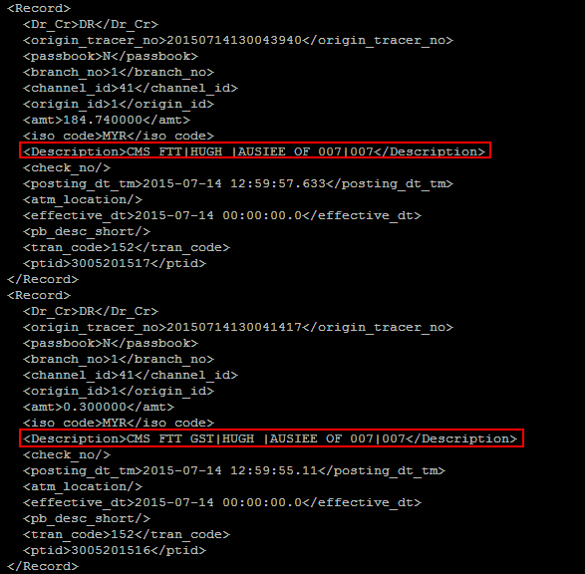
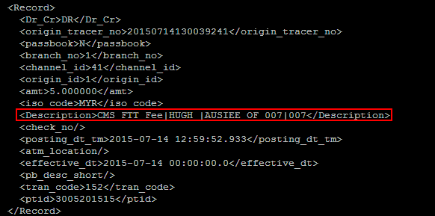
Registered Interbank Transfer (Rentas) Pay Later

Open Interbank Transfer (Rentas) Pay Later
Registered FTT Transfer (Pay Later)
One-Time FTT Transfer (Pay Later)
Registered Interbank Transfer (Rentas) Reccuring
Open Interbank Transfer (Rentas) Reccuring
Registered FTT Transfer (Reccuring)
One-Time FTT Transfer (Reccuring)

ROLE: Initiator
Registered Interbank Transfer (RENTAS)
Confirm Page
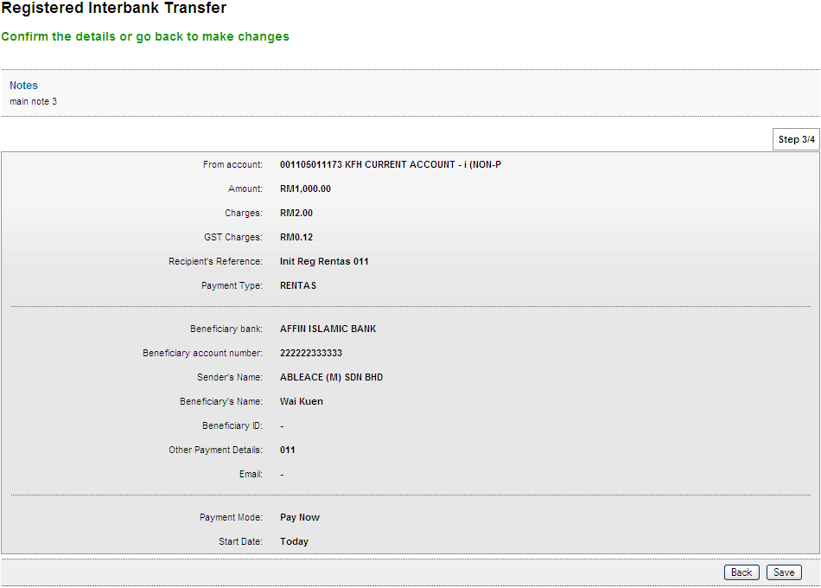
Result Page
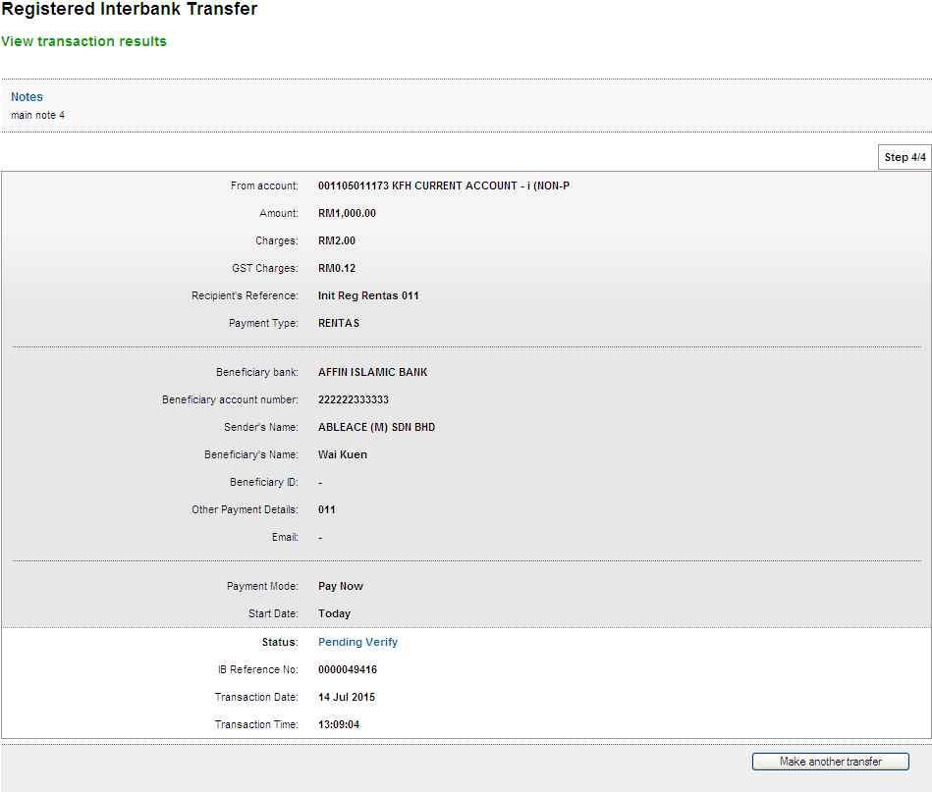

Open Interbank Transfer (RENTAS)
Confirm Page
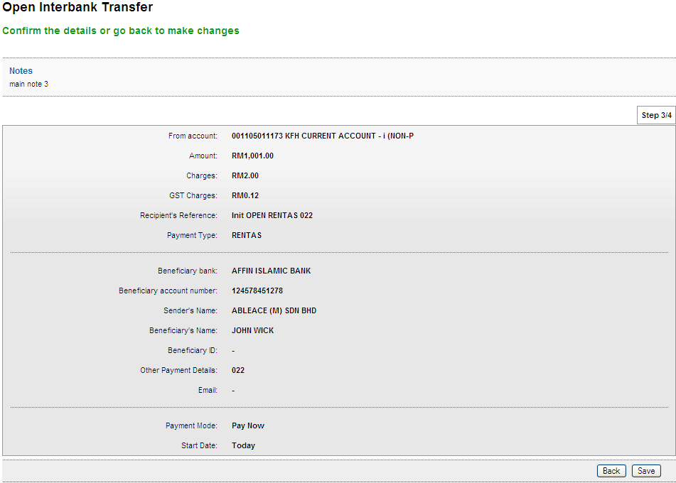
Result Page
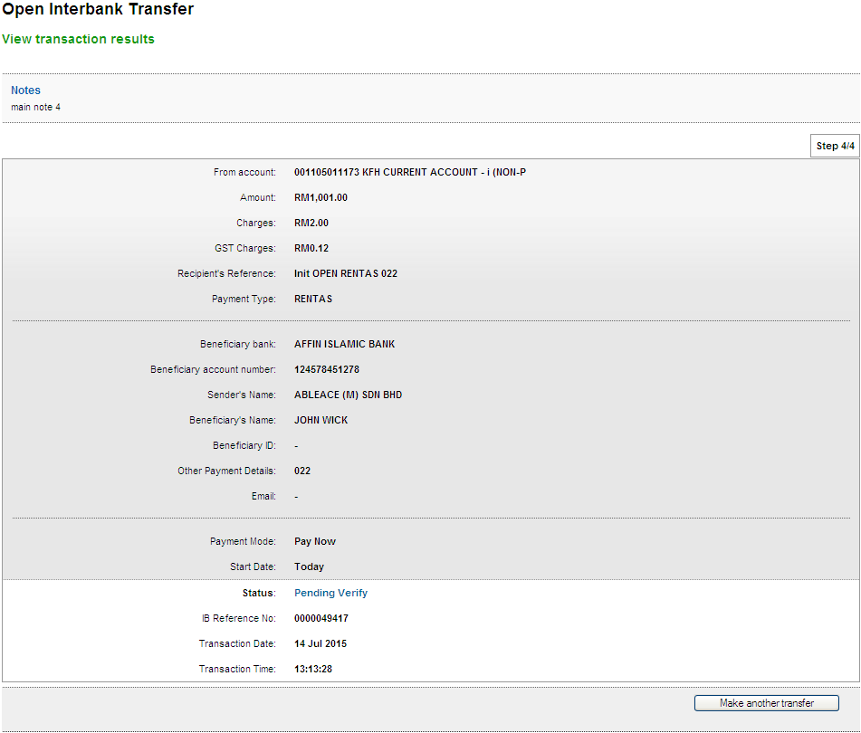

Registered FTT Transfer
Confirm Page
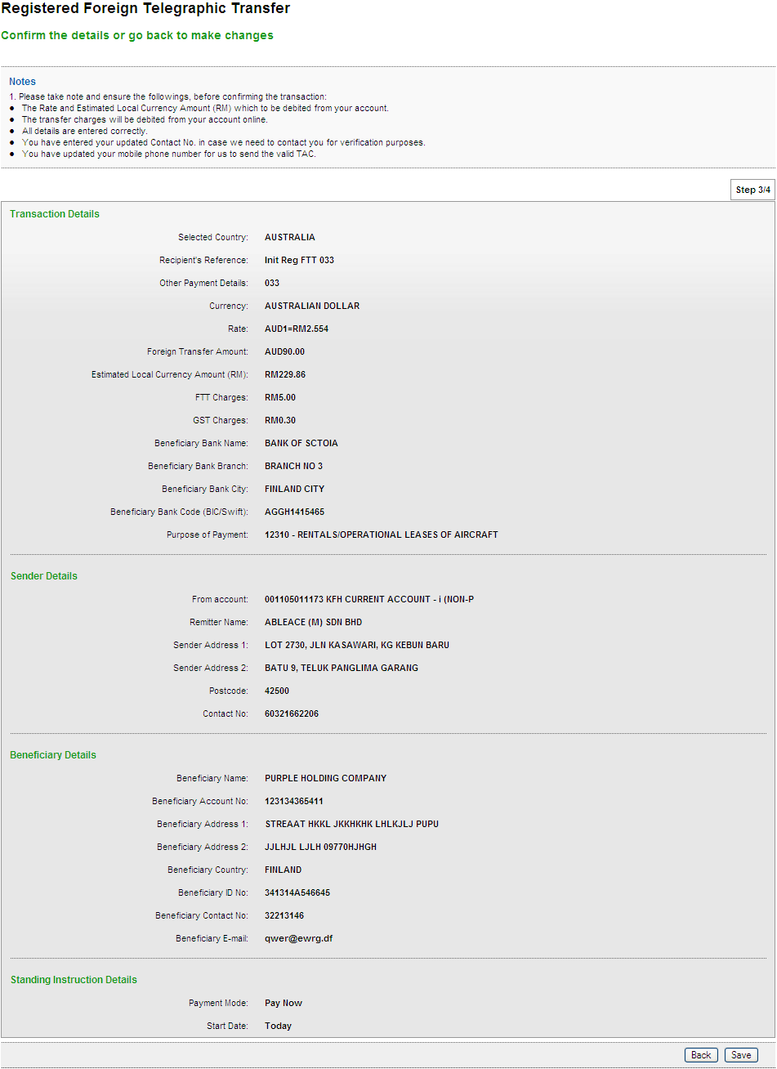
Result Page
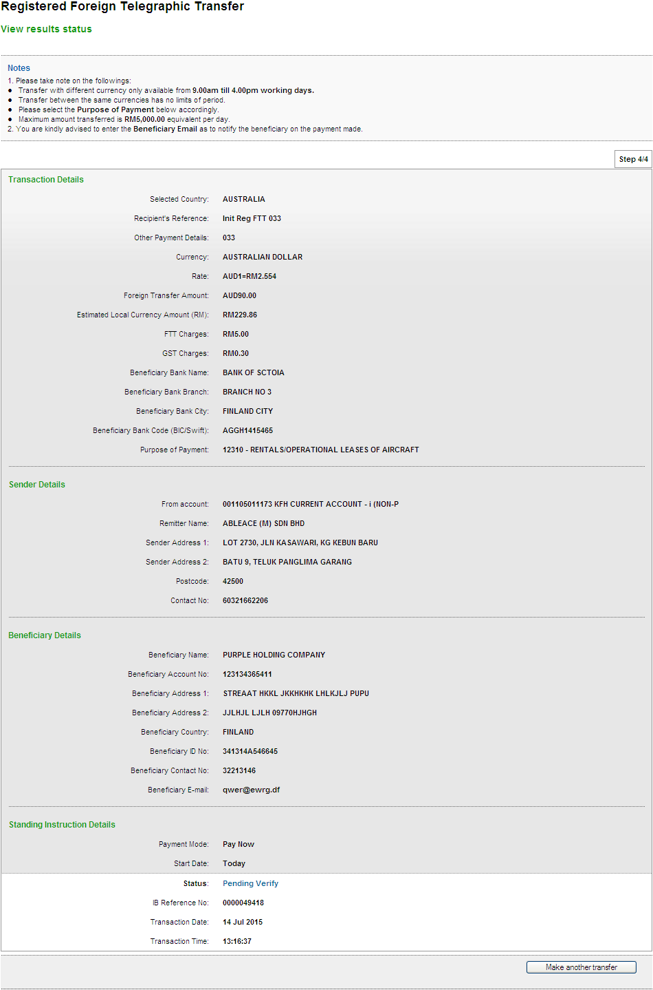

One-Time FTT Transfer
Confirm Page
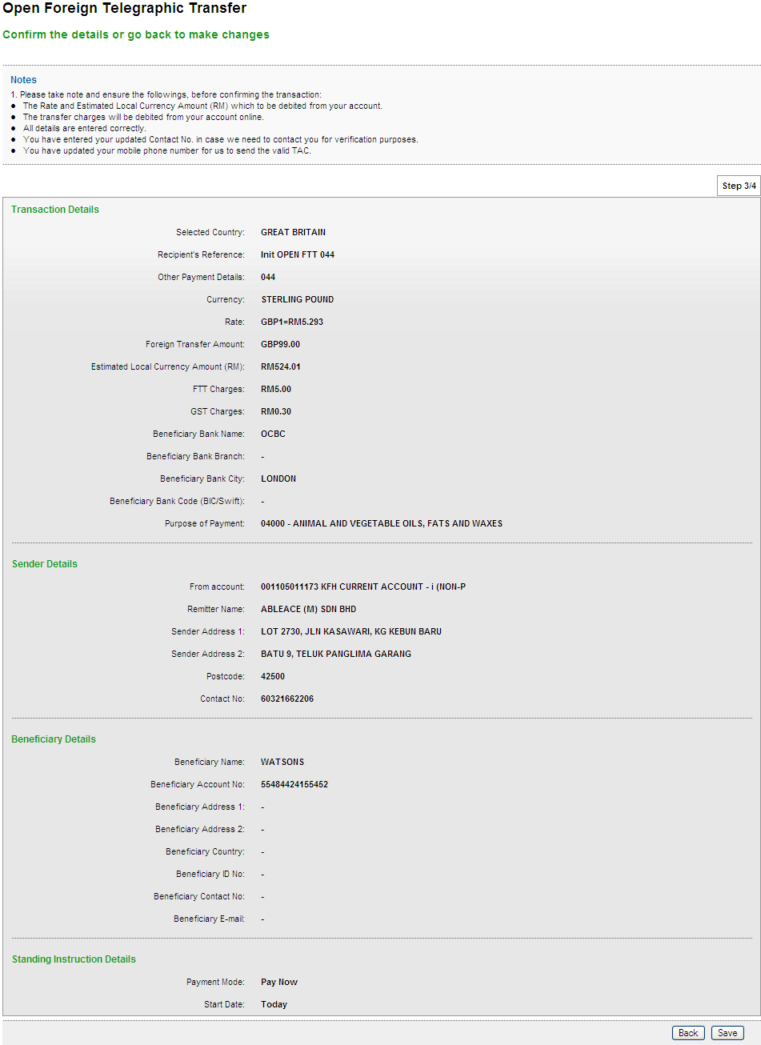
Result Page
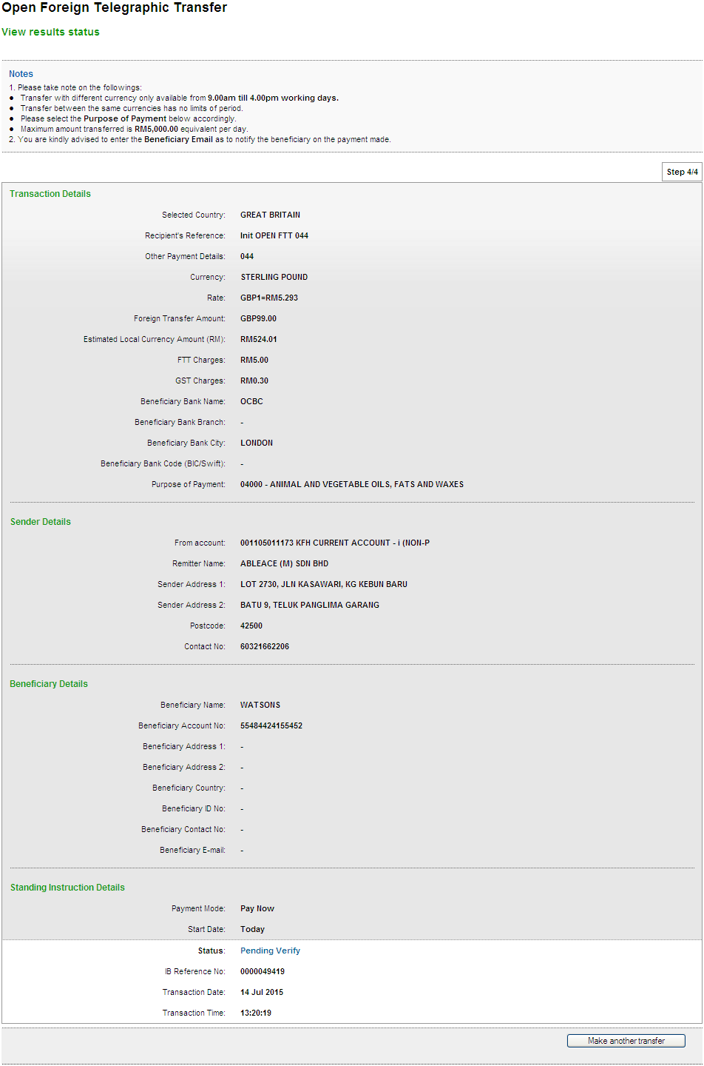
Registered Interbank Transfer (Rentas) Pay Later
Open Interbank Transfer (Rentas) Pay Later
Registered FTT Transfer (Pay Later)
One-Time FTT Transfer (Pay Later)
Registered Interbank Transfer (Rentas) Reccuring
Open Interbank Transfer (Rentas) Reccuring
Registered FTT Transfer (Reccuring)
One-Time FTT Transfer (Reccuring)

ROLE : Verifier
Registered Interbank Transfer (RENTAS)
Confirm Page
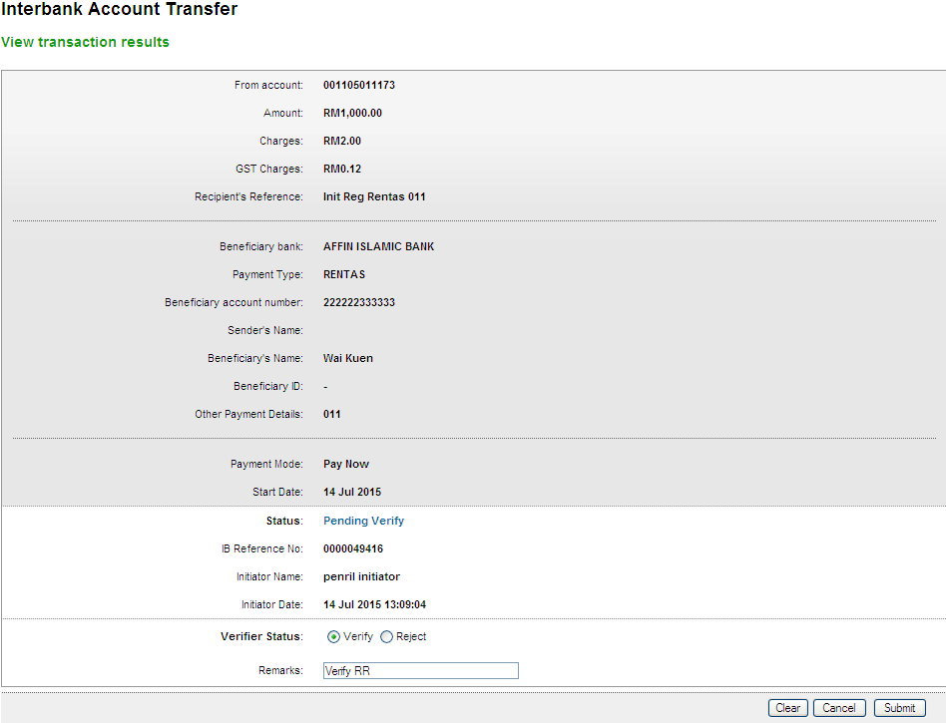
Result Page
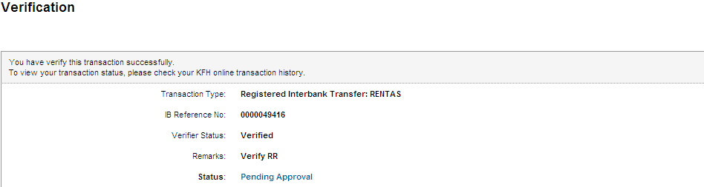

Open Interbank Transfer (RENTAS)
Confirm Page
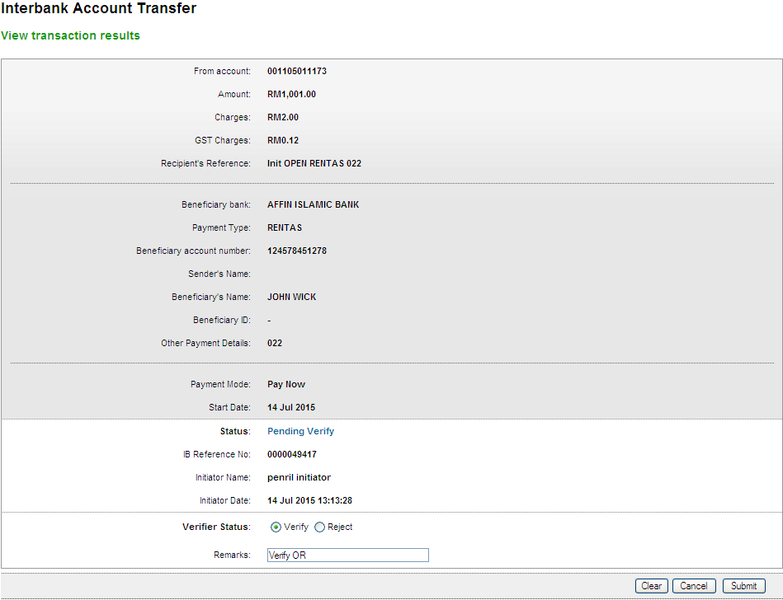
Result Page
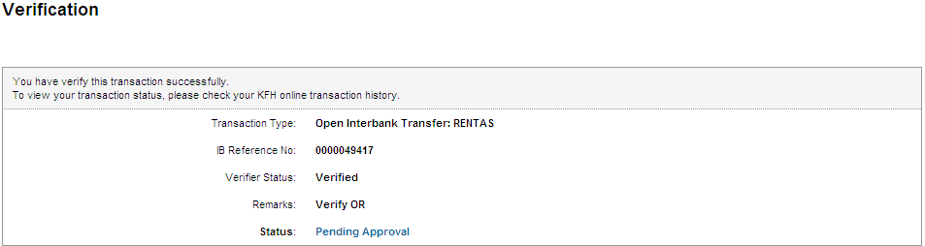

Registered FTT Transfer
Confirm Page
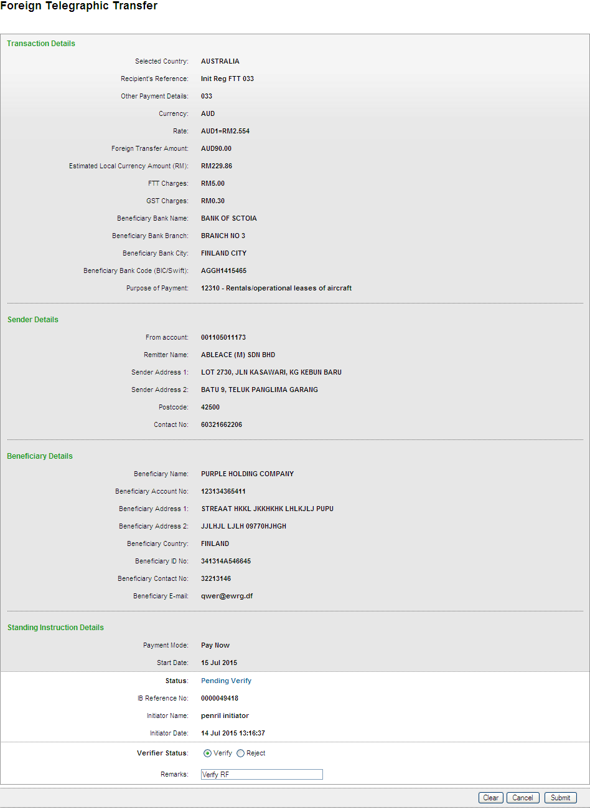
Result Page
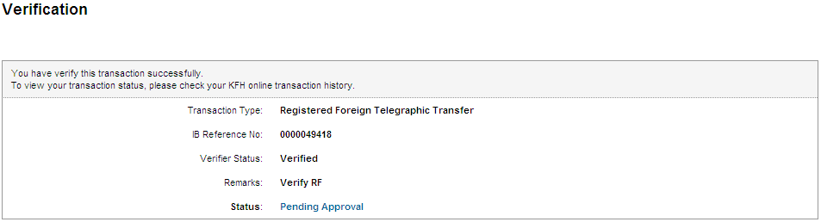

Open FTT Transfer
Confirm Page
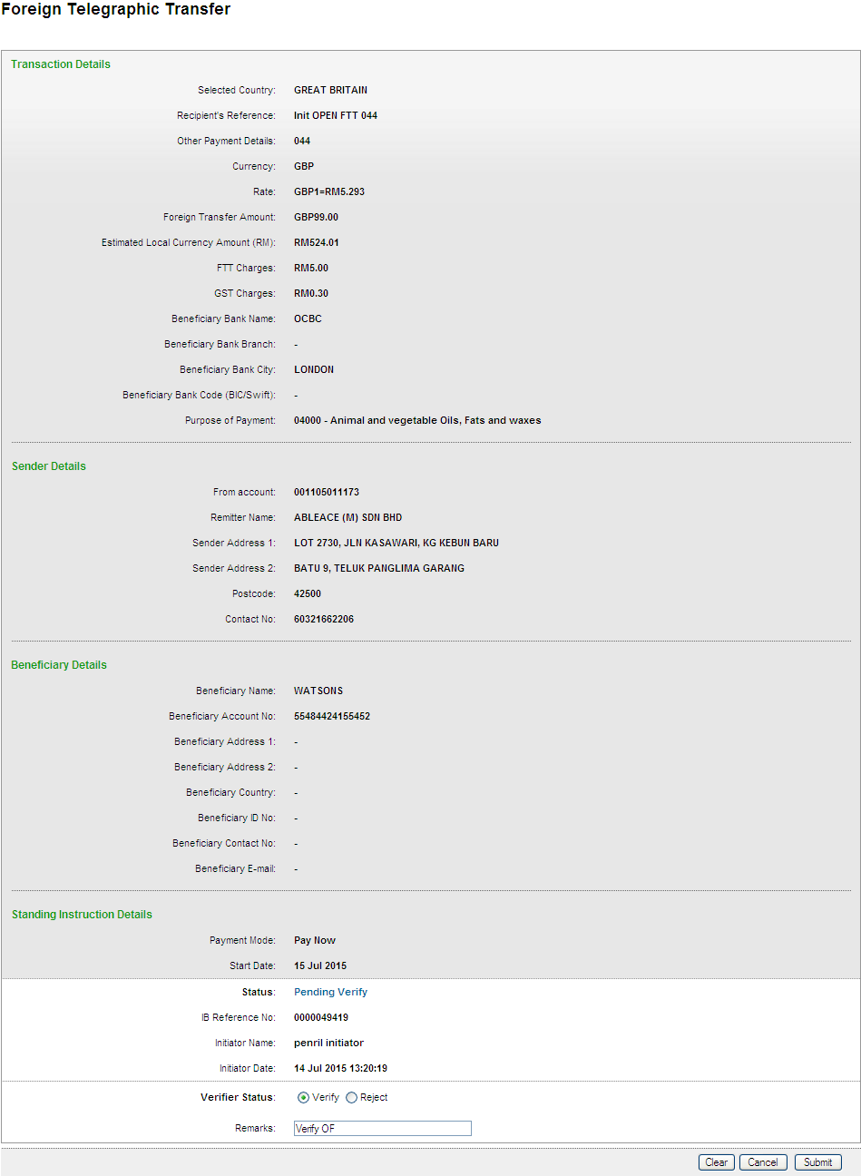
Result Page
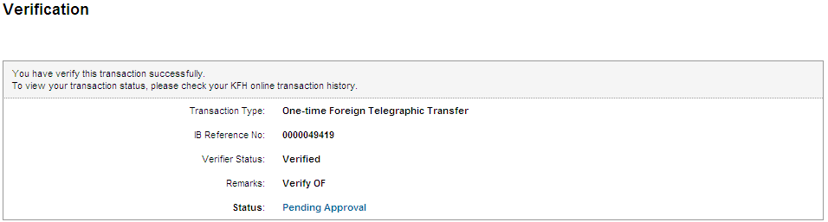
Registered Interbank Transfer (Rentas) Pay Later
Open Interbank Transfer (Rentas) Pay Later
Registered FTT Transfer (Pay Later)
One-Time FTT Transfer (Pay Later)
Registered Interbank Transfer (Rentas) Reccuring
Open Interbank Transfer (Rentas) Reccuring
Registered FTT Transfer (Reccuring)
One-Time FTT Transfer (Reccuring)

ROLE: Approver
Registered Interbank Transfer (RENTAS)
Confirm Page
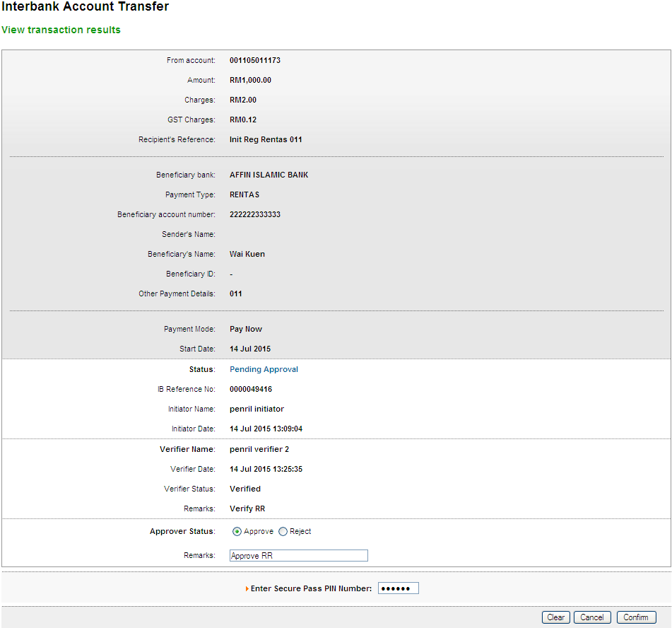
Result Page
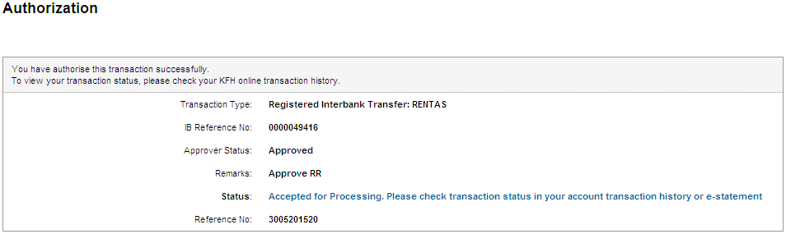
Print Receipt
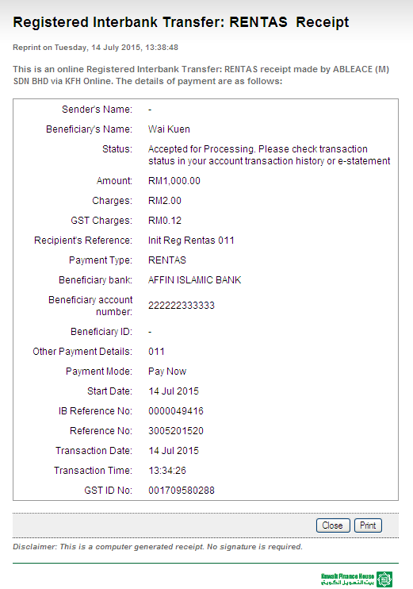
Transaction History
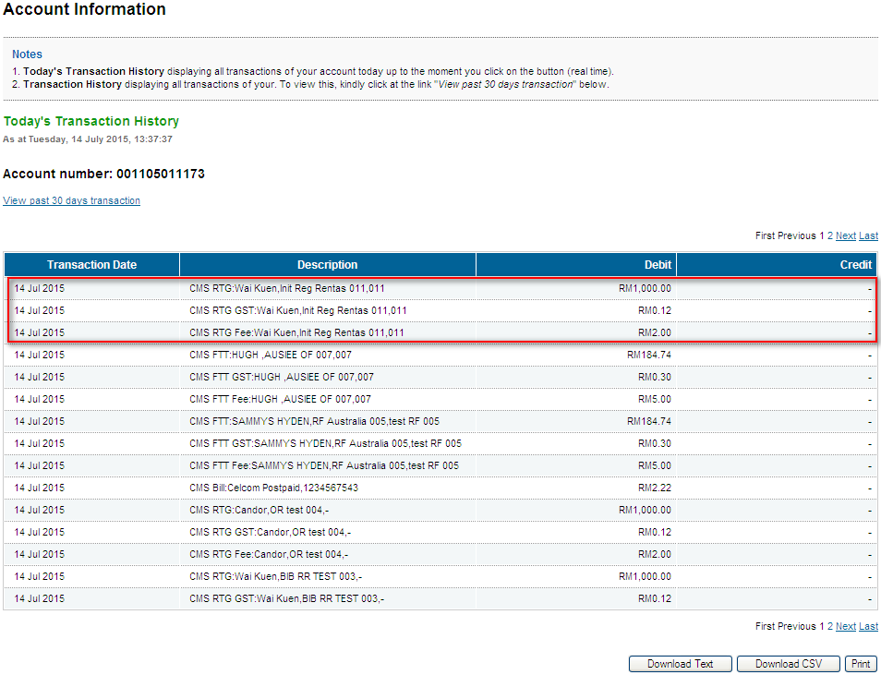
Log
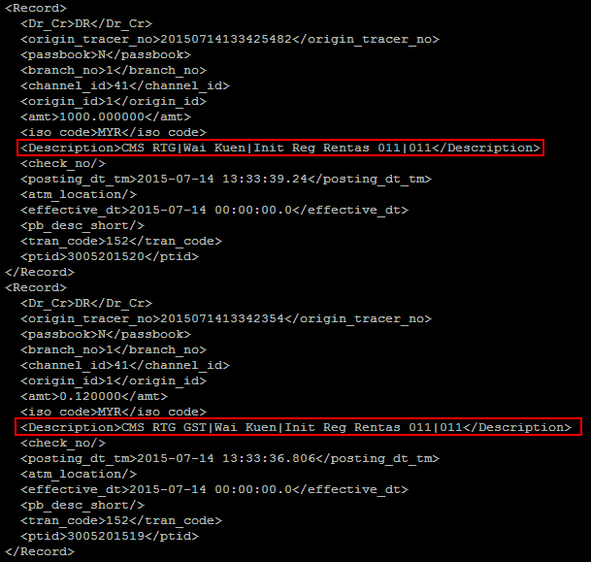
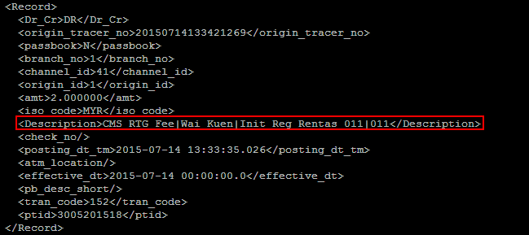
Open Interbank Transfer (RENTAS)
Confirm Page
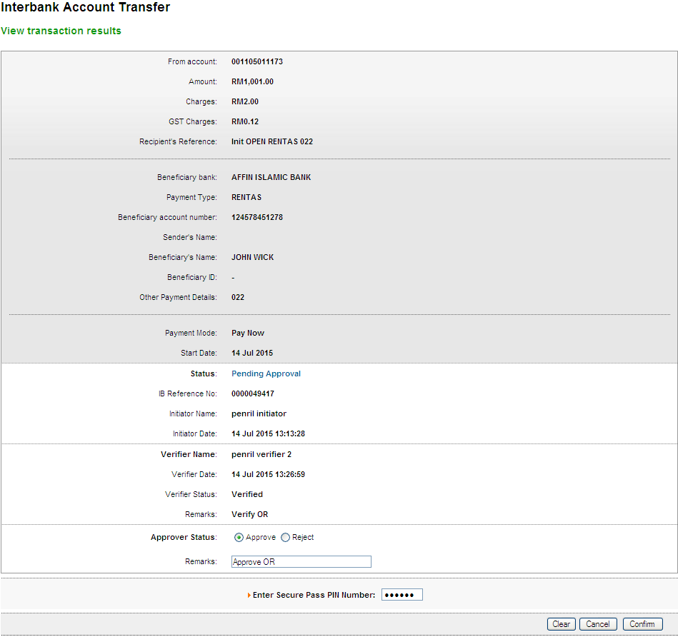
Result Page
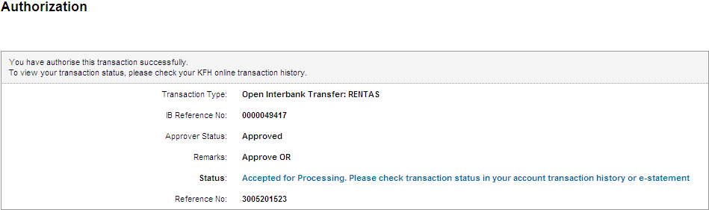
Print Receipt
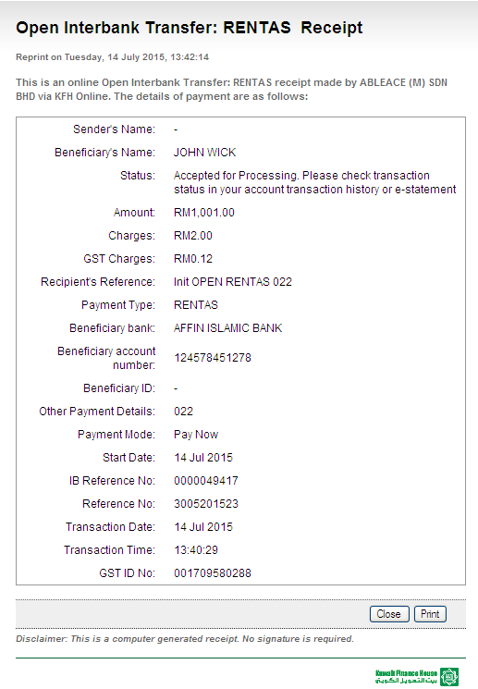
Transaction History
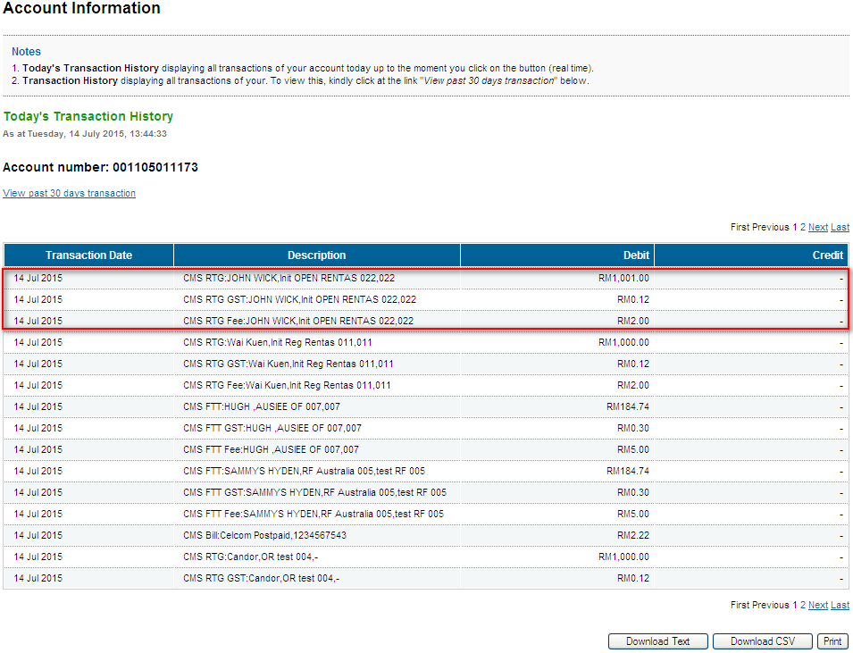
Log
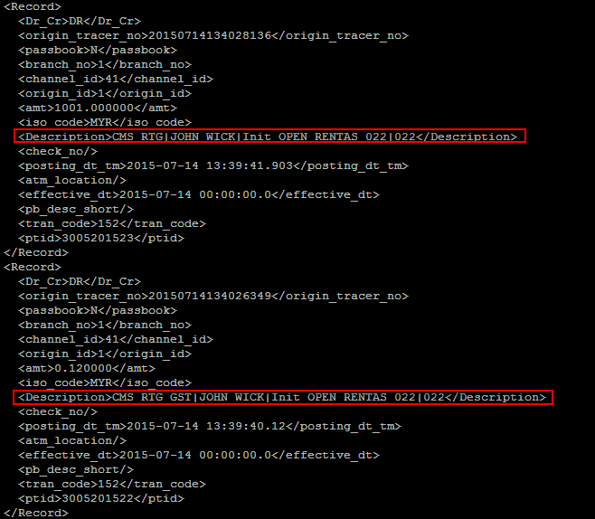
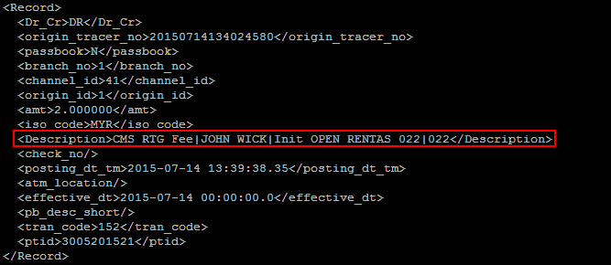
Registered FTT Transfer
Confirm Page
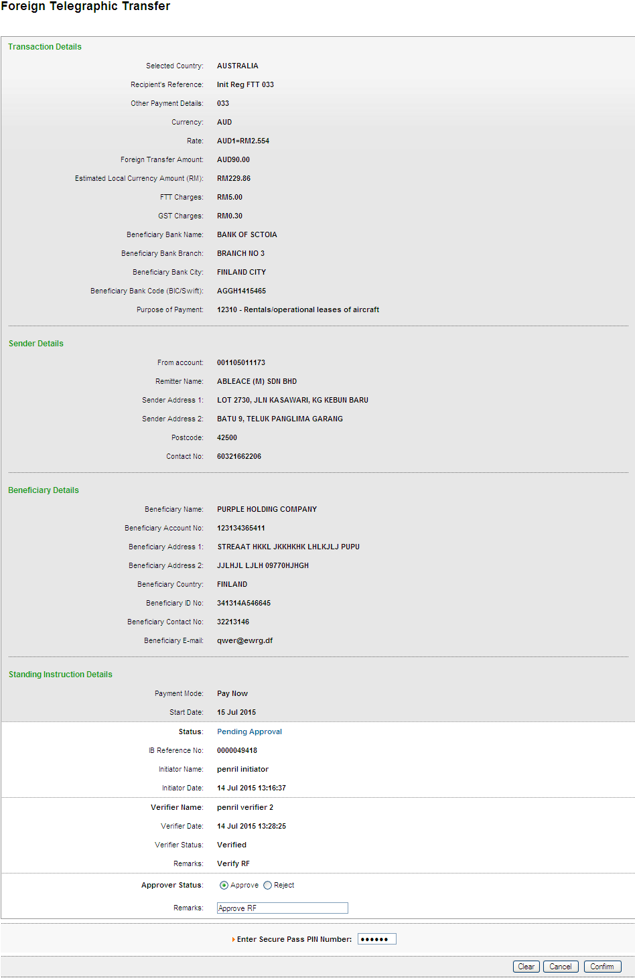
Result Page
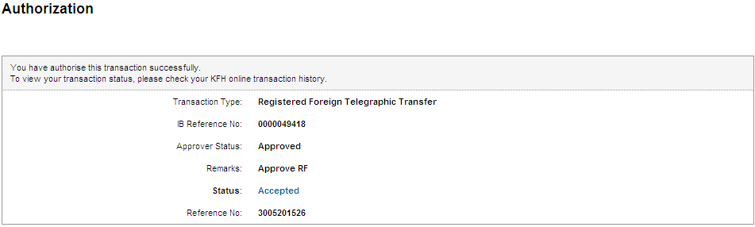
Print Receipt
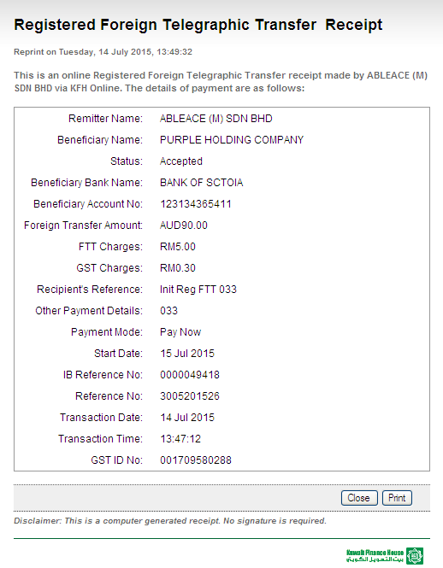
Transaction History
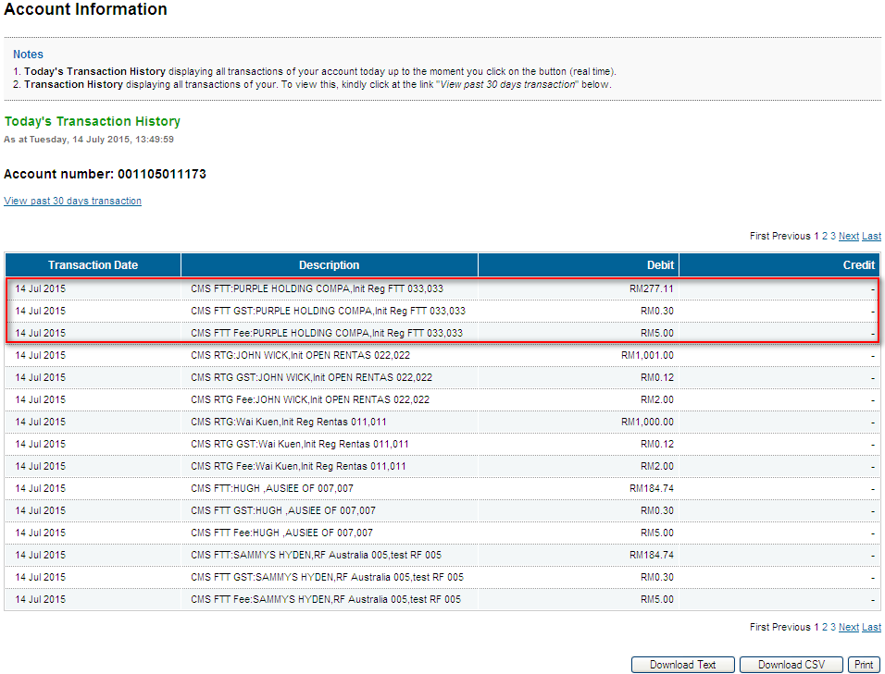
Log
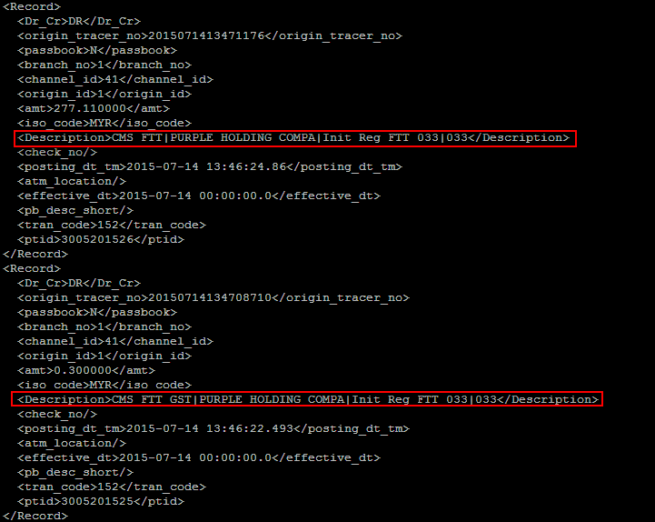
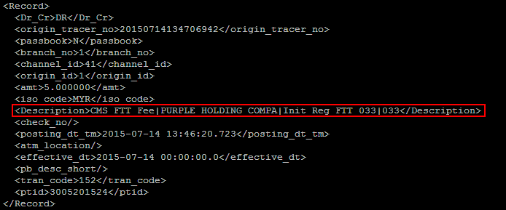
Open FTT Transfer
Confirm Page
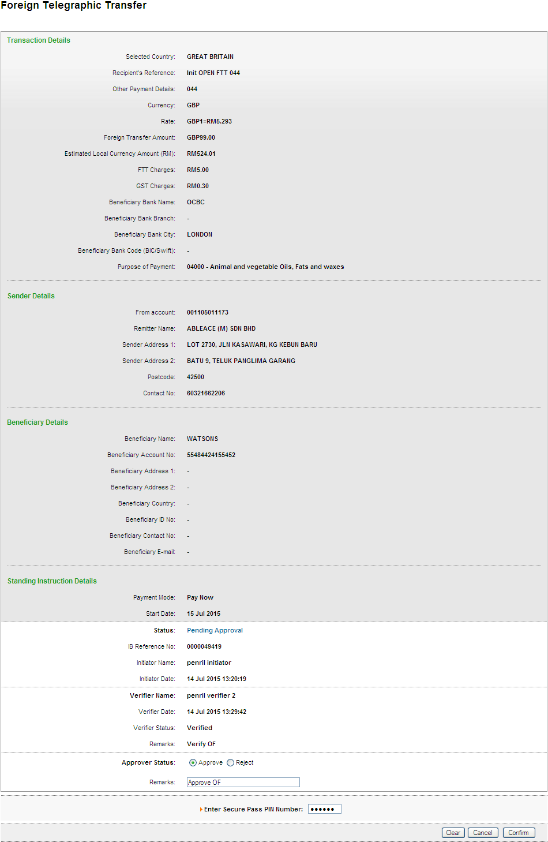
Result Page
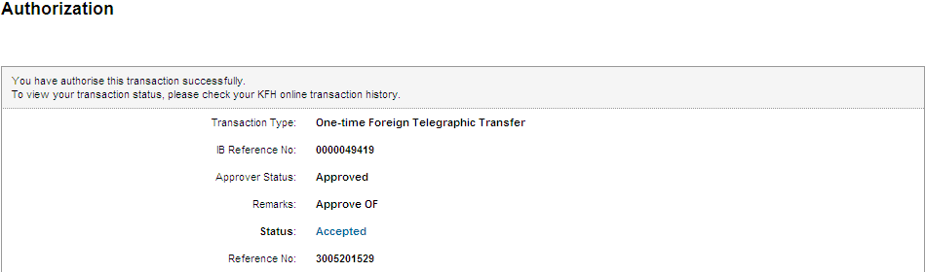
Print Receipt
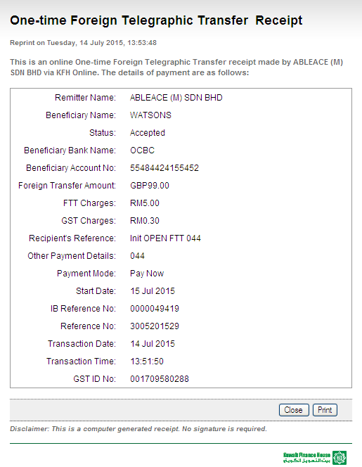
Transaction History
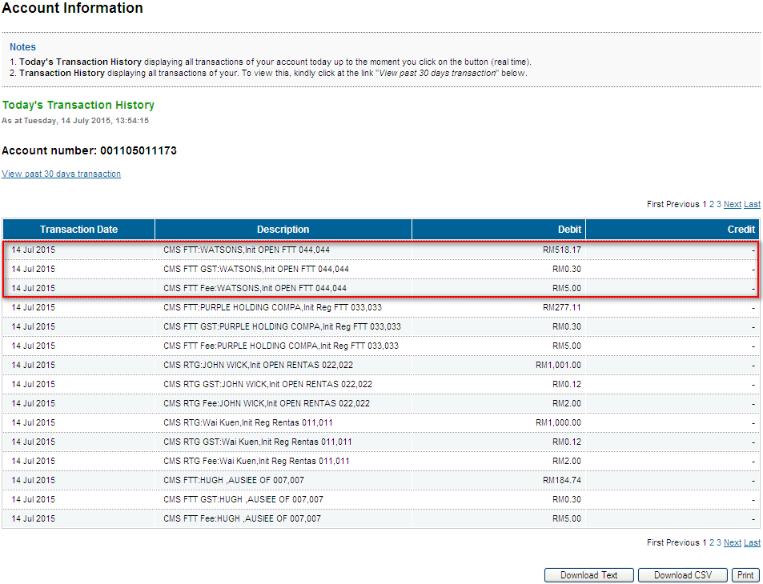
Log
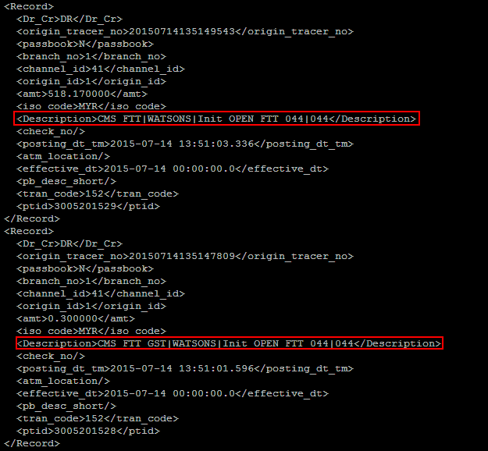
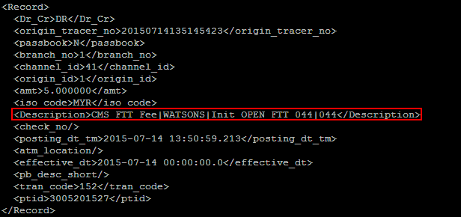
Registered Interbank Transfer (Rentas) Pay Later
Open Interbank Transfer (Rentas) Pay Later
Registered FTT Transfer (Pay Later)
One-Time FTT Transfer (Pay Later)
Registered Interbank Transfer (Rentas) Reccuring
Open Interbank Transfer (Rentas) Reccuring
Registered FTT Transfer (Reccuring)
One-Time FTT Transfer (Reccuring)

ROLE: Init-Veri
Registered Interbank Transfer (RENTAS)
Confirm Page
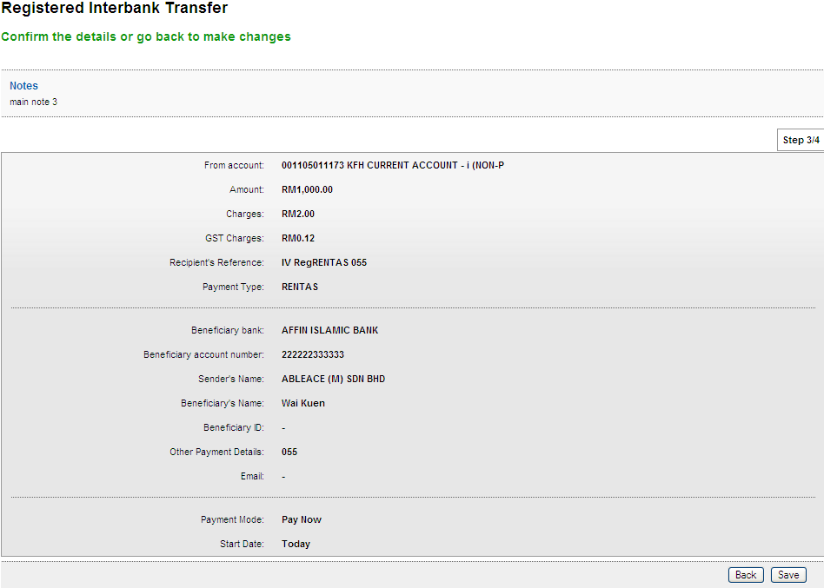
Result Page
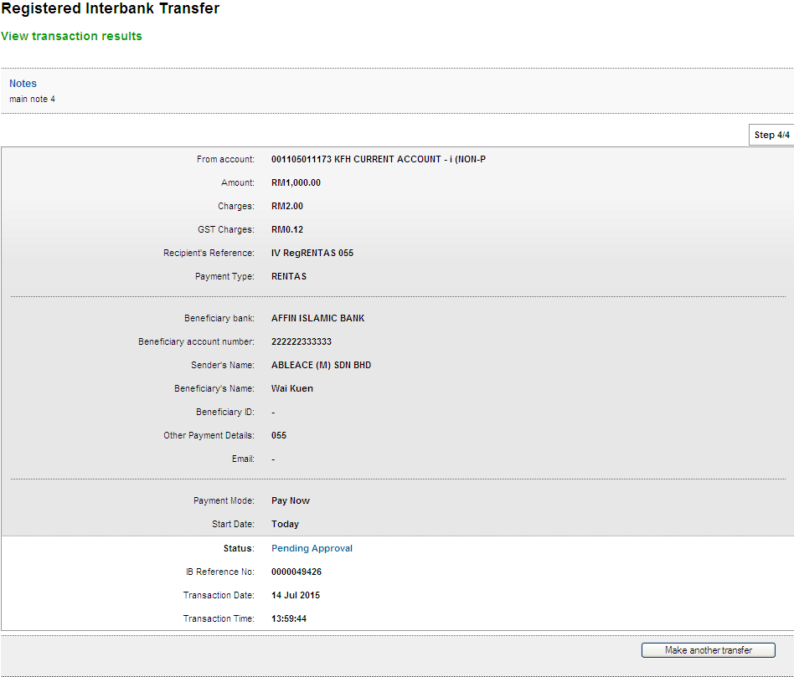

Open Interbank Transfer (RENTAS)
Confirm Page
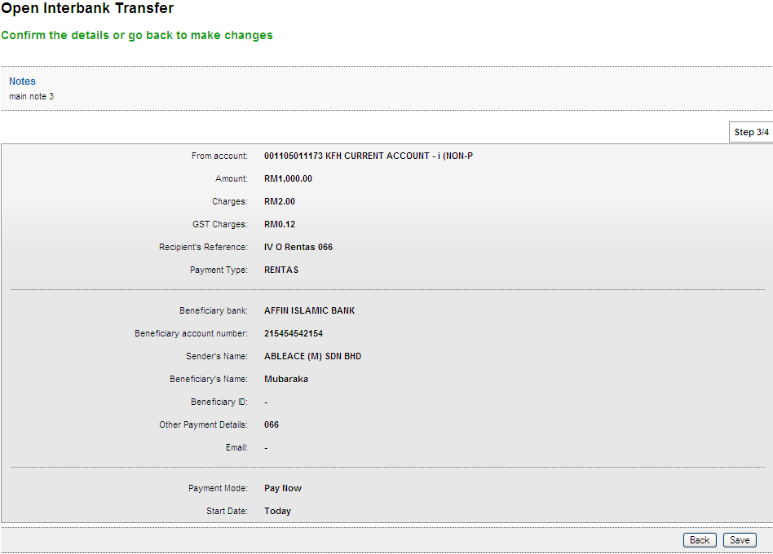
Result Page
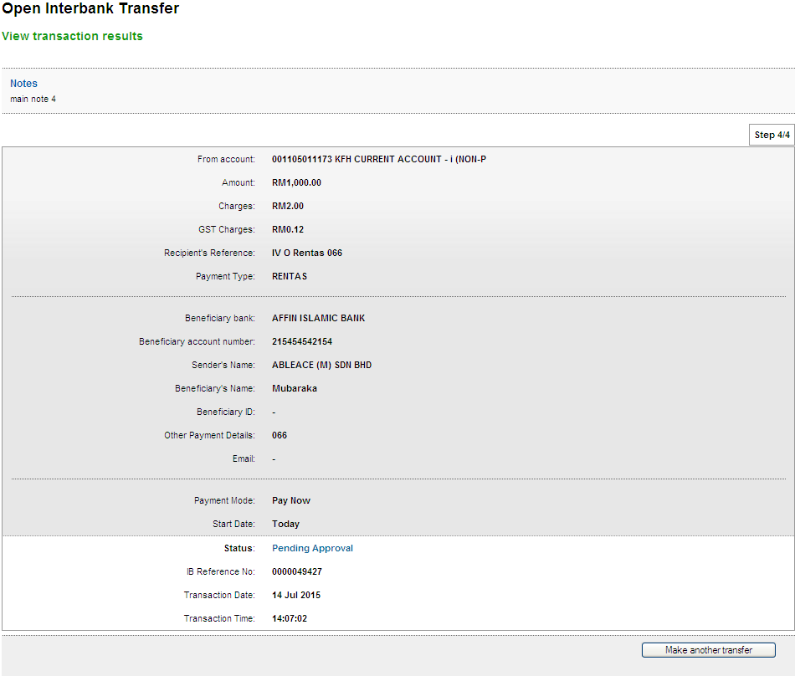

Registered FTT Transfer
Confirm Page
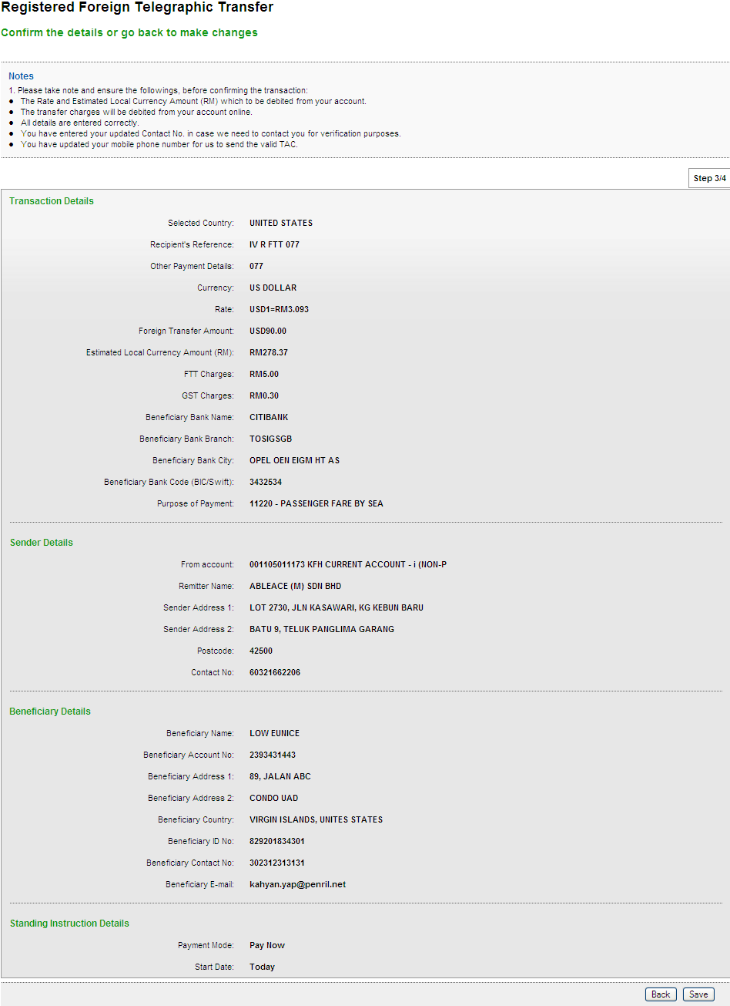
Result Page
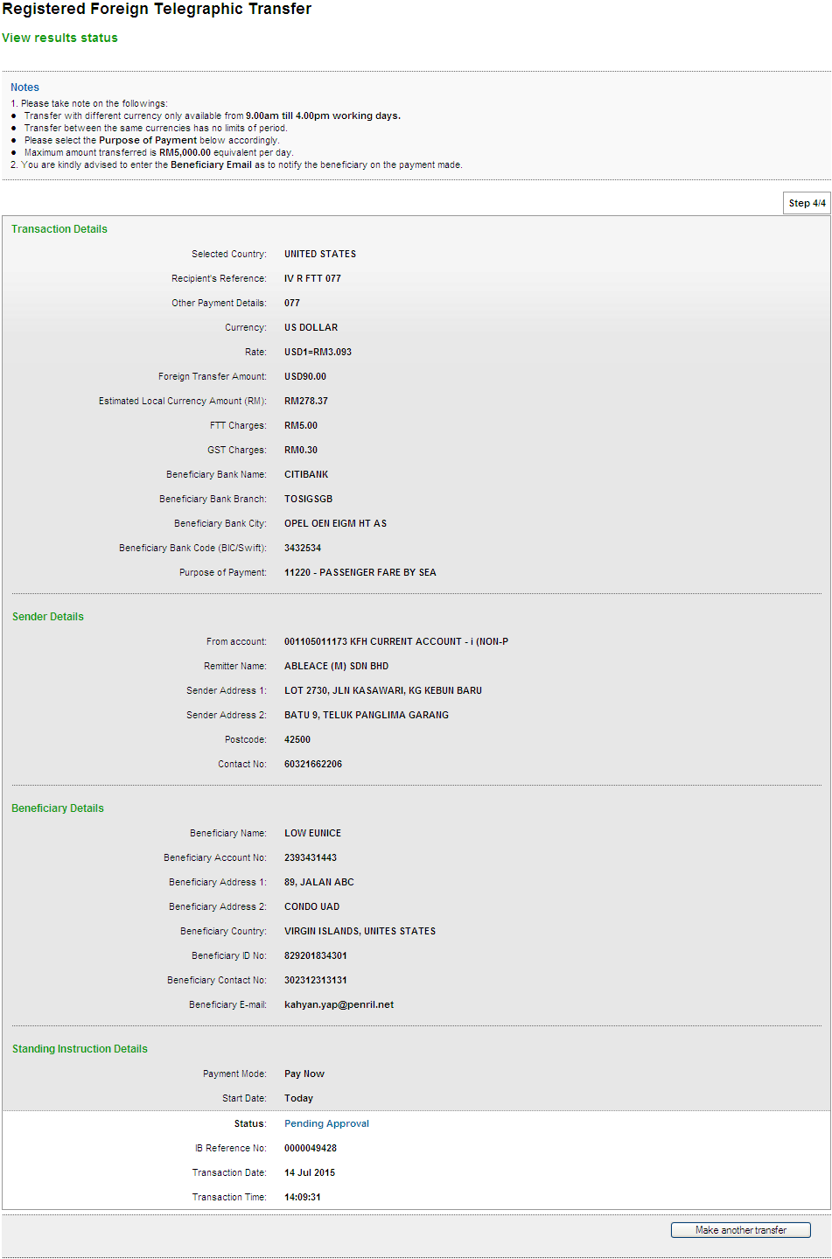

One-Time FTT Transfer
Confirm Page
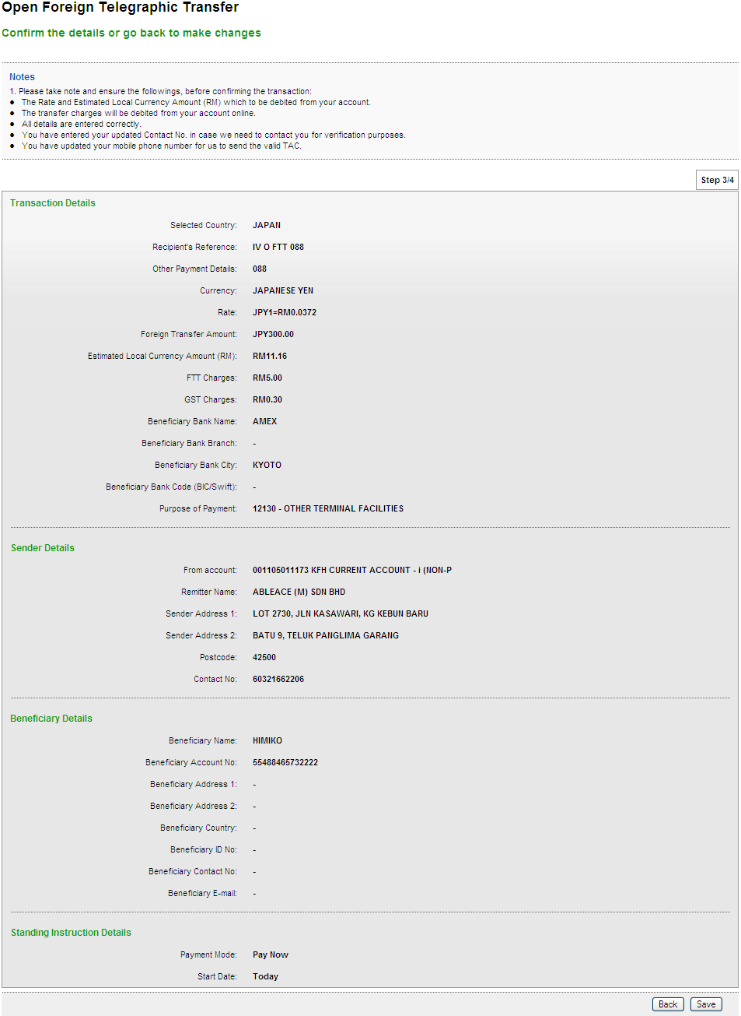
Result Page
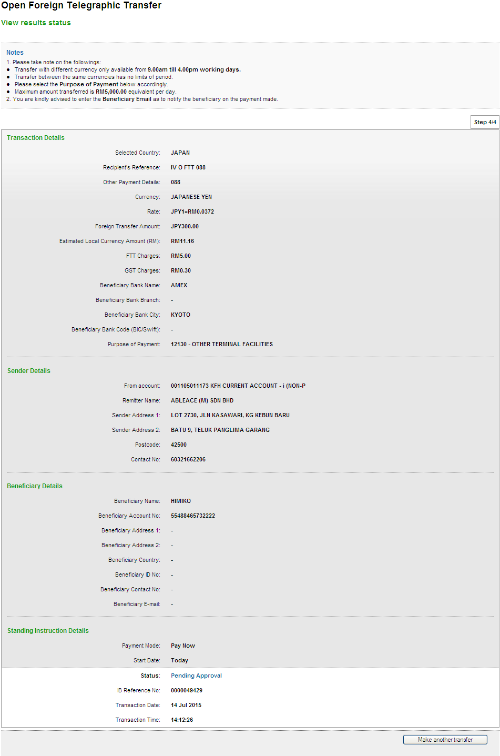
Registered Interbank Transfer (Rentas) Pay Later
Open Interbank Transfer (Rentas) Pay Later
Registered FTT Transfer (Pay Later)
One-Time FTT Transfer (Pay Later)
Registered Interbank Transfer (Rentas) Reccuring
Open Interbank Transfer (Rentas) Reccuring
Registered FTT Transfer (Reccuring)
One-Time FTT Transfer (Reccuring)

ROLE : Approver
Registered Interbank Transfer (RENTAS)
Confirm Page
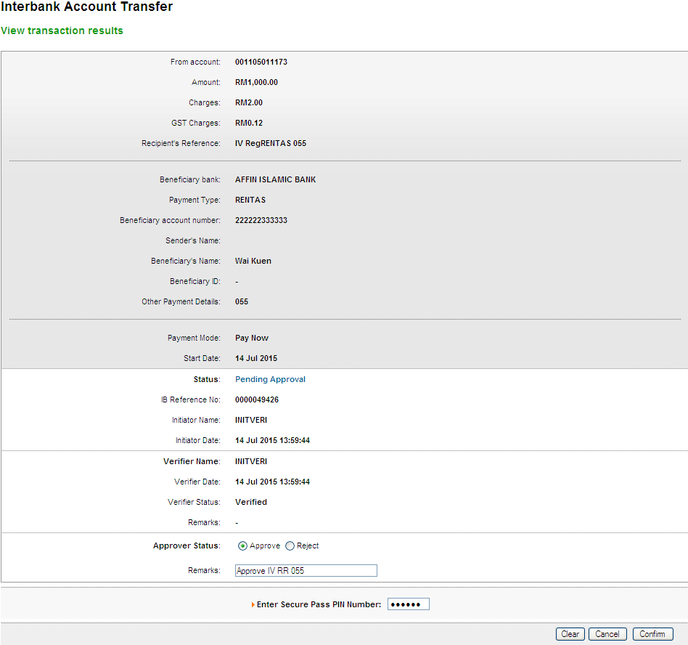
Result Page
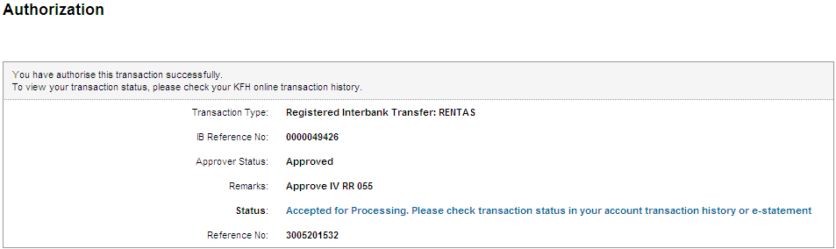
Print Receipt
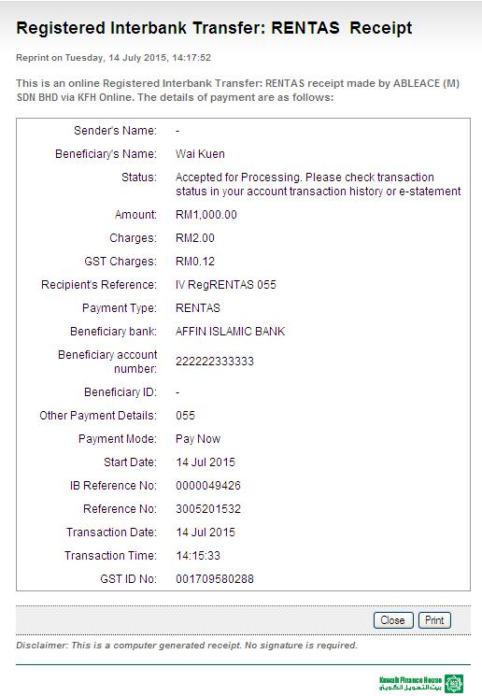
Transaction History
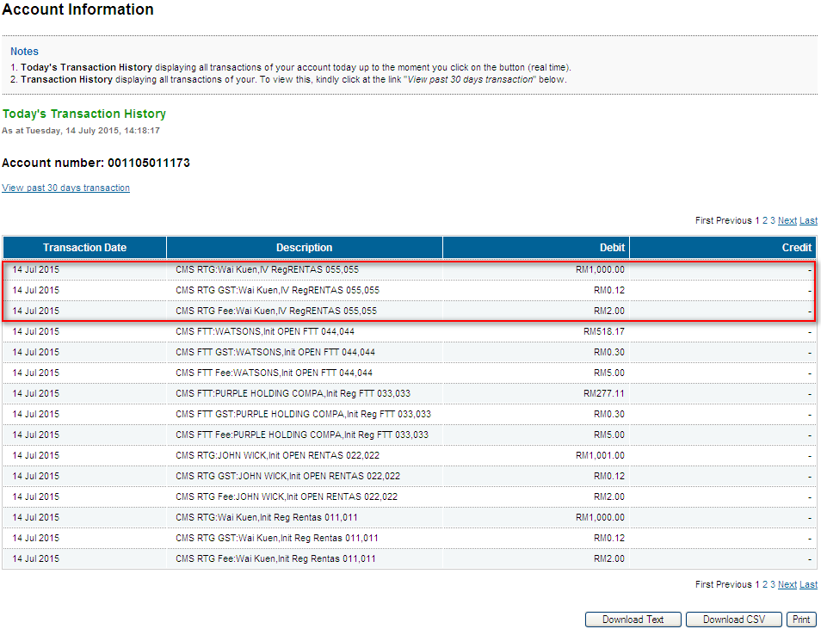
Log
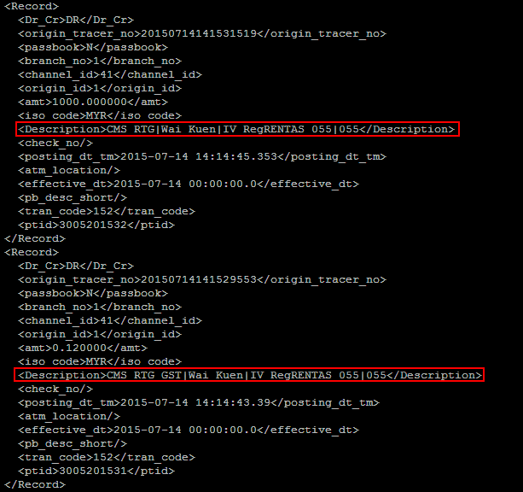
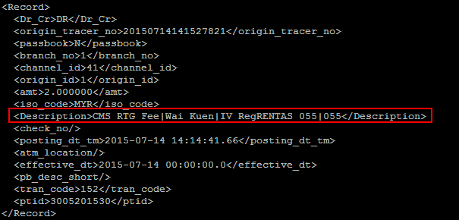
Open Interbank Transfer (RENTAS)
Confirm Page
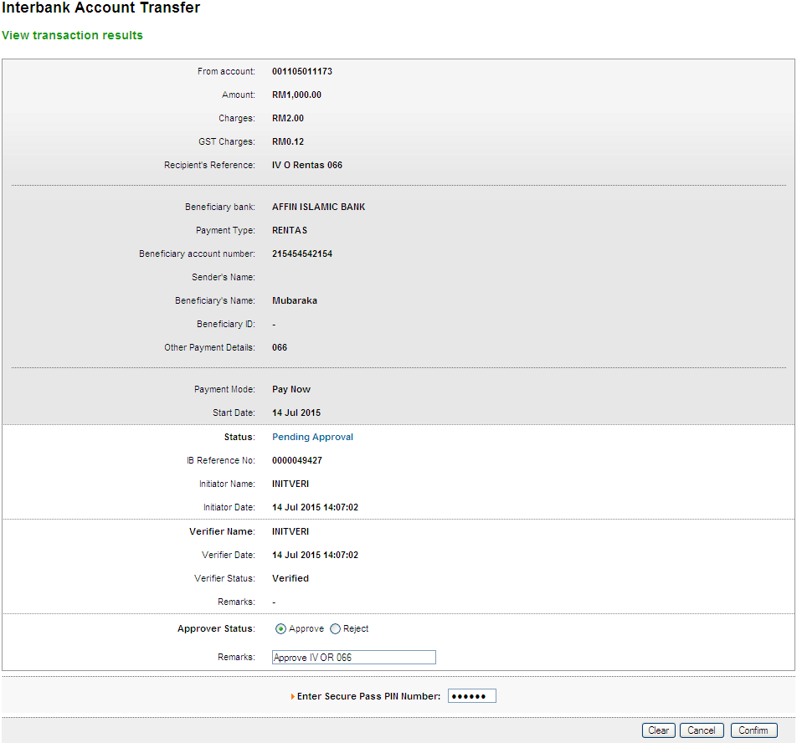
Result Page
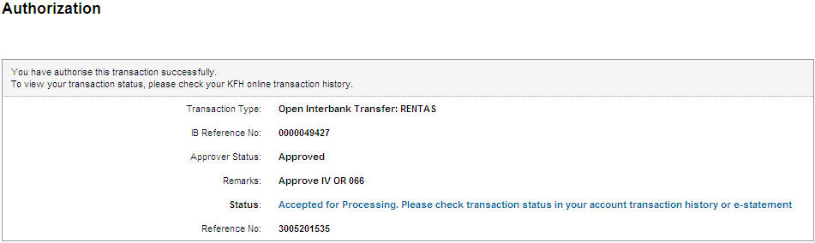
Print Receipt
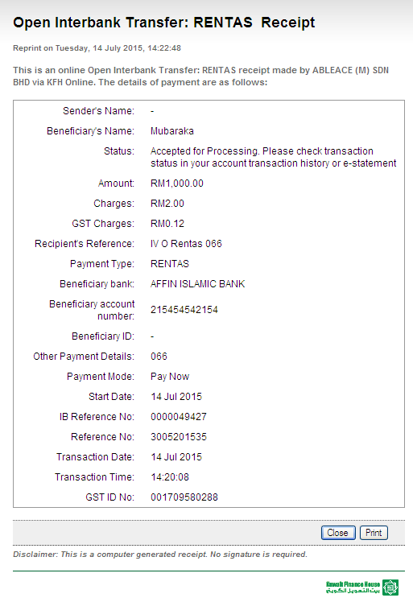
Transaction History
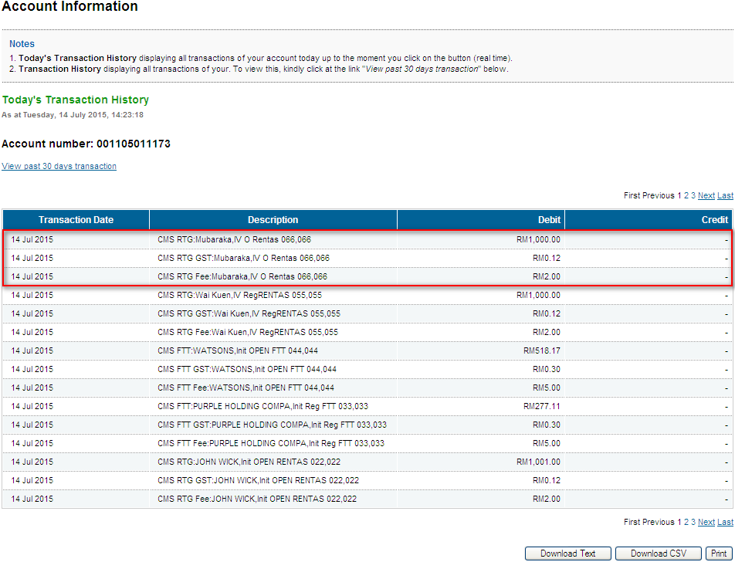
Log
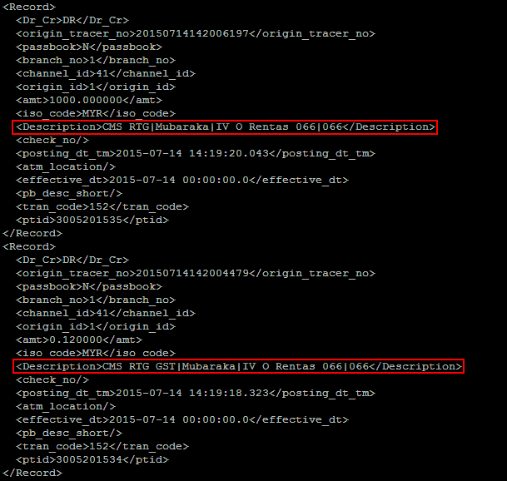
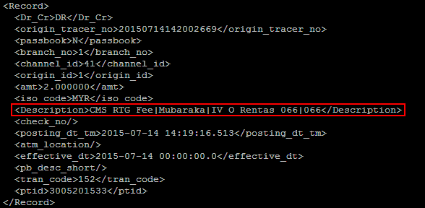
Registered FTT Transfer
Confirm Page
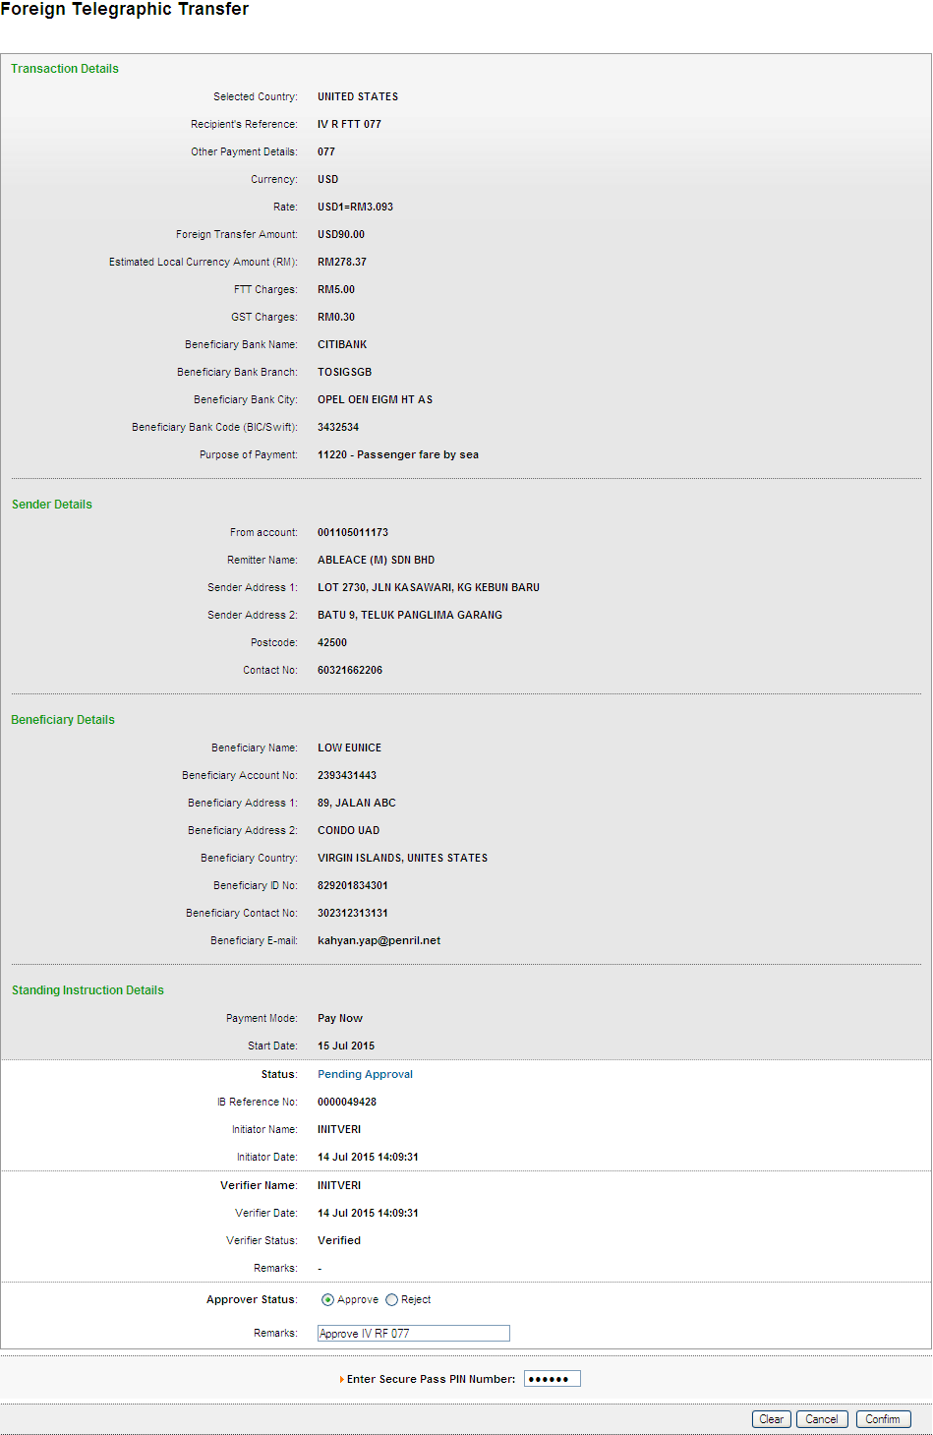
Result Page
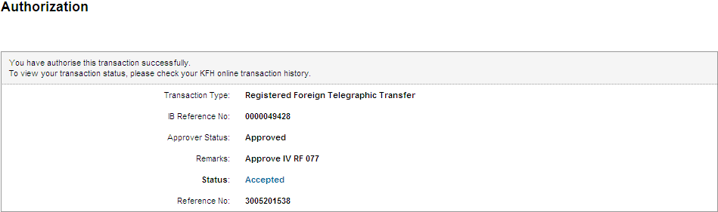
Print Receipt
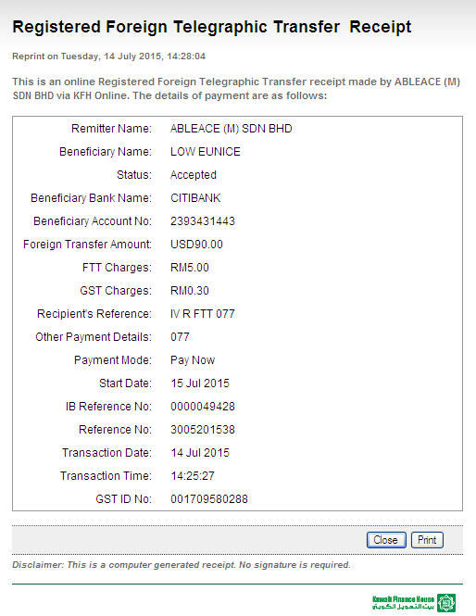
Transaction History
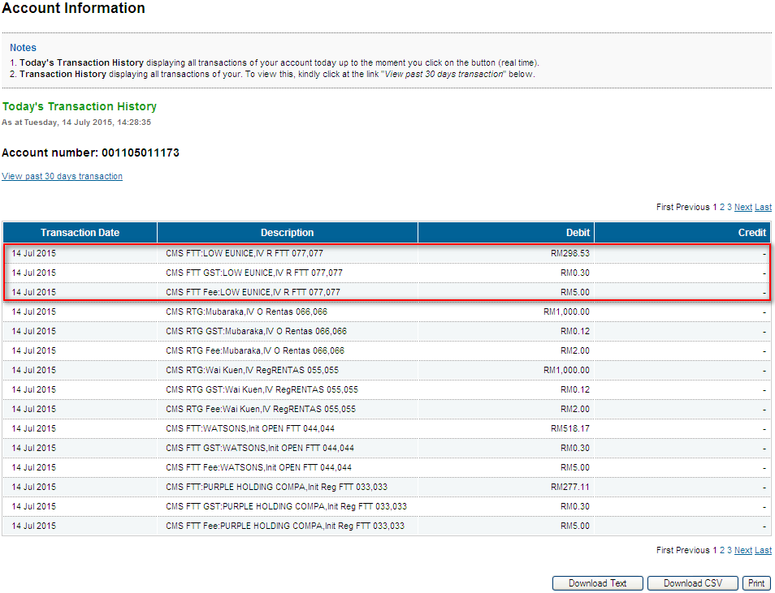
Log
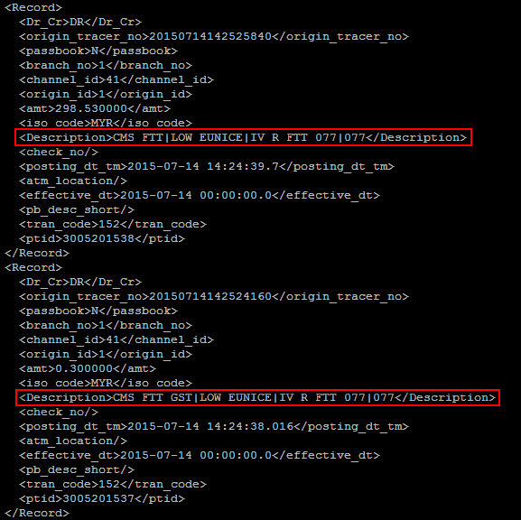
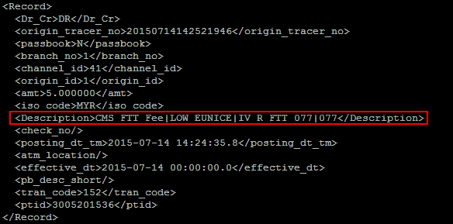
Open FTT Transfer
Confirm Page
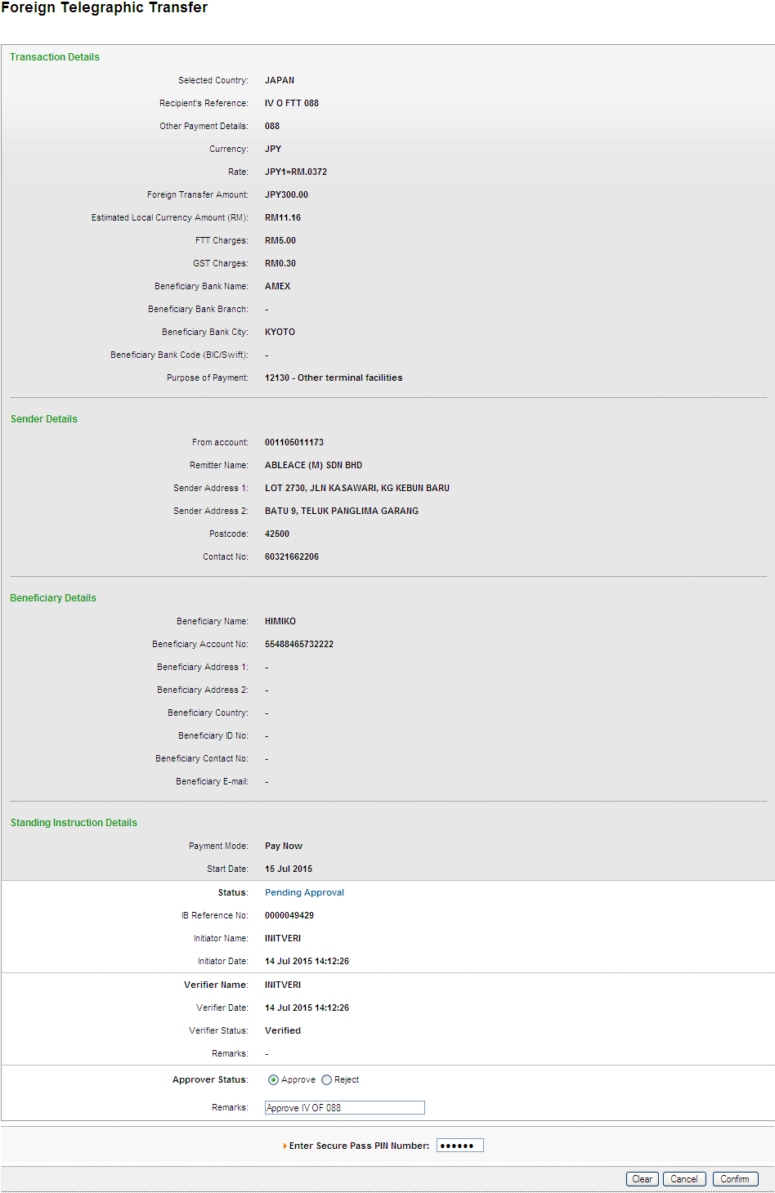
Result Page
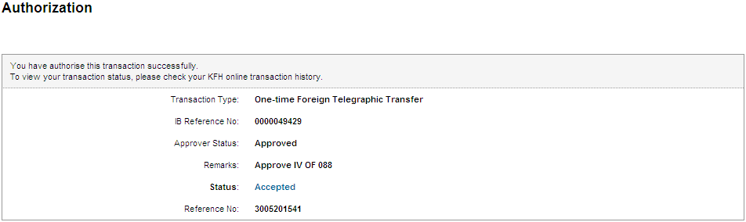
Print Receipt
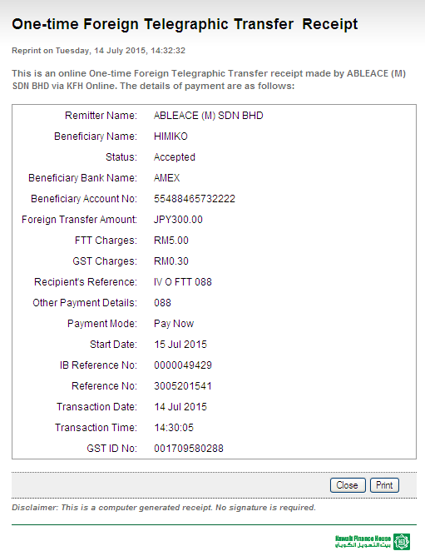
Transaction History
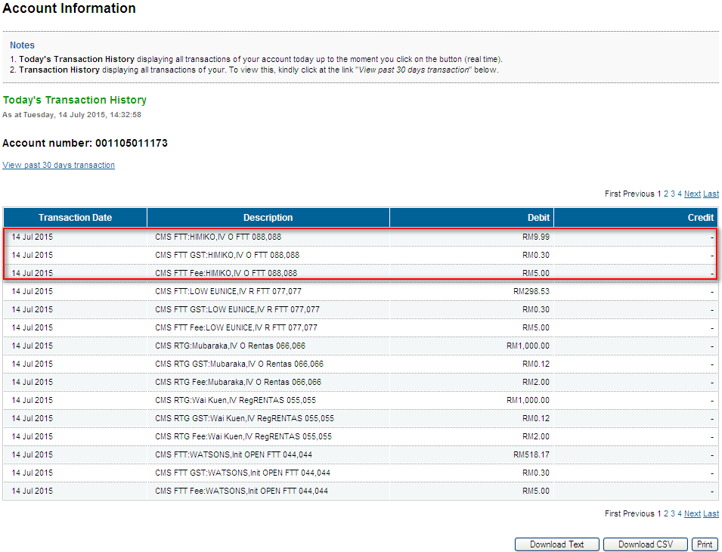
Log
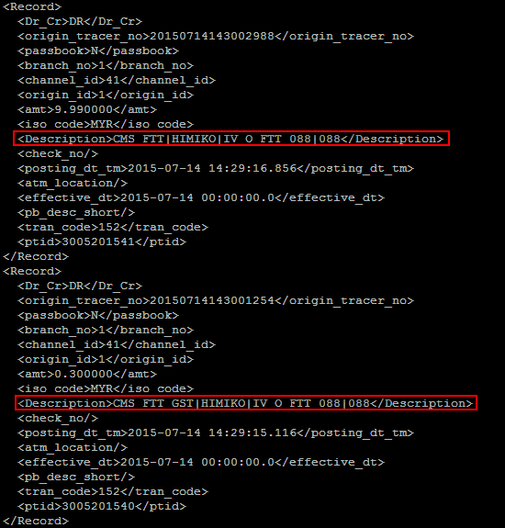
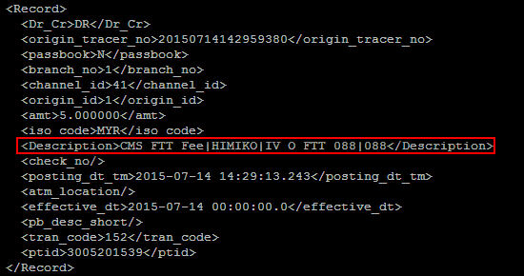
Registered Interbank Transfer (Rentas) Pay Later
Open Interbank Transfer (Rentas) Pay Later
Registered FTT Transfer (Pay Later)
One-Time FTT Transfer (Pay Later)
Registered Interbank Transfer (Rentas) Reccuring
Open Interbank Transfer (Rentas) Reccuring
Registered FTT Transfer (Reccuring)
One-Time FTT Transfer (Reccuring)

Reviewed By: (PMO)
 |  | Name/Position : NorhaidahBintiMdDasuki / Senior Manager, Quality Assurance and Support  Date :

