Retail Internet Banking (RIB)

ELECTRONIC BANKING GROUP

Nama Proyek | Retail Internet Banking (RIB)
Nomor SR
Disiapkan Oleh | Gabbytian Rayvandy | Versi

Test Case No : |  | BII-RIB-SIT / Bug #5407 / ##2746##
Test Objectives : |  | RIB – Bug on BII CC Payment  Via Account Summary (‘Pay’ Button):  - Moving from confirm step to details step must retain payment mode,  - Align full amount, minimum amount and other amount into better looks,  - Remove bracket in IDR for other amount.
Step No. | Actions |  | Steps | Expected Result | Pass / Fail | Actual Result
 | Performing steps of BII CC Payment until step 2 (confirm page) with ‘Payment Mode’ selected as ‘Other Amount’ and goes back to step 1 (details page). |  | - Login RIB as user : ribuser1.  - Password : Bii123456 / Bypass.  Account Summary:  - Click next page until credit card account with number 3562850191305004 appeared,  - Click ‘Pay’ button,  - Select ‘Other Amount’ and fill in any amount,  - Click next,  - Click back. | - After goes back from step 2 to step 1, ‘Payment Mode’ shall retain as previous state (‘Other Amount’). | Pass | - OK
Remark :

Lampiran :

BII CC Payment from Account Summary
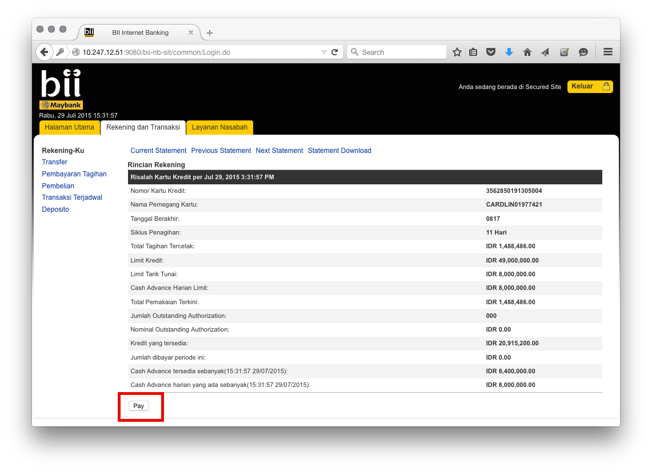

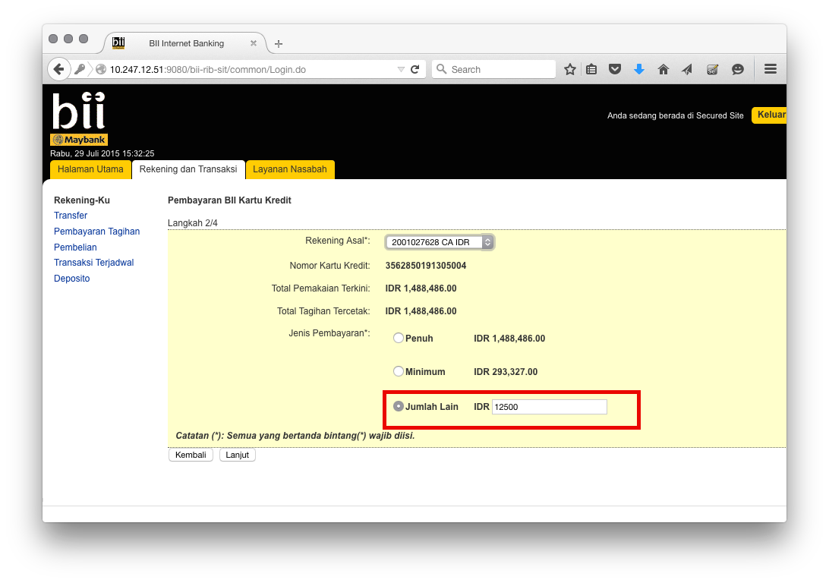

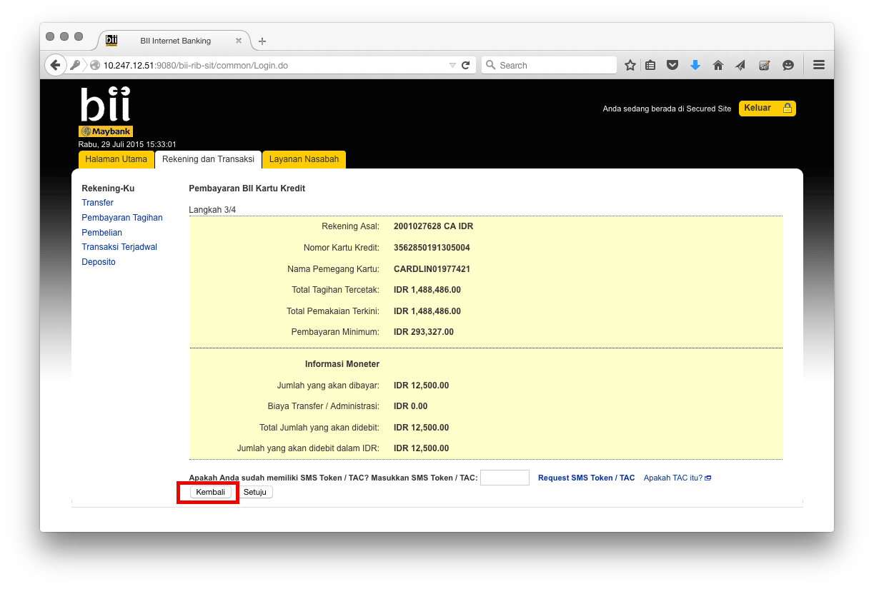
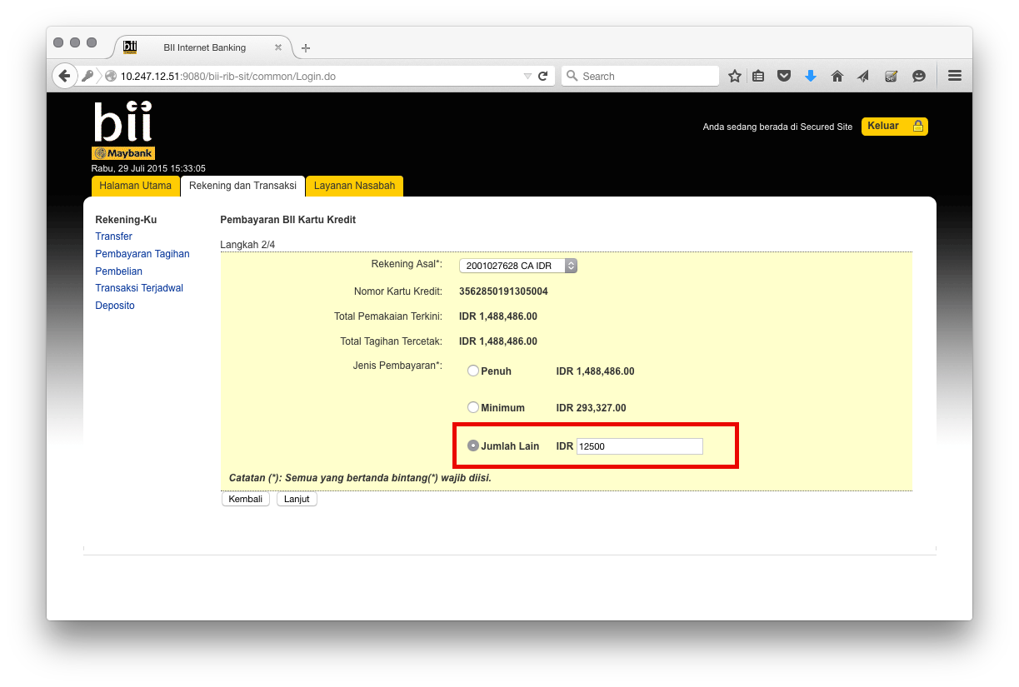

Test Case No : |  | BII-RIB-SIT / Bug #5407 / ##2746##
Test Objectives : |  | RIB – Bug on BII CC Payment  Via Open BII CC Payment:  - Moving from confirm step to details step must retain payment mode,  - Align full amount, minimum amount and other amount into better looks,  - Remove bracket in IDR for other amount.
Step No. | Actions |  | Steps | Expected Result | Pass / Fail | Actual Result
 | Performing steps of BII CC Payment until step 3 (confirm page) with ‘Payment Mode’ selected as ‘Other Amount’ and goes back to step 2 (details page). |  | - Login RIB as user : ribuser1.  - Password : Bii123456 / Bypass.  Open BII CC Payment:  - Select any from account,  - Select existing CC No.: 3562850191305004 from drop down or key in into text box,  - Click next,  - Select ‘Other Amount’ and fill in any amount,  - Click next,  - Click back. | - After goes back from step 3 to step 2, ‘Payment Mode’ shall retain as previous state (‘Other Amount’). | Pass | - OK
Remark :

BII CC Payment from Open BII CC Payment
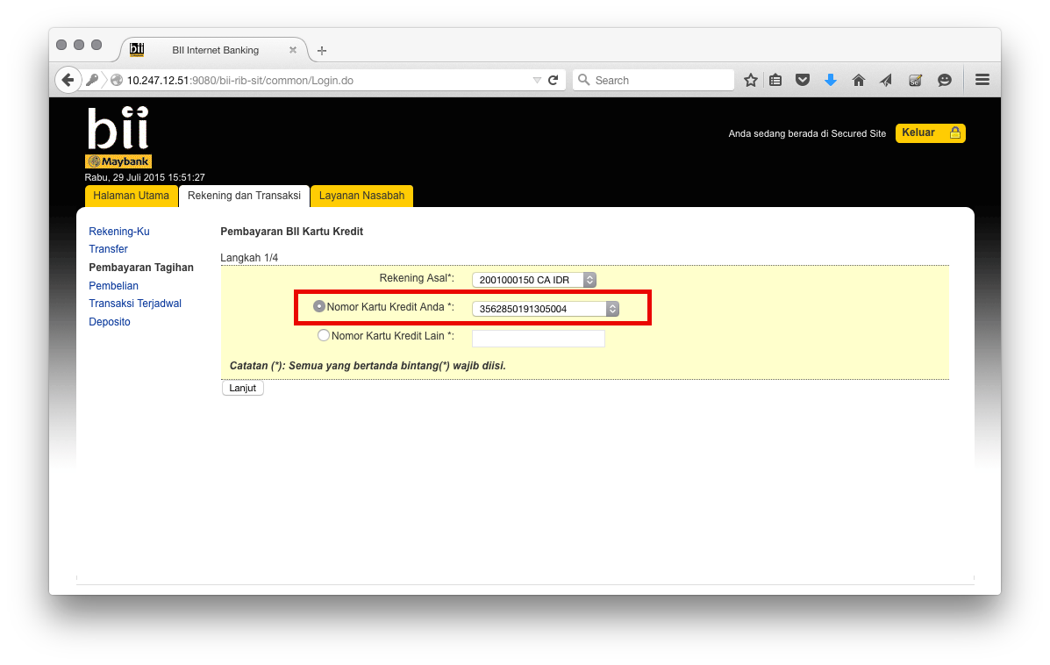

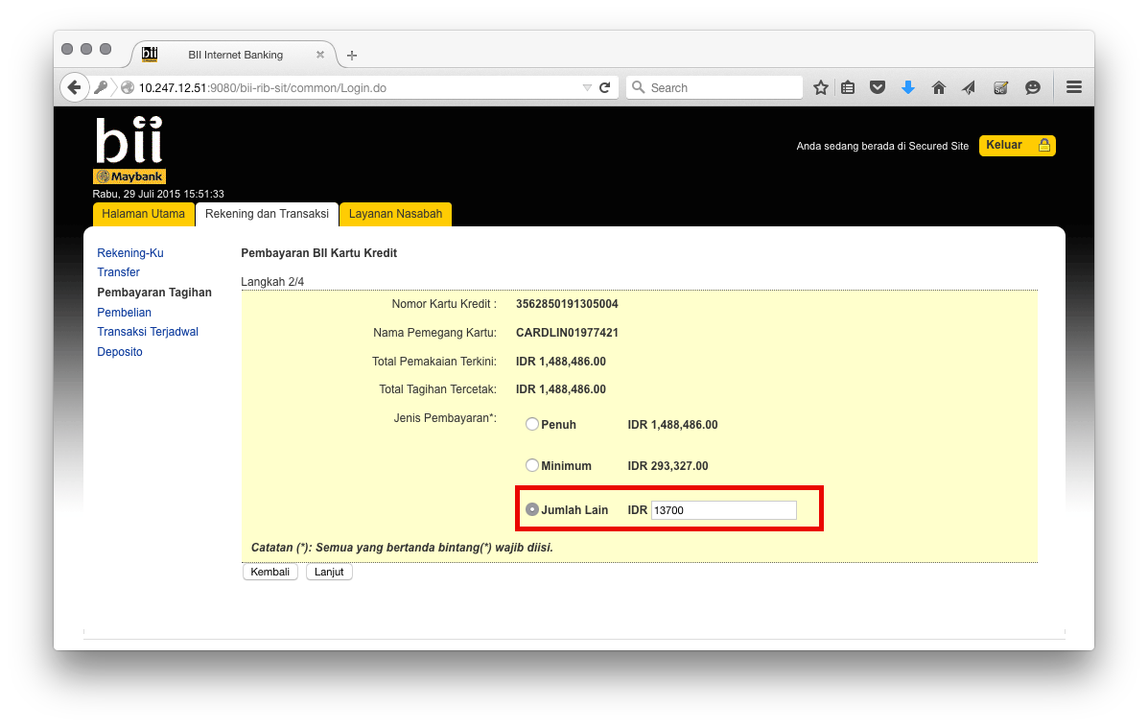
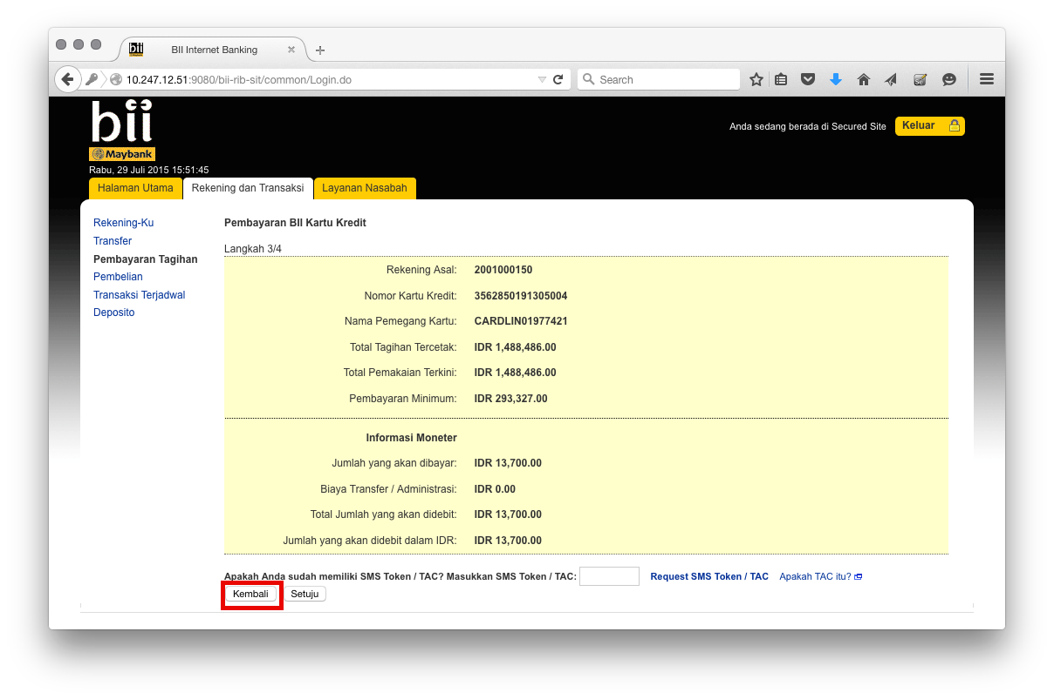
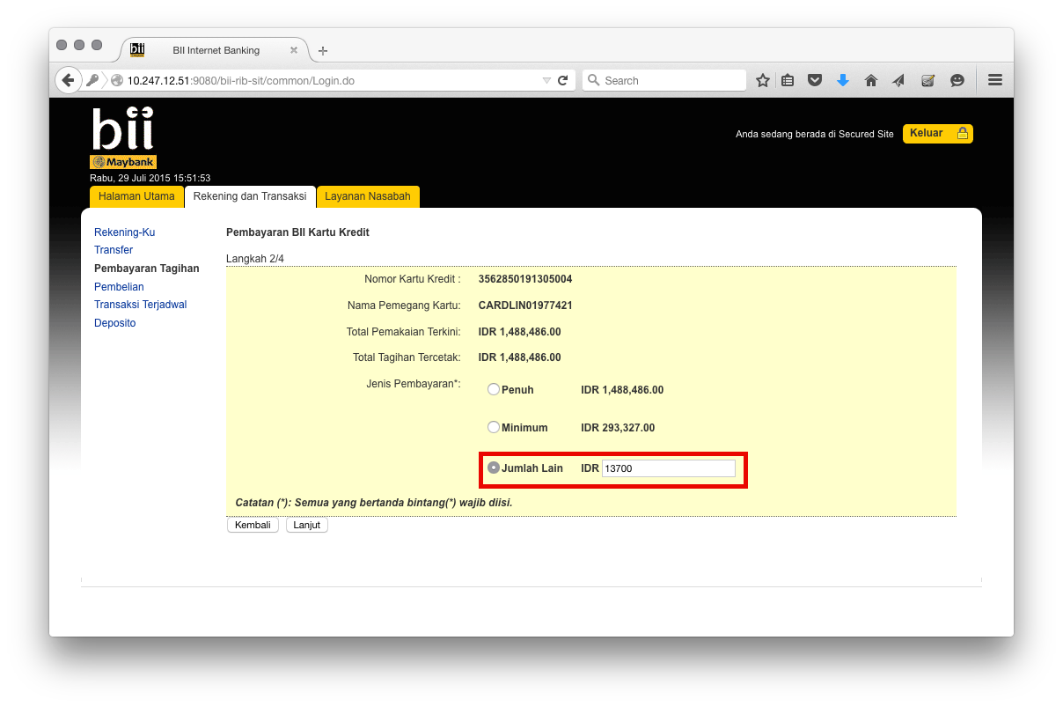

Test Case No : |  | BII-RIB-SIT / Bug #5407 / ##2746##
Test Objectives : |  | RIB – Bug on BII CC Payment  Via Favourite Bill Payment - BII CC:  - Moving from confirm step to details step must retain payment mode,  - Align full amount, minimum amount and other amount into better looks,  - Remove bracket in IDR for other amount.
Step No. | Actions |  | Steps | Expected Result | Pass / Fail | Actual Result
 | Performing steps of BII CC Payment until step 3 (confirm page) with ‘Payment Mode’ selected as ‘Other Amount’ and goes back to step 2 (details page). |  | - Login RIB as user : ribuser1.  - Password : Bii123456 / Bypass.  Favourite Bill Payment – BII CC:  - Select ‘Kartu Kredit Si Ferry’ from drop down list,  - Click ‘Next’ button,  - Select ‘Other Amount’ and fill in any amount,  - Click next,  - Click back. | - After goes back from step 3 to step 2, ‘Payment Mode’ shall retain as previous state (‘Other Amount’). | Pass | - OK
Remark :

