Retail Internet Banking (RIB)

ELECTRONIC BANKING GROUP

Nama Proyek | Retail Internet Banking (RIB)
Nomor SR
Disiapkan Oleh | Gabbytian Rayvandy | Versi | 1.1

Test Case No : |  | BII-RIB-SIT / Bug #5408 / ##2749##
Test Objectives : |  | RIB – Bene Email in add to favorite interbank registration
Step No. | Actions |  | Steps | Expected Result | Pass / Fail | Actual Result
 | Check open interbank realtime transfer. |  | - Login RIB as user : ribuser1.  - Password : Bii123456 / Bypass.  Open Interbank Realtime Transfer:  - Choose Transfer,  - Open Interbank Realtime,  - Choose Bank Central Asia (BCA) as Beneficiary Bank,  - Key in 88888800 in ‘to account no.’ text box as destination account no.,  - Leave the email address blank.  - Proceed till successful page. | - Successfully performed open interbank realtime transaction. | Pass | - OK
 | Check email address value in ‘intebank online maintenance add’ after successfully performed interbank online. |  | - Click add as favourite,  - Make sure if Card Name is included numeric character to induce error message validation,  - Key in ‘rmbp01@biilab.net’ in email address field,  - Click next. | - Email address shall not become blank if there is any error validation. |  | - OK
 | Check favourite registration process till result page. |  | - If above expected result passed, proceed till result page by correcting the beneficary nickname to alphabet only. | - Favourite must be successfully registered. |  | - OK
 | Check newly added favourite. |  | Favourite Interbank Realtime Transfer :  - Choose Transfer,  - Open Interbank Realtime,  - Choose Bank Central Asia (BCA) as Beneficiary Bank,  - Key in 88888800 in ‘to account no.’ text box as destination account no.,  - Leave the email address blank.  - Proceed till successful page. | - Newly added favourite must be usable |  | - OK
Remark :

Lampiran :

Open Interbank Realtime Transfer
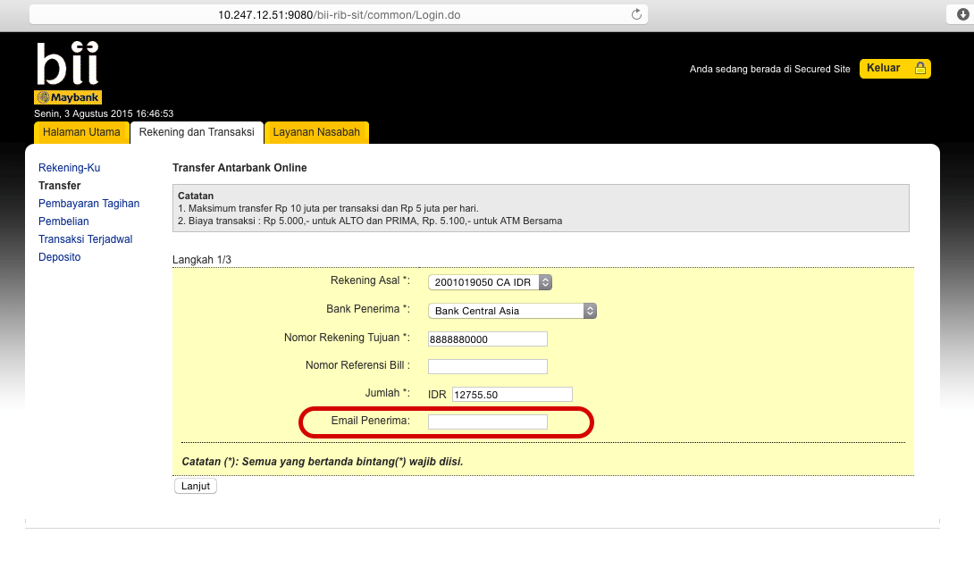
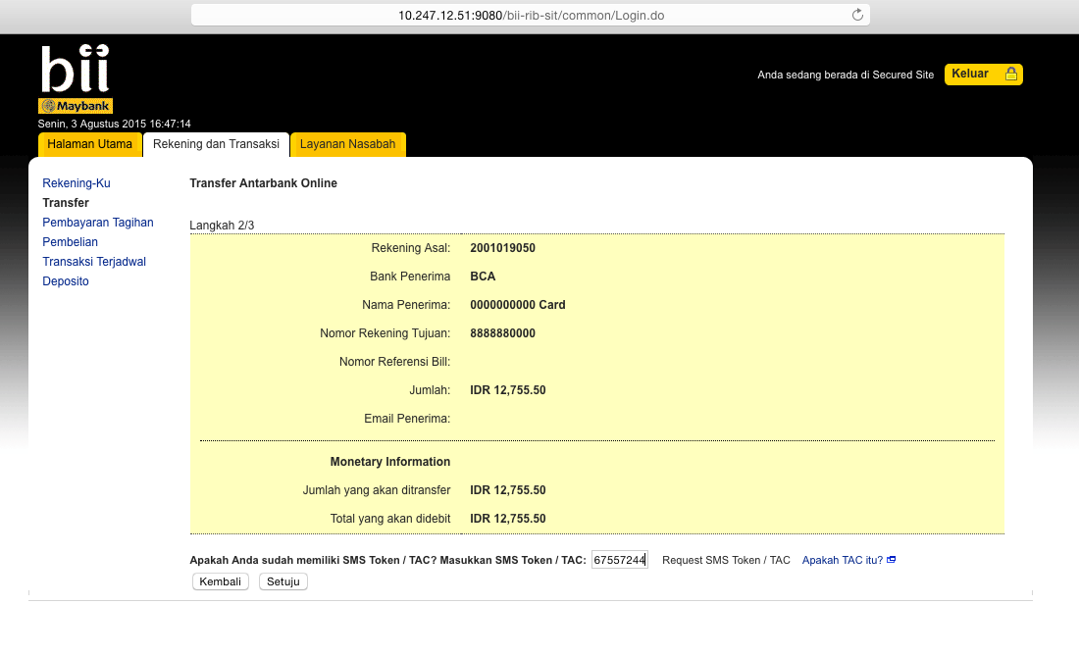
Log:

[8/3/15 16:47:31:962 WIT] 0000010e SystemOut O [03/08/2015] [16:47:31:962] [INFO] [ESBPostpaidPaymentServices]:370 - <<<<<<<<<<<<<<<<< Header >>>>>>>>>>>>>>>>>>>
[8/3/15 16:47:31:963 WIT] 0000010e SystemOut O [03/08/2015] [16:47:31:962] [INFO] [ESBPostpaidPaymentServices]:371 - Message ID: C2A4A37E-86F2-4636-BEF6-AB5255EF3664
[8/3/15 16:47:31:963 WIT] 0000010e SystemOut O [03/08/2015] [16:47:31:963] [INFO] [ESBPostpaidPaymentServices]:372 - Branch Code: 270
[8/3/15 16:47:31:963 WIT] 0000010e SystemOut O [03/08/2015] [16:47:31:963] [INFO] [ESBPostpaidPaymentServices]:373 - Channel ID: M2U
[8/3/15 16:47:31:963 WIT] 0000010e SystemOut O [03/08/2015] [16:47:31:963] [INFO] [ESBPostpaidPaymentServices]:374 - Client Supervisor ID: 0000
[8/3/15 16:47:31:964 WIT] 0000010e SystemOut O [03/08/2015] [16:47:31:963] [INFO] [ESBPostpaidPaymentServices]:375 - Client UserID: 0000
[8/3/15 16:47:31:964 WIT] 0000010e SystemOut O [03/08/2015] [16:47:31:964] [INFO] [ESBPostpaidPaymentServices]:376 - Reference No: M2U/123/2013
[8/3/15 16:47:31:964 WIT] 0000010e SystemOut O [03/08/2015] [16:47:31:964] [INFO] [ESBPostpaidPaymentServices]:377 - Sequence No: 8495
[8/3/15 16:47:31:964 WIT] 0000010e SystemOut O [03/08/2015] [16:47:31:964] [INFO] [ESBPostpaidPaymentServices]:378 - Transaction Date: 03-08-2015
[8/3/15 16:47:31:965 WIT] 0000010e SystemOut O [03/08/2015] [16:47:31:964] [INFO] [ESBPostpaidPaymentServices]:379 - Transaction Time: 16:47:31
[8/3/15 16:47:31:965 WIT] 0000010e SystemOut O [03/08/2015] [16:47:31:965] [INFO] [ESBPostpaidPaymentServices]:111 - <<<<<<<<<<<<<<<<< Request >>>>>>>>>>>>>>>>>>>
[8/3/15 16:47:31:965 WIT] 0000010e SystemOut O [03/08/2015] [16:47:31:965] [INFO] [ESBPostpaidPaymentServices]:112 - RoutingCode:
[8/3/15 16:47:31:965 WIT] 0000010e SystemOut O [03/08/2015] [16:47:31:965] [INFO] [ESBPostpaidPaymentServices]:116 - ### ISO8583MsgType ###
[8/3/15 16:47:31:966 WIT] 0000010e SystemOut O [03/08/2015] [16:47:31:965] [INFO] [ESBPostpaidPaymentServices]:119 - 000 Message Type Identifier: 0100
[8/3/15 16:47:31:966 WIT] 0000010e SystemOut O [03/08/2015] [16:47:31:966] [INFO] [ESBPostpaidPaymentServices]:127 - 003 Processing Code: 471000
[8/3/15 16:47:31:966 WIT] 0000010e SystemOut O [03/08/2015] [16:47:31:966] [INFO] [ESBPostpaidPaymentServices]:131 - 004 Transaction Amount: 1275550
[8/3/15 16:47:31:966 WIT] 0000010e SystemOut O [03/08/2015] [16:47:31:966] [INFO] [ESBPostpaidPaymentServices]:135 - 011 System Trace Audit Number: 094982
[8/3/15 16:47:31:967 WIT] 0000010e SystemOut O [03/08/2015] [16:47:31:966] [INFO] [ESBPostpaidPaymentServices]:139 - 012 Local Time Transaction: 164731
[8/3/15 16:47:31:967 WIT] 0000010e SystemOut O [03/08/2015] [16:47:31:967] [INFO] [ESBPostpaidPaymentServices]:143 - 013 Local Date Transaction: 0803
[8/3/15 16:47:31:967 WIT] 0000010e SystemOut O [03/08/2015] [16:47:31:967] [INFO] [ESBPostpaidPaymentServices]:147 - 022 Pos Entry Mode Code: 018
[8/3/15 16:47:31:967 WIT] 0000010e SystemOut O [03/08/2015] [16:47:31:967] [INFO] [ESBPostpaidPaymentServices]:151 - 032 Acquiring Institution ID: 001
[8/3/15 16:47:31:968 WIT] 0000010e SystemOut O [03/08/2015] [16:47:31:967] [INFO] [ESBPostpaidPaymentServices]:155 - 037 Retrieval Reference Number: 000000094982
[8/3/15 16:47:31:968 WIT] 0000010e SystemOut O [03/08/2015] [16:47:31:968] [INFO] [ESBPostpaidPaymentServices]:163 - 041 Card Acceptor Terminal ID: 11007
[8/3/15 16:47:31:968 WIT] 0000010e SystemOut O [03/08/2015] [16:47:31:968] [INFO] [ESBPostpaidPaymentServices]:170 - 042 Card Acceptor Identification Code: 10.120.12.124
[8/3/15 16:47:31:968 WIT] 0000010e SystemOut O [03/08/2015] [16:47:31:968] [INFO] [ESBPostpaidPaymentServices]:174 - 043 Card Acceptor Name Location: CHRISTOPHER PAUL WHALEY
[8/3/15 16:47:31:968 WIT] 0000010e SystemOut O [03/08/2015] [16:47:31:968] [INFO] [ESBPostpaidPaymentServices]:182 - 048 Additional Data: 000014BCA 0000000000 Card 1014
[8/3/15 16:47:31:969 WIT] 0000010e SystemOut O [03/08/2015] [16:47:31:969] [INFO] [ESBPostpaidPaymentServices]:186 - 049 Currency Code: 360
[8/3/15 16:47:31:969 WIT] 0000010e SystemOut O [03/08/2015] [16:47:31:969] [INFO] [ESBPostpaidPaymentServices]:206 - 102 From Account: 0162001019050
[8/3/15 16:47:31:969 WIT] 0000010e SystemOut O [03/08/2015] [16:47:31:969] [INFO] [ESBPostpaidPaymentServices]:210 - 103 To Account: 8888880000
[8/3/15 16:47:33:616 WIT] 0000010e SystemOut O [03/08/2015] [16:47:33:616] [INFO] [ESBPostpaidPaymentServices]:223 - <<<<<<<<<<<<<<<<< Response >>>>>>>>>>>>>>>>>>>
[8/3/15 16:47:33:617 WIT] 0000010e SystemOut O [03/08/2015] [16:47:33:617] [INFO] [ESBPostpaidPaymentServices]:225 - Response Code: 00
[8/3/15 16:47:33:617 WIT] 0000010e SystemOut O responseData.getDE103ToAccount():8888880000
[8/3/15 16:47:33:617 WIT] 0000010e SystemOut O [03/08/2015] [16:47:33:617] [INFO] [ESBPostpaidPaymentServices]:257 - Message Type Identifier: 0110
[8/3/15 16:47:33:617 WIT] 0000010e SystemOut O [03/08/2015] [16:47:33:617] [INFO] [ESBPostpaidPaymentServices]:258 - Primary Account Number: 5104811099990438
[8/3/15 16:47:33:618 WIT] 0000010e SystemOut O [03/08/2015] [16:47:33:617] [INFO] [ESBPostpaidPaymentServices]:259 - Processing Code: 471000
[8/3/15 16:47:33:618 WIT] 0000010e SystemOut O [03/08/2015] [16:47:33:618] [INFO] [ESBPostpaidPaymentServices]:260 - Amount Transaction: 000001275550
[8/3/15 16:47:33:618 WIT] 0000010e SystemOut O [03/08/2015] [16:47:33:618] [INFO] [ESBPostpaidPaymentServices]:261 - System Trace Audit Number: 094982
[8/3/15 16:47:33:618 WIT] 0000010e SystemOut O [03/08/2015] [16:47:33:618] [INFO] [ESBPostpaidPaymentServices]:262 - Local Time Transaction: null
[8/3/15 16:47:33:618 WIT] 0000010e SystemOut O [03/08/2015] [16:47:33:618] [INFO] [ESBPostpaidPaymentServices]:263 - Local Date Transaction: null
[8/3/15 16:47:33:619 WIT] 0000010e SystemOut O [03/08/2015] [16:47:33:618] [INFO] [ESBPostpaidPaymentServices]:264 - Pos Entry Mode Code: 018
[8/3/15 16:47:33:619 WIT] 0000010e SystemOut O [03/08/2015] [16:47:33:619] [INFO] [ESBPostpaidPaymentServices]:265 - Acquiring Institution ID: 005
[8/3/15 16:47:33:619 WIT] 0000010e SystemOut O [03/08/2015] [16:47:33:619] [INFO] [ESBPostpaidPaymentServices]:266 - Track 2 Data: null
[8/3/15 16:47:33:619 WIT] 0000010e SystemOut O [03/08/2015] [16:47:33:619] [INFO] [ESBPostpaidPaymentServices]:267 - Retrieval Reference Number: 000000094982
[8/3/15 16:47:33:620 WIT] 0000010e SystemOut O [03/08/2015] [16:47:33:619] [INFO] [ESBPostpaidPaymentServices]:268 - Auth Identification Response: 000039
[8/3/15 16:47:33:620 WIT] 0000010e SystemOut O [03/08/2015] [16:47:33:620] [INFO] [ESBPostpaidPaymentServices]:269 - Response Code: 00
[8/3/15 16:47:33:620 WIT] 0000010e SystemOut O [03/08/2015] [16:47:33:620] [INFO] [ESBPostpaidPaymentServices]:270 - Card Acceptor Terminal ID: 00011007
[8/3/15 16:47:33:620 WIT] 0000010e SystemOut O [03/08/2015] [16:47:33:620] [INFO] [ESBPostpaidPaymentServices]:271 - Card Acceptor Identification Code: null
[8/3/15 16:47:33:621 WIT] 0000010e SystemOut O [03/08/2015] [16:47:33:620] [INFO] [ESBPostpaidPaymentServices]:272 - Card Acceptor Name Location: null
[8/3/15 16:47:33:621 WIT] 0000010e SystemOut O [03/08/2015] [16:47:33:621] [INFO] [ESBPostpaidPaymentServices]:273 - 046 Additional Data: 75498708716
[8/3/15 16:47:33:621 WIT] 0000010e SystemOut O [03/08/2015] [16:47:33:621] [INFO] [ESBPostpaidPaymentServices]:274 - 048 Additional Data: 000014BCA 0000000000 Card 1014 000016
[8/3/15 16:47:33:621 WIT] 0000010e SystemOut O [03/08/2015] [16:47:33:621] [INFO] [ESBPostpaidPaymentServices]:275 - Currency Code Transaction: 360
[8/3/15 16:47:33:622 WIT] 0000010e SystemOut O [03/08/2015] [16:47:33:621] [INFO] [ESBPostpaidPaymentServices]:276 - End Point Switch Trace Number: 058339
[8/3/15 16:47:33:622 WIT] 0000010e SystemOut O [03/08/2015] [16:47:33:622] [INFO] [ESBPostpaidPaymentServices]:277 - Network Management Code: null
[8/3/15 16:47:33:622 WIT] 0000010e SystemOut O [03/08/2015] [16:47:33:622] [INFO] [ESBPostpaidPaymentServices]:278 - Original Data Elements: null
[8/3/15 16:47:33:622 WIT] 0000010e SystemOut O [03/08/2015] [16:47:33:622] [INFO] [ESBPostpaidPaymentServices]:279 - Payee: null
[8/3/15 16:47:33:623 WIT] 0000010e SystemOut O [03/08/2015] [16:47:33:622] [INFO] [ESBPostpaidPaymentServices]:280 - From Account: 0162001019050
[8/3/15 16:47:33:623 WIT] 0000010e SystemOut O [03/08/2015] [16:47:33:623] [INFO] [ESBPostpaidPaymentServices]:281 - To Account: 8888880000
Open Interbank Realtime add to Favourite

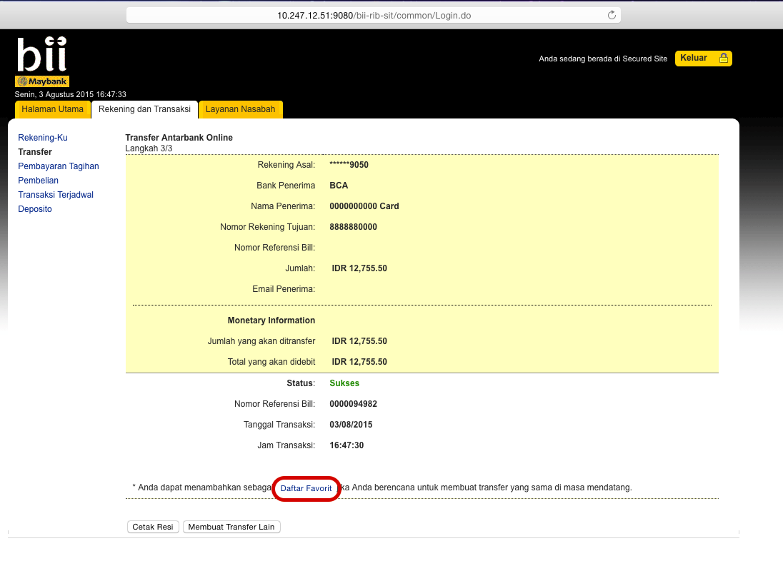

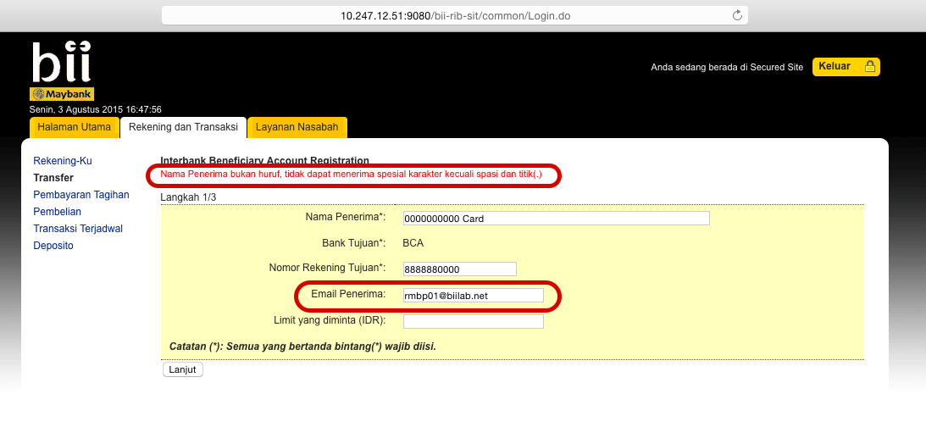
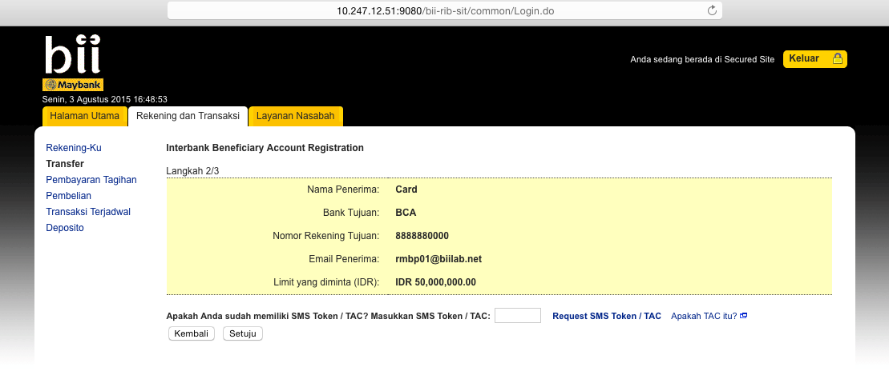
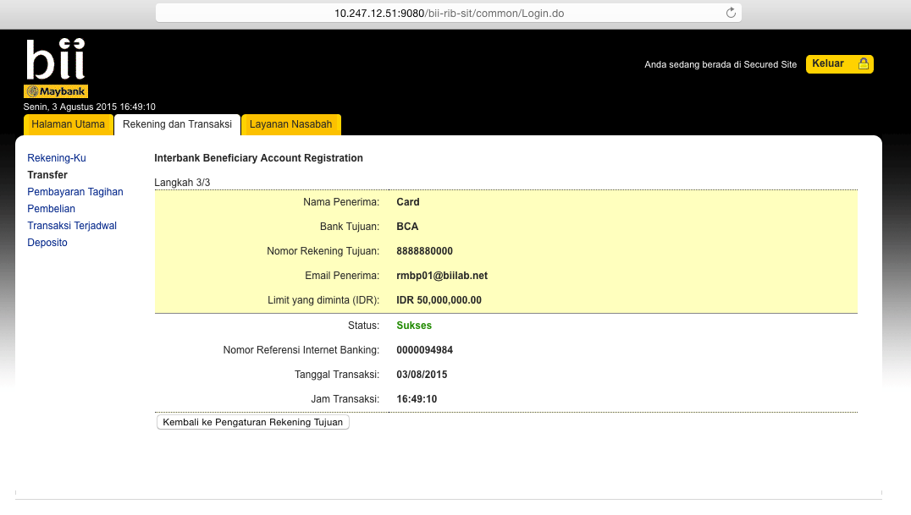

Favourite Interbank Realtime Transfer Using Newly Add Favourite

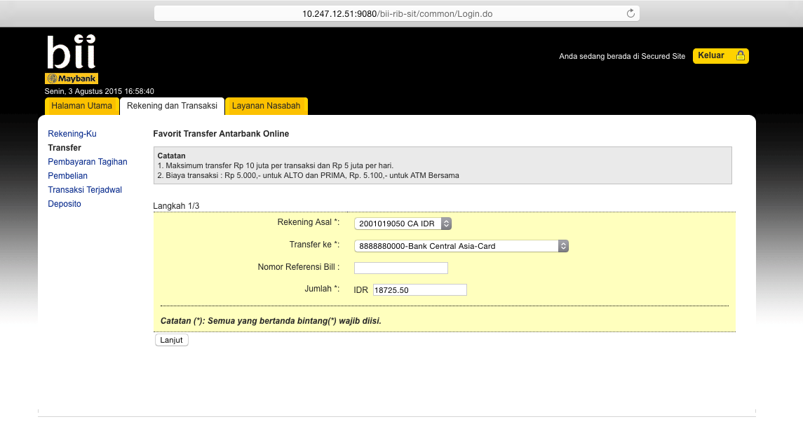
Log:

[8/3/15 17:04:15:357 WIT] 00000181 SystemOut O [03/08/2015] [17:04:15:357] [INFO] [ESBPostpaidPaymentServices]:370 - <<<<<<<<<<<<<<<<< Header >>>>>>>>>>>>>>>>>>>
[8/3/15 17:04:15:357 WIT] 00000181 SystemOut O [03/08/2015] [17:04:15:357] [INFO] [ESBPostpaidPaymentServices]:371 - Message ID: 97F988BE-3F54-4D08-8FDC-66B0C524B18D
[8/3/15 17:04:15:357 WIT] 00000181 SystemOut O [03/08/2015] [17:04:15:357] [INFO] [ESBPostpaidPaymentServices]:372 - Branch Code: 270
[8/3/15 17:04:15:358 WIT] 00000181 SystemOut O [03/08/2015] [17:04:15:357] [INFO] [ESBPostpaidPaymentServices]:373 - Channel ID: M2U
[8/3/15 17:04:15:358 WIT] 00000181 SystemOut O [03/08/2015] [17:04:15:358] [INFO] [ESBPostpaidPaymentServices]:374 - Client Supervisor ID: 0000
[8/3/15 17:04:15:358 WIT] 00000181 SystemOut O [03/08/2015] [17:04:15:358] [INFO] [ESBPostpaidPaymentServices]:375 - Client UserID: 0000
[8/3/15 17:04:15:358 WIT] 00000181 SystemOut O [03/08/2015] [17:04:15:358] [INFO] [ESBPostpaidPaymentServices]:376 - Reference No: M2U/123/2013
[8/3/15 17:04:15:359 WIT] 00000181 SystemOut O [03/08/2015] [17:04:15:358] [INFO] [ESBPostpaidPaymentServices]:377 - Sequence No: 8495
[8/3/15 17:04:15:359 WIT] 00000181 SystemOut O [03/08/2015] [17:04:15:359] [INFO] [ESBPostpaidPaymentServices]:378 - Transaction Date: 03-08-2015
[8/3/15 17:04:15:359 WIT] 00000181 SystemOut O [03/08/2015] [17:04:15:359] [INFO] [ESBPostpaidPaymentServices]:379 - Transaction Time: 17:04:15
[8/3/15 17:04:15:359 WIT] 00000181 SystemOut O [03/08/2015] [17:04:15:359] [INFO] [ESBPostpaidPaymentServices]:111 - <<<<<<<<<<<<<<<<< Request >>>>>>>>>>>>>>>>>>>
[8/3/15 17:04:15:360 WIT] 00000181 SystemOut O [03/08/2015] [17:04:15:359] [INFO] [ESBPostpaidPaymentServices]:112 - RoutingCode:
[8/3/15 17:04:15:360 WIT] 00000181 SystemOut O [03/08/2015] [17:04:15:360] [INFO] [ESBPostpaidPaymentServices]:116 - ### ISO8583MsgType ###
[8/3/15 17:04:15:360 WIT] 00000181 SystemOut O [03/08/2015] [17:04:15:360] [INFO] [ESBPostpaidPaymentServices]:119 - 000 Message Type Identifier: 0100
[8/3/15 17:04:15:360 WIT] 00000181 SystemOut O [03/08/2015] [17:04:15:360] [INFO] [ESBPostpaidPaymentServices]:127 - 003 Processing Code: 471000
[8/3/15 17:04:15:361 WIT] 00000181 SystemOut O [03/08/2015] [17:04:15:360] [INFO] [ESBPostpaidPaymentServices]:131 - 004 Transaction Amount: 1875050
[8/3/15 17:04:15:361 WIT] 00000181 SystemOut O [03/08/2015] [17:04:15:361] [INFO] [ESBPostpaidPaymentServices]:135 - 011 System Trace Audit Number: 094990
[8/3/15 17:04:15:361 WIT] 00000181 SystemOut O [03/08/2015] [17:04:15:361] [INFO] [ESBPostpaidPaymentServices]:139 - 012 Local Time Transaction: 170415
[8/3/15 17:04:15:361 WIT] 00000181 SystemOut O [03/08/2015] [17:04:15:361] [INFO] [ESBPostpaidPaymentServices]:143 - 013 Local Date Transaction: 0803
[8/3/15 17:04:15:361 WIT] 00000181 SystemOut O [03/08/2015] [17:04:15:361] [INFO] [ESBPostpaidPaymentServices]:147 - 022 Pos Entry Mode Code: 018
[8/3/15 17:04:15:362 WIT] 00000181 SystemOut O [03/08/2015] [17:04:15:361] [INFO] [ESBPostpaidPaymentServices]:151 - 032 Acquiring Institution ID: 001
[8/3/15 17:04:15:362 WIT] 00000181 SystemOut O [03/08/2015] [17:04:15:362] [INFO] [ESBPostpaidPaymentServices]:155 - 037 Retrieval Reference Number: 000000094990
[8/3/15 17:04:15:362 WIT] 00000181 SystemOut O [03/08/2015] [17:04:15:362] [INFO] [ESBPostpaidPaymentServices]:163 - 041 Card Acceptor Terminal ID: 11007
[8/3/15 17:04:15:362 WIT] 00000181 SystemOut O [03/08/2015] [17:04:15:362] [INFO] [ESBPostpaidPaymentServices]:170 - 042 Card Acceptor Identification Code: 10.120.12.124
[8/3/15 17:04:15:363 WIT] 00000181 SystemOut O [03/08/2015] [17:04:15:362] [INFO] [ESBPostpaidPaymentServices]:174 - 043 Card Acceptor Name Location: CHRISTOPHER PAUL WHALEY
[8/3/15 17:04:15:363 WIT] 00000181 SystemOut O [03/08/2015] [17:04:15:363] [INFO] [ESBPostpaidPaymentServices]:182 - 048 Additional Data: 000014BCA 0000000000 Card 1014
[8/3/15 17:04:15:363 WIT] 00000181 SystemOut O [03/08/2015] [17:04:15:363] [INFO] [ESBPostpaidPaymentServices]:186 - 049 Currency Code: 360
[8/3/15 17:04:15:363 WIT] 00000181 SystemOut O [03/08/2015] [17:04:15:363] [INFO] [ESBPostpaidPaymentServices]:202 - 098 Payee: 9999999999
[8/3/15 17:04:15:364 WIT] 00000181 SystemOut O [03/08/2015] [17:04:15:363] [INFO] [ESBPostpaidPaymentServices]:206 - 102 From Account: 0162001019050
[8/3/15 17:04:15:364 WIT] 00000181 SystemOut O [03/08/2015] [17:04:15:364] [INFO] [ESBPostpaidPaymentServices]:210 - 103 To Account: 8888880000
[8/3/15 17:04:17:389 WIT] 00000181 SystemOut O [03/08/2015] [17:04:17:388] [INFO] [ESBPostpaidPaymentServices]:223 - <<<<<<<<<<<<<<<<< Response >>>>>>>>>>>>>>>>>>>
[8/3/15 17:04:17:389 WIT] 00000181 SystemOut O [03/08/2015] [17:04:17:389] [INFO] [ESBPostpaidPaymentServices]:225 - Response Code: 00
[8/3/15 17:04:17:389 WIT] 00000181 SystemOut O responseData.getDE103ToAccount():8888880000
[8/3/15 17:04:17:389 WIT] 00000181 SystemOut O [03/08/2015] [17:04:17:389] [INFO] [ESBPostpaidPaymentServices]:257 - Message Type Identifier: 0110
[8/3/15 17:04:17:390 WIT] 00000181 SystemOut O [03/08/2015] [17:04:17:389] [INFO] [ESBPostpaidPaymentServices]:258 - Primary Account Number: 5104811099990438
[8/3/15 17:04:17:390 WIT] 00000181 SystemOut O [03/08/2015] [17:04:17:390] [INFO] [ESBPostpaidPaymentServices]:259 - Processing Code: 471000
[8/3/15 17:04:17:390 WIT] 00000181 SystemOut O [03/08/2015] [17:04:17:390] [INFO] [ESBPostpaidPaymentServices]:260 - Amount Transaction: 000001875050
[8/3/15 17:04:17:390 WIT] 00000181 SystemOut O [03/08/2015] [17:04:17:390] [INFO] [ESBPostpaidPaymentServices]:261 - System Trace Audit Number: 094990
[8/3/15 17:04:17:391 WIT] 00000181 SystemOut O [03/08/2015] [17:04:17:390] [INFO] [ESBPostpaidPaymentServices]:262 - Local Time Transaction: null
[8/3/15 17:04:17:391 WIT] 00000181 SystemOut O [03/08/2015] [17:04:17:391] [INFO] [ESBPostpaidPaymentServices]:263 - Local Date Transaction: null
[8/3/15 17:04:17:391 WIT] 00000181 SystemOut O [03/08/2015] [17:04:17:391] [INFO] [ESBPostpaidPaymentServices]:264 - Pos Entry Mode Code: 018
[8/3/15 17:04:17:391 WIT] 00000181 SystemOut O [03/08/2015] [17:04:17:391] [INFO] [ESBPostpaidPaymentServices]:265 - Acquiring Institution ID: 005
[8/3/15 17:04:17:392 WIT] 00000181 SystemOut O [03/08/2015] [17:04:17:391] [INFO] [ESBPostpaidPaymentServices]:266 - Track 2 Data: null
[8/3/15 17:04:17:392 WIT] 00000181 SystemOut O [03/08/2015] [17:04:17:392] [INFO] [ESBPostpaidPaymentServices]:267 - Retrieval Reference Number: 000000094990
[8/3/15 17:04:17:392 WIT] 00000181 SystemOut O [03/08/2015] [17:04:17:392] [INFO] [ESBPostpaidPaymentServices]:268 - Auth Identification Response: 000057
[8/3/15 17:04:17:392 WIT] 00000181 SystemOut O [03/08/2015] [17:04:17:392] [INFO] [ESBPostpaidPaymentServices]:269 - Response Code: 00
[8/3/15 17:04:17:393 WIT] 00000181 SystemOut O [03/08/2015] [17:04:17:392] [INFO] [ESBPostpaidPaymentServices]:270 - Card Acceptor Terminal ID: 00011007
[8/3/15 17:04:17:393 WIT] 00000181 SystemOut O [03/08/2015] [17:04:17:393] [INFO] [ESBPostpaidPaymentServices]:271 - Card Acceptor Identification Code: null
[8/3/15 17:04:17:393 WIT] 00000181 SystemOut O [03/08/2015] [17:04:17:393] [INFO] [ESBPostpaidPaymentServices]:272 - Card Acceptor Name Location: null
[8/3/15 17:04:17:393 WIT] 00000181 SystemOut O [03/08/2015] [17:04:17:393] [INFO] [ESBPostpaidPaymentServices]:273 - 046 Additional Data: 75496183666
[8/3/15 17:04:17:394 WIT] 00000181 SystemOut O [03/08/2015] [17:04:17:393] [INFO] [ESBPostpaidPaymentServices]:274 - 048 Additional Data: 000014BCA 0000000000 Card 1014 000016
[8/3/15 17:04:17:394 WIT] 00000181 SystemOut O [03/08/2015] [17:04:17:394] [INFO] [ESBPostpaidPaymentServices]:275 - Currency Code Transaction: 360
[8/3/15 17:04:17:394 WIT] 00000181 SystemOut O [03/08/2015] [17:04:17:394] [INFO] [ESBPostpaidPaymentServices]:276 - End Point Switch Trace Number: 058342
[8/3/15 17:04:17:394 WIT] 00000181 SystemOut O [03/08/2015] [17:04:17:394] [INFO] [ESBPostpaidPaymentServices]:277 - Network Management Code: null
[8/3/15 17:04:17:394 WIT] 00000181 SystemOut O [03/08/2015] [17:04:17:394] [INFO] [ESBPostpaidPaymentServices]:278 - Original Data Elements: null
[8/3/15 17:04:17:395 WIT] 00000181 SystemOut O [03/08/2015] [17:04:17:395] [INFO] [ESBPostpaidPaymentServices]:279 - Payee: 9999999999
[8/3/15 17:04:17:395 WIT] 00000181 SystemOut O [03/08/2015] [17:04:17:395] [INFO] [ESBPostpaidPaymentServices]:280 - From Account: 0162001019050
[8/3/15 17:04:17:395 WIT] 00000181 SystemOut O [03/08/2015] [17:04:17:395] [INFO] [ESBPostpaidPaymentServices]:281 - To Account: 8888880000

