Retail Internet Banking (RIB)

ELECTRONIC BANKING GROUP

Nama Proyek | Retail Internet Banking (RIB)
Nomor SR
Disiapkan Oleh | Gabbytian Rayvandy | Versi | 1.1

Test Case No : |  | BII-RIB-SIT / Bug #5365/ ##2706##
Test Objectives : |  | RIB - MSS TAC settings
Step No. | Actions |  | Steps | Expected Result | Pass / Fail | Actual Result
1 | Check TAC Functionality in Link Account Result, positive test. |  | - Login RIB as user : ribuser1.  - Password : Bii123456 / Bypass.  Link Account Module:  - Choose Customer Service,  - Link Account,  - Tick any account that would like to be linked,  - Request TAC,  - Key in TAC received in mobile,  - Click submit. | - Changes must be successfully performed. | Pass | - OK
2 | Check TAC Functionality in Link Account Result, negative test (TAC is not requested). |  | - Login RIB as user : ribuser1.  - Password : Bii123456 / Bypass.  Link Account Module:  - Choose Customer Service,  - Link Account,  - Tick any account that would like to be linked,  - Do not click Request TAC,  - Key in any 8 digit number in TAC text box,  - Click submit. | - System shall throw error “TAC not generated” |  | - OK
3 | Check TAC Functionality in Link Account Result, negative test (key in wrong TAC). |  | - Continue from step2,  - Click request TAC,  - Key in 12345678 (random number).  - Key in any random number until twice more,  - Request TAC,  - Log out and then re-log in. | - System shall throw “Invalid TAC”,  - Lock user upon 3 times attempt.  - User unable to request TAC,  - User unable to log in after log out (next login attempt). |  | - OK
Remark :

Lampiran :

Step 1 – Link Account, Positive Test
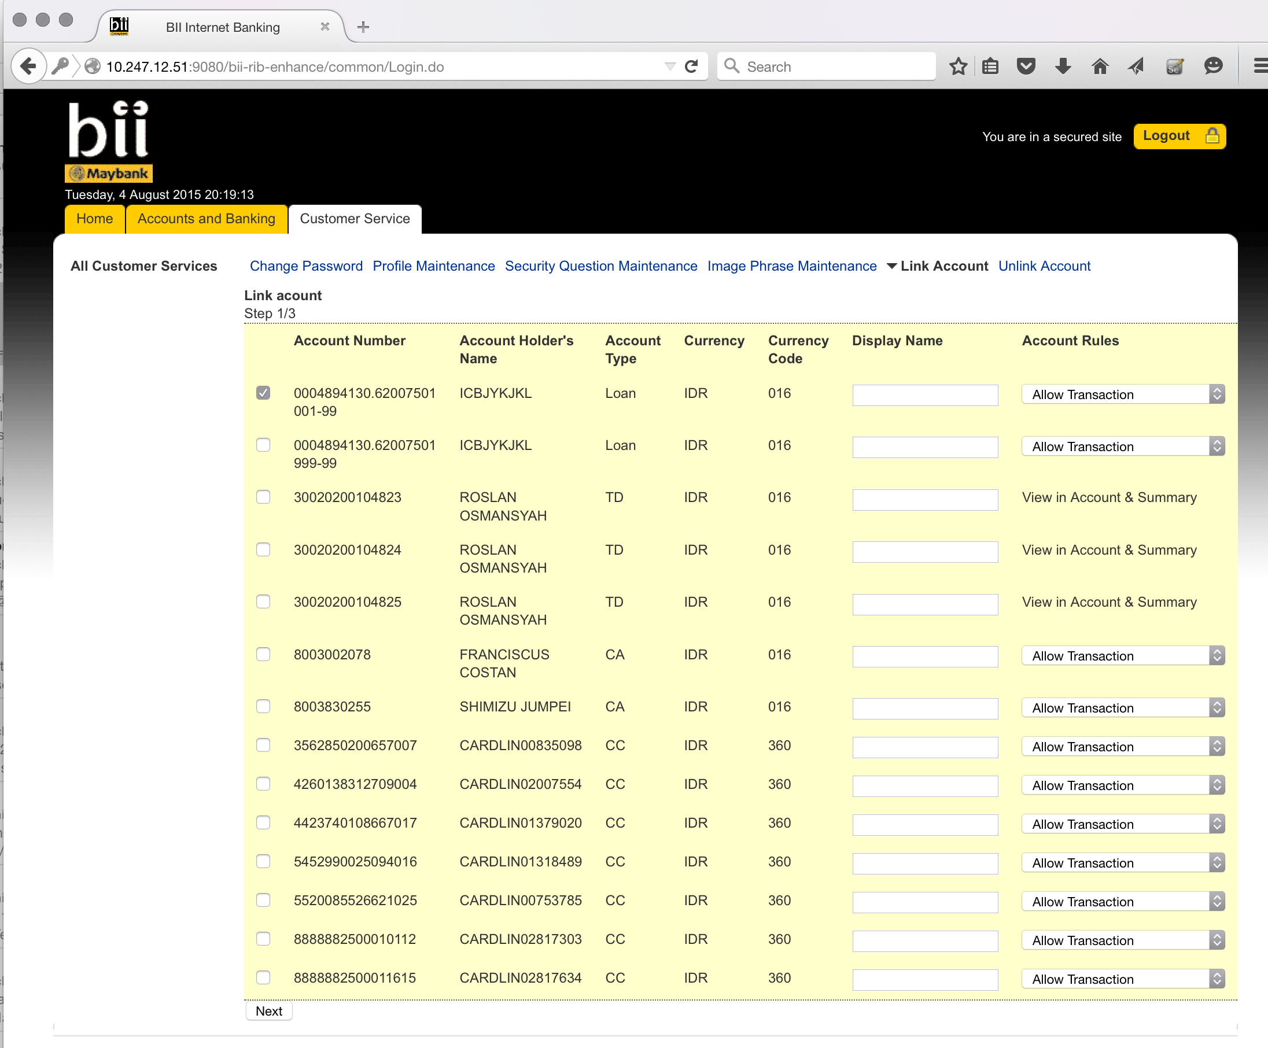

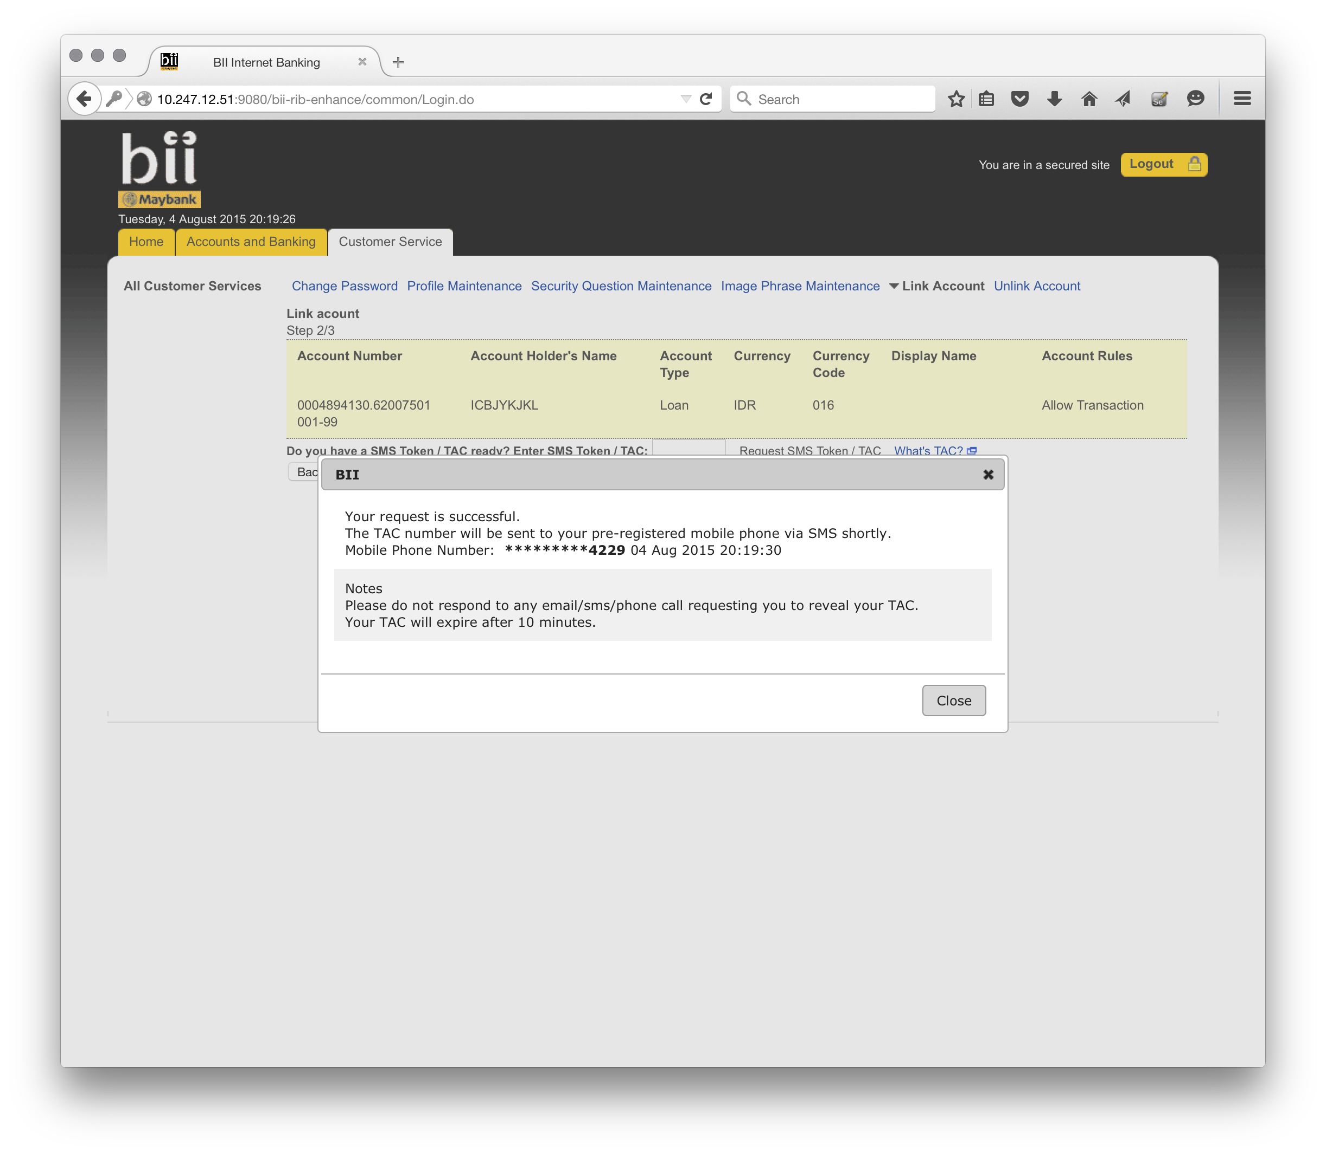
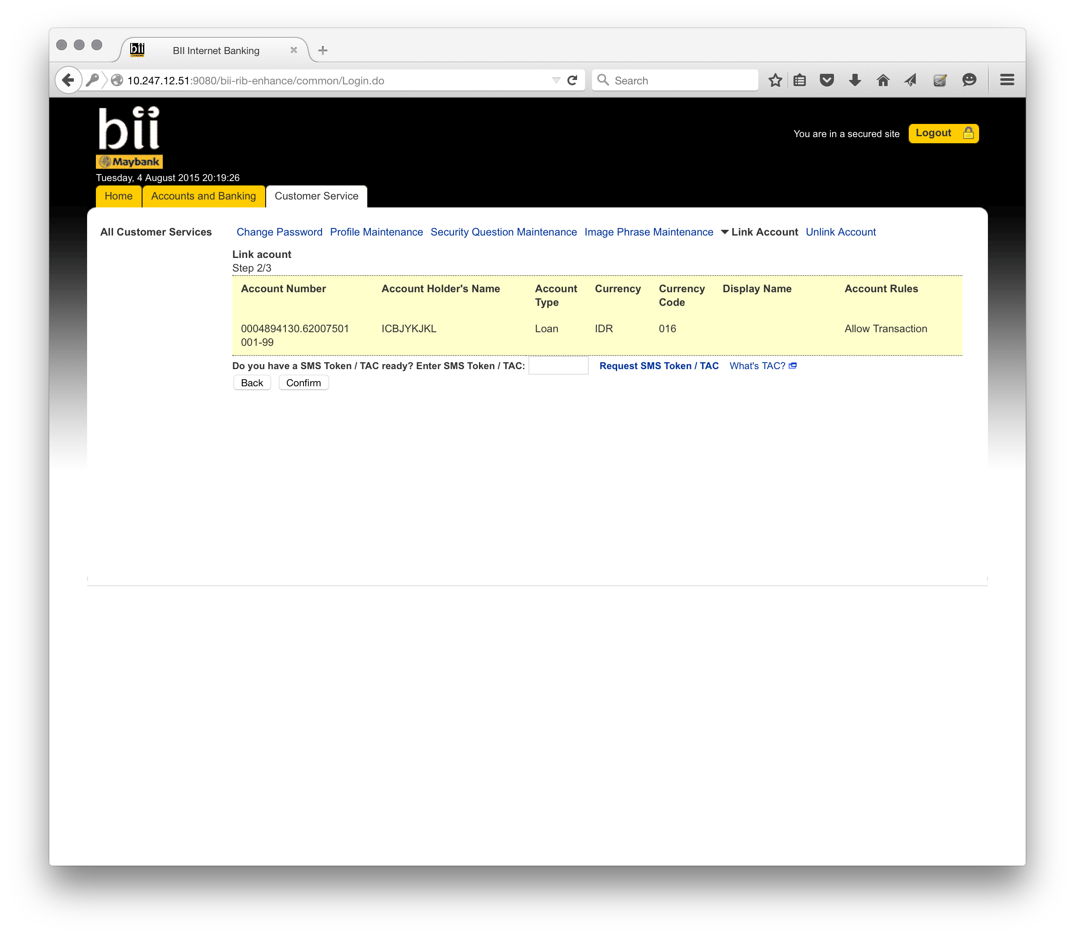
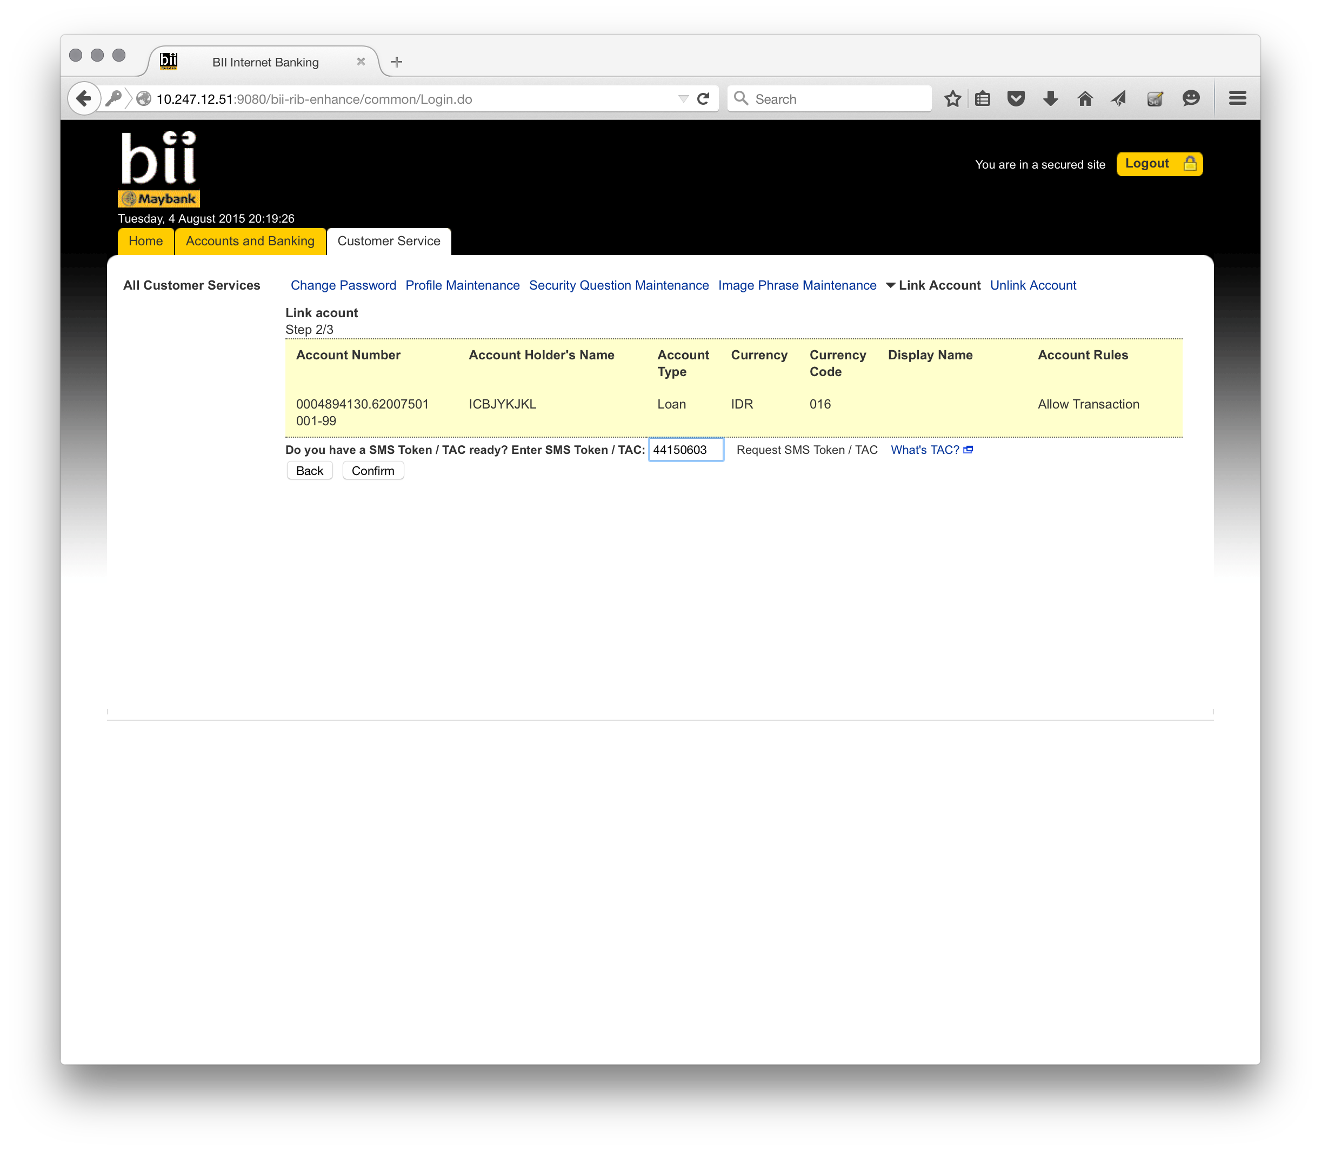
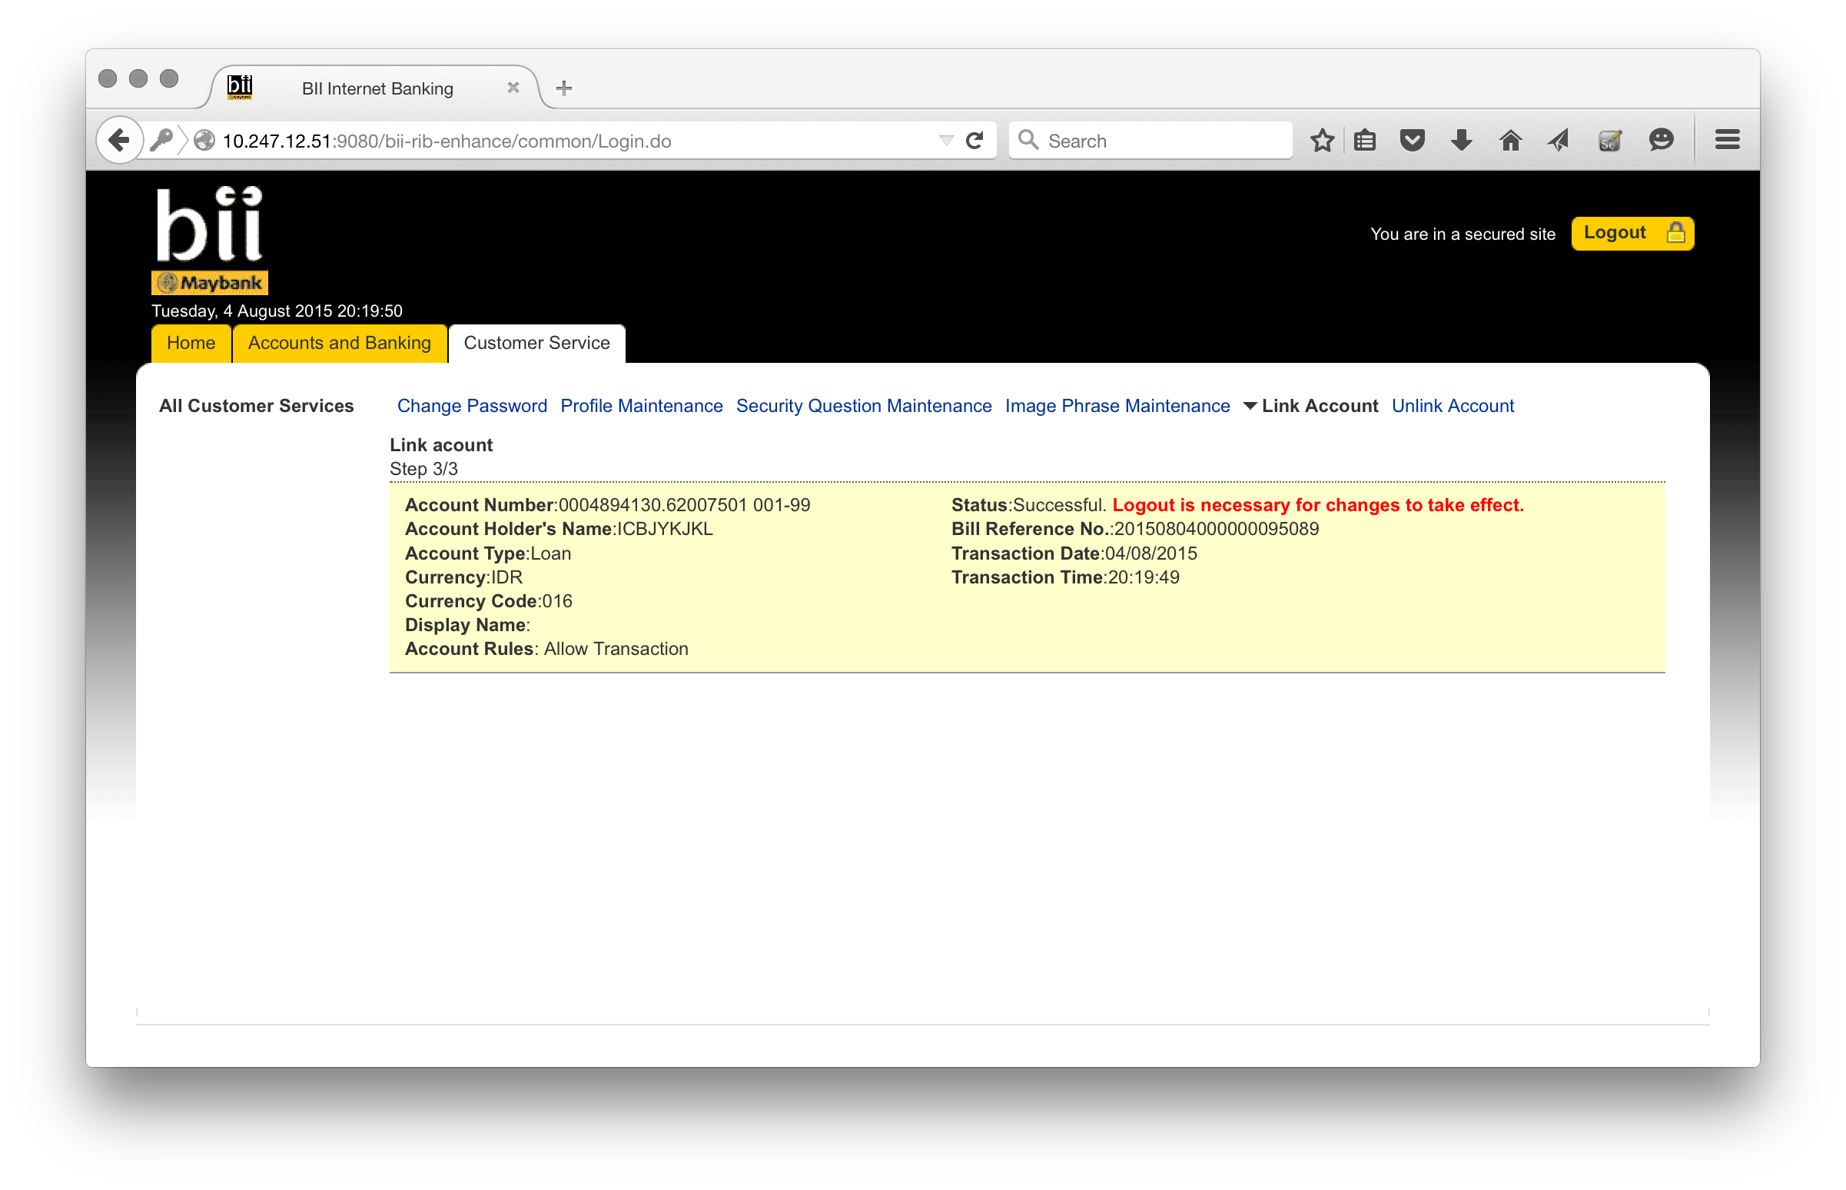
Step 2 – Link Account, Negative Test (Tac not generated)

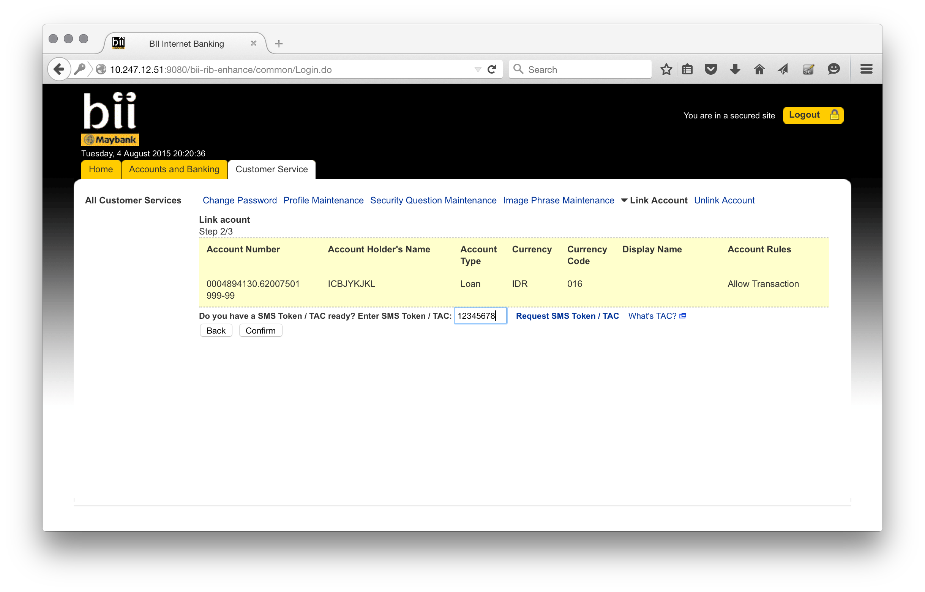

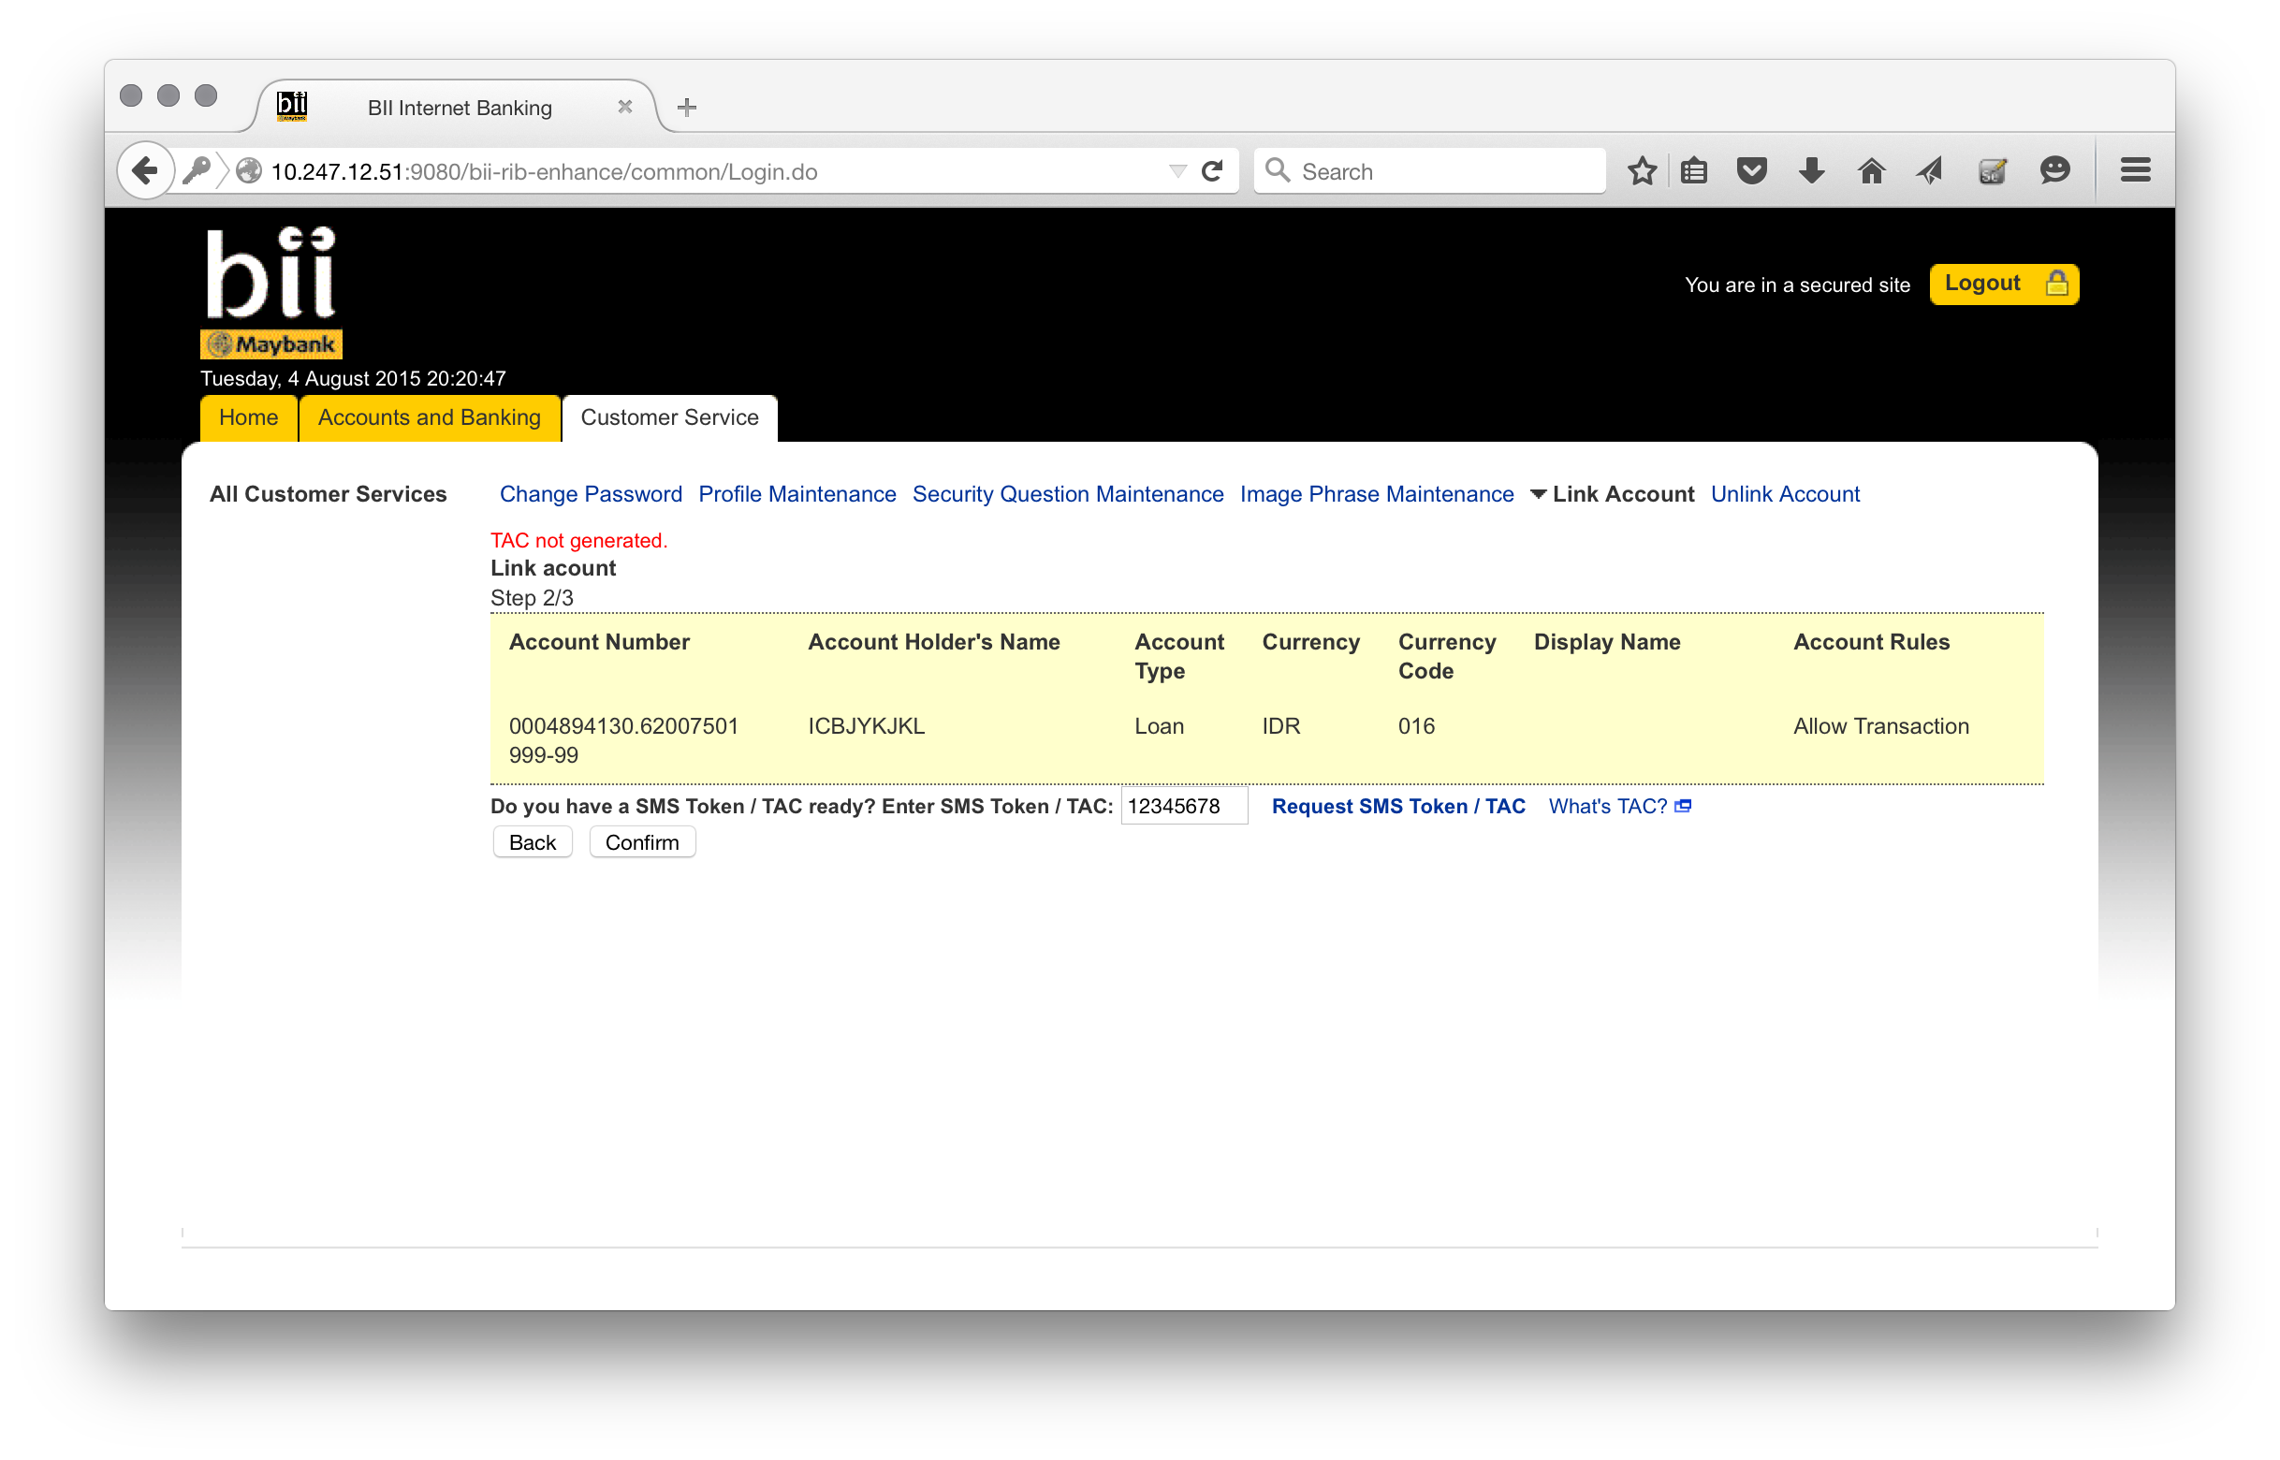
Step 3 – Link Account, Negative Test (Invalid TAC)
