: Publicity

Trade Promotion Activities List

Test Ref : | TPMS/UC-SPP-PUB-001
Test Data Source: | TPMSSystem Design Specification (TPMS_SDS_Mod3-6_v1.0)
Module / Screen: | Trade Promotion Activities List
Objectives: | Test basic functionalities that allow user to access trade promotion activities list

Test Case# | Description | Area Path / Test Step | Expected Result | Test Result (Tick √) |  | Test Date / Tested By : | Remarks / Comment
 |  |  |  | Pass | Fail
3.1.1 | Access to Trade Promotion Activites List | TPMS>Publication>Publicity Listing  - Click on “Publication” sidebar navigation  - Click “Publicity Listing” button | TPMS display the event list.  Sorted by event date, in descending information available includes ( event title, program type, event status, event date, registration dateline & link, event description, event logo, event website link and fee value). |  | fail | 12/08/2015  Leonard Lim | 12/08/2015 - Not exist yet
3.1.2 | Filter activities list | TPMS>Publication>Publicity Listing  - Click on “Publication” sidebar navigation  - Click “Publicity Listing” button  - Click “sort/filter” button for each categories (Year, Month, Sector, Product / Service Category, Program Type, Country and Region) | Display sorted activities list categorized by Year, Month, Sector, Product / Service Category, Program Type, Country and Region. |  | fail | 12/08/2015 Leonard Lim | 12/08/2015 - Not complete yet
3.1.3 | Search activities list | TPMS>Publication>Publicity Listing  - Click on “Publication” sidebar navigation  - Click “Publicity Listing” button.  - Expand Search Filter.  - Enter search inputs.  - Click “Search” button. | Display event listing based on selecting criteria. |  | fail | 12/08/2015 Leonard Lim | 12/08/2015 - Not complete yet

Company Profile Write-up
The page can only be accessed from specific link and does not require any login.
Test Ref : | TPMS/UC-SPP-PUB-001
Test Data Source: | TPMSSystem Design Specification (TPMS_SDS_Mod3-6_v1.0)
Module / Screen: | Company Profile Write-up
Objectives: | Test basic functionalities that allow individual company profile write-up submission

Test Case# | Description | Area Path / Test Step | Expected Result | Test Result (Tick √) |  | Test Date / Tested By : | Remarks / Comment
 |  |  |  | Pass | Fail
3.2.1 | Access to Individual Company Profile Write Up Submission Form | Link from email > TPMS >Individual Company Profile Write Up Submission Form  - Open URL link in notification email. | Display Individual Company Profile Write-up Submission screen. Show company information and display the company write up submission form. |  | fail | 12/08/2015 Leonard Lim | 12/08/2015 - Page Not Exist yet
3.2.2 | Individual Company Profile Write Up Submission Confirmation Page | Link from email > TPMS >Individual Company Profile Write Up Submission Form > Confirmation Page  - Key in required information and click Next button. | Display process information for company to review on confirmation page. |  | Fail | 12/08/2015 Leonard Lim | 12/08/2015 - Not Complete yet
3.2.3 | Individual Company Profile Write Up Submission Result Page | Link from email > TPMS >Individual Company Profile Write Up Submission Confirmation Page > Result Page  - Click “Submit” button. | Display successful message. |  | Fail | 12/08/2015 Leonard Lim | 12/08/2015 - Not complete yet
3.2.4 | Upload Image | Link from email > TPMS > Individual Company Profile Write Up Submission Form  - Upload image besides JPEG/PNG format or bigger than 290px X 220px. | Error Message:-  <Invalid Image> |  | Fail | 12/08/2015 Leonard Lim | 12/08/2015 - Not complete yet
3.2.5 | Enter Individual Company Profile Write Up Submission Details | Link from email > TPMS > Individual Company Profile Write Up Submission Form  - Ignore one or more of inputs (Company Introduction, Product, Image and Promotion Code. | Error Message:-  <Invalid Submission> |  | Fail | 12/08/2015 Leonard Lim | 12/08/2015 - Not complete yet

Company Profile Write-up Listing

Test Ref : | TPMS/UC-SPP-PUB-002
Test Data Source: | TPMSSystem Design Specification (TPMS_SDS_Mod3-6_v1.0)
Module / Screen: | Company Profile Write-up
Objectives: | Test basic functionalities that allow user access company profile write up listing.

Test Case# | Description | Area Path / Test Step | Expected Result | Test Result (Tick √) |  | Test Date / Tested By : | Remarks / Comment
 |  |  |  | Pass | Fail
3.3.1 | Access Pending Write-up Listing page | TPMS > Publication > Pending Write-up Listing  - Click on “Publication” sidebar navigation | Display table list of company’s write-up for the event. |  | fail | 12/08/2015 Leonard Lim | 12/08/2015 - Not complete yet

Individual Company Profile Write-up

Test Ref : | TPMS/UC-SPP-PUB-002
Test Data Source: | TPMSSystem Design Specification (TPMS_SDS_Mod3-6_v1.0)
Module / Screen: | Individual Company Profile Write-up
Objectives: | Test basic functionalities that allow user access individual company profile write up.

Test Case# | Description | Area Path / Test Step | Expected Result | Test Result (Tick √) |  | Test Date / Tested By : | Remarks / Comment
 |  |  |  | Pass | Fail
3.4.1 | Access Individual Company Profile Write-up page | TPMS > Publication >Publicity Listing > Individual Company Profile Write Up  - Click on “Publication” sidebar navigation  - Click “Publicity Listing” button.  - Click “Individual Company Profile Write Up” button | Display company write-up in full. |  | fail | 12/08/2015 Leonard Lim | 12/08/2015 - Not complete yet
3.4.2 | Approve the company write-up | TPMS > Publication > Publicity Listing > Individual Company Profile Write Up  - Click on “Approve” button | Display successful message. |  | fail | 12/08/2015 Leonard Lim | 12/08/2015 - Not complete yet
3.4.3 | Reject the company write-up | TPMS > Publication > Publicity Listing > Individual Company Profile Write Up  - Click on “Reject” button | Display successful message. |  | fail | 12/08/2015 Leonard Lim | 12/08/2015 - Not complete yet
3.4.4 | Update the company write-up | TPMS > Publication > Publicity Listing > Individual Company Profile Write Up  - Click on “Update” button.  - Click “save” button. | Display write-up update form with pre-populated values from the company write-up.  After save, the page will refresh the Individual Company Profile Write-up page. |  | fail | 12/08/2015 Leonard Lim | 12/08/2015 - Not complete yet
3.4.5 | Upload Image | TPMS > Publication > Publicity Listing > Individual Company Profile Write Up  - Upload image besides JPEG/PNG format or bigger than 290px X 220px. | Error Message:-  <Invalid Image> |  | fail | 12/08/2015 Leonard Lim | 12/08/2015 - Not complete yet

Individual Company Profile Promotion via MATRADE Portal
Test Ref : | TPMS/UC-SPP-PUB-003
Test Data Source: | TPMSSystem Design Specification (TPMS_SDS_Mod3-6_v1.0)
Module / Screen: | Individual Company Profile Promotion via MATRADE Portal
Objectives: | Test basic functionalities that allow user access individual company profile promotion via MATRADE portal

Test Case# | Description | Area Path / Test Step | Expected Result | Test Result (Tick √) |  | Test Date / Tested By : | Remarks / Comment
 |  |  |  | Pass | Fail
3.5.1 | Access Individual Company Profile Promotion via MATRADE Portal page | TPMS > Publication > Publicity Listing >Individual Company Profile Promotion via MATRADE  - Click on “Publication” sidebar navigation  - Click “Publicity Listing” button.  - Click “Individual Company Profile Write Up” button | Display participating companies profile list, sorted by the company name in descending order. |  | fail | 12/08/2015 Leonard Lim | 12/08/2015 – Not exist
3.5.2 | View details company write-up in full page | TPMS > Publication > Publicity Listing >Individual Company Profile Promotion via MATRADE > View Detail  - Click “View Details” link | Display company write-up in full. |  | fail | 12/08/2015 Leonard Lim | 12/08/2015 - Not complete yet
3.5.3 | Go back to Individual Company Profile Promotion via MATRADE Portal page | TPMS > Publication > Publicity Listing >Individual Company Profile Promotion via MATRADE > View Detail  - Click “Back” button | Go back to the listing page. |  | fail | 12/08/2015 Leonard Lim | 12/08/2015 - Not complete yet

Email Marketing

Test Ref : | TPMS/UC-CPP-INV-002
Test Data Source: | TPMSSystem Design Specification (TPMS_SDS_Mod3-6_v1.0)
Module / Screen: | Email Marketing Campaign List (Notification Job Listing)
Objectives: | Test basic functionalities that allow user access Email Marketing Campaign List (Notification Job Listing)

Test Case# | Description | Area Path / Test Step | Expected Result | Test Result (Tick √) |  | Test Date / Tested By : | Remarks / Comment
 |  |  |  | Pass | Fail
3.6.1 | Access to Email Marketing Campaign List (Notification Job Listing) page | TPMS>Publication  - Click on “Publication” sidebar navigation | Display Email Marketing page.  Shows all email campaign job, order by Submission Date in descending order. |  | fail | 12/08/2015 Leonard Lim | 12/08/2015 - Not data to test
3.6.2 | Search Email Marketing Campaign List | TPMS>Publication  - Click on “Publication” sidebar navigation  - Click on “Expand” button  - Enter search inputs (Campaign name, Status (Pending/Completed/Sending/Cancelled), Submission Data and Posting Date)  - Click “Search” button | Display Email Marketing page.  Shows all email campaign job, order by Submission Date in descending order based search criterias. |  |  | 12/08/2015 Leonard Lim | 12/08/2015 - Unable to test due no available data existed
3.6.3 | Sent email immediately to the campaign into the email queue | TPMS>Publication  - Click on “Publication” sidebar navigation  - Click on “Sent Now” button | Display successful message. |  | fail | 12/08/2015 Leonard Lim | 12/08/2015 - Not complete yet
3.6.4 | cancel the campaign from sending | TPMS>Publication  - Click on “Publication” sidebar navigation  - Click on “Cancel” button | Display successful message. |  | fail | 12/08/2015 Leonard Lim | 12/08/2015 - Not complete yet
3.6.5 | Forward the same campaign to other recipients | TPMS>Publication  - Click on “Publication” sidebar navigation  - Click on "Forward" button | Display successful message. |  | fail | 12/08/2015 Leonard Lim | 12/08/2015 - Not complete yet

Marketing Campaign Job Summary Report

Test Ref : | TPMS/
Test Data Source: | TPMSSystem Design Specification (TPMS_SDS_Mod3-6_v1.0)
Module / Screen: | Marketing Campaign Job Summary Report
Objectives: | Test basic functionalities that allow user access Marketing Campaign Job Summary Report

Test Case# | Description | Area Path / Test Step | Expected Result | Test Result (Tick √) |  | Test Date / Tested By : | Remarks / Comment
 |  |  |  | Pass | Fail
3.7.1 | Access to Marketing Campaign Job Summary Report page | TPMS>Publication  - Click on “Publication” sidebar navigation  - Click on “[ID]” button | Display Job Summary page. |  | fail | 12/08/2015 Leonard Lim | 12/08/2015 - Not complete yet
3.7.2 | Resend/Forward the same campaign to other company | TPMS>Publication  - Click on “Publication” sidebar navigation  - Click on “Select New Recipient” button | Display successful message. |  | fail | 12/08/2015 Leonard Lim | 12/08/2015 - Not complete yet
3.7.3 | View email template | TPMS>Publication  - Click on “Publication” sidebar navigation  - Click on "<View Template>" link | Display selected Email template |  | fail | 12/08/2015  Leonard Lim | 12/08/2015 - Not complete yet

Event based Campaign

Test Ref : | TPMS/UC-CPP-INV-001
Test Data Source: | TPMSSystem Design Specification (TPMS_SDS_Mod3-6_v1.0)
Module / Screen: | Event based Campaign
Objectives: | Test basic functionalities that allow user access Event based Campaign

Test Case# | Description | Area Path / Test Step | Expected Result | Test Result (Tick √) |  | Test Date / Tested By: | Remarks / Comment
 |  |  |  | Pass | Fail
3.8.1 | Access toEvent based Campaign page | TPMS>Publication>New Event Campaign  - Click on “New Event Campaign” button | Display Event based Campaign page. |  | fail | 12/08/2015 Leonard Lim | 12/08/2015 - Cannot test due to unable to access third party server.  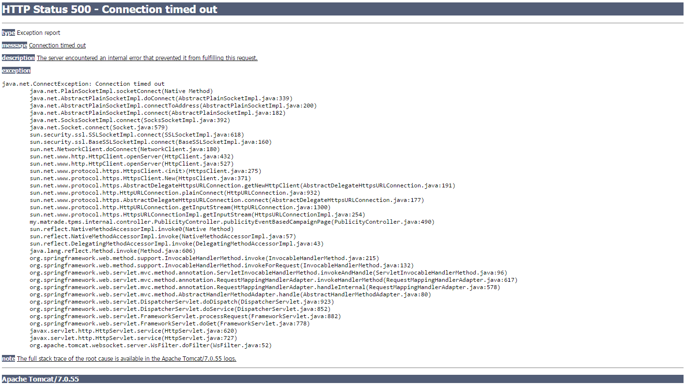
3.8.2 | Create new event based Campaign | TPMS>Publication> New Event Campaign  - Click on “Publication” sidebar navigation  - Click on “New Event Campaign” button | Display event based campaign list |  | fail | 12/08/2015 Leonard Lim | 12/08/2015 - Not complete yet
3.8.3 | Remove event list | TPMS>Publication> New Event Campaign  - Click on “Remove” button | Delete/Remove selected event from event list |  | fail | 12/08/2015 Leonard Lim | 12/08/2015 - Not complete yet
3.8.4 | Remove Recipient List | TPMS>Publication> New Event Campaign  - Click on “Remove” button | Delete/Remove selected recipient from recipient list |  | fail | 12/08/2015 Leonard Lim | 12/08/2015 - Not complete yet
3.8.5 | Select Event | TPMS>Publication> New Event Campaign  - Click on “Select Event” button | Display event List |  | fail | 12/08/2015 Leonard Lim | 12/08/2015 - Not complete yet
3.8.6 | View Search Filter for Select Event | TPMS>Publication> New Event Campaign>Select Event  - Click on “+” | Display Search Form |  | fail | 12/08/2015 Leonard Lim | 12/08/2015 - Not complete yet
3.8.7 | Search Filter for Select Event | TPMS>Publication> New Event Campaign>Select Event  - Enter "Event Name"  - Enter "Program Type"  - Enter "Event Start Date"  - Enter "Event End Date"  - Enter "Location"  - Click on "Search"  - Click on "Clear Search" | If Search:  Display the list of event’s based on search criteria.  If Clear Search:  Empty the all search field. |  | fail | 12/08/2015 Leonard Lim | 12/08/2015 - Not complete yet
3.8.8 | Enter invalid date to Event Start Date and Event End Date | TPMS>Publication> New Event Campaign>Select Event  - Select “Event Name”  - Select “Program Type”  - Enter “50132015” to “Event Start Date”  - Enter “51132015” to “Event End Date”  - Enter “Location”  - Click on “Search” button | Error Message:  < Event Start Date is invalid> and/or <Event End Date is invalid> |  | fail | 12/08/2015 Leonard Lim | 12/08/2015 - Not complete yet
3.8.9 | Enter Event Start Date more than Event End Date | TPMS>Publication> New Event Campaign>Select Event  - Select “Event Name”  - Select “Program Type”  - Select “Event Start Date” more than “Event End Date”  - Select “Event End Date” less than “Event Start Date”  - Enter “Location”  - Click on “Search” button | Error Message:  < Event Start Date is should be less than Event End Date> |  | fail | 12/08/2015 Leonard Lim | 12/08/2015 - Not complete yet
3.8.10 | Select Event | TPMS>Publication> New Event Campaign>Select Event  - Click on “Select” button | Add Selected event to the event list |  | fail | 12/08/2015 Leonard Lim | 12/08/2015 - Not complete yet
3.8.11 | Select Recipient | TPMS>Publication> New Event Campaign  - Click on “Select Recipient” button | Display Recipient List |  | fail | 12/08/2015 Leonard Lim | 12/08/2015 - Not complete yet
3.8.12 | View Search Filter for Select Recipient | TPMS>Publication> New Event Campaign>Select Recipient  - Click on “+” | Display Search Form |  | fail | 12/08/2015 Leonard Lim | 12/08/2015 - Not complete yet
3.8.13 | Search Filter for Select Recipient | TPMS>Publication> New Event Campaign>Select Recipient  - Enter "Company Name"  - Enter "Is Malaysian Company"  - Enter "Is MATRADE member"  - Enter "Is MEEC Exhibitor"  - Enter "Country"  - Enter "State"  - Click on "Search"  - Click on "Clear Search" | If Search:  Display the list of event’s based on search criteria.  If Clear Search:  Empty the all search field. |  | fail | 12/08/2015 Leonard Lim | 12/08/2015 - Not complete yet
3.8.14 | Select Recipient | TPMS>Publication> New Event Campaign>Select Recipient  - Click on “Select” button | Add Selected companies to the invitees list |  | fail | 12/08/2015 Leonard Lim | 12/08/2015 - Not complete yet
3.8.15 | Add New Company | TPMS>Publication> New Event Campaign>Select Recipient  - Click on “Add New Company” button  - Enter all required Fields  - Click on "Save"  - Click on "Cancel" | Display New Company Form.  If Save:  Save the data entered, and add new company in the company list.  If Cancel:  Go back to the previous page. |  | fail | 12/08/2015  Leonard Lim | 12/08/2015 - Not complete yet
3.8.16 | Sent Invitation | TPMS>Publication> New Event Campaign  - Click on “Sent Invitation” button | Save and Add invitation to the notification Queue |  | fail | 12/08/2015 Leonard Lim | 12/08/2015 - Not complete yet

Company based Campaign

Test Ref : | TPMS/UC-CPP-INV-002
Test Data Source: | TPMSSystem Design Specification (TPMS_SDS_Mod3-6_v1.0)
Module / Screen: | Company based Campaign
Objectives: | Test basic functionalities that allow user access Company based Campaign

Test Case# | Description | Area Path / Test Step | Expected Result | Test Result (Tick √) |  | Test Date / Tested By : | Remarks / Comment
 |  |  |  | Pass | Fail
3.9.1 | Access to Company based Campaign page | TPMS>Publication>New Company Campaign  - Click on “New Event Campaign” button | Display Company based Campaign page. | pass |  | 12/08/2015 Leonard Lim | 12/08/2015 –  Pagination Issue  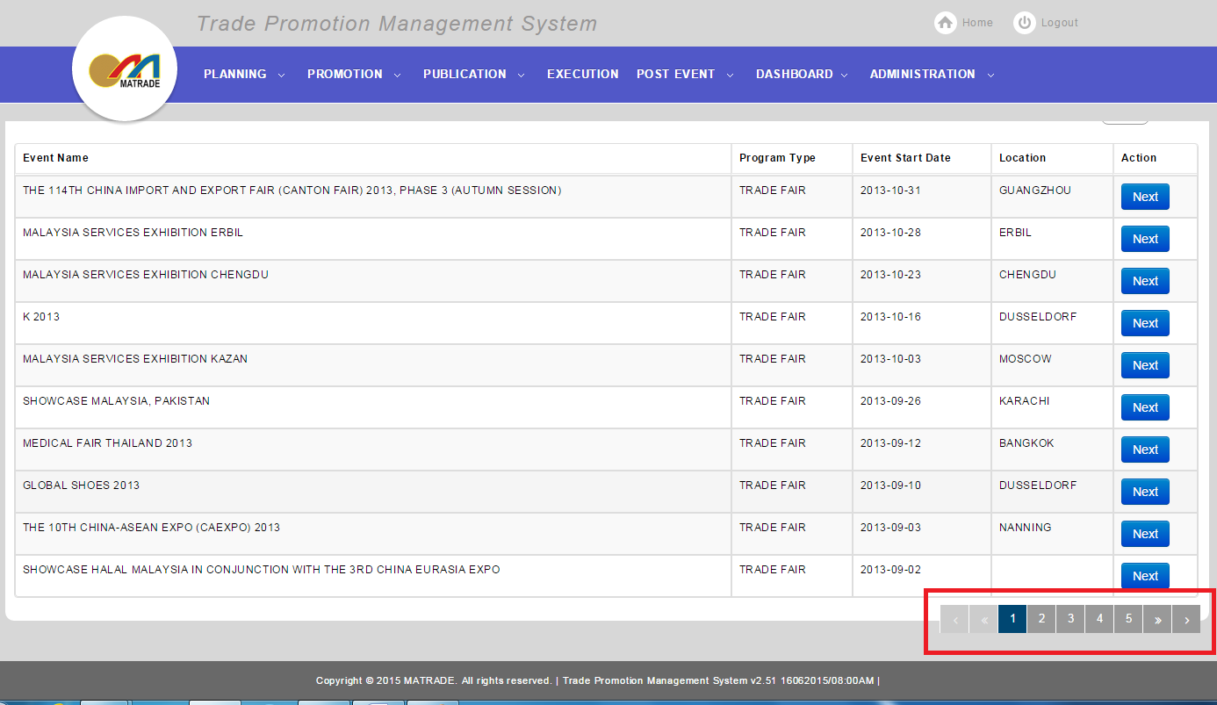
3.9.2 | Create new Company based Campaign | TPMS>Publication> New Company Campaign  - Click on “Publication” sidebar navigation  - Click on “New Company Campaign” button | Display Company based campaign list | Pass |  | 12/08/2015 Leonard Lim | 12/08/2015 –  Pagination Issue
3.9.3 | View Search Filter | TPMS>Publication> New Company Campaign  - Click on “+” | Display Search Form |  | fail | 12/08/2015 Leonard Lim | 12/08/2015 – cannot input search query  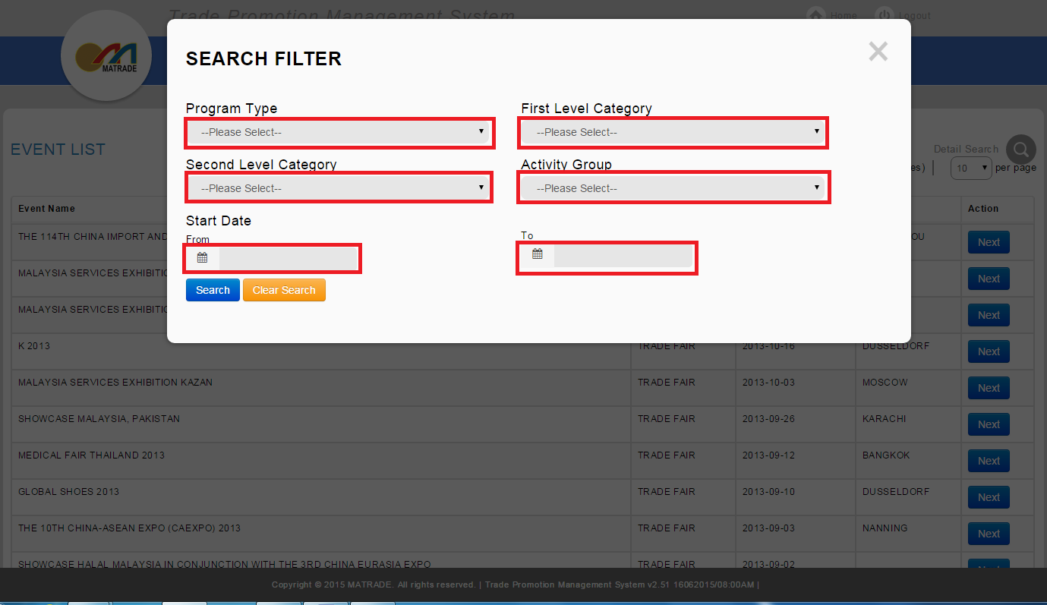
3.9.4 | Search Filter for Select Event | TPMS>Publication> New Company Campaign  - Enter "Program Type "  - Enter "Activity Group"  - Enter "Event Start Date"  - Enter "Event End Date"  - Enter "First Level Category"  - Enter "Second Level Category"  - Click on "Search"  - Click on "Clear Search" | If Search:  Display the list of event’s based on search criteria.  If Clear Search:  Empty the all search field. |  | fail | 12/08/2015 Leonard Lim | 12/08/2015 – cannot search due to unable to select the search filter  Cannot close search filter when click (X) button
3.9.5 | Enter invalid date to Event Start Date and Event End Date | TPMS>Publication> New Company Campaign  - Select “Program Type”  - Select “Activity Group”  - Enter “50132015” to “Event Start Date”  - Enter “51132015” to “Event End Date”  - Enter “First Level Category”  - Enter "Second Level Category"  - Click on “Search” button | Error Message:  < Event Start Date is invalid> and/or <Event End Date is invalid> |  | fail | 12/08/2015 Leonard Lim | 12/08/2015 – Not Complete Yet
3.9.6 | Enter Event Start Date more than Event End Date | TPMS>Publication> New Company Campaign  - Select “Program Type”  - Select “Activity Group”  - Select “Event Start Date” more than “Event End Date”  - Select “Event End Date” less than “Event Start Date”  - Enter “First Level Category”  - Enter "Second Level Category"  - Click on “Search” button | Error Message:  < Event Start Date is should be less than Event End Date> |  | fail | 12/08/2015 Leonard Lim | 12/08/2015 – Not Complete Yet
3.9.7 | View Company Based Invitation | TPMS>Publication> New Company Campaign  - Click on “View” button | Display details of selected event |  | fail | 12/08/2015 Leonard Lim | 12/08/2015 – Not Data
3.9.8 | Remove Company | TPMS>Publication> New Event Campaign  - Click on “Remove” button | Delete/Remove selected Company event from Invitees list |  | fail | 12/08/2015 Leonard Lim | 12/08/2015 – Not Complete Yet
3.9.9 | Select Company | TPMS>Publication> New Company Campaign  - Click on “Select Company” button | Display Invitation Select Companyform |  | fail | 12/08/2015 Leonard Lim | 12/08/2015 – Not Data
3.9.10 | View Search Filter for Select Company | TPMS>Publication> New Company Campaign>Select Company  - Click on “+” | Display Search Form |  |  | 12/08/2015 Leonard Lim | 12/08/2015 –  Interface Not appropriate  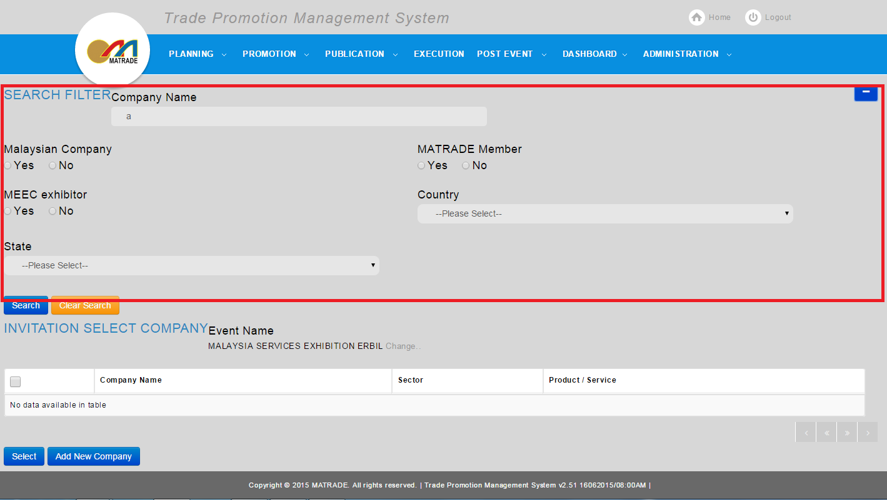  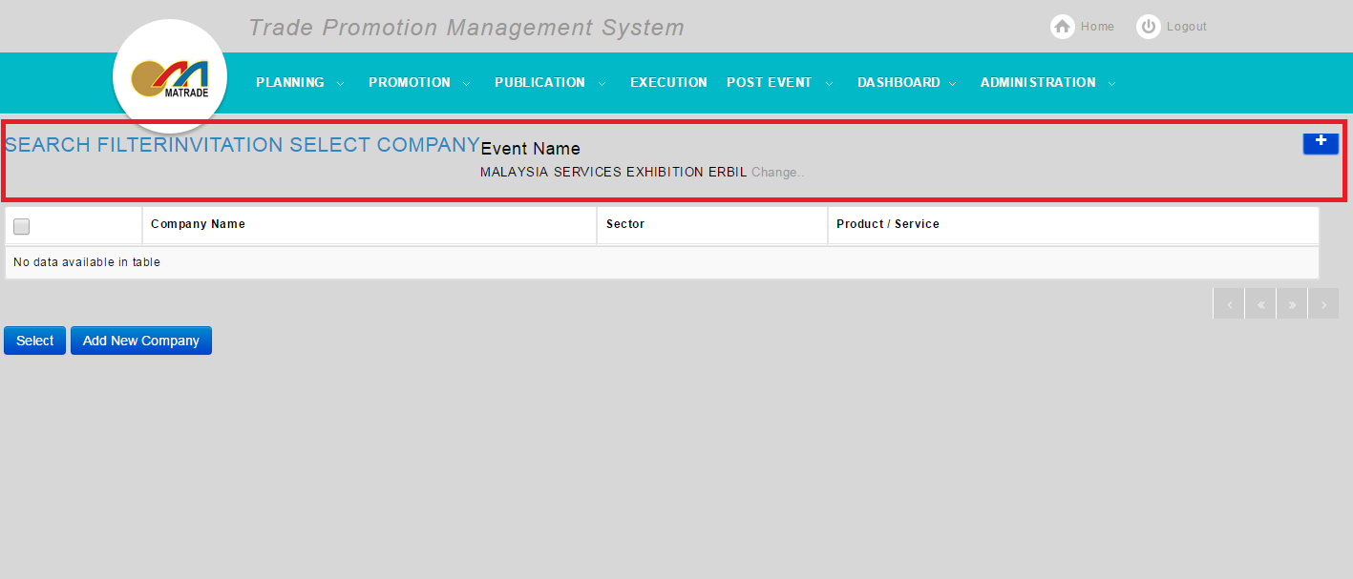
3.9.11 | Search Filter for Select Company | TPMS>Publication> New Company Campaign>Select Company  - Enter "Company Name"  - Enter "Is Malaysian Company"  - Enter "Is MATRADE member"  - Enter "Is MEEC Exhibitor"  - Enter "Country"  - Enter "State"  - Click on "Search"  - Click on "Clear Search" | If Search:  Display the list of event’s based on search criteria.  If Clear Search:  Empty the all search field. |  | fail | 12/08/2015 Leonard Lim | 12/08/2015 – No Data To be Searched
3.9.12 | Change Event | TPMS>Publication> New Company Campaign>Select Company  - Click on "Change" Link  - Select desired event | will display changed event details, instead of the previous one. |  | fail | 12/08/2015 Leonard Lim | 12/08/2015 – Not complete yet
3.9.13 | Select Company | TPMS>Publication> New Company Campaign>Select Company  - Click on “Select” button | Add Selected companies to the invitees list |  | fail | 12/08/2015 Leonard Lim | 12/08/2015 – Not company data to be selected
3.9.14 | Add New Company | TPMS>Publication> New Company Campaign>Select Recipient  - Click on “Add New Company” button  - Enter all required Fields  - Click on "Save"  - Click on "Cancel" | Display New Company Form.  If Save:  Save the data entered, and add new company in the company list.  If Cancel:  Go back to the previous page. |  | fail | 12/08/2015 Leonard Lim | 12/08/2015 –  Unable to fill in some fields (company name, and address)  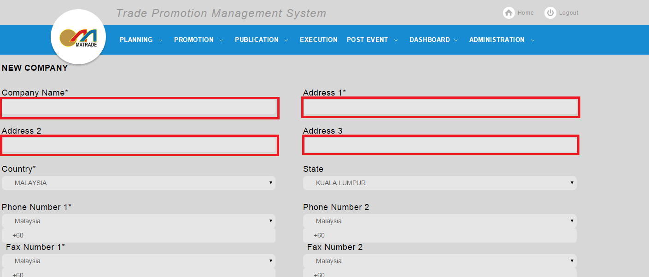  Unable to add Product and Service  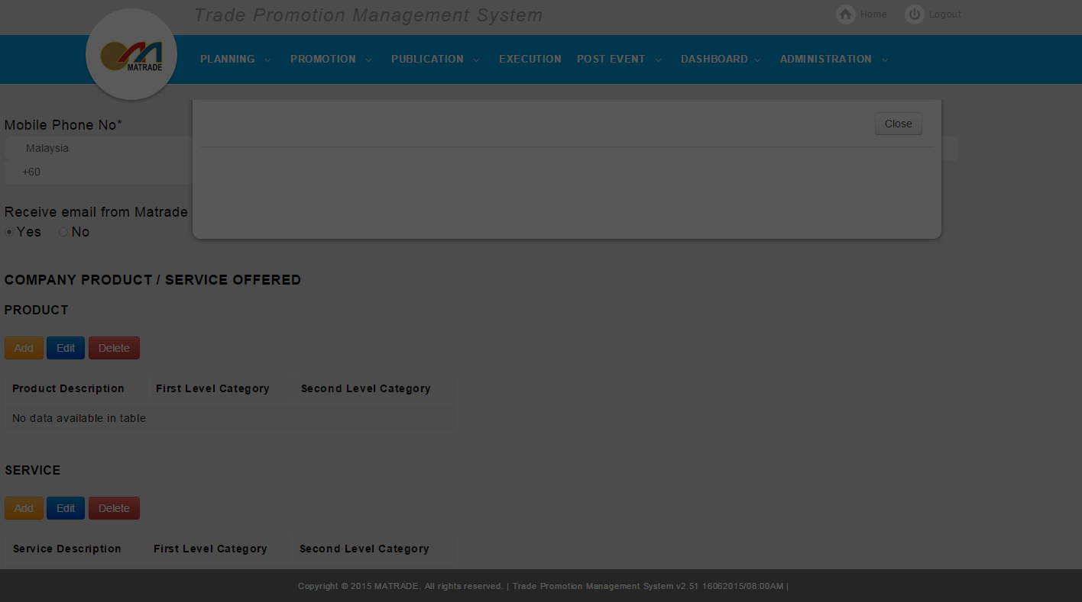  PAGINATION – not appropriate  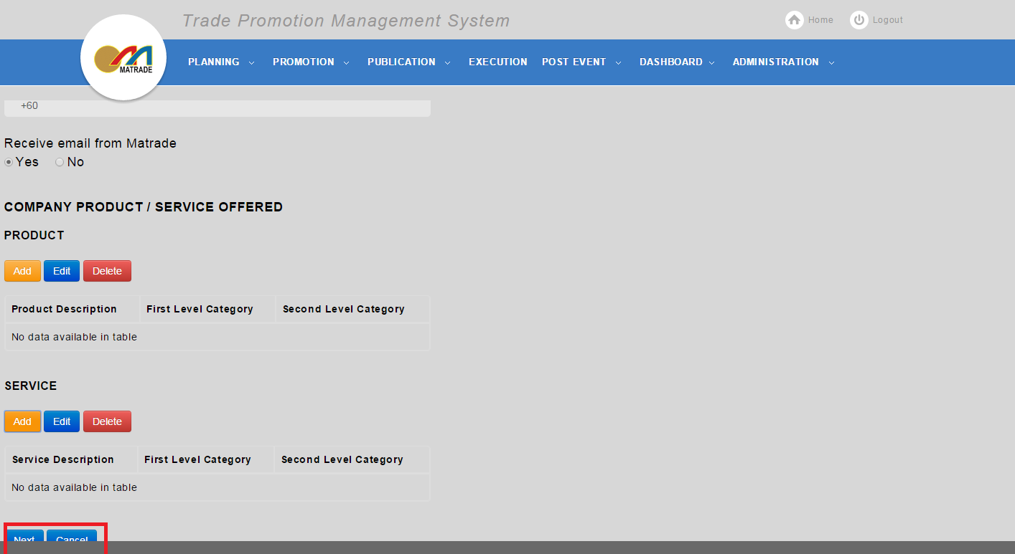
3.9.15 | Sent Invitation | TPMS>Publication> New Company Campaign  - Click on “Sent Invitation” button | Save and Add invitation to the notification Queue |  | fail | 12/08/2015 Leonard Lim | 12/08/2015 – cannot sent Invitation  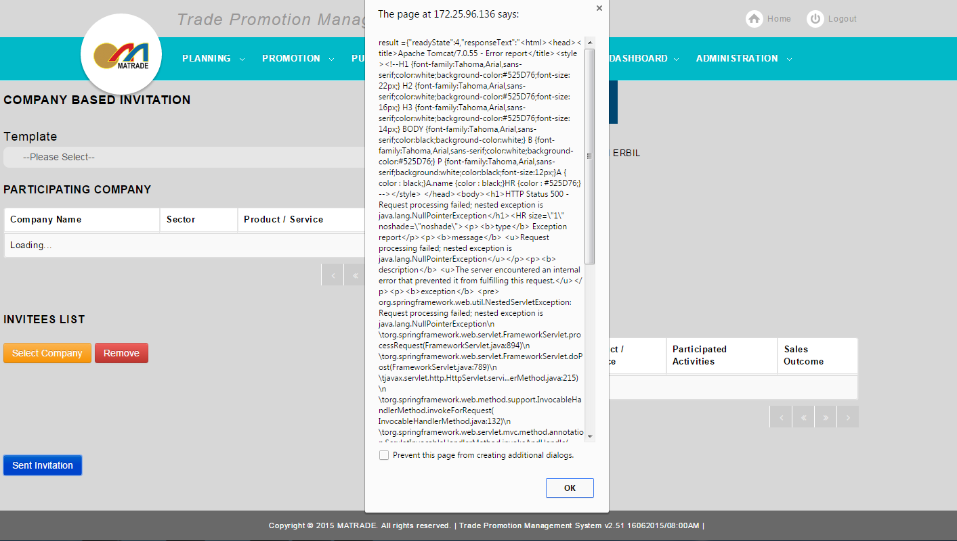

Unsubscribe Option

Test Ref : | TPMS/UC-ADM-EM-006
Test Data Source: | TPMSSystem Design Specification (TPMS_SDS_Mod3-6_v1.0)
Module / Screen: | Unsubscribe Option
Objectives: | Test basic functionalities that allow user to access Unsubscribe option

Test Case# | Description | Area Path / Test Step | Expected Result | Test Result (Tick √) |  | Test Date / Tested By : | Remarks / Comment
 |  |  |  | Pass | Fail
3.10.1 | Access to Unsubscribe Option | TPMS>Publication  - Click on “Publication” sidebar navigation  - Click on "Unsubscribe Option" button | Display Unsubscribe confirmation | Pass |  | 12/08/2015 Leonard Lim
3.10.2 | Unsubscribe Option | TPMS>Publication>Unsubscribe  - Click on “Unsubscribe Option” button  - Click on "Confirm"  - Click on "Cancel" | If Confirm:  Will change the setting, so that the user will not receive notification.  Display "Unsubscribe Success"  If Cancel:  Go back to MATRADE home page |  | Fail | 12/08/2015 Leonard Lim | 12/08/2015 – did not receive notification display.

