: Execution

4.1 Events Listing

Test Ref : | TPMS/UC-MRP-012
Test Data Source: | TPMSSystem Design Specification (TPMS_SDS_Mod3-6_v1.0)
Module / Screen: | Events Listing
Objectives: | Test basic functionalities that allow user to view the list of event execution

Test Case# | Description | Area Path / Test Step | Expected Result | Test Result (Tick √) |  | Test Date / Tested By : | Remarks / Comment
 |  |  |  | Pass | Fail
4.1.1 | Access to Execution Event List | TPMS>Execution  - Click on “Execution” side navigation | TPMS display the list of execution event listing | pass |  | 12/08/2015  Leonard Lim | 12/08/2015 -
4.1.2 | View the Search function | TPMS>Execution  - Click on “+” | System will show the Search function | pass |  | 12/08/2015  Leonard Lim | 12/08/2015 -
4.1.3 | Search Event List | TPMS>Execution>Search  - Select “Program Type”  - Select “Event Start Date”  - Select “Event End Date”  - Select “Officer in Charge”  - Click on “Search” button  - Click on "Clear Search" button | If Search:  Display the list of event’s based on search criteria.  If Clear Search:  Empty the all search field. |  |  | 12/08/2015  Leonard Lim | 12/08/2015 –  Cannot enter some of the field (Event Name, and Program Type)  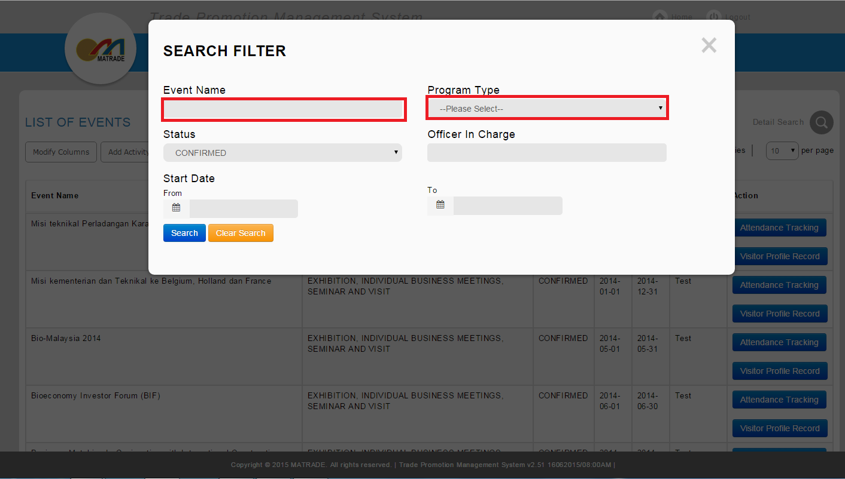
4.1.4 | Enter Invalid Date | TPMS>Execution>Search  - Enter “Program Type”  - Enter “50132015” to “Event Start Date”  - Enter “51132015” to “Event End Date”  - Enter “Officer in Charge”  - Click on “Search” button | Error Message:  < Event Start Date is invalid> and/or <Event End Date is invalid> |  | Fail | 12/08/2015  Leonard Lim | 12/08/2015 – No Error Message displayed
4.1.5 | Enter "Event End Date" Earlier than "Event Start Date" | TPMS>Execution>Search  - Enter “Program Type”  - Enter “02122015” to “Event Start Date”  - Enter “01122015” to “Event End Date”  - Enter “Officer in Charge”  - Click on “Search” button | Error Message:  < Event Start Date is should be less than Event End Date> |  | Fail | 12/08/2015  Leonard Lim | 12/08/2015 – no error message displayed

4.2 Visitor Profile Records

Test Ref : | TPMS/UC-EPP-DO-002
Test Data Source: | TPMSSystem Design Specification (TPMS_SDS_Mod3-6_v1.0)
Module / Screen: | Visitor Profile Records
Objectives: | Test basic functionalities that allow user to access visitor profile records

Test Case# | Description | Area Path / Test Step | Expected Result | Test Result (Tick √) |  | Test Date / Tested By : | Remarks / Comment
 |  |  |  | Pass | Fail
4.2.1 | Access to Visitor Profile Records | TPMS>Execution>Visitor Profile Records  - Click on “Visitor Profile Records" button | Display the list of visitor records.  Ordered by Date Submitted in Descending order. |  | Fail | 12/08/2015  Leonard Lim | 12/08/2015 – No Data
4.2.2 | View the Search function | TPMS>Execution>Visitor Profile Records  - Click on “+” | System will show the Search function | pass |  | 12/08/2015  Leonard Lim | 12/08/2015 -
4.2.3 | Search Event List | TPMS>Execution>Visitor Profile Records >Search  - Select “Company Name”  - Select “Country”  - Select “Business Type”  - Select “Foreign Buyer”  - Select “Trade Lead”  - Select “Enquiry Date”  - Click on “Search” button  - Click on "Clear Search" button | If Search:  Display the list of event’s based on search criteria.  If Clear Search:  Empty the all search field. |  |  | 12/08/2015  Leonard Lim | 12/08/2015 – Unable to Test Due to no Data available to be searched
4.2.4 | Enter Invalid Date | TPMS>Execution>Visitor Profile Records >Search  - Enter “Company Name”  - Enter “Country”  - Enter “Business Type”  - Enter “Foreign Buyer”  - Enter “Trade Lead”  - Enter “50132015” to “Enquiry Date”  - Click on “Search” button | Error Message:  < Enquiry Date is invalid> |  | Fail | 12/08/2015  Leonard Lim | 12/08/2015 – No error message displayed
4.2.5 | Add Record | TPMS>Execution>Visitor Profile>Add Record  - Click on “Add Record" button  - Enter required information  - Click on "Save"  - Click on "Cancel" | If Save:  New Record of meeting will be shown in View Visitor Profile Records list.  If Cancel:  Go back to View Record Page |  | Fail | 12/08/2015  Leonard Lim | 12/08/2015 – cannot add product/ Service category  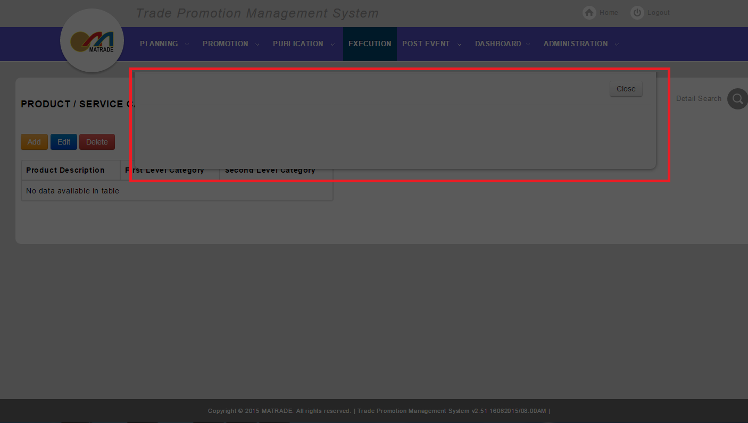

4.3 Attendance Tracking
4.3.1 View Attendance List
Test Ref : | TPMS/UC-EPP-DO-001
Test Data Source: | TPMSSystem Design Specification (TPMS_SDS_Mod3-6_v1.0)
Module / Screen: | View Attendance List
Objectives: | Test basic functionalities that allow user to access Attendance List

Test Case# | Description | Area Path / Test Step | Expected Result | Test Result (Tick √) |  | Test Date / Tested By : | Remarks / Comment
 |  |  |  | Pass | Fail
4.3.1.1 | Access to View Attendance List | TPMS>Execution>Attendance Tracking  - Click on “Attendance Tracking" button | Display list of available activities for attendance tracking. |  | fail | 12/08/2015  Leonard Lim | 12/08/2015 -  Cannot access ‘Attendance Tracking’ page  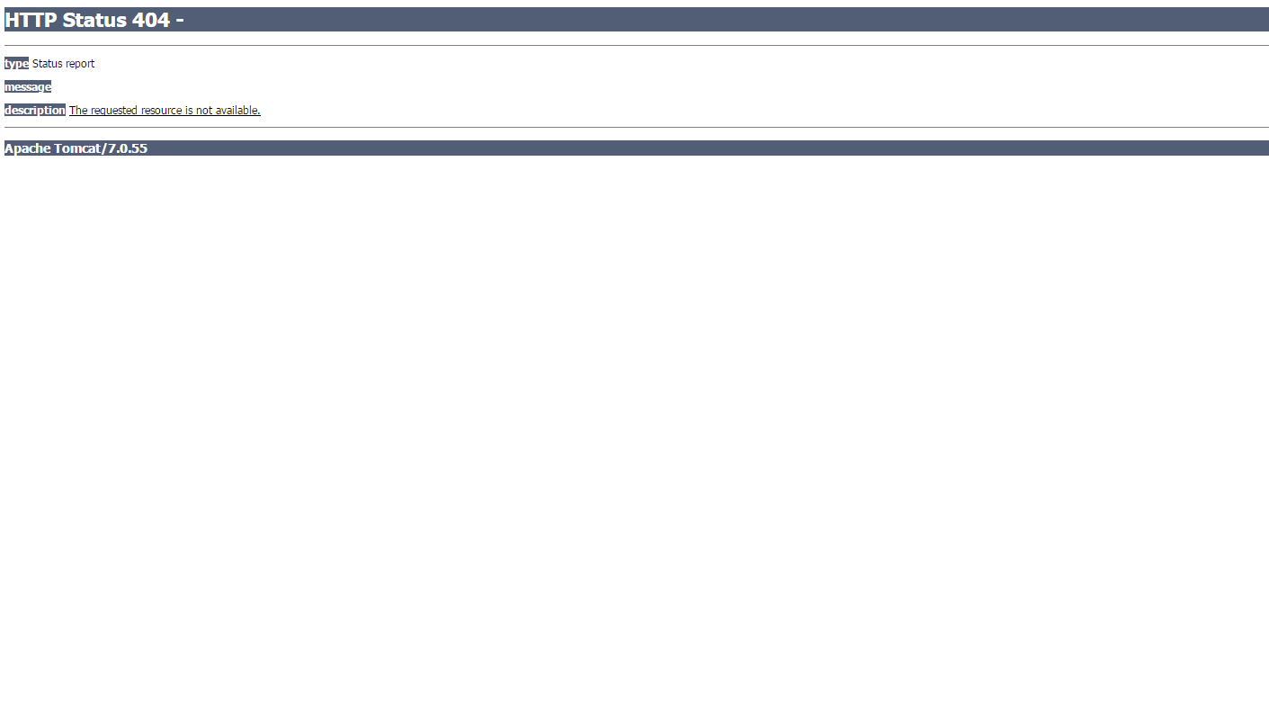
4.3.1.2 | View the Search function | TPMS>Execution> Attendance Tracking  - Click on “+” | System will show the Search function |  | fail | 12/08/2015  Leonard Lim | 12/08/2015 – Not Complete yet
4.3.1.3 | Search Event List | TPMS>Execution> Attendance Tracking>Search  - Select “Representative Name”  - Select “Company Name”  - Select “Company Email”  - Select “Company Application Number”  - Select “Activities With Attendance Status”  - Click on “Search” button  - Click on "Clear Search" button | If Search:  Display the list of event’s based on search criteria.  If Clear Search:  Empty the all search field. |  | fail | 12/08/2015  Leonard Lim | 12/08/2015 – Not Complete yet
4.3.1.4 | View Attendance List | TPMS>Execution>Attendance Tracking  - Select "Activities" | Display list of attendance tracking, based on the activities chosen. |  | fail | 12/08/2015  Leonard Lim | 12/08/2015 – Not Complete yet

4.3.2 Update Representative Information
Test Ref : | TPMS/UC-EPP-DO-001
Test Data Source: | TPMSSystem Design Specification (TPMS_SDS_Mod3-6_v1.0)
Module / Screen: | Update Representative Information
Objectives: | Test basic functionalities that allow user to Update Representative Information

Test Case# | Description | Area Path / Test Step | Expected Result | Test Result (Tick √) |  | Test Date / Tested By : | Remarks / Comment
 |  |  |  | Pass | Fail
4.3.2.1 | Access to Update Representative Information | TPMS>Execution>Attendance Tracking>update  - Click on “Edit" button | Display representative information form that will be changed. |  | fail | 12/08/2015  Leonard Lim | 12/08/2015 – Not Complete yet
4.3.2.2 | Enter Invalid Date | TPMS>Execution>Attendance Tracking>update  - Enter “50132015” to “Check-In Date”  - Enter “51132015” to “Check-Out Date”  - Click on “Save” button | Error Message:  < Check-In Date is invalid> and/or < Check-Out Date is invalid> |  | fail | 12/08/2015  Leonard Lim | 12/08/2015 – Not Complete yet
4.3.2.3 | Enter "Check-Out Date" Earlier than "Check-In Date" | TPMS>Execution>Attendance Tracking>update  - Enter “02122015” to “Check-In Date”  - Enter “01122015” to “Check-Out Date”  - Click on “Save” button | Error Message:  < Check-In Date is should be less than Check-Out Date> |  | fail | 12/08/2015  Leonard Lim | 12/08/2015 – Not Complete yet
4.3.2.4 | Update Representative Information | TPMS>Execution>Attendance Tracking>update  - Click on "Edit"  - Enter the information user wish to Change  - Click on "Save"  - Click on "Cancel" | If Save:  Previous data will be changed, to the new information that user entered.  If Cancel:  Go back to View Attendance List |  | fail | 12/08/2015  Leonard Lim | 12/08/2015 – Not Complete yet

