Create Sub-activity

Test Ref : | TPMS/UC-CPP-DS-004
Test Data Source: | TPMSSystem Design Specification (TPMS_SDS_Mod3-6_v1.0)
Module / Screen: | Create Sub-Activity
Objectives: | Test basic functionalities that allow user toCreate Sub-activity

Test Case# | Description | Area Path / Test Step | Expected Result | Test Result (Tick √) |  | Test Date / Tested By : | Remarks / Comment
 |  |  |  | Pass | Fail
1.5.1 | Access toSub-activity | TPMS>Promotion>Event Listing  - Click on “Sub-activity” Sub navigation | TPMS display the details of selected event's Sub-activity. | pass |  | 12/08/2015  Leonard Lim
1.5.2 | Create Sub-activity | TPMS>Promotion>Event Listing  - Click on “Create” Button  - Enter all required fields  - Click on "Submit"  - Click on "Cancel" | Display Create Sub-activity form.  If Submit:  Create a new sub-activity and add to the sub-activity.  If Cancel:  Go to Sub-activity tab | pass |  | 12/08/2015  Leonard Lim
1.5.3 | Enter invalid date to Event Start Date and Event End Date | TPMS>Promotion> Event Listing  - Select “Type”  - Select "Name"  - Select “Summary”  - Enter “50132015” to “Event Start Date”  - Enter “51132015” to “Event End Date”  - Enter “Venue/Location”  - Enter "Remarks"  - Click on “Submit” button | Error Message:  < Event Start Date is invalid> and/or <Event End Date is invalid> |  | Fail | 12/08/2015  Leonard Lim | 12/08/2015 – no validation for the Date  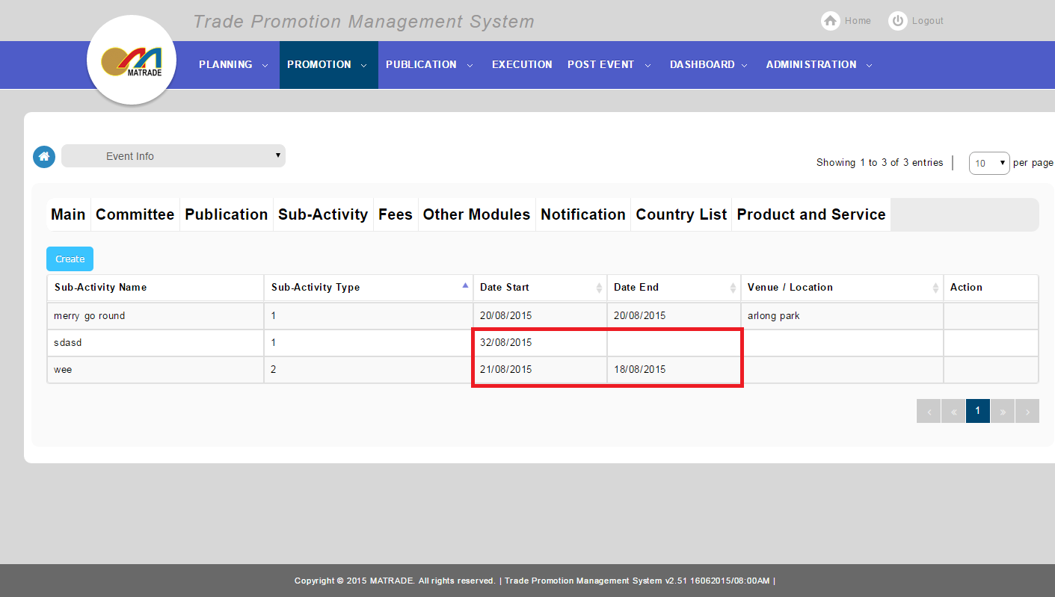
1.5.4 | Enter Event Start Date more than Event End Date | TPMS>Promotion> Event Listing  - Select “Type”  - Select "Name"  - Select “Summary”  - Select “Event Start Date” more than “Event End Date”  - Select “Event End Date” less than “Event Start Date”  - Enter “Venue/Location”  - Enter "Remarks"  - Click on “Submit” button | Error Message:  < Event Start Date is should be less than Event End Date> |  | Fail | 12/08/2015  Leonard Lim | 12/08/2015 – no validation for the date

