Notification Setup

Test Ref : | TPMS/UC-CPP-DS-009
Test Data Source: | TPMSSystem Design Specification (TPMS_SDS_Mod3-6_v1.0)
Module / Screen: | Notification Setup
Objectives: | Test basic functionalities that allow user to access Notification Setup

Test Case# | Description | Area Path / Test Step | Expected Result | Test Result (Tick √) |  | Test Date / Tested By : | Remarks / Comment
 |  |  |  | Pass | Fail
1.10.1 | Access to Notification Setup | TPMS>Promotion>Event Listing  - Click on “Notification” Sub navigation | TPMS display the details of selected event's Notification Setup. | Pass |  | 12/08/2015  Leonard Lim
1.10.2 | Update Notification Setup | TPMS>Promotion>Event Listing  - Click on “Update” Button  - Select all required fields  - Click on "View"  - Click on "Save"  - Click on "Cancel" | Display Notification update form.  If View:  Pop-up window to view the notification template.  If Save:  Save the entered data to database, and change the previous data with the new one.  If Cancel:  Go to Other Module tab |  | Fail | 12/08/2015  Leonard Lim | 12/08/2015 –  No View Button to view template  The data did not change  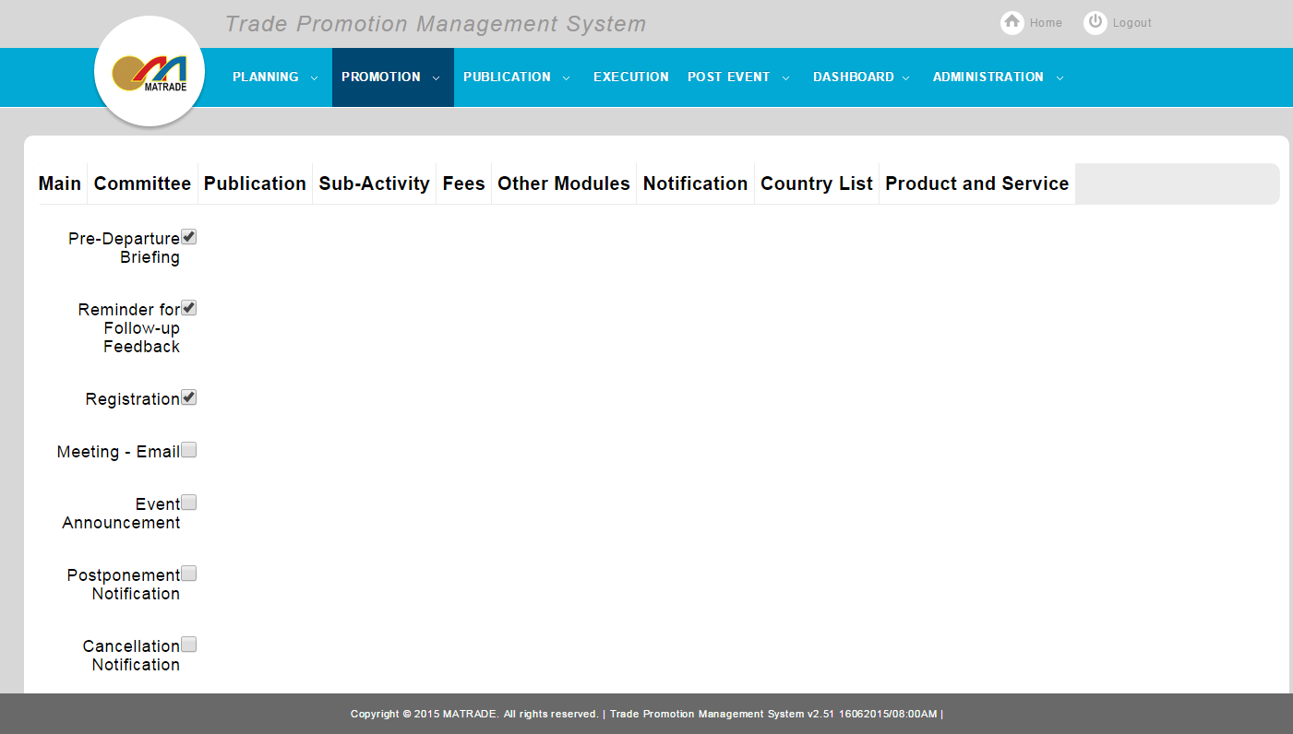  After save:  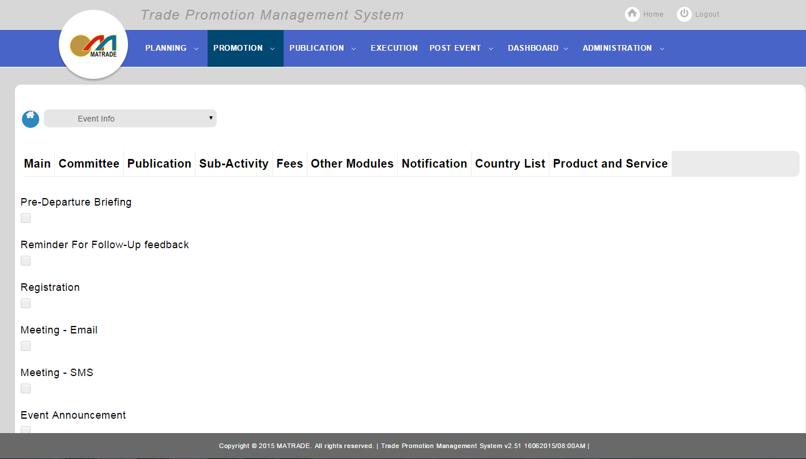
1.10.3 | Customizes Notification Template | TPMS>Promotion>Event Listing  - Click on “Customized” Button  - Select all required fields  - Click on "Save"  - Click on "Discard Changes" | Display Customized template form.  If Save:  Save and add new customized template.  If Discard Changes:  Discard changes made to the template, and continue with standard template |  | Fail | 12/08/2015  Leonard Lim | 12/08/2015 –  Cannot save the template  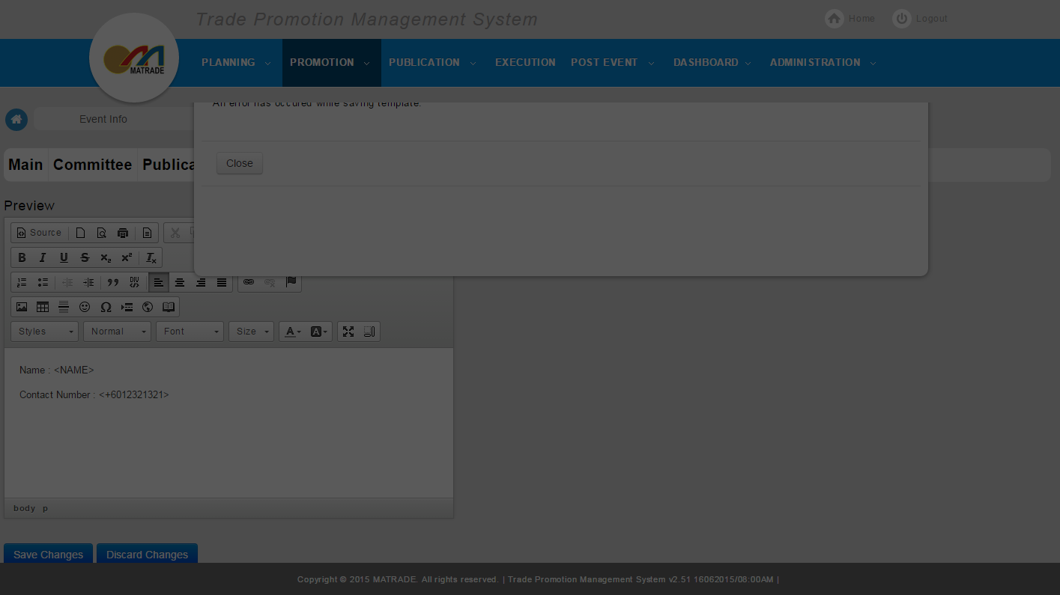  PAGINATION-  