Meeting Scheduler

View Participant Registration

Test Ref : | TPMS/UC-SPP-MS-001
Test Data Source: | TPMSSystem Design Specification (TPMS_SDS_Mod3-6_v1.0)
Module / Screen: | View Participating Registration
Objectives: | Test basic functionalities that allow user to access the meeting scheduler

Test Case# | Description | Area Path / Test Step | Expected Result | Test Result (Tick √) |  | Test Date / Tested By : | Remarks / Comment
 |  |  |  | Pass | Fail
2.4.1.1 | Access to Participating Registration | TPMS>Promotion>Event Listing>Meeting Scheduler  - Click on “Meeting Scheduler” top navigation | TPMS display the List of the meeting scheduled. |  | Fail | 14/08/2015  Leonard Lim | 14/08/2015 – Page Not Exist  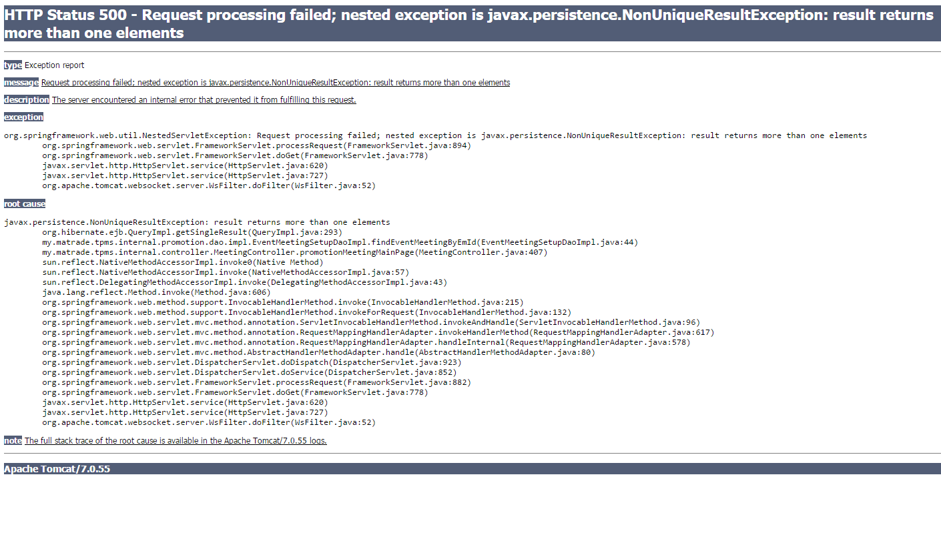

View Participant Registration Details

Test Ref : | TPMS/UC-SPP-MS-001
Test Data Source: | TPMSSystem Design Specification (TPMS_SDS_Mod3-6_v1.0)
Module / Screen: | View Participating Registration Details
Objectives: | Test basic functionalities that allow

Test Case# | Description | Area Path / Test Step | Expected Result | Test Result (Tick √) |  | Test Date / Tested By : | Remarks / Comment
 |  |  |  | Pass | Fail

Update Participant Registration

Test Ref : | TPMS/UC-SPP-MS-003
Test Data Source: | TPMSSystem Design Specification (TPMS_SDS_Mod3-6_v1.0)
Module / Screen: | Update Participant Registration
Objectives: | Test basic functionalities that allow

Test Case# | Description | Area Path / Test Step | Expected Result | Test Result (Tick √) |  | Test Date / Tested By : | Remarks / Comment
 |  |  |  | Pass | Fail

Submit Participant Registration

Test Ref : | TPMS/UC-SPP-MS-002
Test Data Source: | TPMSSystem Design Specification (TPMS_SDS_Mod3-6_v1.0)
Module / Screen: | Submit Participant Registration
Objectives: | Test basic functionalities that allow

Test Case# | Description | Area Path / Test Step | Expected Result | Test Result (Tick √) |  | Test Date / Tested By : | Remarks / Comment
 |  |  |  | Pass | Fail

Meeting Scheduler Setup

Test Ref : | TPMS/UC-SPP-MS-004
Test Data Source: | TPMSSystem Design Specification (TPMS_SDS_Mod3-6_v1.0)
Module / Screen: | Meeting Scheduler Setup
Objectives: | Test basic functionalities that allow

Test Case# | Description | Area Path / Test Step | Expected Result | Test Result (Tick √) |  | Test Date / Tested By : | Remarks / Comment
 |  |  |  | Pass | Fail
2.4.5.1 | Access to Meeting Scheduler Setup | TPMS>Promotion>Event Listing>Meeting Scheduler | TPMS display the form for meeting setup. |  | Fail | 14/08/2015  Leonard Lim | 14/08/2015 – Not Complete Yet
2.4.5.2 | Update Meeting Scheduler Setup | TPMS>Promotion>Event Listing>Meeting Scheduler  - Enter all required information  - Click on "update" |  |  | Fail | 14/08/2015  Leonard Lim | 14/08/2015 – Not Complete Yet

Business Meeting Master List

Test Ref : | TPMS/UC-SPP-MS-008
Test Data Source: | TPMSSystem Design Specification (TPMS_SDS_Mod3-6_v1.0)
Module / Screen: | Business Meeting Master List
Objectives: | Test basic functionalities that allow

Test Case# | Description | Area Path / Test Step | Expected Result | Test Result (Tick √) |  | Test Date / Tested By : | Remarks / Comment
 |  |  |  | Pass | Fail

Business Meeting Schedule Display (SPP021)

Test Ref : | TPMS/UC-SPP-MS-007
Test Data Source: | TPMSSystem Design Specification (TPMS_SDS_Mod3-6_v1.0)
Module / Screen: | Business Meeting Schedule Display (SPP021)
Objectives: | Test basic functionalities that allow

Test Case# | Description | Area Path / Test Step | Expected Result | Test Result (Tick √) |  | Remarks / Comment
 |  |  |  | Pass | Fail

Manual Business Meeting Selection

Test Ref : | TPMS/UC-SPP-MS-006
Test Data Source: | TPMSSystem Design Specification (TPMS_SDS_Mod3-6_v1.0)
Module / Screen: | Manual Business Meeting Selection
Objectives: | Test basic functionalities that allow

Test Case# | Description | Area Path / Test Step | Expected Result | Test Result (Tick √) |  | Remarks / Comment
 |  |  |  | Pass | Fail

Delete Meeting Schedule (SPP023)

Test Ref : | TPMS/UC-SPP-MS-009
Test Data Source: | TPMSSystem Design Specification (TPMS_SDS_Mod3-6_v1.0)
Module / Screen: | Delete Meeting Schedule (SPP023)
Objectives: | Test basic functionalities that allow

Test Case# | Description | Area Path / Test Step | Expected Result | Test Result (Tick √) |  | Remarks / Comment
 |  |  |  | Pass | Fail

Business Meeting Notification

Test Ref : | TPMS/UC-SPP-MS-010
Test Data Source: | TPMSSystem Design Specification (TPMS_SDS_Mod3-6_v1.0)
Module / Screen: | Business Meeting Notification
Objectives: | Test basic functionalities that allow

Test Case# | Description | Area Path / Test Step | Expected Result | Test Result (Tick √) |  | Remarks / Comment
 |  |  |  | Pass | Fail

Notification for Company with No Meeting Scheduled

Test Ref : | TPMS/UC-SPP-MS-011
Test Data Source: | TPMSSystem Design Specification (TPMS_SDS_Mod3-6_v1.0)
Module / Screen: | Notification for Company with No Meeting Scheduled
Objectives: | Test basic functionalities that allow

Test Case# | Description | Area Path / Test Step | Expected Result | Test Result (Tick √) |  | Remarks / Comment
 |  |  |  | Pass | Fail

