Retail Internet Banking (RIB)

ELECTRONIC BANKING GROUP

Project Name | Retail Internet Banking (RIB)
SR No. | 2757
Prepared by | Gabbytian Rayvandy | Version | 1.0

Test Case No : |  | BII-RIB-SIT / Bug #5430 / ##2757##
Test Objectives : |  | M2U interbank realtime transfer not allowed decimal amount.  - To not allow decimal point upon moving from details to confirm for Interbank Realtime, because the switching engine does not support decimal point (beneficiary receives the rounded down amount).
Step No. | Actions |  | Steps | Expected Result | Pass / Fail | Actual Result
1 | Check validation in Interbank Relatime |  | - Login RIB as user : ribuser1.  - Password : Bii123456 / Bypass.  Open Interbank Realtime:  - Key in 123.45 inside the amount text box,  - Key in the rest of the fields,  - Click Next. | - Error message shall appear: “Amount must be numeric.”. | Pass | - OK
2 |  |  | Favourite Interbank Realtime:  - Key in 123.45 inside the amount text box,  - Key in the rest of the fields,  - Click Next. | - Error message shall appear: “Amount must be numeric.”. | Pass | - OK
Remark :

Attachment :

Open Interbank Real Time

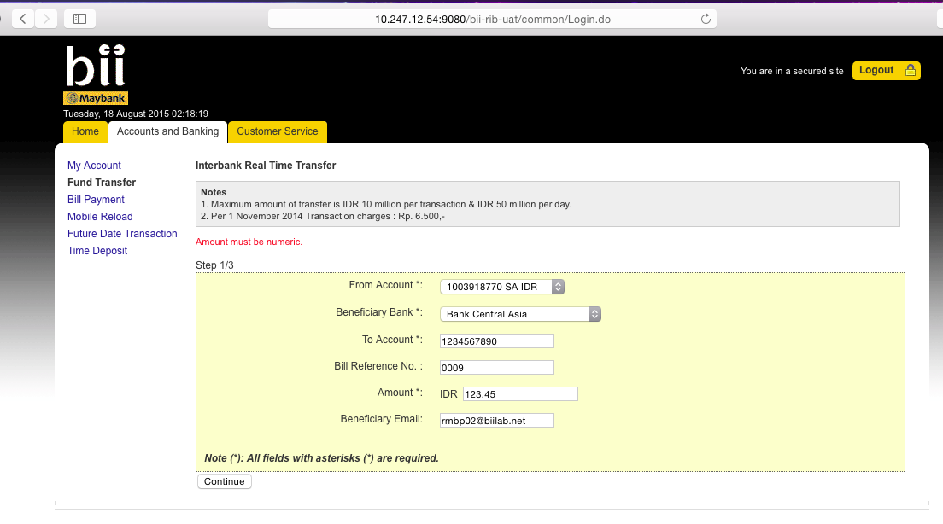
Lampiran :

Favourite Interbank Real Time

