Test Issue Log |  |  |  |  | TIL No.: URF-14-12-163
Project Name: | Conditional Sign-Off IBSCR068 & IBSCR072
Test Stage: | Unit Functionality Integration System Interface  Performance Regression Acceptance Pilot
Test Case Number: | IBG-049 |  |  | Test Started Date: |  | 25/06/2015
Test Title: | BIB EPF- Inaccurate Description
Test Description: | Issue #049 To ensure the Transaction Description for EPF Other Payment in BIB follow the user requirement.  Sender’s Account – To append Payment Code, EPF Number
Test Functionality: | BIB  - Bulk Payment  - EPF Other Payment (Form F, Late Charges Payment, Dividend Loss Payment, Other Charges)  - Bulk Payment Upload File
Test Procedure: | - Perform EPF Other Payment (Form F, Late Charges Payment, Dividend Loss Payment, Other Charges) and Bulk Payment (EPF) for BIB  - View Transaction Description in Transaction History
Test Result: | Pass: Fail: Conditional Pass: |  | Tested by: |  | Leonard Lim
Reason for Failure:
TEST DESCRIPTION
IBG-049: BIB EPF - Inaccurate Description

BIB>Bulk Payment>EPF Other Payment

- Role : Approver All

  - Form F

Confirm Page
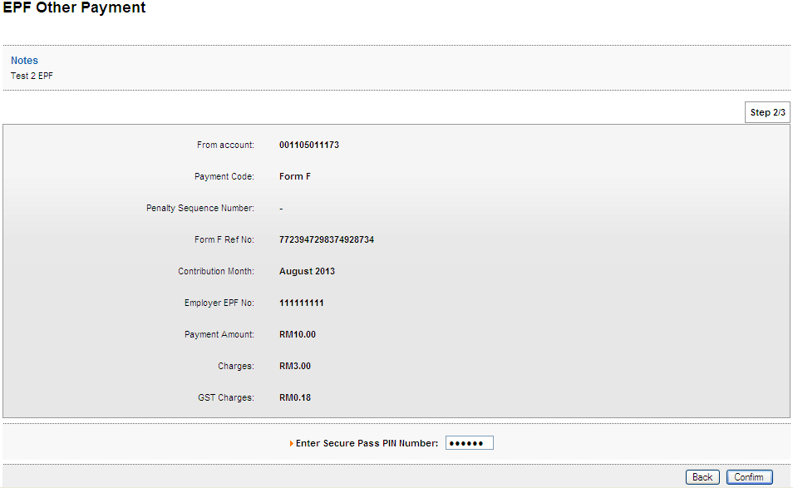

Result Page
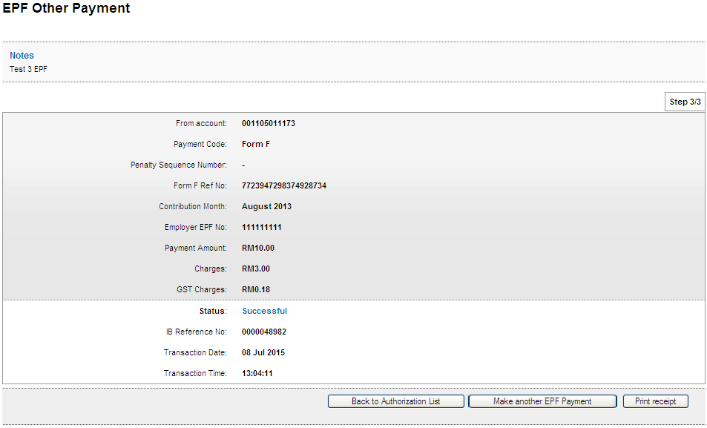

Print Receipt
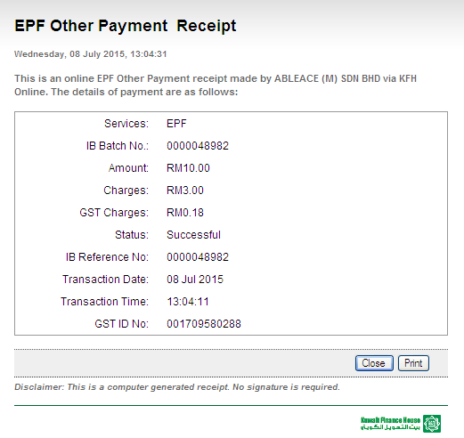

Transaction History
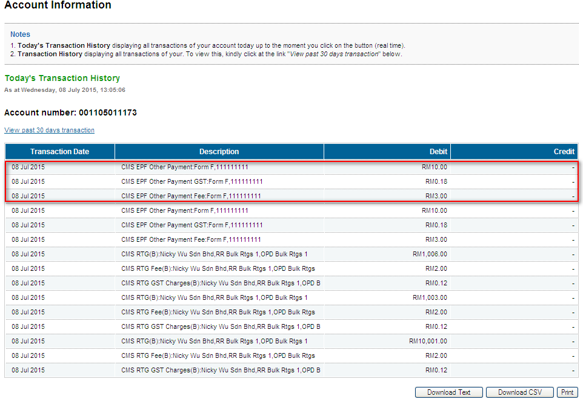

  - Late Charges Payment

Confirm Page
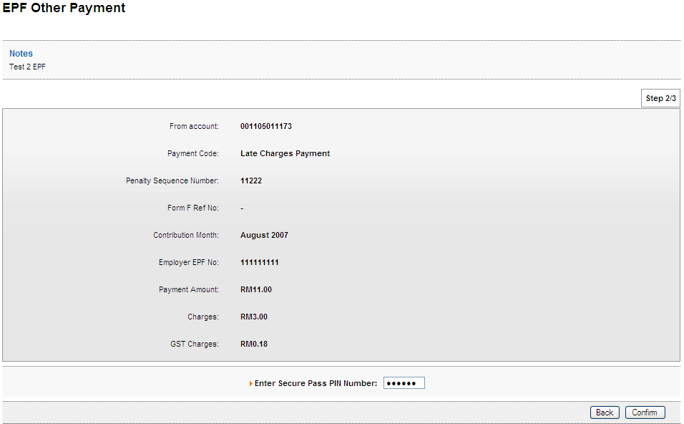

Result Page
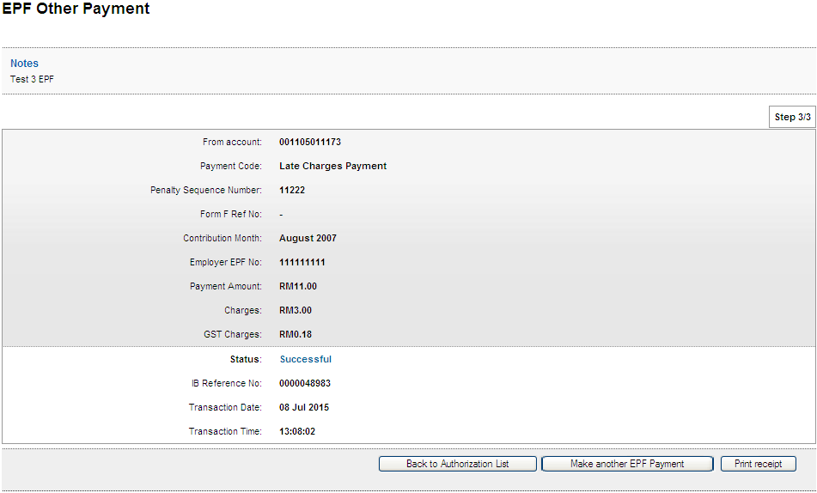

Print Receipt
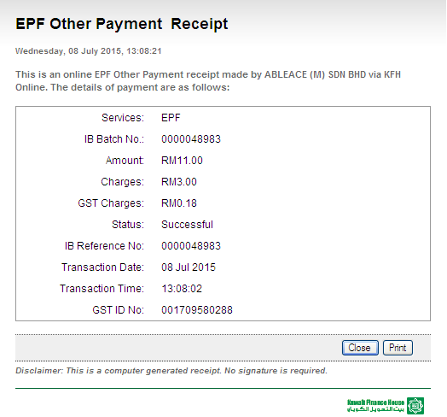

Transaction History
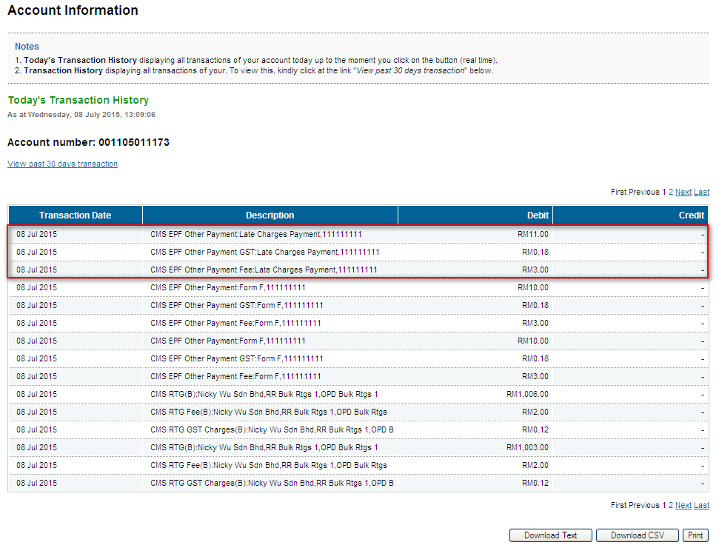

  - Dividend Loss Payment

Confirm Page
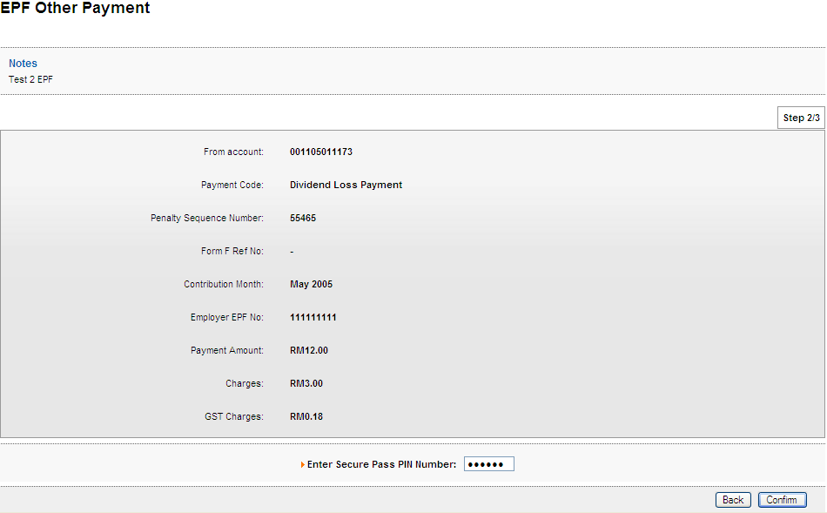

Result Page
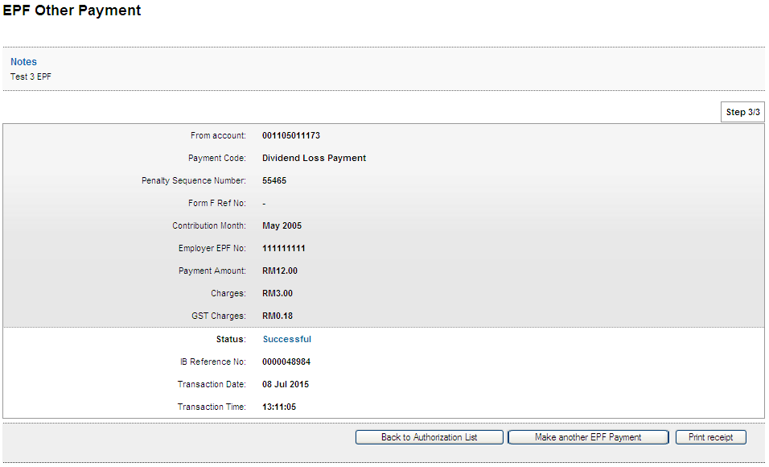

Print Receipt
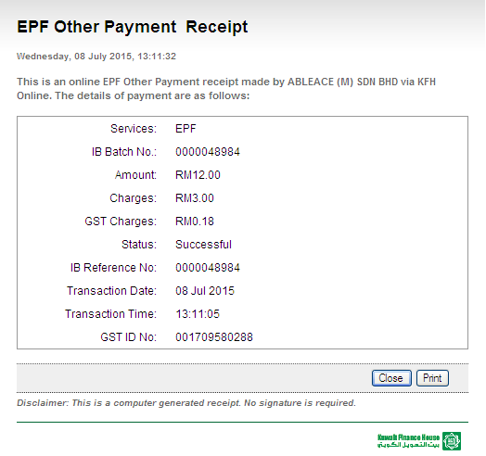

Transaction History
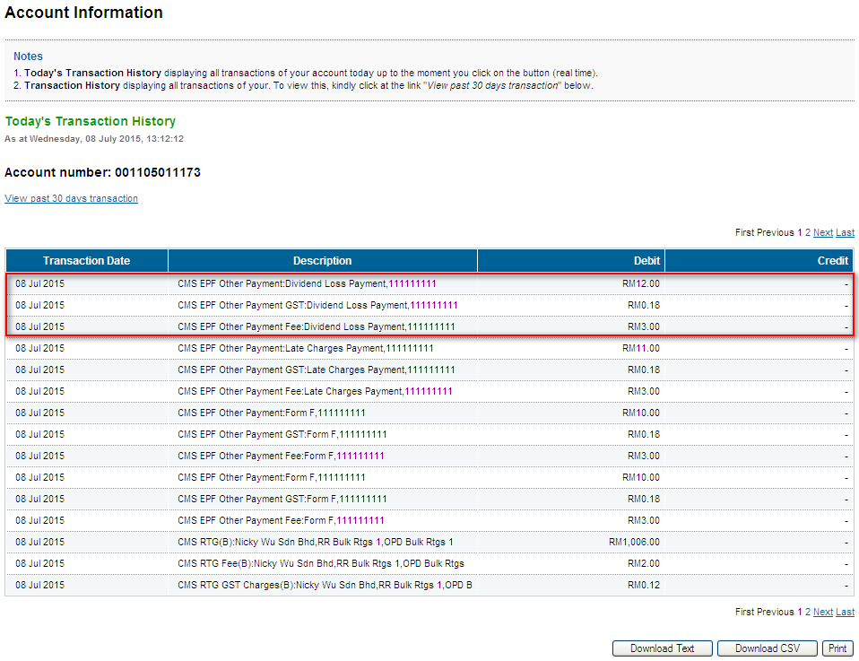

  - Other Charges

Confirm Page
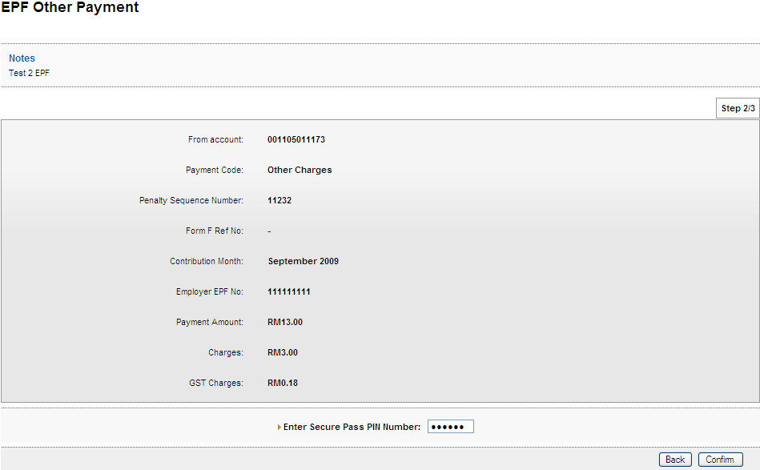

Result Page
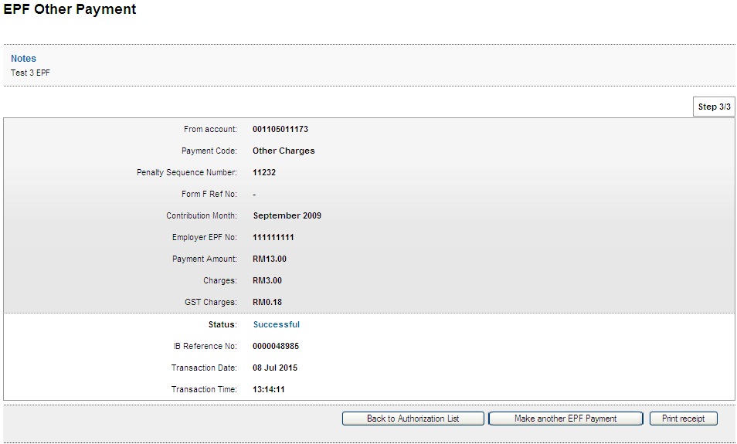

Print Receipt
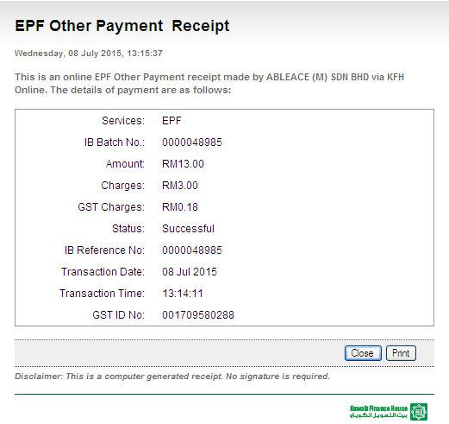

Transaction History
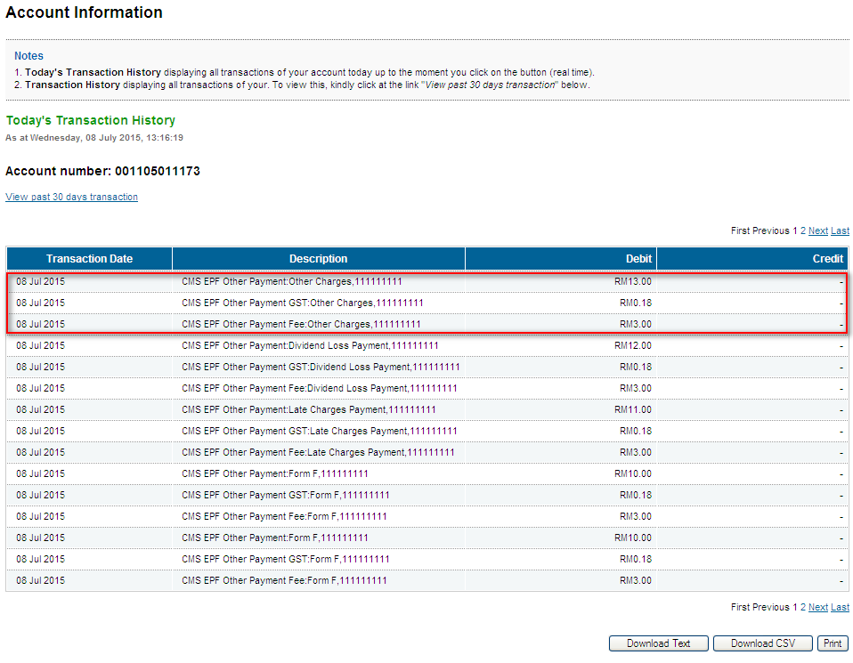

- Role : Initiator>Verifier>Approver

  - Form F

    - Initiator

Confirm Page
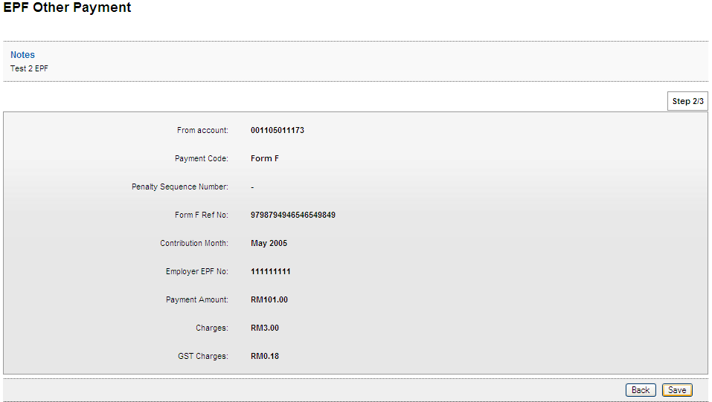

Result Page
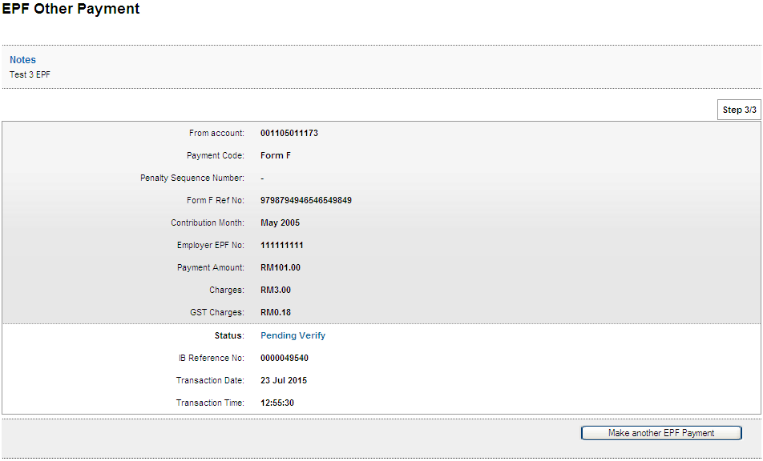

    - Verifier

Confirm Page
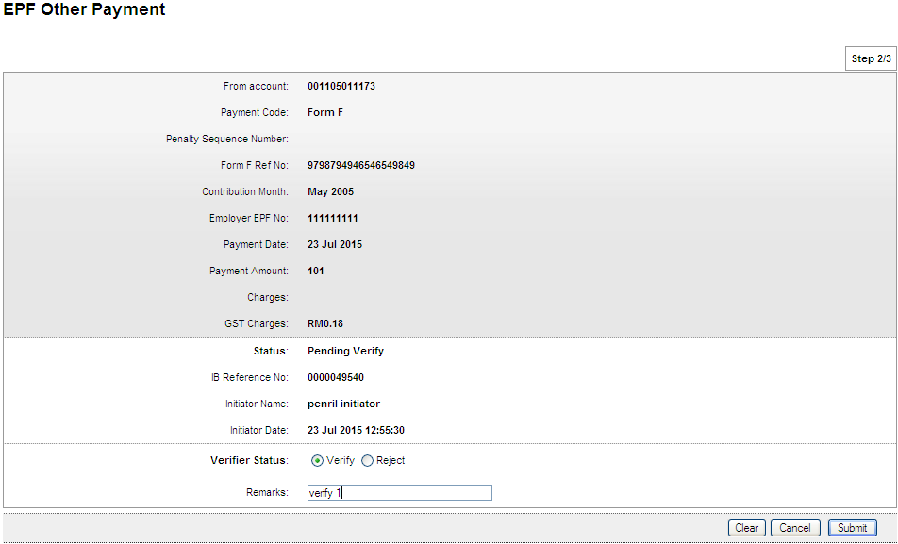
Result Page
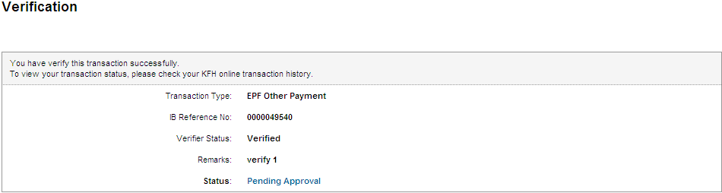

    - Approver

Confirm Page
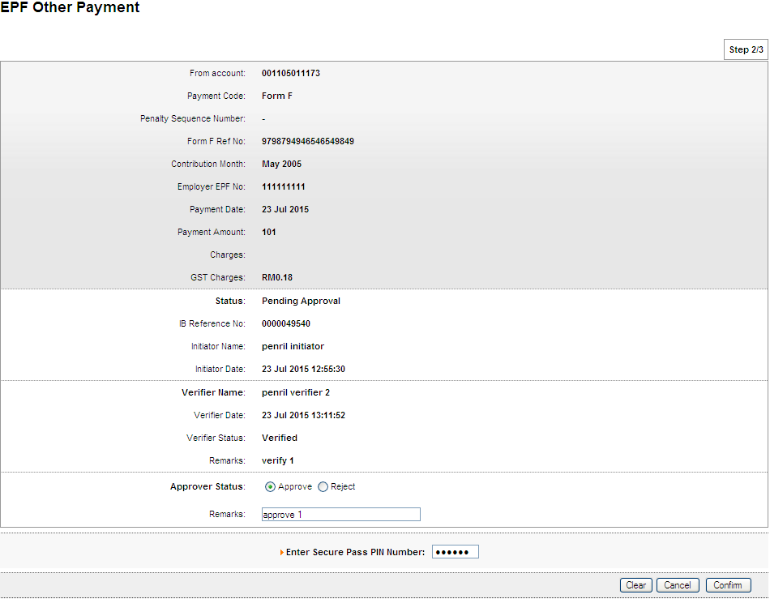

Result Page
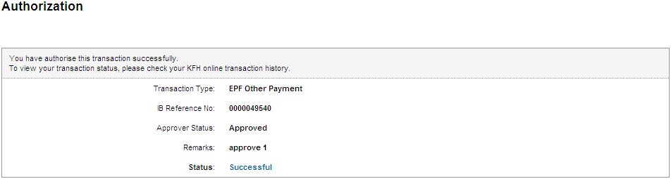

Print Receipt
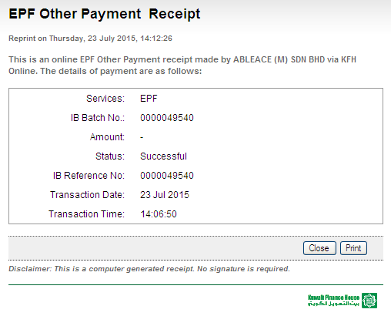

Transaction History
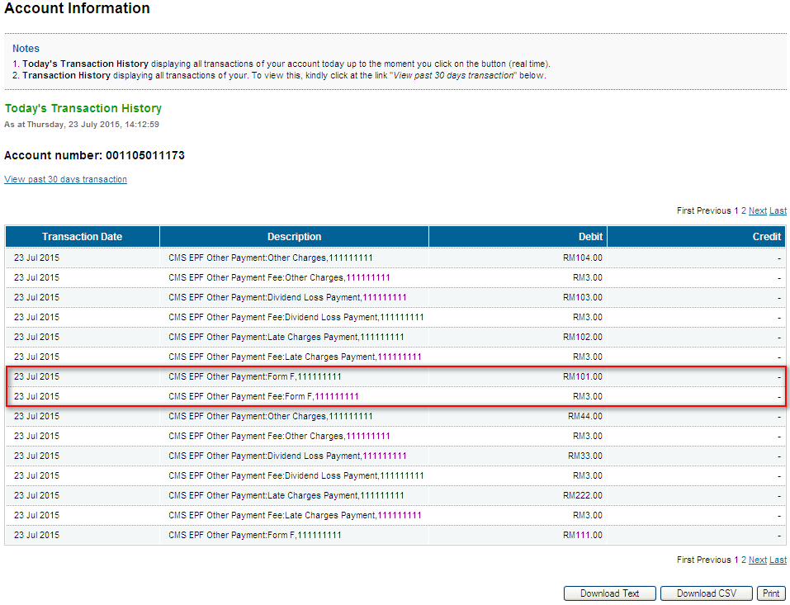
Confirm back on the GST value

  - Late Charges Payment

    - Initiator

Confirm Page
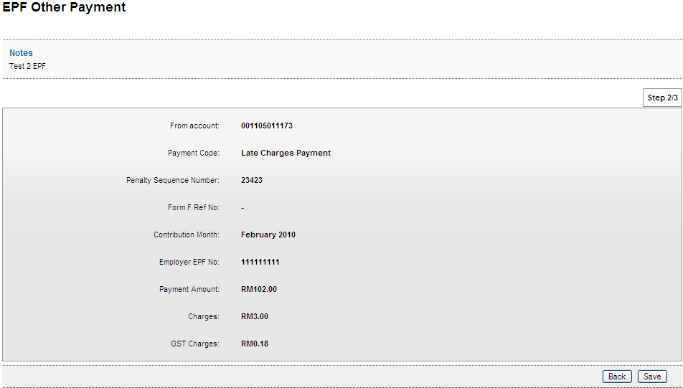

Result Page
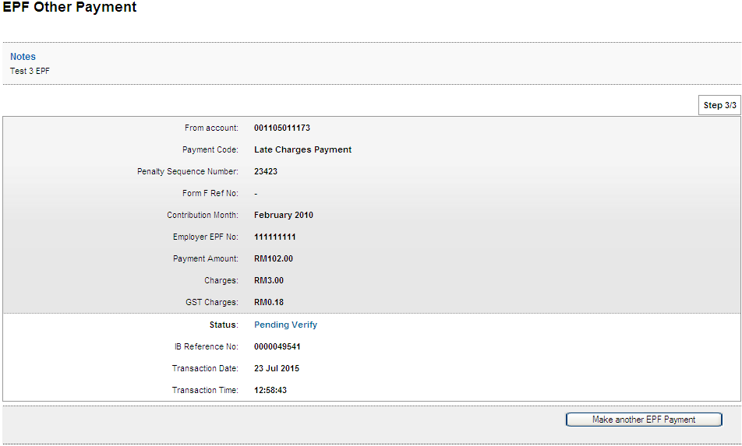

    - Verifier

Confirm Page
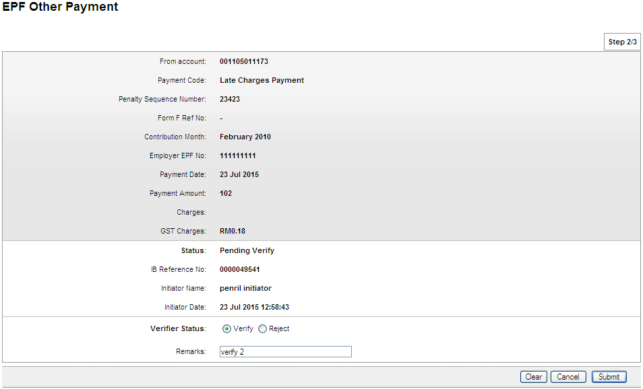

Result Page
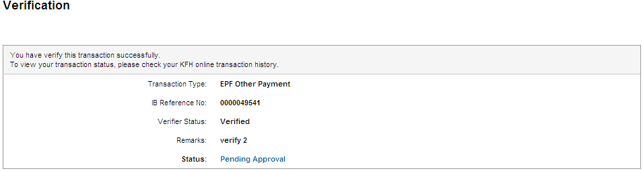

    - Approver

Confirm Page
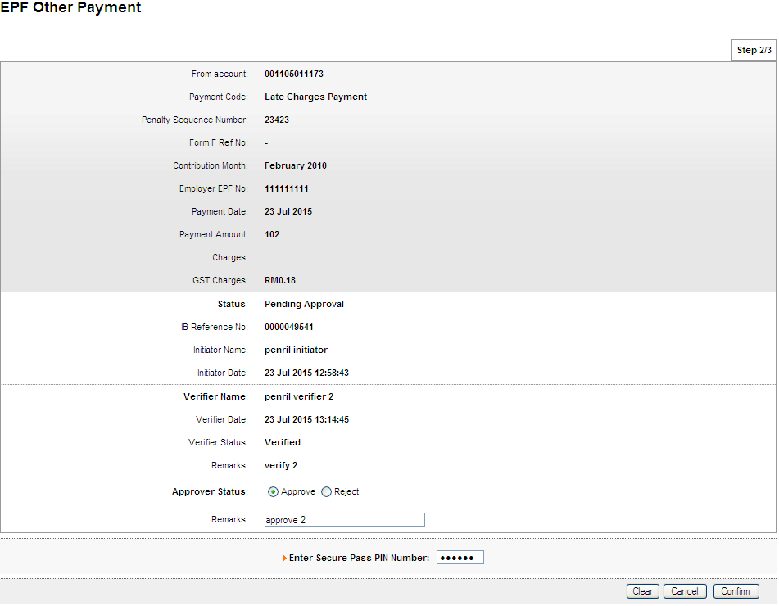

Result Page
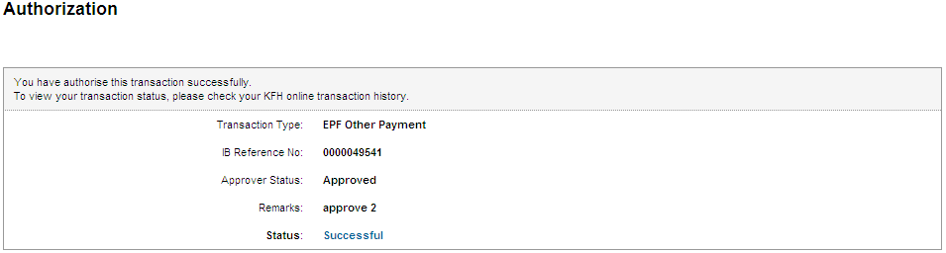

Print Receipt
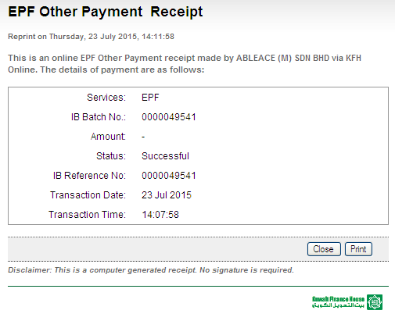
Transaction History
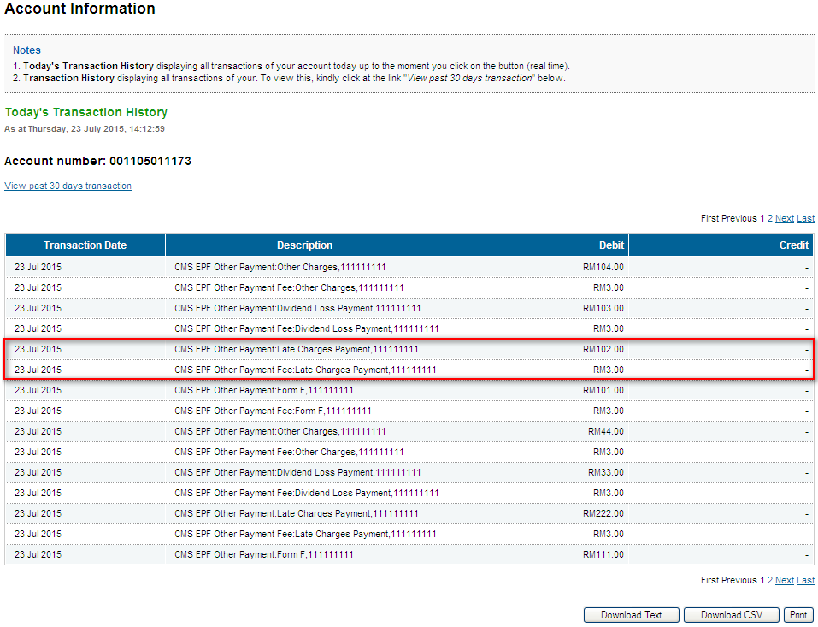
Confirm back on the GST value

  - Dividend Loss Payment

    - Initiator

Confirm Page
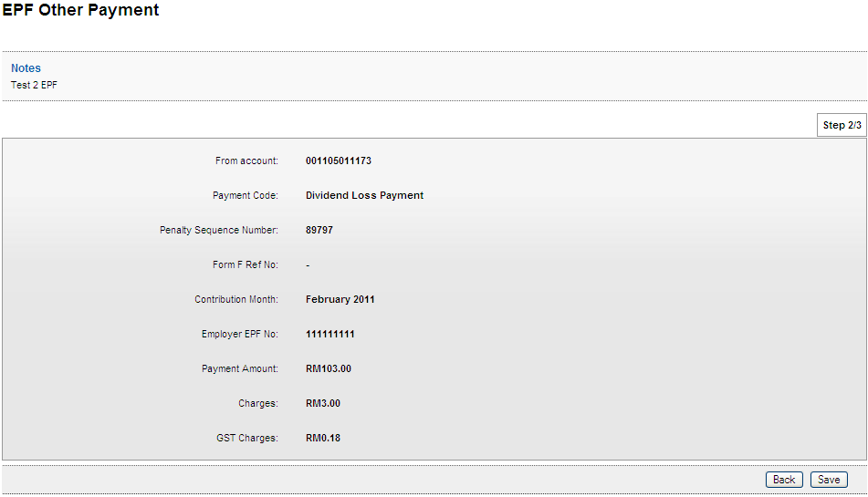

Result Page
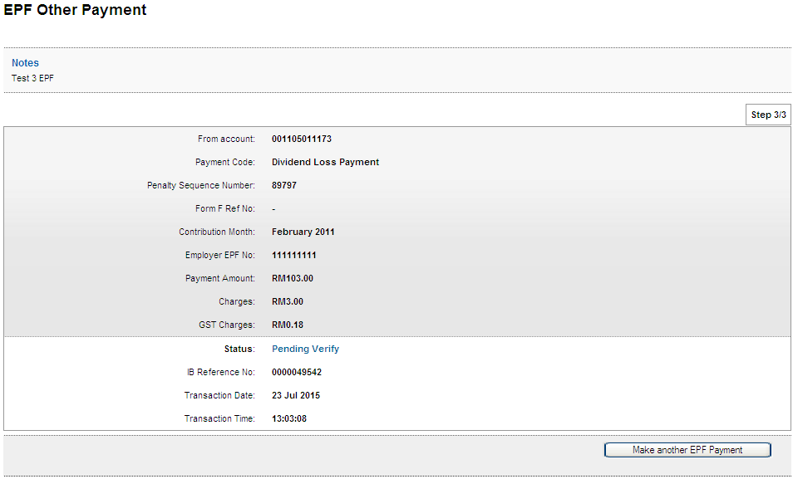

    - Verifier

Confirm Page
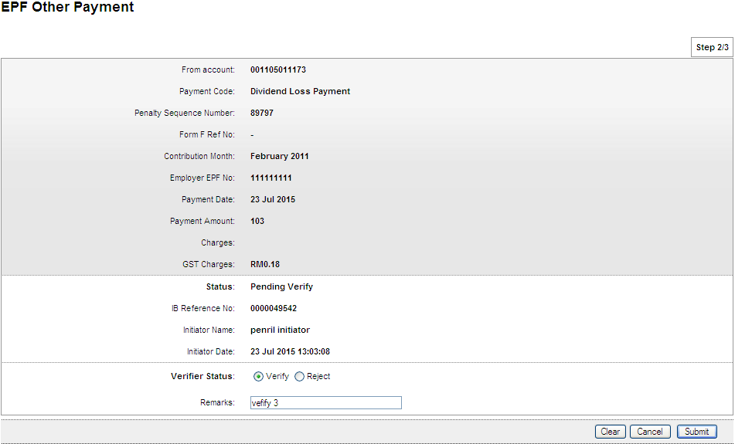

Result Page
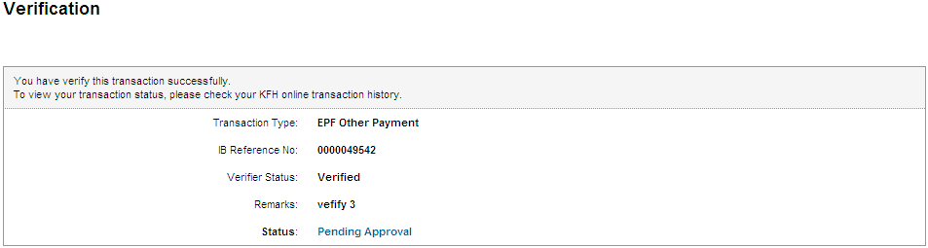

    - Approver

Confirm Page
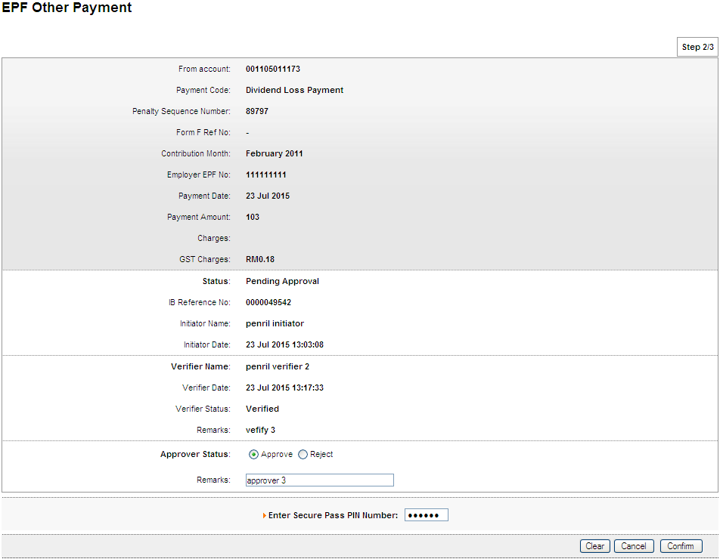

Result Page
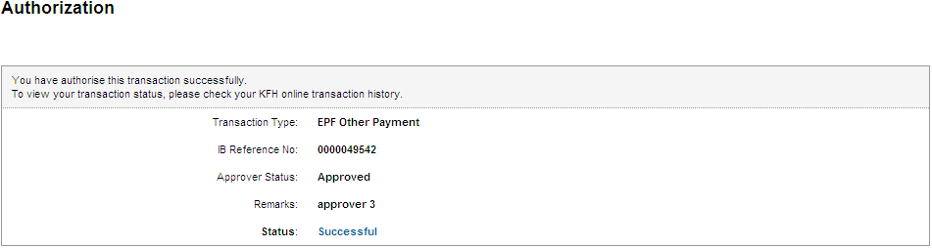

Print Receipt
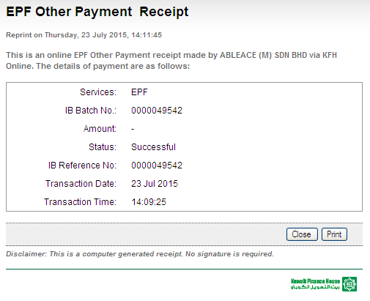

Transaction History
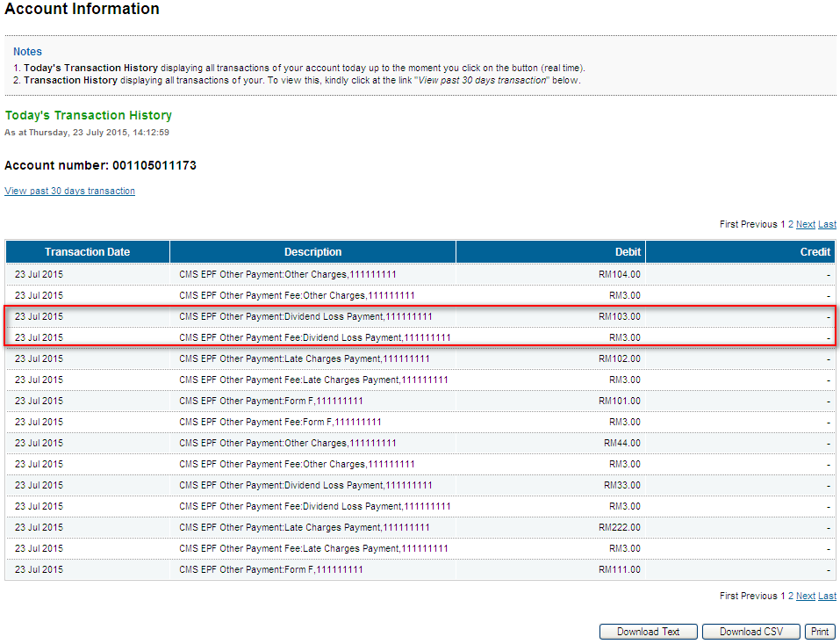
Confirm back on the GST value

  - Other Charges

    - Initiator

Confirm Page
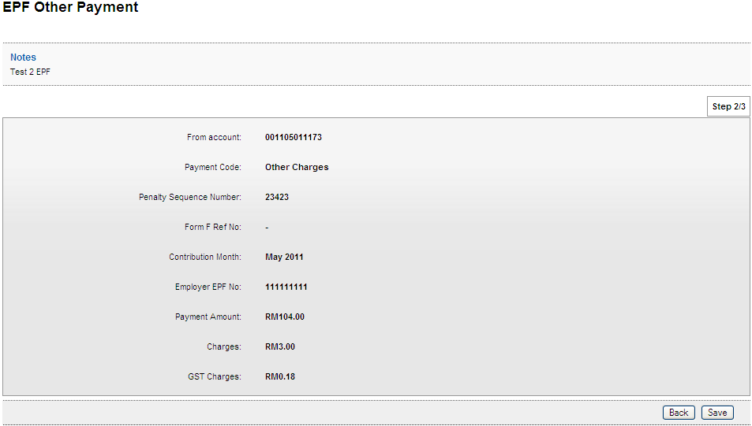

Result Page
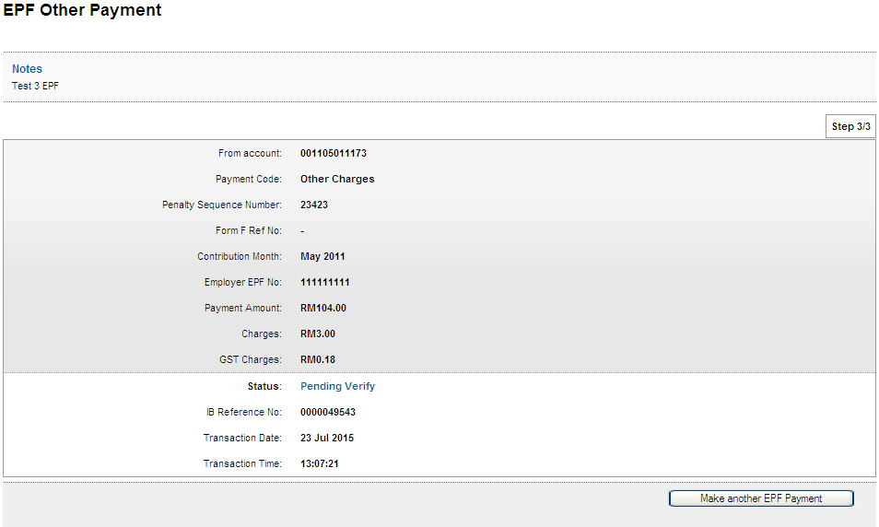

    - Verifier

Confirm Page
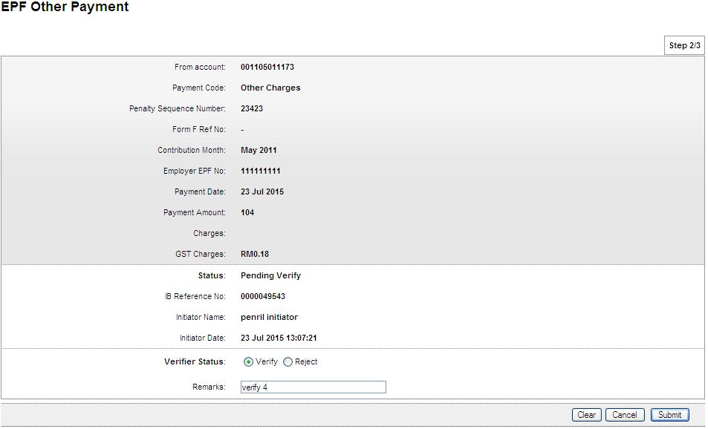

Result Page
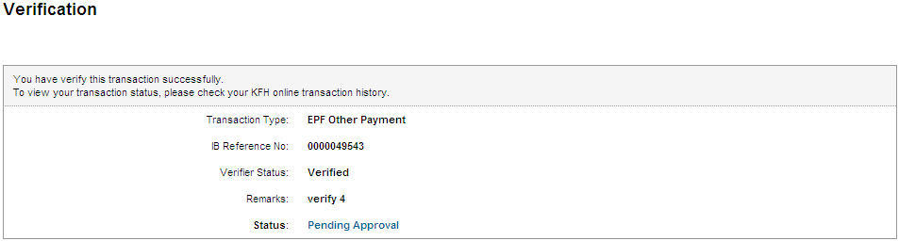

    - Approver

Confirm Page
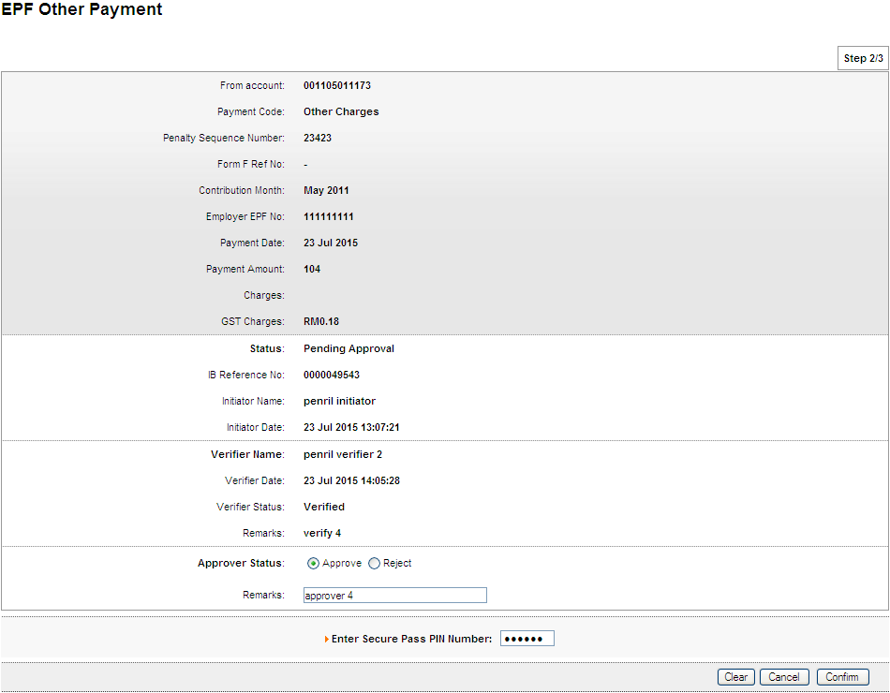

Result Page
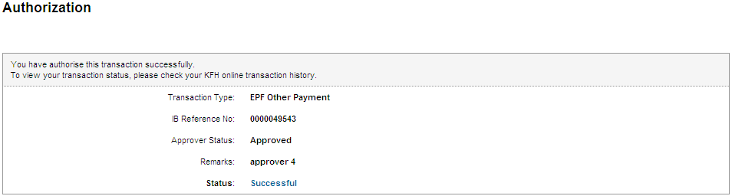

Print Receipt
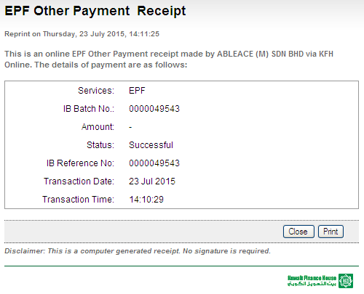
Transaction History
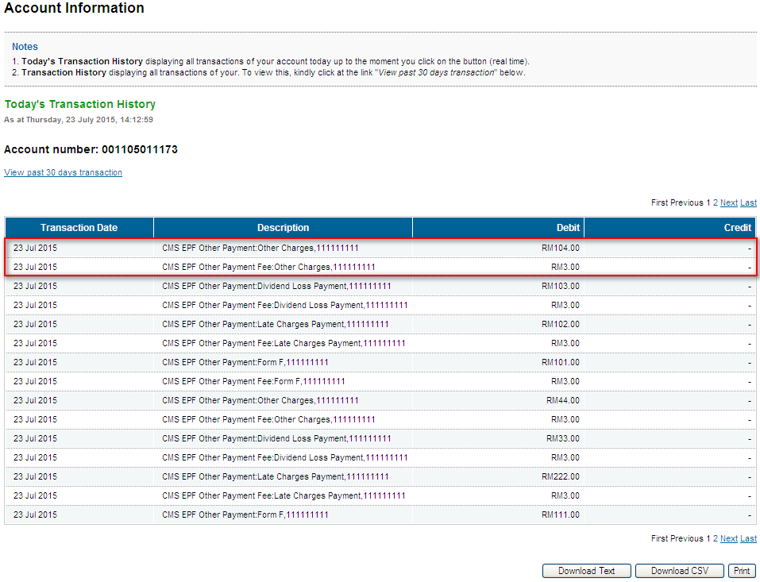
Confirm back on the GST value

- Role : Init+Veri>Approver

  - Form F

    - Init+Veri

Confirm Page
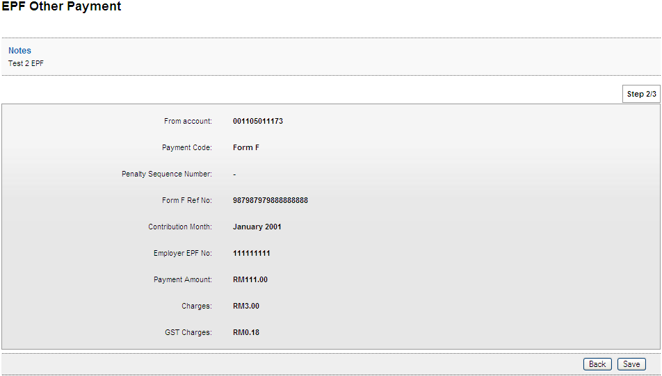

Result Page
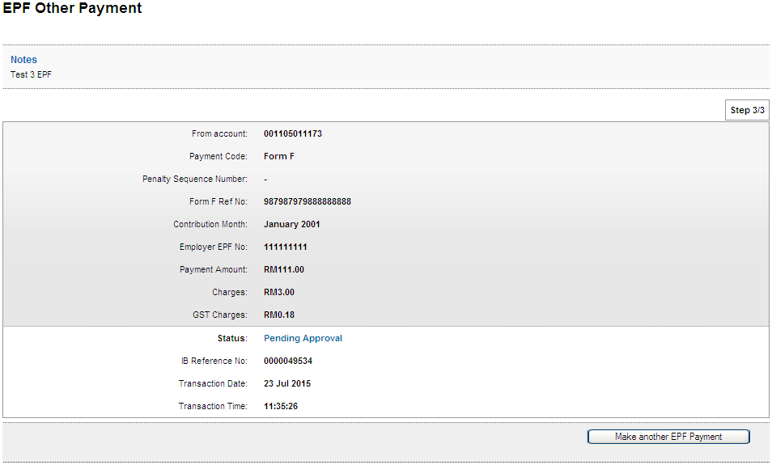

    - Approver

Confirm Page
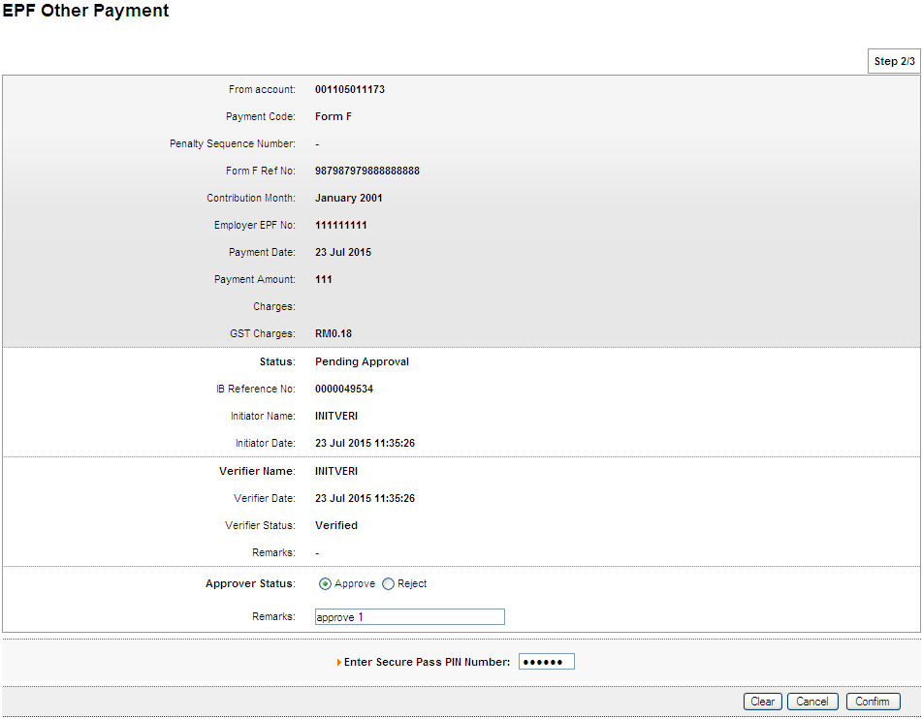

Result Page
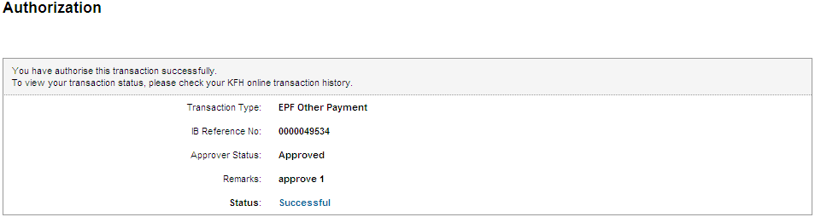

Print Receipt
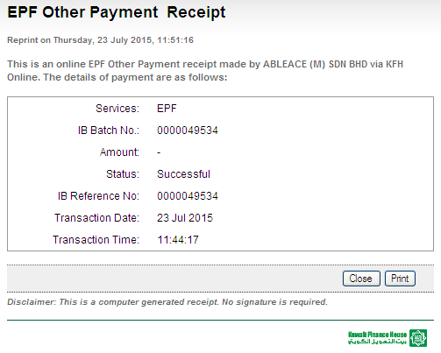

Transaction History
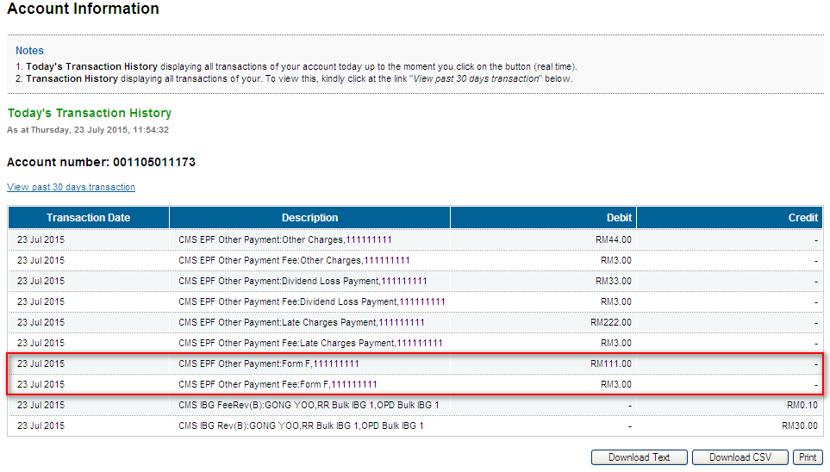
To confirm back on the GST value

  - Late Charges Payment

    - Init+Veri

Confirm Page
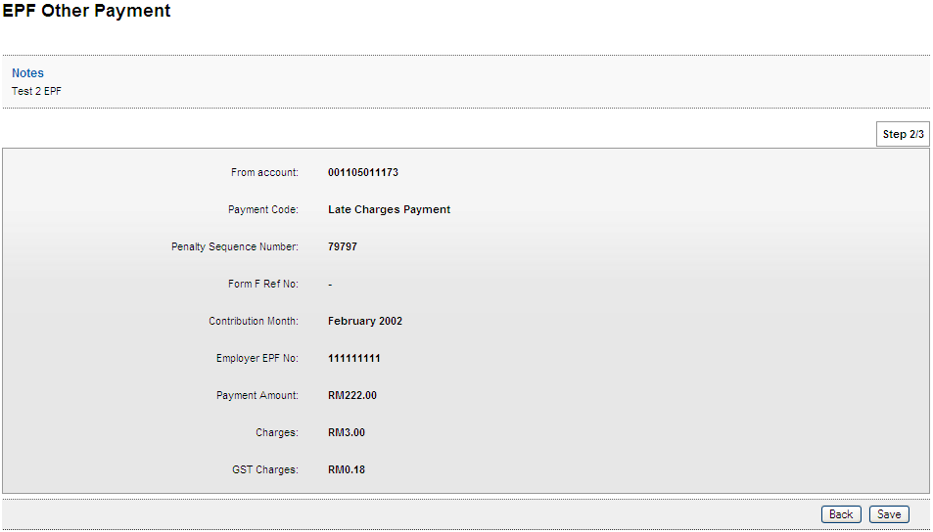

Result Page
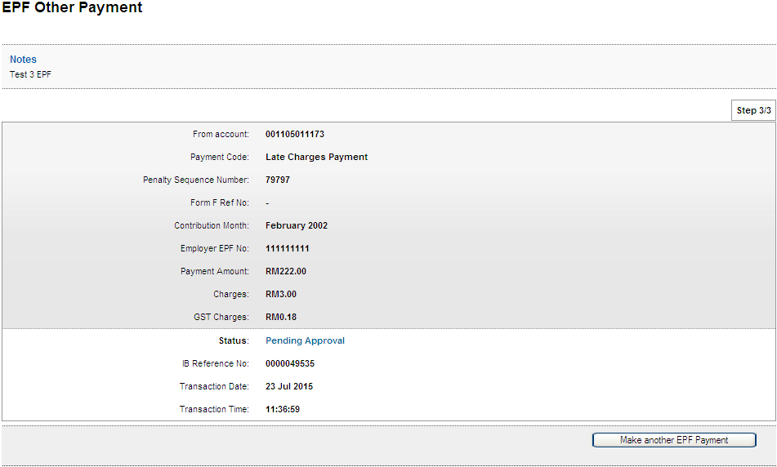

    - Approver

Confirm Page
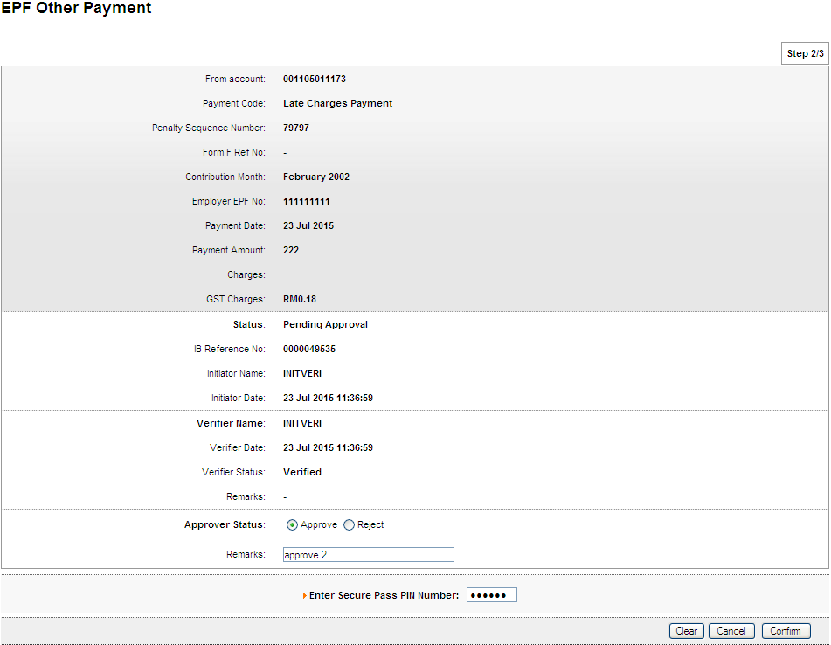

Result Page
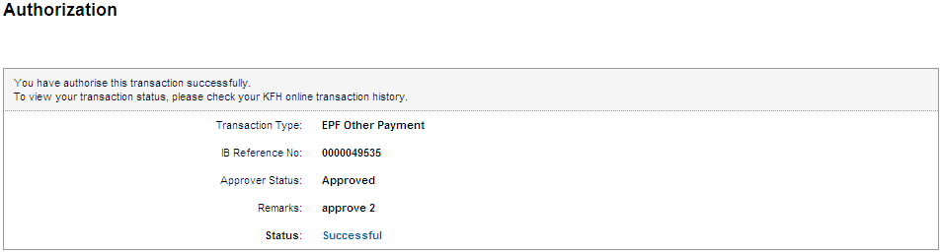

Print Receipt
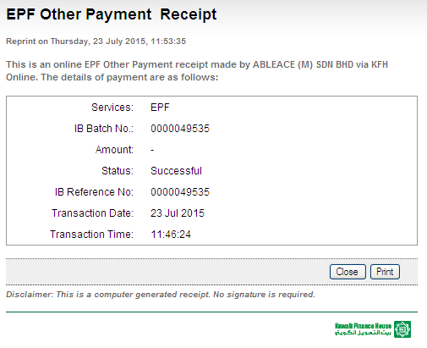

Transaction History
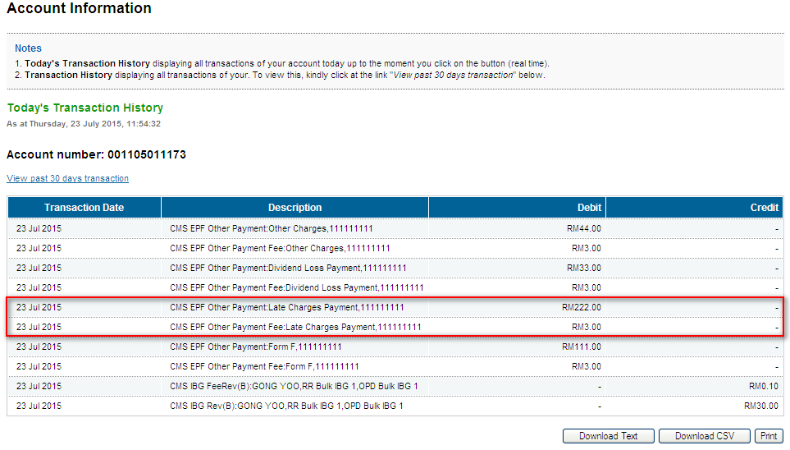
To confirm on the GST value

  - Dividend Loss Payment

    - Init+Veri

Confirm Page
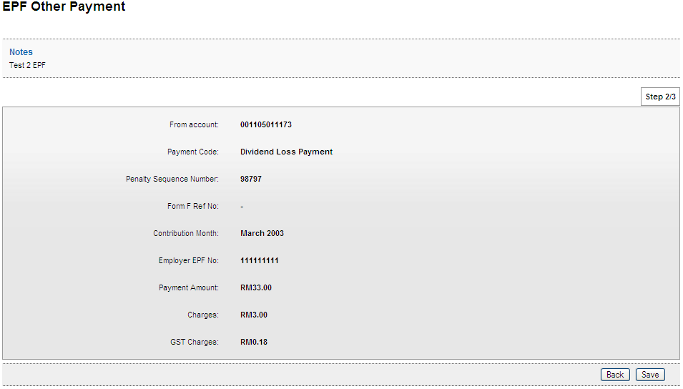

Result Page
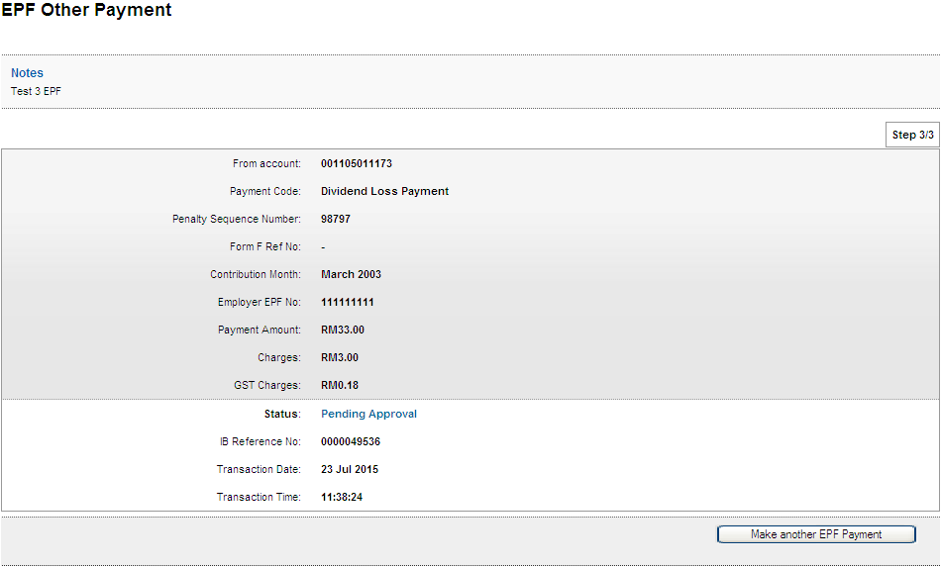

    - Approver

Confirm Page
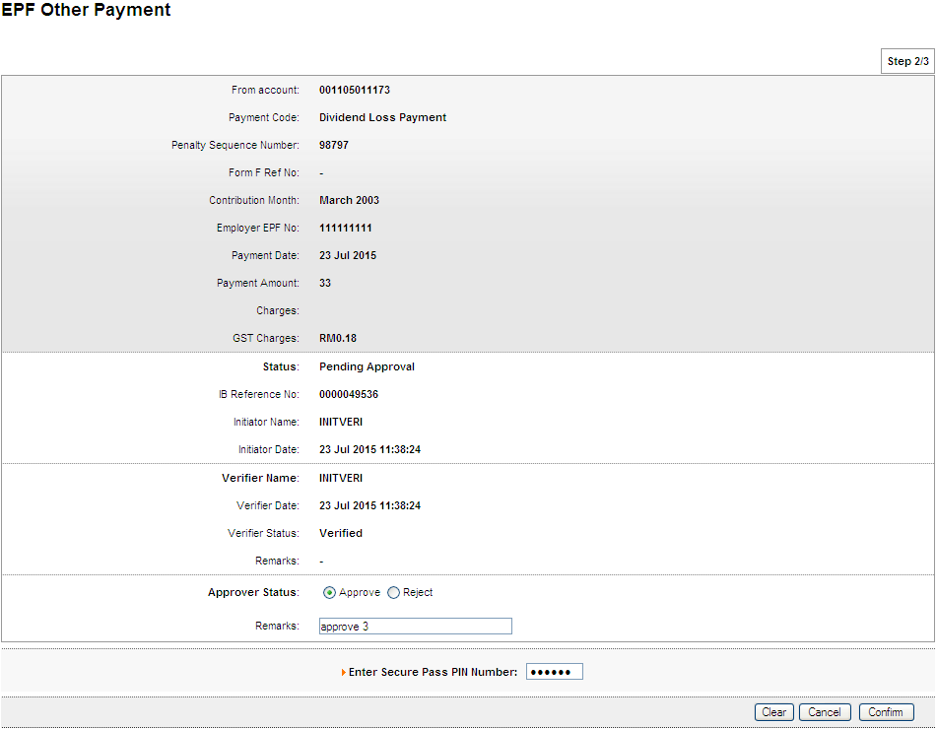

Result Page
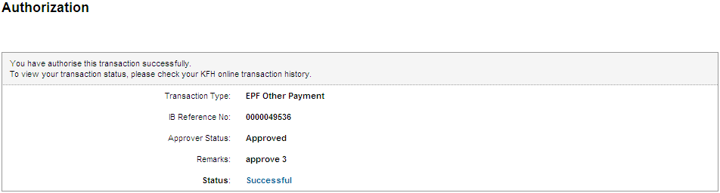

Print Receipt
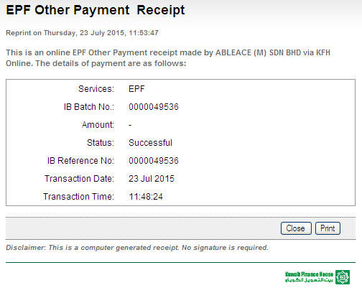

Transaction History
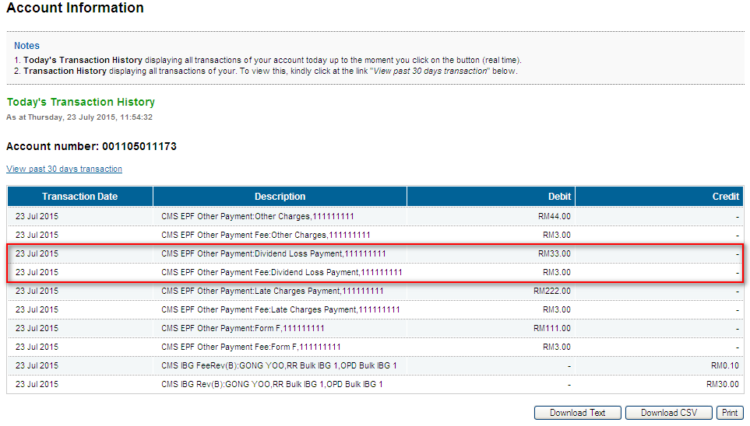
To confirm on the GST value

  - Other Charges

    - Init+Veri

Confirm Page
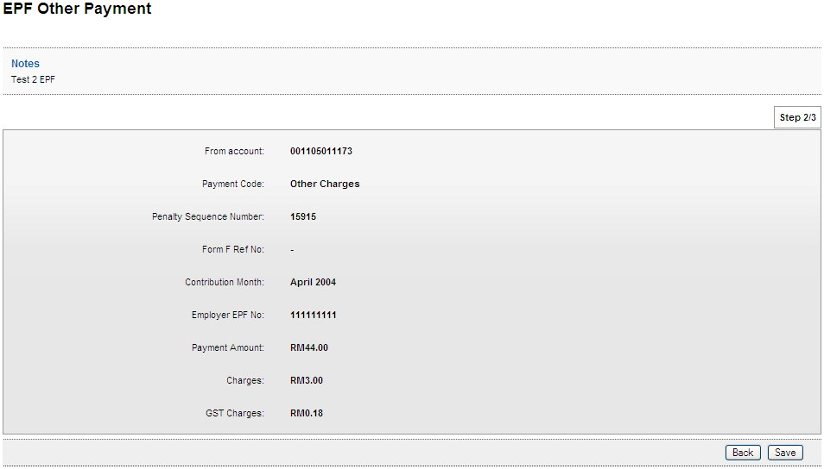

Result Page
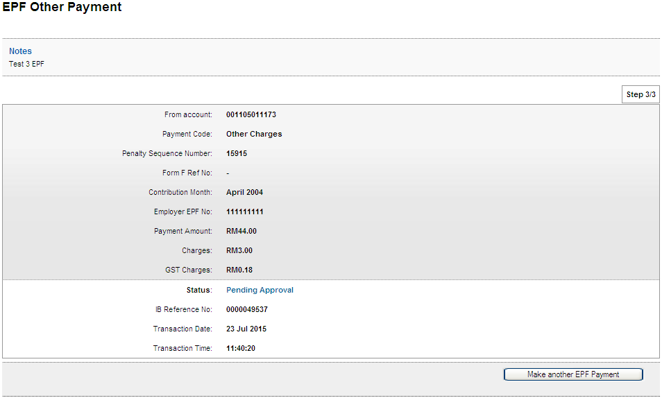

    - Approver

Confirm Page
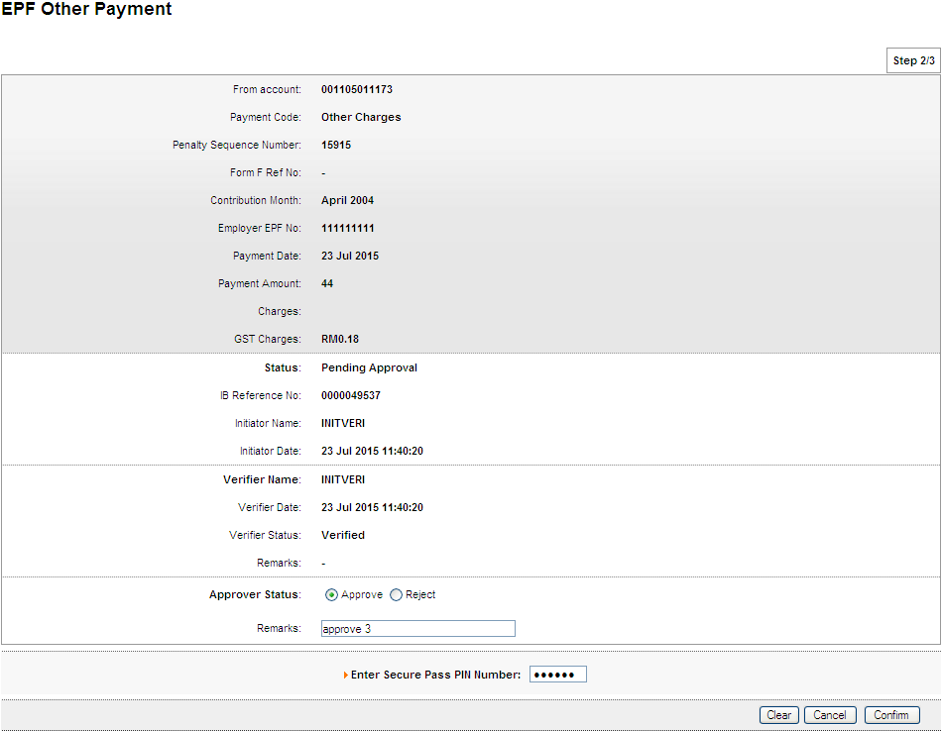

Result Page
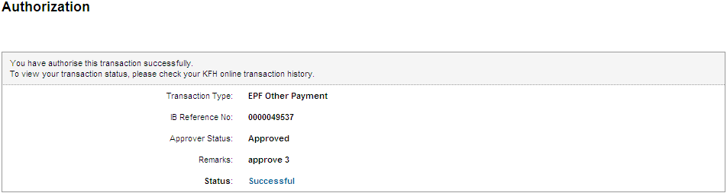

Print Receipt
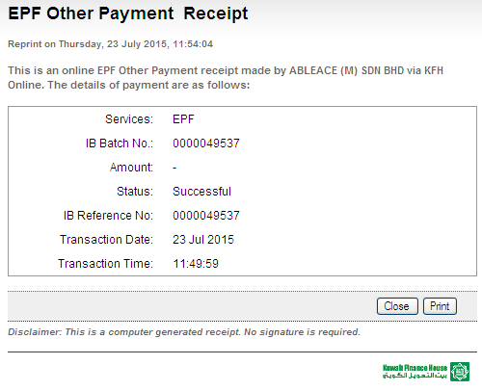

Transaction History
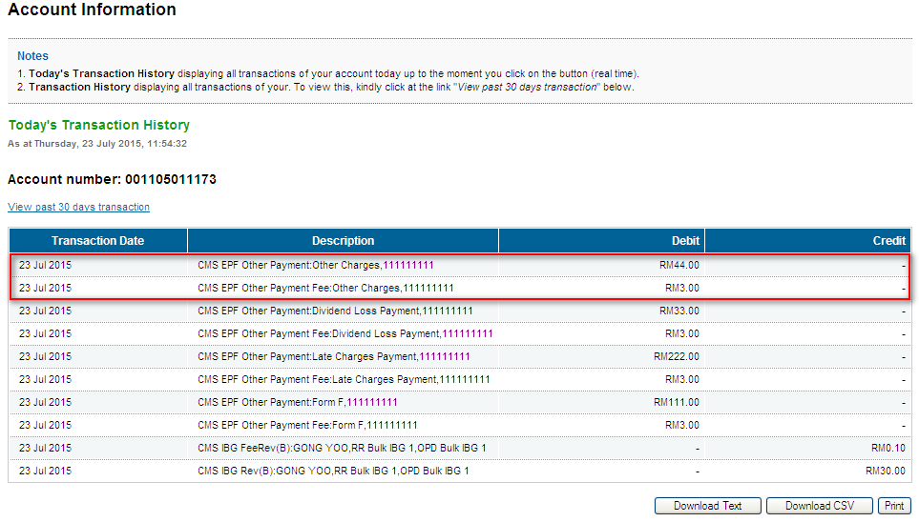
To confirm on the GST value

BIB>Bulk Payment Upload - EPF

Reviewed By: (PMO)
 |  | Name/Position : NorhaidahBintiMdDasuki / Senior Manager, Quality Assurance and Support  Date :

