Registration

View Company Registration List

Test Ref : | TPMS/UC-CPP-REG-001
Test Data Source: | TPMSSystem Design Specification (TPMS_SDS_Mod3-6_v1.0)
Module / Screen: | View Company Registration List
Objectives: | Test basic functionalities that allow user to view the list of registered company's details

Test Case# | Description | Area Path / Test Step | Expected Result | Test Result (Tick √) |  | Test Date / Tested By : | Remarks / Comment
 |  |  |  | Pass | Fail
2.1.1.1 | Access to Company Registration List | TPMS>Promotion>Event Listing>Registration  - Click on “Registration” top navigation | TPMS display the registered company list.  Order by Submission Date in descending order.  Based on the company's participating role | Pass |  | 14/08/15  Leonard Lim  24/08/15  Leonard Lim | 14/08/2015 – No Available data  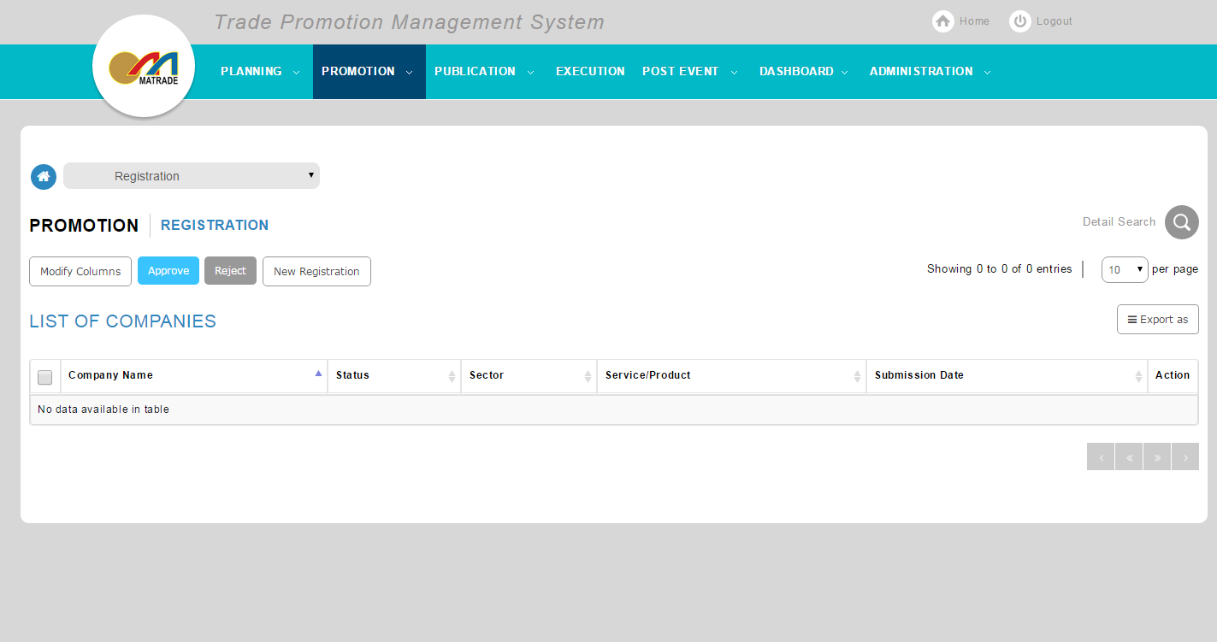  24/08/15-Pass
2.1.1.2 | View the Search function | TPMS>Promotion>Event Listing >Registration>Search  - Click on “+” | System will show the Search function | Pass |  | 14/08/15  Leonard Lim
2.1.1.3 | Search the Registered Company List | TPMS>Promotion>Event Listing >Registration>Search  - Select “Company Type”  - Select “Recipient of BEDP or WEDP”  - Select “Product Level 1”  - Select “Product Level 2”  - Select “Service Level 1”  - Select “Service Level 2”  - Select “Sector”  - Select “Is Bumiputra”  - Select “By MATRADE membership”  - Select “By SME / Non-SME company”  - Select “By Registration Status”  - Click on “Search” button  - Click on "Clear Search" button | If Search:  Display the list of event’s based on search criteria.  If Clear Search:  Empty the all search field. |  | Fail | 14/08/15  Leonard Lim  24/08/15  Leonard Lim | 14/08/2015 – No available Data to test  24/08/15- cannot perform search
2.1.1.4 | Select Company Listing Decision | TPMS>Promotion>Event Listing >Registration  - Select “Company” checkbox  - Select “Decision” dropdown list under Company List  - Click on “Submit” button  - Click on "Export" button | If Submit:  Submit the approval decision for the selected registration.  If Export:  Export selected registration to MS-Excel, MS-Word or PDF  * User may Approve or Reject registration(s) |  | Fail | 14/08/15  Leonard Lim  24/08/15  Leonard Lim | 14/08/2015 – Not Complete Yet  24/08/15 –  No submit Button  Cannot Export data, no pop up window

View Company Registration Details

Test Ref : | TPMS/UC-CPP-REG-002
Test Data Source: | TPMSSystem Design Specification (TPMS_SDS_Mod3-6_v1.0)
Module / Screen: | View Company Registration Details
Objectives: | Test basic functionalities that allow user to view registered company's details

Test Case# | Description | Area Path / Test Step | Expected Result | Test Result (Tick √) |  | Test Date / Tested By : | Remarks / Comment
 |  |  |  | Pass | Fail
2.1.2.1 | Access to Company Registration Details | TPMS>Promotion>Event Listing >Registration>View  - Click on “View" button | Display the details of selected registration. | pass |  | 14/08/15  Leonard Lim | 14/08/2015 - Pass
2.1.2.2 | Approve Company Registration | TPMS>Promotion>Event Listing >Registration>View  - Click on “Approve" button | Approved Company will be listed in the company list. Notification will be sent to the Company's email, along with a link to submit Company Profile Write-Up.  *Only available if:  Status = Pending &  Payment Status = Paid or Free of Charge. | Pass |  | 14/08/15  Leonard Lim  24/08/15  Leonard Lim | 14/08/2015 - Not Complete Yet  24/08/15 – pass
2.1.2.3 | Reject Company Registration | TPMS>Promotion>Event Listing >Registration>View  - Click on “Reject" button  - Enter "Remarks" | Rejected company details will be removed and Notification will be sent to the Company's email.  *Only available if:  Status = Pending &  Payment Status = Paid or Free of Charge. | Pass |  | 14/08/15  Leonard Lim  24/08/15  Leonard Lim | 14/08/2015 - Not Complete Yet  24/08/15 – Pass
2.1.2.4 | Withdraw Company Registration | TPMS>Promotion>Event Listing >Registration>View  - Click on “Withdraw" button  - Enter "Remarks" | Company details will be removed from the list with remarks. | Pass |  | 14/08/15  Leonard Lim  24/08/15  Leonard Lim | 14/08/2015 - Not Complete Yet  24/08/15- Pass
2.1.2.5 | View Company Write Up | TPMS>Promotion>Event Listing >Registration>View  - Click on “View Write Up" link | Registered company will enter their Write-Up notes. |  | fail | 14/08/15  Leonard Lim  24/08/15  Leonard Lim | 14/08/2015 - Not Complete Yet  24/08/15 – No available data

Update Company Registration

Test Ref : | TPMS/UC-CPP-REG-005
Test Data Source: | TPMSSystem Design Specification (TPMS_SDS_Mod3-6_v1.0)
Module / Screen: | Update Company Registration
Objectives: | Test basic functionalities that allow user to update registered company's details

Test Case# | Description | Area Path / Test Step | Expected Result | Test Result (Tick √) |  | Test Date / Tested By : | Remarks / Comment
 |  |  |  | Pass | Fail
2.1.2.1 | Access to Company Registration Update | TPMS>Promotion>Event Listing >Registration>Update  - Click on “Update" button | Display the details of selected registration to be updated. | pass |  | 14/08/15  Leonard Lim  24/08/15  Leonard Lim | 14/08/2015 - Not Complete Yet  24/08/15 – pass
2.1.3.2 | Update Company Registration | TPMS>Promotion>Event Listing >Registration>Update  - Click on “Update" button  - Change Company's information  - Click on "Update"  - Click on "Back" | If Update:  Save Changes made for the company registration.  If Back:  Go back to previous page. | pass |  | 14/08/15  Leonard Lim  24/08/15  Leonard Lim | 14/08/2015 - Not Complete Yet  24/08/15 – pass

Submit Registration for Company (Public)

Test Ref : | TPMS/UC-CPP-REG-003
Test Data Source: | TPMSSystem Design Specification (TPMS_SDS_Mod3-6_v1.0)
Module / Screen: | Submit Registration for Company (Public)
Objectives: | Test basic functionalities that allow user to access the registration form based on event ID

Test Case# | Description | Area Path / Test Step | Expected Result | Test Result (Tick √) |  | Test Date / Tested By : | Remarks / Comment
 |  |  |  | Pass | Fail
2.1.4.1 | Access to Company Registration Form (Public) | MATRADE portal  - User will receive an Email  - Click on the link provided from the Email | Display registration from |  | Fail | 14/08/15  Leonard Lim | 14/08/2015 - Not Complete Yet
2.1.4.2 | Company Registration | MATRADE portal  - Enter all required information  - Click on "Submit" | If Submit: save the information from the form and sent acknowledgement email to the registered company.  *For Malaysian Company: if the requested company information not found, TPMS will display empty form  *For Government Agency or Association: if the requested company information not found, TPMS will display message to request the agency / association to contact MATRADE directly |  | Fail | 14/08/15  Leonard Lim | 14/08/2015 - Not Complete Yet

Submit Registration for Company (Internal)

Test Ref : | TPMS/UC-CPP-REG-004
Test Data Source: | TPMSSystem Design Specification (TPMS_SDS_Mod3-6_v1.0)
Module / Screen: | Submit Registration for Company (Internal)
Objectives: | Test basic functionalities that allow officer to access the registration form based on event ID

Test Case# | Description | Area Path / Test Step | Expected Result | Test Result (Tick √) |  | Test Date / Tested By : | Remarks / Comment
 |  |  |  | Pass | Fail
2.1.5.1 | Access to Company Registration Form (Internal) | TPMS>Promotion>Event Listing >Registration>View>Register New  - Click on "Register New" | Display the required registration from based on event ID | pass |  | 14/08/2015  Leonard Lim  24/08/15  Leonard Lim
2.1.5.2 | Company Registration (With Record(s)) | TPMS>Promotion>Event Listing >Registration>View>Register New  - Enter ROC number / MATRADE registration number / Organization name  - Enter required information  - Click on "Submit" | Display registration form.  If Submit: save the information from the form and sent acknowledgement email to the registered company. | Pass |  | 14/08/2015  Leonard Lim  24/08/15  Leonard Lim | 14/08/2015 - Not company data exist  24/08/15 -Pass
2.1.5.3 | Company Registration (With-Out Record(s)) | TPMS>Promotion>Event Listing >Registration>View>Register New  - Enter ROC number / MATRADE registration number / Organization name  - Click on "Create Company | TPMS prompt officer to create new company.  If Create Company: create new Company details and information. |  |  | 14/08/2015  Leonard Lim  24/08/15 | 14/08/2015 - Not Complete Yet  24/08/15 – No company

