Test Issue Log |  |  |  |  | TIL No.: URF-14-12-163
Project Name: | Conditional Sign-Off IBSCR068 & IBSCR072
Test Stage: | Unit Functionality Integration System Interface  Performance Regression Acceptance Pilot
Test Case Number: | IBG-049 |  |  | Test Started Date: |  | 25/06/2015
Test Title: | BIB EPF- Inaccurate Description
Test Description: | To Ensure transaction Description for EPF Other Payment transaction in BIB.
Test Functionality: | BIB  - Bulk Payment  >EPF Other Payment (Form F, Late Charges Payment, Dividend Loss Payment, Other Charges)  - Bulk EPF Upload
Test Procedure: | EPF Other Payment  - Perform EPF Other Payment (Form F, Late Charges Payment, Dividend Loss Payment, Other Charges) for BIB  - View Transaction Description in Transaction History  Bulk EPF Upload  - Login as Initiator/Init + Veri/Approver All>Perform EPF Bulk Upload> Confirm  - Login as Verifier> Verified Transaction> Confirm  - Login as Approver > Approved Transaction> Confirm  - View Transaction History & Print receipt
 | Pass: Fail: Conditional Pass: |  | Tested by: |  | Leonard Lim & Nurul Akmal Yusof
Reason for Failure:
TEST DESCRIPTION
IBG-049: BIB EPF-Inaccurate Description

EPF Other Payment

Role: Approver All

Form F

Confirm Page
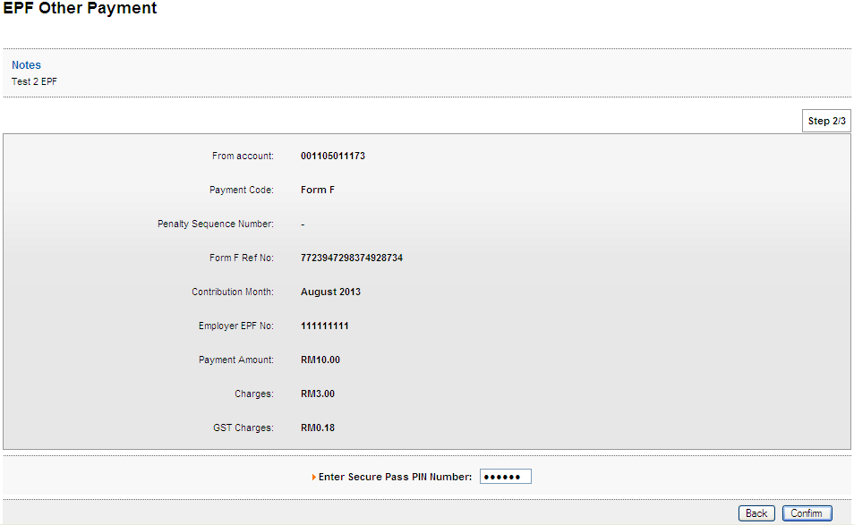
Result Page
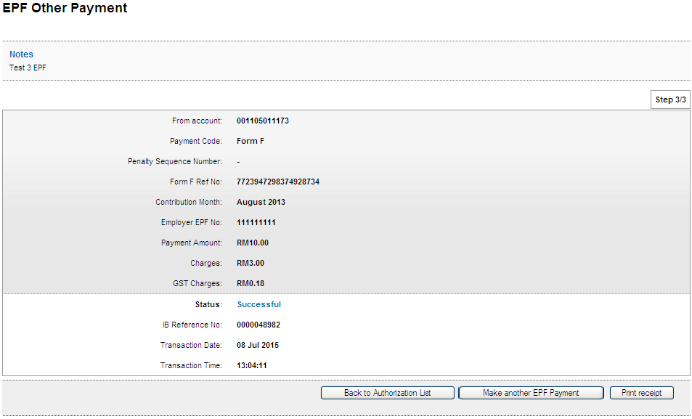
Print Receipt
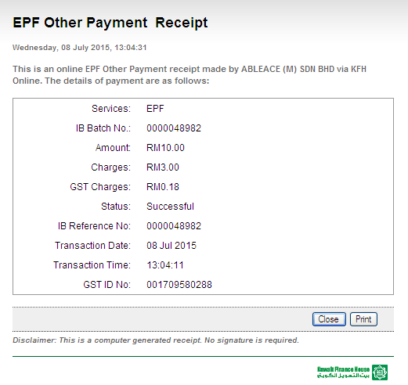
Transaction History
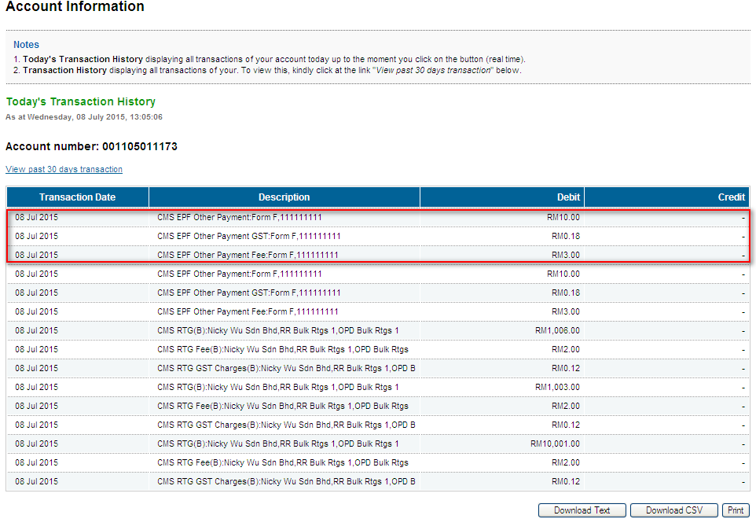

Late Charges Payment
Confirm Page
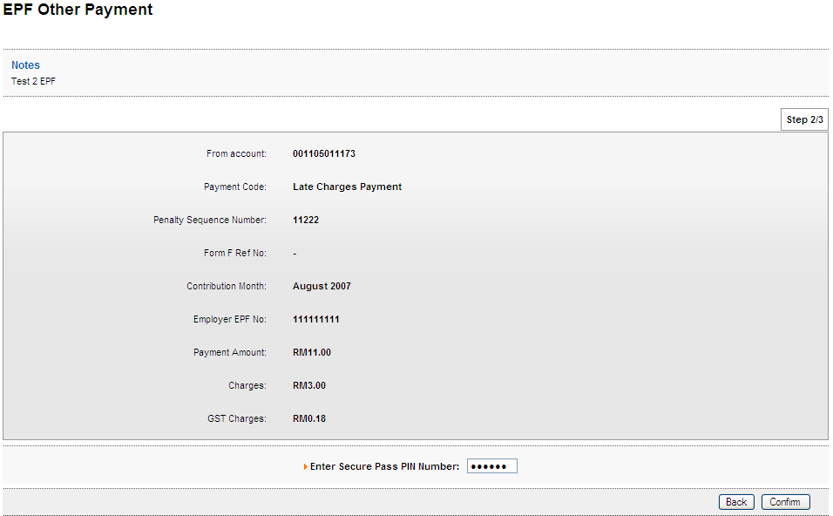
Result Page
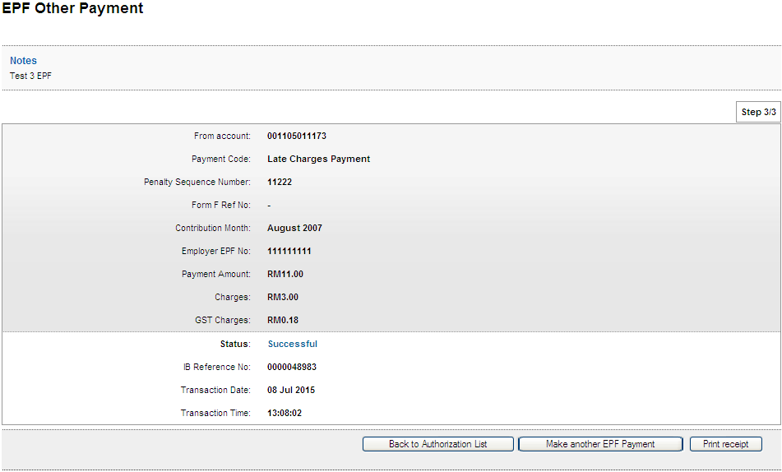
Print Receipt
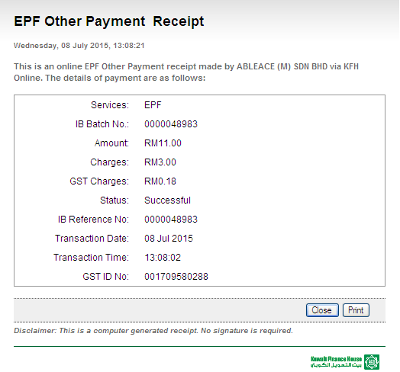
Transaction History
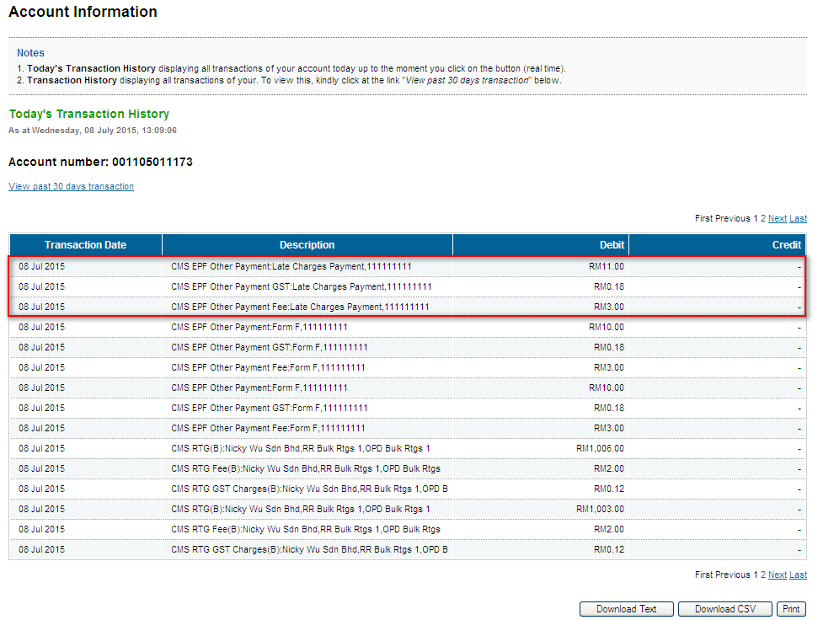

Dividend Loss Payment
Confirm Page
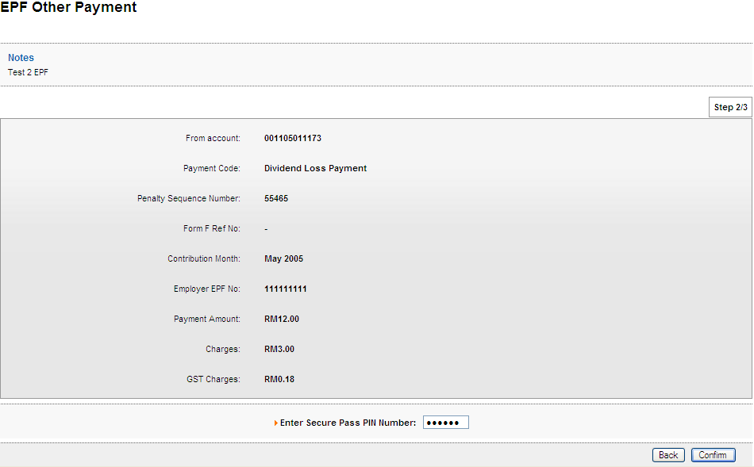
Result Page
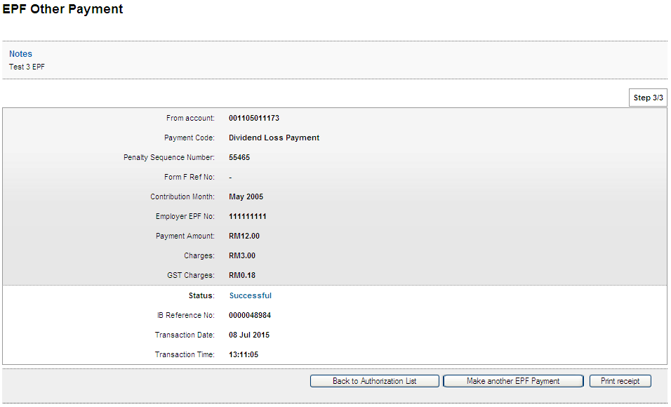
Print Receipt
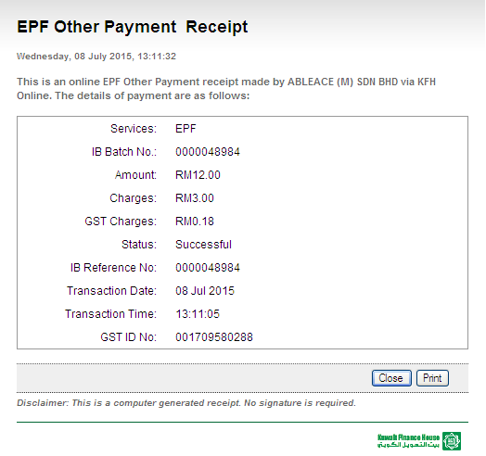
Transaction History
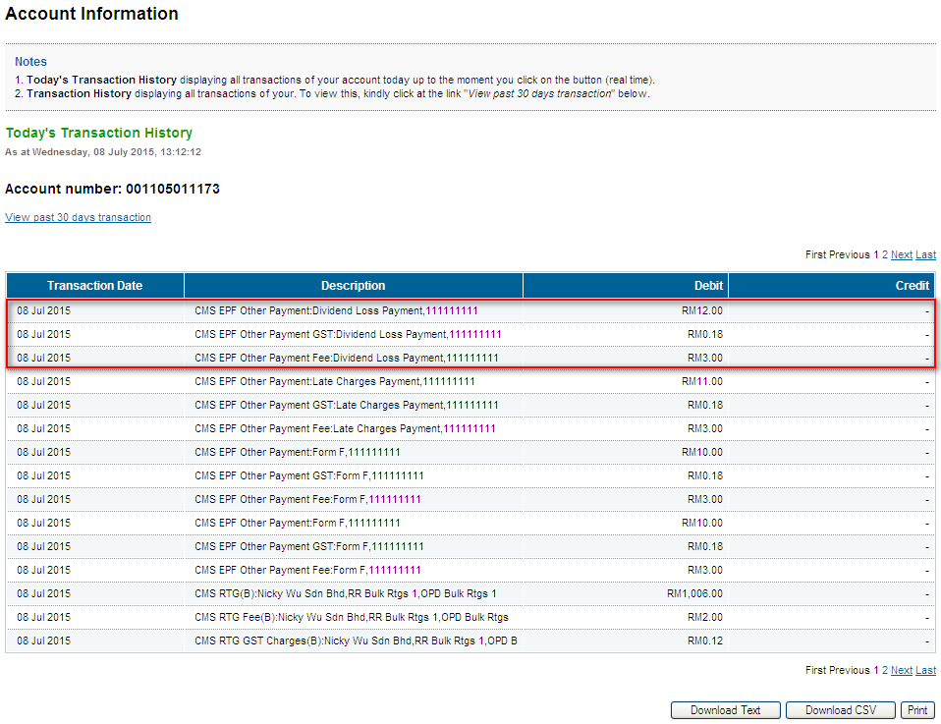

Other Charges
Confirm Page
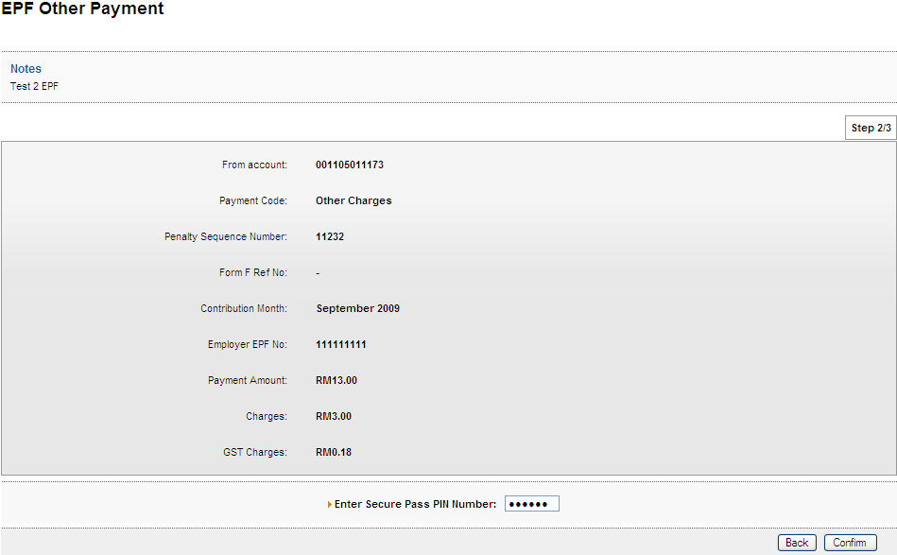
Result Page
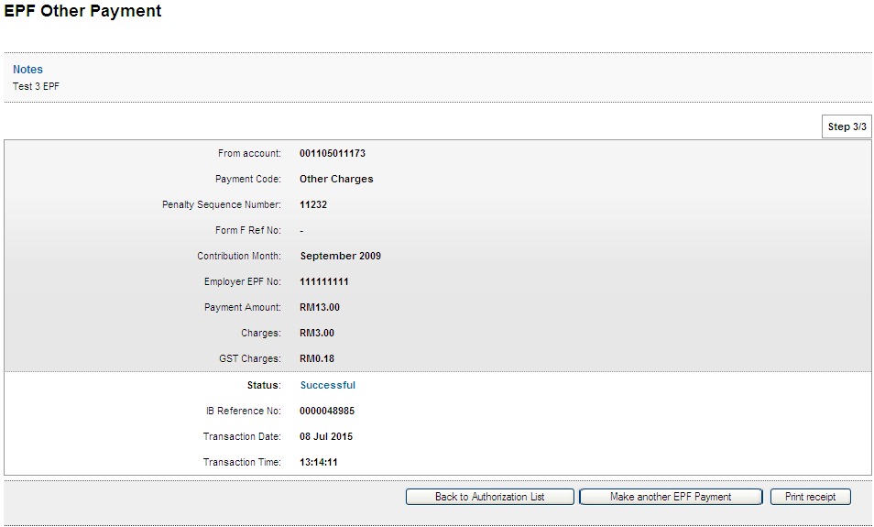
Print Receipt
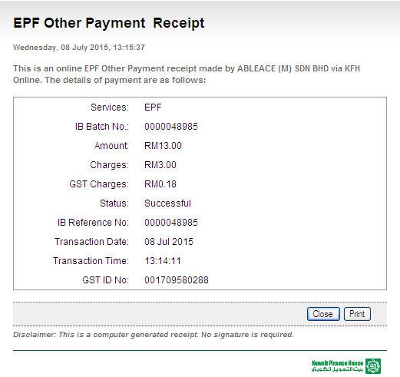
Transaction History
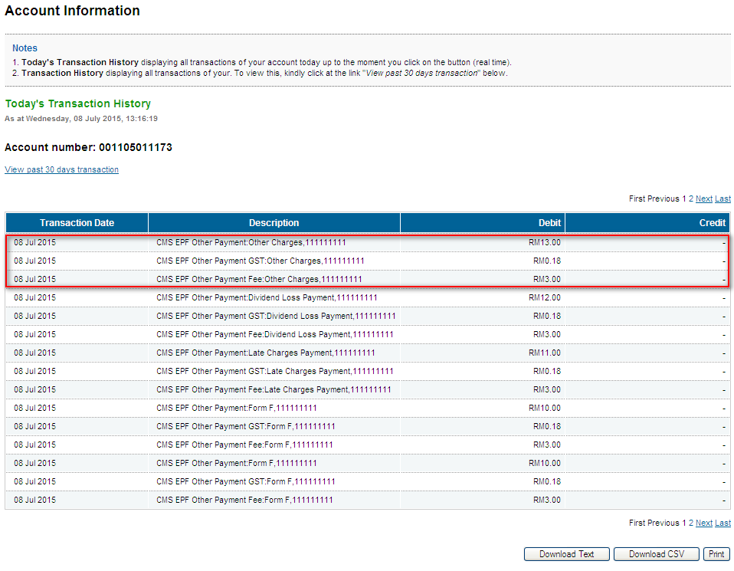

Role: Initiator

Form F
Confirm Page
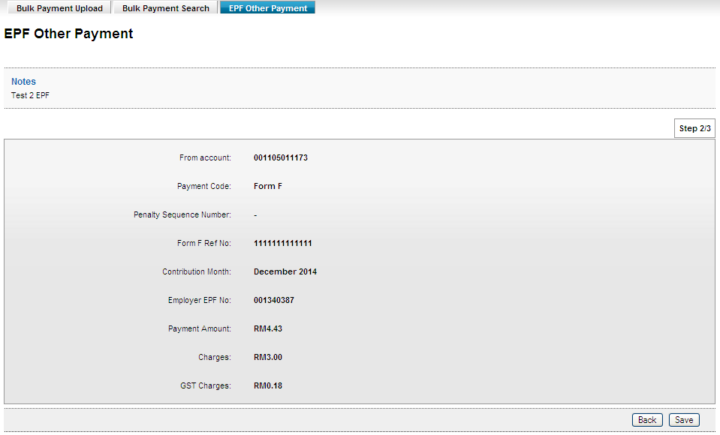

Result Page
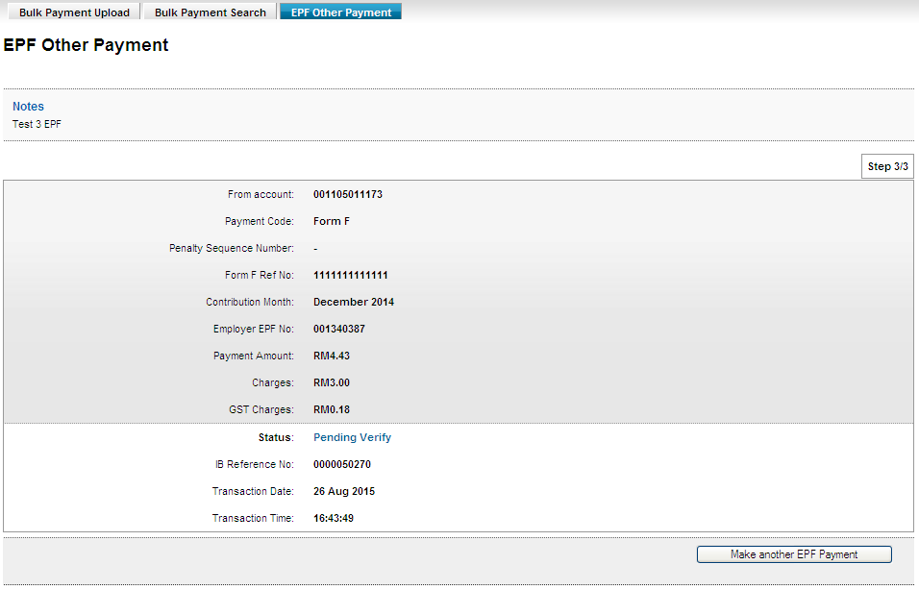

Late Charges Payment
Confirm Page
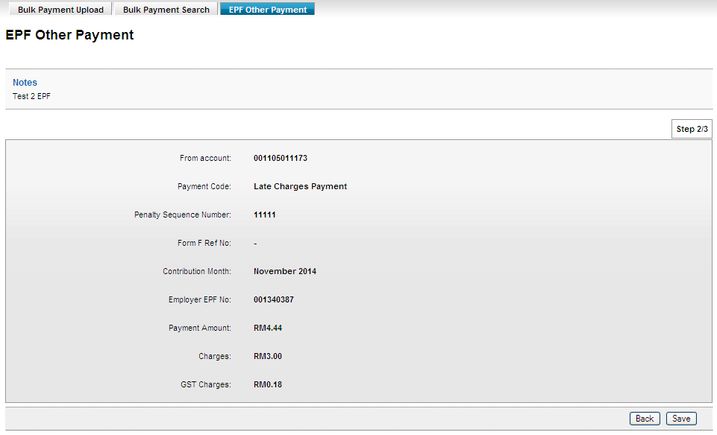
Result Page

Dividend Loss Payment
Confirm Page

Result Page

Other Charges
Confirm Page

Result Page

Role: Verifier

Form F
Confirm Page

Result Page

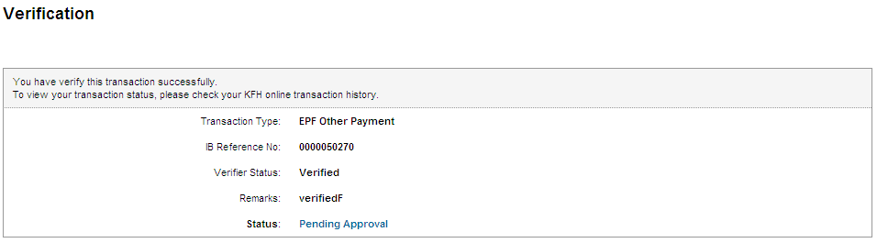

Late Charges Payment
Confirm Page
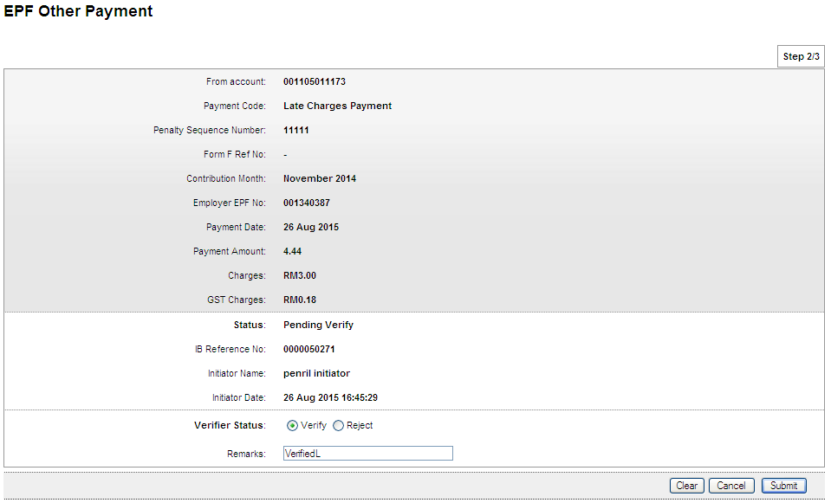

Result Page
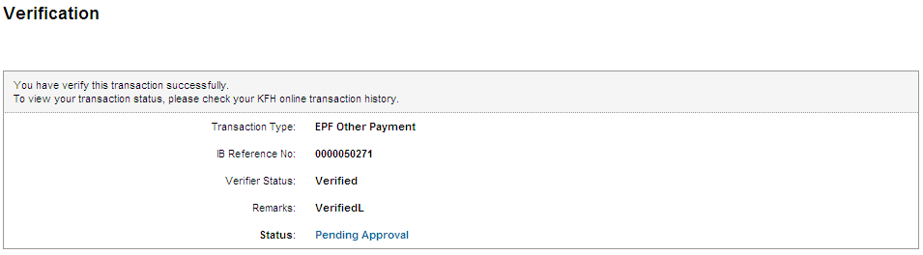

Dividend Loss Payment
Confirm Page
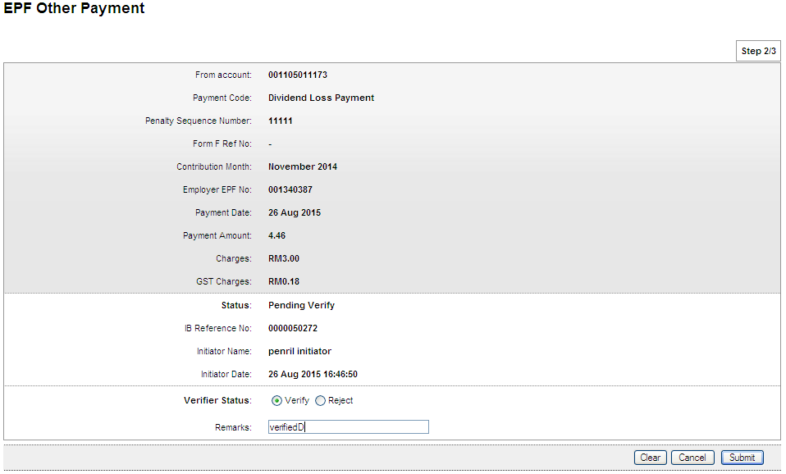

Result Page
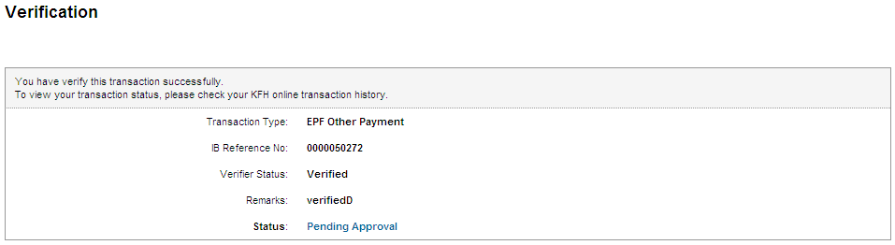

Other Charges
Confirm Page
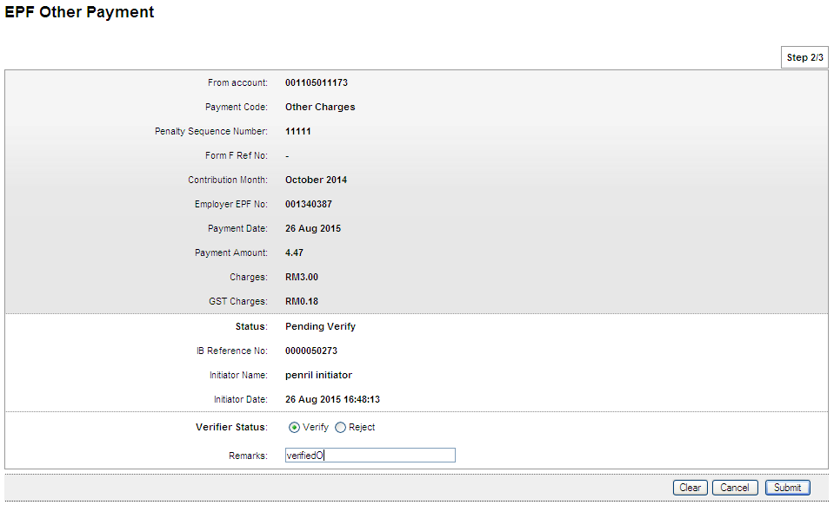

Result Page
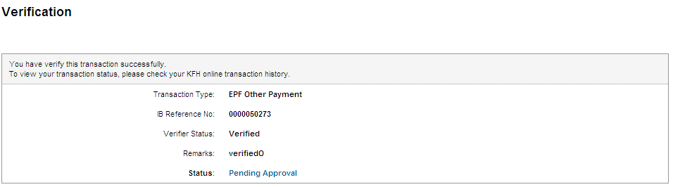

Role: Approver

Form F
Confirm Page
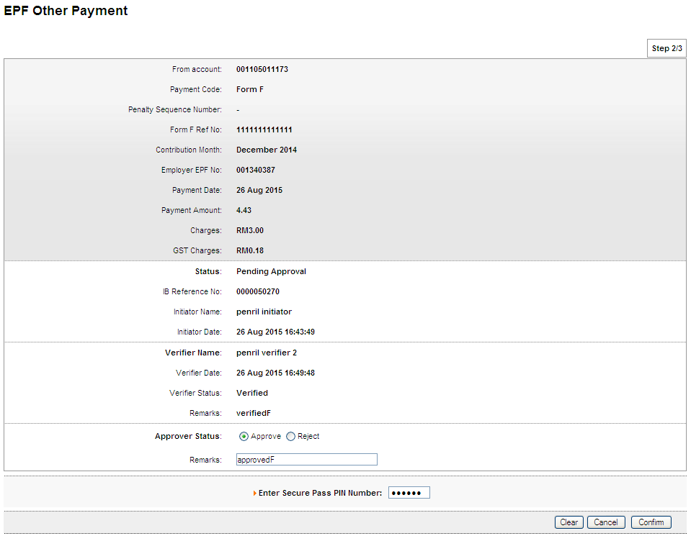

Result Page
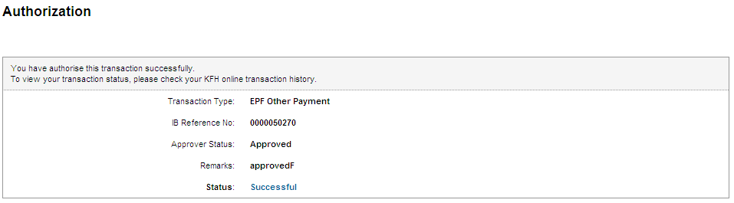

Print Receipt
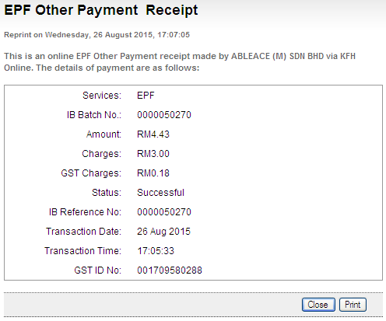

Transaction History
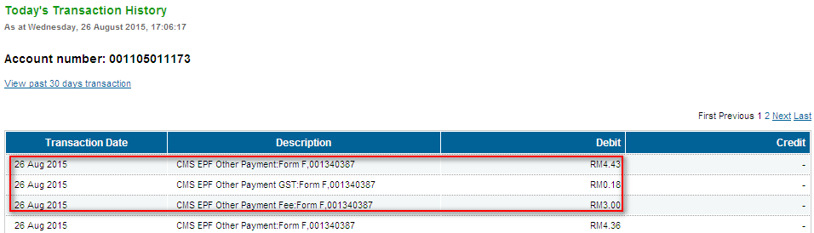

Late Charges Payment
Confirm Page
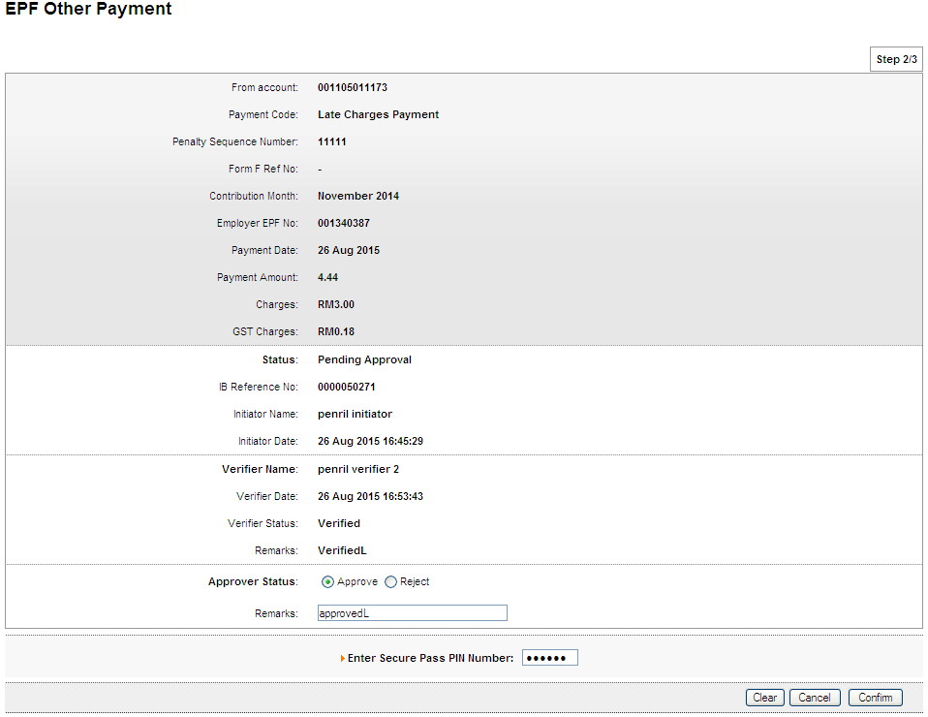

Result Page
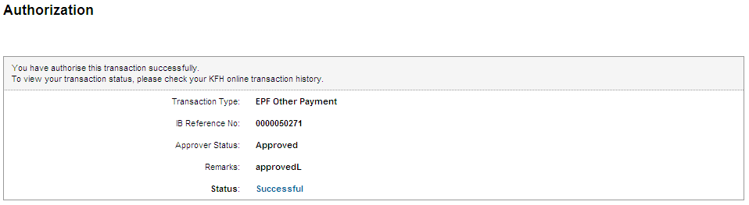

Print Receipt
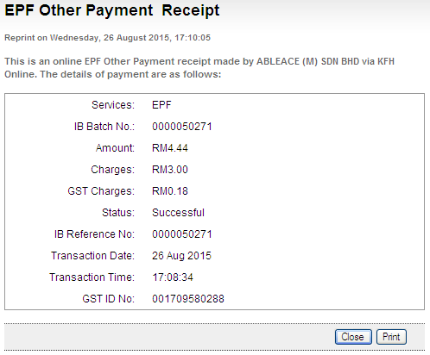

Transaction History
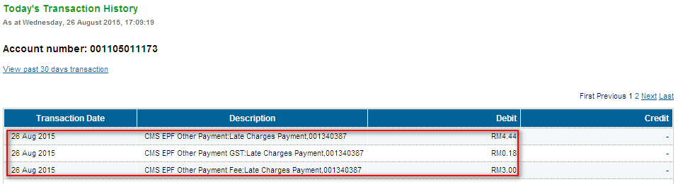

Dividend Loss Payment
Confirm Page
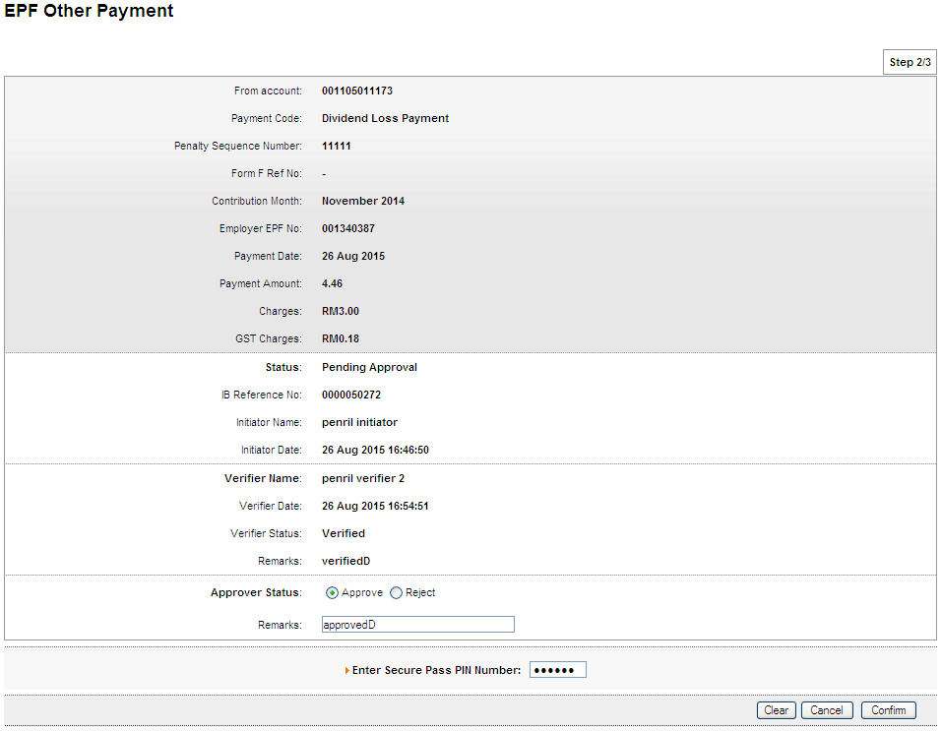

Result Page
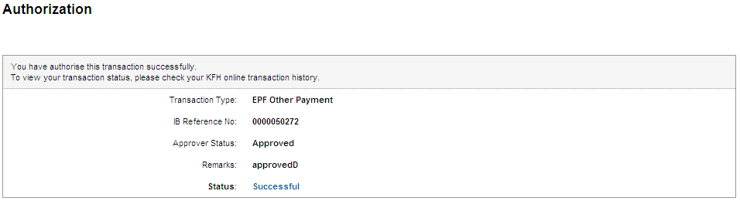

Print Receipt
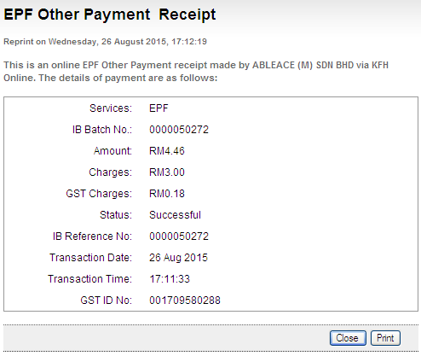

Transaction History
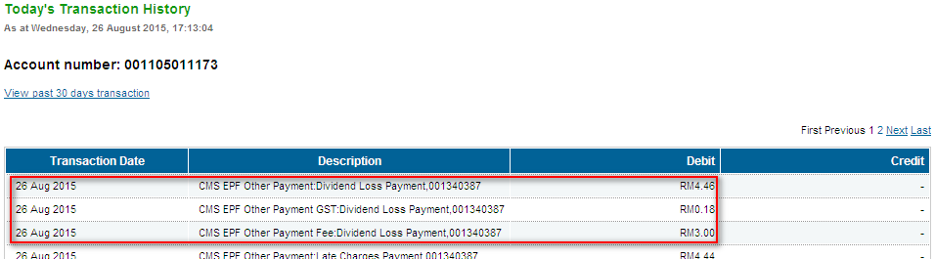

Other Charges
Confirm Page
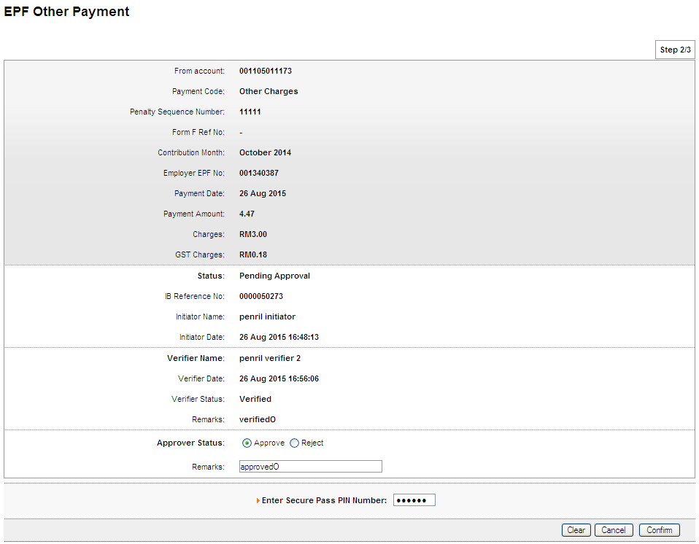

Result Page
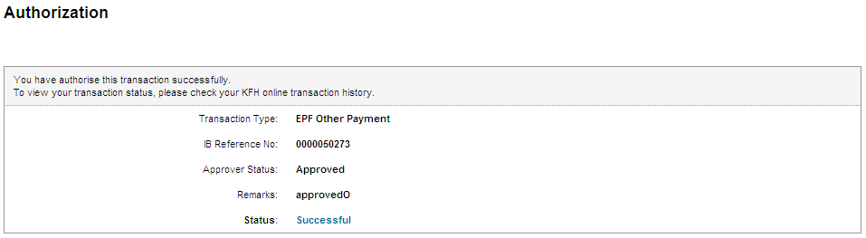

Print Receipt
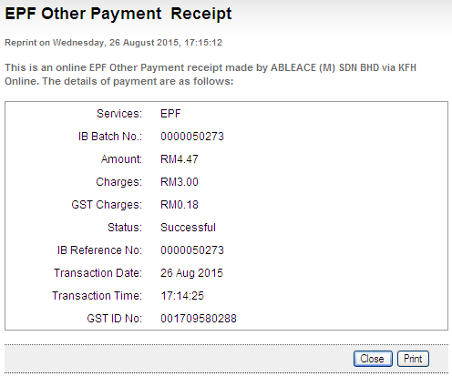

Transaction History

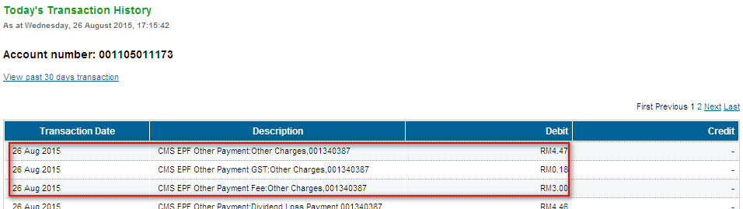

Role: Init-Veri

Form F
Confirm Page
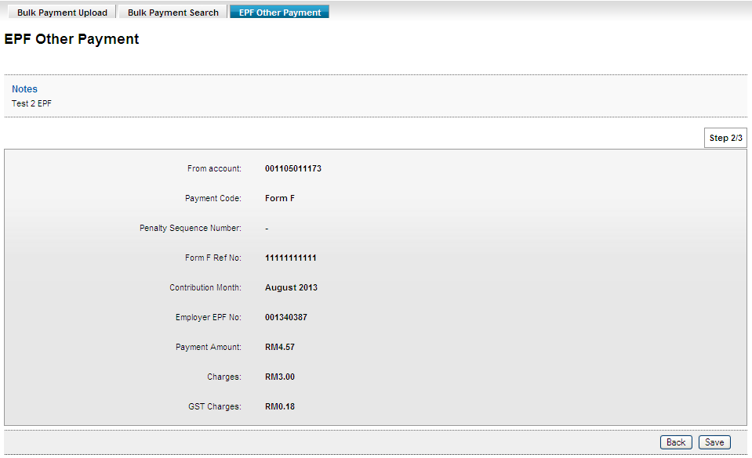
Result Page
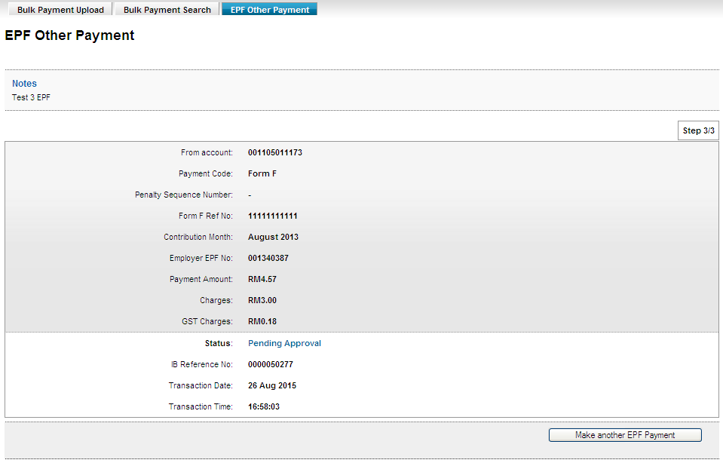

Late Charges Payment
Confirm Page
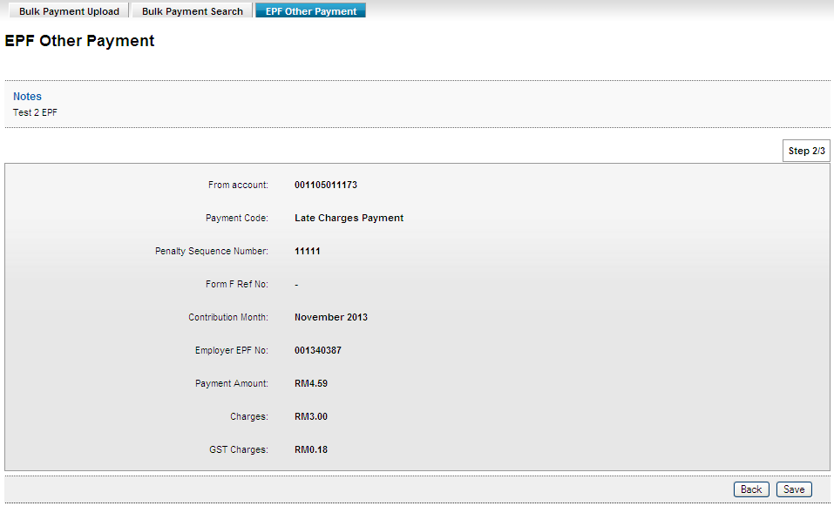

Result Page
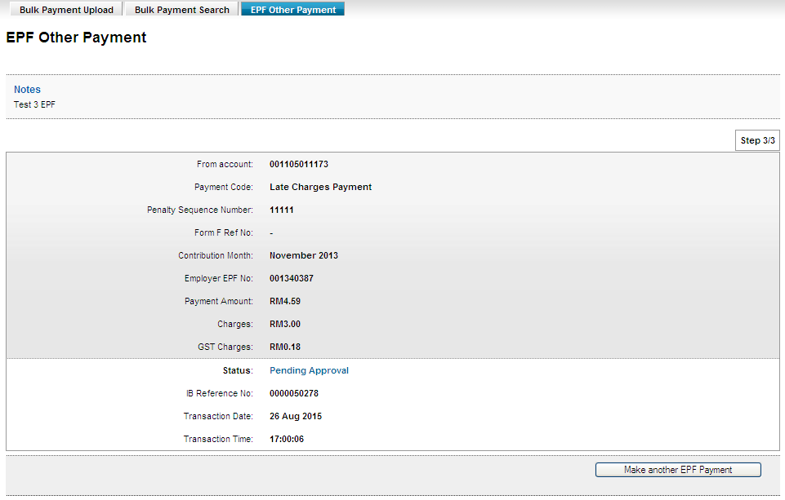

Dividend Loss Payment
Confirm Page
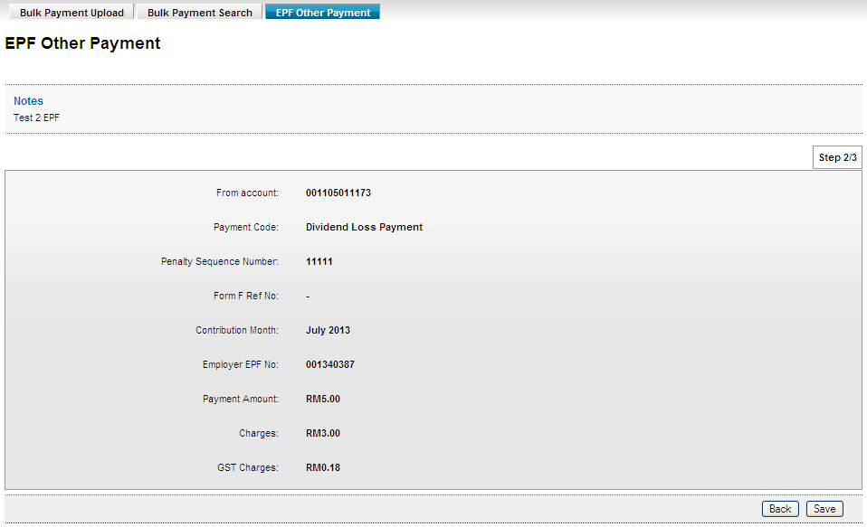

Result Page
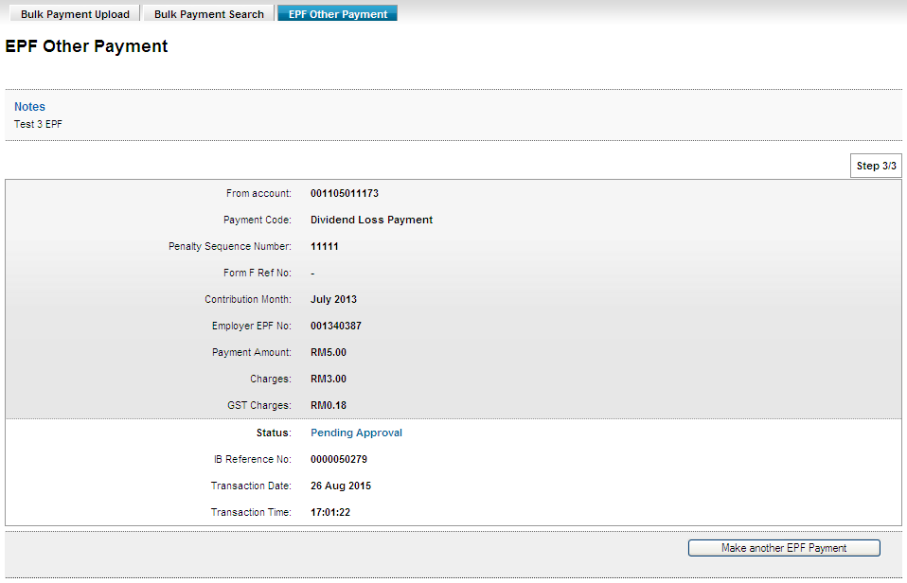

Other Charges
Confirm Page
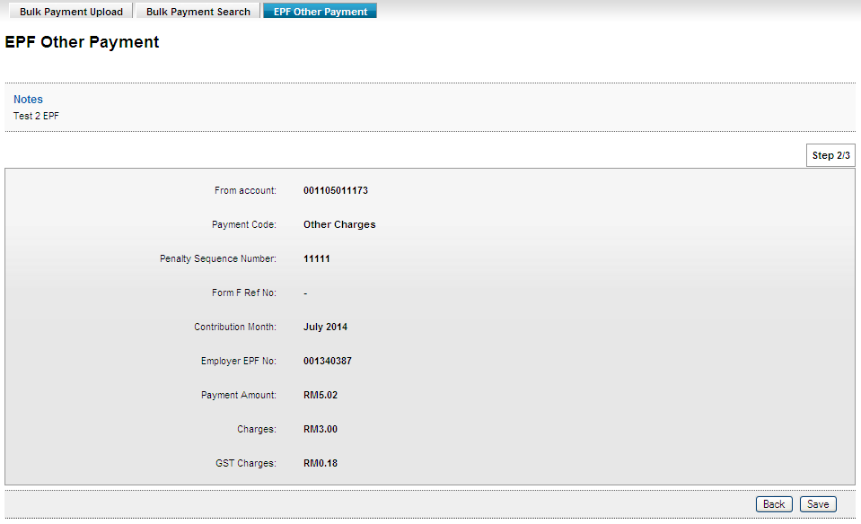

Result Page
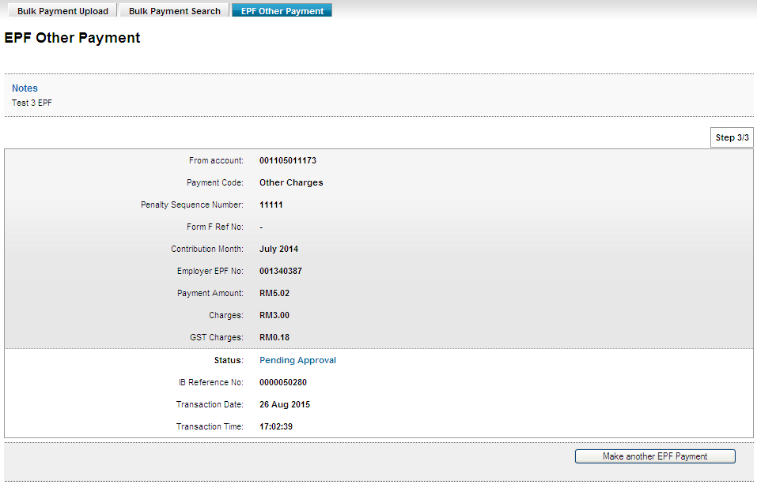

Role: Approver

Form F
Confirm Page
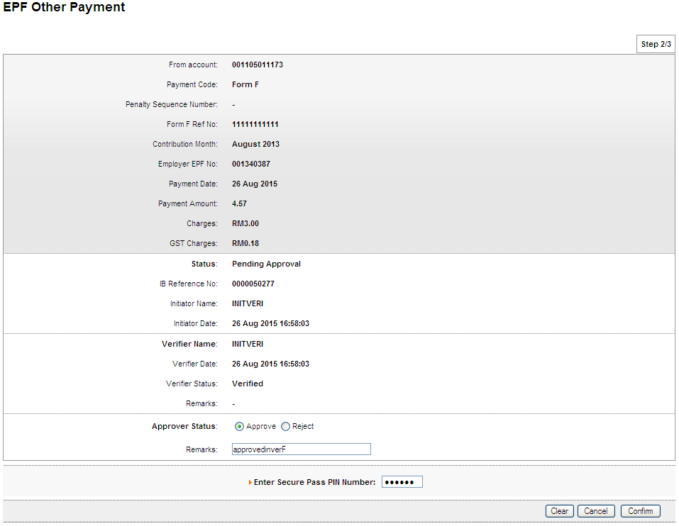

Result Page

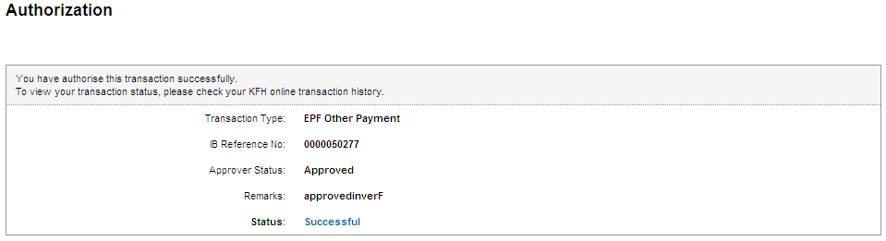

Print Receipt
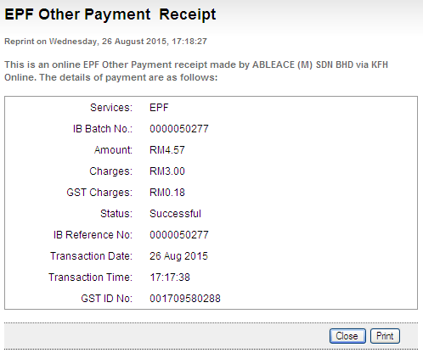

Transaction History
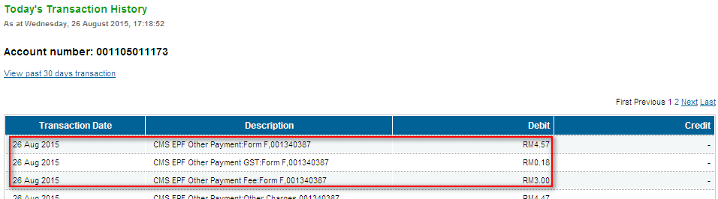

Late Charges Payment
Confirm Page
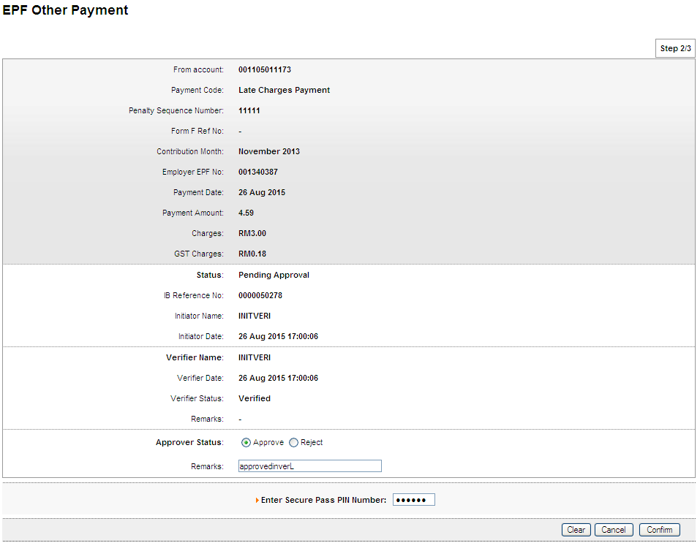

Result Page
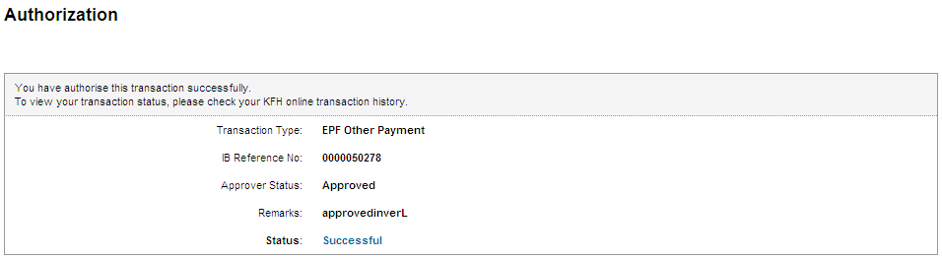

Print Receipt
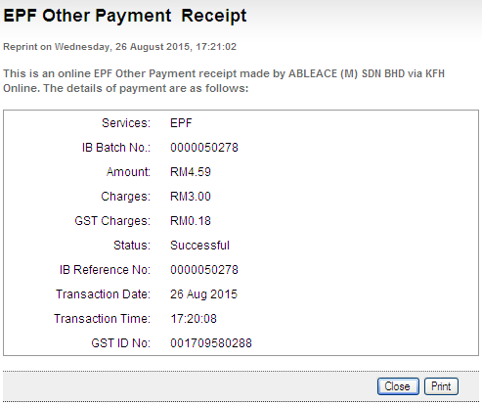

Transaction History
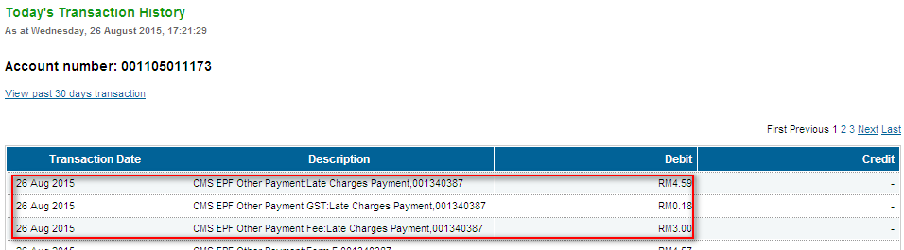

Dividend Loss Payment
Confirm Page
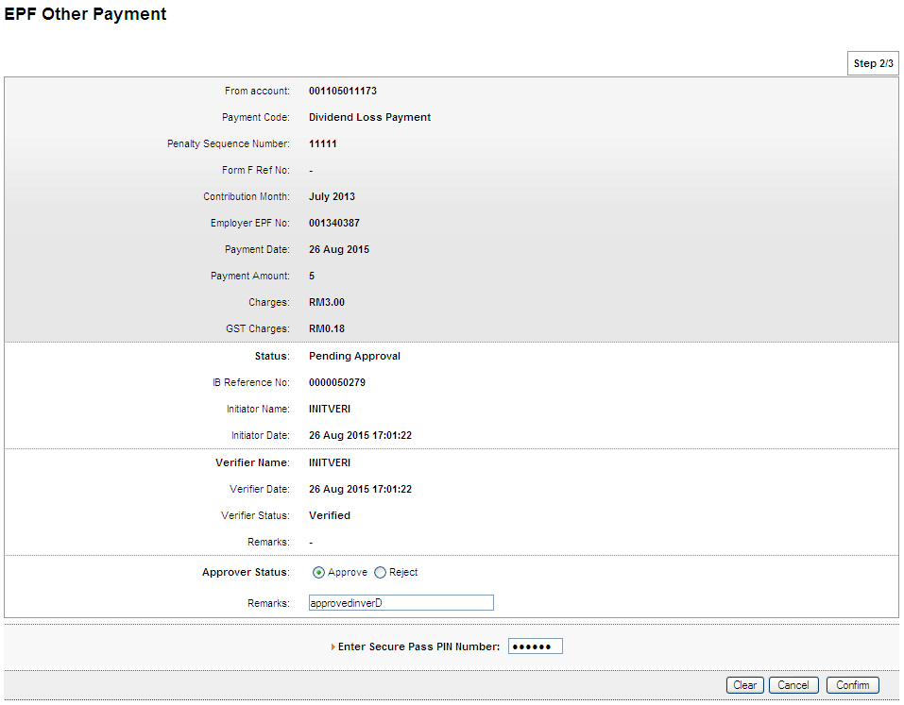

Result Page
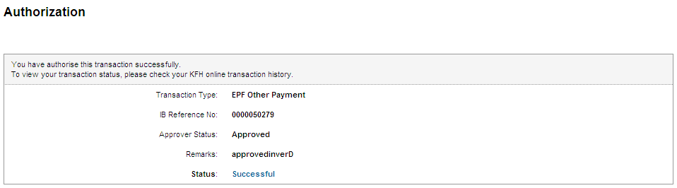

Print Receipt
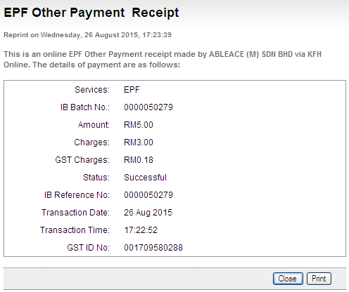

Transaction History
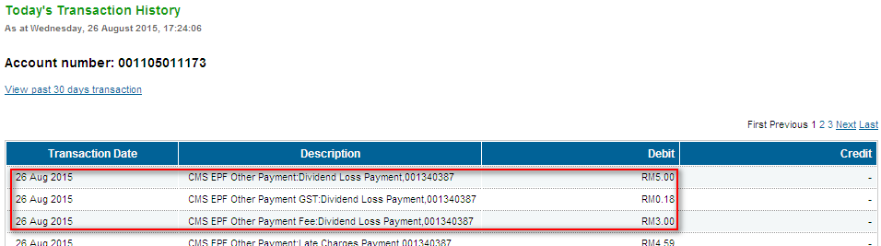

Other Charges
Confirm Page
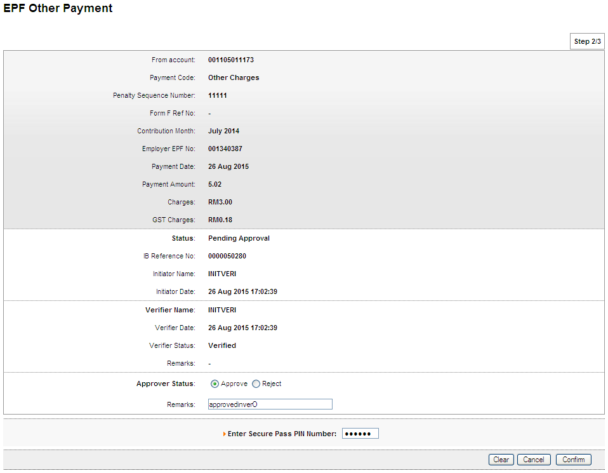

Result Page
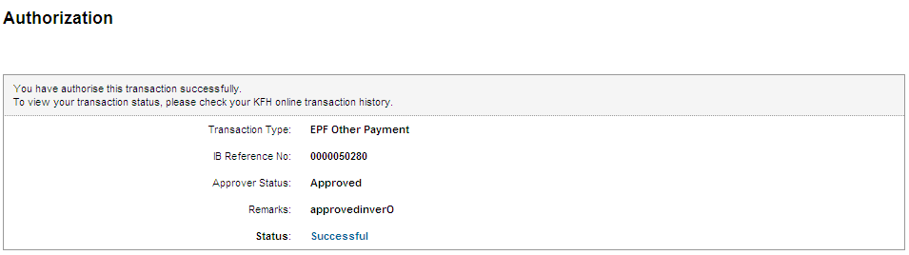

Print Receipt
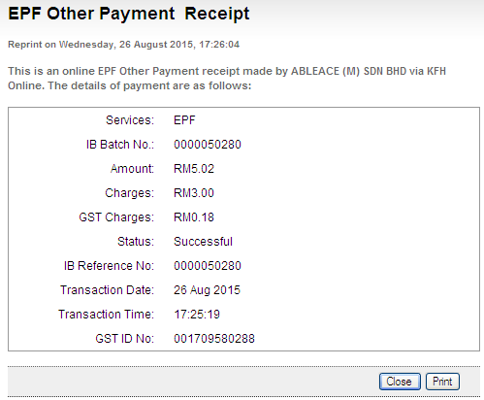

Transaction History
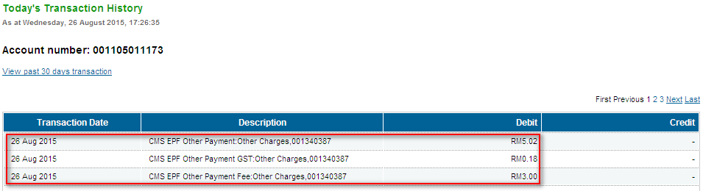

Bulk EPF Upload

Role: Approver All

Confirm Page
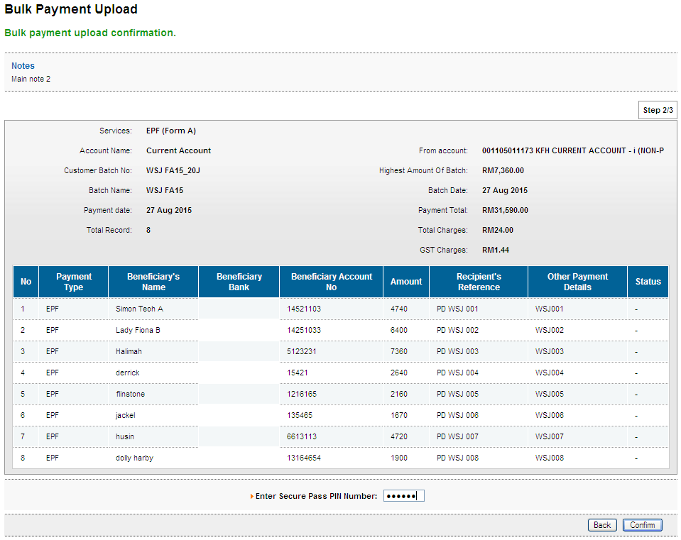

Result Page
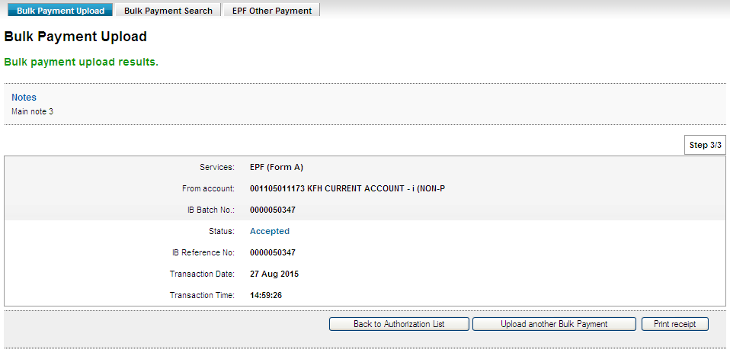
Print Receipt
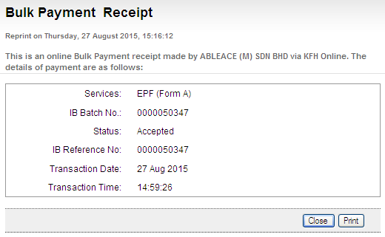
Transaction History
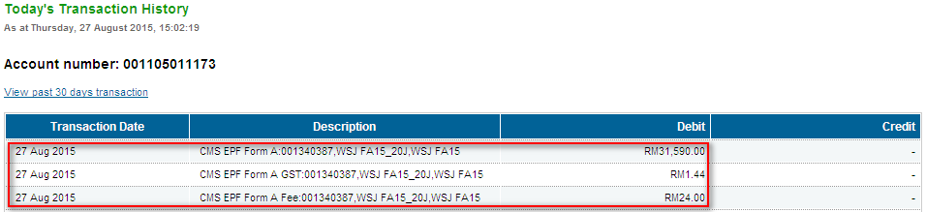

Role: Initiator
Confirm Page
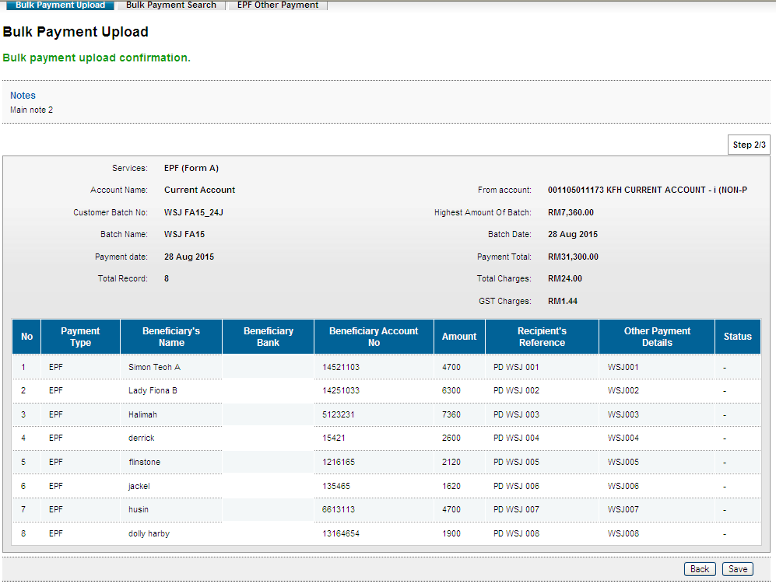
Result Page
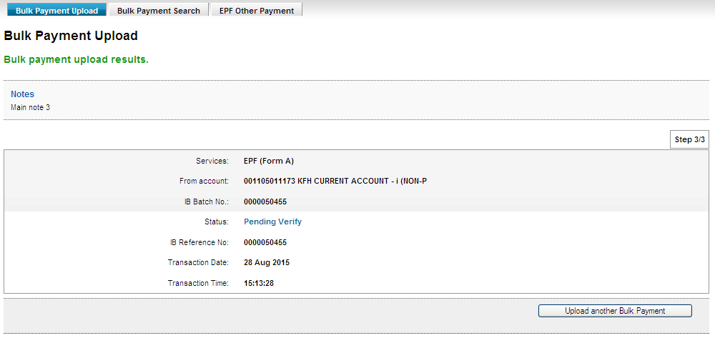

Role: Verifier
Confirm Page
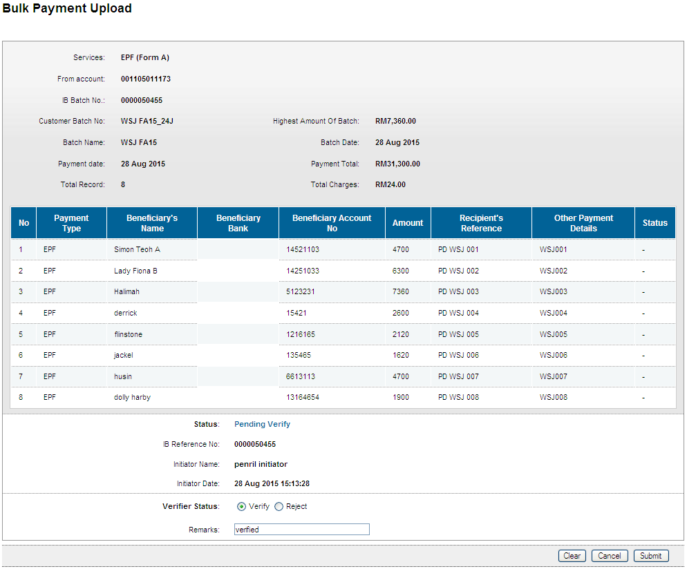
Result Page
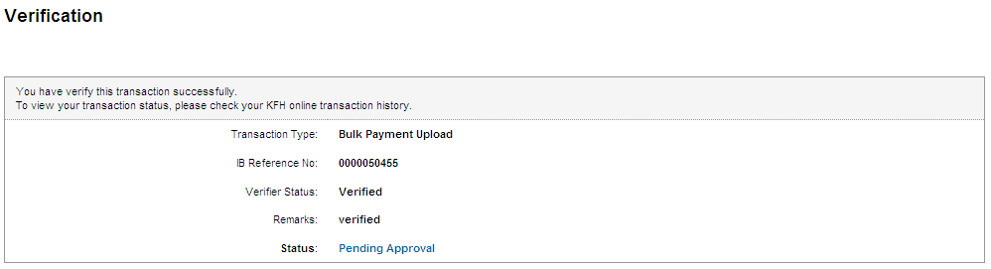

Role: Approver
Confirm Page
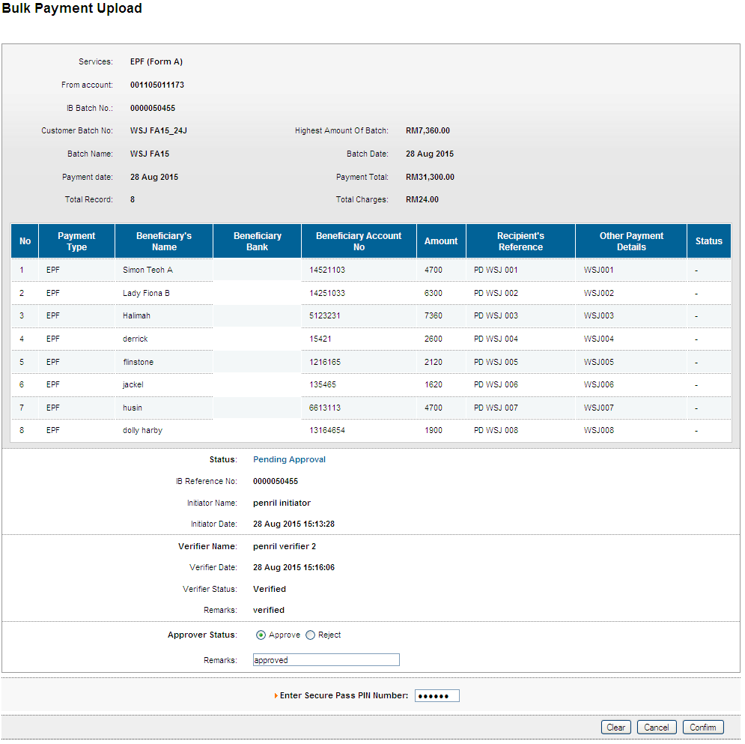
Result Page
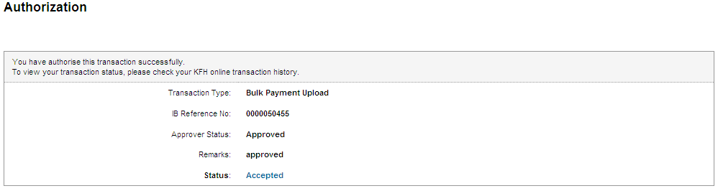
Print Receipt
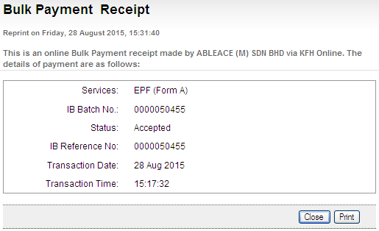

Transaction History
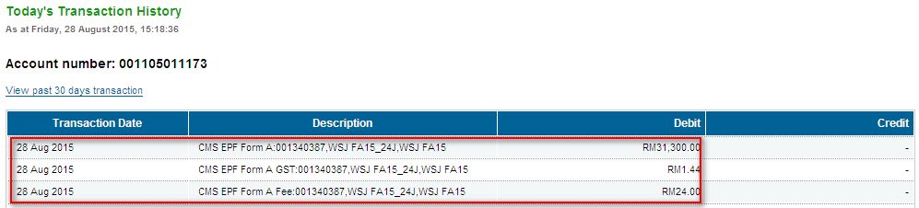

Role: Init + Veri
Confirm Page
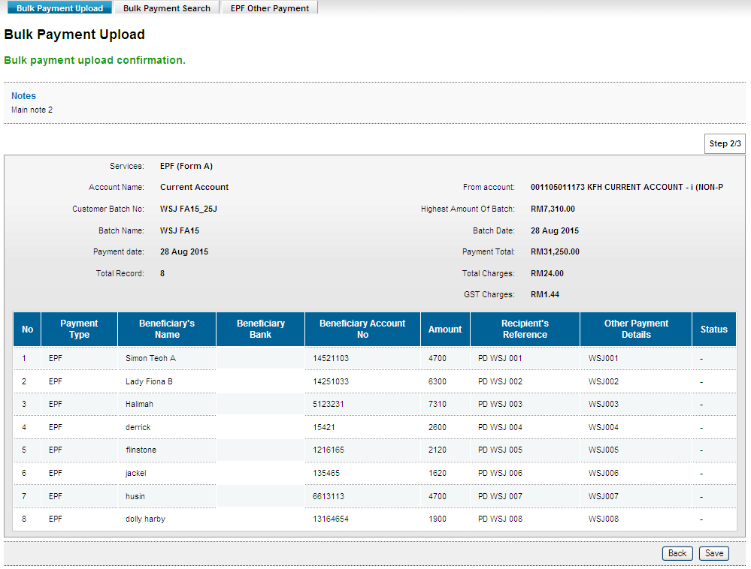
Result Page
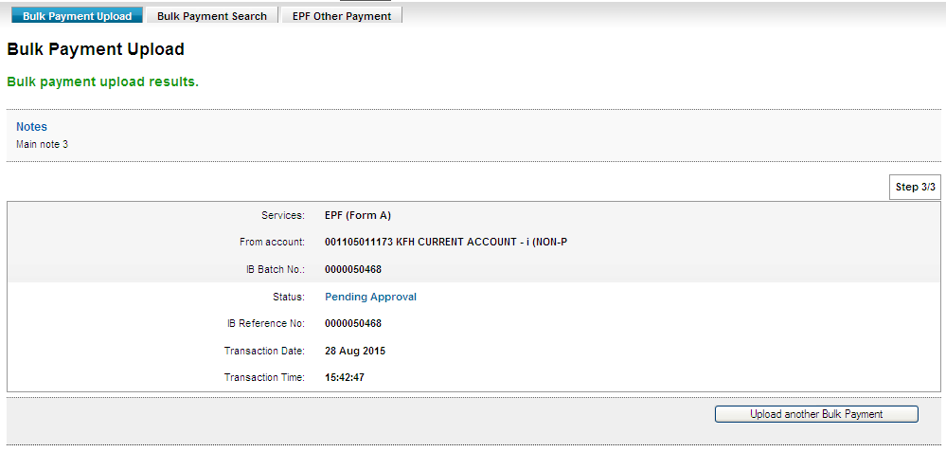

Role: Approver
Confirm Page
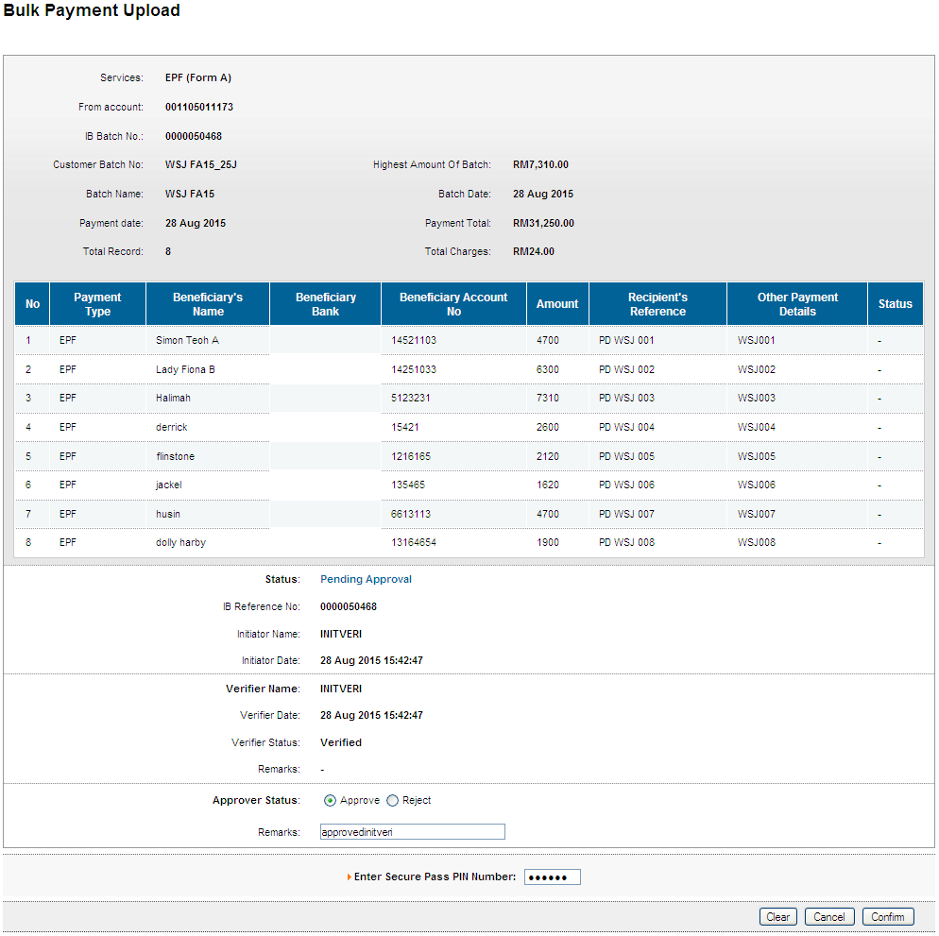
Result Page
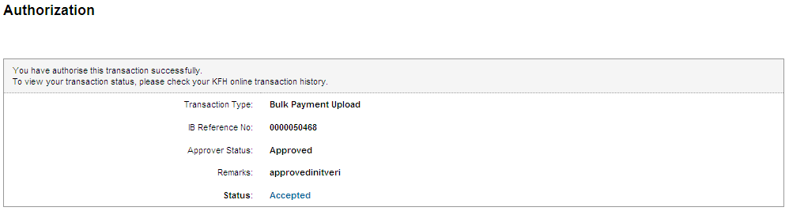
Print Receipt
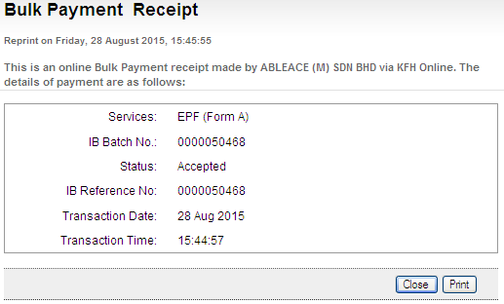
Transaction History
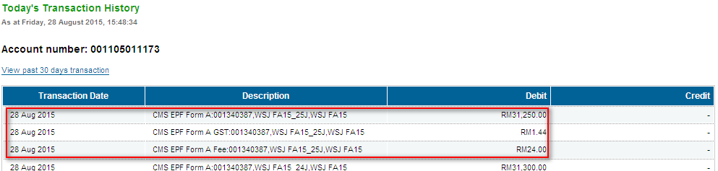

Reviewed By: (PMO)
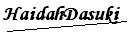 |  | Name/Position : NorhaidahBintiMdDasuki / Senior Manager, Quality Assurance and Support  Date :

