Originator's Name: Chooi So Fun  Project: Banker’s Chq & Demand Draft  Project Manager: Malarvily Muniandy / Christopher Gunn  Owner: PDM / RCB  Date Raised: 02.11.10  Phase/Process:  Functional Area: Consumer | Issue ID Number: BCA-DDA-UAT-C032  Related ID Number:  Priority: High / Medium / Low  Assigned to:  Target Resolution Date:  Actual Closed Date:
Status : Open / Investigate / Retest / Re-Open / Closed / Sign-Off (Circle one)
Category : Bugs / Set-up / Clarification / Repeated / Internal CR / CR (Circle one)
Description:
Application Enquiry – Reprint for Banker’s Cheque Application
1) Address 3 and State are missing in the application form
2) Mode of Payment: Please follow the note as per in Demand Draft Application -
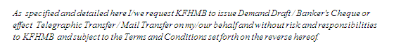

(Refer to screen attached below for further details)
Impact:

Investigation (Description):

Action:

Estimated Impact:

Recommendation:

Accepted (PENRIL/SA/IT):  Date: | Accepted (KFHMB):  Date:
Associated Risk Report: | Risk Report Accepted Date:
Associated Change Request Form: | Change Control Accepted on:

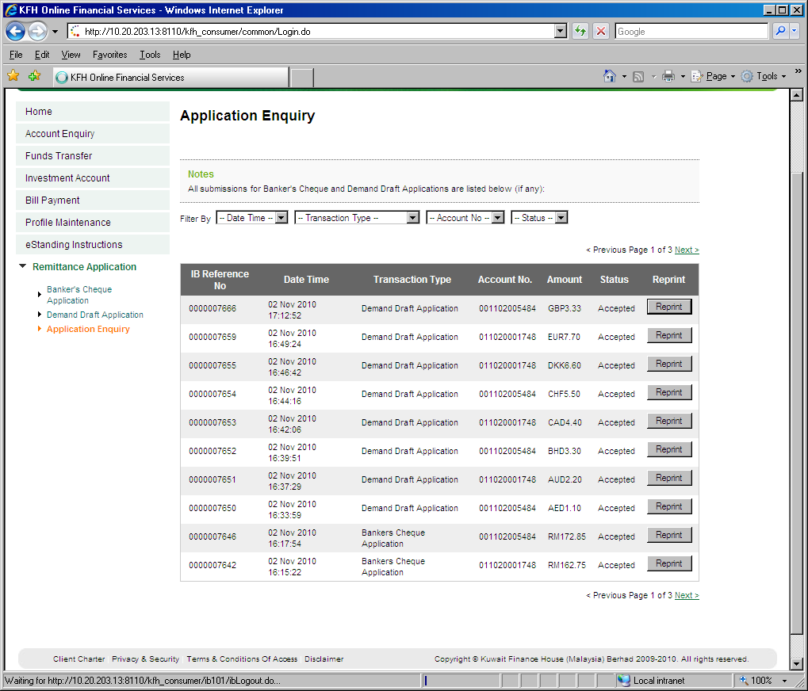
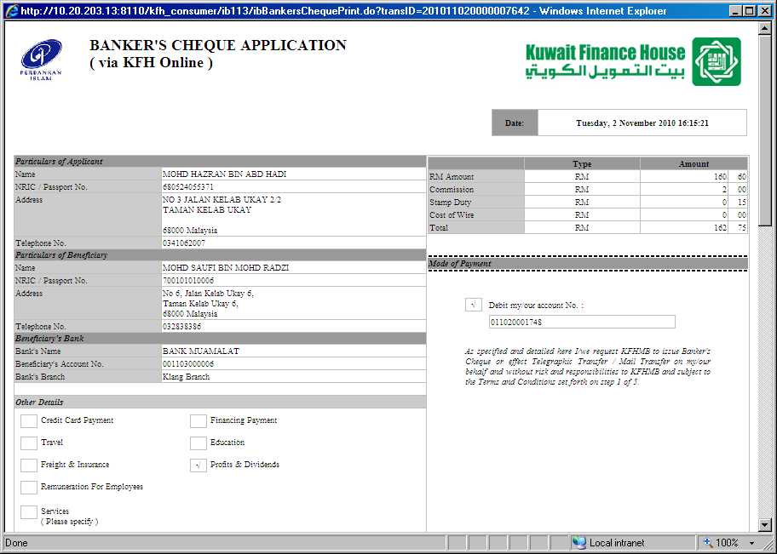
Address 3 and
State are missing
Pls follow as per in Demand Draft Application

