Retail Internet Banking (RIB)

ELECTRONIC BANKING GROUP

Project Name | Retail Internet Banking (RIB)
SR No. | 2755
Prepared by | Gabbytian Rayvandy | Version | 1.0

Test Case No : |  | BII-MSS-SIT / Bug #5414 / ##2755##
Test Objectives : |  | MSS – Edit Customer Profile via Maker Checker  - To check that Customer Profile Edit function can be performed with fast process.
Step No. | Actions |  | Steps | Expected Result | Pass / Fail | Actual Result
1 | Update Customer Profile Using Maker Checker |  | - Login in MSS as user : MSSMaker1.  - Password : Bii123456 / Bypass  - RIB, Customer Profile, search ribuser1,  - Click edit,  - Change email, customer type, and CIF.  - Click next, | - Confirm page shall show updated email, customer type and CIF. | Pass | - OK
2 |  |  | - Click submit. | - Result page shall show successful and pending for approval,  - Shall show this result page in less than 10 seconds. | Pass | - OK
3 |  |  | - Login in MSS as user : mssappr1  - Go to Authorization, approval, click on pending item, | - Confirm page shall show before and after changes details correctly. | Pass | - OK
 |  |  | - Choose Approve, and key in reason,  - Click submit. | - It shall say pending item approved succesfully,  - Shall show this result page in less than 10 seconds. | Pass | - OK
Remark :

Attachment :

MSS – Update Customer Profile

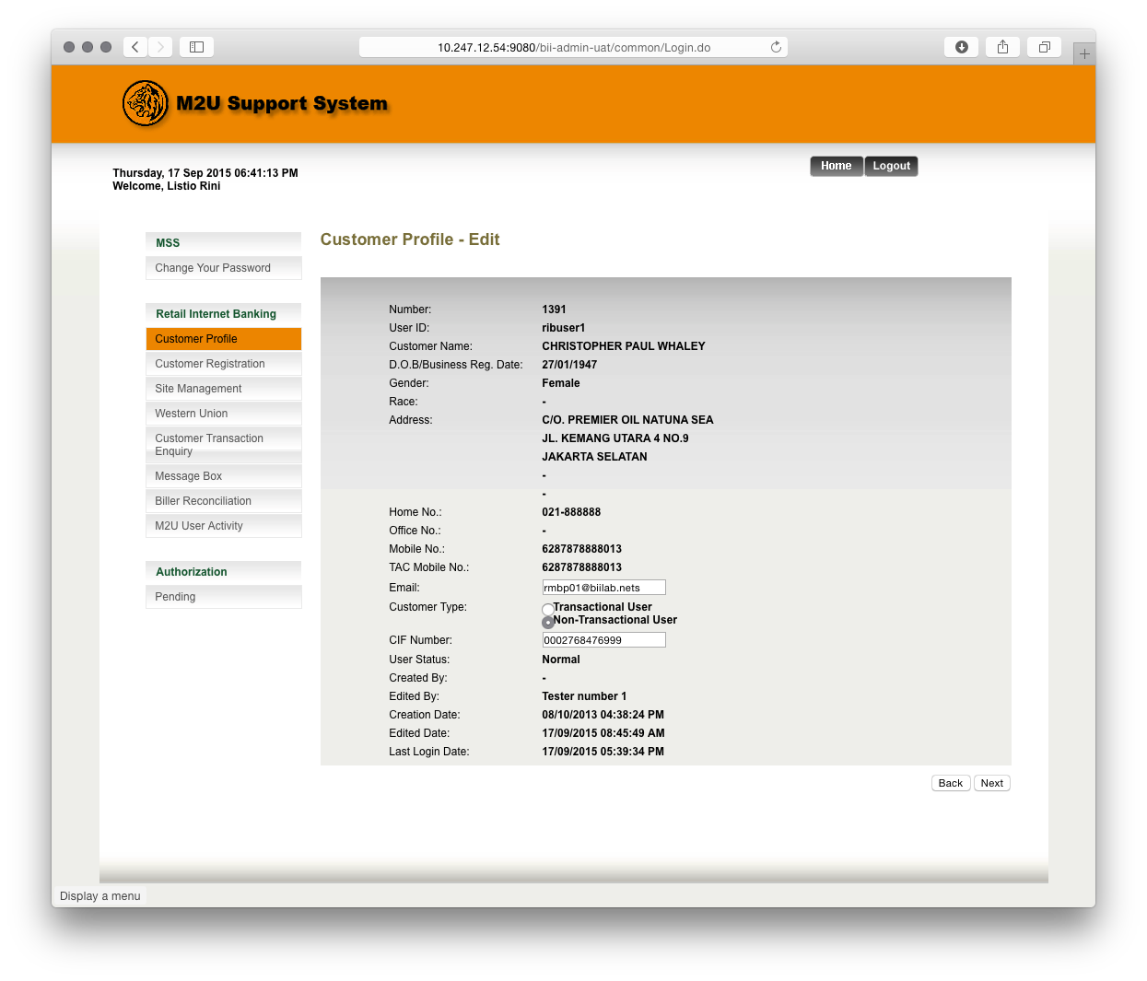
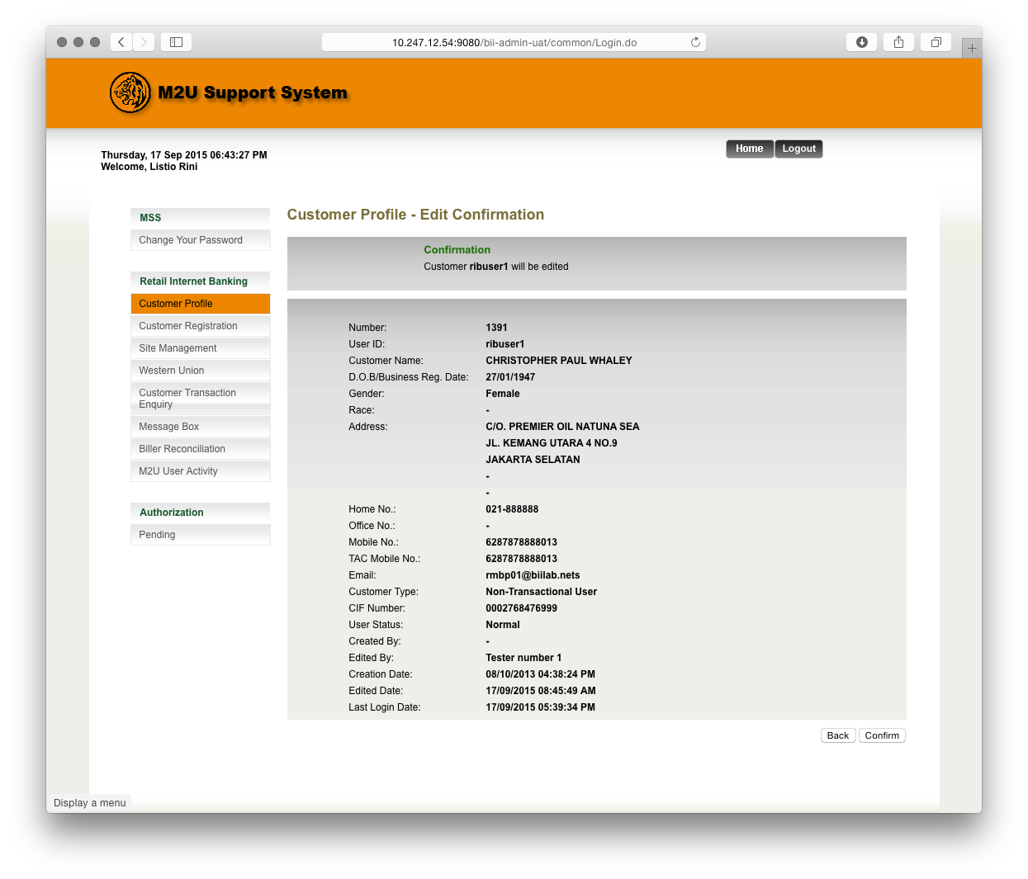
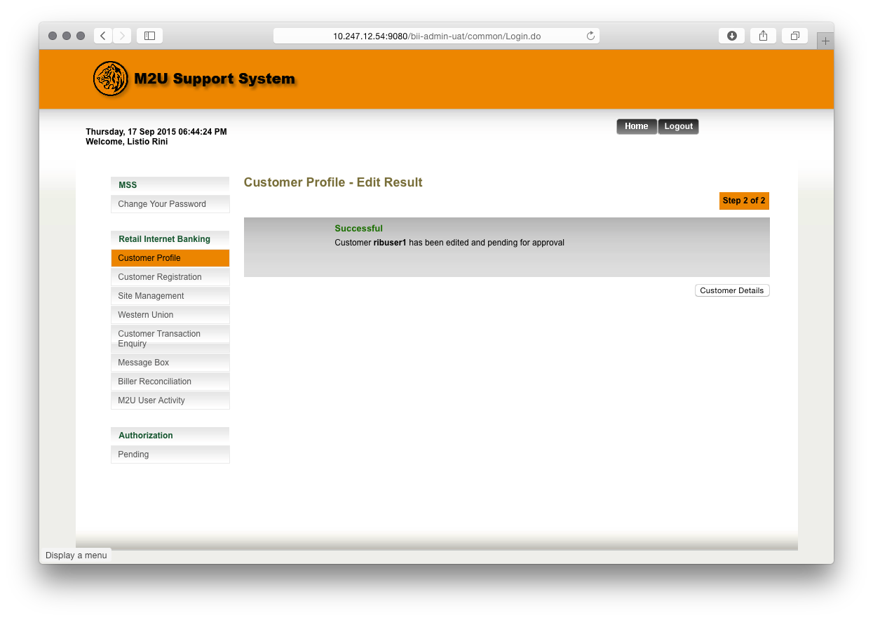
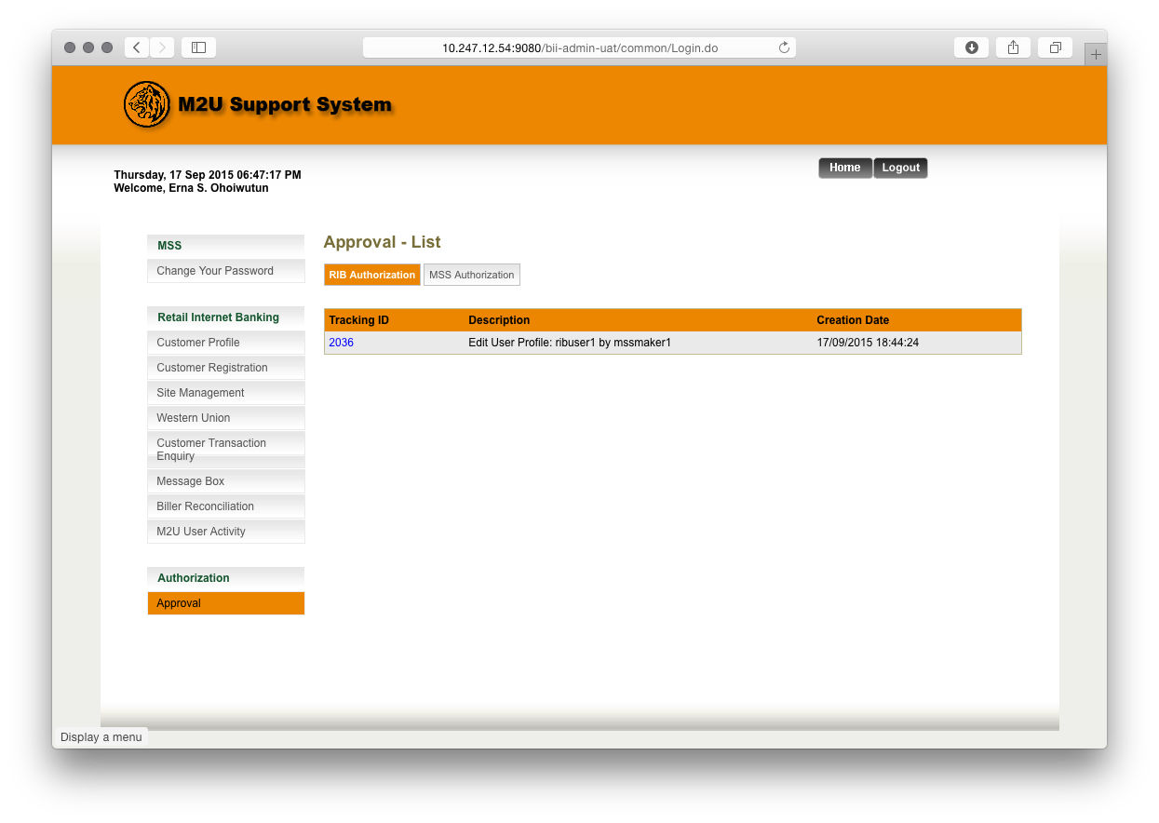
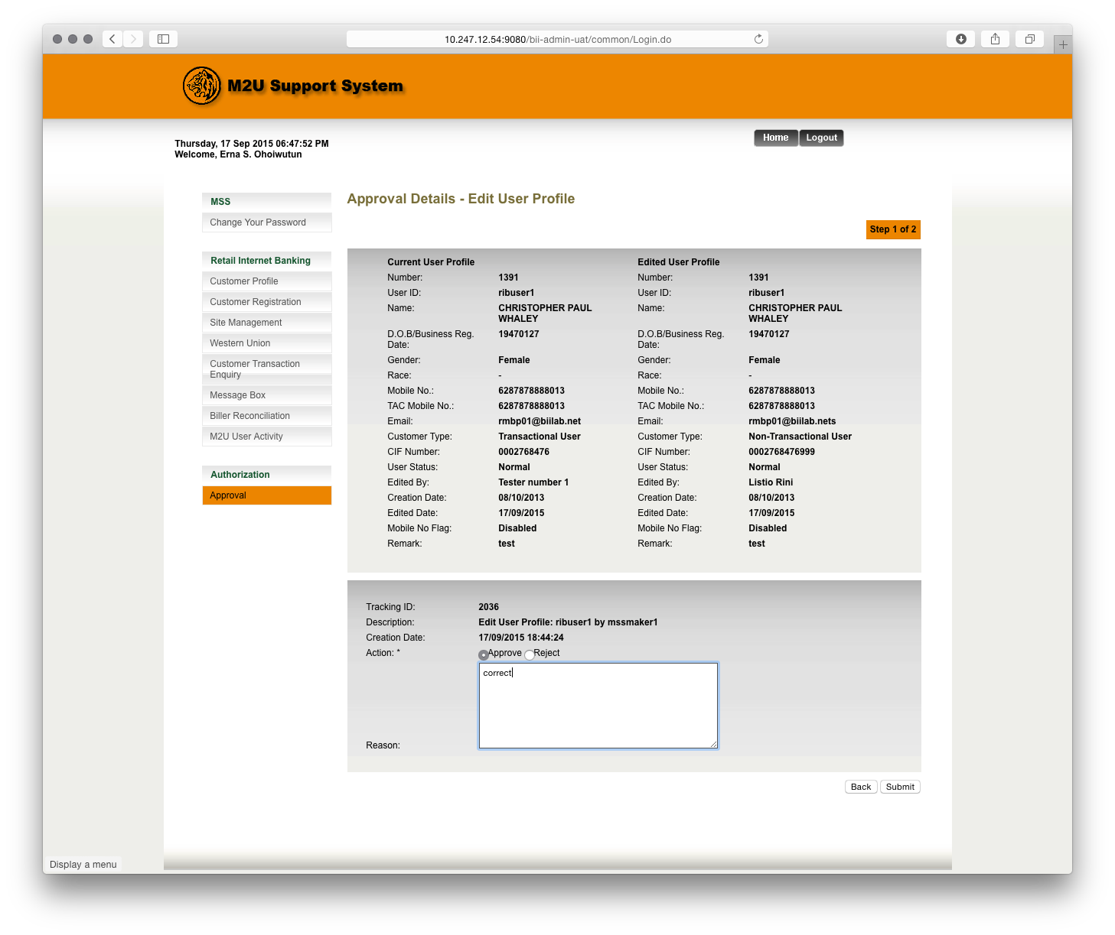
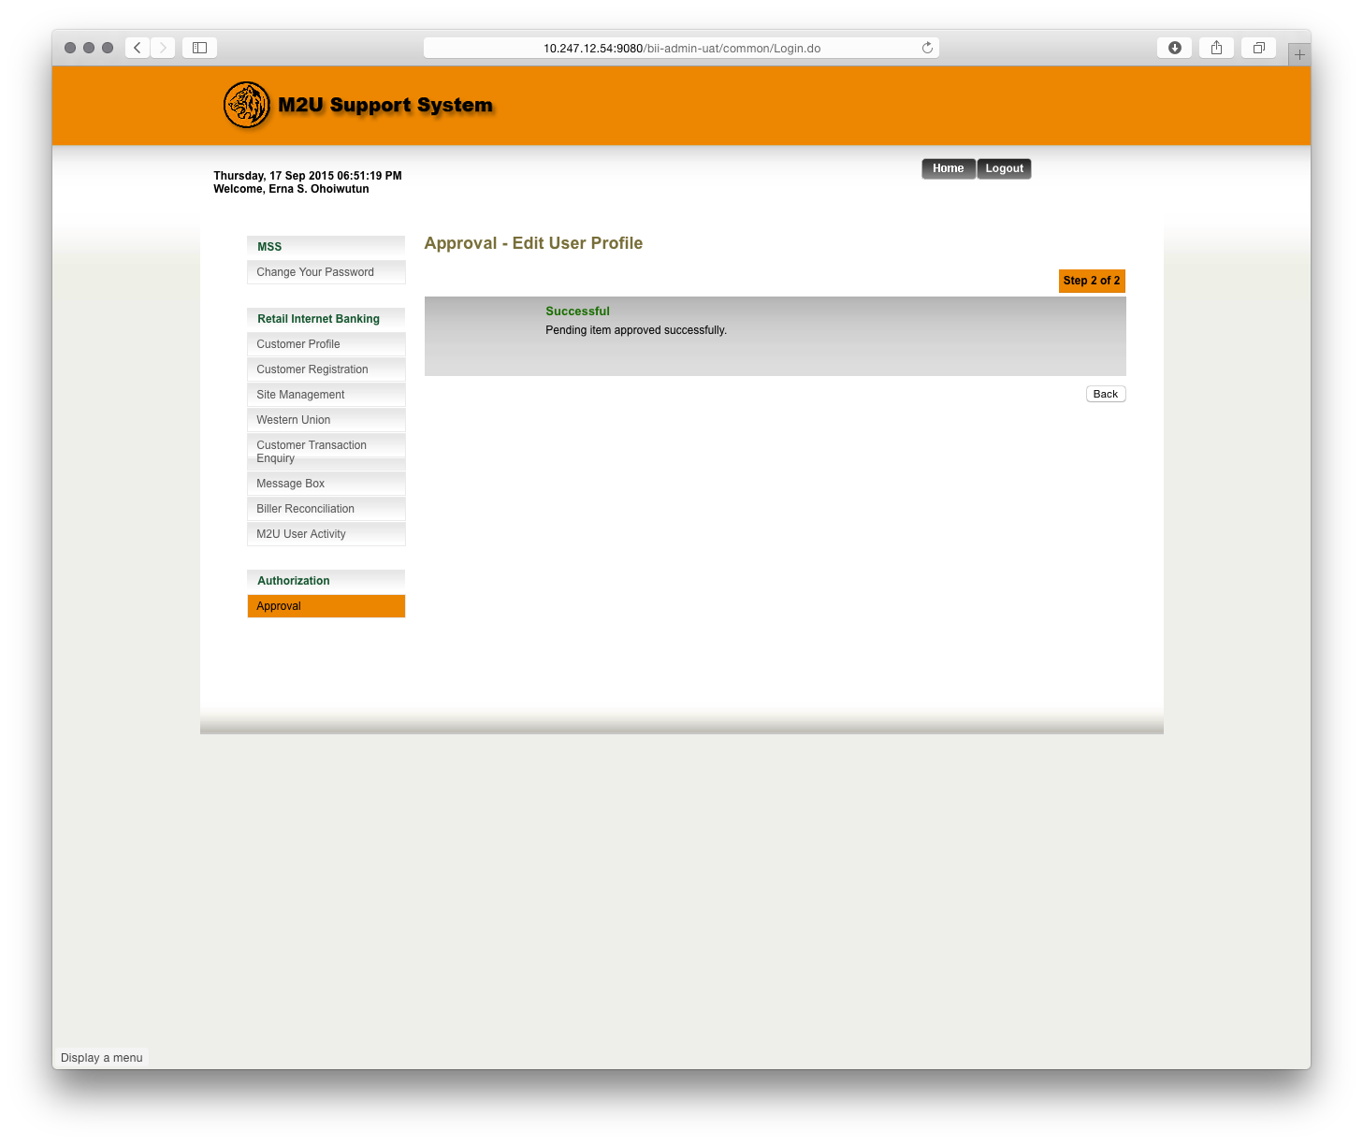
Test Case No : |  | BII-MSS-SIT / Bug #5414 / ##2755##
Test Objectives : |  | MSS – Edit Admin Profile via Maker Checker  - To check that Admin Profile Edit function can be performed with fast process.
Step No. | Actions |  | Steps | Expected Result | Pass / Fail | Actual Result
1 | Update Admin Profile Using Maker Checker |  | - Login in MSS as user : MSSMaker1.  - Password : Bii123456 / Bypass  - Go to Admin, Admin User Profile,  - Edit SATMaker,  - Change all the value, | - Confirm page shall show updated details properly, | Pass | - OK
2 |  |  | - Click submit. | - Result page shall show successful and pending for approval,  - Shall show this result page in less than 10 seconds. | Pass | - OK
3 |  |  | - Login in MSS as user : mssappr1  - Go to Authorization, approval, click on pending item, | - Confirm page shall show before and after changes details correctly. | Pass | - OK
 |  |  | - Choose Approve, and key in reason,  - Click submit. | - It shall say pending item approved succesfully,  - Shall show this result page in less than 10 seconds. | Pass | - OK
Remark :

