Retail Internet Banking (RIB)

**ELECTRONIC BANKING GROUP**

|  |  |  |  |
| --- | --- | --- | --- |
| Project Name | **Retail Internet Banking (RIB)** | | |
| SR No. | 5492 | | |
| **Prepared by** | **Gabbytian Rayvandy** | Version | **1.0** |

**Prerequisites**

In order to achieve successful test result, below check list must be performed:

1. Update table schema to cater with this enhancement:

-- <ScriptOptions statementTerminator=";" />

ALTER TABLE DBO.IB_FTT_TRANSFER ADD COLUMN JENIS_PENERIMA VARCHAR(8) ADD COLUMN STATUS_KEPENDUDUKAN_PENERIMA VARCHAR(8) ADD COLUMN JENIS_TRANSAKSI VARCHAR(8);

CALL SYSPROC.ADMIN_CMD( 'REORG TABLE DBO.IB_FTT_TRANSFER' );

CALL SYSPROC.ADMIN_CMD( 'RUNSTATS ON TABLE DBO.IB_FTT_TRANSFER' );

1. Update configuration files IBBusinessOptionsResources_in.properties & IBBusinessOptionsResources_en.properties with these new values:

skn.jenis.penerima.value=1;2;3

skn.jenis.penerima.display=Perorangan; Perusahaan; Pemerintah

skn.status.kependudukan.penerima.value=1;2

skn.status.kependudukan.penerima.display=Penduduk; Non Penduduk

skn.jenis.transaksi.value=50;51

skn.jenis.transaksi.display=Transfer antar nasabah; Transaksi Pemerintah

Above updates have been performed successfully in SIT environment.

|  |  |  |  |  |  |  |
| --- | --- | --- | --- | --- | --- | --- |
| **Test Case No :** | | BII-RIB-SIT / CR #5492 / | | | | |
| **Test Objectives :** | | **RIB – SKN BI NG Development**   * To check that new fields* are sent to ESB/host/backend system properly, * To check that new fields* are displayed in front end properly, * To check that new fields* are displayed in front end properly,   *New fields refer to:   * + Jenis Penerima,   + Status Kependudukan Penerima,   + Jenis Transaksi | | | | |
| **Step No.** | **Actions** | | **Steps** | **Expected Result** | **Pass / Fail** | **Actual Result** |
| 1 | Perform Open Interbank Transfer via SKN facility during SKN operational hour. | | * Login in RIB via URL: <http://10.247.12.51:9080/bii-rib-enhance/common/Login.do> with below credential’s info: * Username: ribuser, * Password: Bii123456   **Open SKN Transfer:**   * Navigate to ‘Fund Transfer’ > ‘Interbank SKN and RTGS’ > ‘SKN’ * Click ‘Continue’, * Fill up all the details as per screenshot: Choose ‘Transfer Now’, * Click ‘Next’, * Request and key in ‘TAC’, * Click ‘Next’ to complete transaction. | * Result page (with new fields) shall be properly shown, * New fields must be sent to ESB and processed properly in host/backend system, * New fields must be sucessfully captured to database. | Pass | * OK |
| **Remark :** | | | | | | |

**Attachment :**

**RIB – Open SKN Transfer**

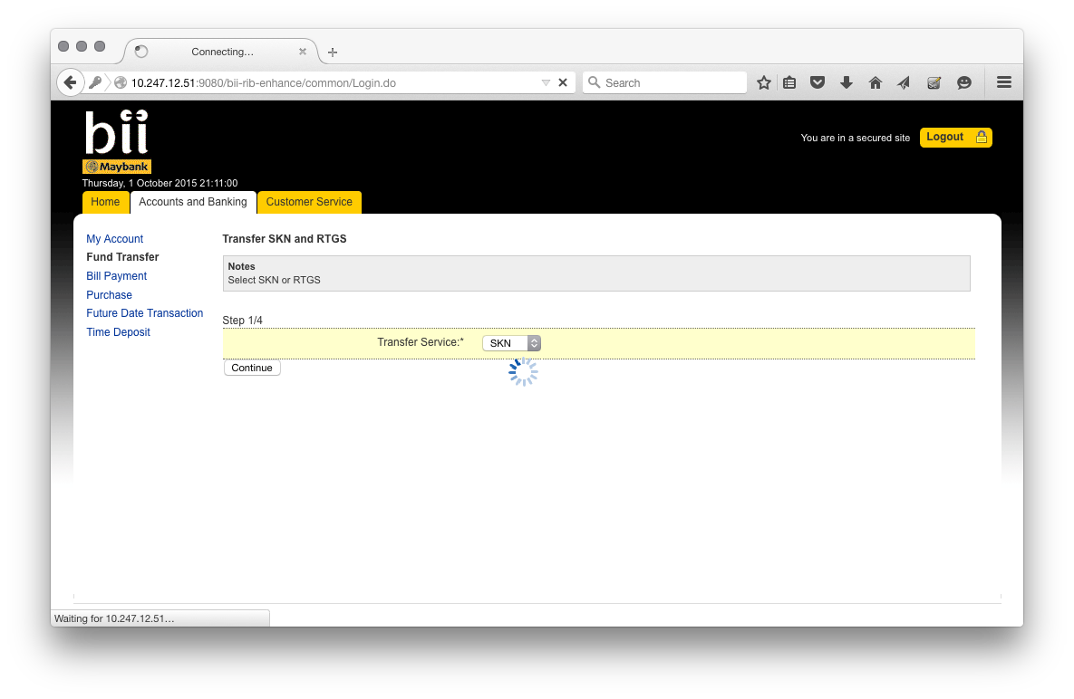

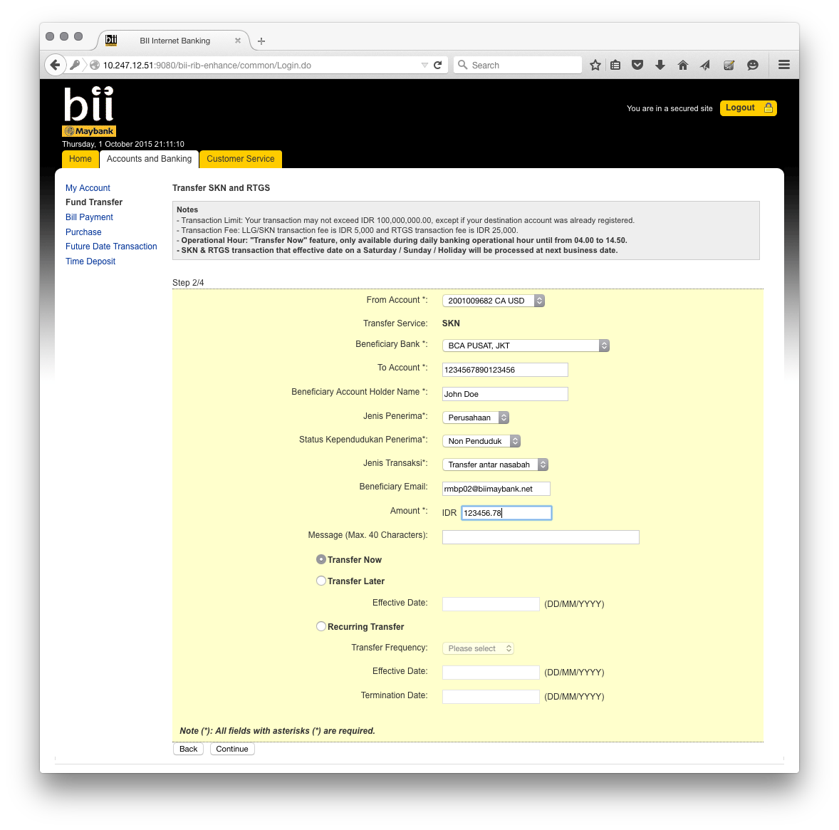

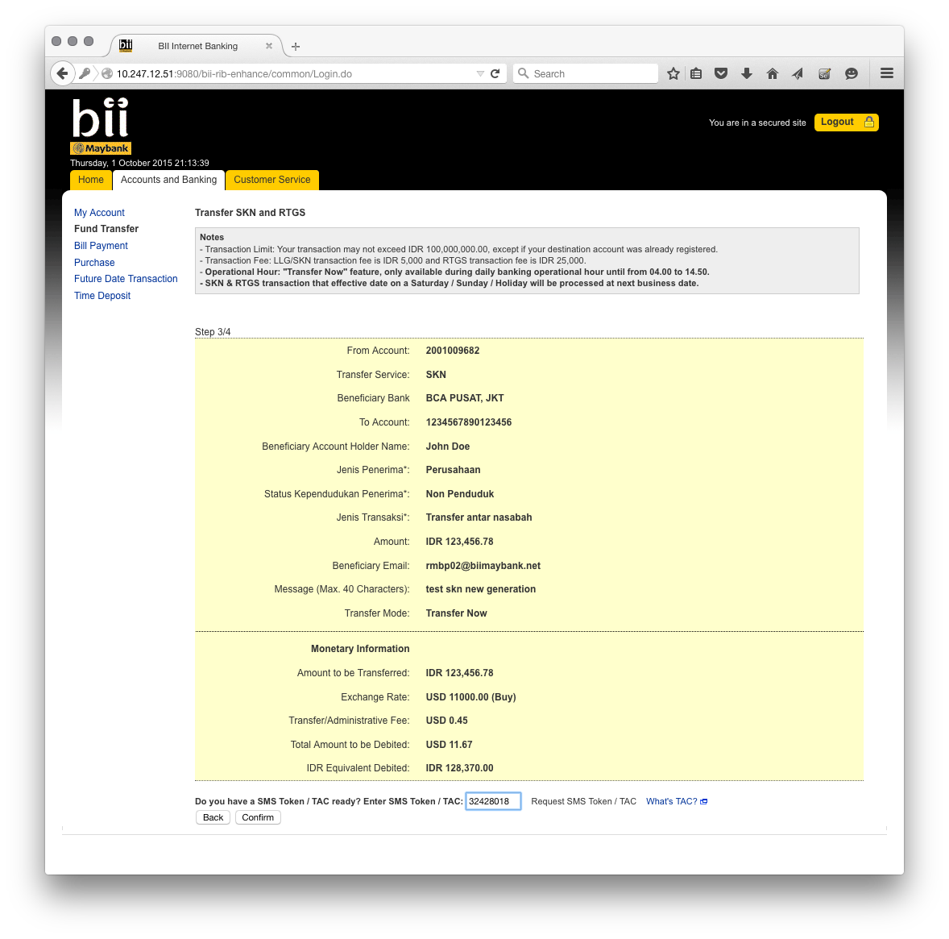

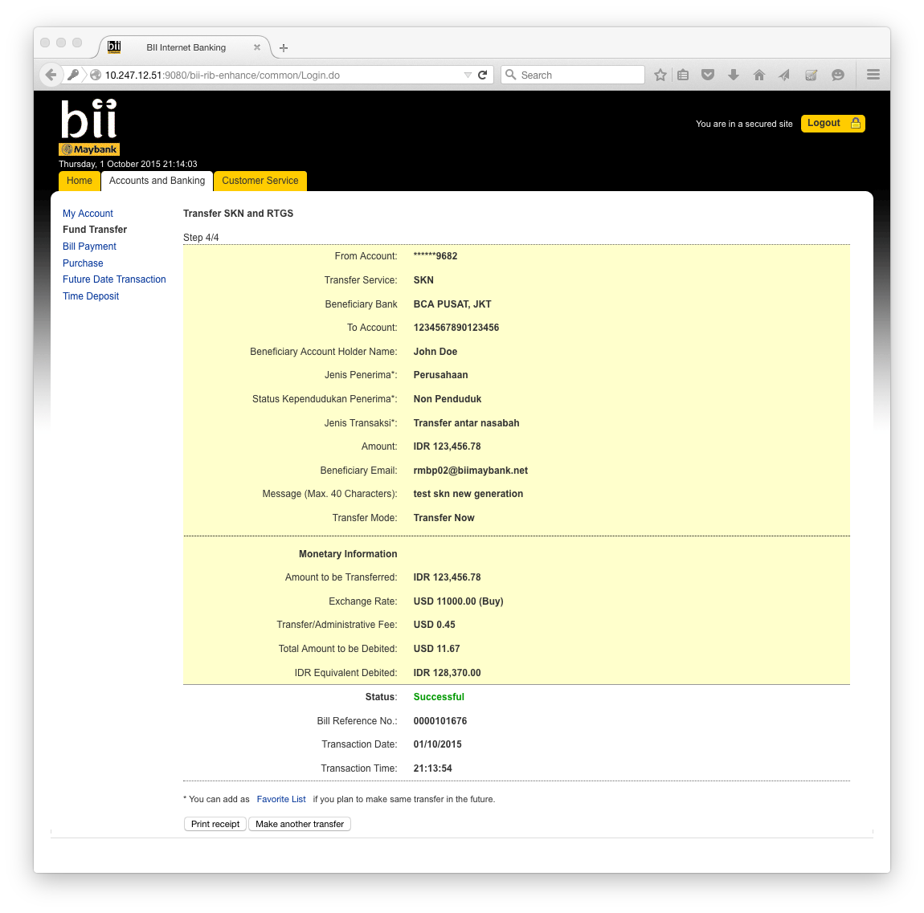

**RIB – Open SKN Transfer – Request Message to ESB/Host/Bank’s Backend System**

[10/1/15 21:13:55:396 WIT] 00000100 SystemOut O [01/10/2015] [21:13:55:395] [INFO] [ESBDomesticTransferServices]:569 - <<<<<<<<<<<<<<<<< Header >>>>>>>>>>>>>>>>>>>

[10/1/15 21:13:55:396 WIT] 00000100 SystemOut O [01/10/2015] [21:13:55:396] [INFO] [ESBDomesticTransferServices]:570 - Message ID: AA2F91DF-0C4F-4528-ABF8-8820792C34F4

[10/1/15 21:13:55:396 WIT] 00000100 SystemOut O [01/10/2015] [21:13:55:396] [INFO] [ESBDomesticTransferServices]:571 - Branch Code: 270

[10/1/15 21:13:55:396 WIT] 00000100 SystemOut O [01/10/2015] [21:13:55:396] [INFO] [ESBDomesticTransferServices]:572 - Channel ID: M2U

[10/1/15 21:13:55:397 WIT] 00000100 SystemOut O [01/10/2015] [21:13:55:396] [INFO] [ESBDomesticTransferServices]:573 - Client Supervisor ID: 0000

[10/1/15 21:13:55:397 WIT] 00000100 SystemOut O [01/10/2015] [21:13:55:397] [INFO] [ESBDomesticTransferServices]:574 - Client UserID: 0000

[10/1/15 21:13:55:397 WIT] 00000100 SystemOut O [01/10/2015] [21:13:55:397] [INFO] [ESBDomesticTransferServices]:575 - Reference No: 201302200000091C5

[10/1/15 21:13:55:398 WIT] 00000100 SystemOut O [01/10/2015] [21:13:55:397] [INFO] [ESBDomesticTransferServices]:576 - Sequence No: 4003

[10/1/15 21:13:55:398 WIT] 00000100 SystemOut O [01/10/2015] [21:13:55:398] [INFO] [ESBDomesticTransferServices]:577 - Transaction Date: 01-10-2015

[10/1/15 21:13:55:398 WIT] 00000100 SystemOut O [01/10/2015] [21:13:55:398] [INFO] [ESBDomesticTransferServices]:578 - Transaction Time: 21:13:55

[10/1/15 21:13:55:403 WIT] 00000100 SystemOut O [01/10/2015] [21:13:55:403] [INFO] [ESBDomesticTransferServices]:247 - <<<<<<<<<<<<<<<<< Request >>>>>>>>>>>>>>>>>>>

[10/1/15 21:13:55:403 WIT] 00000100 SystemOut O [01/10/2015] [21:13:55:403] [INFO] [ESBDomesticTransferServices]:248 - Filler 1:

[10/1/15 21:13:55:404 WIT] 00000100 SystemOut O [01/10/2015] [21:13:55:403] [INFO] [ESBDomesticTransferServices]:249 - Filler 2:

[10/1/15 21:13:55:404 WIT] 00000100 SystemOut O [01/10/2015] [21:13:55:404] [INFO] [ESBDomesticTransferServices]:250 - Filler 3:

[10/1/15 21:13:55:404 WIT] 00000100 SystemOut O [01/10/2015] [21:13:55:404] [INFO] [ESBDomesticTransferServices]:251 - User ID:

[10/1/15 21:13:55:404 WIT] 00000100 SystemOut O [01/10/2015] [21:13:55:404] [INFO] [ESBDomesticTransferServices]:252 - Xmit Account Penerima: 000000001234567890123456

[10/1/15 21:13:55:405 WIT] 00000100 SystemOut O [01/10/2015] [21:13:55:404] [INFO] [ESBDomesticTransferServices]:253 - Xmit Action Code: A

[10/1/15 21:13:55:405 WIT] 00000100 SystemOut O [01/10/2015] [21:13:55:405] [INFO] [ESBDomesticTransferServices]:254 - Xmit Amount: 12345678

[10/1/15 21:13:55:405 WIT] 00000100 SystemOut O [01/10/2015] [21:13:55:405] [INFO] [ESBDomesticTransferServices]:255 - Xmit Approve Date:

[10/1/15 21:13:55:406 WIT] 00000100 SystemOut O [01/10/2015] [21:13:55:405] [INFO] [ESBDomesticTransferServices]:256 - Xmit Approve Time:

[10/1/15 21:13:55:406 WIT] 00000100 SystemOut O [01/10/2015] [21:13:55:406] [INFO] [ESBDomesticTransferServices]:257 - Xmit Bic Code:

[10/1/15 21:13:55:406 WIT] 00000100 SystemOut O [01/10/2015] [21:13:55:406] [INFO] [ESBDomesticTransferServices]:258 - Xmit Cabang Cetak Llg: 003

[10/1/15 21:13:55:406 WIT] 00000100 SystemOut O [01/10/2015] [21:13:55:406] [INFO] [ESBDomesticTransferServices]:259 - Xmit Cabang Kirim: 270

[10/1/15 21:13:55:407 WIT] 00000100 SystemOut O [01/10/2015] [21:13:55:406] [INFO] [ESBDomesticTransferServices]:260 - Xmit Cabang Pelaksana: 003

[10/1/15 21:13:55:407 WIT] 00000100 SystemOut O [01/10/2015] [21:13:55:407] [INFO] [ESBDomesticTransferServices]:261 - Xmit Cabang Terima: 003

[10/1/15 21:13:55:407 WIT] 00000100 SystemOut O [01/10/2015] [21:13:55:407] [INFO] [ESBDomesticTransferServices]:262 - Xmit City Rtgs:

[10/1/15 21:13:55:407 WIT] 00000100 SystemOut O [01/10/2015] [21:13:55:407] [INFO] [ESBDomesticTransferServices]:263 - Xmit Currency Code: 016

[10/1/15 21:13:55:408 WIT] 00000100 SystemOut O [01/10/2015] [21:13:55:407] [INFO] [ESBDomesticTransferServices]:264 - Xmit DBRC Code: C

[10/1/15 21:13:55:408 WIT] 00000100 SystemOut O [01/10/2015] [21:13:55:408] [INFO] [ESBDomesticTransferServices]:265 - Xmit Message 1: SKNFRCA50

[10/1/15 21:13:55:408 WIT] 00000100 SystemOut O [01/10/2015] [21:13:55:408] [INFO] [ESBDomesticTransferServices]:266 - Xmit Message 2:

[10/1/15 21:13:55:409 WIT] 00000100 SystemOut O [01/10/2015] [21:13:55:408] [INFO] [ESBDomesticTransferServices]:267 - Xmit Message 4: test skn new generation

[10/1/15 21:13:55:409 WIT] 00000100 SystemOut O [01/10/2015] [21:13:55:409] [INFO] [ESBDomesticTransferServices]:268 - Xmit Message 5: 1234567890123456

[10/1/15 21:13:55:409 WIT] 00000100 SystemOut O [01/10/2015] [21:13:55:409] [INFO] [ESBDomesticTransferServices]:269 - Xmit Nama Bank Llg: BCA PUSAT, JKT

[10/1/15 21:13:55:409 WIT] 00000100 SystemOut O [01/10/2015] [21:13:55:409] [INFO] [ESBDomesticTransferServices]:270 - Xmit Nama Penerima 1: John Doe

[10/1/15 21:13:55:410 WIT] 00000100 SystemOut O [01/10/2015] [21:13:55:409] [INFO] [ESBDomesticTransferServices]:271 - Xmit Nama Penerima 2:

[10/1/15 21:13:55:410 WIT] 00000100 SystemOut O [01/10/2015] [21:13:55:410] [INFO] [ESBDomesticTransferServices]:272 - Xmit Nama Pengirim 1: CHRISTOPHER P

[10/1/15 21:13:55:410 WIT] 00000100 SystemOut O [01/10/2015] [21:13:55:410] [INFO] [ESBDomesticTransferServices]:273 - Xmit Nama Pengirim 2:

[10/1/15 21:13:55:411 WIT] 00000100 SystemOut O [01/10/2015] [21:13:55:410] [INFO] [ESBDomesticTransferServices]:274 - Xmit No Account Pengirim: 2001009682

[10/1/15 21:13:55:411 WIT] 00000100 SystemOut O [01/10/2015] [21:13:55:411] [INFO] [ESBDomesticTransferServices]:275 - Xmit Oper ID:

[10/1/15 21:13:55:411 WIT] 00000100 SystemOut O [01/10/2015] [21:13:55:411] [INFO] [ESBDomesticTransferServices]:276 - Xmit Puab Flag: N

[10/1/15 21:13:55:411 WIT] 00000100 SystemOut O [01/10/2015] [21:13:55:411] [INFO] [ESBDomesticTransferServices]:277 - Xmit Record Type: L

[10/1/15 21:13:55:412 WIT] 00000100 SystemOut O [01/10/2015] [21:13:55:411] [INFO] [ESBDomesticTransferServices]:278 - Xmit Reff Number: I0000101676

[10/1/15 21:13:55:412 WIT] 00000100 SystemOut O [01/10/2015] [21:13:55:412] [INFO] [ESBDomesticTransferServices]:279 - Xmit Release Date:

[10/1/15 21:13:55:412 WIT] 00000100 SystemOut O [01/10/2015] [21:13:55:412] [INFO] [ESBDomesticTransferServices]:280 - Xmit Release Time:

[10/1/15 21:13:55:412 WIT] 00000100 SystemOut O [01/10/2015] [21:13:55:412] [INFO] [ESBDomesticTransferServices]:281 - Xmit Resident Code: R

[10/1/15 21:13:55:413 WIT] 00000100 SystemOut O [01/10/2015] [21:13:55:412] [INFO] [ESBDomesticTransferServices]:282 - Xmit Resp Code:

[10/1/15 21:13:55:413 WIT] 00000100 SystemOut O [01/10/2015] [21:13:55:413] [INFO] [ESBDomesticTransferServices]:283 - Xmit Resp Text:

[10/1/15 21:13:55:413 WIT] 00000100 SystemOut O [01/10/2015] [21:13:55:413] [INFO] [ESBDomesticTransferServices]:284 - Xmit Rtgs Confirm:

[10/1/15 21:13:55:413 WIT] 00000100 SystemOut O [01/10/2015] [21:13:55:413] [INFO] [ESBDomesticTransferServices]:285 - Xmit Rtgs Kode Capem:

[10/1/15 21:13:55:414 WIT] 00000100 SystemOut O [01/10/2015] [21:13:55:414] [INFO] [ESBDomesticTransferServices]:286 - Xmit Rtgs Nama Capem:

[10/1/15 21:13:55:414 WIT] 00000100 SystemOut O [01/10/2015] [21:13:55:414] [INFO] [ESBDomesticTransferServices]:287 - Xmit Rtgs Tran Code: IFT00000

[10/1/15 21:13:55:414 WIT] 00000100 SystemOut O [01/10/2015] [21:13:55:414] [INFO] [ESBDomesticTransferServices]:288 - Xmit Sandi Bank: 0140012

[10/1/15 21:13:55:415 WIT] 00000100 SystemOut O [01/10/2015] [21:13:55:414] [INFO] [ESBDomesticTransferServices]:289 - Xmit Sign on Flag:

[10/1/15 21:13:55:415 WIT] 00000100 SystemOut O [01/10/2015] [21:13:55:415] [INFO] [ESBDomesticTransferServices]:290 - Xmit SKN Kode Transaksi: 50

[10/1/15 21:13:55:415 WIT] 00000100 SystemOut O [01/10/2015] [21:13:55:415] [INFO] [ESBDomesticTransferServices]:291 - Xmit SKN Warga Negara: 0

[10/1/15 21:13:55:415 WIT] 00000100 SystemOut O [01/10/2015] [21:13:55:415] [INFO] [ESBDomesticTransferServices]:292 - Xmit Source Code: IBS

[10/1/15 21:13:55:416 WIT] 00000100 SystemOut O [01/10/2015] [21:13:55:415] [INFO] [ESBDomesticTransferServices]:293 - Xmit Status: AP

[10/1/15 21:13:55:416 WIT] 00000100 SystemOut O [01/10/2015] [21:13:55:416] [INFO] [ESBDomesticTransferServices]:294 - Xmit Status Ptr:

[10/1/15 21:13:55:416 WIT] 00000100 SystemOut O [01/10/2015] [21:13:55:416] [INFO] [ESBDomesticTransferServices]:295 - Xmit Stt Rtgs:

[10/1/15 21:13:55:416 WIT] 00000100 SystemOut O [01/10/2015] [21:13:55:416] [INFO] [ESBDomesticTransferServices]:296 - Xmit Terbilang:

[10/1/15 21:13:55:417 WIT] 00000100 SystemOut O [01/10/2015] [21:13:55:416] [INFO] [ESBDomesticTransferServices]:297 - Xmit Terminal ID:

[10/1/15 21:13:55:417 WIT] 00000100 SystemOut O [01/10/2015] [21:13:55:417] [INFO] [ESBDomesticTransferServices]:298 - Xmit Tx Date:

[10/1/15 21:13:55:417 WIT] 00000100 SystemOut O [01/10/2015] [21:13:55:417] [INFO] [ESBDomesticTransferServices]:299 - Xmit Tx Time:

[10/1/15 21:13:55:418 WIT] 00000100 SystemOut O [01/10/2015] [21:13:55:417] [INFO] [ESBDomesticTransferServices]:300 - Xmit User Approval:

[10/1/15 21:13:55:418 WIT] 00000100 SystemOut O [01/10/2015] [21:13:55:418] [INFO] [ESBDomesticTransferServices]:301 - Xmit User Level: RL

[10/1/15 21:13:55:418 WIT] 00000100 SystemOut O [01/10/2015] [21:13:55:418] [INFO] [ESBDomesticTransferServices]:302 - Xmit User Oper:

[10/1/15 21:13:55:418 WIT] 00000100 SystemOut O [01/10/2015] [21:13:55:418] [INFO] [ESBDomesticTransferServices]:303 - Xmit User Releaser:

[10/1/15 21:13:55:419 WIT] 00000100 SystemOut O [01/10/2015] [21:13:55:418] [INFO] [ESBDomesticTransferServices]:305 - Xmit Jenis Penerima: 2

[10/1/15 21:13:55:419 WIT] 00000100 SystemOut O [01/10/2015] [21:13:55:419] [INFO] [ESBDomesticTransferServices]:306 - Xmit Status Kependudukan Penerima: 2

[10/1/15 21:13:55:419 WIT] 00000100 SystemOut O [01/10/2015] [21:13:55:419] [INFO] [ESBDomesticTransferServices]:307 - Xmit Jenis Transaksi: 50

[10/1/15 21:13:55:420 WIT] 00000100 SystemOut O [01/10/2015] [21:13:55:420] [INFO] [ESBDomesticTransferServices]:367 - ### TBRDataType ###

[10/1/15 21:13:55:420 WIT] 00000100 SystemOut O [01/10/2015] [21:13:55:420] [INFO] [ESBDomesticTransferServices]:368 - TBR Number: 6270

[10/1/15 21:13:55:420 WIT] 00000100 SystemOut O [01/10/2015] [21:13:55:420] [INFO] [ESBDomesticTransferServices]:369 - Account Currency:

[10/1/15 21:13:55:421 WIT] 00000100 SystemOut O [01/10/2015] [21:13:55:420] [INFO] [ESBDomesticTransferServices]:370 - Amount 1:

[10/1/15 21:13:55:421 WIT] 00000100 SystemOut O [01/10/2015] [21:13:55:421] [INFO] [ESBDomesticTransferServices]:371 - Amount 2:

[10/1/15 21:13:55:421 WIT] 00000100 SystemOut O [01/10/2015] [21:13:55:421] [INFO] [ESBDomesticTransferServices]:372 - Amount 3:

[10/1/15 21:13:55:422 WIT] 00000100 SystemOut O [01/10/2015] [21:13:55:421] [INFO] [ESBDomesticTransferServices]:373 - Amount 4:

[10/1/15 21:13:55:422 WIT] 00000100 SystemOut O [01/10/2015] [21:13:55:422] [INFO] [ESBDomesticTransferServices]:374 - Amount 5:

[10/1/15 21:13:55:422 WIT] 00000100 SystemOut O [01/10/2015] [21:13:55:422] [INFO] [ESBDomesticTransferServices]:375 - Check No: 0000000

[10/1/15 21:13:55:422 WIT] 00000100 SystemOut O [01/10/2015] [21:13:55:422] [INFO] [ESBDomesticTransferServices]:376 - COACP Fee:

[10/1/15 21:13:55:423 WIT] 00000100 SystemOut O [01/10/2015] [21:13:55:422] [INFO] [ESBDomesticTransferServices]:377 - COASCM Fee:

[10/1/15 21:13:55:423 WIT] 00000100 SystemOut O [01/10/2015] [21:13:55:423] [INFO] [ESBDomesticTransferServices]:378 - COASCM Interest:

[10/1/15 21:13:55:423 WIT] 00000100 SystemOut O [01/10/2015] [21:13:55:423] [INFO] [ESBDomesticTransferServices]:379 - Description:

[10/1/15 21:13:55:423 WIT] 00000100 SystemOut O [01/10/2015] [21:13:55:423] [INFO] [ESBDomesticTransferServices]:380 - Destination Account Currency: 016

[10/1/15 21:13:55:424 WIT] 00000100 SystemOut O [01/10/2015] [21:13:55:423] [INFO] [ESBDomesticTransferServices]:381 - Destination Account No:

[10/1/15 21:13:55:424 WIT] 00000100 SystemOut O [01/10/2015] [21:13:55:424] [INFO] [ESBDomesticTransferServices]:382 - Destination Amount: 12345678

[10/1/15 21:13:55:424 WIT] 00000100 SystemOut O [01/10/2015] [21:13:55:424] [INFO] [ESBDomesticTransferServices]:383 - Destination Description:

[10/1/15 21:13:55:424 WIT] 00000100 SystemOut O [01/10/2015] [21:13:55:424] [INFO] [ESBDomesticTransferServices]:384 - Destination PBK Description:

[10/1/15 21:13:55:425 WIT] 00000100 SystemOut O [01/10/2015] [21:13:55:424] [INFO] [ESBDomesticTransferServices]:385 - Destination Ref No: I0000101676

[10/1/15 21:13:55:425 WIT] 00000100 SystemOut O [01/10/2015] [21:13:55:425] [INFO] [ESBDomesticTransferServices]:386 - Fee 1: 45

[10/1/15 21:13:55:425 WIT] 00000100 SystemOut O [01/10/2015] [21:13:55:425] [INFO] [ESBDomesticTransferServices]:387 - Fee 2: 165000

[10/1/15 21:13:55:426 WIT] 00000100 SystemOut O [01/10/2015] [21:13:55:425] [INFO] [ESBDomesticTransferServices]:388 - Fee Account No: 460503001

[10/1/15 21:13:55:426 WIT] 00000100 SystemOut O [01/10/2015] [21:13:55:426] [INFO] [ESBDomesticTransferServices]:389 - Fee CP Description 1:

[10/1/15 21:13:55:426 WIT] 00000100 SystemOut O [01/10/2015] [21:13:55:426] [INFO] [ESBDomesticTransferServices]:390 - Fee FSCM Description 1:

[10/1/15 21:13:55:426 WIT] 00000100 SystemOut O [01/10/2015] [21:13:55:426] [INFO] [ESBDomesticTransferServices]:391 - Filler:

[10/1/15 21:13:55:427 WIT] 00000100 SystemOut O [01/10/2015] [21:13:55:426] [INFO] [ESBDomesticTransferServices]:392 - Flag Univ:

[10/1/15 21:13:55:427 WIT] 00000100 SystemOut O [01/10/2015] [21:13:55:427] [INFO] [ESBDomesticTransferServices]:393 - GL Interest Description:

[10/1/15 21:13:55:427 WIT] 00000100 SystemOut O [01/10/2015] [21:13:55:427] [INFO] [ESBDomesticTransferServices]:394 - Interest Description 1:

[10/1/15 21:13:55:427 WIT] 00000100 SystemOut O [01/10/2015] [21:13:55:427] [INFO] [ESBDomesticTransferServices]:395 - Sequence No: 1676

[10/1/15 21:13:55:428 WIT] 00000100 SystemOut O [01/10/2015] [21:13:55:428] [INFO] [ESBDomesticTransferServices]:396 - Source Account Currency: 039

[10/1/15 21:13:55:428 WIT] 00000100 SystemOut O [01/10/2015] [21:13:55:428] [INFO] [ESBDomesticTransferServices]:397 - Source Account No: 2001009682

[10/1/15 21:13:55:429 WIT] 00000100 SystemOut O [01/10/2015] [21:13:55:428] [INFO] [ESBDomesticTransferServices]:398 - Source Account No 1:

[10/1/15 21:13:55:429 WIT] 00000100 SystemOut O [01/10/2015] [21:13:55:429] [INFO] [ESBDomesticTransferServices]:399 - Source Account No 2:

[10/1/15 21:13:55:429 WIT] 00000100 SystemOut O [01/10/2015] [21:13:55:429] [INFO] [ESBDomesticTransferServices]:400 - Source Amount: 1122

[10/1/15 21:13:55:429 WIT] 00000100 SystemOut O [01/10/2015] [21:13:55:429] [INFO] [ESBDomesticTransferServices]:401 - Source and Destination Description: Transfer

[10/1/15 21:13:55:430 WIT] 00000100 SystemOut O [01/10/2015] [21:13:55:429] [INFO] [ESBDomesticTransferServices]:402 - Source Description: Domestic SKN

[10/1/15 21:13:55:430 WIT] 00000100 SystemOut O [01/10/2015] [21:13:55:430] [INFO] [ESBDomesticTransferServices]:403 - Source Destination Account Currency:

[10/1/15 21:13:55:430 WIT] 00000100 SystemOut O [01/10/2015] [21:13:55:430] [INFO] [ESBDomesticTransferServices]:404 - Source Fee Description: Domestic SKN

[10/1/15 21:13:55:430 WIT] 00000100 SystemOut O [01/10/2015] [21:13:55:430] [INFO] [ESBDomesticTransferServices]:405 - Source Fee PBK Description:

[10/1/15 21:13:55:431 WIT] 00000100 SystemOut O [01/10/2015] [21:13:55:430] [INFO] [ESBDomesticTransferServices]:406 - Source PBK Description:

[10/1/15 21:13:55:431 WIT] 00000100 SystemOut O [01/10/2015] [21:13:55:431] [INFO] [ESBDomesticTransferServices]:407 - Source Ref No: I0000101676

[10/1/15 21:13:55:431 WIT] 00000100 SystemOut O [01/10/2015] [21:13:55:431] [INFO] [ESBDomesticTransferServices]:408 - TBR Description: SKN-Curent VLS

[10/1/15 21:13:55:431 WIT] 00000100 SystemOut O [01/10/2015] [21:13:55:431] [INFO] [ESBDomesticTransferServices]:409 - Trx Fee:

[10/1/15 21:13:55:432 WIT] 00000100 SystemOut O [01/10/2015] [21:13:55:431] [INFO] [ESBDomesticTransferServices]:410 - Trx Fee 1:

[10/1/15 21:13:55:432 WIT] 00000100 SystemOut O [01/10/2015] [21:13:55:432] [INFO] [ESBDomesticTransferServices]:411 - Trx Fee 2:

[10/1/15 21:13:55:432 WIT] 00000100 SystemOut O [01/10/2015] [21:13:55:432] [INFO] [ESBDomesticTransferServices]:412 - Universal Destination Description 1:

[10/1/15 21:13:55:432 WIT] 00000100 SystemOut O [01/10/2015] [21:13:55:432] [INFO] [ESBDomesticTransferServices]:413 - Universal Destination Description 2:

[10/1/15 21:13:55:433 WIT] 00000100 SystemOut O [01/10/2015] [21:13:55:432] [INFO] [ESBDomesticTransferServices]:414 - Universal Destination Description 3:

[10/1/15 21:13:55:433 WIT] 00000100 SystemOut O [01/10/2015] [21:13:55:433] [INFO] [ESBDomesticTransferServices]:415 - Universal Destination Description 4:

[10/1/15 21:13:55:433 WIT] 00000100 SystemOut O [01/10/2015] [21:13:55:433] [INFO] [ESBDomesticTransferServices]:416 - Universal Fee Description 1: I0000101676

[10/1/15 21:13:55:433 WIT] 00000100 SystemOut O [01/10/2015] [21:13:55:433] [INFO] [ESBDomesticTransferServices]:417 - Universal Source Description 1: Trf BCA PUSAT, JKT John Doe

[10/1/15 21:13:55:434 WIT] 00000100 SystemOut O [01/10/2015] [21:13:55:433] [INFO] [ESBDomesticTransferServices]:418 - Universal Source Description 2:

[10/1/15 21:13:55:434 WIT] 00000100 SystemOut O [01/10/2015] [21:13:55:434] [INFO] [ESBDomesticTransferServices]:419 - Universal Source Description 3:

[10/1/15 21:13:55:434 WIT] 00000100 SystemOut O [01/10/2015] [21:13:55:434] [INFO] [ESBDomesticTransferServices]:420 - Universal Source Description 4:

[10/1/15 21:13:55:434 WIT] 00000100 SystemOut O [01/10/2015] [21:13:55:434] [INFO] [ESBDomesticTransferServices]:421 - Universal Source Destination Description 2:

[10/1/15 21:13:55:435 WIT] 00000100 SystemOut O [01/10/2015] [21:13:55:435] [INFO] [ESBDomesticTransferServices]:422 - Universal Source Destination Description 3:

[10/1/15 21:13:55:435 WIT] 00000100 SystemOut O [01/10/2015] [21:13:55:435] [INFO] [ESBDomesticTransferServices]:423 - Universal Source Destination Description 4:

[10/1/15 21:14:02:816 WIT] 00000100 SystemOut O [01/10/2015] [21:14:02:816] [INFO] [ESBDomesticTransferServices]:438 - <<<<<<<<<<<<<<<<< Response >>>>>>>>>>>>>>>>>>>

[10/1/15 21:14:02:816 WIT] 00000100 SystemOut O [01/10/2015] [21:14:02:816] [INFO] [ESBDomesticTransferServices]:440 - Response Code: 00

[10/1/15 21:14:02:817 WIT] 00000100 SystemOut O [01/10/2015] [21:14:02:816] [INFO] [ESBDomesticTransferServices]:442 - Response Description: PROCESSING COMPLETE

[10/1/15 21:14:02:818 WIT] 00000100 SystemOut O [01/10/2015] [21:14:02:818] [INFO] [ESBDomesticTransferServices]:453 - Failed: 0

[10/1/15 21:14:02:818 WIT] 00000100 SystemOut O [01/10/2015] [21:14:02:818] [INFO] [ESBDomesticTransferServices]:454 - Reversed: 0

[10/1/15 21:14:02:818 WIT] 00000100 SystemOut O [01/10/2015] [21:14:02:818] [INFO] [ESBDomesticTransferServices]:455 - Success: 2

[10/1/15 21:14:02:819 WIT] 00000100 SystemOut O [01/10/2015] [21:14:02:818] [INFO] [ESBDomesticTransferServices]:456 - Transactions: 2

[10/1/15 21:14:02:820 WIT] 00000100 SystemOut O [01/10/2015] [21:14:02:819] [INFO] [ESBDomesticTransferServices]:471 - ### TransactionDetailType ####

[10/1/15 21:14:02:820 WIT] 00000100 SystemOut O [01/10/2015] [21:14:02:820] [INFO] [ESBDomesticTransferServices]:472 - Response Code: 0

[10/1/15 21:14:02:820 WIT] 00000100 SystemOut O [01/10/2015] [21:14:02:820] [INFO] [ESBDomesticTransferServices]:473 - Response Data: Success

[10/1/15 21:14:02:820 WIT] 00000100 SystemOut O [01/10/2015] [21:14:02:820] [INFO] [ESBDomesticTransferServices]:474 - Reversal Code: null

[10/1/15 21:14:02:821 WIT] 00000100 SystemOut O [01/10/2015] [21:14:02:821] [INFO] [ESBDomesticTransferServices]:475 - Reversal Data: null

[10/1/15 21:14:02:821 WIT] 00000100 SystemOut O [01/10/2015] [21:14:02:821] [INFO] [ESBDomesticTransferServices]:476 - Sequence: 1

[10/1/15 21:14:02:821 WIT] 00000100 SystemOut O [01/10/2015] [21:14:02:821] [INFO] [ESBDomesticTransferServices]:477 - TBR Code: 6270

[10/1/15 21:14:02:822 WIT] 00000100 SystemOut O [01/10/2015] [21:14:02:821] [INFO] [ESBDomesticTransferServices]:478 - Terminal ID: FC13

[10/1/15 21:14:02:822 WIT] 00000100 SystemOut O [01/10/2015] [21:14:02:822] [INFO] [ESBDomesticTransferServices]:479 - User ID: 0913

[10/1/15 21:14:02:822 WIT] 00000100 SystemOut O [01/10/2015] [21:14:02:822] [INFO] [ESBDomesticTransferServices]:480 - UUID:

[10/1/15 21:14:02:822 WIT] 00000100 SystemOut O [01/10/2015] [21:14:02:822] [INFO] [ESBDomesticTransferServices]:471 - ### TransactionDetailType ####

[10/1/15 21:14:02:823 WIT] 00000100 SystemOut O [01/10/2015] [21:14:02:822] [INFO] [ESBDomesticTransferServices]:472 - Response Code: 00

[10/1/15 21:14:02:823 WIT] 00000100 SystemOut O [01/10/2015] [21:14:02:823] [INFO] [ESBDomesticTransferServices]:473 - Response Data: PROCESSING COMPLETE

[10/1/15 21:14:02:823 WIT] 00000100 SystemOut O [01/10/2015] [21:14:02:823] [INFO] [ESBDomesticTransferServices]:474 - Reversal Code: null

[10/1/15 21:14:02:823 WIT] 00000100 SystemOut O [01/10/2015] [21:14:02:823] [INFO] [ESBDomesticTransferServices]:475 - Reversal Data: null

[10/1/15 21:14:02:824 WIT] 00000100 SystemOut O [01/10/2015] [21:14:02:823] [INFO] [ESBDomesticTransferServices]:476 - Sequence: 2

[10/1/15 21:14:02:824 WIT] 00000100 SystemOut O [01/10/2015] [21:14:02:824] [INFO] [ESBDomesticTransferServices]:477 - TBR Code: EF01

[10/1/15 21:14:02:824 WIT] 00000100 SystemOut O [01/10/2015] [21:14:02:824] [INFO] [ESBDomesticTransferServices]:478 - Terminal ID: FC13

[10/1/15 21:14:02:824 WIT] 00000100 SystemOut O [01/10/2015] [21:14:02:824] [INFO] [ESBDomesticTransferServices]:479 - User ID: 0913

[10/1/15 21:14:02:825 WIT] 00000100 SystemOut O [01/10/2015] [21:14:02:824] [INFO] [ESBDomesticTransferServices]:480 - UUID:

[10/1/15 21:14:02:825 WIT] 00000100 SystemOut O [01/10/2015] [21:14:02:825] [INFO] [WsIntegrationService]:104 -

<<<<<<<<<<<<<<<<< Performance Calculate Result >>>>>>>>>>>>>>>>>>>

Class: {http://www.bankbii.com/TransactionServices/}TransactionServices

MessageID: AA2F91DF-0C4F-4528-ABF8-8820792C34F4

Start Time: Thu Oct 01 21:13:55 WIT 2015

End Time: Thu Oct 01 21:14:02 WIT 2015

Time Used to complete whole service (in miliseconds): 7430

**RIB – Open SKN Transfer – Record in Database**

**Query:**

SELECT TRNX_ID, JENIS_PENERIMA, STATUS_KEPENDUDUKAN_PENERIMA, JENIS_TRANSAKSI FROM DBO.IB_FTT_TRANSFER WHERE TRNX_ID = '20151001000000101676';

**Query Result:**

**Apple SSD 512GB:Users:rayvandy:Desktop:Screen Shot 2015-10-01 at 21.49.23.png**