1. Failed to validate **Amount** if insert alphanumeric.

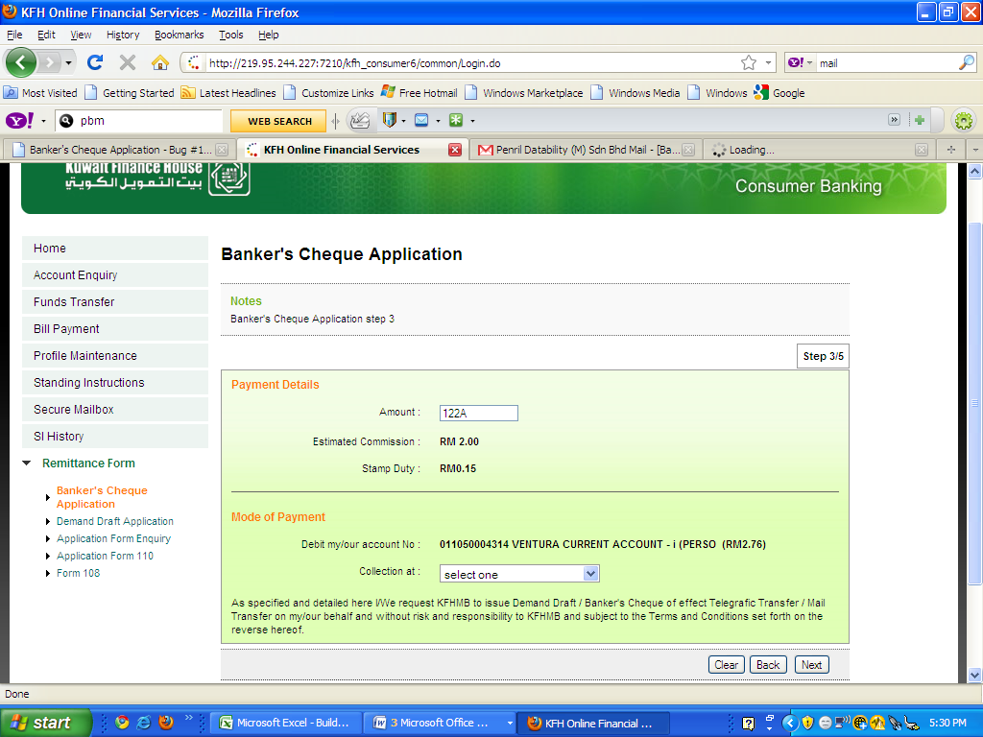

1. After click Next Button, It will go to error page.

