**Services 🡪 e-Billers List**

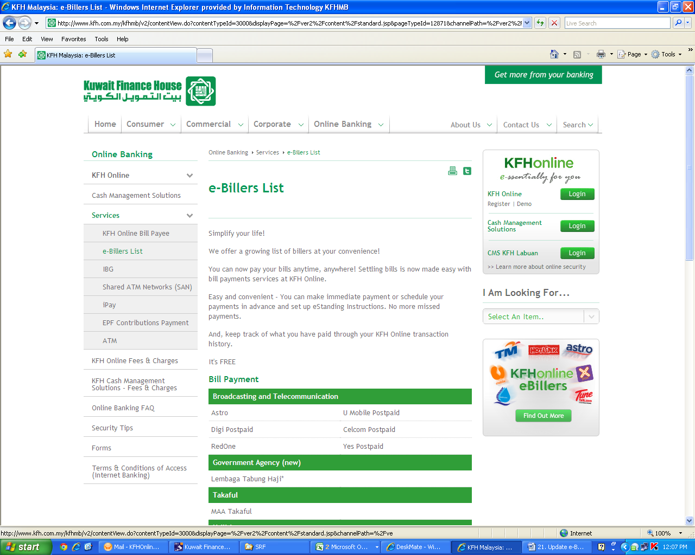

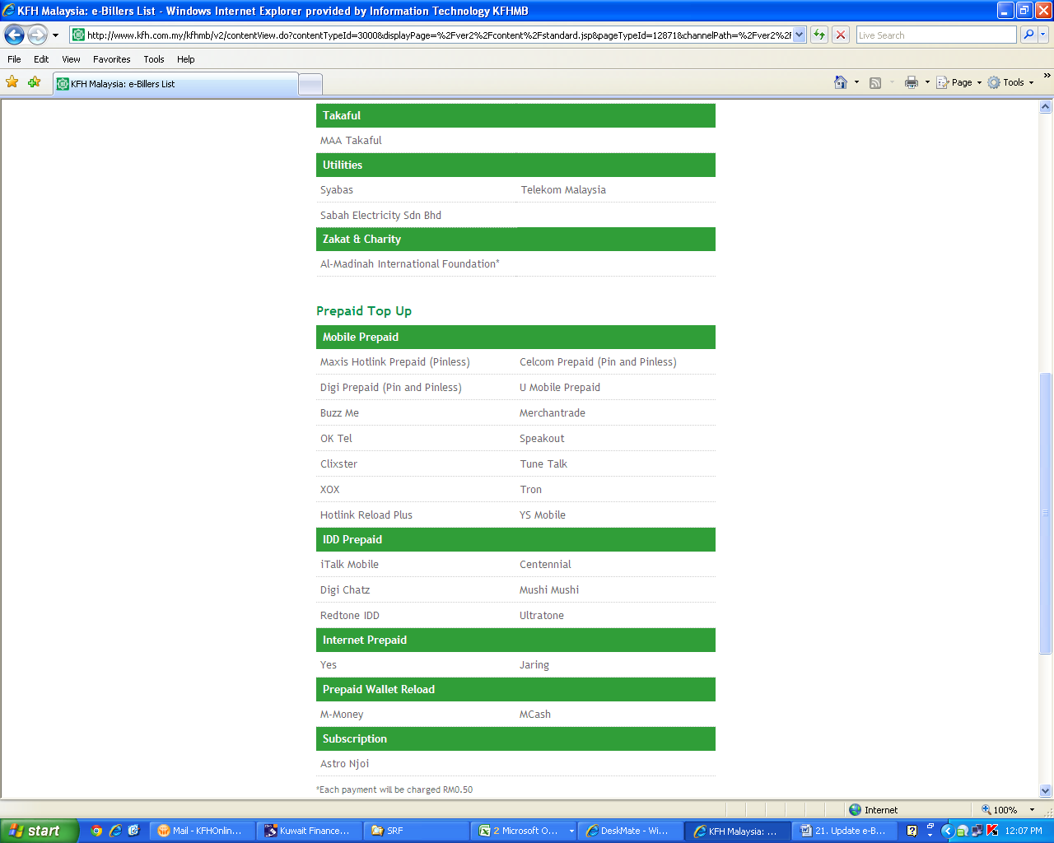

**To Remove:**

**Hotlink Reload Plus**

**To Rename:**

**Clixster to MyAngkasa@M8**

**To Remove:**

**- Telekom Malaysia**