Internal testing result |  |  |  |  |  | SCP ID: 2813
Project Name: | Business Internet Banking
Test Stage: | Unit Functionality Integration System Interface  Performance Regression Acceptance Pilot
Test Case Number: | - |  |  | Test Started Date: |  | 19/10/2015
Test Title: | Bulk Upload – IBG Failed & Incorrect Toll Free No.
Test Description: | 1st Testing – BAU  To test bulk upload as usual  2nd Testing – unsuccessful test  - To test bulk upload for IBG with unsuccessful result  - To check on the toll free number at the unsuccessful reason
Test Functionality: | - BIB>Bulk Payment> Bulk Payment Upload  - BIB> Bulk Payment> Bulk Payment Search
Test Procedure: | - Perform transaction at Bulk Payment Upload  - Run Bulk Payment engine which IBG Web Service pointing change to wrong URL.  - Check the unsuccessful transaction reason
Test Result: | Pass: Fail: | Tested by: |  |  | Lizahwati binti Basirun
Reason for Failure:
TEST DESCRIPTION
1st Testing – BAU

Bulk Payment Upload

Open/Payroll

Confirm Page
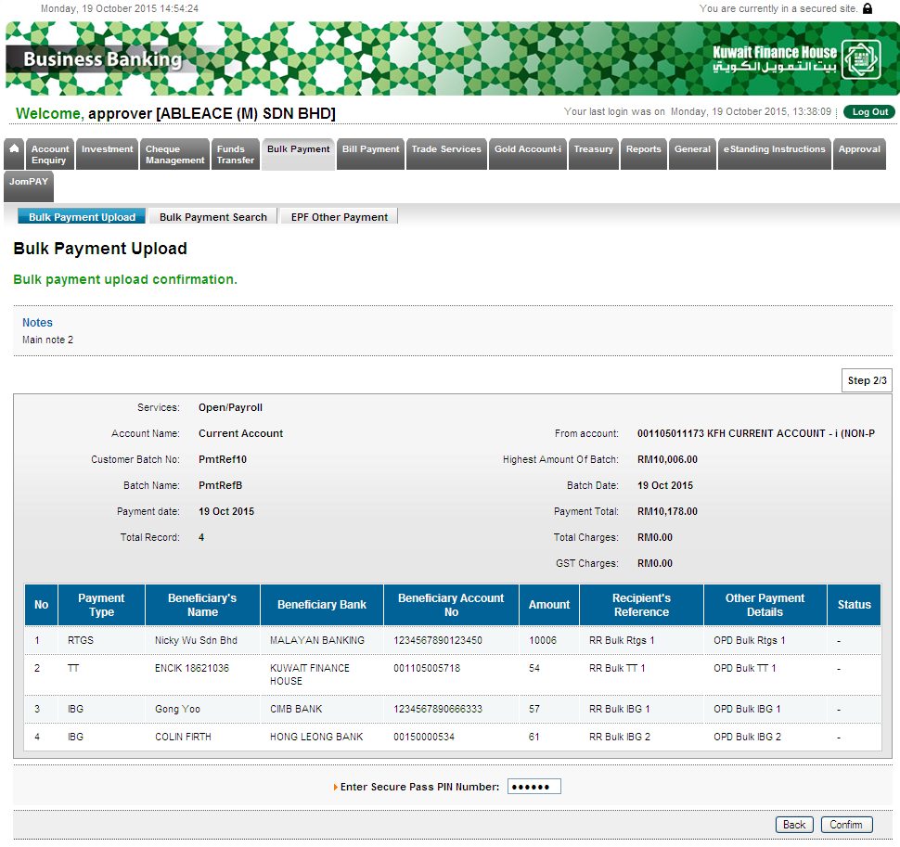

Result Page
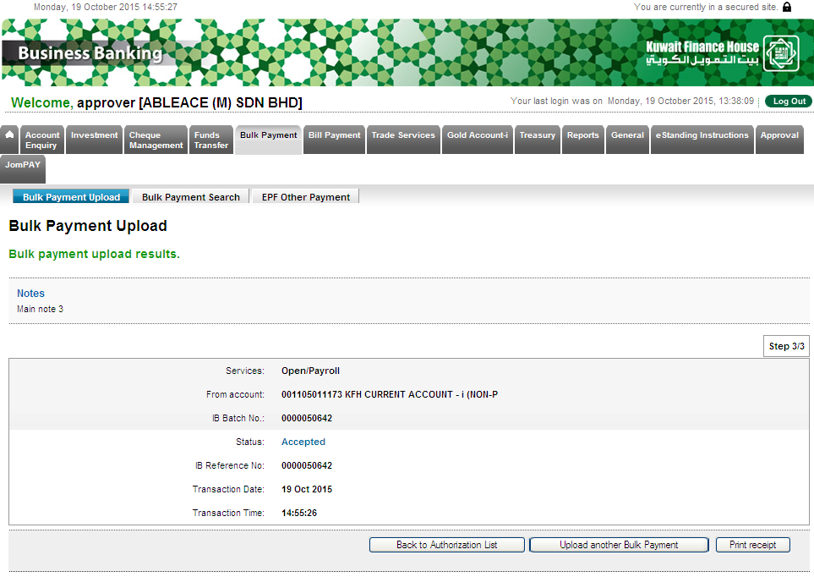

Receipt
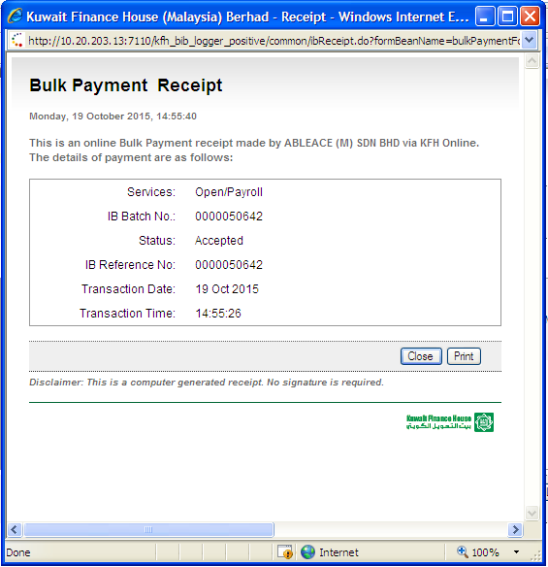

KFH Online Transaction History
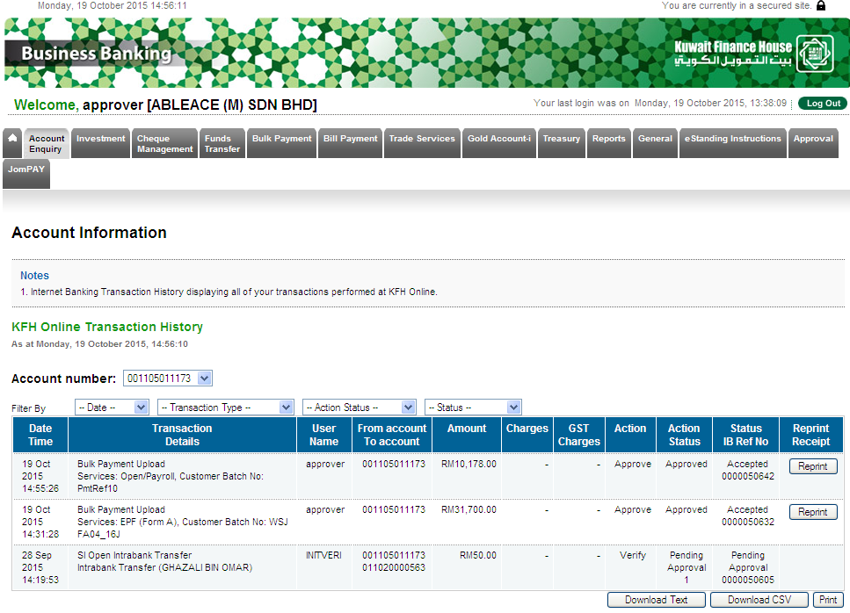

Transaction History
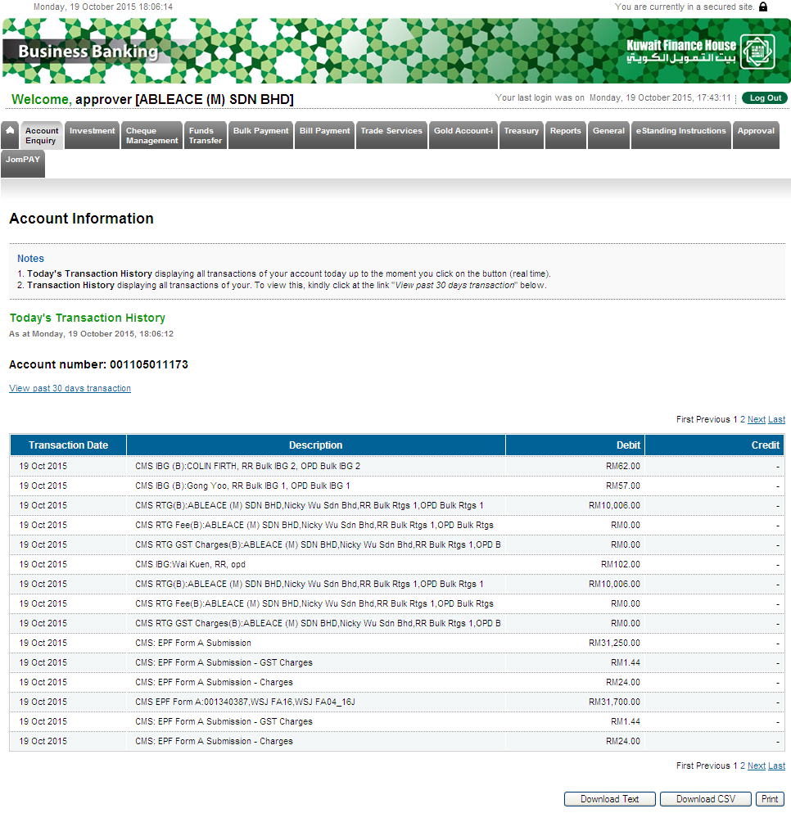

EPF (Form A)

Confirm Page
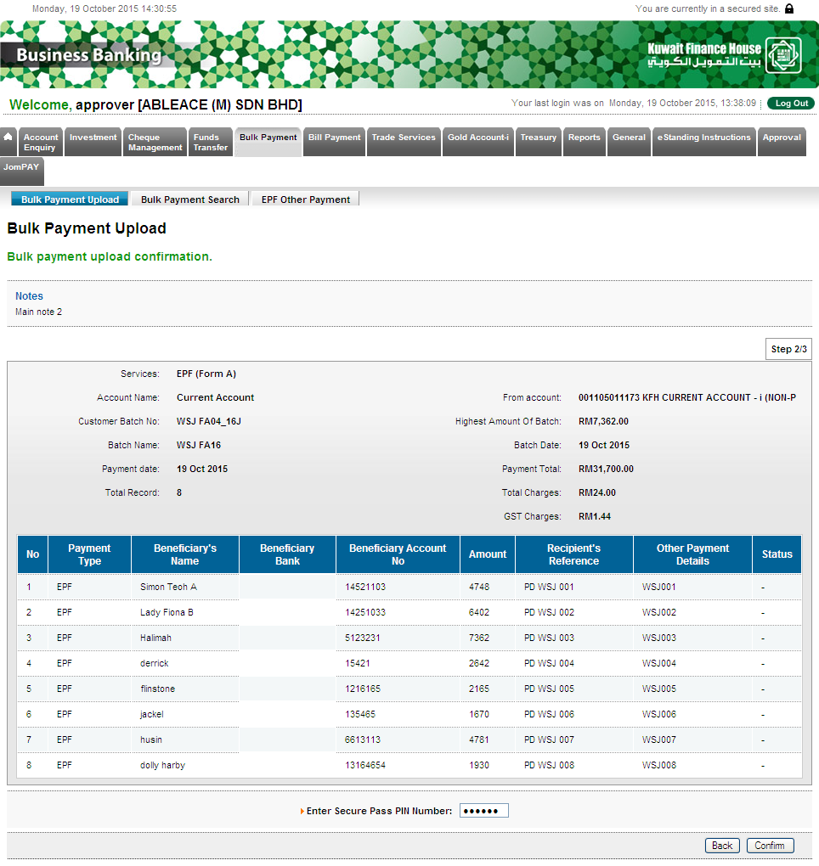

Result Page
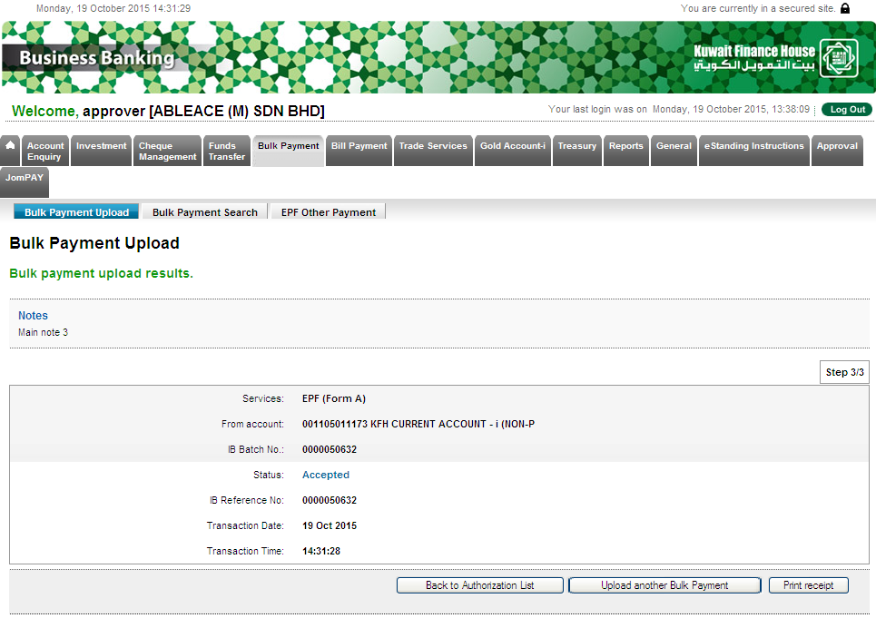

Receipt
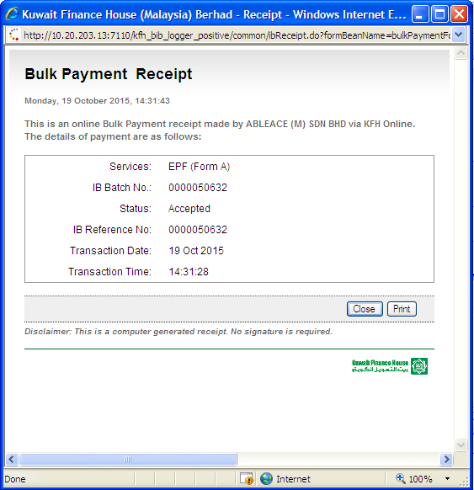

KFH Online Transaction History
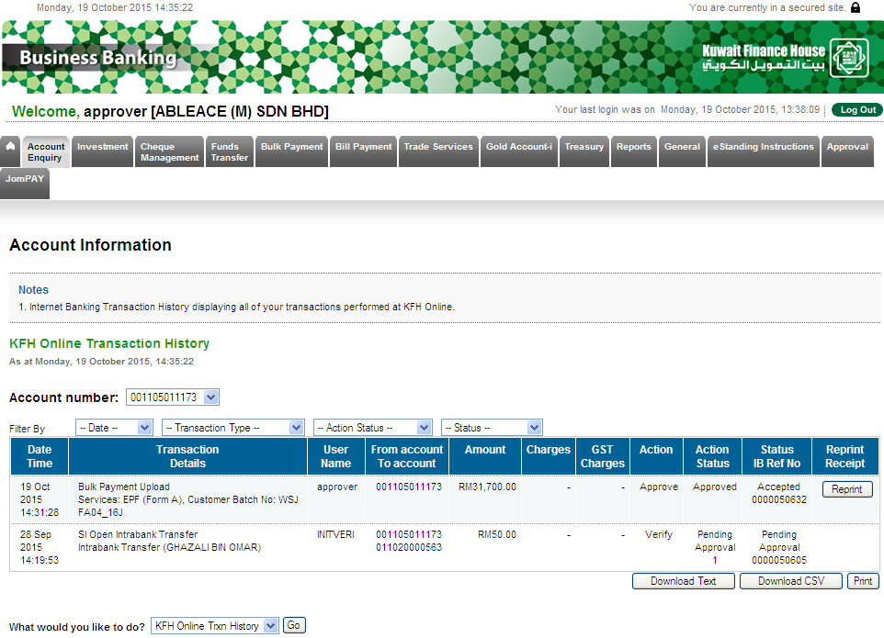

Transaction History

2nd Testing – Unsuccessful test (IBG)

Confirm Page
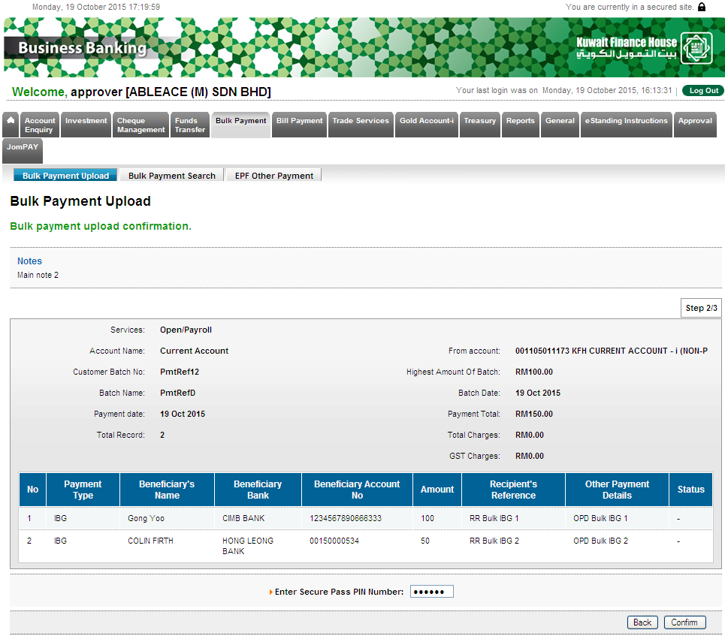

Result Page

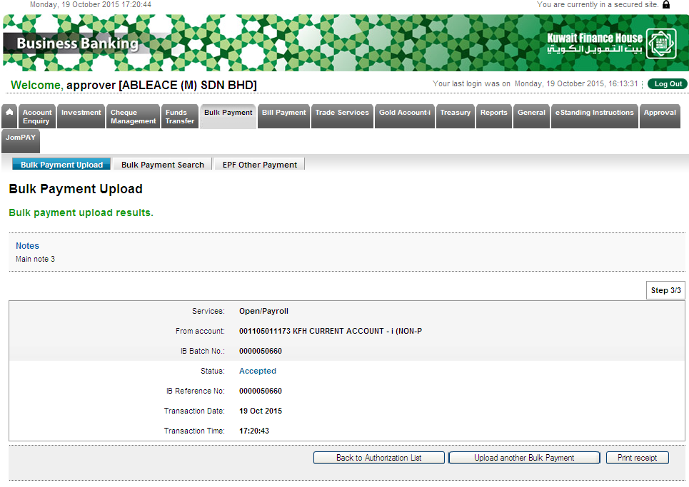

Bulk Payment search details
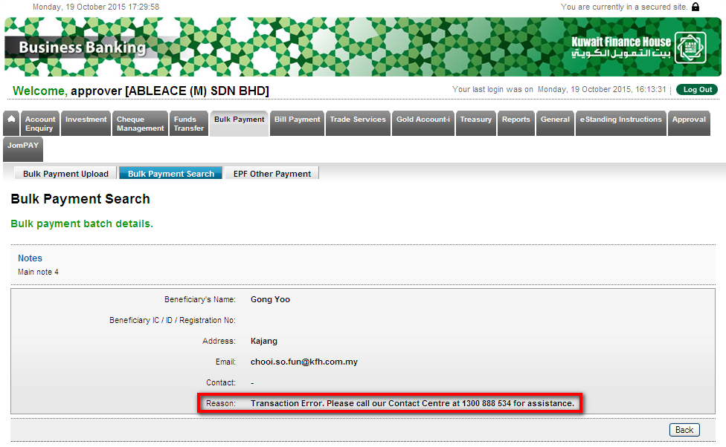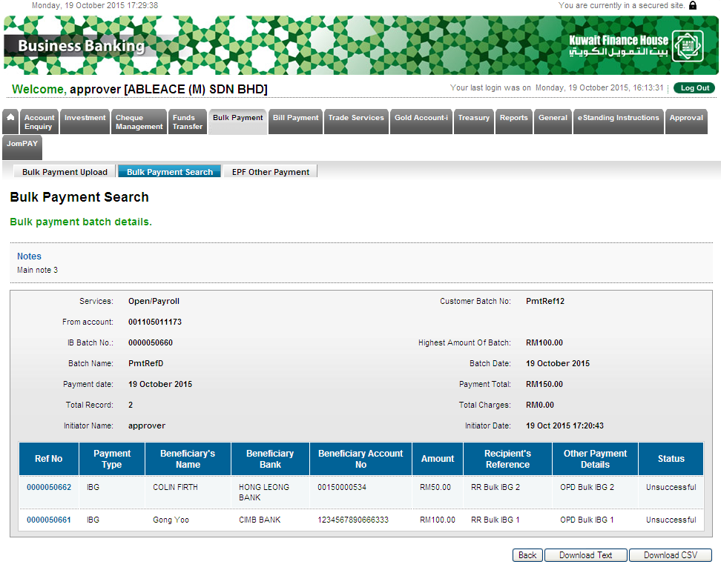
 |  |  | Name/Position : NorhaidahBintiMdDasuki / Senior Manager, Quality Assurance and Support  Date :

